LAPORAN UAS PEMROGRAMAN BERBASIS PLATFORM

Nama : Ariel Siletty
Nim : 202351057
Prodi : Ilmu Komputer

1. Judul Aplikasi
"Aplikasi Pengaduan Masyarakat Digital"
Platform Mobile untuk Pelaporan dan Penanganan Masalah Masyarakat

2. Deskripsi Singkat Aplikasi
Aplikasi mobile berbasis React Native yang memfasilitasi masyarakat dalam melaporkan berbagai masalah di lingkungan (infrastruktur, sosial, lingkungan, keamanan) dan memungkinkan pemerintah (admin) untuk menanggapi serta menindaklanjuti pengaduan tersebut secara real-time.
Tujuan Utama:
- Menyediakan saluran pengaduan digital yang mudah diakses 24/7
- Mempercepat waktu respon pemerintah terhadap keluhan masyarakat
- Meningkatkan transparansi proses penanganan pengaduan
- Membangun database terstruktur untuk analisis permasalahan publik

3. Fitur Utama dan Fitur Tambahan

Fitur Utama:
- Sistem Autentikasi Lengkap
  - Registrasi dengan validasi NIK (16 digit)
  - Login dengan email dan password
  - Role-based access (Masyarakat & Admin)
  - Session management dengan JWT
- Manajemen Pengaduan
  - Form pengaduan dengan kategori terstruktur
  - Upload foto bukti (URL-based)
  - Tracking status real-time
  - Riwayat perubahan status
- Dashboard Interaktif
  - Overview statistik pengaduan
  - Daftar pengaduan dengan filter status
  - Quick actions untuk admin
  - Pull-to-refresh untuk update data
- Sistem Notifikasi
  - Update status otomatis
  - Deadline reminder untuk admin
  - Responsive alerts untuk user

Fitur Tambahan:
- Validasi Form Real-time
- Search & Filter pengaduan
- Export data sederhana
- Responsive design untuk berbagai device
- Offline capability (basic)
- Multi-language ready (structure)
- Dark mode support

4. Arsitektur Sistem

Arsitektur Full-Stack:

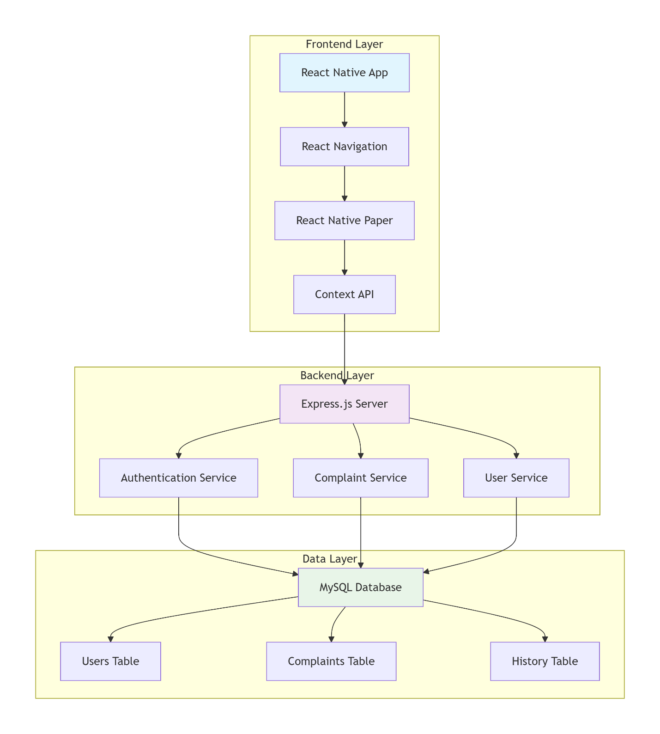

Komponen Arsitektur:
- Client-Side: React Native dengan Native Modules
- Server-Side: Node.js dengan Express.js Framework
- Database: MySQL dengan relational schema
- Communication: RESTful API dengan JSON format
- Authentication: JWT dengan bcrypt hashing

5. UML Diagram

Use Case Diagram:

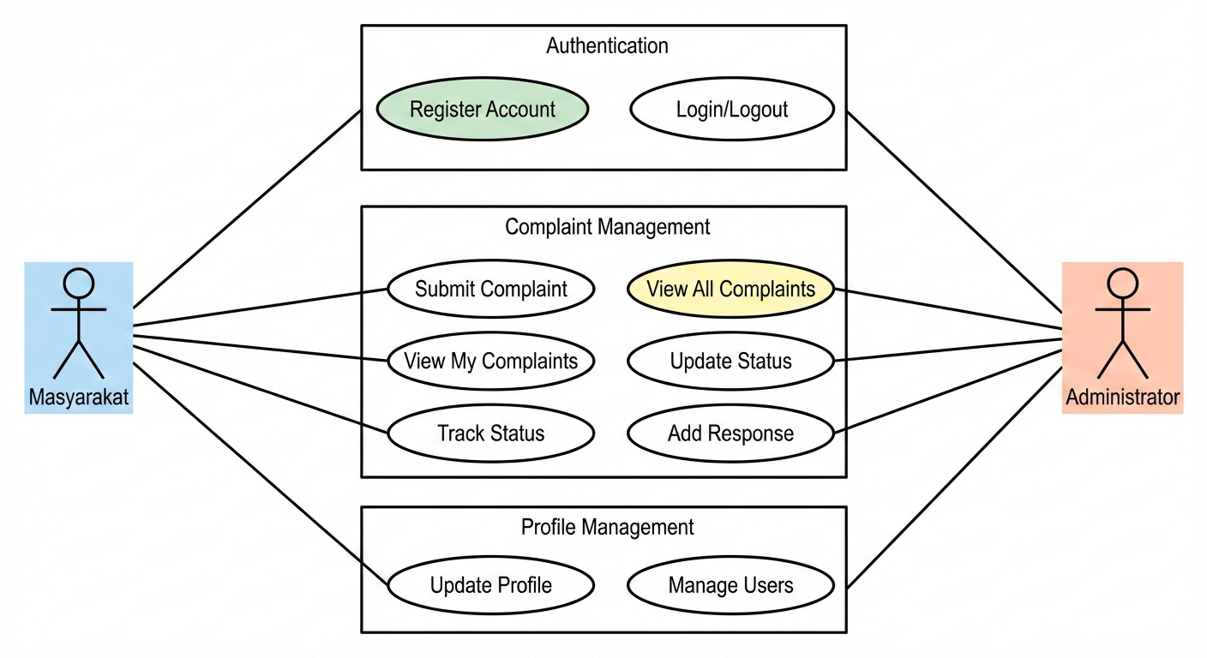

Class Diagram:

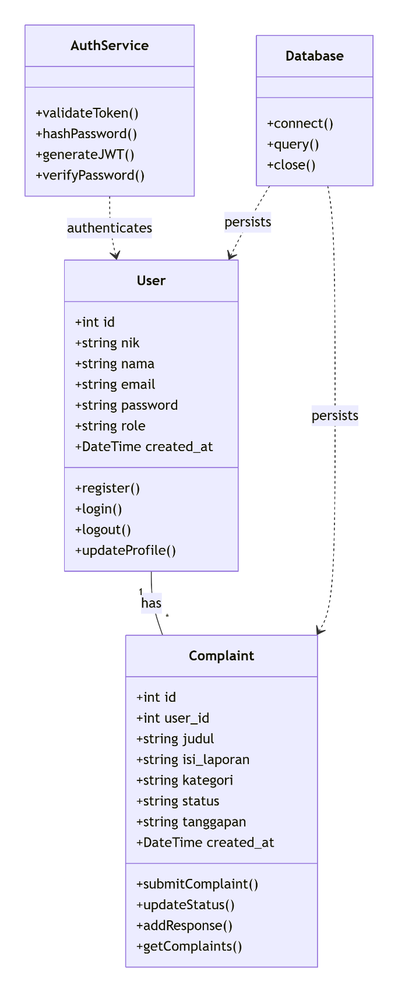
- ERD (Entity Relationship Diagram)

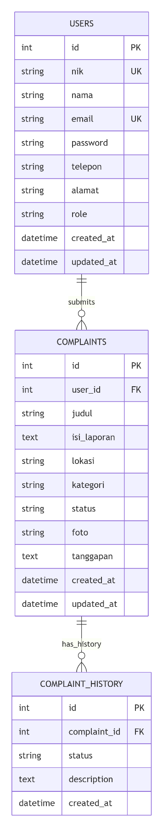

7. Flowchart / User Flow

User Registration Flow:

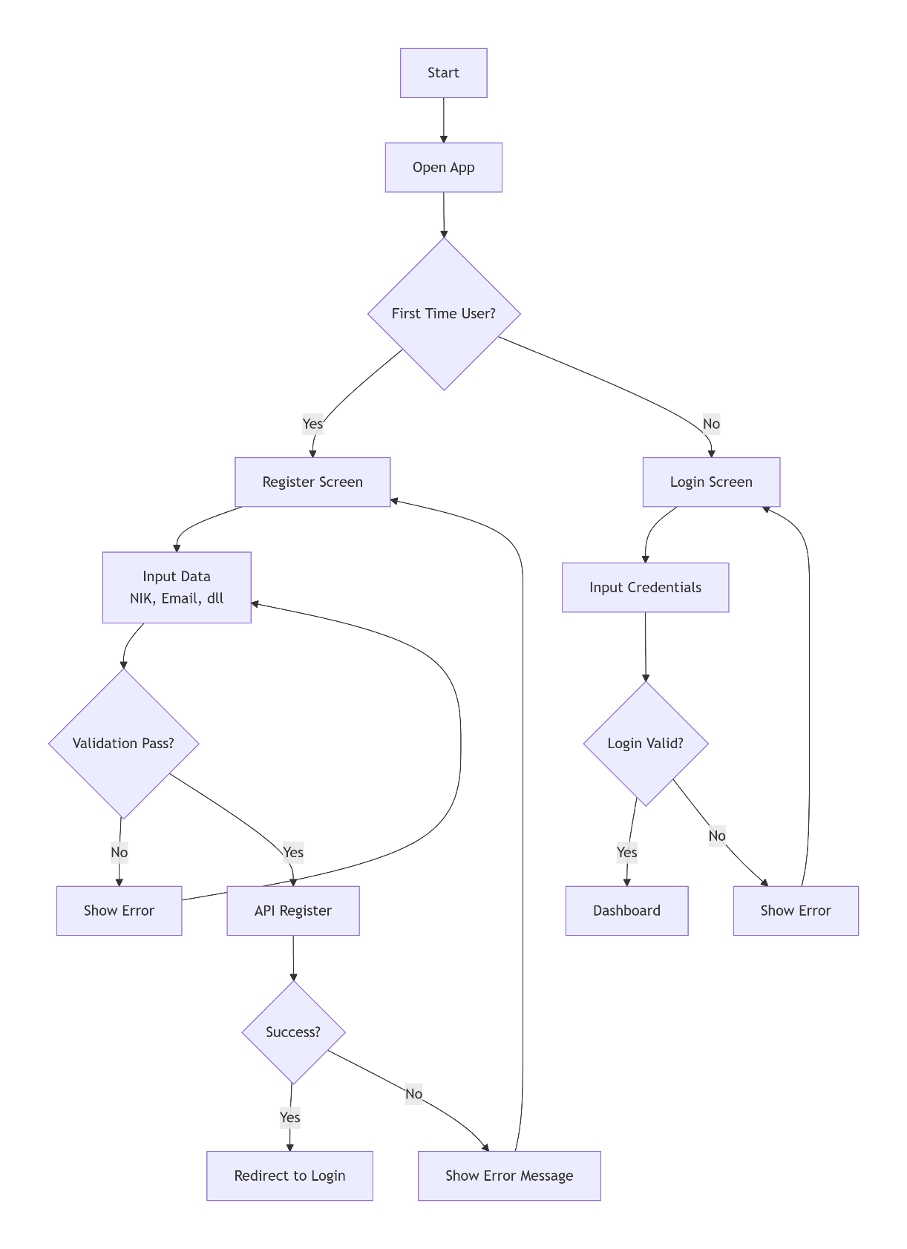

8. Teknologi yang Digunakan

Frontend Development:
text
React Native 0.72.3
├── React 18.2.0
├── React Navigation 6.x
│ ├── Stack Navigator
│ └── Tab Navigator
├── React Native Paper 5.x
│ ├── Material Design Components
│ └── Theme Support
├── Axios 1.5.0
├── React Context API
└── Async Storage

Backend Development:
text
Node.js 18.x
├── Express.js 4.18.2
├── MySQL2 3.6.0
├── JSON Web Token 9.0.2
├── bcryptjs 2.4.3
├── CORS 2.8.5
├── Dotenv 16.3.1
└── Nodemon 3.0.1 (Dev)

Database:
text
MySQL 8.0
├── Relational Database
├── ACID Compliance
├── Foreign Key Constraints
└── Transaction Support

Development Tools:
- Visual Studio Code - Code Editor
- Postman - API Testing
- MySQL Workbench - Database Management
- Git - Version Control
- Expo CLI - React Native Development

Deployment:
- Backend: Node.js hosting (Render/Railway)
- Database: MySQL Cloud/Server
- Mobile App: Expo Publish/App Stores

9. Desain Database

Table 1: users
sql
CREATE TABLE users (
id INT PRIMARY KEY AUTO_INCREMENT,
nik VARCHAR(16) UNIQUE NOT NULL,
nama VARCHAR(100) NOT NULL,
email VARCHAR(100) UNIQUE NOT NULL,
password VARCHAR(255) NOT NULL,
telepon VARCHAR(15),
alamat TEXT,
role ENUM('masyarakat', 'admin') DEFAULT 'masyarakat',
is_active BOOLEAN DEFAULT TRUE,
last_login TIMESTAMP NULL,
created_at TIMESTAMP DEFAULT CURRENT_TIMESTAMP,
updated_at TIMESTAMP DEFAULT CURRENT_TIMESTAMP ON UPDATE CURRENT_TIMESTAMP,

INDEX idx_email (email),
INDEX idx_nik (nik),
INDEX idx_role (role)
);

Table 2: complaints
sql
CREATE TABLE complaints (
id INT PRIMARY KEY AUTO_INCREMENT,
user_id INT NOT NULL,
judul VARCHAR(200) NOT NULL,
isi_laporan TEXT NOT NULL,
lokasi VARCHAR(200),
kategori ENUM('infrastruktur', 'sosial', 'lingkungan', 'keamanan', 'lainnya') NOT NULL,
foto VARCHAR(255),
status ENUM('pending', 'diproses', 'selesai', 'ditolak') DEFAULT 'pending',
tanggapan TEXT,
created_at TIMESTAMP DEFAULT CURRENT_TIMESTAMP,
updated_at TIMESTAMP DEFAULT CURRENT_TIMESTAMP ON UPDATE CURRENT_TIMESTAMP,

FOREIGN KEY (user_id) REFERENCES users(id) ON DELETE CASCADE,
INDEX idx_user_id (user_id),
INDEX idx_status (status),
INDEX idx_kategori (kategori),
INDEX idx_created_at (created_at)
);

Table 3: complaint_history (Audit Trail)
sql
CREATE TABLE complaint_history (
id INT PRIMARY KEY AUTO_INCREMENT,
complaint_id INT NOT NULL,
status VARCHAR(50) NOT NULL,
description TEXT,
created_by INT,
created_at TIMESTAMP DEFAULT CURRENT_TIMESTAMP,

FOREIGN KEY (complaint_id) REFERENCES complaints(id) ON DELETE CASCADE,
FOREIGN KEY (created_by) REFERENCES users(id) ON DELETE SET NULL,
INDEX idx_complaint_id (complaint_id),
INDEX idx_created_at (created_at)
);

Sample Data:
sql
-- Default Admin Account
INSERT INTO users (nik, nama, email, password, role) VALUES
('1234567890123456', 'Admin System', 'admin@pengaduan.com', '$2a$10$92IXUNpkjO0rOQ5byMi.Ye4oKoEa3Ro9llC/.og/at2.uheWG/igi', 'admin');

-- Sample User
INSERT INTO users (nik, nama, email, password, telepon, alamat) VALUES
('3210987654321098', 'Budi Santoso', 'budi@example.com', '$2a$10$92IXUNpkjO0rOQ5byMi.Ye4oKoEa3Ro9llC/.og/at2.uheWG/igi', '081234567890', 'Jl. Merdeka No. 123');

10. Dokumentasi API

Base URL: http://localhost:5000/api

Authentication Endpoints:

1. Register User
http
POST /register
Content-Type: application/json

Request Body:
{
"nik": "1234567890123456",
"nama": "John Doe",
"email": "john@example.com",
"password": "password123",
"telepon": "081234567890",
"alamat": "Jl. Contoh No. 123"
}

Response (201 Created):
{
"message": "Registrasi berhasil",
"userId": 1
}

Response (400 Bad Request):
{
"error": "Email atau NIK sudah terdaftar"
}

2. Login User
http
POST /login
Content-Type: application/json

Request Body:
{
"email": "john@example.com",
"password": "password123"
}

Response (200 OK):
{
"message": "Login berhasil",
"token": "eyJhbGciOiJIUzI1NiIsInR5cCI6IkpXVCJ9...",
"user": {
"id": 1,
"nik": "1234567890123456",
"nama": "John Doe",
"email": "john@example.com",
"telepon": "081234567890",
"alamat": "Jl. Contoh No. 123",
"role": "masyarakat"
}
}

Complaint Endpoints:

3. Create Complaint
http
POST /complaints
Authorization: Bearer {token}
Content-Type: application/json

Request Body:
{
"judul": "Jalan Rusak Parah",
"isi_laporan": "Jalan di depan rumah terdapat lubang besar...",
"lokasi": "Jl. Merdeka No. 123",
"kategori": "infrastruktur",
"foto": "http://example.com/photo.jpg"
}

Response (201 Created):
{
"message": "Pengaduan berhasil dikirim",
"complaintId": 1
}

4. Get User Complaints
http
GET /my-complaints
Authorization: Bearer {token}

Response (200 OK):
{
"complaints": [
{
"id": 1,
"judul": "Jalan Rusak Parah",
"isi_laporan": "...",
"status": "pending",
"created_at": "2024-01-15T10:30:00Z"
}
]
}

5. Get All Complaints (Admin Only)
http
GET /complaints
Authorization: Bearer {token}

Response (200 OK):
{
"complaints": [
{
"id": 1,
"judul": "Jalan Rusak Parah",
"user_nama": "John Doe",
"user_nik": "1234567890123456",
"status": "pending",
"created_at": "2024-01-15T10:30:00Z"
}
]
}

6. Update Complaint Status (Admin Only)
http
PUT /complaints/{id}
Authorization: Bearer {token}
Content-Type: application/json

Request Body:
{
"status": "diproses",
"tanggapan": "Pengaduan sedang ditangani oleh dinas terkait"
}

Response (200 OK):
{
"message": "Status pengaduan berhasil diperbarui"
}

Error Responses:
json
{
"error": "Error message here"
}
HTTP Status Codes:
- 200 - Success
- 201 - Created
- 400 - Bad Request
- 401 - Unauthorized
- 403 - Forbidden
- 404 - Not Found
- 500 - Internal Server Error

11. Tampilan UI (Screenshot)

1. Login Screen
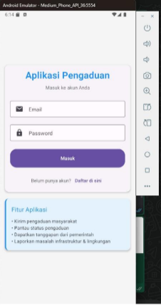

2. Dashboard Screen

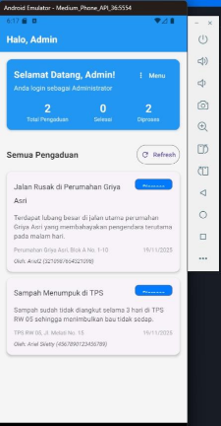

3. Complaint Detail Screen

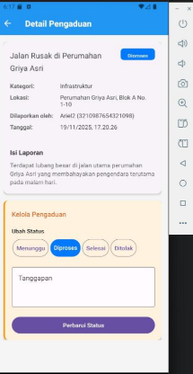

12. Penjelasan CRUD dan Fitur Tambahan

CRUD Operations:

1. CREATE Operations
- User Registration: Membuat akun baru dengan validasi NIK dan email
- Complaint Submission: Membuat pengaduan baru dengan kategori dan lokasi
- Admin Response: Membuat tanggapan resmi untuk pengaduan
Implementation Example:
javascript
// Create Complaint
const submitComplaint = async (complaintData) => {
const response = await api.post('/complaints', complaintData);
return response.data;
};

2. READ Operations
- User Login: Membaca credential untuk authentication
- Get Complaints: Membaca daftar pengaduan (user/admin view)
- Complaint Detail: Membaca detail lengkap pengaduan
- Profile Data: Membaca data profil user
Implementation Example:
javascript
// Read User Complaints
const fetchComplaints = async () => {
const response = await api.get('/my-complaints');
return response.data.complaints;
};

3. UPDATE Operations
- Status Update: Mengupdate status pengaduan (admin only)
- Profile Update: Mengupdate data profil user
- Complaint Edit: Mengedit pengaduan (dalam batas waktu tertentu)
Implementation Example:
javascript
// Update Complaint Status
const updateStatus = async (complaintId, newStatus) => {
const response = await api.put(`/complaints/${complaintId}`, {
status: newStatus
});
return response.data;
};

4. DELETE Operations
- Account Deletion: Menghapus akun user (soft delete)
- Complaint Removal: Menghapus pengaduan (admin only, dengan audit trail)

Fitur Tambahan:

1. Real-time Validation
javascript
// Form validation implementation
const validateComplaintForm = (data) => {
const errors = {};
if (!data.judul.trim()) errors.judul = 'Judul wajib diisi';
if (data.isi_laporan.length < 10) errors.isi_laporan = 'Minimal 10 karakter';
if (!data.kategori) errors.kategori = 'Pilih kategori';
return errors;
};

2. Status Tracking System
javascript
// Status tracking with color coding
const statusConfig = {
pending: { label: 'Menunggu', color: '#FFA500', icon: 'clock' },
diproses: { label: 'Diproses', color: '#007AFF', icon: 'progress-wrench' },
selesai: { label: 'Selesai', color: '#34C759', icon: 'check-circle' },
ditolak: { label: 'Ditolak', color: '#FF3B30', icon: 'close-circle' }
};

3. Search and Filter
javascript
// Filter complaints by status
const filterComplaints = (complaints, filter) => {
return complaints.filter(complaint => {
if (filter.status && complaint.status !== filter.status) return false;
if (filter.search) {
const searchLower = filter.search.toLowerCase();
return complaint.judul.toLowerCase().includes(searchLower) ||
complaint.lokasi.toLowerCase().includes(searchLower);
}
return true;
});
};

4. Pull-to-Refresh
javascript
// Implementation in Dashboard
<ScrollView
refreshControl={
<RefreshControl
refreshing={refreshing}
onRefresh={handleRefresh}
colors={['#2196F3']}
/>
}
>

13. Link Deployment dan GitHub Repository

GitHub Repository:
text
https://github.com/yourusername/aplikasi-pengaduan-masyarakat
Repository Structure:
text
├── /backend
│ ├── server.js
│ ├── package.json
│ ├── database.sql
│ └── /middleware
├── /frontend
│ ├── App.js
│ ├── package.json
│ ├── /src
│ │ ├── /screens
│ │ ├── /components
│ │ └── /services
│ └── /assets
└── README.md

Deployment Links:
- Backend API: pengaduan-masyarakat-app-production.up.railway.app

Testing Credentials:
- Admin: email: admin@pengaduan.com, password: password
- User: email: tester@gmail.com, password: 12345678

Installation Instructions:
bash
# Clone repository
git clone https://github.com/egner-npc/pengaduan-masyarakat-app.git
cd pengaduan-masyarakat-app

# Backend setup
cd backend
npm install
# Configure .env file
npm start

# Frontend setup
cd ../frontend
npm install
npx expo start

14. Kesimpulan dan Evaluasi Diri

Kesimpulan Proyek:
Aplikasi Pengaduan Masyarakat berhasil dikembangkan dengan implementasi lengkap fitur-fitur utama yang dibutuhkan. Sistem ini telah memenuhi tujuan awal sebagai platform digital yang menghubungkan masyarakat dengan pemerintah untuk pelaporan masalah lingkungan. Aplikasi ini menunjukkan bahwa teknologi mobile dapat menjadi solusi efektif untuk meningkatkan transparansi dan efisiensi dalam pelayanan publik.

