User’s Manual

# 1.0 General Information

This project was developed by a group of 3 people Ariel, Willit and Kevin therefore the name AWK comes from the first letters of each of our names and is also a reference to the data extraction Linux tool AWK.   
  
2.0 Application Usage

## How to Start

If you have an account, login with it.

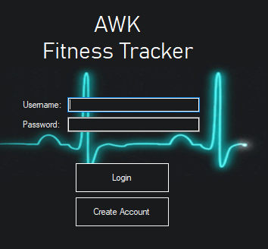

Otherwise, create a new account.

Input the necessary data. Choose the account type.

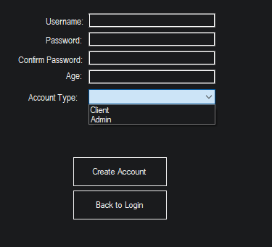

If type is Admin, you will receive a token to confirm that you are allowed to create such account.

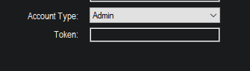

Once account is made, log into the application.

## BMI Calculator

To use the BMI Calculator, you must right click the “Check BMI” button on the right-hand side. Then you will be brought to a screen that will ask you to type in your weight and height. It will also show a BMI chart. Then, right-click the button “Calculate BMI” and it will display your BMI + a word classification at the bottom.

## Physical Fitness Tracking

To use the Physical Fitness Tracking, you must right click the “Physical Fitness Tracking” button on the right-hand side. Then you will be brought to a screen where you can select the exercise Walking, Jogging, Running, Jump-Roping, Swimming, Weightlifting. Once you select, type the amount of time you did in minutes. Then right click Calculate and log calories: It will log the number of calories you burnt and display it to you.

## Diet Tracking

To use the Physical Fitness Tracking, you must right click the “Physical Fitness Tracking” button on the right-hand side. Then you will be brought to a screen where you can select the exercise Walking, Jogging, Running, Jump-Roping, Swimming, Weightlifting. Once you select, type the amount of time you did in minutes. Then right click Calculate and log calories: It will log the number of calories you burnt and display it to you.

## Water intake Tracking

To use the Water Intake Tracking, you must right click the “Physical Fitness Tracking” button on the right-hand side. Then you will be brought to a screen where you can enter the amount of water you drank in ML and your weight. Then click the button, “Add Water Log”, it will then display at the top what your daily water intake should be and will also log the amount of ML you drank.

## Weight Tracking

To use the Weight Tracking, you must right click the “Weight Tracking” button on the right-hand side. Then you will be brought to a screen where you enter your weight in lbs. Once you enter your weight, then right click add Weight Log: It will log your weight.