STATEMENT OF WORK
_______________________________________________________________________

In order to generate an accurate and attempting donation list for potential donors, secure Non-Governmental Organizations (NGOs) financial stability, finding the most interested NGOs by machine learning is the best way to implement in donation recommendation application.
________________________________________________________________________________________

THIS STATEMENT OF WORK (this “SOW”) is entered into by and between the undersigned Buyer and Service Provider pursuant to the Project Services Agreement (the “Agreement”) governing the following Project:

Elance Project Name: Dragnet – NGO recommendation
Elance Project Team: Hung-Yi Chen 100845864

All capitalized terms not defined in this SOW have the meanings given to such terms in the Agreement, unless the context requires otherwise. The information in this SOW shall be considered Confidential Information under the terms of the Agreement.

1 Project Description

Non-Governmental Organizations (NGOs) help the public keep an eye on whether politicians are misusing public money or breaking the law. They help the people get organized and make their opinions known to our representatives through petitions or peaceful protests. And NGOs take care of social issues that easily get ignored by the public or burdensome issues, like sick kids, human trafficking, environmental crime etc.
Therefore, securing financial support to NGOs is hugely vital. Every donation should not be wasted or withdrawn. For donors, finding a suitable NGO is the right thing to do before every penny gets donated. Therefore, building a recommendation platform by machine learning will increase higher donation willingness from users as well as complying a better user experience.

2 Key Assumptions

Dataset has below main columns:
- category: NGO service industry
- score: financial score (fscore), accountability & transparency score(ascore)
- Financial Health (fscore):
Charity Navigator’s evaluations are based on the financial information that each charity provides in its informational tax return, the IRS Form 990. With that information, we analyze each charity’s financial performance in seven key areas, which assess its financial efficiency and capacity, in relation to the charity’s cause area. Their final score of ‘Financial Health’ comes from combining a charity’s scores on a zero to ten scale for each of the seven performance metrics.

- Accountability & Transparency (ascore):
Charity Navigator uses two sources to evaluate an organization’s Accountability & Transparency: information provided by an organization on their Form 990 and information collected from a review of the charity’s website. We use that information to score the organization on seventeen different metrics, which assess whether the charity follows best practices of governance and ethics, and whether the charity makes it easy for donors to find critical information about the organization. We then assign a rating for the organization’s overall Accountability & Transparency.

- Overall score (score):
In our two-dimensional rating system, the overall score is not a sum but rather a measurement of the distance of two component scores from a perfect score of 100 and 100. The smaller the distance to the perfect score, the better the overall score.
- size: organizational size (big, medium, small)
- money flow: administration expense percentage, program expense percentage, fundraising expense percentage
Dataset limitation and constraints:
- All NGOs have been filed tax report in United States

3 Scope of Services

This ML module will use category, score, size, money flow distribution columns to train the module. The dataset is from Kaggle.com and Charity Navigator.[1] [2]

4 Key Test Indicators
This recommendation system needs to use the combination of unsupervised and reinforcement learning,
- Unsupervised: Silhouette Coefficient [5]
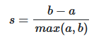
a: The mean distance between a sample and all other points in the same class.
b: The mean distance between a sample and all other points in the next nearest cluster.
- Reinforcement: cumulative reward plot [6]
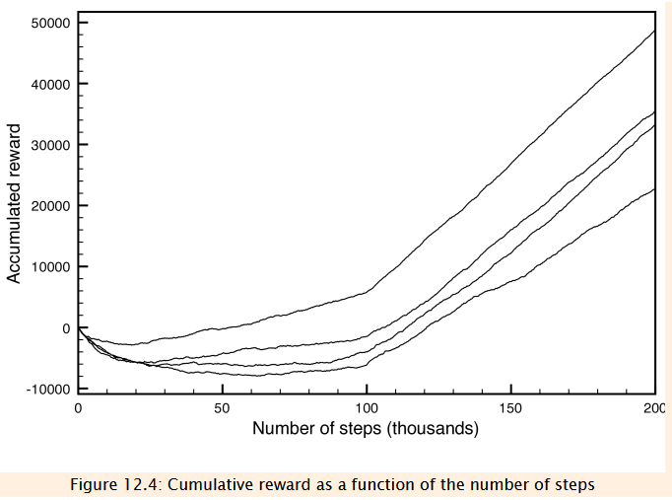
Reference
[1] NGOs portfolio dataset, katyjqian, updated 3 years ago (Version 1), https://www.kaggle.com/katyjqian/charity-navigator-scores-expenses-dataset/version/1
[2] Charity Navigator, https://www.charitynavigator.org/index.cfm?bay=content.view&cpid=5593#rating
[3] Why EDA is necessary for Machine Learning? Srimal Ashish, Jul 29, 2018, https://medium.com/@srimalashish/why-eda-is-necessary-for-machine-learning-233b6e4d5083
[4] How To Perform Exploratory Data Analysis -A Guide for Beginners, Nimit Vanawat, August 12, 2021, https://www.analyticsvidhya.com/blog/2021/08/how-to-perform-exploratory-data-analysis-a-guide-for-beginners/
[5] Clustering performance evaluation, Scikit document, https://scikit-learn.org/stable/modules/clustering.html#clustering-performance-evaluation
[6] Evaluating Reinforcement Learning Algorithms, Artificial Intelligence 2E Foundations of computational agents, https://artint.info/2e/html/ArtInt2e.Ch12.S6.html

