

With Ariella Levine (levjam), Louis Petro (petrol), and Elijah Valenciano (elijahv)

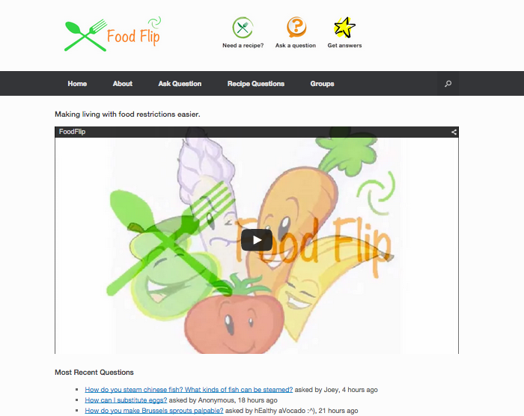This is what foodflip.com looks like:

When a user asks a question, the page looks like this:

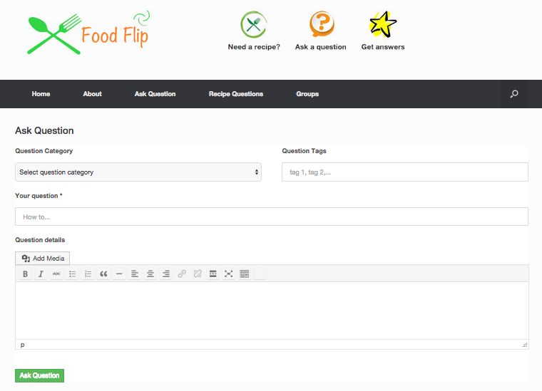

When a user is looking at the different answers for a specific question, the page looks like this:­­­­

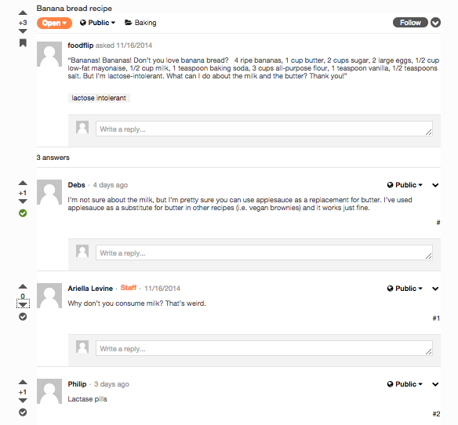

This is what the webpage looks like when a user is browsing through questions:

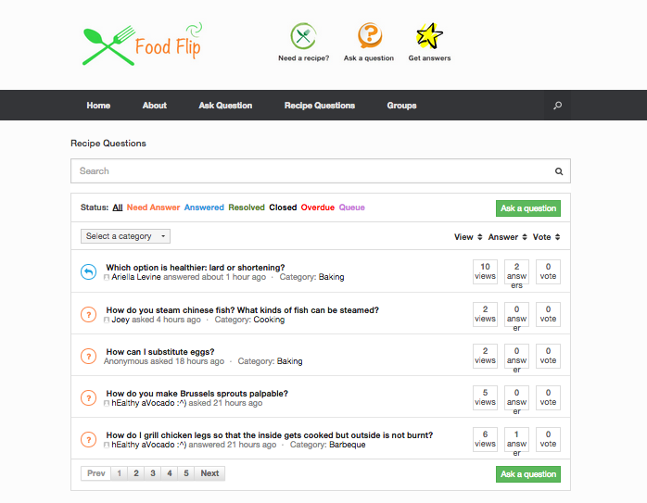

This is what the webpage looks like when a user is browsing through groups:

(A user can also create a new group by clicking ‘Create a Group’)

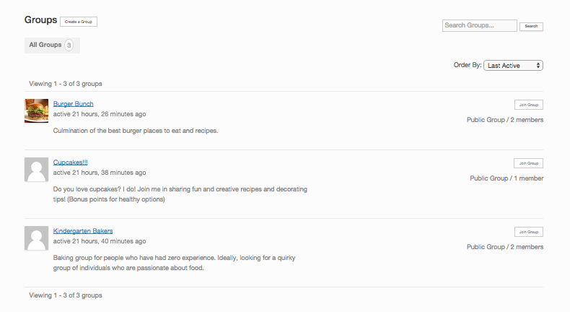

Here we show our data analysis. The following two graphs were created with the help of the Google graphs API. The first graph analyses which category users ask about the most and the second graph analyses the frequency of tags being used.

