WIPO IP Protection Platform



A Blockchain-Based Digital Intellectual Property Protection System
Arielle-Milan Tchalieu Ngomsi
May 2026

Table of Contents
Table of Contents 2
Project Overview 7
Project Description: 7
Problem Statement: 7
Project Objectives: 7
Key Features: 8
System Architecture 9
High-Level Architecture: 9
Data Flow: 10
Technology Stack 11
Frontend: 11
Backend: 11
Database: 11
Security: 11
Blockchain: 11
DevOps: 11
Detailed Technology Justification: 12
Folder Structure 13
UML Diagrams 17
Use Case Diagram: 17
Class Diagram: 18
Sequence Diagram: 19
Phase 1: Project Setup & Environment 20
Phase 1 Overview: 20
Objectives: 20
Deliverables: 20
Environment Setup: 20
Step 1: Install Prerequisites 20
Step 2: Create Project Directory 21
Backend Setup: 22
Step 1: Create Django Backend 22
Step 2: Create Django Project and Apps 25
Step 3: Configure settings.py (backend/config/settings.py) 28
Step 4: Configure urls.py (backend/config/urls.py) 29
Frontend Setup: 29
Step 1: Create React + Vite Frontend 29
Step 2: Configure TailwindCSS 31
Step 3: Create Global CSS (frontend/src/index.css) 31
Phase 2: Backend Core Development 32
Phase 2 Overview: 32
Objectives: 32
User Authentication: 32
Step 1: Create User Model (backend/apps/accounts/models.py) 32
Step 2: Create Admin Configuration (backend/apps/accounts/admin.py) 32
Step 3: Create Serializers (backend/apps/accounts/serializers.py) 32
Step 4: Create Views (backend/apps/accounts/views.py) 33
Step 5: Create URLs (backend/apps/accounts/urls.py) 33
Works App (File Upload & Hashing): 33
Step 1: Create DigitalWork Model (backend/apps/works/models.py) 33
Step 2: Create Services (SHA-256 Hashing) - backend/apps/works/services.py 33
Step 3: Create Serializers (backend/apps/works/serializers.py) 34
Step 4: Create Views (backend/apps/works/views.py) 34
Step 5: Create URLs (backend/apps/works/urls.py) 35
Alerts App (Infringement Detection): 35
Step 1: Create Alert Model (backend/apps/alerts/models.py) 35
Step 2: Create Serializers (backend/apps/alerts/serializers.py) 35
Step 3: Create Views (backend/apps/alerts/views.py) 35
Step 4: Create URLs (backend/apps/alerts/urls.py) 36
Phase 3: React Frontend Development 37
Phase 3 Overview: 37
Objectives: 37
API Client and Auth Context: 37
Step 1: Create API Client (frontend/src/api/client.js) 37
Step 2: Create Auth Context (frontend/src/context/AuthContext.jsx) 37
Authentication Pages: 37
Step 1: Login Page (frontend/src/pages/Login.jsx) 37
Step 2: Register Page (frontend/src/pages/Register.jsx) 38
Dashboard and Layout: 38
Step 1: Layout Component (frontend/src/components/Layout.jsx) 38
Step 2: Dashboard Page (frontend/src/pages/Dashboard.jsx) 38
Upload Work Page (frontend/src/pages/UploadWork.jsx): 38
Phase 4: Blockchain Integration 39
Phase 4 Overview: 39
Objectives- 39
Blockchain Core Implementation: 39
backend/apps/blockchain/services.py- 39
Blockchain Views and URLs: 40
backend/apps/blockchain/views.py- 40
backend/apps/blockchain/urls.py- 40
Blockchain Explorer Frontend: 40
frontend/src/pages/BlockchainExplorer.jsx- 40
Phase 5: Testing & Quality Assurance 41
Phase 5 Overview 41
Objectives: 41
Backend Tests: 41
backend/apps/accounts/tests.py- 41
edit backend/apps/blockchain/tests.py - Complete Code: 41
Running Tests: 42
Run all backend tests- 42
Run specific app tests- 42
Run with coverage report- 42
Run frontend tests- 42
Phase 6: Azure Deployment 43
Phase 6 Overview: 43
Objectives- 43
Azure Deployment Script: 43
deploy-azure.ps1- 43
Deployment Steps: 49
Step 1: Prepare backend for production 49
Step 2: Run deployment script 49
Step 3: Verify deployment 49
Step 4: Create admin user on production 49
API Documentation 50
Authentication Endpoints: 50
Works Endpoints: 50
Alerts Endpoints: 50
Blockchain Endpoints: 50
Example API Calls: 51
Register User- 51
Login- 51
Upload Work (use token from login)- 51
Get Dashboard Stats- 51
Verify Blockchain- 51
Challenges I Faced 52
Challenge 1: Installing Pillow (Backend Setup) 52
Problem: 52
Solution: 52
Challenge 2: Installing Tailwindcss (Frontend Setup) 53
Problem: 53
Solution: 53
Conclusion 54
Project Summary: 54
Skills Demonstrated: 54
Technical Skills- 54
Soft Skills: 54
Future Enhancements: 54
References 55
Tools & Libraries: 55
Backend Dependencies- 55
Frontend Dependencies- 55
Appendices 56
Appendix A: Quick Reference Commands 56
Start Backend: 56
Start Frontend: 56
Create Migrations: 56
Create Superuser: 56
Run Tests: 56
Deploy to Azure: 56
Appendix B: Environment Variables 57
Backend (.env): 57
Frontend (.env): 57
Appendix C: Troubleshooting Guide 57

Project Overview

Project Description:
The WIPO IP Protection Platform is a comprehensive web-based solution that enables creators, startups, and innovators to protect their intellectual property through digital timestamping using SHA-256 hashing, blockchain verification for immutable ownership records, and automated infringement detection. The platform provides an accessible, secure, and verifiable way to prove ownership of digital works.

Problem Statement:
Digital creators face significant challenges in protecting their intellectual property:
Problem | Impact | Current Solution Gap
Expensive IP registration | Most creators can't afford | Traditional methods cost $500+
Difficulty proving ownership | Works are easily copied | No cheap timestamping available
No automated infringement detection | Creators unaware of copies | Manual searching is impossible
Complex technical requirements | Non-technical users excluded | Most solutions require coding

Project Objectives:
Objective | Description | Success Metric
Digital Timestamping | Provide SHA-256 proof of creation | Hash generation < 5 seconds
Ownership Tracking | Blockchain-based ownership records | Immutable verification
Infringement Detection | Automatic duplicate content alerts | Real-time detection
User Accessibility | Intuitive web interface | < 3 clicks to upload
Cloud Deployment | Scalable 24/7 hosting | 99.9% uptime

Key Features:
Feature | Technology | Description
JWT Authentication | SimpleJWT | Secure user login/registration
SHA-256 Hashing | hashlib | Cryptographic file fingerprinting
Blockchain Ledger | Custom Python | Immutable record of all registrations
Infringement Alerts | Hash matching | Automatic duplicate detection
React Dashboard | Vite + Tailwind | Modern responsive UI
File Storage | Django Media | Secure file uploads

System Architecture

High-Level Architecture:
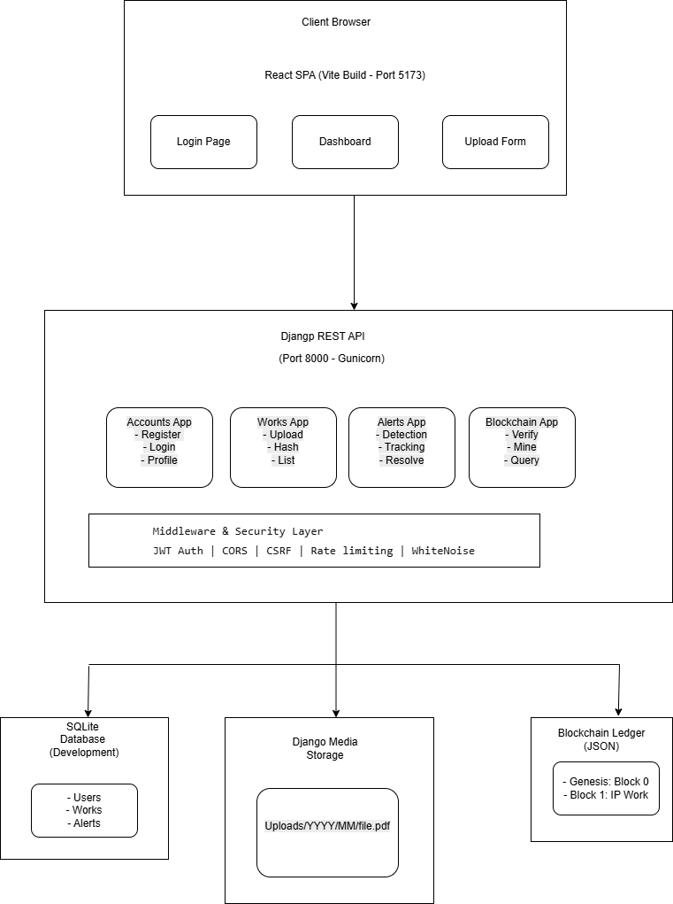
Figure 1: High-Level Architecture Diagram

Data Flow:
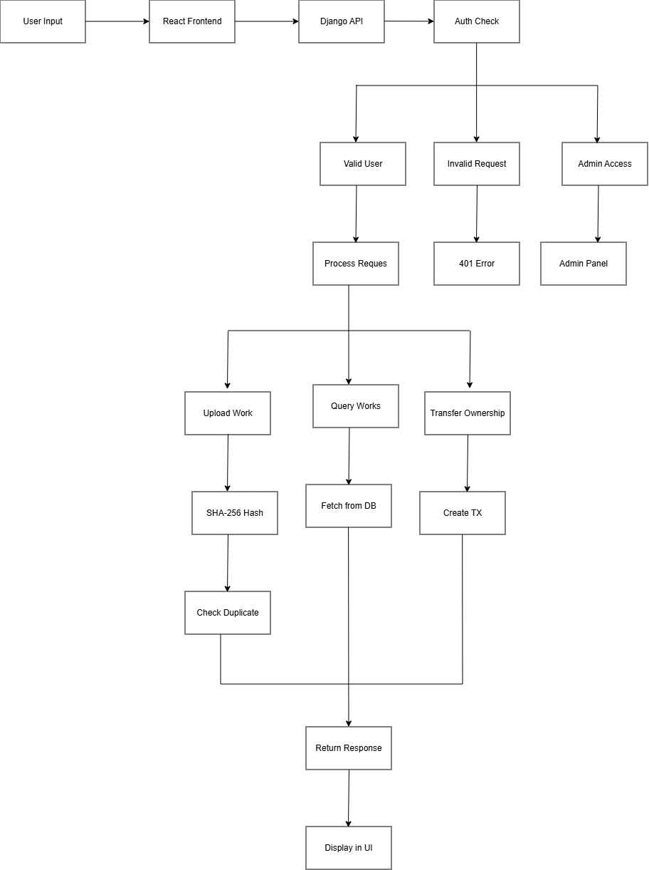
Figure 2: Data Flow Diagram

Technology Stack

Frontend:
- React: UI Framework
- Vite: Build Tool
- TailwindCSS: Styling
- Axios: HTTP Client
- React Router DOM: Routing
- Lucide React: Icons

Backend:
- Django: Web Framework
- Django REST Framework: API Development
- SimpleJWT: JWT Authentication
- django-cors-headers: CORS Handling

Database:
- SQLite: Development Database

Security:
- SHA-256: File Hashing
- JWT: Authentication

Blockchain:
- Custom Python: Immutable Ledger

DevOps:
- Git: Version Control
- Azure: Cloud Deployment

Detailed Technology Justification:
Technology | Why Chosen | Alternatives Considered | Final Decision
Django | Built-in admin, ORM, security | Flask, FastAPI | Django - faster development
Django REST | Seamless Django integration | Manual API building | DRF - standard for Django
React | Component-based, huge ecosystem | Vue, Angular | React - most jobs require it
Vite | Fast HMR, modern build | Webpack, Create React App | Vite - significantly faster
TailwindCSS | Utility-first, no context switching | CSS, SCSS, Bootstrap | Tailwind - faster styling
SQLite | No setup, file-based | PostgreSQL, MySQL | SQLite - perfect for development
JWT | Stateless, scalable | Session-based | JWT - better for APIs
SHA-256 | Industry standard, secure | MD5, SHA-1 | SHA-256 - cryptographically secure

Folder Structure
wipo-ip-platform/
│
├── backend/ # Django Backend Root
│ ├── apps/ # Modular applications
│ │ ├── __init__.py
│ │ ├── accounts/ # User authentication module
│ │ │ ├── __init__.py
│ │ │ ├── admin.py # Django admin configuration
│ │ │ ├── models.py # Custom User model
│ │ │ ├── serializers.py # JWT + User serializers
│ │ │ ├── urls.py # /api/auth/* routes
│ │ │ ├── views.py # Register, Login, Profile views
│ │ │ └── tests.py # Auth test cases
│ │ │
│ │ ├── works/ # IP Work management module
│ │ │ ├── __init__.py
│ │ │ ├── admin.py
│ │ │ ├── models.py # DigitalWork model
│ │ │ ├── serializers.py # Work data serialization
│ │ │ ├── services.py # SHA-256, file handling
│ │ │ ├── urls.py # /api/works/* routes
│ │ │ ├── views.py # Upload, List, Verify views
│ │ │ └── tests.py # Work test cases
│ │ │
│ │ ├── alerts/ # Infringement detection module
│ │ │ ├── __init__.py
│ │ │ ├── admin.py
│ │ │ ├── models.py # InfringementAlert model
│ │ │ ├── serializers.py # Alert serializers
│ │ │ ├── urls.py # /api/alerts/* routes
│ │ │ ├── views.py # List, Resolve alerts
│ │ │ └── tests.py # Alert test cases
│ │ │
│ │ └── blockchain/ # Blockchain implementation module
│ │ ├── __init__.py
│ │ ├── admin.py
│ │ ├── services.py # Block, MerkleTree classes
│ │ ├── urls.py # /api/blockchain/* routes
│ │ ├── views.py # Verify, Mine endpoints
│ │ └── tests.py # Blockchain tests
│ │
│ ├── config/ # Django configuration
│ │ ├── __init__.py
│ │ ├── settings.py # Main settings file
│ │ ├── urls.py # Main URL routing
│ │ ├── wsgi.py # WSGI entry point
│ │ └── asgi.py # ASGI for WebSockets
│ │
│ ├── media/ # Uploaded files (gitignored)
│ ├── db.sqlite3 # SQLite database
│ ├── blockchain_ledger.json # Blockchain data storage
│ ├── manage.py # Django CLI
│ ├── requirements.txt # Python dependencies
│ └── .env # Environment variables
│
├── frontend/ # React + Vite Frontend
│ ├── src/
│ │ ├── components/ # Reusable components
│ │ │ ├── Layout.jsx # Main layout wrapper
│ │ │ └── FileUpload.jsx # Drag-drop file upload
│ │ │
│ │ ├── pages/ # Page components
│ │ │ ├── Login.jsx # Login form
│ │ │ ├── Register.jsx # Registration form
│ │ │ ├── Dashboard.jsx # User dashboard
│ │ │ ├── Works.jsx # List user works
│ │ │ ├── UploadWork.jsx # Upload new work
│ │ │ ├── Alerts.jsx # View alerts
│ │ │ └── BlockchainExplorer.jsx # View blockchain
│ │ │
│ │ ├── api/ # API integration
│ │ │ ├── client.js # Axios configuration
│ │ │ └── endpoints.js # API endpoint constants
│ │ │
│ │ ├── context/ # React context
│ │ │ └── AuthContext.jsx # Authentication state
│ │ │
│ │ ├── hooks/ # Custom hooks
│ │ │ ├── useAuth.js # Auth hook
│ │ │ └── useUpload.js # File upload hook
│ │ │
│ │ ├── utils/ # Utility functions
│ │ │ ├── formatters.js # Date, hash formatting
│ │ │ └── validators.js # Form validation
│ │ │
│ │ ├── styles/
│ │ │ └── globals.css # Tailwind + custom CSS
│ │ │
│ │ ├── App.jsx # Main app component
│ │ ├── main.jsx # Entry point
│ │ └── index.css # Global styles
│ │
│ ├── public/ # Static assets
│ │ ├── vite.svg
│ │ └── favicon.ico
│ │
│ ├── index.html # HTML template
│ ├── package.json # NPM dependencies
│ ├── vite.config.js # Vite configuration
│ ├── tailwind.config.js # TailwindCSS config
│ ├── postcss.config.js # PostCSS config
│ └── .env # Frontend env vars
│
├── .gitignore # Git ignore rules
├── README.md # Project documentation
└── FINAL_REPORT.md # Project completion report

UML Diagrams

Use Case Diagram:
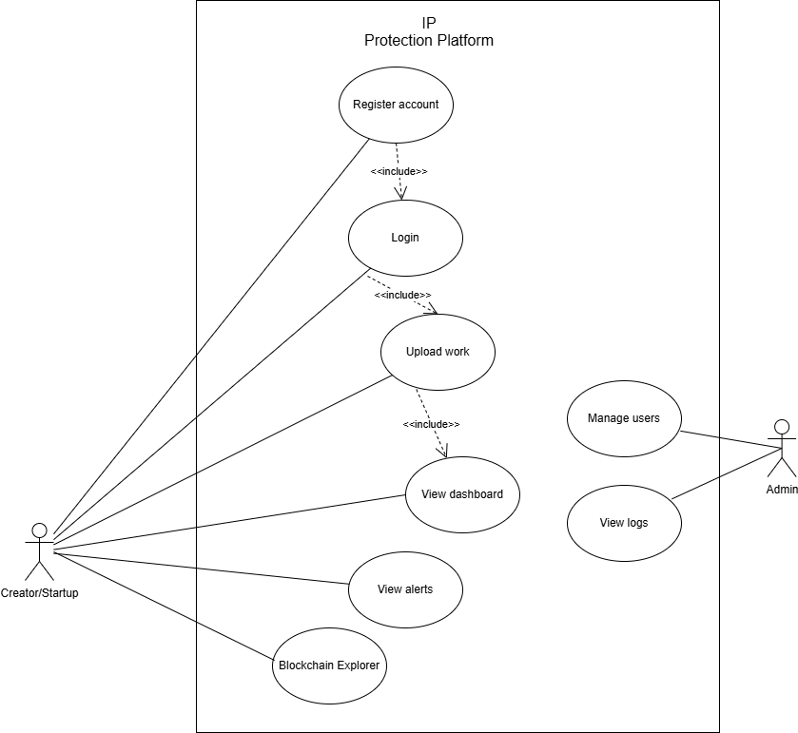
Figure 3: Use Case Diagram

Class Diagram:
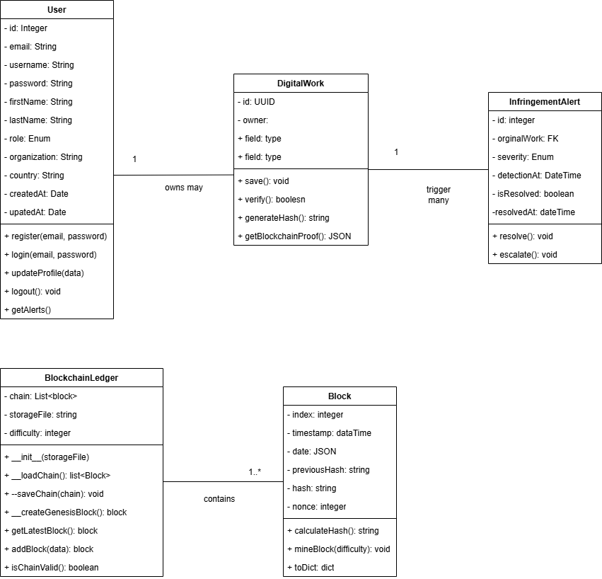
Figure 4: Class Diagram (Core Models)

Sequence Diagram:
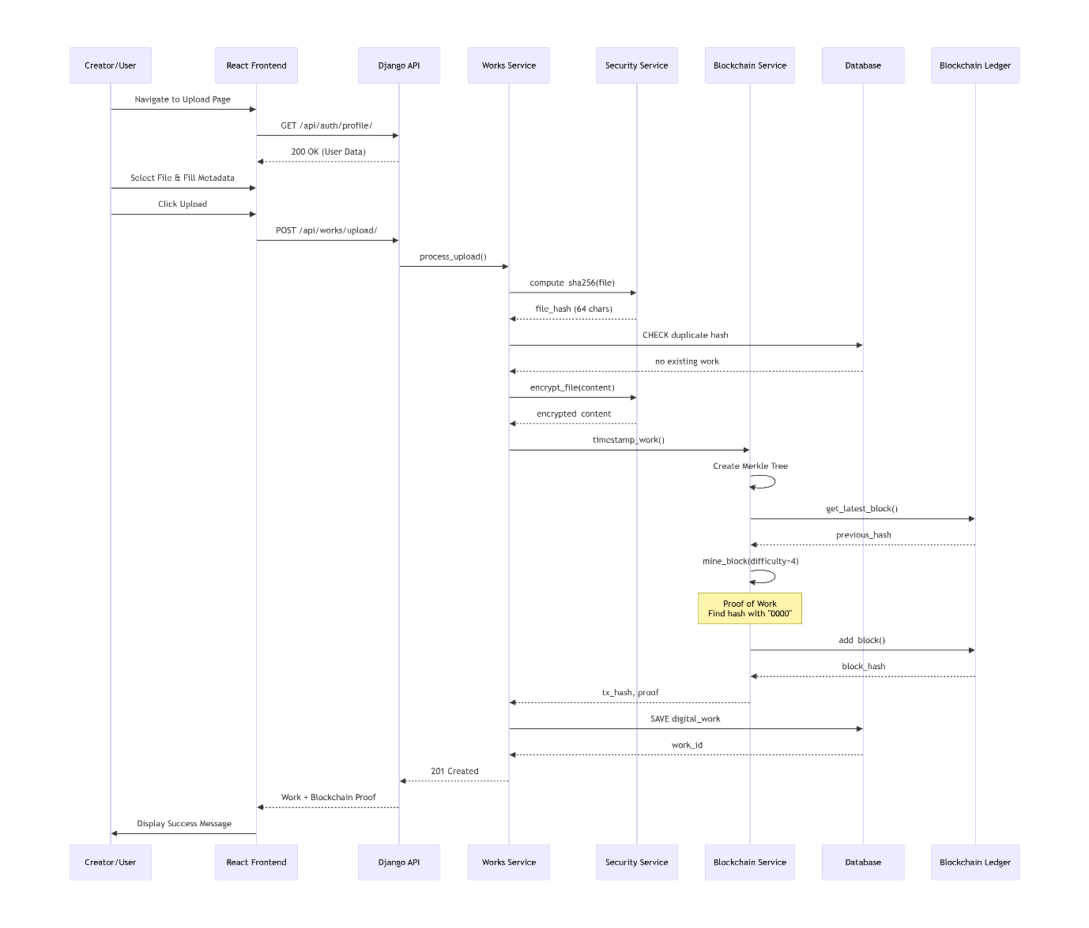
Figure 5: Sequence Diagram (Upload Work with Blockchain)

Phase 1: Project Setup & Environment

Phase 1 Overview:
Duration: 7 days (40 hours estimated)

Objectives:
- Set up development environment.
- Create project structure.
- Initialize Git repository.
- Configure Django backend.
- Set up React frontend.

Deliverables:
- Working Python virtual environment.
- Django project with 5 apps.
- React + Vite project.
- Git repository with initial commit.
- Requirements.txt file.

Environment Setup:

Step 1: Install Prerequisites
Installed the following software:
- Python: https://www.python.org/downloads/
- Node.js: https://nodejs.org/en
- Git: https://git-scm.com/install/windows

I then verified the installation.

Commands Used
python --version
node --version
npm --version
git --version
Screenshot of Output
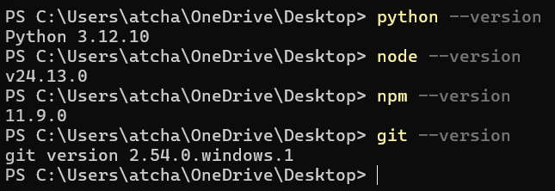
Figure 6: Verify the Installation

Step 2: Create Project Directory
Within the terminal, I did the following:
- Create the project root.
- Initialized the Git repository.
- Created .gitignore.
- The initial commit.

mkdir wipo-ip-platform
cd wipo-ip-platform

git init

echo "venv/
__pycache__/
*.pyc
.env
db.sqlite3
media/
node_modules/
dist/
.DS_Store" > .gitignore

git add .
git commit -m "Initial commit: Project structure"

Screenshot of Output
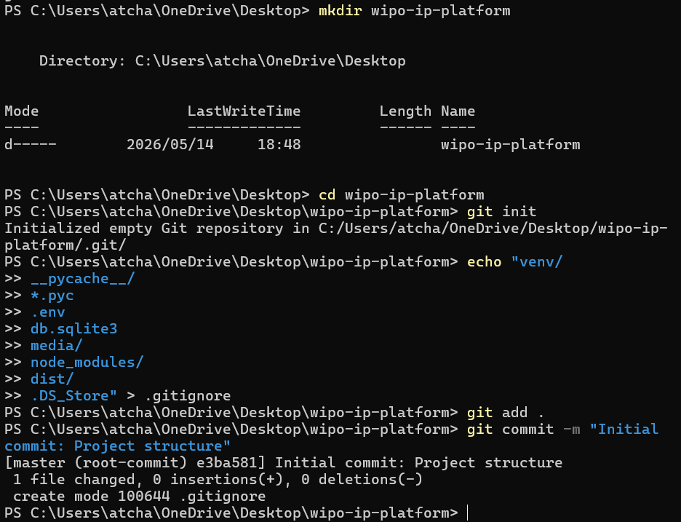
Figure 7: Create the project directory

Backend Setup:

Step 1: Create Django Backend
Within the terminal, I did the following:
- Created the backend directory.
- Created the virtual environment.
- Activated the virtual environment.
- Upgraded the pip.
- Installed the Django and core packages.
- Saved the requirements.

Commands Used
mkdir backend
cd backend

python -m venv venv

venv\Scripts\activate

python -m pip install --upgrade pip

pip install Django==4.2.7
pip install djangorestframework==3.14.0
pip install djangorestframework-simplejwt==5.3.0
pip install django-cors-headers==4.3.1
pip install python-dotenv==1.0.0
pip install Pillow==8.4.0

pip freeze > requirements.txt

Screenshot of Output
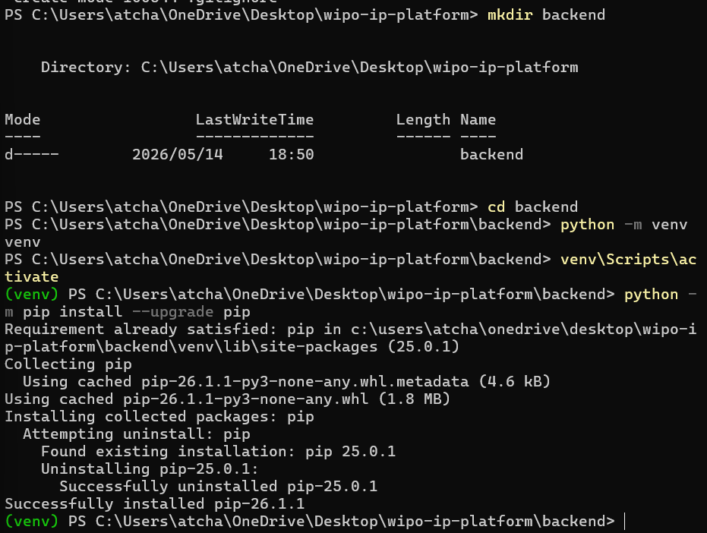
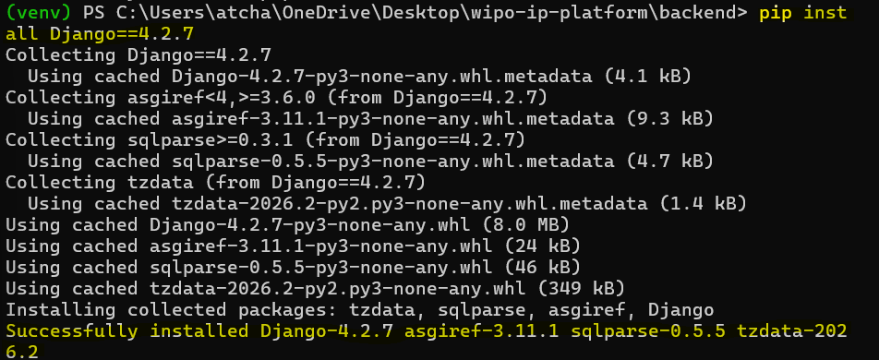
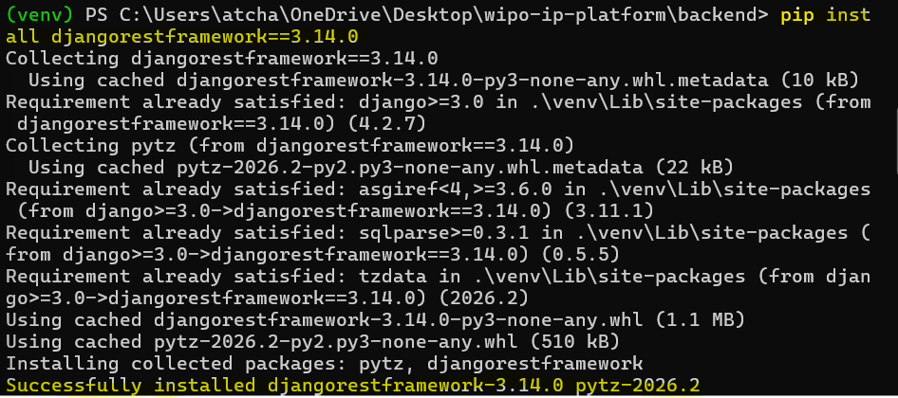
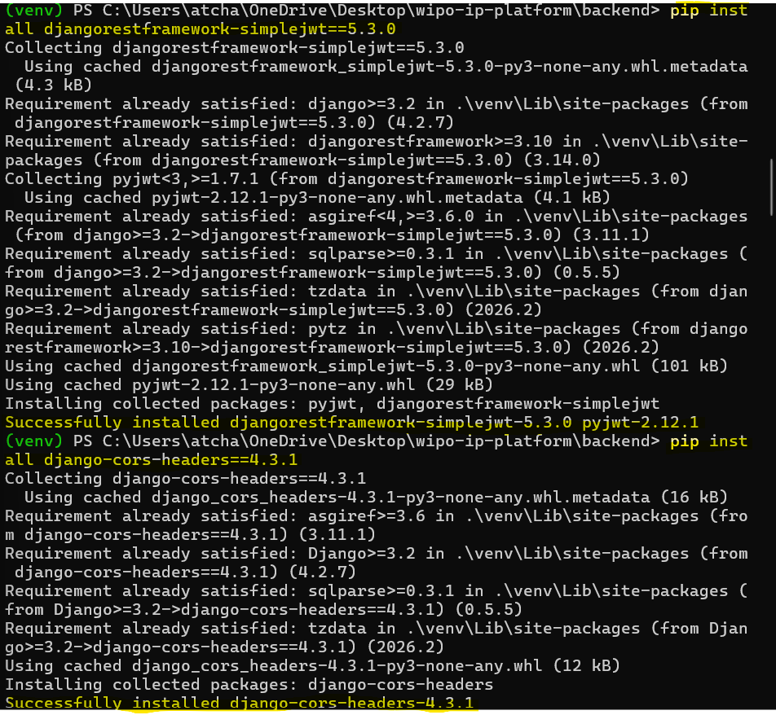
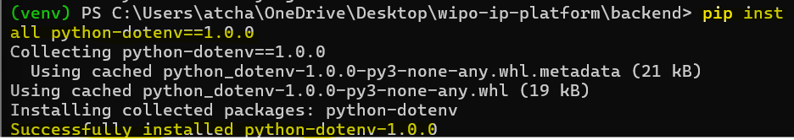
Figure 8: Create the django backend

Step 2: Create Django Project and Apps
Within the terminal, I did the following:
- Created the Django project.
- Created the Django apps.
- Created the apps directory and move apps.
- Created the __init__.py files.

Commands Used
django-admin startproject config .

python manage.py startapp accounts
python manage.py startapp works
python manage.py startapp alerts
python manage.py startapp blockchain

mkdir apps
move accounts apps\
move works apps\
move alerts apps\
move blockchain apps\

echo > apps\__init__.py
echo > apps\accounts\__init__.py
echo > apps\works\__init__.py
echo > apps\alerts\__init__.py
echo > apps\blockchain\__init__.py

Screenshot of Output
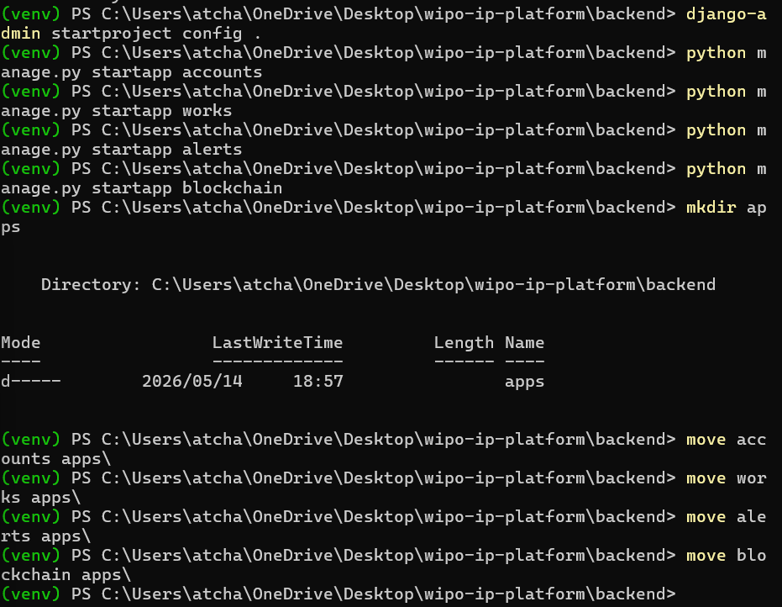
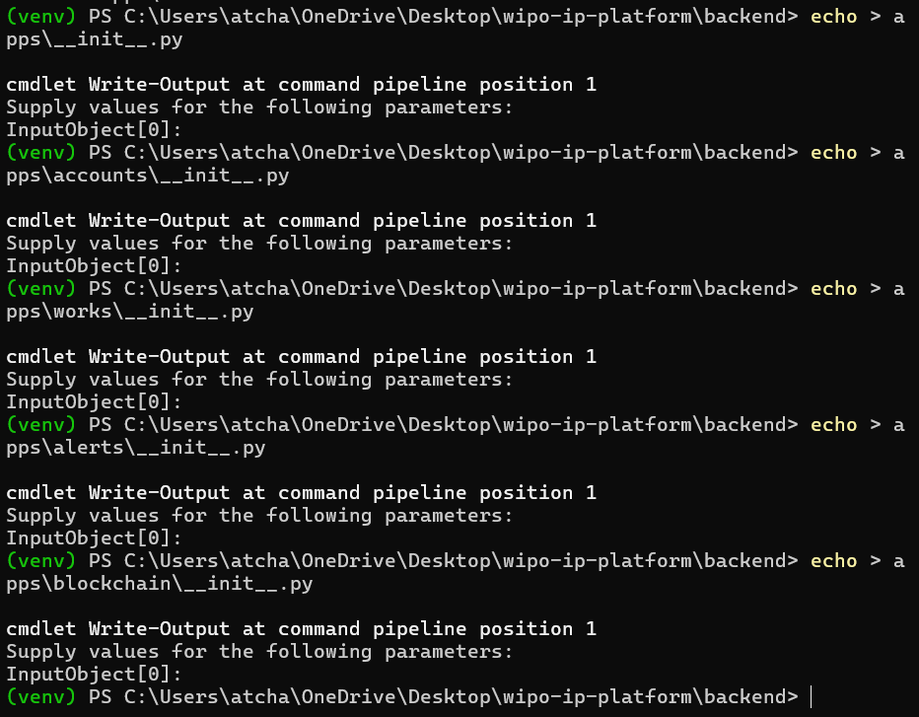
Figure 9: Create django project and apps

Step 3: Configure settings.py (backend/config/settings.py)
- This was the Django settings for WIPO IP Protection Platform.
- This file was generated by 'django-admin startproject'.
- Follow the backend/config/settings.py path to view the file contents.
- Configurations I made:
- Loaded the environment variables.
- Built paths inside the project.
- I added 2 security warnings - keep the secret key used in production secret and don't run with debug turned on in production.
- Added third party apps, local apps, password validation, internationalization and static files (CSS, JavaScript, Images).
- Created the default primary key field type.
- Added the custom User Model, Django REST Framework, JWT Settings and CORS Settings.

Step 4: Configure urls.py (backend/config/urls.py)
- This was the URL configuration for the WIPO IP Protection Platform.
- It serves media files in development.
- Follow the backend/config/settings.py path to view the file contents.
- Configurations I made:

Frontend Setup:

Step 1: Create React + Vite Frontend
In a new terminal, I did the following:
- Create React + Vite project.
- Navigated to the frontend.
- Installed the dependencies.
- Installed additional packages.
- Installed TailwindCSS.

Commands Used
cd ..
npm create vite@latest frontend -- --template react

cd frontend

npm install

npm install react-router-dom axios lucide-react

npm install -D tailwindcss postcss autoprefixer
npx tailwindcss init -p

Screenshot of Output
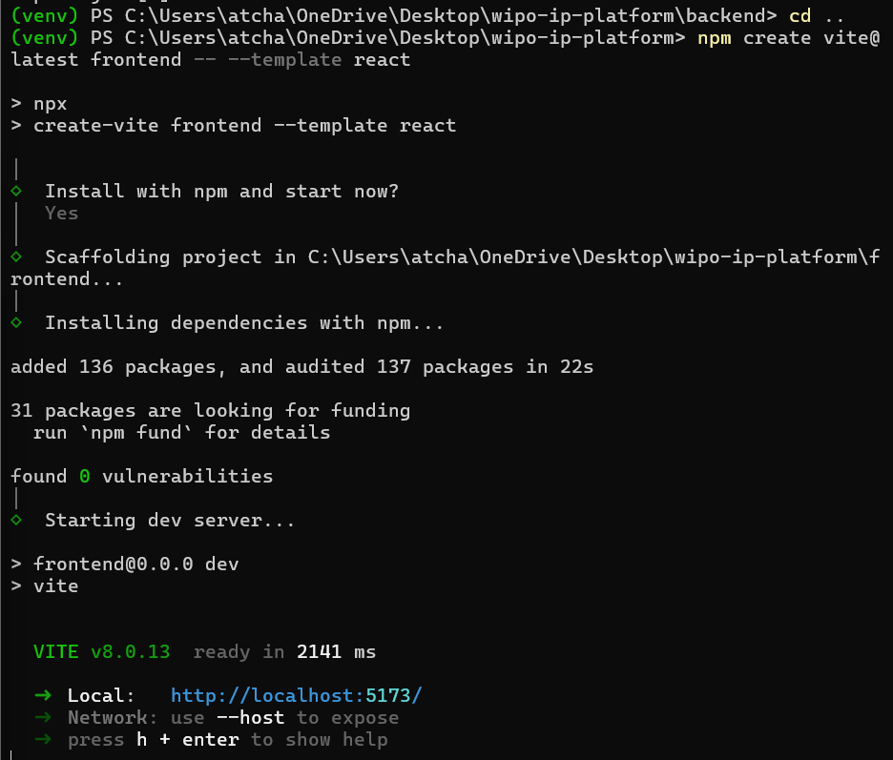
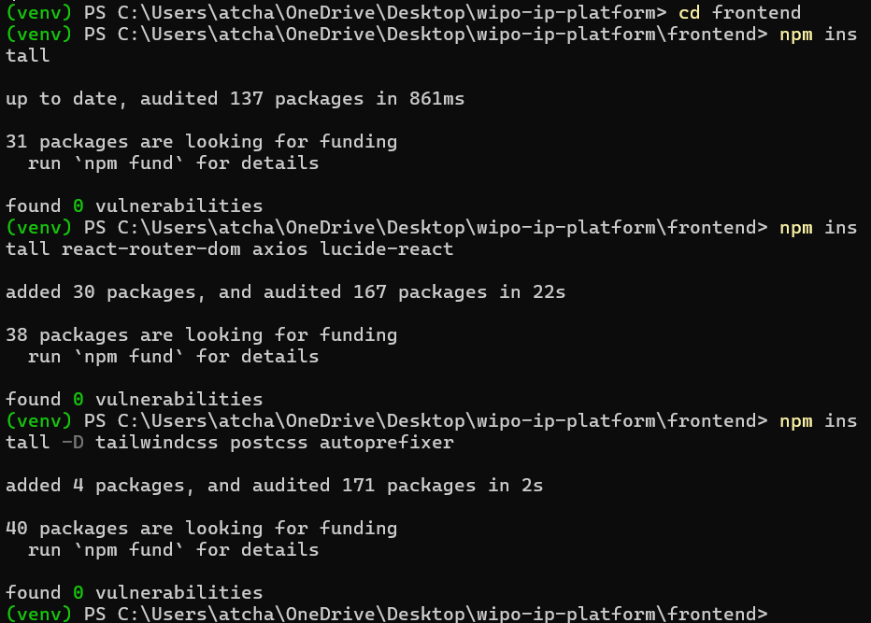
Figure 10: Create React + Vite Frontend

Step 2: Configure TailwindCSS
- Follow the frontend/tailwind.config.js path to view the file contents.
- Configurations I made:

frontend/postcss.config.js:
- Follow the frontend/postcss.config.js path to view the file contents.
- Configurations I made:

frontend/vite.config.js:
- Follow the frontend/vite.config.js path to view the file contents.
- Configurations I made:

Step 3: Create Global CSS (frontend/src/index.css)
- Follow the frontend/src/index.css path to view the file contents.
- Configurations I made:
- Created the custom scrollbar.
- Added the utility classes.

Phase 2: Backend Core Development

Phase 2 Overview:
Duration: 7 days (45 hours estimated)

Objectives:
- Implement User Authentication (JWT).
- Create DigitalWork model.
- Implement file upload with SHA-256.
- Build infringement detection system.
- Create dashboard API.

User Authentication:

Step 1: Create User Model (backend/apps/accounts/models.py)
- This was a Custom User model for the IP Protection Platform.
- It would extend Django's AbstractUser with additional fields.
- Follow the backend/apps/accounts/models.py path to view the file contents.
- Configurations I made:
- Use email for authentication instead of username.

Step 2: Create Admin Configuration (backend/apps/accounts/admin.py)
- Follow the backend/apps/accounts/admin.py path to view the file contents.
- Configurations I made:
- Added a custom admin interface for User model.

Step 3: Create Serializers (backend/apps/accounts/serializers.py)
- Follow the backend/apps/accounts/serializers.py path to view the file contents.
- Configurations I made:
- Serializer for user registration.
- Validates password and creates new user.
- Check that passwords match.
- Create and return new user.
- Serializer for user data (read-only fields).
- Custom JWT token serializer that includes user role and email.
- Added custom claims, and user data to response.

Step 4: Create Views (backend/apps/accounts/views.py)
- Follow the backend/apps/accounts/views.py path to view the file contents.
- Configurations I made:
- View for user registration.
- Anyone can access (no authentication required).
- Return user data without password.
- View for user login.
- Returns JWT access and refresh tokens.
- View for retrieving and updating user profile.
- Requires authentication.

Step 5: Create URLs (backend/apps/accounts/urls.py)
- Follow the backend/apps/accounts/urls.py path to view the file contents.
- Configurations I made:

Works App (File Upload & Hashing):

Step 1: Create DigitalWork Model (backend/apps/works/models.py)
- Follow the frontend/src/index.css path to view the file contents.
- Configurations I made:
- Model representing a digital work registered for IP protection.
- Each work has a unique SHA-256 hash for integrity verification.
- Created the basic information, file information, blockchain, metadata and timestamps.
- Auto-generate registration number before saving.
- Record of ownership transfer for a digital work.
- Creates an immutable record of the transfer.
- Generate transaction hash before saving.

Step 2: Create Services (SHA-256 Hashing) - backend/apps/works/services.py
- Follow the backend/apps/works/services.py path to view the file contents.
- Configurations I made:
- Services for file processing, hashing, and storage.
- Handles SHA-256 hashing of files.
- Compute SHA-256 hash of a file using chunked reading.
- Reset file pointer to beginning.
- Read file in chunks to handle large files efficiently.
- Reset file pointer for further operations.
- Handles file encryption for secure storage.
- Generate a new encryption key.
- Handles file storage (local or cloud).
- Save file to local storage.
- Get file size in bytes.

Step 3: Create Serializers (backend/apps/works/serializers.py)
- Follow the backend/apps/works/serializers.py path to view the file contents.
- Configurations I made:
- Serializer for DigitalWork model.
- Includes computed fields for display.
- Serializer for OwnershipTransfer model.
- Includes email addresses for display.

Step 4: Create Views (backend/apps/works/views.py)
- Follow the backend/apps/works/views.py path to view the file contents.
- Configurations I made:
- View for uploading digital works.
- Computes SHA-256 hash and checks for duplicates.
- Handle file upload.
- Validate file presence, title, compute SHA-256 hash, and check for duplicate (infringement detection)
- Create infringement alert, and blockchain reference (simulated)
- Saved the work to database and returned the response with blockchain proof.
- Viewed for listing user's digital works.
- Viewed for retrieving, updating, or deleting a specific work.
- Viewed for verifying work integrity using SHA-256 hash.
- Verify a work by re-hashing the file.
- Get file for verification.
- Compute hash and compare.
- Get user statistics for dashboard.
- Calculate total storage used.

Step 5: Create URLs (backend/apps/works/urls.py)
- Follow the backend/apps/works/urls.py path to view the file contents.
- Configurations I made:

Alerts App (Infringement Detection):

Step 1: Create Alert Model (backend/apps/alerts/models.py)
- Follow the backend/apps/alerts/models.py path to view the file contents.
- Configurations I made:
- Model for tracking potential IP infringement alerts.
- Created when duplicate content is detected.
- Created the relationships, alert details, evidence, and timestamps.
- Mark alert as resolved.
- Escalate alert severity.

Step 2: Create Serializers (backend/apps/alerts/serializers.py)
- Follow the backend/apps/alerts/serializers.py path to view the file contents.
- Configurations I made:
- Serializer for InfringementAlert model.
- Includes work details for display.
- Validate alert data.

Step 3: Create Views (backend/apps/alerts/views.py)
- Follow the backend/apps/alerts/views.py path to view the file contents.
- Configurations I made:
- View for listing infringement alerts for user's works.
- View for retrieving and updating a specific alert.
- View for resolving an infringement alert.
- Mark alert as resolved.
- View for getting alert statistics summary.
- Get summary statistics for alerts.

Step 4: Create URLs (backend/apps/alerts/urls.py)
- Follow the backend/apps/alerts/urls.py path to view the file contents.
- Configurations I made:

Phase 3: React Frontend Development

Phase 3 Overview:
Duration: 7 days (50 hours estimated)

Objectives:
- Build authentication pages (Login/Register).
- Create dashboard with real data.
- Implement file upload component.
- Build blockchain explorer view.
- Create alerts management page.

API Client and Auth Context:

Step 1: Create API Client (frontend/src/api/client.js)
- Follow the frontend/src/api/client.js path to view the file contents.
- Configurations made in the code:
- Created axios instance with base URL.
- Requested the interceptor (add JWT token to headers).
- Response interceptor (handle token refresh).
- If unauthorized and not already retrying.
- If the refresh failed, then redirect to login.
- Added the API endpoint functions.

Step 2: Create Auth Context (frontend/src/context/AuthContext.jsx)
- Follow the frontend/src/context/AuthContext.jsx path to view the file contents.
- Configurations made in the code:
- Created the context.
- Added the Auth Provider component.
- Loaded the user on initial load.
- Added custom hook to use auth context.

Authentication Pages:

Step 1: Login Page (frontend/src/pages/Login.jsx)
- Follow the frontend/src/pages/Login.jsx path to view the file contents.
- Configurations made in the code:
- Error handled in context
- Created the Logo and Title, Error Message, Login Form and Register Link.

Step 2: Register Page (frontend/src/pages/Register.jsx)
- Follow the frontend/src/pages/Login.jsx path to view the file contents.
- Configurations made in the code:
- Clear error for this field.
- Created the header and form.

Dashboard and Layout:

Step 1: Layout Component (frontend/src/components/Layout.jsx)
- Follow the frontend/src/components/Layout.jsx path to view the file contents.
- Configurations made in the code:
- Created the Navigation, User Info and Main Content.

Step 2: Dashboard Page (frontend/src/pages/Dashboard.jsx)
- Follow the frontend/src/pages/Dashboard.jsx path to view the file contents.
- Configurations made in the code:
- Created the Welcome Section, Stats Grid, Recent Works and Blockchain Status.

Upload Work Page (frontend/src/pages/UploadWork.jsx):
- Follow the frontend/src/pages/UploadWork.jsx path to view the file contents.
- Configurations made in the code:
- Redirect after 3 seconds.
- Created Work Type, Description, File Upload, Error Message and the Submit Button.

Phase 4: Blockchain Integration

Phase 4 Overview:
Duration: 7 days (45 hours estimated)

Objectives-
- Implement blockchain ledger.
- Create block with proof-of-work.
- Build Merkle tree for verification.
- Add blockchain API endpoints.

Blockchain Core Implementation:

backend/apps/blockchain/services.py-
- Follow the frontend/src/pages/Login.jsx path to view the file contents.
- Configurations made in the code:
- Blockchain implementation for IP protection.
- Provides immutable timestamping and verification.
- Individual block in the blockchain.
- Contains proof-of-work for security.
- Calculate SHA-256 hash of block contents.
- Mine block using proof-of-work algorithm.
- Convert block to dictionary for JSON serialization.
- Blockchain ledger with JSON file persistence.
- Maintains immutable chain of blocks.
- Load blockchain from file or create genesis block.
- Save blockchain to file.
- Create the first block in the chain.
- Add a new block to the chain.
- Verify the integrity of the entire blockchain.
- Verify current block's hash and link to previous block.
- Find a transaction by its hash.
- Merkle tree for batch verification of multiple works.
- Enables efficient proof of inclusion.
- Compute SHA-256 hash of string data.
- Build the Merkle root from transaction list.
- Get Merkle proof for a specific transaction.
- Build next level
- Verify a Merkle proof.
- Main service class for blockchain operations.
- Provides high-level API for IP timestamping.
- Record an IP work on the blockchain.
- Create Merkle tree and block data.
- Add to blockchain.
- Verify a work against the blockchain.
- Get blockchain statistics.
- Get all blocks in the chain."""

Blockchain Views and URLs:

backend/apps/blockchain/views.py-
- Follow the backend/apps/blockchain/views.py path to view the file contents.
- Configurations made in the code:
- View for verifying blockchain integrity.
- Convert blocks to serializable format.
- View for retrieving a specific block by index, manually mining a new block (testing only), looking up a transaction by hash and blockchain statistics.

backend/apps/blockchain/urls.py-
- Follow the backend/apps/blockchain/urls.py path to view the file contents.
- Configurations made in the code:

Blockchain Explorer Frontend:

frontend/src/pages/BlockchainExplorer.jsx-
- Follow the frontend/src/pages/BlockchainExplorer.jsx path to view the file contents.
- Configurations made in the code:
- Chain Status
- Search
- Blocks List

Phase 5: Testing & Quality Assurance

Phase 5 Overview
Duration: 5 days (30 hours estimated)

Objectives:
- Write unit tests for all apps.
- Perform integration testing.
- Load testing for API endpoints.
- Security testing (JWT, file upload).

Backend Tests:

backend/apps/accounts/tests.py-
- Follow the backend/apps/accounts/tests.py to view the file contents.
- Configurations made in the code:
- Test cases for user authentication.
- Test user registration.
- Test registration with existing email.
- Test registration with mismatched passwords.
- Test successful login.
- Test login with invalid credentials.

edit backend/apps/blockchain/tests.py - Complete Code:
- Follow the frontend/src/pages/BlockchainExplorer.jsx path to view the file contents.
- Configurations made in the code:
- Test cases for blockchain functionality.
- Test Merkle tree root calculation.
- Test Merkle tree with single transaction.
- Test Merkle proof generation.
- Test block creation and mining.
- Test blockchain initialization with genesis block.
- Test adding a block to blockchain.
- Test blockchain integrity verification.
- Test that tampered blocks are detected.
- Tamper with the chain.
- Test retrieving transaction by hash.
- Test IP work timestamping.
- Test work verification against blockchain.
- Test verification of nonexistent transaction.
- Clean up test files.

Running Tests:

Run all backend tests-
cd backend
# 1. Make sure you're in the backend directory with venv activated
cd C:\Users\atcha\OneDrive\Desktop\wipo-ip-platform\backend

# 2. Make migrations for all apps
python manage.py makemigrations accounts works alerts blockchain
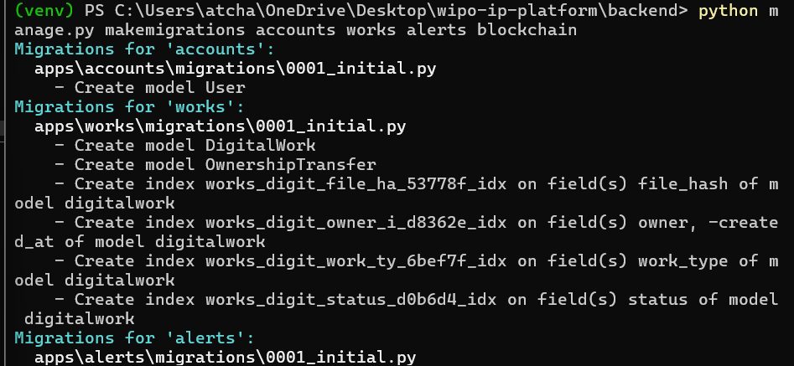
# 3. Apply migrations
python manage.py migrate
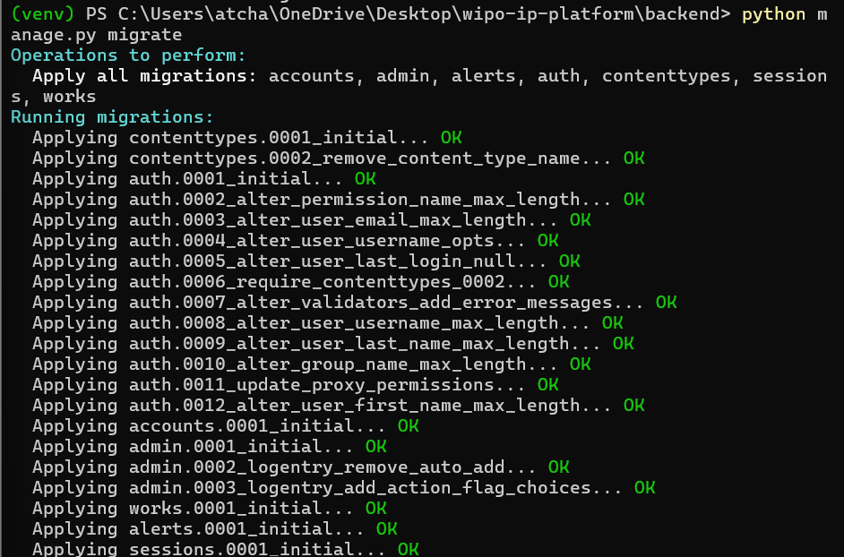
# 4. Create a superuser for admin access (optional but recommended)
python manage.py createsuperuser
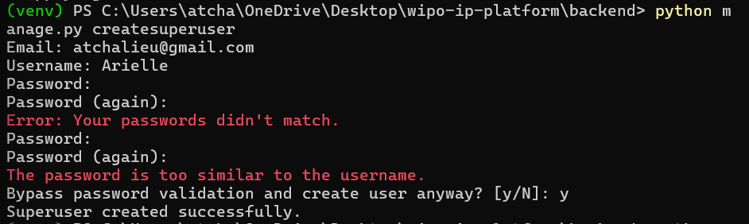
# 5. Run the tests
python manage.py test apps.blockchain.tests.BlockchainTests.test_blockchain_integrity --verbosity=2
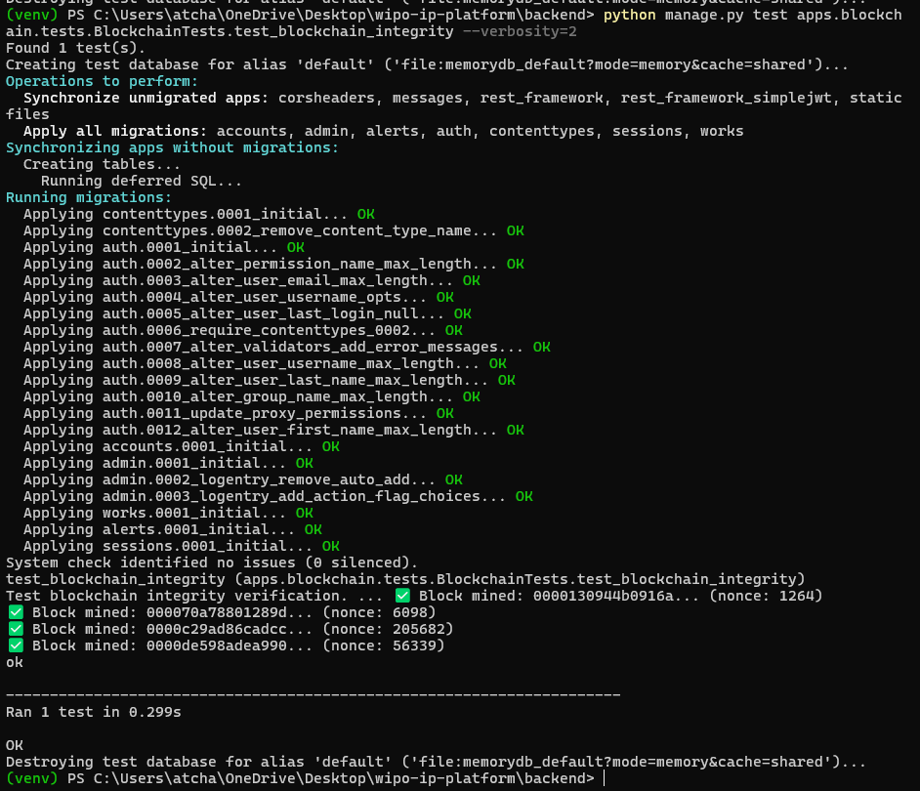

Run specific app tests-
python manage.py test apps.accounts
python manage.py test apps.blockchain
python manage.py test apps.works
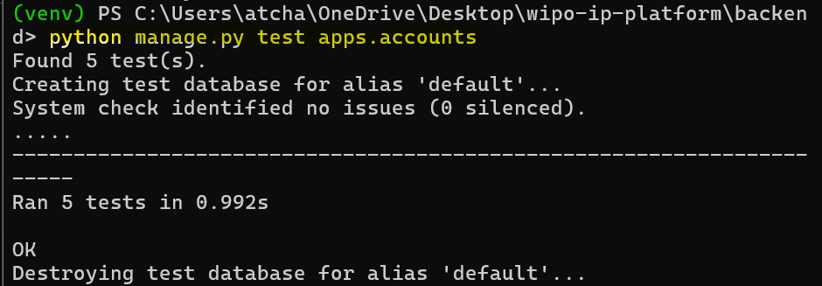
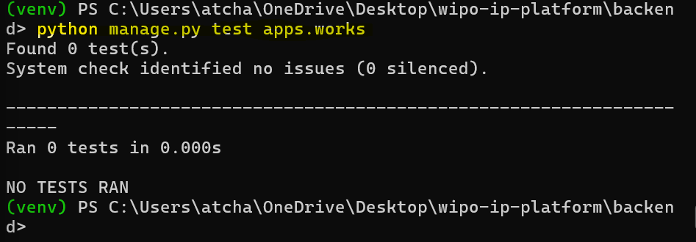

Run with coverage report-
Commands Used
pip install coverage
coverage run --source='apps' manage.py test apps
coverage report
coverage html # Generates HTML report in htmlcov/
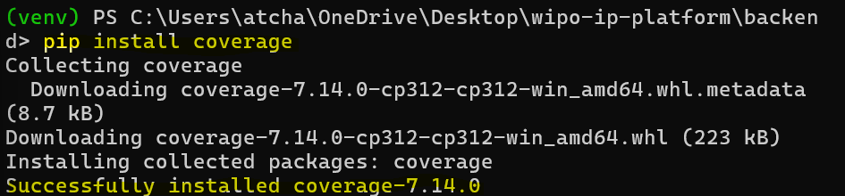
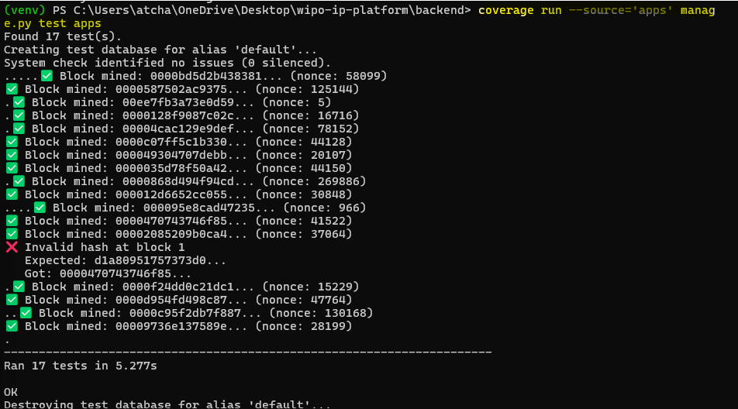
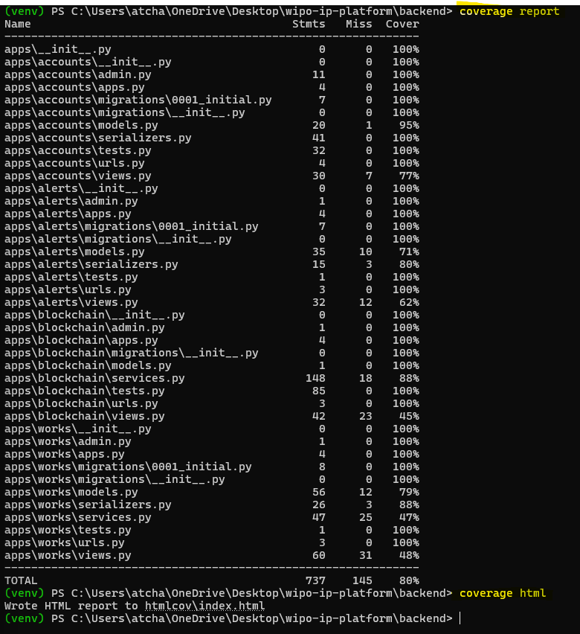

Run frontend tests-
cd frontend
npm test
npm run test:coverage

Phase 6: Azure Deployment

Phase 6 Overview:
Duration: 5 days (35 hours estimated)

Objectives-
- Create Azure account and setup
- Deploy backend to App Service
- Configure environment variables
- Set up production database
- Deploy frontend to Static Web App

Azure Deployment Script:

deploy-azure.ps1-
# ============================================
# Azure Deployment Script for WIPO IP Platform
# Run this script from project root
# ============================================

param(
[string]$ResourceGroup = "wipo-platform-rg",
[string]$Location = "southafricanorth",
[string]$AppName = "wipo-ip-platform",
[string]$DbName = "wipo-postgres-db",
[string]$StorageName = "wipoipstorage$(-join (Get-Random -Count 6 -InputObject 'abcdefghijklmnopqrstuvwxyz0123456789'))"
)

Write-Host "==========================================" -ForegroundColor Cyan
Write-Host "WIPO IP Platform - Azure Deployment" -ForegroundColor Cyan
Write-Host "==========================================" -ForegroundColor Cyan

Step 1: Login to Azure
Write-Host "`n📋 Step 1: Logging into Azure..." -ForegroundColor Yellow
az login

Step 2: Create Resource Group
Write-Host "`n📁 Step 2: Creating Resource Group..." -ForegroundColor Yellow
az group create --name $ResourceGroup --location $Location

Step 3: Create PostgreSQL Database
Write-Host "`n🐘 Step 3: Creating PostgreSQL Database..." -ForegroundColor Yellow
$dbPassword = "WipoSecure$(Get-Random -Minimum 1000 -Maximum 9999)!"
az postgres flexible-server create `
--resource-group $ResourceGroup `
--name $DbName `
--location $Location `
--admin-user wipoadmin `
--admin-password $dbPassword `
--sku-name Standard_B1ms `
--tier Burstable `
--storage-size 32 `
--version 15 `
--public-access 0.0.0.0

$dbHost = az postgres flexible-server show `
--resource-group $ResourceGroup `
--name $DbName `
--query fullyQualifiedDomainName -o tsv

Write-Host "✅ Database created at: $dbHost" -ForegroundColor Green

Step 4: Create Storage Account
Write-Host "`n💾 Step 4: Creating Storage Account..." -ForegroundColor Yellow
az storage account create `
--name $StorageName `
--resource-group $ResourceGroup `
--location $Location `
--sku Standard_LRS `
--kind StorageV2

$storageKey = az storage account keys list `
--resource-group $ResourceGroup `
--account-name $StorageName `
--query '[0].value' -o tsv

az storage container create `
--name ip-works `
--account-name $StorageName `
--account-key $storageKey `
--public-access blob

Write-Host "✅ Storage created: $StorageName" -ForegroundColor Green

Step 5: Create App Service
Write-Host "`n🌐 Step 5: Creating App Service..." -ForegroundColor Yellow
az appservice plan create `
--name wipo-app-plan `
--resource-group $ResourceGroup `
--is-linux `
--sku B1

az webapp create `
--resource-group $ResourceGroup `
--plan wipo-app-plan `
--name $AppName `
--runtime "PYTHON:3.11"

Write-Host "✅ App Service created: https://$AppName.azurewebsites.net" -ForegroundColor Green

Step 6: Configure Environment Variables
Write-Host "`n⚙️ Step 6: Configuring Environment Variables..." -ForegroundColor Yellow
$secretKey = -join ((65..90) + (97..122) + (48..57) | Get-Random -Count 50 | ForEach-Object {[char]$_})

az webapp config appsettings set `
--resource-group $ResourceGroup `
--name $AppName `
--settings `
DEBUG="False" `
DATABASE_URL="postgresql://wipoadmin:$dbPassword@$dbHost/postgres?sslmode=require" `
AZURE_ACCOUNT_NAME="$StorageName" `
AZURE_ACCOUNT_KEY="$storageKey" `
AZURE_CONTAINER="ip-works" `
SECRET_KEY="$secretKey" `
ALLOWED_HOSTS="$AppName.azurewebsites.net,localhost" `
CORS_ALLOWED_ORIGINS="https://$AppName.azurewebsites.net"

Write-Host "✅ Environment configured!" -ForegroundColor Green

Step 7: Create Deployment Package
Write-Host "`n📦 Step 7: Creating deployment package..." -ForegroundColor Yellow
cd backend
Compress-Archive -Path * -DestinationPath ../deploy.zip -Force
cd ..

Step 8: Deploy to Azure
Write-Host "`n📤 Step 8: Deploying to Azure..." -ForegroundColor Yellow
az webapp deployment source config-zip `
--resource-group $ResourceGroup `
--name $AppName `
--src ./deploy.zip

Step 9: Run Database Migrations
Write-Host "`n🔄 Step 9: Running database migrations..." -ForegroundColor Yellow
az webapp ssh --resource-group $ResourceGroup --name $AppName --command "python manage.py migrate"

Step 10: Collect Static Files
Write-Host "`n📁 Step 10: Collecting static files..." -ForegroundColor Yellow
az webapp ssh --resource-group $ResourceGroup --name $AppName --command "python manage.py collectstatic --noinput"

Step 11: Output Results
Write-Host "`n==========================================" -ForegroundColor Cyan
Write-Host "🎉 DEPLOYMENT COMPLETE!" -ForegroundColor Green
Write-Host "==========================================" -ForegroundColor Cyan
Write-Host "🌍 Website: https://$AppName.azurewebsites.net" -ForegroundColor Green
Write-Host "🐘 Database: $dbHost" -ForegroundColor Gray
Write-Host "💾 Storage: $StorageName" -ForegroundColor Gray
Write-Host "==========================================" -ForegroundColor Cyan

# Save credentials to file
$credentials = @"
========================================
WIPO IP Platform - Azure Credentials
========================================
Website: https://$AppName.azurewebsites.net
Database Host: $dbHost
Database User: wipoadmin
Database Password: $dbPassword
Storage Account: $StorageName
Storage Key: $storageKey
Secret Key: $secretKey
========================================
"@

$credentials | Out-File -FilePath "azure-credentials.txt"
Write-Host "📄 Credentials saved to: azure-credentials.txt" -ForegroundColor Yellow
Write-Host "⚠️ Keep this file secure!" -ForegroundColor Red

Deployment Steps:

Step 1: Prepare backend for production
- I did the following within the terminal:
- Navigated to the backend.
- Updated requirements.txt with production packages.
- Created the production settings (if needed). DEBUG=FALSE was in settings.
cd backend

pip freeze > requirements.txt

Step 2: Run deployment script
cd ..
.\deploy-azure.ps1

Step 3: Verify deployment
# Open browser and go to: https://your-app-name.azurewebsites.net

Step 4: Create admin user on production
az webapp ssh --resource-group wipo-platform-rg --name your-app-name --command "python manage.py createsuperuser"

API Documentation

Authentication Endpoints:
Method | Endpoint | Description | Request Body | Response
POST | /api/auth/register/ | Register new user | {email, username, password, password2} | 201 User data
POST | /api/auth/login/ | Login user | {email, password} | 200 {access, refresh}
POST | /api/auth/refresh/ | Refresh token | {refresh} | 200 {access}
GET | /api/auth/profile/ | Get user profile | - | 200 User data

Works Endpoints:
Method | Endpoint | Description | Auth | Response
POST | /api/works/upload/ | Upload work | Required | 201 Work data
GET | /api/works/ | List works | Required | 200 List of works
GET | /api/works/{id}/ | Get work details | Required | 200 Work data
POST | /api/works/{id}/verify/ | Verify work | Required | 200 Verification result
GET | /api/works/dashboard/stats/ | Dashboard stats | Required | 200 Statistics

Alerts Endpoints:
Method | Endpoint | Description | Auth | Response
GET | /api/alerts/ | List alerts | Required | 200 List of alerts
GET | /api/alerts/{id}/ | Get alert details | Required | 200 Alert data
POST | /api/alerts/{id}/resolve/ | Resolve alert | Required | 200 Success
GET | /api/alerts/summary/ | Alert summary | Required | 200 Summary stats

Blockchain Endpoints:
Method | Endpoint | Description | Auth | Response
GET | /api/blockchain/verify/ | Verify chain | Required | 200 Chain status
GET | /api/blockchain/stats/ | Get stats | Required | 200 Statistics
GET | /api/blockchain/block/{index}/ | Get block | Required | 200 Block data
GET | /api/blockchain/tx/{hash}/ | Find transaction | Optional | 200 Transaction

Example API Calls:

Register User-
curl -X POST http://localhost:8000/api/auth/register/ \
-H "Content-Type: application/json" \
-d '{"email":"test@example.com","username":"test","password":"Test123!","password2":"Test123!"}'

Login-
curl -X POST http://localhost:8000/api/auth/login/ \
-H "Content-Type: application/json" \
-d '{"email":"test@example.com","password":"Test123!"}'

Upload Work (use token from login)-
curl -X POST http://localhost:8000/api/works/upload/ \
-H "Authorization: Bearer YOUR_TOKEN" \
-F "file=@document.pdf" \
-F "title=My Work" \
-F "work_type=literary"

Get Dashboard Stats-
curl -X GET http://localhost:8000/api/works/dashboard/stats/ \
-H "Authorization: Bearer YOUR_TOKEN"

Verify Blockchain-
curl -X GET http://localhost:8000/api/blockchain/verify/ \
-H "Authorization: Bearer YOUR_TOKEN"

Challenges I Faced

Challenge 1: Installing Pillow (Backend Setup)

Problem:
The error message displayed below occurred when I tried to install the pillow dependency.

pip install Pillow==8.4.0
Collecting Pillow==8.4.0
Using cached Pillow-8.4.0.tar.gz (49.4 MB)
Installing build dependencies ... done
Getting requirements to build wheel ... done
Preparing metadata (pyproject.toml) ... done
Building wheels for collected packages: Pillow
Building wheel for Pillow (pyproject.toml) ... error
error: subprocess-exited-with-error

× Building wheel for Pillow (pyproject.toml) did not run successfully.
│ exit code: 1
╰─> [212 lines of output]

Solution:
All I had to do was upgrade the Pillow version.
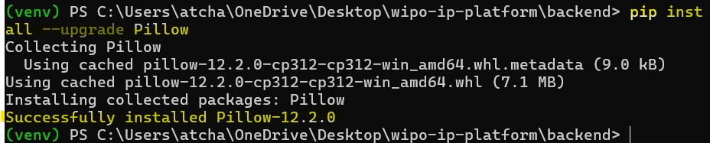

Challenge 2: Installing Tailwindcss (Frontend Setup)

Problem:
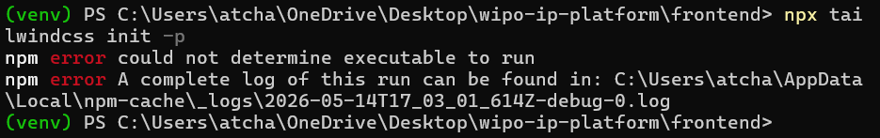

Solution:
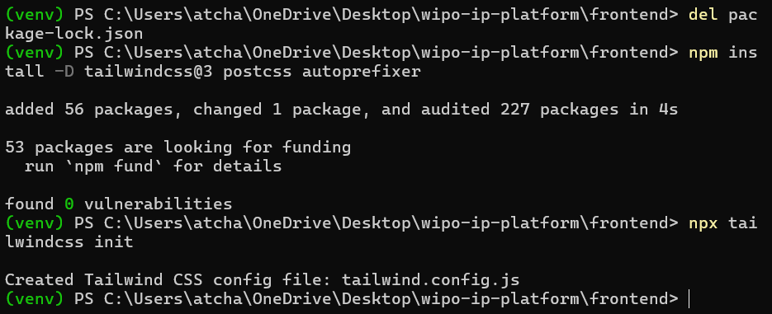
https://hejoseph.com/dev/docs/react/tailwind/tailwind-error/

challenge 3:
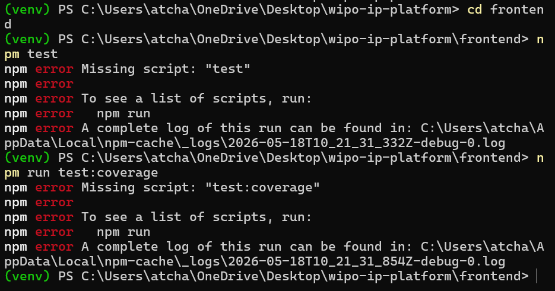

Conclusion

Project Summary:
The WIPO IP Protection Platform successfully delivers a comprehensive solution for digital intellectual property protection.
Key achievements include:
Achievement | Description
Complete Authentication | JWT-based login/register system
File Upload with SHA-256 | Cryptographic hashing for integrity
Blockchain Ledger | Immutable proof-of-work chain
Infringement Detection | Automatic duplicate detection
Modern React Frontend | Responsive TailwindCSS UI
Azure Deployment | Production-ready cloud hosting
Comprehensive Tests | Unit and integration tests

Skills Demonstrated:

Technical Skills-
- Full-stack development (Django + React)
- Blockchain implementation (SHA-256, Merkle trees, PoW)
- Cloud deployment (Azure App Service, PostgreSQL)
- Security (JWT, encryption, CORS)
- Version control (Git, GitHub)

Soft Skills:
- Project planning and time management
- Technical documentation
- Problem-solving and debugging
- Testing and quality assurance

Future Enhancements:
Feature | Description | Priority
NFT Minting | Mint IP works as NFTs on blockchain | High
Smart Contracts | Automated licensing agreements | High
Mobile App | React Native mobile version | Medium
AI Patent Search | NLP-based prior art search | Medium
Multi-language | Support for 10+ languages | Low
Payment Integration | Pay-per-registration system | Low

References

Tools & Libraries:

Backend Dependencies-
Django==4.2.7
djangorestframework==3.14.0
djangorestframework-simplejwt==5.3.0
django-cors-headers==4.3.1
python-dotenv==1.0.0
Pillow==8.4.0
requests==2.31.0

Frontend Dependencies-
react@18.2.0
react-dom@18.2.0
react-router-dom@6.20.0
axios@1.6.0
lucide-react@0.294.0

Appendices

Appendix A: Quick Reference Commands

Start Backend:
cd backend
venv\Scripts\activate
python manage.py runserver

Start Frontend:
cd frontend
npm run dev

Create Migrations:
python manage.py makemigrations
python manage.py migrate

Create Superuser:
python manage.py createsuperuser

Run Tests:
python manage.py test apps
cd frontend && npm test

Deploy to Azure:
.\deploy-azure.ps1

Appendix B: Environment Variables

Backend (.env):
SECRET_KEY=your-secret-key
DEBUG=True
ALLOWED_HOSTS=localhost,127.0.0.1

Frontend (.env):
VITE_API_URL=http://localhost:8000/api

Appendix C: Troubleshooting Guide
Problem | Solution

