TLS/SSL Secure Message Exchange

Installation & Setup Steps
Python was already installed on my laptop. The only additional thing I needed to install was OpenSSL. “openssl req -newkey rsa:2048 -nodes -keyout server.key -x509 -days 365 -out server.crt” was used in the command entered in the terminal to generate a self-signed certificate and private key.

Screenshot of Command:
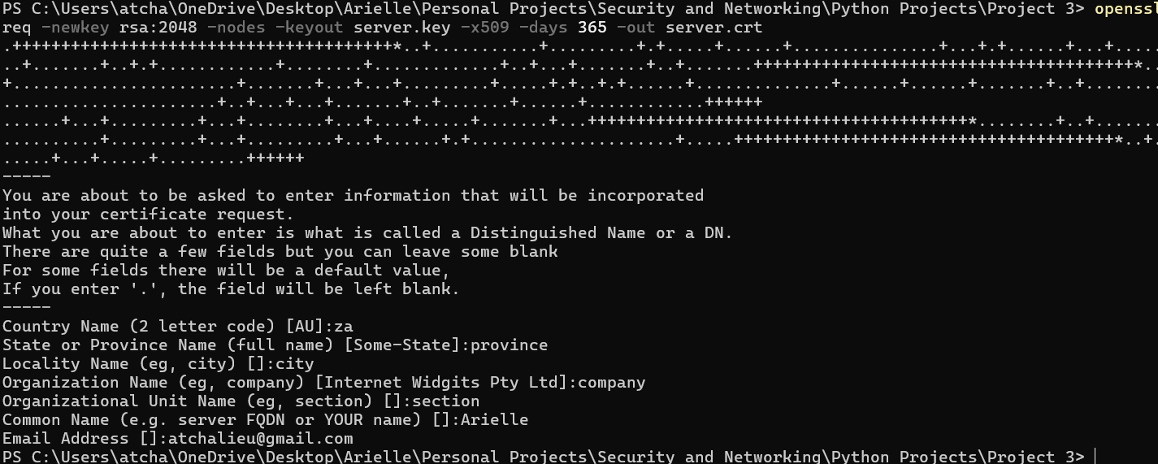

TLS Server (tcp_server.py)
Accepts secure connections and echoes received messages back to the client.

Python Source Code:
import socket
import ssl

HOST = '127.0.0.1'
PORT = 65433

context = ssl.create_default_context(ssl.Purpose.CLIENT_AUTH)
context.load_cert_chain(certfile="server.crt", keyfile="server.key")

with socket.socket(socket.AF_INET, socket.SOCK_STREAM) as server_socket:
server_socket.bind((HOST, PORT))
server_socket.listen(1)
print(f"Secure server listening on {HOST}:{PORT}")
with context.wrap_socket(server_socket, server_side=True) as secure_socket:
conn, addr = secure_socket.accept()
with conn:
print(f"Connected by {addr}")
while True:
data = conn.recv(1024)
if not data:
break
conn.sendall(data)

Screenshot of Output:
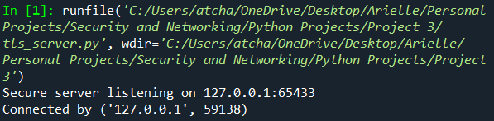

TLS Client (tcp_client.py)
Connects securely to the server, sends messages, and displays echoed responses.

Python Source Code:
import socket
import ssl

HOST = '127.0.0.1'
PORT = 65433

context = ssl.create_default_context()
context.check_hostname = False
context.verify_mode = ssl.CERT_NONE

with socket.create_connection((HOST, PORT)) as client_socket:
with context.wrap_socket(client_socket, server_hostname=HOST) as secure_socket:
print(f"Connected securely to {HOST}:{PORT}")
while True:
message = input("Enter message (or 'exit' to quit): ")
if message.lower() == 'exit':
break
secure_socket.sendall(message.encode())
response = secure_socket.recv(1024).decode()
print(f"Received: {response}")

Screenshot of Output:
