TCP Chat Application

TCP Server (tcp_server.py)
Listens for incoming connections, receives commands, executes them, and sends back the results.

Python Source Code:
import socket
import subprocess

HOST = '127.0.0.1'
PORT = 65432

def execute_command(command):
try:
output = subprocess.check_output(command, shell=True, stderr=subprocess.STDOUT)
except subprocess.CalledProcessError as e:
output = e.output
return output

with socket.socket(socket.AF_INET, socket.SOCK_STREAM) as server_socket:
server_socket.bind((HOST, PORT))
server_socket.listen()
print(f"Server listening on {HOST}:{PORT}")
conn, addr = server_socket.accept()
with conn:
print(f"Connected by {addr}")
while True:
command = conn.recv(1024).decode()
if not command or command.lower() == 'exit':
break
output = execute_command(command)
conn.sendall(output)

Screenshot of Output:
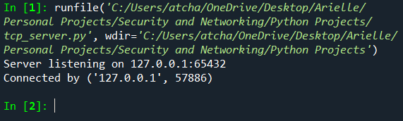

TCP Client (tcp_client.py)
Connects to the server, sends shell commands, and displays the results.

Python Source Code:
import socket

HOST = '127.0.0.1'
PORT = 65432

with socket.socket(socket.AF_INET, socket.SOCK_STREAM) as client_socket:
client_socket.connect((HOST, PORT))
while True:
command = input("Enter command to execute (or 'exit' to quit): ")
client_socket.sendall(command.encode())
if command.lower() == 'exit':
break
output = client_socket.recv(4096).decode()
print(f"Output:\n{output}")

Screenshot of Output:
