Can Microbes Access Carbon in Soils?

Jacqueline E. Pitts

# Why is Microbial Access to SOM Important?

Microbial access to soil organic matter exerts a significant control on carbon cycling in soil. Ekschmitt et al (2005) note a discrepancy between the high amount of organic matter in soil and the extremely high decomposing capabilities of microbes. If SOM is accessible to microbes, they will degrade it relatively rapidly, regardless of its chemical structure (Dungait et al, 2012). However, if it is not accessible, that SOM will remain in the soil as a carbon pool. At long time scales relevant in global carbon cycle models, it isn’t the rate of growth or production of litter that happen at the seasonal or yearly frequency, but rather the production of stabilized materials in mineral soil - the “big, slow pools” - that influences the global carbon cycle most.

# Regulatory Gate Hypothesis

Kemmitt et al (2008) are some of the first to describe the importance of microbial accessibility in the dynamics of SOM mineralization. According to the Regulatory Gate Hypothesis (Figure 1), the rate-limiting step of SOM mineralization is an abiotic one, later explained as a breakdown of physical and/or energetic barriers, but essentially referring to the accessibility of SOM to soil microbes.

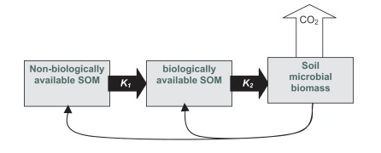

Figure 1, from Kemmitt et al (2008). DOI: 10.1016/j.soilbio.2007.06.021

As described by Schimel and Schaeffer (2012) and shown in Figure 2, the rate at which OM in soil can be metabolized is limited by microbes’ ability to access it (“access”). The fate of that OM once it is accessed depends on the community composition and functional groups of organisms present (“allocation”). Figure 2 shows the relative roles of both physical access to soil carbon and allocation in the dynamics of soil carbon.

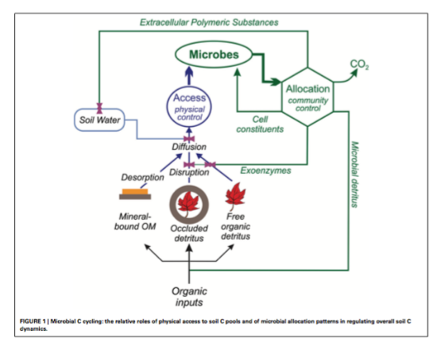

Figure 2, from Schimel and Schaeffer (2012). DOI: 10.3389/fmicb.2012.00348

# Limits on Microbial Access to SOM

What influences microbial access to SOM? Water, oxygen, substrate and organism/enzyme must all come together (in space and time) for SOM turnover at the pore space level (Kuka et al, 2007). The physical preservation or protection of SOM from microbial decomposition has a few major causes: occlusion within aggregates, adsorption onto minerals, complexity and heterogeneity of the physical landscape within soils, and wet/dry cycles that may inhibit or promote diffusion.

Important Publications:

Dungait et al, 2012 DOI: 10.1111/j.1365-2486.2012.02665.x

Ekschmitt et al, 2005 DOI: 10.1016/j.geoderma.2004.12.024

Schimel and Schaeffer, 2012 DOI: 10.3389/fmicb.2012.00348

# 1. Occlusion

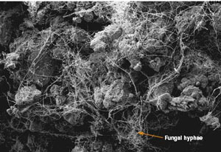

Figure 3, showing a soil microeggrate from <https://www.extension.umn.edu/agriculture/soils/soil-properties/the-soil-is-alive/>

Occlusion within aggregates is an important process that can render SOM inaccessible microbes. One way that aggregates contribute to inaccessibility is by limiting movement of microbial enzymes. Aggregates can also limit the activity of microorganisms through environmental constraints like low oxygen. In order to make SOM bound in aggregates available for microbial decomposition, both physical disruption and exoenzymes are often necessary.

# 2. Adsorption



Figure 4, visualizing adsorption, from <https://simple.wikipedia.org/wiki/Adsorption>

Adsorption onto minerals is another way that SOM can be physically protected from microbes. SOM is adsorbed on the surfaces of clay and amorphous iron and aluminum colloids because of the large charged surface area on these molecules. This can protect SOM from microbial decomposition because the adsorption affinity of SOM is often greater than the affinity of microbial enzymes to SOM.

# 3. Physical Landscape of the Soil

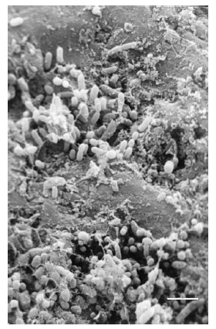

Figure 5 showing the heterogeneous soil landscape, from Or et al. (2007). <DOI:10.1016/j.advwatres.2006.05.025>

The complexity and heterogeneity of the physical landscape within soils contributes to the physical stability of SOM against microbial decomposition. The distance or difficulty of movement across soils can inhibit microbial access to SOM. This can be protective mechanism if the amount of energy it costs for the microbe to get within the vicinity of SOM is greater than the energy acquired from decomposing it. Deeper soils tend to protect SOM more than shallow soils simply because there is more restricted connectivity between microbes and substrate (Ekschmitt et al, 2008).

# 4. Wet/Dry Cycles

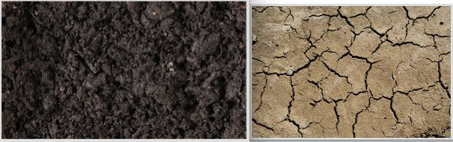

Figure 6, wet and dry soils, from <https://www.shutterstock.com/video/search/wet-soil> and <https://www.featurepics.com/online/Dry-Soil-Background-Photo396566.aspx>

Lastly, wet/dry cycles in soils affect the availability of SOM to microbes. Microbes are extremely dependent on the presence of water in soil for many reasons. Dry soils can effectively immobilize bacteria that depend on water films for transportation. In addition, lack of water can prevent diffusion, a major method for materials transfer both into and out of microbial cells. Lastly, water helps solubilize resources and render them more accessible to microbes and without it, many molecules remain sorbed to mineral surfaces.

# Applications to Earth Systems Models (ESMs)

Currently, much work is being done to more accurately portray soil carbon dynamics in Earth System Models (ESMs). In a recent review paper, Luo et al (2016) acknowledged some of the shortcomings of current models for soil carbon dynamics, one major one being the modeling of microbial influences on soil C. Figure 3 shows a consensus on recommended soil processes, databases, and modeling techniques to direct future work in ESMs. Microbial processes and SOC stabilization fall in the top 3 of the processes to better capture in ESMs. Soil C pool is the top database to enhance for ESM accuracy. Continued and increased attention towards microbial access to SOM should improve the accuracy of ESM models in each of these 3 areas.

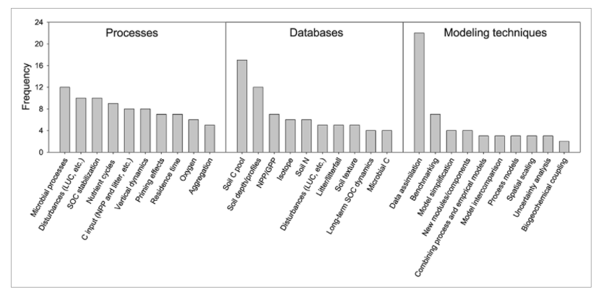

Figure 7, from Luo et al. (2016). DOI: 10.1002/2015GB005239

Current ESMs utilize simple equations and matrices to describe soil carbon dynamics, yet they disagree widely in their projections. Wieder et al (2015) are working to explicitly include non-linear microbial dynamics into their models, giving them the potential to explain microbial stabilization and decomposition of soil C. Microbial accessibility to substrates still has not been parameterized in ESMs and may be the determining factor for the magnitude of the effect of microbes on SOM turnover (Wieder et al, 2015, Schimel and Shaeffer, 2012). However, Luo et al (2016) suggest the need for further observation and evaluation before these can be effectively incorporated into ESMs.

Important Publications:

Wieder et al, 2015 DOI: 10.1002/2015GB005188

Luo et al, 2016, DOI: 10.1002/2015GB005239

# References

Dungait, J., Hopkins, D., Gregory, A., Whitmore, A. (2012) Soil organic matter turnover is governed by accessibility not recalcitrance. Global Chnage Biology, 18, 1781-1796. DOI: 10.1111/j.1365-2486.2012.02665.x

Ekschmitt K, Liu M, Vetter S, Fox O, Wolters V (2005) Strategies used by soil biota to overcome soil organic matter stability – why is dead organic matter left over in the soil? Geoderma, 128, 167–176.

Ekschmitt K, Kandeler E, Poll C et al. (2008) Soil carbon preservation through habitat constraints and biological limitations on decomposer activity. Journal of Plant Nutrition and Soil Science, 171, 27–35.

Kemmitt SJ, Lanyon CV, Waite IS et al. (2008) Mineralization of native soil organic matter is not regulated by the size, activity or composition of the soil microbial biomass – a new perspective. Soil Biology and Biochemistry, 40, 61–73. DOI: 10.1016/j.soilbio.2007.06.021.

Kuka K, Franko U, Ru ̈hlmann J (2007) Modelling the impact of pore space distribution on C turnover. Ecological Modelling, 208, 295–306.

Luo, Y. Q. et al. (2016) Toward more realistic projections of soil carbon dynamics by Earth system models. Global Biogeochem. Cycles 30, 40–56, DOI: 10.1002/2015gb005239.

Or, D. et al. (2007) Physical constraints affecting bacterial habitats and activity in unsaturated porous media - a review. Advances in Water Resources 30, 1505-1527, DOI: 10.1016/j.advwatres.2006.05.025.

Schimel, J., and S. Schaeffer (2012) Microbial control over carbon cycling in soil. Frontiers in Microbiology 3, 1-11, DOI: 10.3389/fmicb.2012.00348.

Six J, Elliott E, Paustian K (2000) Soil macroaggregate turnover and microaggregate formation: a mechanism for C sequestration under no-tillage agriculture. Soil Biol- ogy and Biochemistry, 32, 2099–2103.

Six J, Conant R, Paul E, Paustian K (2002) Stabilization mechanisms of soil organic matter: implications for C-saturation of soils. Plant and Soil, 241, 155– 176.

Wieder, W. R., et al., (2015) Explicitly representing soil microbial processes in Earth system models. Global Biogeochem. Cycles 29, DOI: 10.1002/2015GB005188.