SC Hub: Climate and carbon stocks

Casey McGrath

# The State of Science: Earth System Modeling

The state of climate science has been ever evolving in the face of global climate change. Global climate change is the overall increase of the Earth’s temperature by the input of greenhouse gases into the Earth’s atmosphere. This increase in temperature not only affects the planet’s atmosphere, but also the terrestrial (land-based) processes involved in the Earth’s crust, both above ground and below ground. One of the most important processes being effected in terrestrial ecosystems is the soil carbon cycle. See the previous blog [post](https://powellcenter-soilcarbon.github.io/SOC-Hub/global-context/2017/05/04/Dynamic-role/) titled the “Dynamic role of soil and terrestrial ecosystems in the global C cycle” to learn the essentials on the soil carbon cycle.

Earth system models (ESM) work to integrate the interactions between the atmosphere, plants, soil and water to predict responses to certain conditions. ESMs are important for predicting the future effects of climate change on soil carbon stocks. Current ESMs suggest there is significant potential soil to uptake a large amount of carbon from the atmosphere within this century, given the use of best land management practices. As with all models there are uncertainties within these relationships nonetheless. Findings from Heimann and Reichstein (2008) suggest that the relationship between climate and carbon in terrestrial systems is actually a series of nested systems of positive feedback loops. Accurately accounting for the nested systems within the larger system creates major challenges in accurate ESMs (Figure 1).

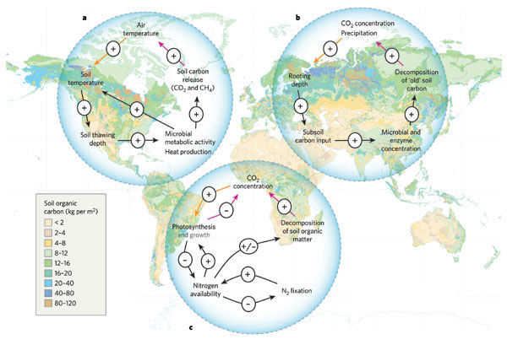

Figure 1: Three examples of positive feedback loops of carbon dioxide with terrestrial ecosystems overlaid on a global map of soil organic carbon (SOC) stocks. (Heimann and Reichmann, 2008).

**Resources**

Todd-Brown et al. 2014 [DOI](<https://doi.org/10.5194/bg-11-2341-2014>)

Heimann and Reichstein (2008) [DOI](<https://doi.org/10.1038/nature06591>)

# Changing climate and it’s complicated relationship with soil carbon

Different climates present different challenges to ESM. Dependent on the latitude a soil falls upon the soil carbon will have different vulnerabilities to global climate change. Table 1 shows the amount of carbon in each soil by biome. Permafrost and peatlands have some of the highest amounts of soil organic carbon (SOC) trapped within their soils. As the Earth’s temperature increases the carbon stored in these soils is threatened by the melting of these partially frozen soils and therefore reigniting the metabolisms of the microbes in the soil, which then respire CO2 back into the atmosphere. This melting permafrost is a key example of the uncertainties that effect ESMs. The main sources of uncertainty in ESMs are climate control on net primary productivity (NPP), soil respiration, tropical forest to savannah conversion, and the turnover time of live carbon or live plant biomass. More about these sources of uncertainty can be found in this sections resources.

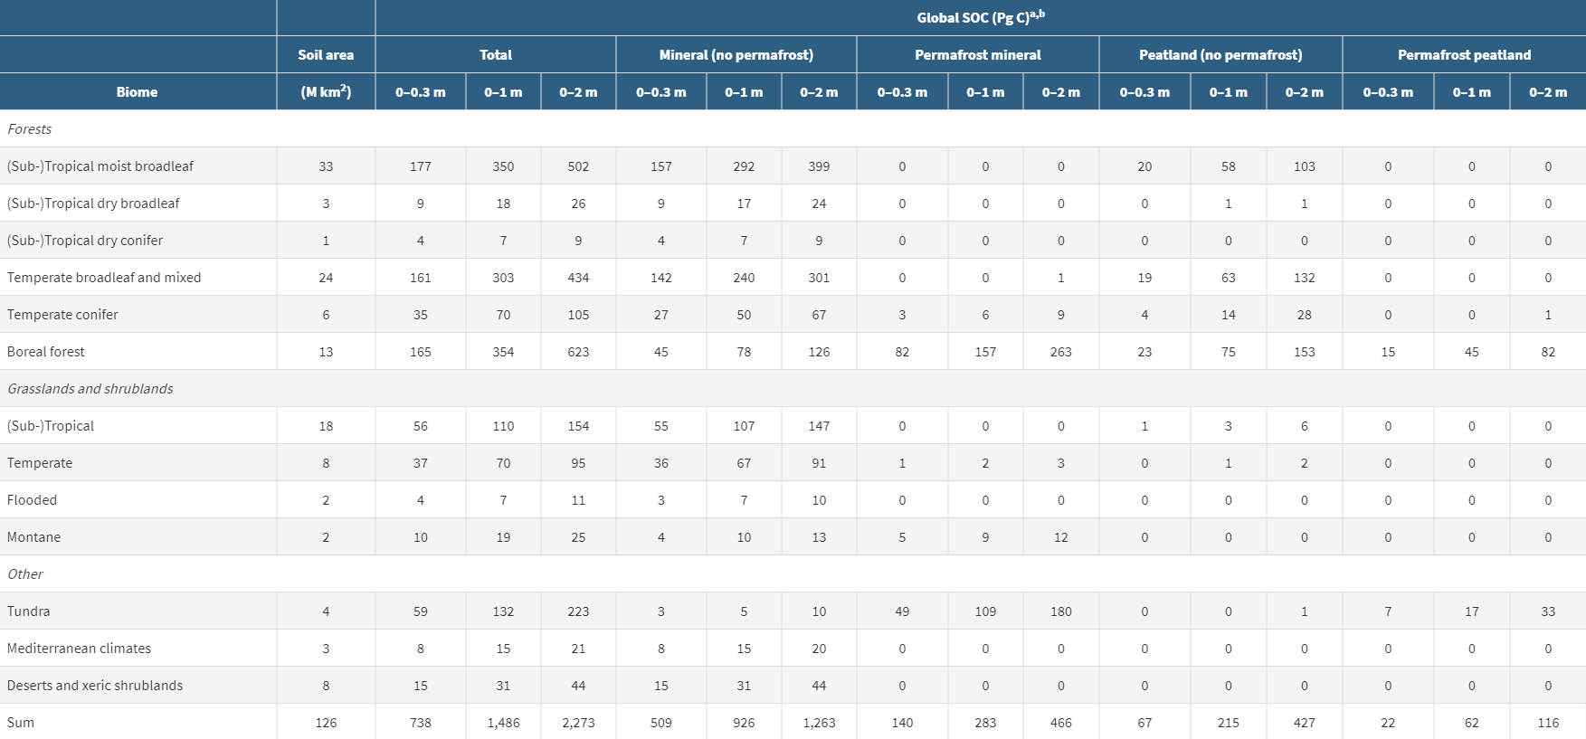

Table 1: SOC by biome given by Jackson et al. 2017 [DOI](https://doi.org/10.1146/annurev-ecolsys-112414-054234)

One ESM that is trying to reduce this uncertainty, specifically in the turnover time of live carbon, is the Coupled Model Intercomparison Project Phase 5 (CMIP5). This model is looking at the two main pools of carbon live (vegetation) and dead (decomposing organic matter) in order to address how carbon may be changing with climate change. By separating the carbon into two separate pools the variables on carbon feedbacks can be better controlled and manipulated within the model. Figure 2 shows the results from the CMIP5 model.

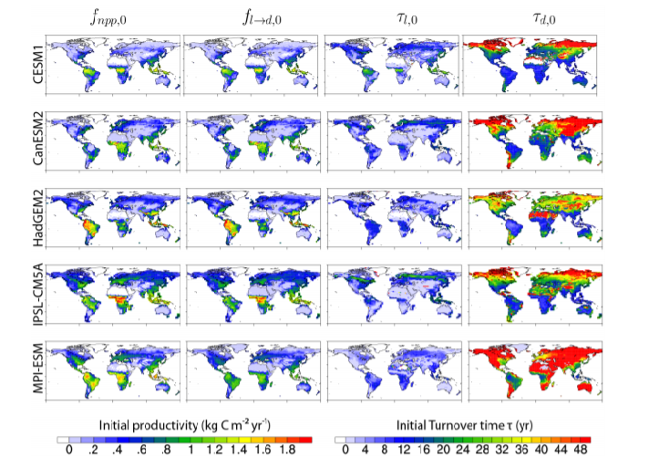

Figure 2: The five ESMs once CMIP5 protocol of the two carbon pool system is applied. The left two columns are the carbon inputs (live pools) and the right two columns are the carbon outputs (dead pools) (Koven et al., 2015).

**Resources**

Olson et al. (2011), [DOI]([https://doi.org/10.1641/00063568(2001)051[0933:TEOTWA]2.0.CO;2](https://doi.org/10.1641/00063568(2001)051%5b0933:TEOTWA%5d2.0.CO;2))

Fung et al., (2005) [DOI](<https://doi.org/10.1073/pnas.0504949102>)

Jones et al., 2003 [DOI](<https://doi.org/10.1029/2005JD006548>)

Friedlingstein et al., (2006) [DOI](<https://doi.org/10.1175/JCLI3800.1>)

Friend et al., (2014) [DOI](<https://doi.org/10.1073/pnas.1222477110>)

Koven et al. (2015) [DOI](<https://doi.org/10.5194/bg-12-5211-2015>)

# Models for Management: How ESMs help make informed decisions

It is important to understand the amount of soil carbon across the globe as well as how it may change over time in order to managed it correctly. By understanding how soil carbon react under different management practices we can help manage the land for it’s best use and for the health of the overall environment. Land use emits 25% of the total anthropogenically influenced greenhouse gases (GHG) into the atmosphere. Of this 25%, the biggest contributors to GHG are agriculture and deforestation, making them the two main focuses of many ESMs.

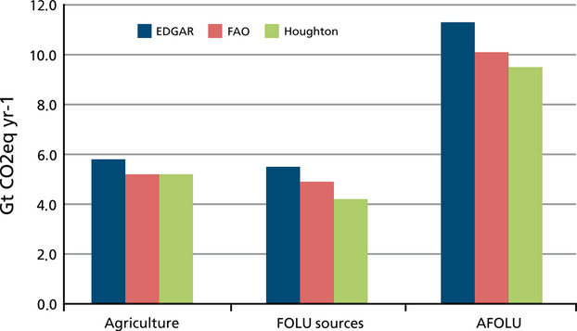

Figure 3: The total yearly contribution of CO2 from agriculture, forestry and other land uses (FOLU) and the combined agriculture forestry and other land uses (AFOLU).

Movements are already being made to help sequester carbon through better land management, specifically in agriculture. The “4 per mil initiative” in France is looking to secure food and climate security by increasing the quantity of organic matter in the top 30-40cm of soils by 4% each year on over 570 million farms across the world [4permil](https://www.4p1000.org/). These movements however are only possible with an integrated implementation approach across scientists, land managers, farmers and policy makers. This discussion starts with ESM models of what SOC stocks look like across the globe and then predicting the positive effects that proper land management can have on increasing the SOC in vulnerable areas like those under agriculture.

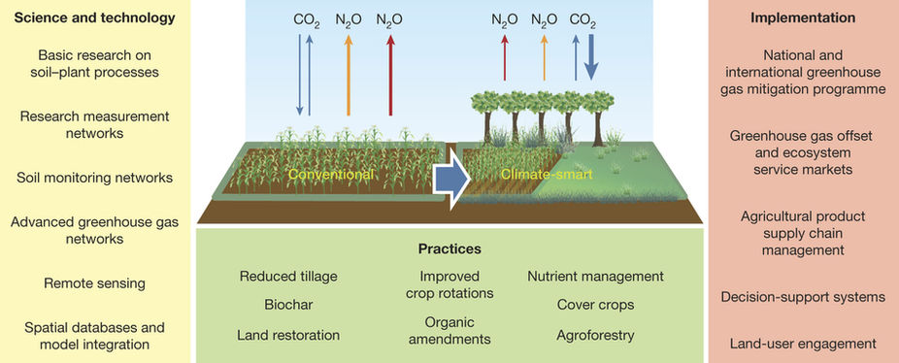

Figure 4: Cross discipline cooperation in model creation and implementation of practice and policies to transition into “climate smart” agriculture. (Paustian et al., 2016).

**Resources**

(Tubiello et al., 2015) [DOI](<https://doi.org/10.1111/gcb.12865>)

(Paustian et al.2016)[DOI](https://doi.org/10.1038/nature17174)

# Where have we come from?: The first global SOC models

The original models in the global climate cycle looked at soil carbon stocks within an area as a relationship between precipitation, evapotranspiration, carbon minerals and the Holdridge world life zones (more commonly referred to as biomes). These early models of global terrestrial carbon failed to account for the effects of climate change that would be brought into fruition many years after the original models were established.

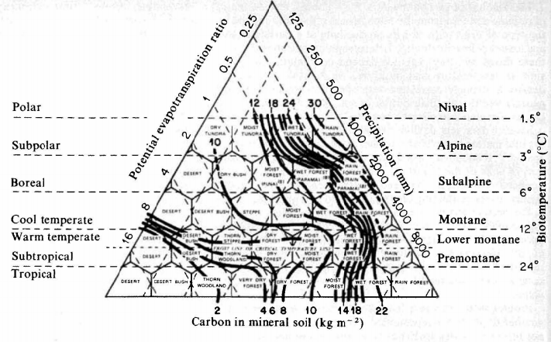

Figure 5: Contours of soil carbon density overlaid on the Holdridge world life zones, displaying the old view of how carbon stocks were distributed globally (Post et al.1982).

Figure 6 shows how the total global estimates in carbon density have evolved overtime. Some estimates have been over the current level (#28) and others have been underestimated. As we enter this new period of climate change and all the heavy uncertainty around the relationship of terrestrial carbon and the atmosphere, we need to evolve the ESM models to encompass this change. Protocols like those in CMIP5 are helping to address this uncertainty but are only scratching the surface of what is to come.

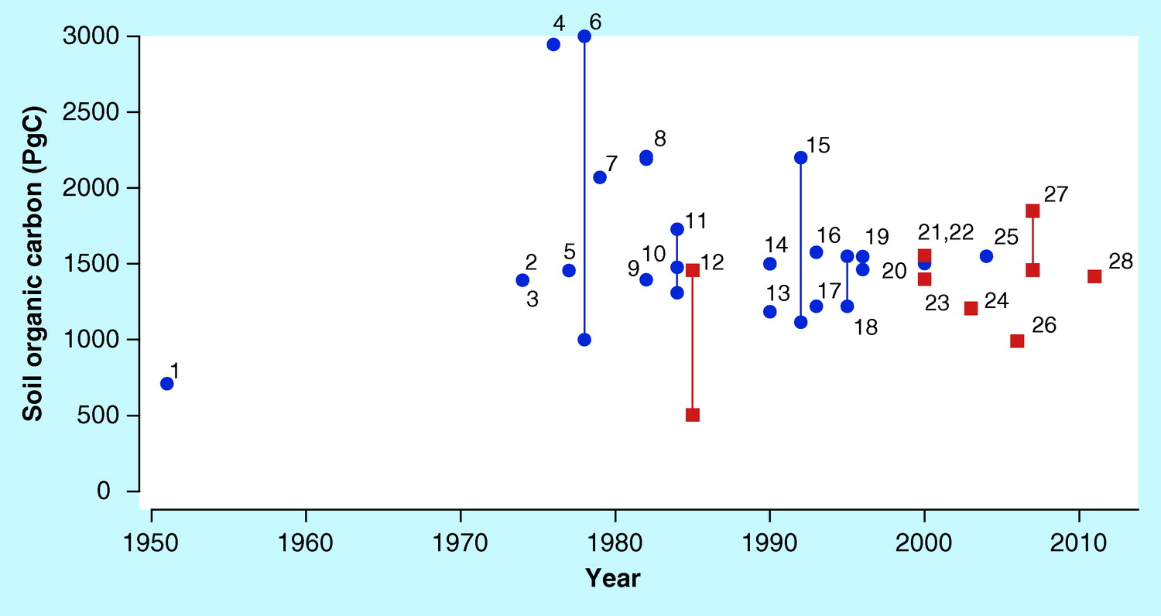

Figure 6: The estimates of the global distribution of carbon density (tons of C ha-1) extracted from literature of that time (Scharlemann et al. 2014).

Resources

Post et al., (1982)[DOI](<https://doi.org/10.1038/298156a0)>.

Scharlemann et al. (2014) [DOI](<https://doi.org/10.4155/cmt.13.77>)

# Types of Models

There are several different types of models that have been developed in ESM. Most often the type of model developed depends on the accessibility to the data you have. Models based on empirical relationships (real data) can be stronger since they are validated with on the ground measurements. However, when this type of data is unavailable models can be based on known mechanisms, physics and first principles. Steefel et al. (2005) argues taking a more integrated systems approach to ESM development. They describe this scientific integrated system as a model “where individual time and space-dependent processes are linked and where the relative importance of individual sub-processes cannot be fully assessed without considering them in the context of the other dynamic processes”. This means linking all processes of carbon sequestration, organic matter decomposition, and carbon transport across spatial and temporal timescales into a continuum, rather than a separate, linear model. This can also be referred to as reactive transport modeling.

There are three types of reactive transport modeling, continuum models, pore scale models, and hybrid models. Continuum models averaging the systems properties across a control volume or representative elementary volume (REV). This is the most common and efficient method of modelling since it averages nested systems to address the larger global scale. Pore scale models “aim to capture pore scale behavior through a set of rules governing mass transport and chemical/biological reactions within and between individual pores” (Steefel et al. 2005). These models are efficient for use on computational power. Hybrid models use a hierarchical system to link different continuum models representing a characteristic length scale to the next continuum to model the entire system.

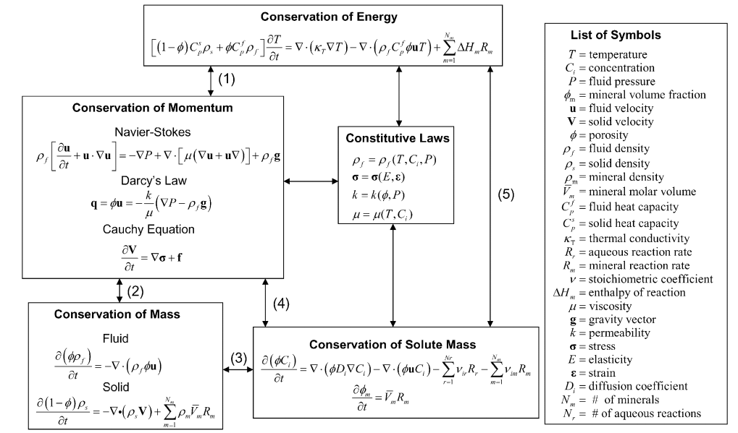

Figure 7: Governing equations for a reactive transport system (Steefel et al., 2005)

For all these approaches there are many challenges to scaling. When a model scales from a soil pore to ESM there is many associated uncertainties. The on the ground data used to validate the model may not represent the true values within the system and the data could upscale or downscale the model predictions. Also there may there is not enough data for the model and extrapolating it to cover an ecosystem or entire planet is not representative of the randomness within the system.

Nonetheless, changing from a linear model to a multi continua model is the new focus of ESMs in order to create accurate forecasts for how climate change may affect carbon stocks across different ecosystems. The mechanisms of carbon sequestration and decomposition are so complex and variant by climate that they require a modeling approach that reflects the complexities and nonlinearity of the environment. Bradford et al. (2016) suggest “model-knowledge integration” where models can be accurately represented by adding our advanced knowledge of carbon stabilization to improve feedback projections. Moving forward we need to bring together theory, measurement and modeling in order to predict accurate relationships and create sustainable management decisions *(link to Jon’s paper)*.

Resources

Steefel et al., (2005) [DOI](<https://doi.org/10.1016/j.epsl.2005.09.017>)

Bradford et al., (2016) [DOI](<https://doi.org/10.1038/nclimate3071>)

# Improving empirical relationships to strength ESM: Enter ISCN and ISEN

Efforts are being made to quantify global carbon stocks using empirical relationships that have been determined from existing datasets. The International Soil Carbon Network (ICSN) is a “large-scale synthesis of soil carbon science” [ISCN](http://iscn.fluxdata.org/). This network synthesizes data about soil carbon into a single platform that then can be used to understand some of the still under answered questions on soil carbon dynamics. One of the largest questions is carbon stabilization and destabilization and under what conditions do either exist, which is critical in the face of climate change. Mostly soil carbon experiments focus solely on the top 30 cm of soil and the relationship of climate change to deep soil carbon is still widely unexplored. The is what created the call for the International Soil Experimental Network (ISEN). ISEN is a global database of manipulative soil warming experiments that focus specifically on the effects of warming deep (at least to 1m) soil profiles (Torn et al. 2015). Networks like the ISCN and ISEN provide the framework for the addition of data into a global soil carbon database. This data can then be used to extrapolate global soil carbon stocks and how they may change in the future due to climate change. This kind of data is an important step in reducing uncertainty in ESMs.

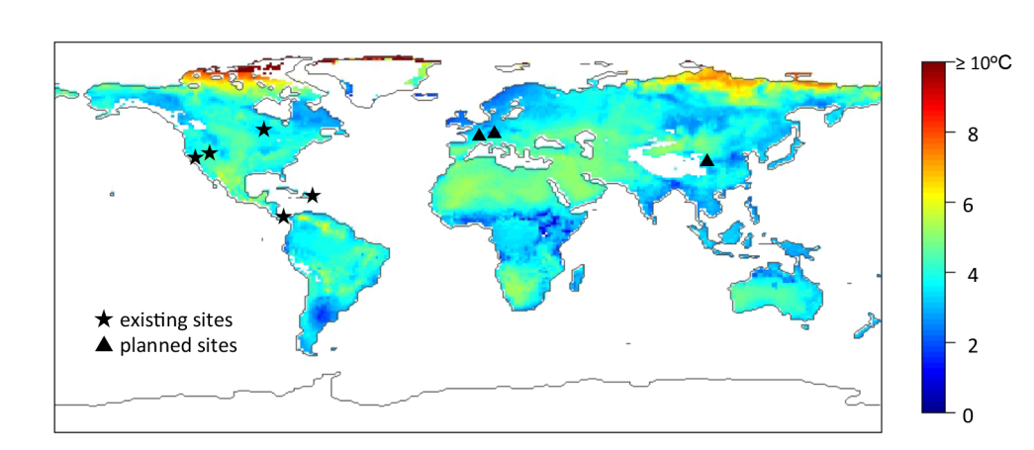

Figure 8: Existing and planned sites for the ISEN at the time of the paper publication. The global temperature map shows the predicted increase in mean temperature for 2080-2100 at 0.01 m soil depth (Torn et al. 2015)

Resources:

Torn et al., (2015) [DOI](<https://doi.org/10.5194/soil-1-575-2015>)