SC Hub:Linkages between soil order, ecosystems and climate

Casey McGrath

# Classifying the World’s soils

Across the planet there are a wide variety of ecosystems all hosted by a unique soil. Each soil is defined by different factors of soil pedogensis all that give a soil its distinct capabilities to hold nutrients, water and organisms for that area of the world. Different soil types are important to the biodiversity of ecosystems and the organisms they hold. Just as biodiversity of plants and animals is important to overall ecosystem health, the biodiversity of the worlds soils are what provide the skin of the Earth’s crust that make it possible to sustain life.

Like the five kingdom classification system, soil scientists have worked to group together soils with similar characteristics into groups called orders. The two widely recognized ways for classifying soil orders are from the International Union of Soil Sciences and the U.S. Department of Agriculture soil orders. The International Union of Soil Sciences created the World Reference Base which delineated global soils into 30 different soil orders and is the International soil classification system. The USDA Soil Taxonomy has 12 soil orders and is the American soil classification system. Each order is differentiated by one or two dominant physical, chemical, or biological properties.

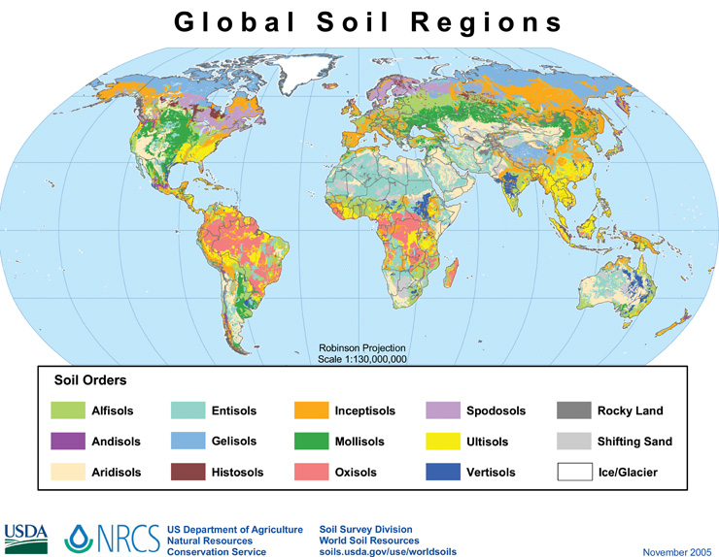

**Figure 1:** The Global Soil Regions map using the USDA 12 order soil taxonomy system. (NRCS)

**Further Resources**

Check out this [link](https://www.nrcs.usda.gov/wps/portal/nrcs/detail/soils/edu/?cid=nrcs142p2_053588) to explore the USDA 12 soil orders of Soil Taxonomy

To explore the 30 orders of the World Reference Base classification system, click [here](http://www.fao.org/soils-portal/soil-survey/soil-classification/world-reference-base/en/)

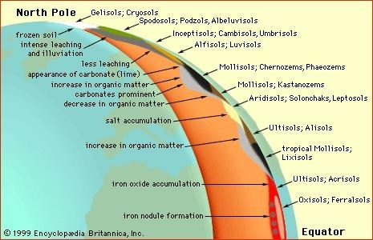

**Figure 2:** Soil types in the Northern Hemisphere and their weathering processes classified by both the World Reference Base adn USDA Soil Taxonomy.

# Soils formation to biome creation

Soil pedogensis is the process of soil formation from a series of environmental factors. The five main factors of soil pedogensis are, climate, organisms (including humans), relief, parent material, and time. Commonly referred to as CLORPT, these factors along with their processes of additions, removals, transfers and transformations create each pedon of attributes, soil type (classification), qualities and suitability.

FACTORS + PROCESSES = PEDON

These soil forming factors and processes are unique to each climate, thus resulting in unique pedons. An example would be that artic soils have a soil forming factor of parent material influenced by glacial despoists and they have a process of freeze thaw transformations. Tropical soils on the other hand can be formed by different parent material of volcanic orgins (although not all volcanically dervied parnet material is in the tropics) that has been influenced by the process of leaching by heavy rains. It is this stark difference in factors and processes that give the Earth its unique soil pedons, resulting in the worlds unique ecosystems!

Why do we care about a diversity of soil types? Soils are the second most important influence on vegetation after climate. To understand the link between climate and vegetation see the previous blog post titled “Climate and Plant Distribution” (Link to GW and PL blog post 2aiii). The fertility of the soil along with the climate determine the type and density of aboveground biomass for a region. In Figure 3 below the vegetation type, temperature and precipitation regime are categorized along a gradient below.

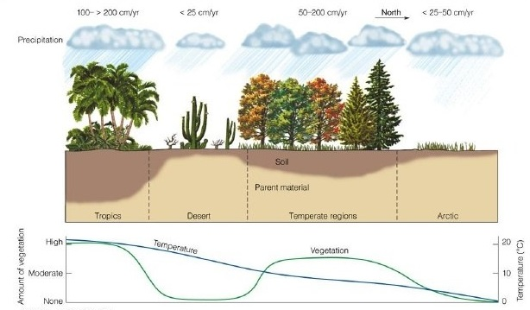

**Figure 3:** The effects of climate on soil formation and dominant vegetation type. Soils are he second most important influence on vegetation after climate (Thomson Higher Education (2007)

The density of vegetation for an area influences the belowground biomass in both roots and decomposing organic matter. Looking back at Figure 2 we can see that tropical and temperate regions hosted more organic matter than desert and arctic regions. This phenomenon is due to the density of vegetation in these regions that is vulnerable to quicker rates of decomposition. This cycle of the organic matter from the intake of carbon from the atmosphere through photosynthesis, to forming the aboveground biomass and then decomposing into the soils is one example of the many ecosystem services that the soil provides.

**Further References:**

Bockheim et al. (2014) [doi](https://doi.org/10.1016/j.geoderma.2014.02.016)  
Van Cleve and Powers (Chapter 9, 1995) [doi](https://doi.org/10.2136/1995.carbonforms.c9)

# Importance of unique soils to ecosystem services

Soils are critical in providing and supporting many of the ecosystem services. The Millennium Ecosystem Assessment defines ecosystem services as “the benefits people derive from ecosystems.” Basically these are the services that the Earth provides for free, and that most humans live their day to day lives without even thinking of them. The ecosystem service benefits fall into four main categories, supporting, provisioning, regulating and cultural services. Supporting services are necessary for the functioning of all other ecosystem services, provisioning services provide food, water and raw material to humans, regulating systems control the quality of air, water, climate, pests and disease, and cultural services provide spiritual, recreational, aesthetic enrichment. These services vary by each natural system due to climate differences, but all have one thing in common, humans need them in order to survive.

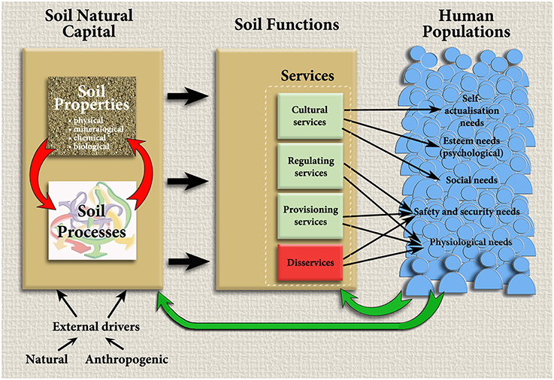

**Figure 4:** The proponents to ecosystem services from soil and how they provide to human populations. Millenium Ecosystem Assessment (2005).

Some of the ecosystem services provided by soil (or that involve soil) are listed from the Intergovermental Panel on Climate Change (IPCC) 2002 report:

*Clean air & water   
*Cultural, spiritual & recreational values   
*Decomposition and cycling of organic matter   
*Gas exchange and carbon sequestration   
*Maintenance of soil structure   
*Medicines   
*Plant growth control   
*Pollination   
*Production of food, fuel & energy   
*Regulation of nutrients and uptake   
*Seed dispersal   
*Soil detoxification   
*Soil formation & prevention of soil erosion   
*Suppression of pests and diseases

Who knew that soils have been under our feet this entire time providing most of the means we need to live?! Clearly this a lengthy list of services, all important for sustaining life. We need soils for the air we breathe, the water we drink, the food we consume, and everything in between. Without healthy soil there cannot be healthy ecosystems and in turn a healthy global human population.

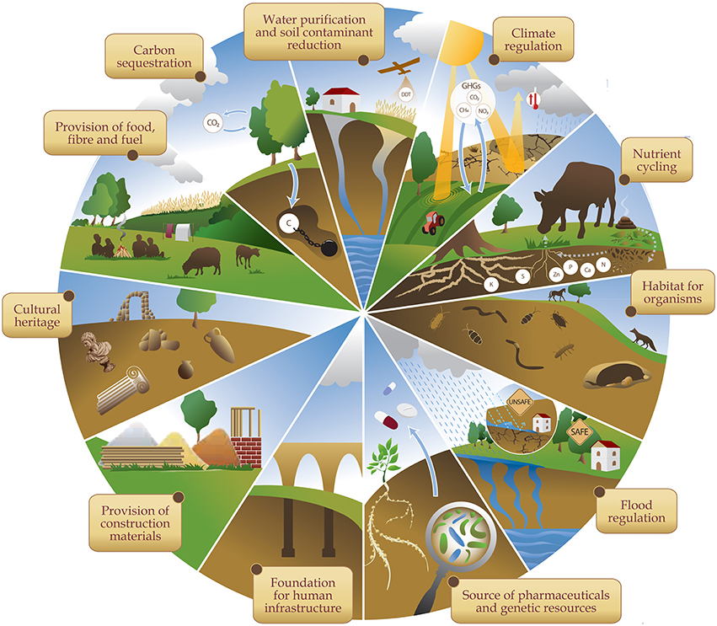

**Figure 5:** The main ecosystem services provided by soils (Food and Agriculture Organization of the United Nations).

“The nation that destroys its soil, destroys itself.”   
 —Franklin Delano Roosevelt

According to the Millennium Ecosystem Assessment 60% of ecosystem services are being degraded or used unsustainably. Nonlinear changes in ecosystem services include accelerating, abrupt and potentially irreversible changes to ecosystems. These nonlinear changes are becoming more and more common as climate change comes to the forefront as one of our greatest global issues. Due to the undetectable nature of these changes it is near to impossible to predict these events through modeling therefore the human capabilities to adapt are inhibited (See blog post titled Global Carbon Modeling to understand more about these abrupt changes and thershold modeling for climate change (Link to 2av.post)). One of these nonlinear responses to increased fossil fuel emissions is the atmospheres capacity to cleanse itself from potent greenhouse gases. The overwhelming amount of greenhouse gases in the atmosphere is inhibiting the Earth’s capability to regulate its global air temperature. Scientists have been heavily focused on this nonlinear change since the 1980s. Soils may hold some of the keys in helping to regulate the carbon within the atmosphere. Without managing these soils properly we could have more issues in the future with balancing the ecosystem cycles.

Connecting back to soil taxonomy, each unique soil type provides particular ecosystem services to the biome it is a part of. For example, soils in tropical climates, that have volcanic parent material, hold special physical and chemical properties that make it able to sequester carbon better than other soils by creating aggregates that make the carbon inaccessible to microbes. If the microbes cannot access the carbon in the soil then they cannot respire it and it stays in the ground rather than going into the atmosphere. This property is unique to volcanic parent material because of the role of iron and aluminum organo mineral particles play in stabilizing the aggregate particles. This makes these tropical soils important to ecosystem services involving the global carbon cycle.

**Further References:**

Millenium Ecosystem Assessment [link](https://www.millenniumassessment.org/documents/document.356.aspx.pdf)  
Clothier et al. 2011 [doi](https://doi.org/10.1002/9780470960257.ch9)  
Baveye et al. 2016 [doi](https://doi.org/10.3389/fenvs.2016.00041)

# Soils and carbon sequestration: Locking up greenhouse gases underground

Sequestration of carbon is one of biggest ecosystem services. While there is carbon above ground that you can see in the form of vegetation, there is also so much carbon below ground. Soils hold ⅔ of the worlds carbon for terrestrial ecosystems. Carbon enters the vegetation through photosynthesis from the atmosphere and then is inputted into the soils through roots and decomposing organic matter. This organic matter (carbon) will either stay in the soil or be respired out back to the atmosphere (link to post 1 (susans)).The amount of carbon allocated to each ecosystem is associated with climatic controls, like precipitation and temperature as well as the soil type, determining its pH and mineral components. See Figure 6 below from Jackson et al. (2017) to understand how much carbon is above and below ground for each ecosystem.

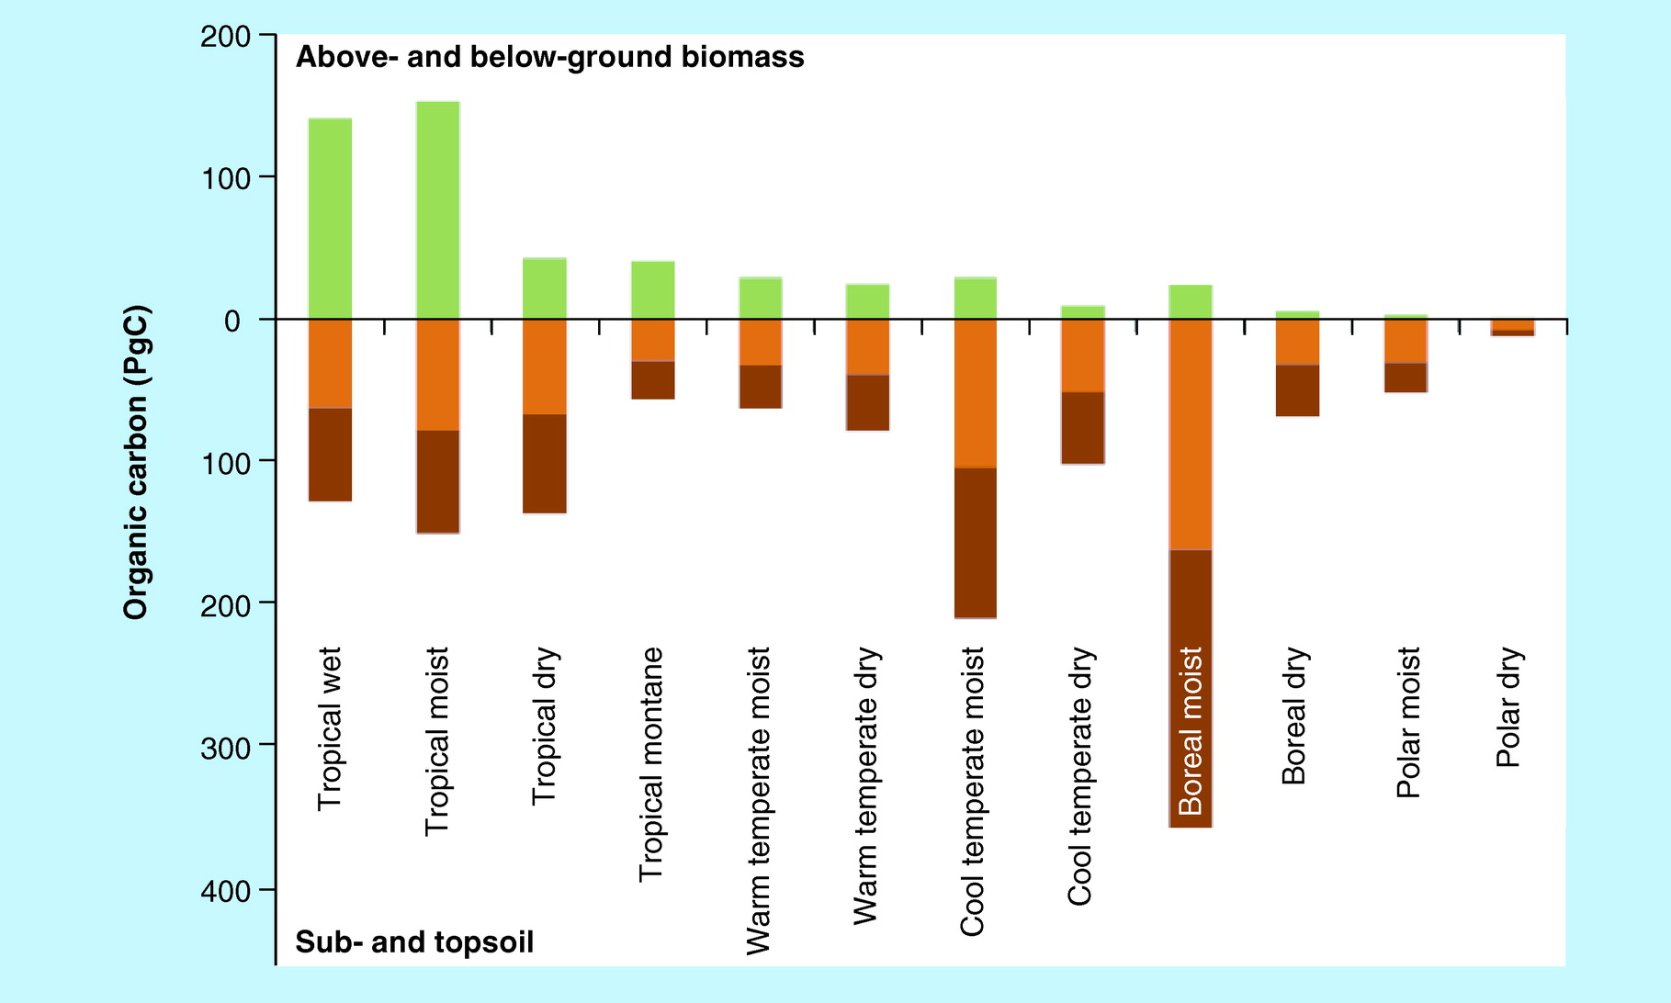

**Figure 6:**The amount of carbon above (green) and below ground biomass (topsoil = orange, subsoil = brown) for each biome. (Jackson et al., 2017).

From this figure we can see that warmer wetter climates hold more organic carbon in their above ground biomass, while colder, wetter climates hold more carbon in their below ground biomass. This large amount of below ground biomass in the colder, wetter region of boreal moist biomes can be attributed to permafrost. Permafrost is soil that is frozen for more than two consecutive years. With rising global temperatures the permafrost thaws and activates the microbes within the soil. These now mobilized microbes start to decompose the carbon within the soil and the carbon is respired as the greenhouse gas of CO2. This creates a negative feedback loop that accelerates the consequences of climate change.

Learning to manage the carbon cycle in soils as an ecosystem service is critical for the health of our planet, especially in the midst of climate change. By properly managing each soil, for each specific ecosystem we can study how we may be able to input more carbon into the soil from the atmosphere provided the greenhouse gas effect does not overwhelm the mechanisms protecting carbon form respiration in each ecosystem first. From tropical soils using volcanic minerals to stabilize organic matter to arctic soils losing their ability to freeze microbial activity, the difference in challenges facing soil carbon sequestration varies by biome type. By using global models we can try to predict the areas that should be focused on to have land use management changes that could dramatically alter the amount of carbon in the atmosphere. (link again to 2av.post)

**Further Resources:**

Jackson et al. (2017) [doi](https://doi.org/10.1146/annurev-ecolsys-112414-054234)  
Vitharana et al. (2017) [doi](https://doi.org/10.1002/2016JG003421/)  
Raich et al. (2006) [doi](https://doi.org/10.1890/05-0023)  
Torn et al. (2005) [doi](https://doi.org/10.1002/9780470494950.ch6)