Spectral Analyses

Kristy Lam

# What is Spectral Analysis?

Spectral analysis, or spectroscopy, is increasingly being used by soil scientists to quantify and identify organic matter and carbon in samples. In general chemistry, we learned that all matter emit electromagnetic radiation. The electromagnetic spectrum shows the scale of wavelengths emitted (Figure 1).

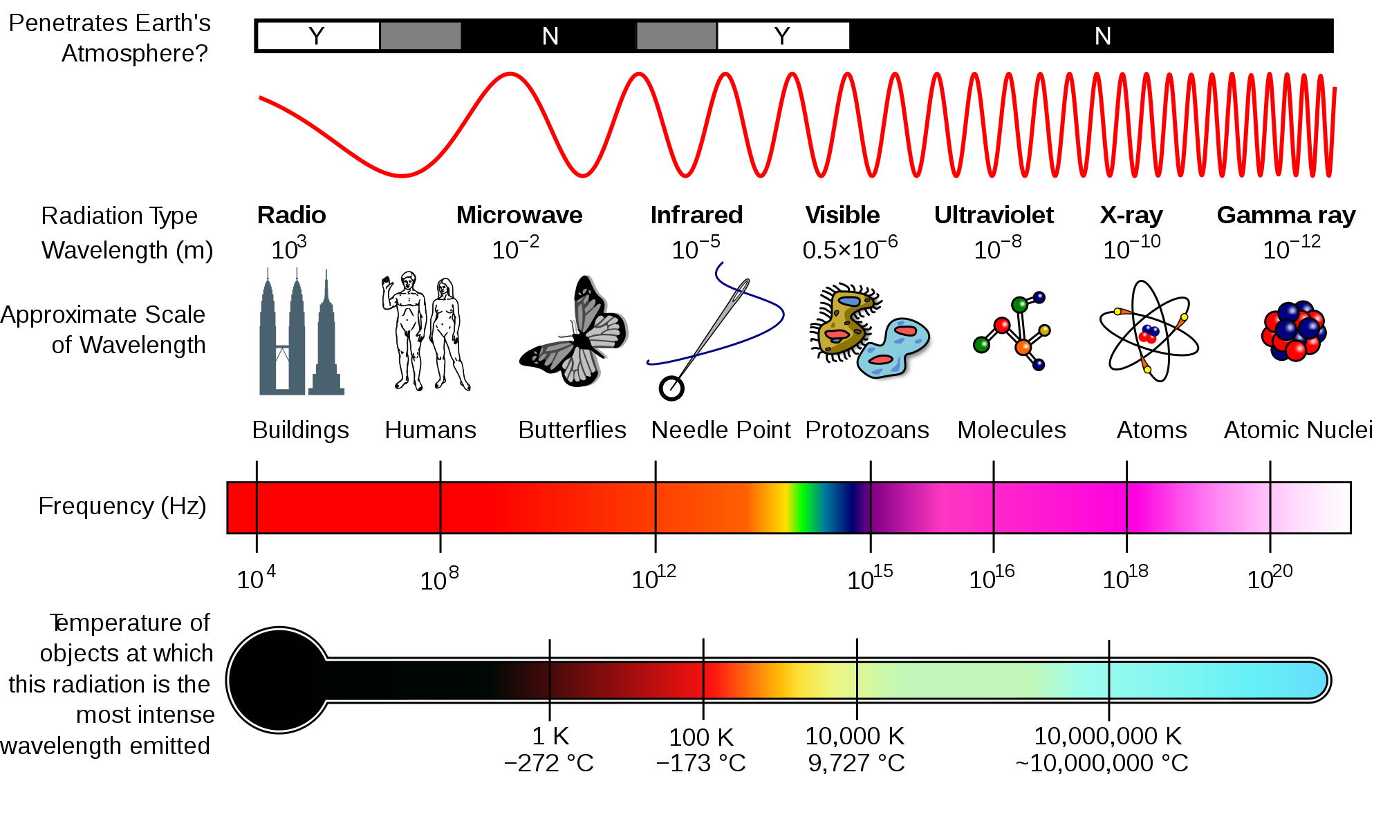

Figure 1. Electromagnetic spectrum from [Wikipedia](https://en.wikipedia.org/wiki/File:EM_Spectrum_Properties_edit.svg#filelinks)

In the context of soil science, spectral analysis involves identifying different types of organic compounds in a sample based on the reflectance (i.e. spectral signature) or absorption of a specific type or wavelength of electromagnetic radiation. SOM includes a variety of different forms of carbon that originate from heterogeneous sources (i.e. plants, animals, microbes, and transformations associated with decomposition). Thus, the advantage of spectral analyses is that these techniques can identify and broadly classify organic matter based on the compounds’ ability to absorb and/or emit electromagnetic radiation. However, these methods often require adequate statistical and/or numerical analyses techniques (i.e. Fourier Transformation to convert time-domain data to frequency-domain data or Partial Least Squares Regression to sort through many highly collinear spectral bands from relatively few observations). In addition, the results of spectral analyses may need to be coupled with other analytical approaches (i.e. biological, chemical, physical, or thermal fractionation - include links to these pages) to determine the implication of SOM composition for soil health and soil best management practices. Recent studies (see “Applications(link)” section) have utilized these techniques to their advantage to answer relevant questions about SOM dynamics and stability. Many techniques of spectral analysis exist, but this section will focus on a few that are commonly used in soil science.

Sources:  
Brown et al. (2006) DOI: [10.1016/j.geoderma.2005.04.025](http://linkinghub.elsevier.com/retrieve/pii/S0016706105001564)  
Denef et al. (2009) DOI: [10.1017/CBO9780511711794](https://www.cambridge.org/core/books/soil-carbon-dynamics/6E3BE5527BCBE2147B09CDB5F76D8788)

# Methods of Spectral Analyses

## A. Infrared (IR) Spectroscopy

In infrared spectroscopy, infrared light interacts with a molecule causing the bonds to vibrate, stretch, bend, rock, etc., which characterizes the component atoms. For example, a compound such as vanillin will absorb infrared light corresponding in energy to the vibrations made, thus resulting in a unique reflection of its molecular structure (Figure 2). Furthermore, Figure 3 shows the infrared range from 700nm to 1,000,000nm, with the exception of VNIR and FTIR, which looks at a portion of the visible spectrum.

Sources:  
[Michigan State University](https://www2.chemistry.msu.edu/faculty/reusch/virttxtjml/spectrpy/infrared/infrared.htm)

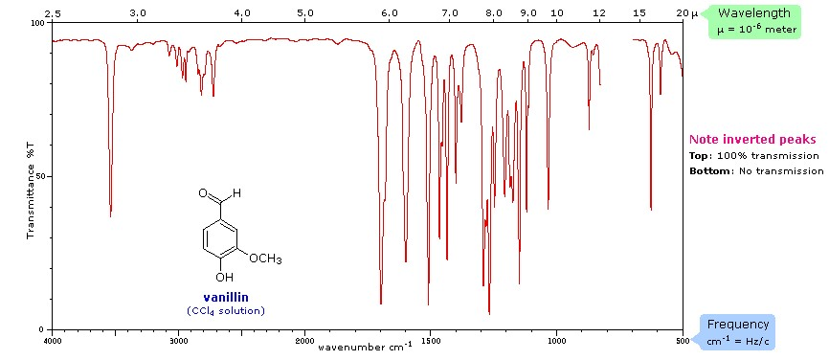

Figure 2. Spectral signature of vanillin (CCl4) from [Michigan State University](https://www2.chemistry.msu.edu/faculty/reusch/virttxtjml/spectrpy/infrared/infrared.htm)

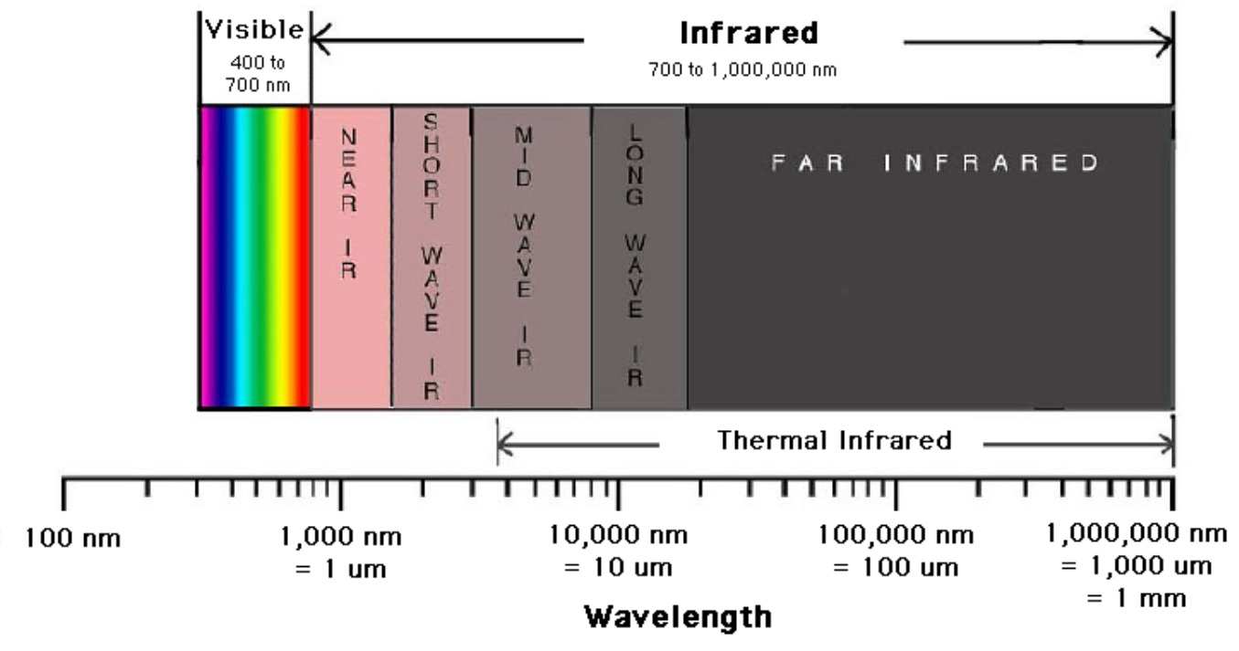

Figure 3. A breakdown of the infrared region of the electromagnetic spectrum from [Digital Earth Watch](http://dew.globalsystemsscience.org/key-messages/near-infrared-and-the-electromagnetic-spectrum)

### 1. Visible Near-Infrared (VNIR) - 350-2500nm

VNIR reflectance is used to determine soil mineralogy, clay content, cation exchange capacity (CEC), and concentrations of SOC, soil inorganic carbon, and citrate-dithionite extractable Fe (Table 1). One of the most desirable qualities of the VNIR technique is that it is quick and relatively inexpensive, compared to the other techniques.

Sources:  
Brown et al. (2006) DOI: [10.1016/j.geoderma.2005.04.025](http://linkinghub.elsevier.com/retrieve/pii/S0016706105001564)

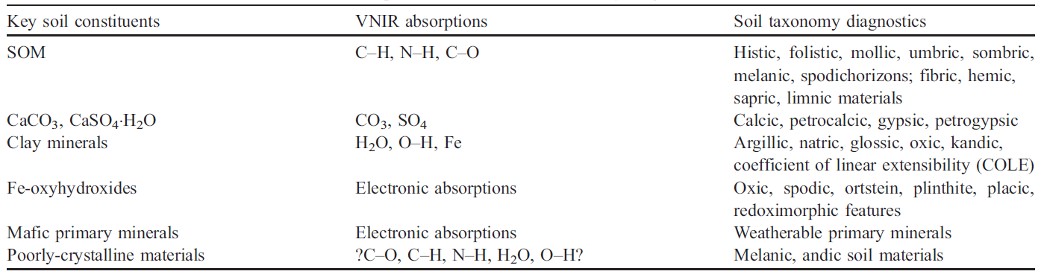

Table 1. A list of key soil constituents, their VNIR absorptions, and the associated soil taxonomy diagnostics from Brown et al.(2006) [10.1016/j.geoderma.2005.04.025](http://linkinghub.elsevier.com/retrieve/pii/S0016706105001564)

### 2. Fourier-Transform Infrared (FTIR) 400-4,000nm

This method, most commonly used in soil science research, utilizes polychromatic radiation to excite molecular bonds of inorganic and organic compounds, which then generates a spectrum based on the functional groups in the material. It also takes continuous measurements of atmospheric gases in the field, thus, having good sensitivity to soil gases. SOM produces a “fingerprint” in the IR spectrum, then the chemical family or identity can be determined using a reference database.

Sources:  
EAG Laboratory (<https://www.eag.com/>)  
Denef et al. (2009) DOI: [10.1017/CBO9780511711794](https://www.cambridge.org/core/books/soil-carbon-dynamics/6E3BE5527BCBE2147B09CDB5F76D8788)  
Parkih at al. (2014) DOI: [10.1016/B978-0-12-800132-5.00001-8](https://www-sciencedirect-com.eres.library.manoa.hawaii.edu/science/article/pii/B9780128001325000018?via=ihub)

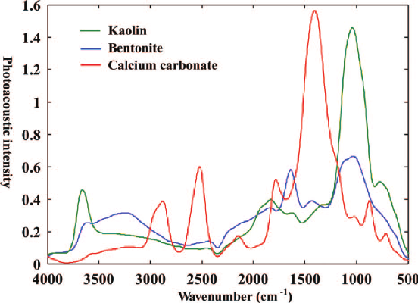

Figure 4. FTIR spectra of kaolin, bentonite, and calcium carbonate from Du and Zhou (2011) [10.1080/05704928.2011.570837](https://www.tandfonline.com/doi/abs/10.1080/05704928.2011.570837)

## B. Nuclear Magnetic Resonance (NMR) Spectroscopy

This method involves aligning magnetic nuclei of a specific isotope (i.e. 13C) by a strong external magnet, then perturbing it with a radio wave. Once the molecule absorbs the external energy, the nuclei resonate at a certain frequency, which then tells us the chemical environment that the nuclei resides in (i.e. nature of bonds, constituent organic functional groups, etc). Figure 5 below shows the spectrum of camphor. In addition, 13C NMR can determine chemical composition of soil organic matter, where compounds are identified based on proportion of total carbon in the sample in different organic functional groups, such as alkyl, aromatic, and carboxylic groups (Figure 5). This method is non-destructive and avoids the potential for secondary reactions. However, 13C only represents about 1% of whole C in soil sample, and interference from paramagnetic metal ions in soil (ex. Fe and Mn) can cause interference with the NMR signals.

Check out this [video from Thermo Fisher](https://www.thermofisher.com/us/en/home/industrial/spectroscopy-elemental-isotope-analysis/molecular-spectroscopy/nuclear-magnetic-resonance-nmr.html).

Sources:  
Reeves III et al. (2012) DOI: [10.1016/B978-0-12-386897-8.00020-6](https://www.sciencedirect.com/science/article/pii/B9780123868978000206)  
Denef et al. (2009) DOI: [10.1017/CBO9780511711794](https://www.cambridge.org/core/books/soil-carbon-dynamics/6E3BE5527BCBE2147B09CDB5F76D8788)  
EAG Laboratory (<https://www.eag.com/>)

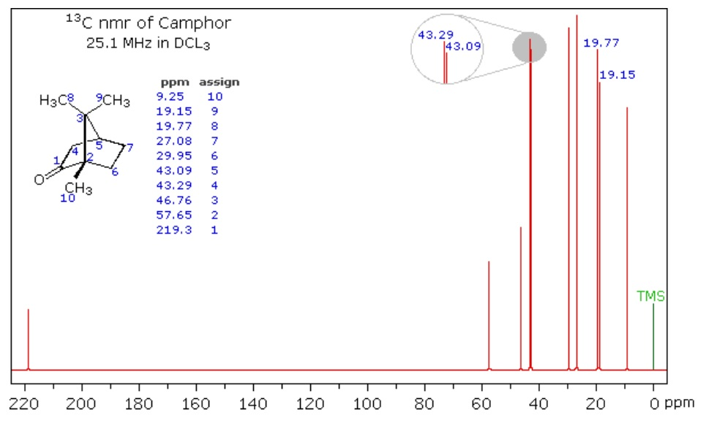

Figure 5. Spectrum of Camphor from [Michigan State University](https://www2.chemistry.msu.edu/faculty/reusch/virttxtjml/spectrpy/nmr/nmr1.htm)

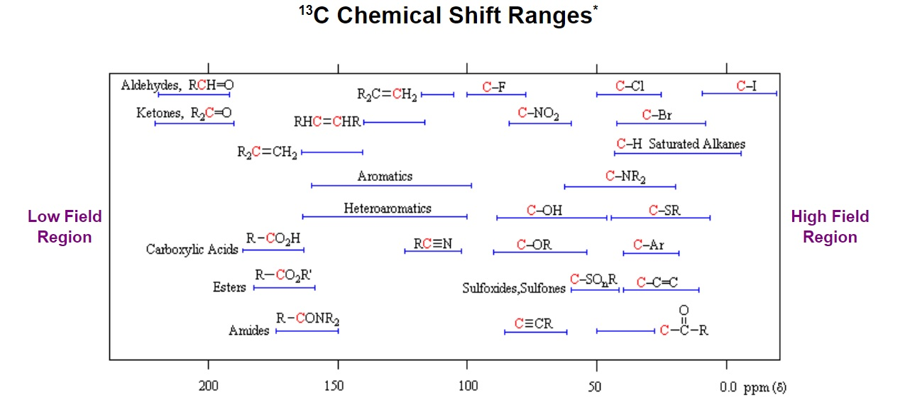

Figure 6. General distribution of carbon chemical shifts associated with different functional groups from [Michigan State University](https://www2.chemistry.msu.edu/faculty/reusch/virttxtjml/spectrpy/nmr/nmr1.htm)

## C. Raman Spectroscopy

This method, like IR spectroscopy, is used to determine and identify the chemical structure of compounds through vibrational spectroscopy and provides qualitative analysis of SOC/SOM. Additionally, this technique provides better resolution than FTIR and analyzes at a small scale (i.e. 1µm). Taquet et al. (2012) found that one of the advantages of Raman is that it is portable and robust, thus allowing quantitative analyses of absolute gas concentrations.

Sources:  
Taquet et al. (2012) DOI: [10.1016/j.ijggc.2012.10.003](http://linkinghub.elsevier.com/retrieve/pii/S1750583612002368)  
EAG Laboratory (<https://www.eag.com/>)

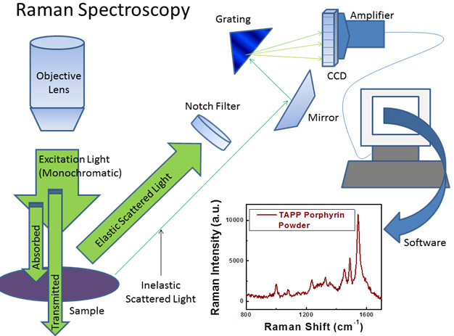

Figure 7. Diagram of Raman spectrometer and the resulting spectra of TAPP Porphyrin powder from [University of Maryland](http://www.chem.umd.edu/wp-content/uploads/2014/01/)

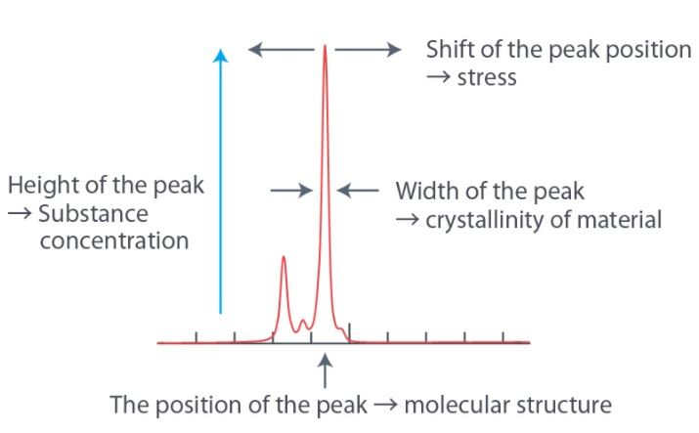

Figure 8. Compound characteristics as they are related to a spectral signature produced from a Raman spectrometer from [nanophoton](https://www.nanophoton.net/raman/raman-spectroscopy.html)

## D. X-ray

### 1. X-ray Absorption Near-Edge Structure (XANES) or Near edge X-ray Absorption Fine Structure (NEXAFS)

XANES spectroscopy determines the oxidation state of specific elements in a soil and is often used to identify carbon nanotubes (CNTs) using elemental mapping and analyze interface reactions. Interactions between CNT largely depend on the environment in which they are (i.e. saturated soil). In samples with a high C content, x-rays tend to be absorbed, easily pass through water, and do not deflect or scatter through air bubbles, thus, enabling samples to be tested for CNTs. Figure 9 shows the 3 phases of a XANES/NEXAFS spectra.

Sources:  
Jokic et al.(2003) DOI: [10.1016/S0016-7037(03)00101-7](http://www.sciencedirect.com/science/article/pii/S0016703703001017)  
Sedlmair et al. (2012) DOI: [10.1016/j.chemgeo.2011.08.009](http://www.sciencedirect.com/science/article/pii/S0009254111003433)

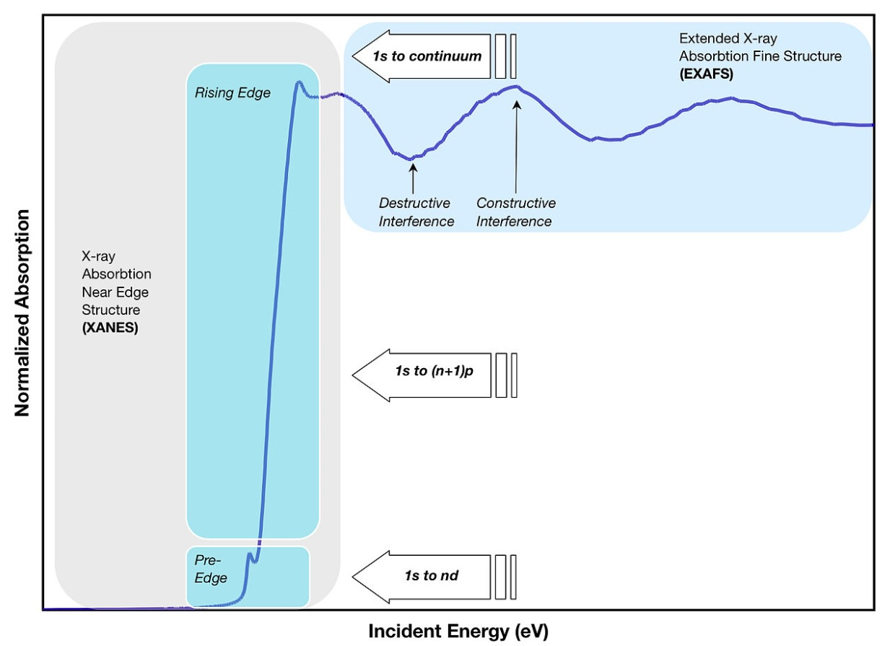

Figure 9. Example of a XANES/NEXAFS spectra from [Wikipedia](https://en.wikipedia.org/wiki/X-ray_absorption_spectroscopy)

### 2. X-Ray Fluorescence (XRF)

This non-destructive technique is used to quantify the elemental compositions of SOM and measure film thickness and composition. The soil sample is irradiated with X-rays that interact with the innermost electrons of the atom (K- and L-shells), causing the emission of X-rays with energies characteristic of the elements present (Figure 10). This method can analyze a few micrometers to several millimeters depending on the material.

Sources:  
EAG Laboratory (<https://www.eag.com/>)

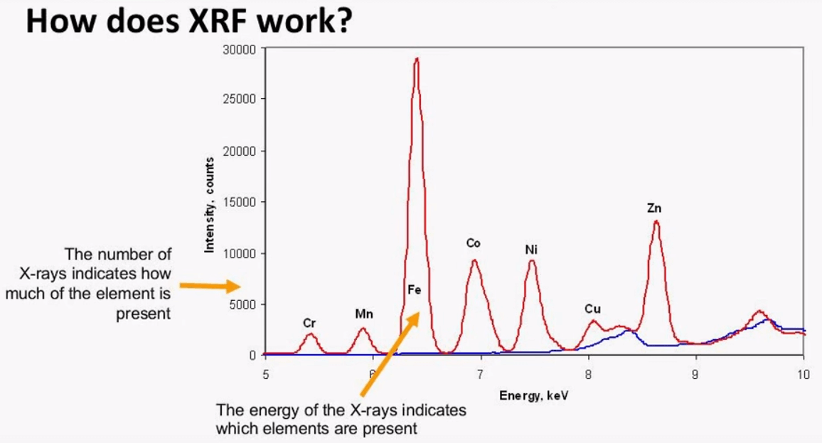

Figure 10. XRF spectra of a sample containing various elements from [Metallurgist](https://www.911metallurgist.com/blog/sample-preparation-methods-for-xrf-analysis)

# Applications

**Pollutants in the soil**

Jokic et al. (2003) analyzed prairie wetland soils in Saskatchewan, Canada using elemental analysis, NMR and XANES spectroscopy with an emphasis on organic carbon and sulphur structures. After comparison with adjacent upland and cultivated soils, they found that the wetland soils have a significant sequestering ability for pollutants such as polycyclic aromatic hydrocarbon (PAHs). Thus, drying of the wetlands, caused by either drainage or climate change, may result in the rapid decomposition of the more labile organic matter, releasing carbon dioxide into the atmosphere. DOI: [10.1016/S0016-7037(03)00101-7](http://www.sciencedirect.com/science/article/pii/S0016703703001017)

**Soil carbon and climate change**

Another study done by Gillespie et al. (2014) characterized and developed relationships between the chemistry and bioavailability of SOC in the horizons of Subarctic earth hummocks. Biodegradability was assessed in a laboratory controlled mineralization study, XANES was used to characterize the chemical composition of the SOM, and thermal stability was determined by Rock-Eval pyrolysis. Their results indicated that there may be a pool of labile SOC, relatively rich in phenolic compounds, in perennially frozen soils which may be susceptible to decomposition in a warming climate. DOI: [10.1016/j.soilbio.2013.09.021](http://www.sciencedirect.com/science/article/pii/S0038071713003222)

**Modelling soil carbon fractions**

In Florida, Knox et al. (2015) sampled 1014 sites for individual pools of soil carbon to better understand processes such as decomposition and accretion of soil C. VNIR, MIR, and a combination of the VNIR-MIR spectral region were used to estimate four different soil C fractions - total carbon, soil organic carbon, recalcitrant carbon, and hydrolysable carbon. Partial least squares regression (PLSR) and random forest (RF) was successful in modelling the four fractions, although, the latter is recommended for future studies planning to conduct chemometric analysis of C fractions. DOI: [10.1016/j.geoderma.2014.10.019](http://linkinghub.elsevier.com/retrieve/pii/S0016706114003863)