**Quatro Menswear**

Style Guide &

Design of E-Commerce Website

Designer: Arienne Johnson

**Quatro** is a designer menswear retailer, with a store located in Toronto and a fully functioning e-commerce site. Clients are required to go for a fitting before purchasing all tuxedos, or three piece suits, however other items are available to be shipped.

The **style** we are trying to convey here at Quatro is classic, sophisticated and mature. We are staying with the original colour scheme, but changing the order/layout of where the colours go. We simplified the logo to keep the look consistent, and removed one colour from that particular logo. The goal is to target men 30 years old and up, by creating a classy yet still mature look in the website and all their designs.

**Mind Map – Quatro’s Website**

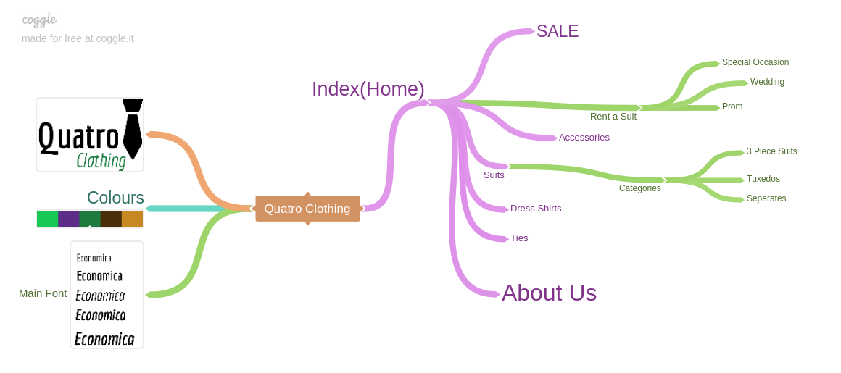

**Wireframe - Home Page**

**Mobile Desktop**

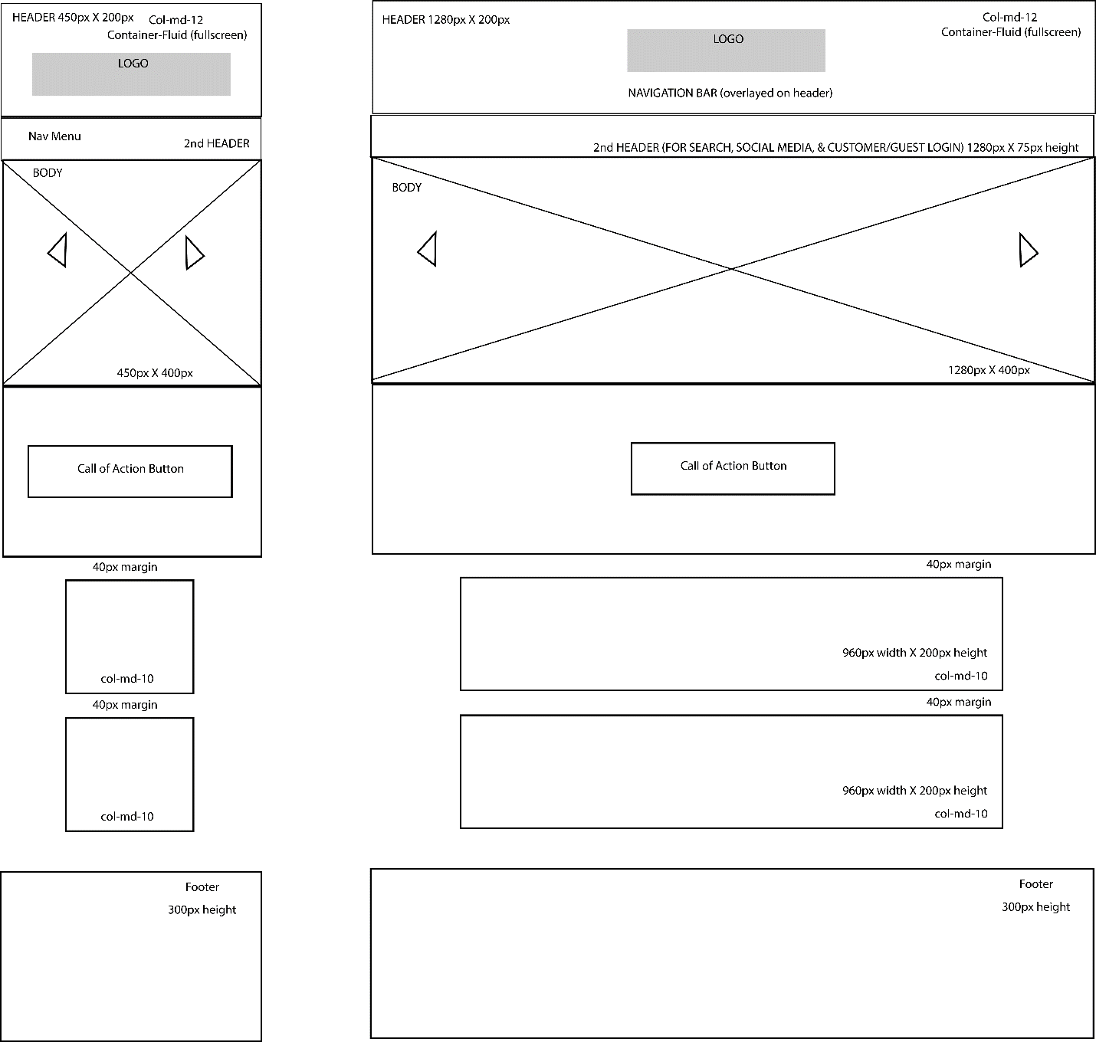

**Wireframe – List of Products Page**

**Mobile Desktop**

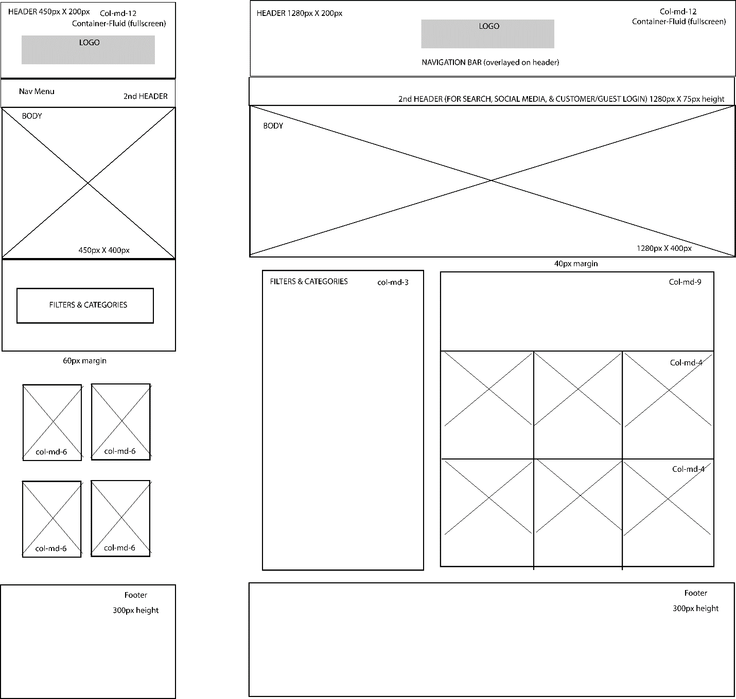

**Wireframe – Individual Product Page**

**Mobile Desktop**

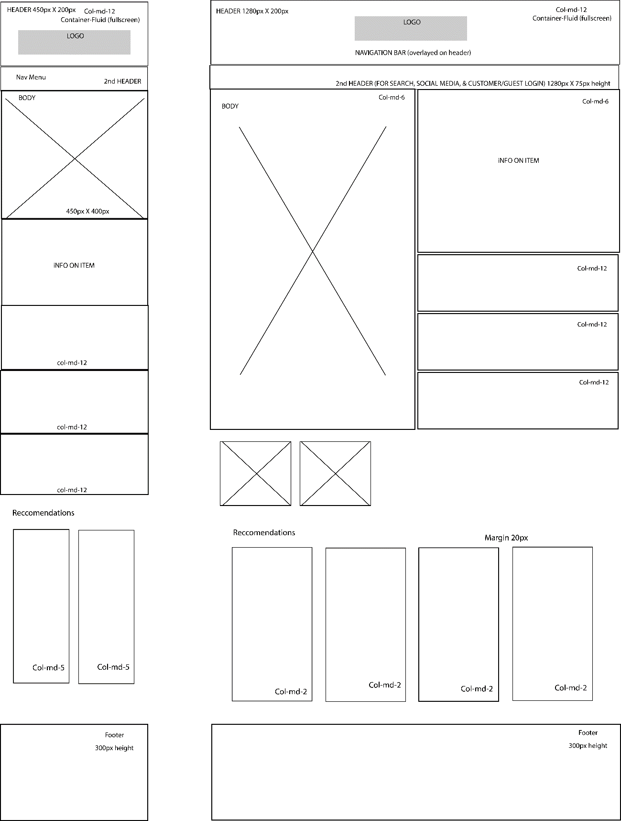

**Final Webpages Design**

**Home Page**

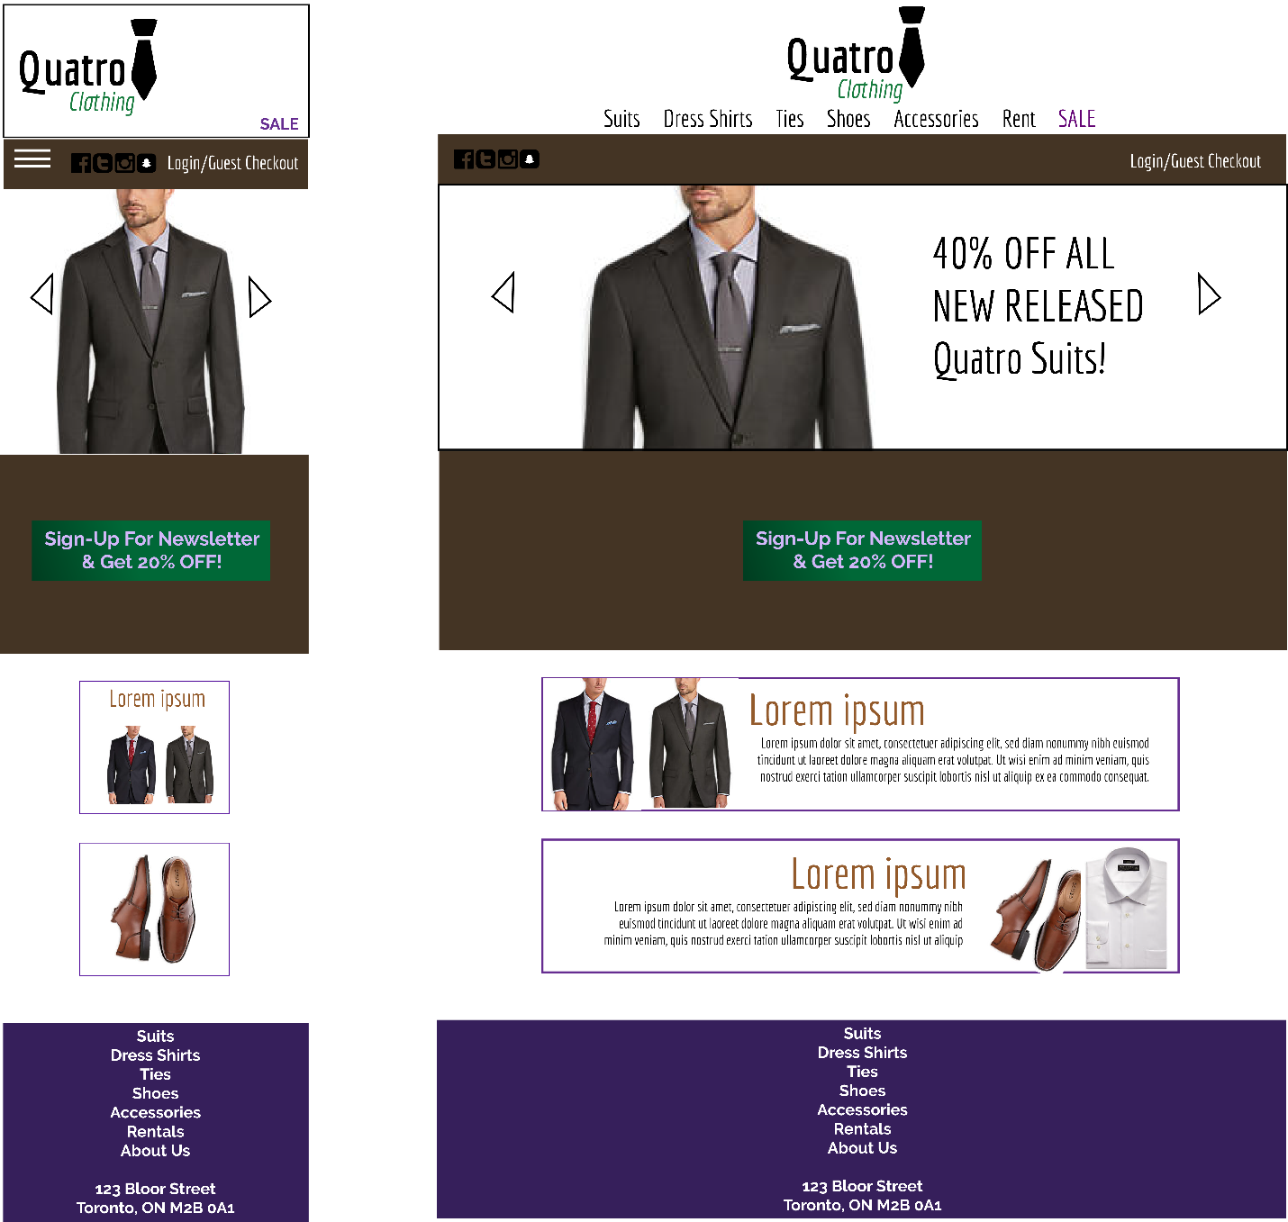

**Final Webpages Design**

**List of Products**

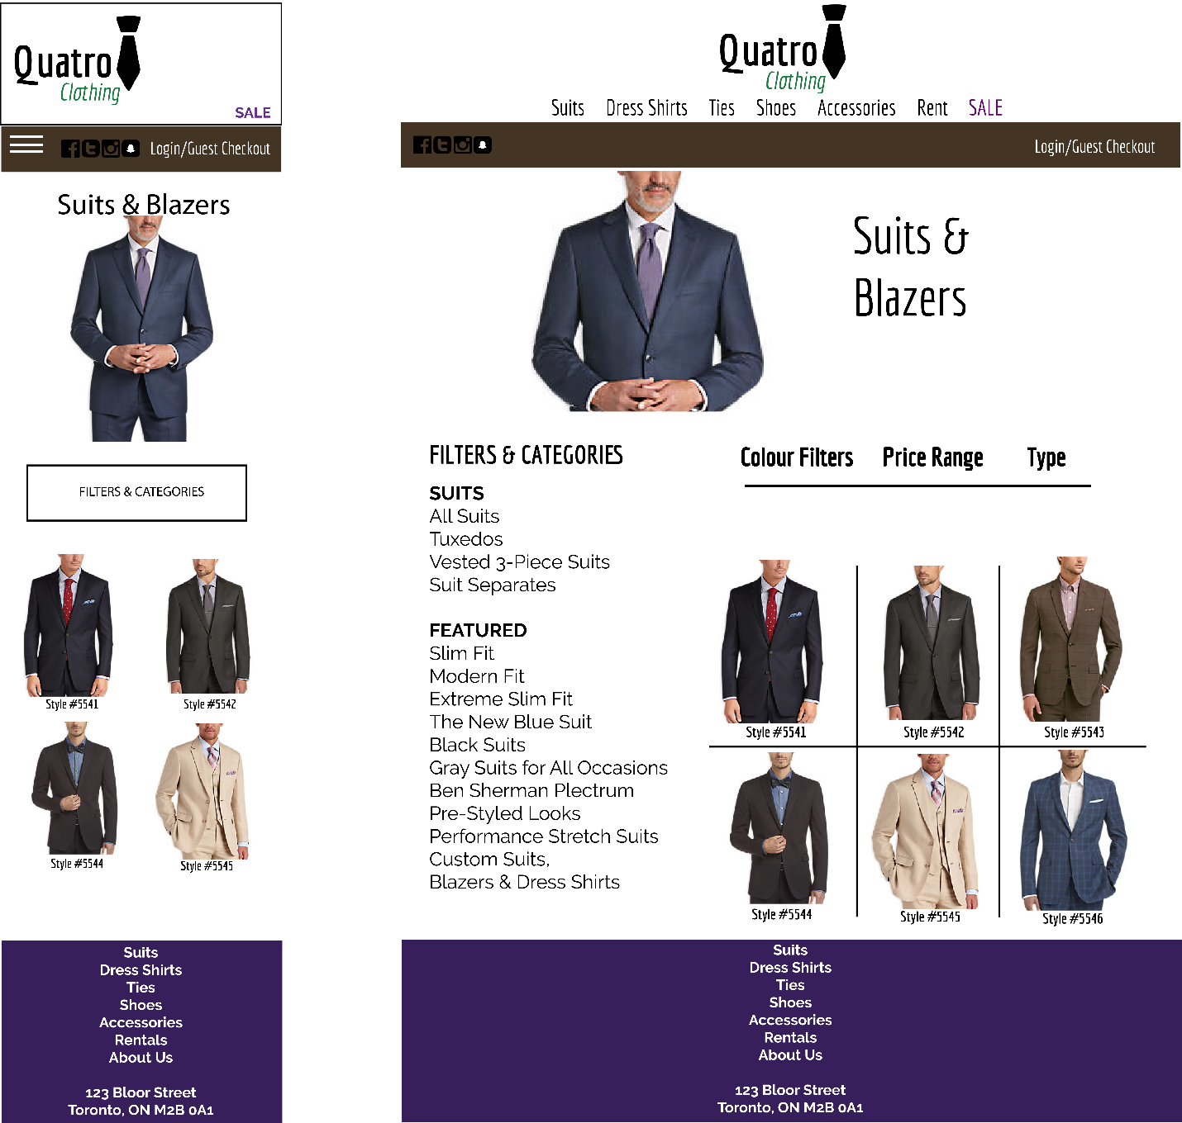

**Final Webpages Design**

**Individual Product Page**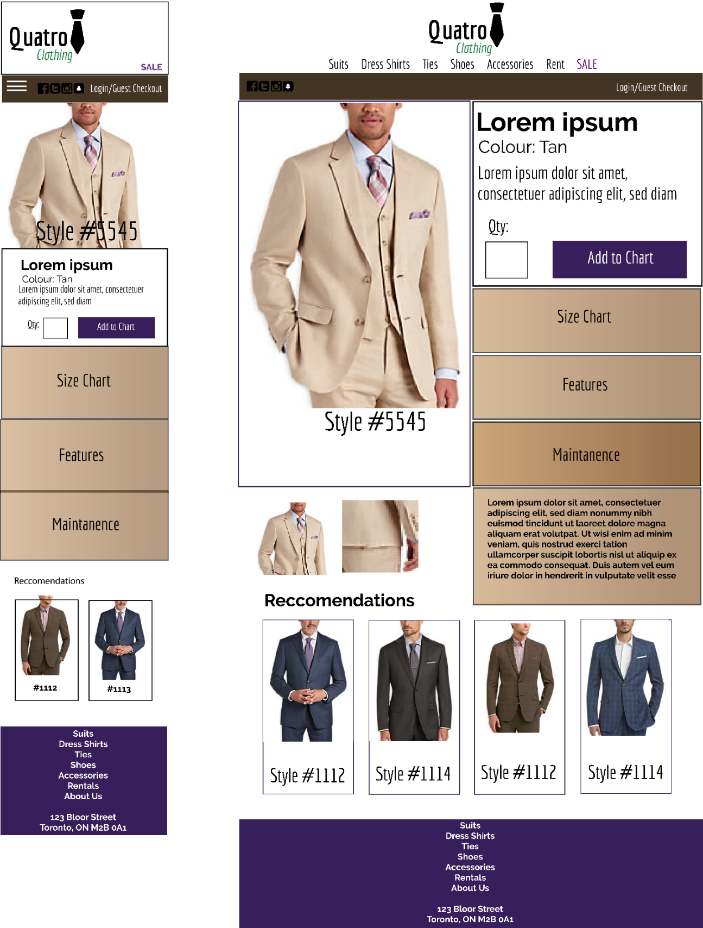

**Elements & Features in Webpages**

****Carousel Slider – jQuery

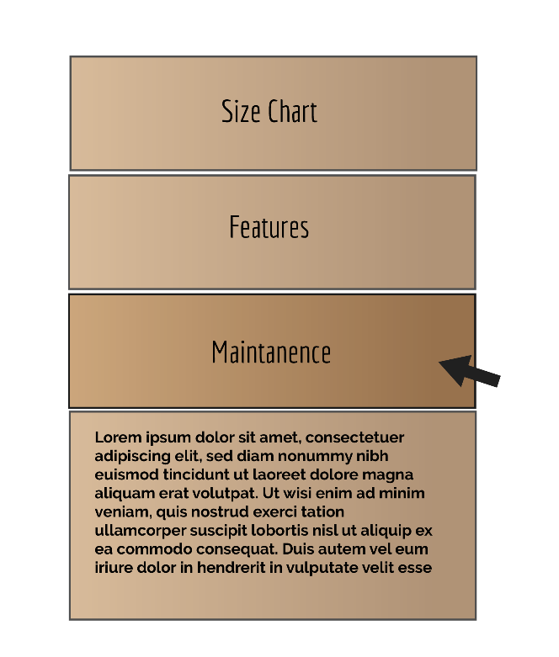Hover changes – CSS3 Animations

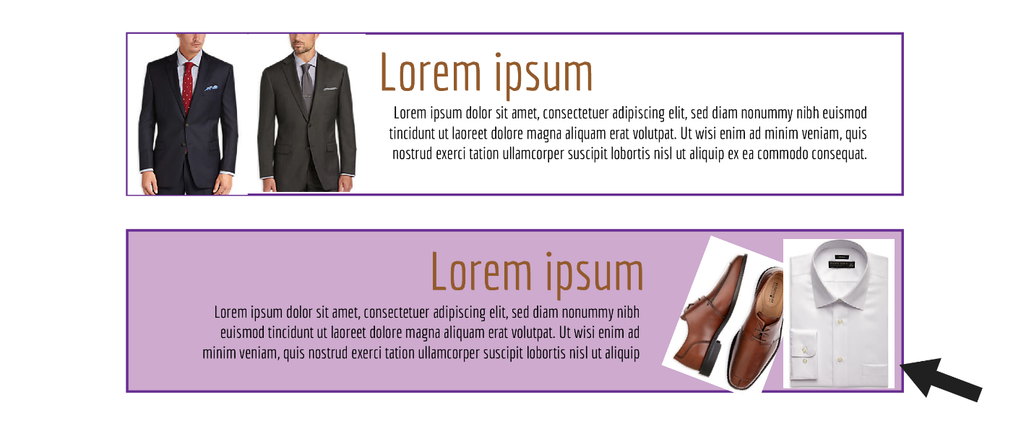

**Style Guide Composition**

**Company:** Quarto (Menswear)

**Commerce Type:** Men’s Suits and Formal Retailer

**Target:** Men ages 30+

**Colour Pallette**

**Keeping the colours similar to the original, and still classic to menswear.**



**Hex Codes**

**Typography**

**Typefaces used**

**Example of Economica Typeface**

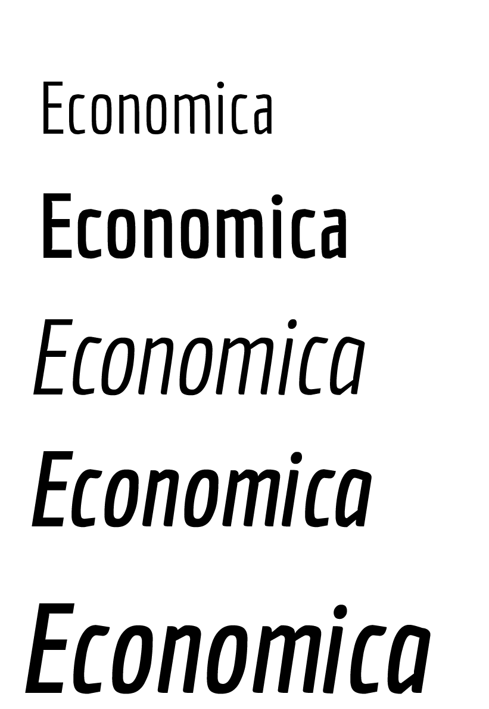Raleway

Economica

Times New Roman

**Fonts**

Raleway 14pt Regular

**Raleway 14pt Bold**

Economica 14pt Regular

**Economica 14pt Bold**

Times New Roman 14pt Regular

**Times New Roman 14pt Bold**

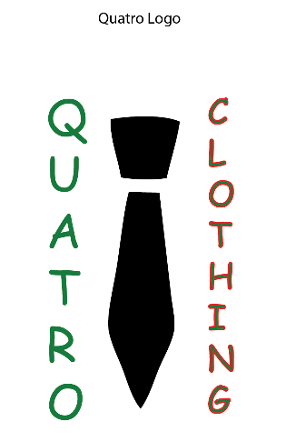**Logo**

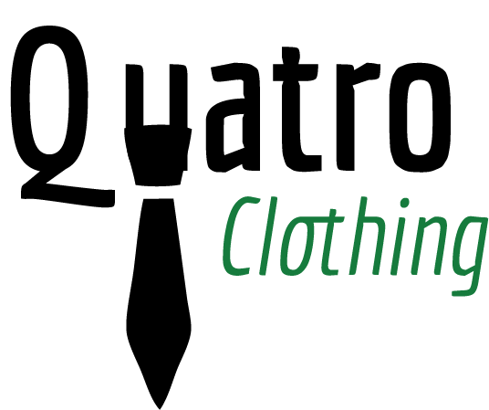Logos (variations)



**Final**

