**Style Guide Composition**

**Company:** Quarto (Menswear)

**Commerce Type:** Men’s Suits and Formal Retailer

**Target:** Men ages 30+

**Colour Pallette**

**Keeping the colours similar to the original, and still classic to menswear.**



**Hex Codes**

**Typography**

**Typefaces used**

**Example of Economica Typeface**

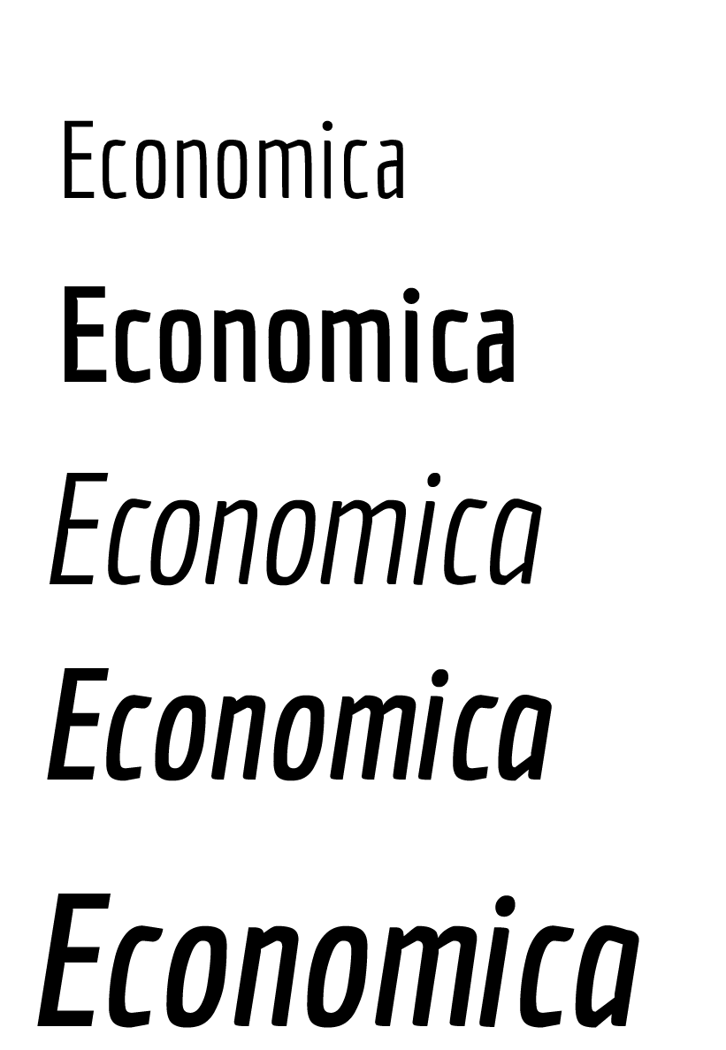Raleway

Economica

Times New Roman

**Fonts**

Raleway 14pt Regular

**Raleway 14pt Bold**

Economica 14pt Regular

**Economica 14pt Bold**

Times New Roman 14pt Regular

**Times New Roman 14pt Bold**

**Logo**

Old Logos (variations)



**Final**

