Student Name: Gabriel Solomon

Course: CIS123 Programming in Lava53

Date: 8/3/2120

# UML Class Diagram

Students should delete this UML example. Students should then copy/paste their own UML class diagram image into Microsoft Word. This is an image.

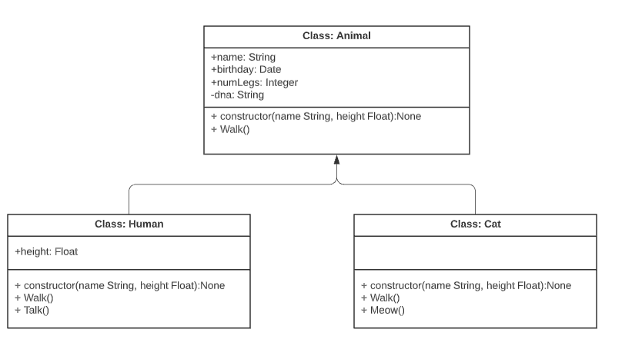

# Code

Students should delete this example code. Students should then copy/paste their own code from VS Code into Microsoft Word. This is NOT a screen capture image.

*/\**

*To compile: javac HelloWorld.java*

*To run: java HelloWorld*

*\*/*

*// declares a class hello world*

public class HelloWorld {

*// "main" makes this class a java app that can be executed*

    public static *void* main(final *String*[] args) {

*// output hello world to the system's output device*

        System.out.println("Hello world");

    }

}

# Demo Video of software running

* Students should delete this youtube link. Students should then copy/paste the unlisted and accessible youtube demo video of their software running here.
* Unlisted YouTube Video demo of your software running.
* Test your video for accessibility (that I can access it) prior to submission by asking someone you know to click on the link to test it or by using Chrome’s Incognito feature.

<https://youtube.com/watch?v=2uCXIbkbDSEkjk23k3>

# Image of GitHub Desktop History of Commits

Students should delete this image of GitHub Desktop History. Students should then copy/paste the screen capture image of their GitHub Desktop History here. This is a screen capture image.

