Lesson L-003
Print your first line with echo
Module M01: First Contact with the Terminal · Domain D01: Command Line & Environment Fluency · Week 1 · Day 3 · 13 minutes

LinkedIn post (copy-paste ready)
The first time I typed a command into a terminal, I sat there for a second waiting to see if I had broken something. Then a line printed, the prompt came back, and I realised the machine was answering me. That’s the whole feeling.
This is Day 3 of a 171-lesson path I am taking publicly, from zero to a Principal Artificial Intelligence (AI) Architect role. Week one is the command line. Today is your first actual command: you type a line, the terminal types one back. Ten minutes, zero risk, zero files changed.
The analogy I use is a doorbell. You press once, it sounds once, and you know it worked because you heard it. That is exactly what the terminal does on the first command anyone learns. The word is echo. Press it like a doorbell.

The five exchanges in this lesson
Every one of these is one line at the prompt, then Enter. The terminal prints a response and returns you to a fresh prompt, ready for the next one.
- echo Hello, world prints Hello, world.
- echo "Hello, world" prints the same thing, but with double quotes the shell treats everything inside as one argument.
- echo 'Hello, world' prints the same thing again, but single quotes protect the text from every form of shell interpretation. That will matter later when the text contains a dollar sign.
- echo on its own prints a blank line. A small proof that the command ran.
- echo $USER prints your own username, because the shell replaced $USER with its value before echo ever saw the line.
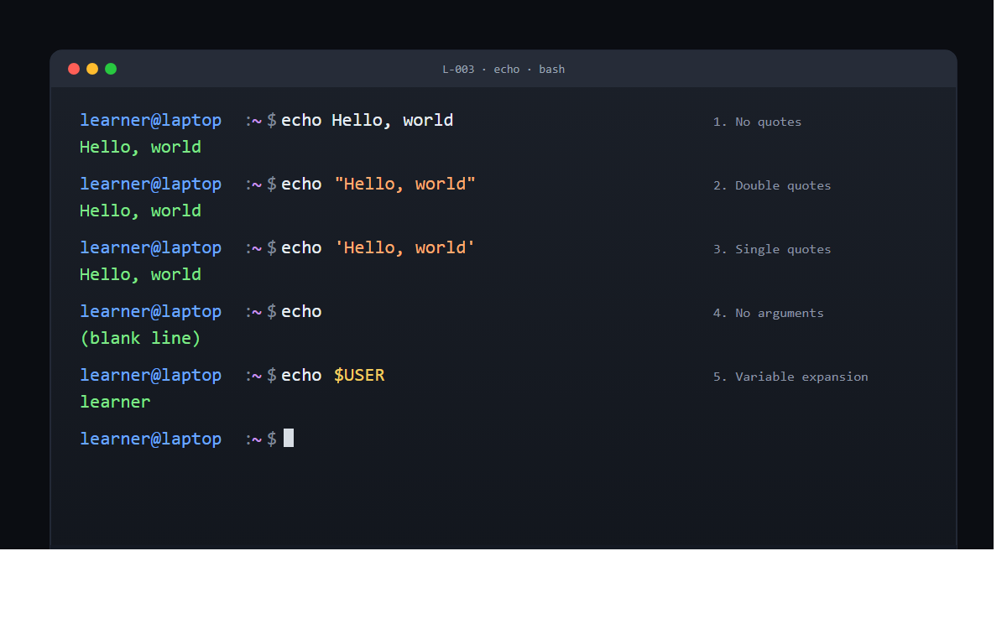
What’s actually happening behind the curtain
Echo is the simplest command in the Command-Line Interface (CLI). Its job is to print its arguments to the screen, joined by single spaces, followed by a newline. That is the whole of it.
The interesting work happened before echo was called. The shell, the program that reads your keystrokes, did two things to your line first. It split the line into tokens using whitespace as the separator. Then, when it saw $USER, it looked up the value of the variable and replaced the token with that value. Only after that did it hand the list of tokens to echo and ask echo to print them.
That two-step process explains the three small surprises in the exercise above.
No-quotes and double-quotes look identical because the whitespace inside Hello, and world lands in the same place either way. Single quotes would have mattered if you had written echo '$USER' (which prints the literal string $USER) compared with echo "$USER" (which prints your username). The no-arguments case printed a blank line because echo still emits the trailing newline even when it has nothing else to say.
Why this is the whole atom of the terminal
Argument in, result out, prompt back, ready for the next one. That is the command-response rhythm, and it is the full pattern of every interaction you will ever have at a command line. Python will feel like this. Git will feel like this. Terraform, the Azure CLI, the AWS CLI, every tool a principal architect uses in a normal working day will feel like this. The answers get more interesting as the curriculum goes on, but the rhythm does not change.
That is also why echo is the first real command in this path. It strips the rhythm down to its bare atoms. You type, it types back. Nothing is installed, nothing is created, nothing can break. The only thing you are training is the reflex of writing a line, pressing Enter, and reading what appears.
Two quick experiments before you move on
Try these two with your own terminal, while you have it open:
echo $HOME
echo $SHELL
$HOME prints the absolute path of your home folder. $SHELL prints the path of the shell program reading the commands (probably /bin/zsh on macOS or /bin/bash on most Linux). Both are set automatically when you log in. Both will reappear in later lessons about environment variables and filesystem navigation.
One more, a little denser:
echo "My user is $USER and my shell is $SHELL"
The shell expanded both variables inside the double-quoted string and handed echo a finished sentence. Same mechanism as before, used more densely.
The verification
If echo Hello, world printed Hello, world on the next line and returned you a prompt, the lesson is done. Three times over, counting the quoted variants. If it produced command not found, you typed a letter wrong. If it printed quote marks in the output, your quotes were curly smart-quotes from a word processor, not straight quotes from the keyboard.
Ten minutes. One word. The first real command in the curriculum, and the whole pattern of every command after it.
Full lesson on GitHub
Try it and tell me what your echo $SHELL printed. That will tell us which flavour of command line you are on, and which week-two lesson to read closely.
#LearnToCode #AIArchitect #SolutionsArchitecture #TerminalBasics #HealthcareAI

GitHub article (full lesson)
Ringing a doorbell is the simplest form of talking to a machine. You press once, it sounds once, and you know it worked because you heard it. The terminal waiting in front of you works the same way. You type one line, press Enter, and it types back whatever you asked for. That is the entire Command-Line Interface (CLI) in one gesture, and every other lesson in this curriculum is a variation on it. Your first word is echo. Press it like a doorbell.


What you will do
Type echo Hello, world, press Enter, and watch the terminal print the same text back on the next line.

Before you start
You need an open terminal window from L-002: Read a prompt like a sign at a train station, sitting at its default prompt. If you closed it, open a new one. Nothing else is required. No files will be created, nothing will be downloaded, and no settings will change. Echo is read-only: it prints to the screen and returns you to the prompt.
If your prompt ends in $ (Bash on Linux, Windows Subsystem for Linux), % (Zsh on macOS), or > (PowerShell on Windows), you are in the right place. Every command below works identically on all three.

Step by step
Each step is one line typed at the prompt, followed by pressing Enter. You do not need to type the prompt itself; only the characters after it.

1. The plain form
Type:
echo Hello, world
You will see:
Hello, world
The prompt returns on the line below, ready for the next command.

2. With double quotes
Type:
echo "Hello, world"
You will see the same line:
Hello, world
The output looks identical, but what happened inside the shell is different. The quotes told the shell to treat everything between them as one argument instead of splitting on whitespace. That distinction will matter in later lessons when the text contains a dollar sign, a backtick, or other characters the shell cares about.

3. With single quotes
Type:
echo 'Hello, world'
You will see:
Hello, world
Same output, stricter rule. Single quotes protect the text from every form of shell interpretation. Whatever is between them is sent to echo verbatim.

4. With no arguments
Type:
echo
You will see a blank line, then the prompt back. Echo with nothing to print still prints a newline. It is a small proof that the command ran.

5. With a variable
Type:
echo $USER
You will see your own username printed on the next line. On PowerShell, use echo $env:USERNAME instead. In both cases the shell looked up the value of the variable before echo ever saw it, and handed echo the result as a plain argument.


Check it worked
After step 1, the exact text Hello, world should appear on the line directly below your command. The prompt should return on the line after that, blinking cursor and all. If you see a message like command not found: ech or 'echo' is not recognized, you typed a letter wrong. Retype and try again.
If you see literal quote marks in the output ("Hello, world" or 'Hello, world'), the quote characters came from a word processor that swapped straight quotes for curly ones when you pasted. Type the line directly in the terminal instead of pasting from a document.
If steps 1, 2, and 3 each produced the exact string Hello, world on the next line, and step 5 produced your own username, the lesson is done. You have executed a command, confirmed its output, and returned the terminal to a ready state. Three times over.

What just happened
Echo is a built-in command whose job is to print its arguments to the screen, joined by single spaces, followed by a newline. That is the whole of it. The interesting work happened before echo was called.
The shell, the program that reads your keystrokes, did two things to your line before echo saw anything. First, it split the line into tokens using whitespace as the separator, so echo Hello, world became three tokens: echo, Hello,, and world. Second, when it saw $USER, it expanded the variable to its current value and replaced the token with that value. Only after that did it hand the list of tokens to echo and ask echo to print them.
That two-step process explains the three small surprises in the exercise. No-quotes and double-quotes look identical because the whitespace inside Hello, and world lands in the same place either way. Single quotes would have mattered if you had written echo '$USER' (which prints the literal string $USER) compared with echo "$USER" (which prints your username). The no-arguments case printed a blank line because echo still emits the trailing newline even when it has nothing else to say.
The CLI rhythm you just felt is the atom of every interaction in this curriculum. Argument in, result out, prompt back, ready for the next one. Python will feel like this. Git will feel like this. Terraform will feel like this. The answers get more interesting, but the rhythm does not change.

Going further
Try two more variables your shell already knows about:
echo $HOME
echo $SHELL
$HOME prints the absolute path of your home directory. $SHELL prints the path of the shell program reading these commands (for example, /bin/zsh or /bin/bash). Both are set automatically when you log in, and both will reappear in lessons on environment variables and on navigating the filesystem.
For one more small experiment, run:
echo "My user is $USER and my shell is $SHELL"
Notice how the shell expanded both variables inside the double-quoted string and handed echo the finished sentence. That is the same mechanism you just saw, used more densely.

What's next
Next is L-004: Find out where you are with pwd, where the command-response rhythm produces a more useful answer: the absolute path of the folder your terminal is standing in.

