Lesson L-005
List the contents of a directory with ls
Module M01: First Contact with the Terminal · Domain D01: Command Line & Environment Fluency

LinkedIn post (copy-paste ready)

The terminal has exactly two commands for the question every beginner actually asks in their first ten minutes: where am I, and what is here? Yesterday I showed the first one, pwd. Today is the second one, ls, and it is the command I still type the most on any given day of real work.
This is Day 5 of a 171-lesson path I am taking publicly, from zero to a Principal Artificial Intelligence (AI) Architect role. Week one is the command line. Today is the "what is here?" command. Thirteen minutes, zero risk, zero files changed.
The analogy I use is a file cabinet drawer. A drawer sits closed most of the time, holding its contents out of sight. Pulling the drawer open is the cheapest gesture in the room: no paper is read, no folder is removed, you are just looking at what is in there before you reach for anything. Your terminal's drawer-open gesture is ls, two letters short for list.

What ls actually does
ls with no arguments prints the list of names in the current working directory, the same directory pwd would return. By default it shows visible entries only, in columns, names only. No sizes, no owners, no dates.
What ls -la actually does
Add the -l flag and the output becomes a table: one row per entry, with permissions, link count, owner, group, size in bytes, modification time, and finally the name. Add the -a flag and the table also includes entries whose names start with a dot (dotfiles), plus two entries named . and ... Those two are not decorations. . is the directory itself; .. is its parent. Every directory on every mainstream operating system has both.
The one character that tells you the whole story
The first character of each long-format row is the type of the entry. d means "directory"; you can step into it and list further. - means "regular file"; it has content inside it and no children below it. That is the answer to "what is the difference between a file and a folder?" at the command line, and it is the thing that took me the longest to notice on my own when I started.
drwxr-xr-x 12 learner learner 4096 Apr 18 10:15 .
-rw-r--r-- 1 learner learner 3771 Apr 10 14:22 .bashrc
The first row is a directory. The second is a file. The rest of the row is the same shape; only the leading letter is different.
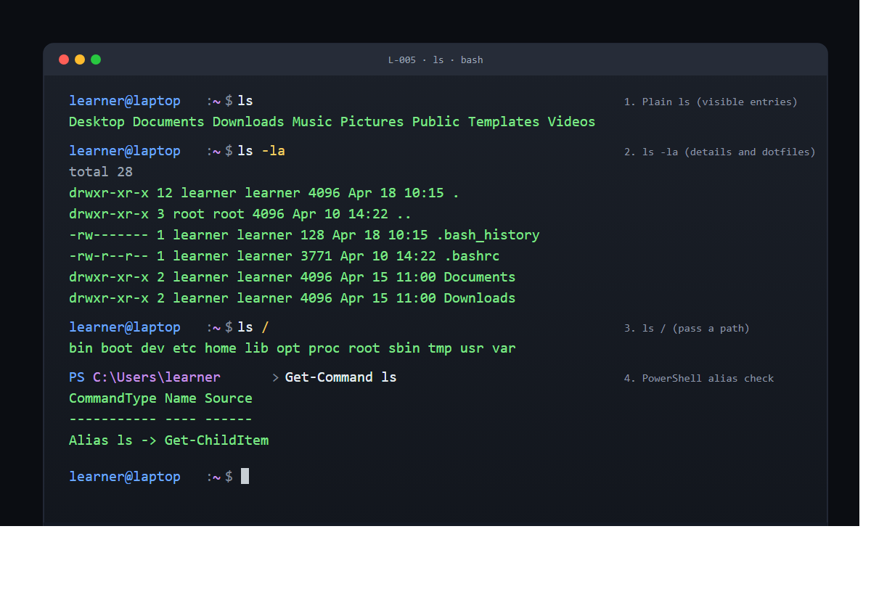
Same command, different target
ls takes an argument: the path of the directory to list. ls / on macOS or Linux lists the root of the filesystem. ls C:\ on Windows PowerShell does the same. You did not have to move anywhere first; you just asked the question about somewhere else.
This is a pattern you will see on every command-line tool in the rest of the curriculum. Most commands have a default target (the current directory, the current file, the current branch, the current project) and accept an explicit one when you want it. Learning to notice the default, and to override it when needed, is a lot of what "getting fluent at the command line" actually means.
The PowerShell detail
On Windows PowerShell, ls is not a separate program. Get-Command ls will tell you it is an alias for Get-ChildItem, which is the native PowerShell way to list a directory. dir is another alias for the same command. Same rhythm, same answer, slightly different column headers in the output.
This is a second pattern worth naming early. A command that works "everywhere" usually works because either the tool was ported (true for Git, Python, Node) or a wrapper aliases the native command to the Unix name you already know (true for PowerShell's ls, cd, pwd, and about a dozen others). Both matter; they surface in different ways.
Why pwd plus ls is the first pair every troubleshooting guide teaches
pwd tells you where you are. ls tells you what is around you. Together they are the standing orientation: the address plus the inventory. Every other question a shell can answer, from "can I read this file?" to "is this the right branch?", starts from one or both of them.
That is why, if you open any help forum for any tool that runs on a command line, the first question the helper asks is some form of "what does pwd say, and what does ls show?" They are not being pedantic; they are making you confirm the two facts that every subsequent answer depends on.
The verification
If ls printed a short list of names with no error, and ls -la printed a block of rows where each row started with either d or - followed by nine more permission characters, the lesson is done. If you saw command not found or 'ls' is not recognized, you typed it wrong; it is two letters.
Thirteen minutes. Two commands. Two questions answered. The rest of the week is about moving through the directories those two questions introduced.
Full lesson with the PowerShell alias check and the options for reading sizes in human units: https://github.com/AriesEmber/Principal-AI-Architect-Curriculum/blob/main/modules/M01-first-contact-with-the-terminal/lessons/L-005-list-the-contents-of-a-directory-with-ls.md
Try it and tell me what ls -la showed in your home directory. The shape of the dotfile list tells us which operating system you are working on.
#LearnToCode #AIArchitect #SolutionsArchitecture #TerminalBasics #HealthcareAI

· · ·

GitHub article (full lesson)

Every office has a file cabinet with drawers. A drawer sits closed most of the time, holding its contents out of sight. Pulling the drawer open is the cheapest gesture in the room: no paper is read, no folder is removed, you are just looking at what is in there before you reach for anything. Your terminal has the same gesture. It is a two-letter command called ls, short for list, and it is how a Command-Line Interface (CLI) learner answers the sibling question to "where am I?": what is in here with me. You are about to open the drawer.


What you will do
Type ls, see the names of everything in the current folder, then type ls -la to see the same list with every detail the shell can print about each entry.

Before you start
You need an open terminal from L-004: Find out where you are with pwd, sitting at its default home-directory prompt. If you are not sure where you are, run pwd first and confirm it returns your home path. Nothing will be created, nothing will be deleted, no settings will change. ls is another read-only question.
If your prompt ends in $ (Bash on Linux or Windows Subsystem for Linux), % (Zsh on macOS), or > (PowerShell on Windows), every command below works identically.

Step by step

1. Ask what is here
Type:
ls
You will see a short list of names, either spread across the window in columns or one per line if the window is narrow. On a fresh home directory the names are almost always the top-level folders the operating system (OS) created for you.
Desktop Documents Downloads Music Pictures Public Templates Videos
You did not tell ls where to look, so it used the working directory, which is what pwd would return: your home folder.

2. Ask for every detail
Type:
ls -la
The output grows in two directions. The rows now include entries whose names start with ., which the plain ls hid from you. And each row is a full tabular record:
total 28
drwxr-xr-x 12 learner learner 4096 Apr 18 10:15 .
drwxr-xr-x 3 root root 4096 Apr 10 14:22 ..
-rw------- 1 learner learner 128 Apr 18 10:15 .bash_history
-rw-r--r-- 1 learner learner 3771 Apr 10 14:22 .bashrc
drwxr-xr-x 2 learner learner 4096 Apr 15 11:00 Documents
drwxr-xr-x 2 learner learner 4096 Apr 15 11:00 Downloads
Read across each row and you get, in order: a permissions string, a link count, an owner, a group, a size in bytes, a modification date and time, and finally the name.
The two entries named . and .. are not decoration. Every directory on every mainstream operating system has them. . is the directory itself; .. is its parent. They are the reason cd .. works in the next lesson, and you have already met them here.

3. Tell ls to look somewhere else
ls takes an argument: the path of the directory to list. Try the root of the filesystem.
On macOS or Linux:
ls /
bin boot dev etc home lib opt proc root sbin tmp usr var
On Windows PowerShell:
ls C:\
Same command-response rhythm, same idea, different target. You did not leave the home directory; you asked ls to report on somewhere else.

4. Optional: see the PowerShell alias
On Windows PowerShell, ls is not a separate program. It is an alias for Get-ChildItem.
Get-Command ls
CommandType Name Source
----------- ---- ------
Alias ls -> Get-ChildItem
dir is also an alias for the same command. The column format of the output is slightly different from the bash version (PowerShell shows Mode, LastWriteTime, Length, Name), but the question being asked is identical.


Check it worked
After step 1, you should see a single row (or a short stack of rows) of folder names with no error. After step 2, you should see a header row total N and a block of rows with ten characters in the first column of each. If the first character is d, that entry is a folder. If it is -, that entry is a file.
If you see command not found: ls or 'ls' is not recognized, you typed it wrong. It is two letters: l and s.
If the output of step 2 looks different from the example but has the same shape (ten-character permission field, size, date, name), you are on a Linux or macOS system and everything is working. If the output uses column headers like Mode and LastWriteTime, you are on PowerShell and everything is also working.
If ls -la returned no rows at all, not even . and .., the directory you were in was deleted from under the shell while you were reading. Close the window and open a new one; it will land back in your home directory.

What just happened
ls prints the list of names the directory holds. By default it skips entries whose names start with a dot and it prints only the names, in columns, without any trailing details. That default is tuned for the most common use of ls, which is a quick glance at what is visible in the current folder.
The flags change the shape of the report without changing the question. -a says "include every entry, even the hidden ones." -l says "give me the long form, one row per entry, with permissions, owner, size, date, and name." You can combine them as -la, which is what most people run in practice.
Knowing the long form matters because it is how you answer the question the spine set up at the top of this lesson: what is the difference between a file and a folder? The answer is the very first character of each long-format row. d is a directory you can step into (with the command you will learn next) and list further. - is a regular file with content inside it and no children below it. That is the whole distinction, at the shell level.
ls is also the answer to the question "what is around me?" which is the sibling of "where am I?" from the previous lesson. pwd returns the address; ls returns the inventory. Together they give you complete situational awareness of a directory before you do anything else in it.

Going further
Try ls on a directory you have never stood in. On macOS or Linux:
ls /etc
/etc is where most system programs store their configuration files. The output is long; that is by design, because this is where the operating system keeps its settings.
On Windows PowerShell:
ls C:\Windows
Pass -la on the same directory and look at the permission columns. You will see that not every entry on the system is owned by your user account, and some entries are not readable by you at all. That is a preview of the permissions model you will meet in module two.
One small quality-of-life flag for later: on macOS or Linux, ls -lh prints sizes in kilobytes, megabytes, and gigabytes instead of raw bytes. Experienced users turn it on by default.

What's next
Next is L-006: Move around with cd and relative paths. Now that you know where you stand and what is around you, it is time to actually move.

