L-006: Move around with cd and relative paths
Module M01: First contact with the terminal · Week 1, Day 6 · 13-minute lesson · terminal_auto capture mode

LinkedIn post
The first time I tried to move between folders from a terminal, I typed the full path to a folder that was right next to me. It worked, and it also took twice as long as it should have. Then someone showed me `cd Documents`, with no slash and no full path, and I realized the shell had a whole second mode I had been ignoring.
This is Day 6 of a 171-lesson path I am taking publicly, from zero to a Principal Artificial Intelligence (AI) Architect role. Week one is the command line. Today is how the shell walks, and why every command you will ever run on a command line takes one of two kinds of address.
The analogy I use is a house. If someone in the hallway asks where the kitchen is, you say "go to the kitchen." If the same person calls from across town, you have to say "go to 123 Main Street, then the kitchen." Same destination, different starting point, different directions. The terminal works the same way, and the command for walking is `cd`, short for change directory (CD).

Relative paths start where you stand
Type `cd Documents` and the shell walks into the `Documents` folder inside the current directory. The name `Documents` has no leading slash, so the shell interprets it starting from wherever `pwd` would return. That is what "relative" means: the starting point is here.
$ pwd
/home/learner
$ cd Documents
$ pwd
/home/learner/Documents
Every command that takes a filename works the same way. When you open a file in an editor, pass a file to a script, or run a program with an input argument, the shell interprets the name relative to the current directory unless you tell it otherwise.
Two dots walk you back up
`cd ..` walks up one level. The two dots are a special entry that exists inside every directory on Linux, macOS, and Windows. You actually already met them: when you ran `ls -la` in the previous lesson, the first two rows of the output were `.` (this directory) and `..` (the parent). The shell is not doing anything magic with `cd ..`; it is reading the same `..` entry the long-form `ls` showed you.
Absolute paths start at the front door
Type `cd /` on macOS or Linux, or `cd C:\` on Windows PowerShell, and the shell stops caring where you were standing. The leading slash (or drive letter) is the signal that flips the path from "starting here" to "starting at the filesystem root."
$ cd /
$ pwd
/
Relative paths are for short moves. Absolute paths are for jumps across the system, or for anything that needs to work the same way from any starting directory. Every production script you will ever read uses absolute paths for files that matter, for exactly this reason.
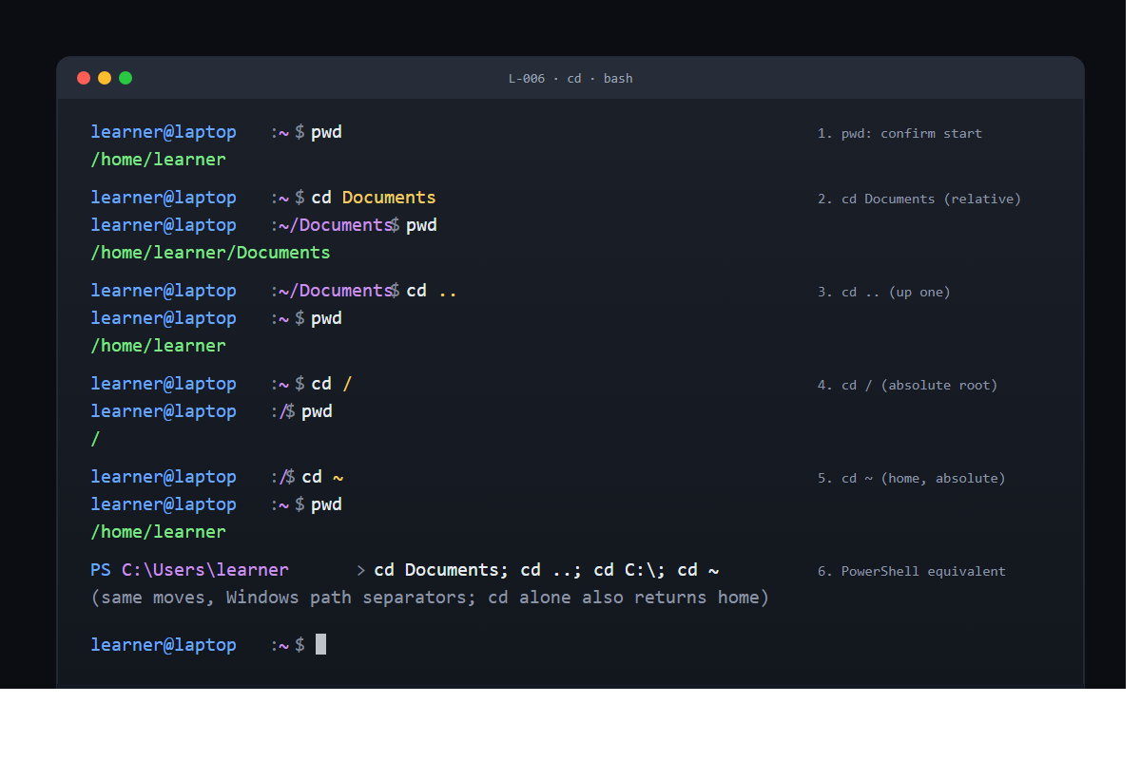
The three shortcuts worth memorizing today
- `.` is this directory. - `..` is the parent directory. - `~` is your home directory.
All three work inside `cd` and inside almost every other command on a command line. `cd ~` gets you home from anywhere, and so does `cd` with no argument at all. That alone is worth the lesson: no matter how lost you feel in the shell, one keystroke puts you back at a known starting point.
Windows PowerShell uses the same words
On Windows PowerShell, `cd` is an alias for `Set-Location`, and every move in this lesson works with the Windows path separator. `cd Documents`, `cd ..`, `cd C:\`, and `cd ~` all land in the expected place. The operating system (OS) difference is cosmetic: the shell's walking vocabulary is the same.
Why this is the lesson that changes the shell from intimidating to navigable
Until you know the two kinds of path, every new folder feels like a puzzle. Once you know it, the shell becomes a map you can walk around in. Most of the "this tool is hard" feeling that new Command-Line Interface (CLI) users describe is this one trick undiscovered. Relative for short moves, absolute for long ones. Two rules, covers everything.
The verification
If `pwd` reported a different path after each `cd`, and you got home again with `cd ~` or `cd` alone, the lesson is done. If `pwd` did not change, `cd` silently failed, almost always because of a typo or a case mismatch (macOS and Linux are case-sensitive; Windows is not). Run `ls` first, confirm the name exists in the list, try again.
Thirteen minutes. One command, two kinds of path, three shortcuts. Tomorrow's capstone builds on all of them to make and remove a folder of your own.
Full lesson with the `cd -` extension and the Windows PowerShell details: https://github.com/AriesEmber/Principal-AI-Architect-Curriculum/blob/main/modules/M01-first-contact-with-the-terminal/lessons/L-006-move-around-with-cd-and-relative-paths.md
Try it and tell me how many times you had to hit the "emergency brake" (`cd` with no argument) on your first pass. For most of us it is more than zero.
#LearnToCode #AIArchitect #SolutionsArchitecture #TerminalBasics #HealthcareAI

GitHub article (canonical)
Picture yourself standing in the hallway of a house. Someone asks where the kitchen is and you say, "go to the kitchen." That answer works because you are both already inside the house. If the same person calls you from across town, the answer has to change. Now you have to say, "go to 123 Main Street, then to the kitchen." Same destination, different starting point, different directions. Your terminal works the same way. When you say "go to Documents," the Command-Line Interface (CLI) uses your current directory as the starting point. When you say "go to the root of the disk," you give the full address from the front door of the operating system (OS). You are about to give your terminal both kinds of directions, with a two-letter command called `cd`, short for change directory (CD).


What you will do
Run `cd` three times, once with a relative path (`cd Documents`), once to walk back up (`cd ..`), and once with an absolute path (`cd /` on macOS or Linux, `cd C:\` on Windows), confirming each move with `pwd`.

Before you start
You need an open terminal from [L-004: Find out where you are with pwd](./L-004-find-out-where-you-are-with-pwd.md), with the prompt at your home directory. Run `pwd` first and confirm it returns your home path before you move. You also need the `ls` command from [L-005: List the contents of a directory with ls](./L-005-list-the-contents-of-a-directory-with-ls.md) so you know a `Documents` folder exists to walk into. If `ls` does not show a `Documents` folder, substitute any other folder name you see in the list.
Nothing will be created, nothing will be deleted, no settings will change. `cd` rearranges where the shell is standing; it does not touch any file.

Step by step

1. Confirm where you stand
Type:
pwd
You should see your home path, something like `/home/learner` on Linux, `/Users/learner` on macOS, or `C:\Users\learner` on Windows. This is the starting point for every path in this lesson.

2. Walk into a subdirectory with a relative path
Type:
cd Documents
The shell says nothing. That silence is normal: `cd` is quiet on success and only speaks when something goes wrong. Check that the move happened by asking `pwd` again.
pwd
/home/learner/Documents
The path has grown by one segment. You did not tell `cd` where home was; the shell used where you were standing as the starting point. That is what "relative" means: relative to here.

3. Walk back up one level
Type:
cd ..
The two dots are a special entry that exists inside every directory on every mainstream OS. You saw `..` yourself when you ran `ls -la` in the previous lesson. It points at the directory's parent. Use `pwd` to confirm the walk.
pwd
/home/learner
You are back where you started. `..` is still a relative path; it just happens to always point at one specific place.

4. Jump to an absolute location
Type, on macOS or Linux:
cd /
Or on Windows PowerShell:
cd C:\
The leading slash (or the drive letter) is the signal that flips the shell from "starting here" to "starting at the root of the filesystem." Check it:
pwd
/
You have jumped all the way to the top of the disk. Nothing about where you were before matters; an absolute path names the destination from the front door.

5. Return home
Type:
cd ~
The tilde is shorthand that every modern shell expands to your home directory. You can also type `cd` with no argument at all and land in the same place.
pwd
/home/learner
You are home again, having walked there with an absolute path. That is five moves, three flavors of path, one command.


Check it worked
After each `cd`, `pwd` should report a new path. If `pwd` does not change, the `cd` silently failed, which usually means a typo in the folder name. The shell is case-sensitive on macOS and Linux: `cd documents` is not the same as `cd Documents`. On Windows it is case-insensitive, so both will work there.
If you see `cd: no such file or directory: Documents`, the folder you named does not exist in the current directory. Run `ls` first, pick a name you actually see in the list, and try again.
If you get stuck in an unfamiliar directory, type `cd` with no argument and press enter. The shell puts you back in your home directory no matter where you were. That is the emergency brake for this lesson.

What just happened
A path is the name of a location on the disk. Every path is interpreted one of two ways:
- Relative. Starts without a leading slash, like `Documents` or `..`. The shell uses your current working directory (the one `pwd` returns) as the starting point and walks from there. - Absolute. Starts with `/` on macOS and Linux, or with a drive letter like `C:\` on Windows. The shell ignores where you are standing and walks from the filesystem root.
`cd` is the verb that takes a path, of either kind, and changes the shell's current working directory to match. That change is why the prompt in the animation above shifts from `~` to `~/Documents` to `/` and back: the prompt is showing you the new `pwd` after each successful move, which is how most shells are configured out of the box.
There is one more piece to notice. The special names `.` (this directory), `..` (parent directory), and `~` (home directory) are the three shortcuts every professional relies on in daily work. `.` matters less for `cd` (running `cd .` does nothing useful) but shows up constantly with other commands. `..` is the way you walk up. `~` is the way you go home from anywhere. Memorize those three and most of the shell's movement vocabulary is already in your hands.

Going further
The shell remembers the directory you were in before the most recent `cd`. You can jump back to it with `cd -`.
cd Documents
cd -
/home/learner
The shell prints the destination, which is a quiet confirmation that the jump worked. This is how experienced users bounce between two working directories without retyping their full paths. `cd -` is supported on bash, zsh, and PowerShell version 6 or later. If you are on an older Windows PowerShell, it will not recognize the dash; just type the full path instead.

What's next
Next is [L-007: Make and remove directories (capstone)](./L-007-make-and-remove-directories-capstone.md). Now that you can stand somewhere (`pwd`), look around (`ls`), and walk (`cd`), you have every skill you need to build your first folder of your own.

