L-007 · Make and remove directories (capstone)
Module M01 · First contact with the terminal · Week 1 capstone

LINKEDIN POST (copy-paste to LinkedIn)
The first folder I ever created from a terminal sat on my desktop untouched for a week because I did not know how to delete it. I could make things; I could not unmake them. The rm -r command was two keystrokes away the whole time, but nobody had told me. The fix is a 90-second lesson that everybody skips and everybody needs.
This is Day 7 of a 171-lesson path I am taking publicly, from zero to a Principal Artificial Intelligence (AI) Architect role. Today is the week-one capstone. Six commands, one round trip: make a directory, put a file in it, take the whole thing back down.
The analogy I use is a filing cabinet. Slide it in. Pull the drawer. Drop a note. Push it back. Shred the whole thing when the project is over. The terminal has one verb for each of those motions, and by the end of today you will know them all.

Animated typewriter walkthrough of the ten-exchange capstone
The six commands in one flow
pwd
mkdir practice-cli
ls
cd practice-cli
ls
touch hello.txt
ls
cd ..
rm -r practice-cli

Nine lines, ten seconds of typing, and you have built and destroyed a complete project folder. Every real codebase, every cloud deployment, every Machine Learning (ML) experiment you will ever run starts with this exact sequence.
`mkdir` makes a directory
mkdir is short for "make directory." The name after it is the folder you are creating, and because the name has no leading slash the shell creates it inside the current directory. It is silent on success, loud on failure. If you see no output, the folder was made.
`touch` makes an empty file
touch was originally designed to update a file's last-modified timestamp. Its useful side effect is that if the file does not exist, touch creates it, empty. Every professional I know uses touch as the one-keyword way to make a new empty file. There is a longer way involving redirection (echo > hello.txt), but touch is shorter and more honest about what it does.
`rm -r` deletes a directory and everything in it
rm means remove. The -r flag is "recursive": walk into every sub-directory and remove every file on the way down, then remove the directories themselves, then remove the top-level directory you named. One command cleans up a whole project folder.
$ ls
Desktop Documents Downloads practice-cli
$ rm -r practice-cli
$ ls
Desktop Documents Downloads

Read that carefully because it matters: rm -r does not move files to a recycle bin. It deletes them. On macOS and Linux the deletion is permanent unless your filesystem has snapshots. On Windows PowerShell the equivalent is Remove-Item -Recurse, which behaves the same way. The cost of being careless with rm -r is a project you cannot get back.
The mental habit that keeps you safe: never type rm -r against a path you did not just create yourself, and always run ls first to see what is actually there before you delete.
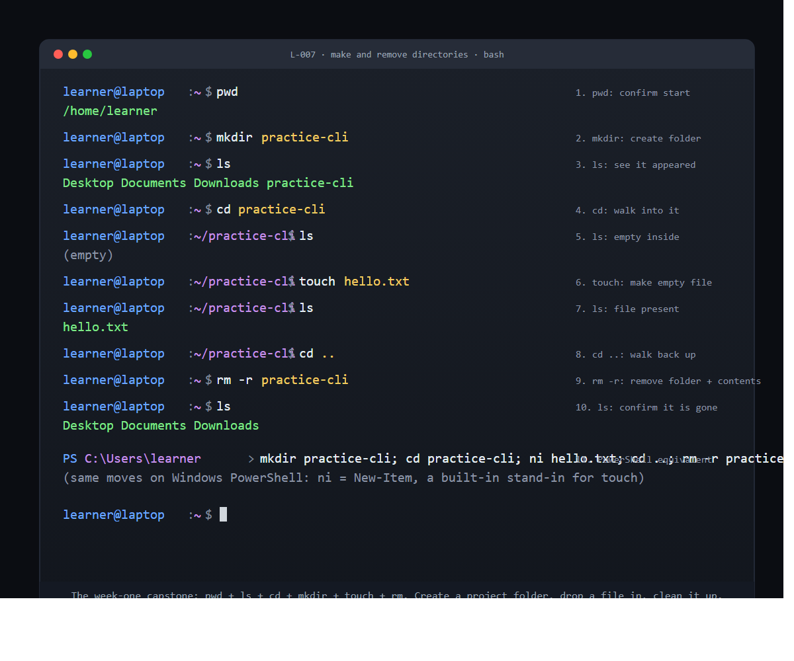
Static panel of the ten exchanges plus the PowerShell equivalent
The symmetry is the lesson
Two verbs create. One verb destroys. Three verbs observe and move. That is the complete vocabulary for reshaping a file tree from a Command-Line Interface (CLI), and every tool you will ever install on top (Git, Docker, Terraform, the cloud command-line tools) assumes you already have this vocabulary.
• mkdir creates a directory
• touch creates a file
• rm -r removes a directory and everything in it
• pwd reports where you are standing
• ls reports what is here
• cd walks you somewhere else
Six commands. One keystroke of difference between the destroy verb and a mistake you cannot take back. This is why serious command-line users develop the habit of reading the line before they press enter.
Windows PowerShell uses the same words
mkdir practice-cli, cd practice-cli, cd .., rm -r practice-cli all work on Windows PowerShell with identical behavior. The only swap is the touch step: PowerShell does not have touch by default, but it has New-Item hello.txt (or the shorter alias ni hello.txt), which creates an empty file the same way. If you are on Windows, write ni hello.txt anywhere you see touch hello.txt in this curriculum and the rest reads the same.
What finishing week one actually gives you
Seven days ago this curriculum started with opening a terminal. Today you can create a project folder, put files in it, navigate around, and clean up after yourself, on any operating system (OS) a professional will ever hand you. That is the full floor of every technical job I have ever done. Everything the next 164 lessons teach, starting tomorrow with reading files, runs on top of the ten seconds of typing you just learned.
The thing that trips most people up is not any individual command. It is not believing that the command actually worked, because the shell does not say anything back. Silent success is the shell's default, and it takes a few rounds of mkdir, ls, mkdir, ls before the silence stops feeling like failure. Run the sequence twice today. The second time will feel different.
The verification
After running the nine-line sequence, ls in your home directory should show the same folders it showed at the start. No practice-cli, no hello.txt. If something extra is still there, rm -r <name> it and run ls again until the directory is clean.
Full lesson with the mkdir -p nested-directory extension and the full set of failure modes: https://github.com/AriesEmber/Principal-AI-Architect-Curriculum/blob/main/modules/M01-first-contact-with-the-terminal/lessons/L-007-make-and-remove-directories-capstone.md
Tomorrow: cat and less, the first two ways to read what is actually inside a file.
#LearnToCode #AIArchitect #SolutionsArchitecture #TerminalBasics #HealthcareAI

GITHUB ARTICLE (full canonical lesson)
Picture setting up a new filing cabinet for a new project. You slide a fresh cabinet into place, pull the top drawer open, confirm the drawer is empty, and drop a single note inside. Later, when the project is over, you shred the whole cabinet and its contents in one motion. Six days of this curriculum so far have been about knowing where you stand and how to move. Today is the first day you create something of your own. You are about to build a directory, put a file in it, and take the whole thing back down, using six commands: pwd, ls, cd, mkdir, touch, and rm. That is the full vocabulary of week one, combined for the first time in one flow.

Animated typewriter walkthrough of the ten-exchange capstone
What you will do
Make a new directory called practice-cli in your home folder, walk into it, confirm it is empty, drop a blank text file inside, walk back out, and delete the whole directory.
Before you start
You need an open terminal and a home directory. Four prior lessons give you everything else. L-004: Find out where you are with pwd taught you how to confirm you are at home. L-005: List the contents of a directory with ls taught you how to look around. L-006: Move around with cd and relative paths taught you how to walk into a folder and back out. This lesson adds the last two verbs you need to do real work: make and remove.
Before the first command, run pwd once and confirm it reports your home directory. If it does not, run cd with no argument to return home. The whole lesson assumes home as the starting point.
Step by step
1. Confirm where you stand
pwd

/home/learner

macOS will show /Users/learner instead, and Windows PowerShell will show C:\Users\learner. Any of those is the correct starting line. The path is what every command in this lesson works relative to.
2. Make a new directory
mkdir practice-cli

mkdir stands for "make directory." The name after it is the folder you are creating, and because the name has no leading slash the shell creates it inside the current directory. The command is silent on success, just like cd was.
3. Confirm the directory exists
ls

Desktop Documents Downloads practice-cli

Your exact listing will differ, but practice-cli should be in it. If it is not, re-read the mkdir line for a typo and run it again. mkdir on an existing folder will error; on a new name it will quietly create the folder.
4. Walk into the new directory
cd practice-cli

The prompt's path segment changes from ~ to ~/practice-cli. That is the Command-Line Interface (CLI) showing you the change directory (CD) move worked.
5. Look around inside
ls

No output. The folder you just made is empty; ls prints nothing when there is nothing to list. This silence is normal and expected, not a bug.
6. Create an empty file
touch hello.txt

touch is a single-word command that was originally designed to update a file's last-modified timestamp. It has a side effect: if the file does not exist, touch creates it, empty. That side effect is why every professional uses touch as the one-keyword way to make an empty file.
7. Confirm the file exists
ls

hello.txt

One file, zero bytes, ready to edit later. This is the state of every real project folder you will ever make: a directory with some number of files and sub-directories inside it. You just built the minimum version.
8. Walk back up
cd ..

The two dots take you up one level, back to your home directory. The prompt's path segment returns to ~.
9. Remove the directory and its contents
rm -r practice-cli

rm means remove. The -r flag means recursive: remove the named directory and everything inside it, walking down through every sub-directory on the way. Silent on success.
There is one piece of this command worth reading twice. rm -r does not move files to a recycle bin. It deletes them. On macOS and Linux the deletion is permanent unless you are using a filesystem with snapshot support. On Windows PowerShell the equivalent (Remove-Item -Recurse) behaves the same way. Type the target carefully, and never run rm -r against a path you did not just create yourself in this lesson.
ls

Desktop Documents Downloads

practice-cli is gone. The cabinet has been shredded. That is all six week-one commands, strung together in one flow.

Static panel of the ten exchanges plus the PowerShell equivalent
Check it worked
At the end of the sequence, ls in your home directory should not show practice-cli. If it does, the rm -r line did not run or hit a typo. Run it again.
If you see rm: cannot remove 'practice-cli': No such file or directory, you were not standing in your home directory when you ran the removal. Run pwd to see where you are. If it says anything other than home, run cd with no argument and try the removal again.
If you see mkdir: cannot create directory 'practice-cli': File exists on step 2, a folder by that name is already there from a prior attempt. Remove it first with rm -r practice-cli and start over, or pick a different name like practice-cli-2 for this run.
The shell is case-sensitive on macOS and Linux. practice-cli and Practice-CLI are two different directories. Windows is case-insensitive, so either works there. If you are on a team that mixes platforms, always lowercase your directory names; it avoids a class of surprises.
What just happened
Six commands, one round trip. pwd reports where you are standing. ls reports what is in the current directory. cd changes the current directory. mkdir creates a new directory. touch creates an empty file. rm -r deletes a directory and everything in it. That is the complete vocabulary for navigating and shaping a file tree from a command line.
Two of the commands create (mkdir, touch). One destroys (rm). Three observe and move (pwd, ls, cd). The symmetry is useful to remember: for every create verb there is a corresponding destroy verb. The other half of mkdir is rmdir, which removes an empty directory. The other half of touch (for the purpose of removing the file it created) is plain rm without the -r flag. rm -r is the hammer version that handles both directories and files and their contents in one command; most of the time it is the only removal command you need.
The filing-cabinet image holds up through the whole lesson because every step maps to a physical action: mkdir slides the cabinet in, cd pulls the drawer open, ls looks inside, touch drops a note, cd .. pushes the drawer back, rm -r shreds the cabinet and everything in it. Once those mappings are in your hands, the shell stops feeling like a puzzle and starts feeling like a set of tools that match the mental model you already had for organizing paper.
Going further
The mkdir command has a flag called -p (short for "parents") that creates a whole chain of directories in one go. Try this in your home folder:
mkdir -p work/2026/april
cd work/2026/april
pwd

/home/learner/work/2026/april

Three levels of nesting, one command. Without -p, running mkdir work/2026/april would fail because the intermediate directories do not exist yet. The -p flag also makes the command silent-on-success when the directory already exists, which is why every shell script you will ever read that creates directories uses -p by default. It is safe to run twice.
Clean up afterward with one rm -r at the top of the branch:
cd ~
rm -r work

Everything under work/, including 2026/april/, is removed in one pass. That is the pattern for every temporary project folder you will ever need to clean up.
What's next
Next is L-008: Read a file's contents with cat and less. You just made an empty file with touch; the next lesson is how to open a file that has something in it and read what is inside, which is the first operating system (OS) skill most learners recognize from daily life.

