L-011 · Install a package manager
Module M02 · Files, editors, and package managers · Week 2 day 4

LINKEDIN POST (copy-paste to LinkedIn)
The first real tool I installed from the command line took me an afternoon, because I downloaded it from three different websites, picked the wrong build for my processor twice, and ended up with two half-broken copies in two folders I could not remember. A package manager is the fix. One command, one version, installed in the place your system expects, removable with one more command. Today you set it up on whichever Operating System (OS) you use.

From zero technical knowledge to AI literacy.
Through data, cloud, MLOps, and applied GenAI systems.

Day 11 of 171. Module 2: Files, Editors, and Package Managers (Day 4).

A package manager is the single most useful tool on a developer laptop, and two of the three major operating systems ship it for free. Windows 11 comes with winget. Debian and Ubuntu come with apt. macOS does not ship one by default, so you install Homebrew once, and you are done for the life of the machine.

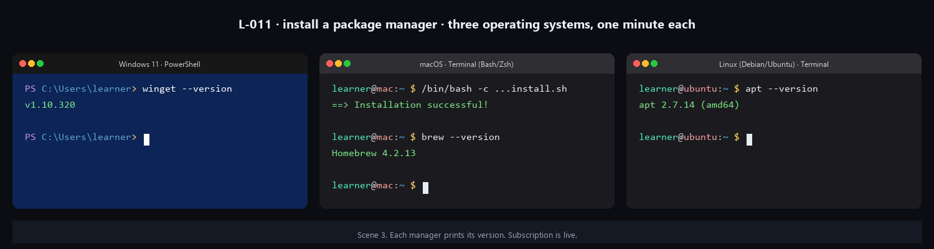

The analogy

Setting up a delivery subscription. One-time setup, then every future order arrives at your door without a trip to the store. The "store" is the project's website and its download page. The "subscription" is the package manager. Once it is in place, installing a tool looks like winget install <name>, brew install <name>, or apt install <name>. Three words. No browser involved.

Pick the block for your OS

Each block is self-contained. Run one, skip the others.

Windows 11 (PowerShell). Confirm winget is present:

winget --version

Expected: something like v1.10.320. If instead you see 'winget' is not recognized, register the App Installer package:

Add-AppxPackage -RegisterByFamilyName -MainPackage Microsoft.DesktopAppInstaller_8wekyb3d8bbwe
winget --version

winget ships with Windows 11 as part of a system component called App Installer. You are not installing it; you are confirming it.

macOS (Terminal). Install Homebrew. The install command is one line from brew.sh:

/bin/bash -c "$(curl -fsSL https://raw.githubusercontent.com/Homebrew/install/HEAD/install.sh)"

Heads up: this downloads and runs Homebrew's official installer script over Hypertext Transfer Protocol Secure (HTTPS). The script pauses to show you what it will do, then asks for your login password so it can create folders owned by root. The full install takes two to five minutes. When it finishes, paste the two-line "Next steps" block that the installer prints (it adds brew to your shell's PATH), then confirm:

brew --version

Expected: Homebrew 4.2.13 or newer.

Linux (Debian-family Terminal). Confirm apt is present:

apt --version

Expected: apt 2.7.14 (amd64) or similar. On non-Debian distributions, the command name is different but the idea is identical: dnf --version on Fedora and Red Hat, pacman --version on Arch, zypper --version on openSUSE.

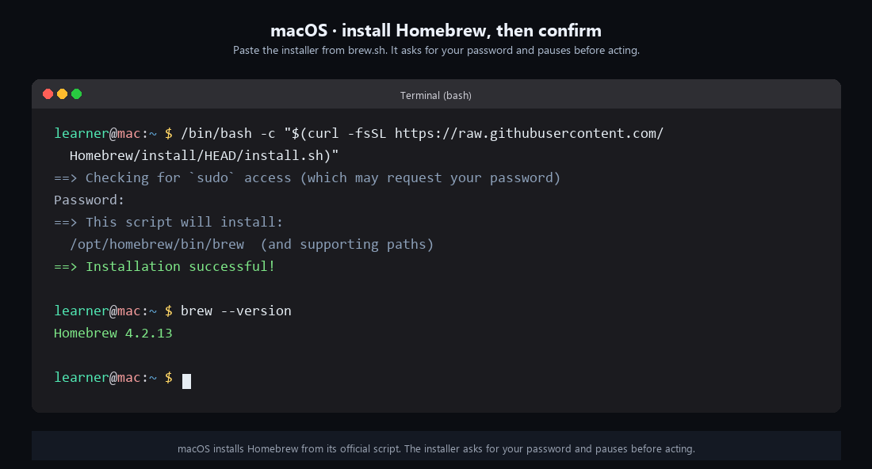

What you are actually trusting

The moment that matters in this lesson is the moment the installer asks for your password on macOS, or the moment winget reaches out to its repository on Windows. That is when the trust model becomes visible. You are not trusting "the internet." You are trusting a specific curated repository with its own maintainers, review process, and signatures:

- winget pulls from Microsoft's winget-pkgs list, a public GitHub repository reviewed by Microsoft staff and community maintainers.
- Homebrew pulls from its homebrew-core tap, a public GitHub repository with its own bot-assisted review process.
- apt pulls from the Debian or Ubuntu archive, which has run the longest and formal-est review process of the three, going back to the late 1990s.

You can audit the source of any package in any of those repositories before you install it. You usually will not. But the fact that you could, and the fact that you can name which repository you pulled it from months later when a security advisory lands, is the difference between a package manager and a random download button on a website. The audit trail is the feature that matters.

Why macOS has to install one and the others do not

A small detail worth noticing. macOS does not ship a default Command-Line Interface (CLI) package manager. It has the App Store for graphical apps, but for command-line tools there is nothing built in. Homebrew filled that gap about fifteen years ago as a community project, and it became the default because there was no Apple-supplied alternative. Windows took the opposite path: Microsoft shipped winget in 2020 precisely to not leave the gap open. Debian/Ubuntu shipped apt before most developers on this post were born.

The story tells you something about how an operating system sees its role. Microsoft and the Debian maintainers treat the package manager as part of the OS. Apple treats it as something the community can handle. Neither is wrong; they lead to different experiences on day one.

The delivery subscription is live

After today, when a future lesson says "install X," the command is one line:

winget install X # Windows

brew install X # macOS
apt install X # Linux (sudo apt install X for system-wide)

You can now install your first tool with one of these. That is L-012, where we install tree and use it to see folder structure the way a picture would show it.

Full lesson with the full commands, the troubleshooting paths, and a tour of search for each manager: https://github.com/AriesEmber/Principal-AI-Architect-Curriculum/blob/main/modules/M02-files-editors-and-package-managers/lessons/L-011-install-a-package-manager.md

Tomorrow: install tree through the package manager you just set up, and see your home directory as an outline.

#LearnToCode #AIArchitect #SolutionsArchitecture #PackageManagers #HealthcareAI

GITHUB ARTICLE (full canonical lesson)
Think of a package manager as a delivery subscription for software. Before the subscription, every grocery run was a separate trip: drive to the store, find the aisle, read the label, carry the bag home, repeat for the next thing. After the subscription, you text one address and the box shows up on your porch the next day. A package manager works the same way for command-line tools. You set it up once. Every future tool you want, you ask the package manager for it by name, and the tool shows up on your machine without a web download, a zip, or an installer wizard. Today you set up that subscription on whichever Operating System (OS) you use. Windows 11 and modern Linux ship the subscription already active, so the task is to confirm it. macOS needs a one-time install. Either way, at the end of this lesson a package manager answers a version check with a clean line of text.



What you will do

Install a package manager (macOS) or confirm the one your OS already ships (Windows, Linux) and print its version number.

Before you start

You need to have completed L-010: Understand file paths, extensions, and hidden files and have a terminal open at your home directory. Run Get-Location (PowerShell) or pwd (Bash) if you need to confirm where you are standing.

This lesson branches by Operating System. Each block below is self-contained: pick the one that matches your machine and run only that block. The three blocks use three different package managers because each OS has its own default. You do not need the other blocks.

Two more preflight items. First, the macOS block asks for your login password, so be ready to type it once. Second, all three blocks talk to the internet: the installer on macOS downloads its script from GitHub, and both winget and apt check their repositories to report their version. A live connection is enough; no company network or special configuration is needed.

Step by step

On Windows 11 (PowerShell)

Windows 11 ships the Windows Package Manager, whose Command-Line Interface (CLI) is named winget, as part of a system component called App Installer. You do not install it; you confirm it. In your PowerShell window, type:

winget --version

You should see a version string, something like:

v1.10.320

The exact number will differ because App Installer updates itself through the Microsoft Store. Any v1.x line means you are ready.

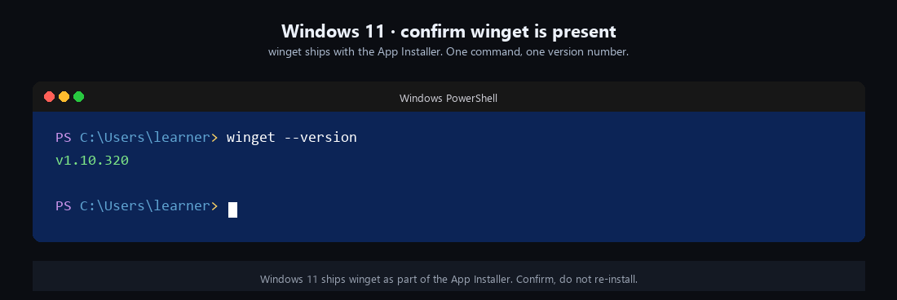

If the line winget: The term 'winget' is not recognized appears, the App Installer registration did not finish. This happens on a freshly imaged Windows 11 machine where you have logged in for the first time only minutes ago. Run:

Add-AppxPackage -RegisterByFamilyName -MainPackage Microsoft.DesktopAppInstaller_8wekyb3d8bbwe
winget --version

The first line re-registers the App Installer package for your user; the second line runs the version check again. You are done when the version prints.

On macOS (Terminal)

macOS does not ship a default package manager, so you install one: Homebrew. Homebrew is community-maintained, and its official install command lives on its home page at brew.sh. You paste one command into Terminal and wait.

Heads up. The next command downloads an installer script over Hypertext Transfer Protocol Secure (HTTPS) from the Homebrew GitHub repository and runs it on your machine. The script is the project's official installer, and it pauses to show you exactly what it will do before acting. But once the install completes, removing Homebrew is a separate uninstall command, not a simple undo. Only paste the command if you are installing Homebrew on purpose.

/bin/bash -c "$(curl -fsSL https://raw.githubusercontent.com/Homebrew/install/HEAD/install.sh)"

The /bin/bash -c "..." wrapper tells your shell to run the quoted text inside a fresh Bash process, regardless of whether your interactive shell is Zsh, Bash, or Fish. Inside the quotes, curl -fsSL <url> downloads the installer script from the Uniform Resource Locator (URL) at raw.githubusercontent.com, and the $(...) syntax hands the downloaded text to bash as the script to run.

Three things happen in order. First, the installer prints a list of what it will install (the brew command, its support folders under /opt/homebrew, and a few helper tools) and pauses for you to press Return. Second, it asks for your login password so it can use sudo to create directories owned by root. Third, it downloads and installs Homebrew itself. The whole run takes two to five minutes on a modern machine.



When the installer finishes, it prints a short "Next steps" block with two lines to paste. The first is an eval command that adds the brew command to your shell's PATH environment variable, which is the list of folders your shell scans when you type a command name. Paste that line into the same Terminal window and press Return. Then confirm the install with:

brew --version

Expected output:

Homebrew 4.2.13

The exact number will be whatever version is current the day you run this.

On Linux (Debian or Ubuntu, Terminal)

Debian-family Linux (Debian, Ubuntu, Linux Mint, Pop!_OS, Raspberry Pi OS, and the Windows Subsystem for Linux when you chose Ubuntu) ships the Advanced Package Tool, whose command is apt. It is already present on every install. Confirm with:

apt --version

Expected output:

apt 2.7.14 (amd64)

Numbers will vary.

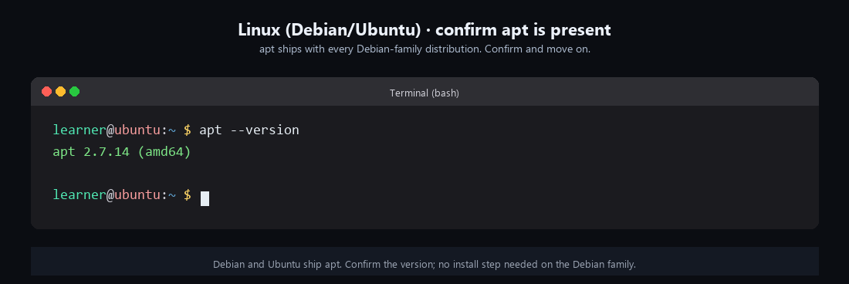

If your distribution is not Debian-family, the command name is different but the idea is the same. Fedora and Red Hat Enterprise Linux use dnf; Arch uses pacman; openSUSE uses zypper. Run the version check for whichever one your distribution ships:

dnf --version # Fedora, RHEL
pacman --version # Arch, Manjaro
zypper --version # openSUSE

One of these prints a version. That is your package manager, and the next lesson works with whichever one you have.

Check it worked

Run the version command one more time. A single line of text with a version number on it means you are done. Specifically:

- Windows 11 prints something like v1.10.320. If instead you see 'winget' is not recognized, the App Installer did not register; re-run the Add-AppxPackage line in the Windows block above.
- macOS prints Homebrew 4.x.x. If instead you see brew: command not found, the installer's PATH step did not land. Open a new Terminal window and try brew --version again; the PATH change only applies to shells started after the installer finished. If it still fails, re-run the two-line eval block from the installer's "Next steps" output.
- Linux prints apt 2.x.x (amd64) on Debian-family, or dnf 4.x.x, Pacman v6.x.x, or zypper 1.x.x on the other families. If the command does not print, you are on a distribution I have not listed; run which dnf || which pacman || which zypper || which apt to find the one that is installed.

Once any of these commands prints a version, the subscription is live. You now have a tool that knows how to install other tools.

What just happened

A package manager is a CLI that does three jobs you used to do by hand: it finds the software you asked for in a curated repository, it downloads the right build for your OS and processor, and it installs the files into the places your system expects them. When you want to upgrade or remove the tool later, the package manager handles that too, because it recorded what it put where.

The three commands in this lesson look small but they do more than report a version. They also confirm that the manager's repository connection is working, which is what "ready to install the next tool" actually means.

The trust model is the part worth noticing. When you download a tool from a random website, you are trusting that one website, one file, one time. When you install the same tool through a package manager, you are trusting the manager's curated repository: Microsoft's winget-pkgs list on Windows, Homebrew's core tap on macOS, Debian's package archive on Linux. These repositories have maintainers, review processes, and cryptographic signatures. You still decide which repositories to trust, and you still read what you are installing, but the gap between "a random website" and "a curated repository with a paper trail" is the reason package managers have become the default way to install command-line software on every major OS.

Three quick mappings to carry forward. Windows uses winget (Microsoft, built in since Windows 10 version 1809). macOS uses Homebrew (community, installed from brew.sh). Debian and Ubuntu use apt (Debian, built in since the late 1990s); other Linux families use dnf, pacman, or zypper depending on the distribution. Every command-line install in the rest of this curriculum assumes one of these is on your machine.

Going further

Open the home page for the package manager you set up and find the page that explains the search command:

- winget: https://learn.microsoft.com/windows/package-manager/winget/search
- Homebrew: https://brew.sh, then the "Documentation" link in the top navigation, then the brew search entry.
- apt: man apt in your terminal prints the manual page, and the section on subcommands lists search.

Run the search command with a term you care about. Try winget search python, brew search ffmpeg, or apt search jq. Read the first few results. You do not need to install anything yet; this is a tour of what the manager knows about.

What's next

Next is L-012: Install your first tool with a package manager, where you place the first order on the subscription you just set up.

