L-009 · Edit a file with nano
Module M02 · Files, editors, and package managers · Week 2 day 2

LINKEDIN POST (copy-paste to LinkedIn)
The first terminal editor I tried asked me to memorise forty keystrokes before I could save a file. The second one printed its shortcuts at the bottom of the screen. Three minutes later I was editing. Today's lesson is that second editor, nano, and the two keystrokes you actually need: Ctrl+O to save and Ctrl+X to exit.
This is Day 9 of a 171-lesson path from zero to a Principal Artificial Intelligence (AI) Architect role. Second day of module 2. Five exchanges: open nano on hello.txt, type three lines, save with Ctrl+O and Enter, exit with Ctrl+X, then read the file back with cat. The same keystrokes work on Windows PowerShell, macOS, Linux, and the Windows Subsystem for Linux (WSL).
The analogy is a typewriter with a help menu along the bottom edge. Every shortcut the machine understands is printed right there on the carriage. You do not have to remember the shortcuts. You only have to read them. That is nano's whole personality. Unlike vi or emacs, which expect you to memorise their commands before you can edit a file, nano prints the commands on the screen.

Side-by-side PowerShell (left, primary) and Bash (right) walkthrough. Five exchanges: launch nano on hello.txt, type three lines, save with Ctrl+O, confirm with Enter and exit with Ctrl+X, read back with cat
The one-time install on Windows 11
Nano ships with macOS and almost every Linux distribution. PowerShell on Windows 11 does not include it. The fastest install:
winget install GNU.Nano

winget is Windows 11's built-in package manager. First run asks you to accept the source agreement; type Y and press Enter. You run this once. After that nano works from every new PowerShell window. On macOS, Linux, or WSL the command is already on your PATH and no install is needed.
The five exchanges
nano hello.txt
(type: hello from nano / this is line two / good night)
Ctrl+O
Enter
Ctrl+X
cat hello.txt

The same sequence works identically in PowerShell and Bash. Nano is a separate program from the shell, so the shell does not get a say in how the editor behaves. That is why the two columns of the walkthrough show the same keystrokes on both sides.
What nano paints on the screen
When you run nano hello.txt, the editor clears the terminal and paints three regions:
• A title strip at the top that shows the version, the filename, and whether the buffer has been modified since the last save.
• An editing area in the middle where your cursor sits and where the text you type goes.
• A help strip at the bottom that lists the most-used shortcuts as ^O Write Out, ^X Exit, ^W Where Is.
The caret symbol (^) is the standard Unix notation for Ctrl. ^O means hold Ctrl and press O. ^X means hold Ctrl and press X. This notation is older than most Unix users and shows up everywhere: in manuals, in stty output, in documentation for any terminal tool. Once you know ^ means Ctrl, you can read any terminal help strip in the world.
Why nano says "Write Out" instead of "Save"
The O in Ctrl+O is for "Out" (as in "write out"), not "Save". Nano calls the save action "Write Out" because the buffer is what the editor writes out to a file on disk. The distinction matters more later, when you learn about editor buffers that exist only in memory, but for today it is fine to read Write Out as "save".
When you press Ctrl+O, nano shows File Name to Write: hello.txt at the bottom and waits. It already proposed hello.txt because that is what you launched it with. Press Enter to accept. Nano writes the file and shows [ Wrote 3 lines ]. You are back in the editor with the file now on disk.
The Modified marker
As soon as you type the first character, the top strip changes from [ New File ] to Modified. That word is nano's way of saying the on-disk file no longer matches what is in the editor. It is the editor's single most useful status cue: as long as you see Modified, you have unsaved work. Once you save, the word disappears.
If you press Ctrl+X to exit while Modified is still showing, nano asks Save modified buffer? and waits for Y or N. It refuses to throw away your work silently.
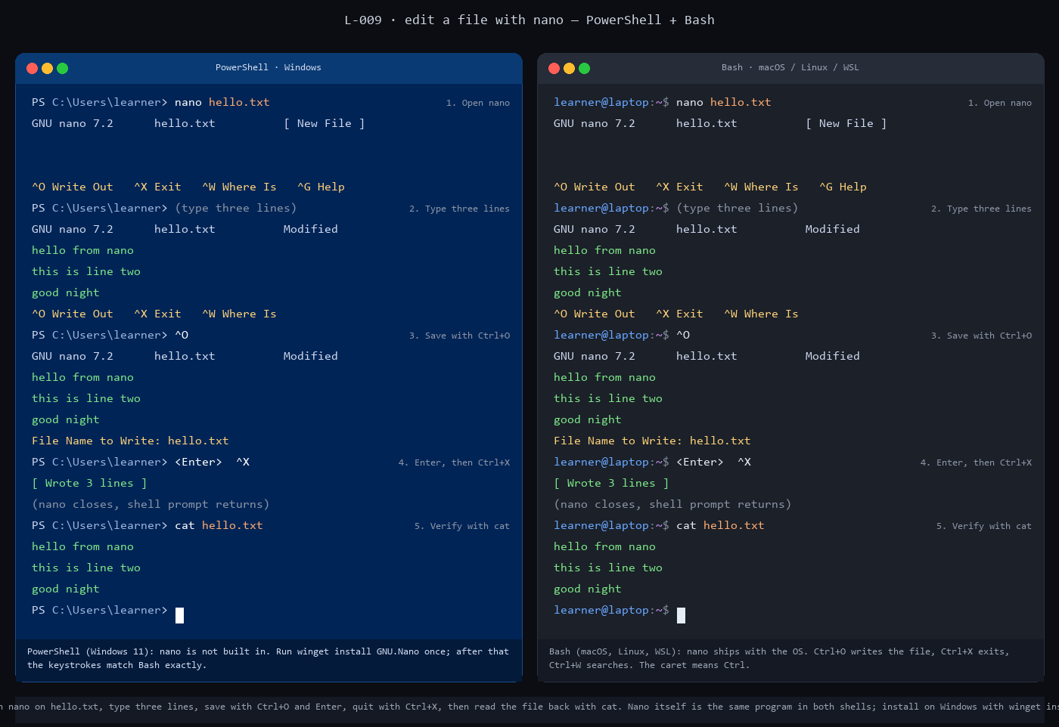
Side-by-side static panel of the 5 exchanges. PowerShell on the left, Bash on the right, with the nano editor screen rendered inline inside the output area of each exchange
The rule worth remembering from this lesson
Any program that paints its own screen over the terminal keeps control until you intentionally exit. Pagers use q. Nano uses Ctrl+X. An interactive Python session uses exit(). A sub-shell uses exit. Each tool has its own exit verb. The first thing to learn about any new terminal tool is how to quit it.
Nano is the gentlest member of that family because the exit key is printed on the screen. That is a worthy design choice. A tool that teaches you how to leave it is a tool you can safely enter.
The keystroke to try next
Ctrl+W (Where Is) searches the file. Open a long file, press Ctrl+W, type a search string, press Enter, and nano jumps to the first match. Press Alt+W (or Meta+W on macOS) to jump to the next match. The same shortcut works on any file in any directory, which makes nano a surprisingly capable quick-grep tool when you do not want to leave the editor.
The verification
After the five exchanges, cat hello.txt prints the three lines you typed, in order. If the output is empty, the save did not happen; redo Ctrl+O and Enter. If the output has lines you did not type, another editor window or a prior save wrote over the file; rerun the lesson from step 1.
Full lesson with the full commands, the Ctrl+W search extension, and the failure modes: https://github.com/AriesEmber/Principal-AI-Architect-Curriculum/blob/main/modules/M02-files-editors-and-package-managers/lessons/L-009-edit-a-file-with-nano.md
Tomorrow: the rules that govern the paths the files you just edited actually live at.
#LearnToCode #AIArchitect #SolutionsArchitecture #TerminalBasics #HealthcareAI

GITHUB ARTICLE (full canonical lesson)
Picture a typewriter with a help menu along the bottom edge. Every shortcut it understands is printed right there on the carriage: hit this key to insert a page, that key to underline, a third key to eject the page. You do not have to remember the shortcuts. You only have to read them. A terminal text editor called nano works the same way. Today you open a file in nano, type three lines, save with Ctrl+O, exit with Ctrl+X, and read the file back to confirm it stuck. By the end you will have edited a text file from the Command-Line Interface (CLI) for the first time.

Side-by-side PowerShell (left, primary) and Bash (right) walkthrough. Five exchanges: launch nano on hello.txt, type three lines, save with Ctrl+O, confirm with Enter and exit with Ctrl+X, read back with cat
What you will do
Open nano on a new file named hello.txt, type three lines, save with Ctrl+O then Enter, exit with Ctrl+X, and verify with cat hello.txt.
Before you start
You need a terminal at your home directory, the way L-008: Read a file's contents with cat and less left you. Run pwd and confirm you are at your home path (C:\Users\<yourname> on Windows PowerShell, /Users/<yourname> on macOS, /home/<yourname> on Linux or the Windows Subsystem for Linux (WSL)).
Nano ships with the operating system (OS) on macOS and almost every Linux distribution, so if you are in Bash or Zsh there is nothing to install. PowerShell on Windows 11 does not include nano. A one-time install puts it on your PATH:
winget install GNU.Nano

winget is the package manager built into Windows 11. The first time you run it, Windows will ask you to accept the source agreement; type Y and press Enter. The install takes under a minute. You only run this once. After that, nano works from every new PowerShell window you open.
If you are on Windows 10 or on a machine without winget, two good alternatives are the portable binary from nano-editor.org or the nano bundled with Git for Windows, both of which run from a PowerShell or Git Bash prompt.
Today you only need to remember two keystrokes: Ctrl+O to save and Ctrl+X to exit. Nano prints both of them at the bottom of the screen, so you do not actually have to remember anything.
Step by step
PowerShell commands are shown first because PowerShell is the default shell on Windows 11 and the primary shell of this curriculum. The Bash and Zsh equivalent follows each PowerShell block for readers on macOS, Linux, or WSL.
1. Open nano with a new file
nano hello.txt

nano hello.txt

The command is the same in both shells. Nano clears the terminal and paints its own screen. The top strip reads:
GNU nano 7.2 hello.txt [ New File ]

The title bar tells you which version of GNU nano is running, which file is open, and whether the file is new. The bottom strip lists the shortcuts:
^O Write Out ^X Exit ^W Where Is ^G Help

The caret symbol (^) means hold Ctrl and press the key that follows it. ^O is Ctrl+O. ^X is Ctrl+X.
2. Type three lines
Type these three lines into the buffer, pressing Enter between each line:
hello from nano
this is line two
good night

As soon as you type the first character, the top strip changes from [ New File ] to Modified. That word is nano's way of saying the on-disk file no longer matches what is in the editor. Your work exists only in memory until you save.
3. Save the file with Ctrl+O
Press Ctrl+O. The bottom of the screen changes to show:
File Name to Write: hello.txt

Nano is asking which filename to write to. It already proposed hello.txt because that is what you passed on the command line.
4. Confirm with Enter, then exit with Ctrl+X
Press Enter to accept the filename. Nano writes the buffer to disk and shows a short confirmation:
[ Wrote 3 lines ]

Now press Ctrl+X. Nano closes and hands control back to the shell. The PowerShell or Bash prompt returns.
5. Verify with cat
Read the file back to confirm it saved correctly.
cat hello.txt

cat hello.txt

hello from nano
this is line two
good night

Three lines, in the order you typed them. The save worked.

Side-by-side static panel of the 5 exchanges: launch nano, type three lines, save with Ctrl+O, confirm with Enter and exit with Ctrl+X, verify with cat
Check it worked
cat hello.txt should print exactly the three lines you typed. If nothing prints, the file did not save; repeat steps 3 and 4.
If you pressed Ctrl+X before Ctrl+O, nano noticed the buffer was modified and asked Save modified buffer?. Type Y then Enter, and nano will ask for the filename (same as Ctrl+O). Type Y and Enter again and nano exits cleanly, with the file on disk.
If the filename prompt shows a path you did not expect, press Ctrl+C to cancel the save, then press Ctrl+O again and retype hello.txt.
If nano hello.txt returns nano: command not found on PowerShell, the winget install GNU.Nano step did not run or did not finish. Close and reopen PowerShell (so it picks up the new PATH), run nano --version to confirm, and try again.
What just happened
Nano is a full-screen text editor that runs inside the terminal. Unlike cat (which dumps a file to stdout) or less (which pages through a file), nano draws its own text user interface (TUI) on top of the terminal window: the title strip at the top, the editing area in the middle, and the help strip at the bottom.
The help strip is why nano exists. Every other long-running Unix editor (vi, vim, emacs) expects you to learn its shortcuts before you can use it; nano prints the shortcuts on the screen. That single design choice is the reason nano is the default editor most Linux distributions put in front of a first-time user when they run visudo, crontab -e, or any other command that drops them into an editor.
Two rules carry forward from this lesson. First, the caret notation (^O for Ctrl+O) is standard across Unix terminal tools, so when you see ^C or ^D in a future lesson, you already know they mean Ctrl+C and Ctrl+D. Second, any tool that drops you into a full-screen interface keeps the terminal until you intentionally exit. Pagers use q, nano uses Ctrl+X, a Python Read-Eval-Print Loop (REPL) uses exit(). Each tool has its own exit verb. Learning them is part of the price of admission.
Going further
Ctrl+W is nano's "Where Is" (search) shortcut. Open a longer file and try it.
nano /etc/services

nano $Env:SystemRoot\System32\drivers\etc\services

On Bash, /etc/services is the text file the OS uses to look up standard network ports. On Windows, $Env:SystemRoot is the environment variable that holds the Windows install path (usually C:\Windows), and Windows ships a very similar services file.
Inside nano, press Ctrl+W. Nano prompts Search:. Type http and press Enter. Nano jumps to the first line that contains http. Press Alt+W (or Meta+W on macOS) to jump to the next match. Press Ctrl+X to exit when you have seen enough.
What's next
Next is L-010: Understand file paths, extensions, and hidden files. You now know how to read a file two ways and how to edit one; the next lesson names the rules that govern the paths those files live at.

