L-010 · Understand file paths, extensions, and hidden files
Module M02 · Files, editors, and package managers · Week 2 day 3

LINKEDIN POST (copy-paste to LinkedIn)
The first time I moved a project folder between my laptop and a remote machine, half my scripts broke because they had absolute paths baked into them. The fix was one rule: treat a path like a postal address, and know which form to write for which job. Today's lesson is that rule, plus two others: what a file extension actually means, and why ls on one machine shows different files than ls on another.
This is Day 10 of a 171-lesson path from zero to a Principal Artificial Intelligence (AI) Architect role. Module 2, Day 3. Seven exchanges in the terminal: print your home path, write note.txt, read it with a short name and a long name, rename it to note.md, read it again, then list the directory with hidden files revealed. Works the same on Windows PowerShell, macOS, Linux, and the Windows Subsystem for Linux (WSL).
The analogy is a postal address. A full address has a country, a city, a street, and a house number. Each part narrows the search. Drop parts from the end and you describe something less specific. A file path works the same way. The drive letter or root is the country. The deepest folder is the street. The filename is the house number. Every file has this kind of address, and there are two conventional ways to write it down.

Side-by-side PowerShell (left, primary) and Bash (right) walkthrough. Seven exchanges: print the home path, write note.txt, read it with a relative path, read it with an absolute path, rename to note.md, read the renamed file, then list the directory with dotfiles revealed
Two ways to write a path
The file note.txt sitting in your home directory has two honest addresses:
• Relative. note.txt. Read as "in my current folder." Short. Portable. Stops working if you change folders.
• Absolute. C:\Users\learner\note.txt on PowerShell, or /home/learner/note.txt on Bash. Read as "from the root of the filesystem." Long. Works no matter which folder you are standing in.
There is also a shortcut, ~, which expands to your home directory in both shells. cat ~\note.txt in PowerShell and cat ~/note.txt in Bash both read the same file as the absolute form, without making you spell out your username.
Relative paths are what you use most of the time. Absolute paths are what you write into scripts that will run from a scheduled task, a container, or a different person's machine, because "my current folder" means different things to different callers.
Extensions are labels, not locks
The suffix after the last dot in a filename is a naming convention. A .txt file is usually plain text. A .md file is usually Markdown. A .py file is usually Python. But no part of the filesystem enforces the convention. You can rename a text file to .md, .sql, or .elvis, and the shell reads the same bytes back.
PS> Rename-Item note.txt note.md
PS> cat note.md
hello paths

The content is identical. The rename only changed the label. The operating system (OS) does not check that .md content is Markdown. Applications that open files by double-click use the extension to decide which program to launch (a .md goes to your Markdown viewer; a .txt goes to Notepad), but the shell's cat command does not care.
Later in the curriculum you will meet the separate idea of a content type, which is how a web server tells a browser how to interpret a response. The filename extension is a hint to programs on your own machine; the content type is the actual contract over the network.
Hidden files work differently on Windows and Unix
Run ls in your home directory on Bash and you will see maybe five or ten files. Run Get-ChildItem on PowerShell in the same directory and you will see thirty. The difference is not your directory. It is what the two shells consider hidden.
• Bash hides any filename that starts with a dot. .bashrc, .gitconfig, .ssh, .vscode: all invisible to ls until you add -a.
• PowerShell does not care about the leading dot. It respects the Windows Hidden file *attribute*, which is a separate flag in the filesystem metadata. A file named .gitconfig on Windows is visible by default because nothing set its Hidden attribute. Get-ChildItem -Force adds files whose Hidden attribute is set.
This means the same home directory, listed on Windows and on WSL, looks different. Not because the files are different. Because the two shells use different rules to decide what to hide.
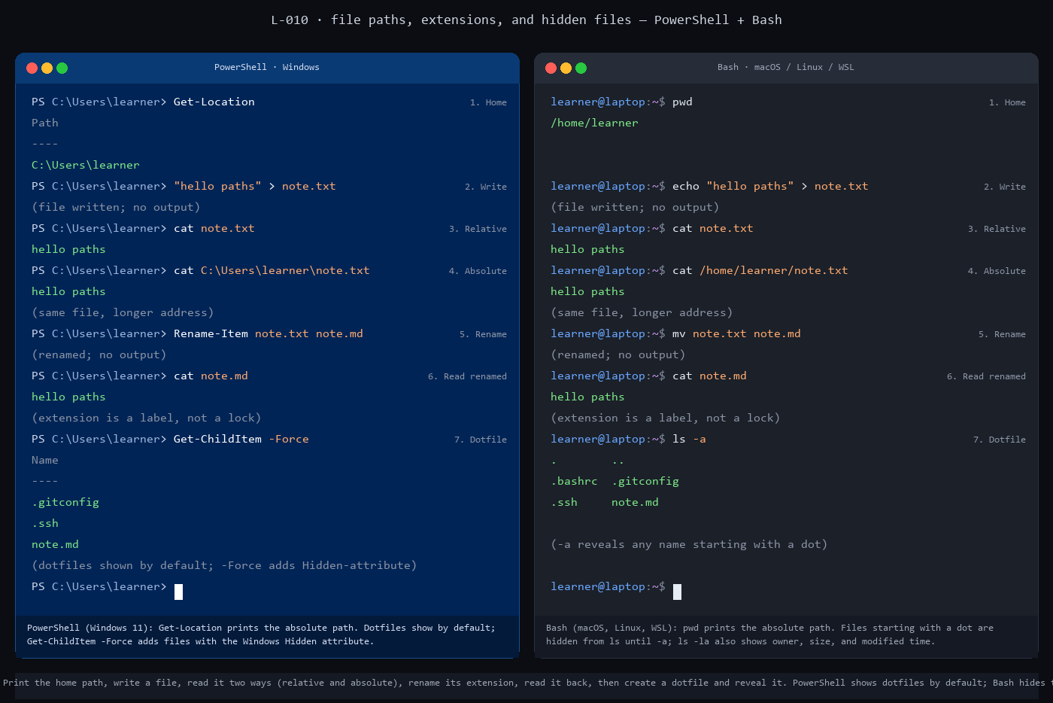
Side-by-side static panel of the 7-exchange walkthrough. PowerShell on the left, Bash on the right, with each exchange showing the command, its output, and a short comment line
Why hidden at all?
Hiding is not security. Anyone with a terminal can list a hidden file if they know to ask for it, and anyone with read permission can read its contents. Hiding is tidying. Your home directory collects per-user configuration files over time, one per tool: Git's config, the shell's startup file, the Secure Shell client's known-hosts list, the editor's state. You almost never need to see them in a casual listing. Keeping them out of the default view is a convenience, not a protection.
The upside of this convenience is that moving a tool's settings between machines is easy. .gitconfig is just a text file. Copy it to a new laptop and you have brought your Git identity with you. Same for .bashrc, .vscode, and most of the others. Hidden files are often the most portable files on your machine.
The rule worth keeping
Three rules carry forward from this lesson.
1. Write relative paths by default. Write absolute paths when the caller will run your command from somewhere else. Scripts, scheduled tasks, containers, and CI jobs all count as "somewhere else." 2. Do not trust a file's extension to tell you what it contains. Trust it to tell you what the author intended. When you need to know what is actually inside, open the file. 3. When the same command shows different files on different shells, check the hiding rule first. Bash looks at the dot; PowerShell looks at the attribute. The file is almost always there; the question is whether your shell's default view is showing it.
The one-line drill
Count your hidden and visible files together:
(Get-ChildItem -Force ~).Count

ls -a ~ | wc -l

On a fresh Windows install with a few developer tools installed, the count is usually around 30 to 50. On a long-lived developer laptop it is often 200+. Every line is a tool that decided it needed to store something per-user.
Full lesson with the full commands, the dotfile cleanup, and the .gitconfig exploration: https://github.com/AriesEmber/Principal-AI-Architect-Curriculum/blob/main/modules/M02-files-editors-and-package-managers/lessons/L-010-understand-file-paths-extensions-and-hidden-files.md
Tomorrow: install the package manager that installs every other tool the rest of the curriculum uses.
#LearnToCode #AIArchitect #SolutionsArchitecture #TerminalBasics #HealthcareAI

GITHUB ARTICLE (full canonical lesson)
A postal address has a country, a city, a street, and a house number. Each part narrows the search. Drop the house number and you are describing the street. Drop the street and you are describing the city. A file path works the same way. The drive letter or root stands in for the country. The deepest folder is the street. The filename is the house number. Every file on your computer has an address that looks like this, and there are two conventional ways to write it: from the root down (absolute) or from where you are standing (relative). Today you write one file's address two ways, rename it to see that its extension is a label and not a lock, and reveal the files that hide from the default directory listing. You use the Command-Line Interface (CLI) for all of it.

Side-by-side PowerShell (left, primary) and Bash (right) walkthrough. Seven exchanges: print the home path, write note.txt, read it with a relative path, read it with an absolute path, rename to note.md, read the renamed file, then list the directory with dotfiles revealed
What you will do
Print your home directory's absolute path, write a short file, read it two ways (with a relative path and with an absolute path), rename it to change the extension, read it again to confirm the content is unchanged, and list the directory with hidden files revealed.
Before you start
You need a terminal open at your home directory, the way L-009: Edit a file with nano left you. Run pwd (Bash) or Get-Location (PowerShell) and confirm you are at your home path.
This lesson works on Windows 11 (PowerShell), macOS (Bash or Zsh), Linux (Bash or Zsh), and the Windows Subsystem for Linux (WSL). No install step is required. The commands are built into the shell.
You only need a writable home directory. The lesson creates one file called note.txt, renames it to note.md, and writes a second file called .tag to demonstrate dotfile listing. Nothing is deleted automatically; you can clean up at the end with Remove-Item note.md, .tag (PowerShell) or rm note.md .tag (Bash).
Step by step
PowerShell commands are shown first because PowerShell is the default shell on Windows 11 and the primary shell of this curriculum. The Bash and Zsh equivalent follows each PowerShell block for readers on macOS, Linux, or WSL.
1. Print the absolute home path
Get-Location

pwd

Both commands print the same kind of answer: the absolute path of your current working directory. On PowerShell the output starts with a drive letter (for example C:\Users\learner). On Bash it starts with a single forward slash (for example /Users/learner on macOS, /home/learner on Linux or WSL).
Get-Location is PowerShell's built-in name for this command; pwd is a shipped alias that matches the Bash name, so typing pwd in PowerShell works too.
2. Write a short file
"hello paths" > note.txt

echo "hello paths" > note.txt

The > operator sends the output of the preceding command or expression into a file. PowerShell evaluates the quoted string as output directly; Bash needs echo to produce the output first. Either way, note.txt now contains the two words hello paths followed by a newline. Neither shell prints anything on success, which is the Unix convention: silence means it worked.
3. Read the file with a relative path
cat note.txt

cat note.txt

Output:
hello paths

The argument note.txt is a *relative path*. The shell reads it as "a file called note.txt in my current working directory." Because you are in your home directory, the shell resolves this to the full path C:\Users\learner\note.txt (or /home/learner/note.txt) and hands that to cat.
Relative paths are the form you use most of the time. They are shorter and they are portable: the same command works no matter which machine the same folder structure lives on.
4. Read the same file with an absolute path
cat C:\Users\learner\note.txt

cat /home/learner/note.txt

Output:
hello paths

Replace learner with your actual username. The file is the same file; the path is just longer because it names the file all the way from the root of the filesystem. An absolute path works from any working directory. You could cd to a different folder and the same absolute-path cat command would still print the same content.
The two forms (note.txt and C:\Users\learner\note.txt) are the two conventional ways to refer to a file. A third shortcut, ~, expands to your home directory in both PowerShell 7 and Bash, so cat ~\note.txt (PowerShell) and cat ~/note.txt (Bash) also work.
5. Rename the file to change the extension
Rename-Item note.txt note.md

mv note.txt note.md

Neither shell prints anything on success. The file on disk is still the same bytes; only the filename changed.
6. Read the renamed file
cat note.md

cat note.md

Output:
hello paths

Same content. The operating system (OS) does not check that a .md file contains Markdown or that a .txt file contains plain text. The extension is a naming convention, useful to humans and to programs that look at filenames to decide what to do (a double-click on .md usually opens a Markdown previewer; a double-click on .txt usually opens Notepad or TextEdit). But no part of the filesystem enforces the convention. You can rename note.md to note.sql or note.gibberish and the shell will read the same bytes back.
7. List the directory with hidden files revealed
Get-ChildItem -Force

ls -a

Output (yours will differ):
PowerShell: Bash:
.gitconfig . ..
.ssh .bashrc .gitconfig
note.md .ssh note.md

Both commands list every file in the current directory, including the ones that the default listing hides. The specifics differ by shell:
• Bash hides any filename that starts with a dot. ls alone omits them; ls -a adds them. The entries . and .bashrc and .gitconfig are examples of such dotfiles.
• PowerShell does not care about the leading dot. It respects a different hiding mechanism called the Windows Hidden file *attribute*. Get-ChildItem alone already lists dotfiles like .gitconfig; the -Force flag adds files whose Hidden attribute is set.
Try creating a dotfile yourself:
"sticky note" > .tag
cat .tag

echo "sticky note" > .tag
cat .tag

Both print sticky note. The file is there, regardless of shell. The only difference is whether the default ls or Get-ChildItem shows it.

Side-by-side static panel of the 7-exchange walkthrough. PowerShell on the left, Bash on the right, with each exchange showing the command, its output, and a short comment line
Check it worked
Three things should be true at the end:
1. cat note.md prints hello paths (the rename kept the content). 2. cat .tag prints sticky note (the dotfile exists and is readable). 3. Running Get-ChildItem -Force (PowerShell) or ls -a (Bash) shows note.md and .tag in the listing.
If cat note.md prints nothing, the rename did not take; re-run step 5 and confirm there is no note.txt left in the directory. If cat .tag returns No such file or directory, the write in step 7 did not land in your current directory; run pwd or Get-Location and try again from your home path.
If Get-ChildItem -Force shows many entries you did not create, that is normal. Your home directory collects configuration files over time: .gitconfig from Git, .ssh from OpenSSH, .wslconfig from WSL, .vscode from Visual Studio Code, and so on. Every tool that needs a per-user config file lands one there.
What just happened
Three ideas carry forward from this lesson.
Paths are addresses. Every file has an absolute path that names it from the root of the filesystem (a drive letter on Windows, a single forward slash on Unix). Every file also has one or more relative paths that name it from some other directory. The shortcut ~ expands to your home directory in both shells and lets you write short absolute-like paths regardless of where you are standing. Reading, writing, and renaming files does not care which form you use, as long as the path resolves to the same file.
Extensions are labels. The suffix after the last dot in a filename is a naming convention. It tells humans and programs what kind of content to expect. But no part of the filesystem enforces the convention. You can rename a text file to .md, .sql, or .elvis, and the shell reads the same bytes. Later lessons introduce the separate idea of a *content type* (the Hypertext Transfer Protocol header Content-Type: text/markdown), which is how web servers and browsers actually agree on how to interpret a file. The filename extension is a hint; the content type is a contract.
Hidden is a convention, and the convention differs by platform. On Unix, a file whose name starts with . is hidden from ls unless you add -a. This is not security; it is tidying. The home directory collects per-user configuration files, and hiding them out of the default listing keeps the working view uncluttered. On Windows, the shell respects a file-attribute mechanism instead: a file is hidden when its Hidden bit is set in the filesystem metadata, regardless of its name. PowerShell's Get-ChildItem -Force shows Hidden-attribute files; ls -a in Bash shows dotfile-convention files. A file named .gitconfig created on Windows is usually not Hidden-attribute-marked, so it shows by default in PowerShell but not in Bash. Knowing this asymmetry means you will not debug a phantom bug when the same dotfile appears or disappears between shells.
Going further
Count the files in your home directory, both visible and hidden.
(Get-ChildItem -Force ~).Count

ls -a ~ | wc -l

Then read one of the config files with cat to see what is inside. .gitconfig is a good candidate: it holds your Git user name and email, and occasionally other settings.
cat ~\.gitconfig

cat ~/.gitconfig

If you have never used Git on this machine, the file may not exist; that is fine. Try .bashrc (Bash), .zshrc (Zsh), or $PROFILE (PowerShell) instead.
What's next
Next is L-011: Install a package manager. You have been creating and renaming files by hand; the next lesson installs the tool that installs every other tool, so the rest of the curriculum's commands can arrive on your machine without a web download per install.

