Lesson L-002
Read a prompt like a sign at a train station
Module M01: First Contact with the Terminal · Domain D01: Command Line & Environment Fluency · Week 1 · Day 2 · 10 minutes

LinkedIn post (copy-paste ready)
For months I typed into a terminal without noticing that the characters to the left of my cursor were trying to tell me something. Then someone pointed at four tokens and the whole line clicked.
This is Day 2 of a 171-lesson path I am taking publicly, from zero to a Principal Artificial Intelligence Architect role. Week one is the command line. Today is ten minutes of pure observation. No commands that change anything, no installs, no sign-ups. Just learning to read a sign that you already have in front of you.
The analogy I use is a train station. A sign on a station platform does three quiet jobs. It tells you where you are (platform number), who is there with you (which line), and that a train is about to depart (the destination). The prompt on your terminal does the same three jobs, plus one more. Once you can point at each piece and name what it is, the Command-Line Interface (CLI) stops looking like a riddle and starts looking like a sign.

The four questions every prompt answers
Regardless of which Operating System (OS) you are on, your prompt is trying to answer four questions:
- Who am I on this machine? (Username.)
- Which machine am I on? (Hostname.)
- Where in the filesystem am I standing? (Current directory.)
- Is the machine waiting for my next command? (Prompt character.)
Write those four questions down on a sticky note before you read the rest of this post. That is the template you will fill in.
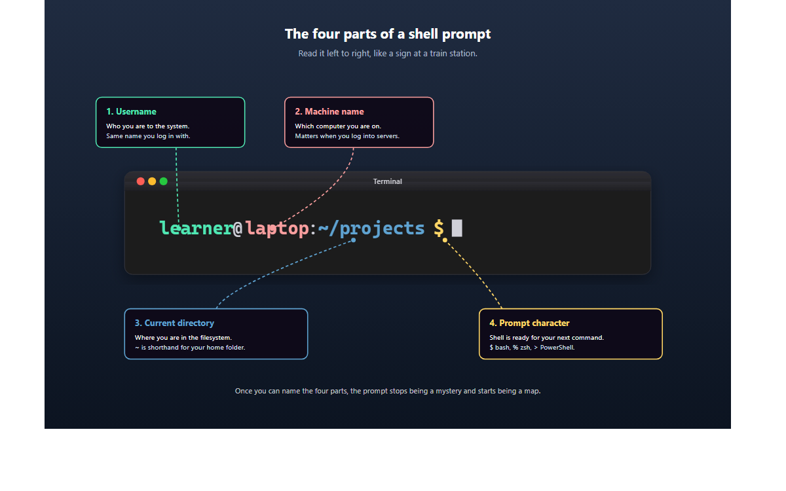
On macOS (Zsh)
Your prompt reads learner@MacBook-Pro ~ %.
Four tokens, spaces separate them. learner is your username. MacBook-Pro is the name of the Mac. ~ is shorthand for your home folder at /Users/learner. % is the prompt character that Zsh, the default shell on macOS, uses for a regular user.
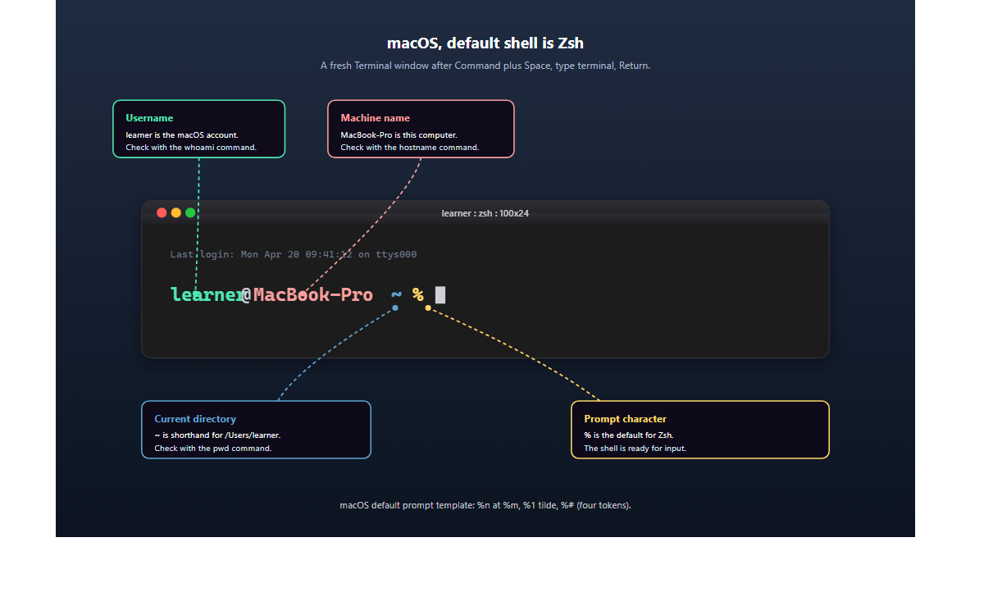
On Linux (Bash on Ubuntu, Fedora, or Debian)
Your prompt reads learner@laptop:~/projects$.
Same four tokens, packed tighter. Username before the @. Hostname between @ and :. Directory between : and $. The $ is the Bash default for a regular user. If you ever see # in that last position, you are running as root, which is a risk topic for a later lesson.
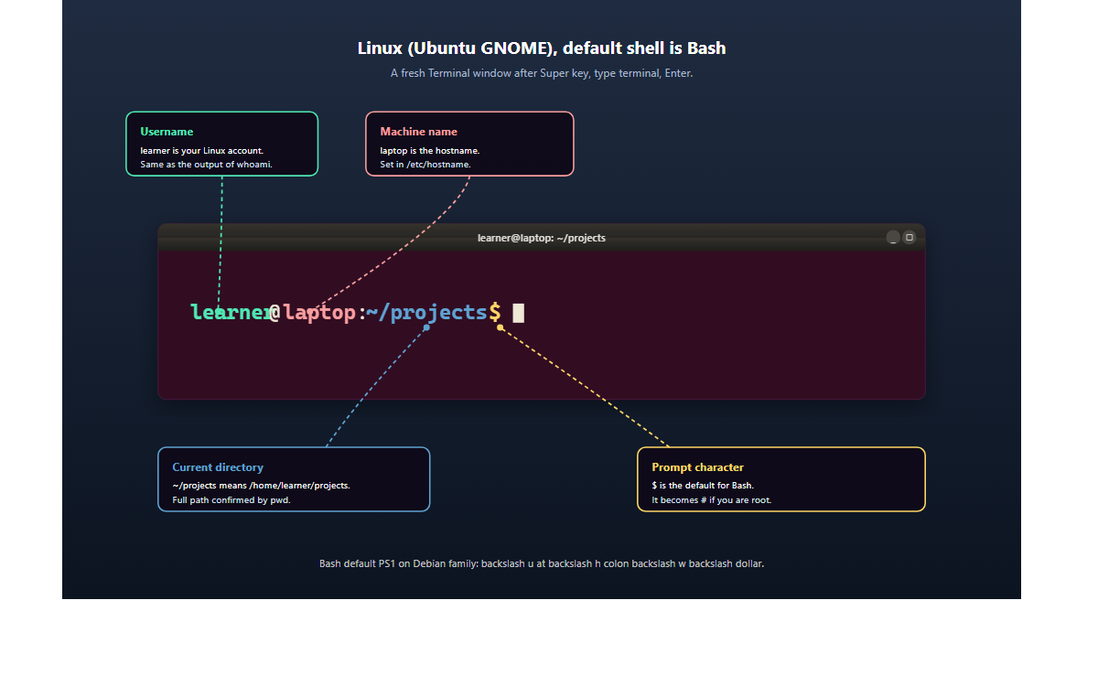
On Windows 11 (PowerShell in Windows Terminal)
Your prompt reads PS C:\Users\learner>.
PowerShell hides two of the four tokens to keep the line short. PS is the shell indicator, it tells you PowerShell is running (Command Prompt would show nothing here). C:\Users\learner is the current directory in full Windows style, no tilde shorthand. > is the prompt character.
The username and hostname still exist, they are just not printed. Type whoami and the terminal prints your username. Type hostname and it prints your machine name. Both are one-line commands with no side effects.
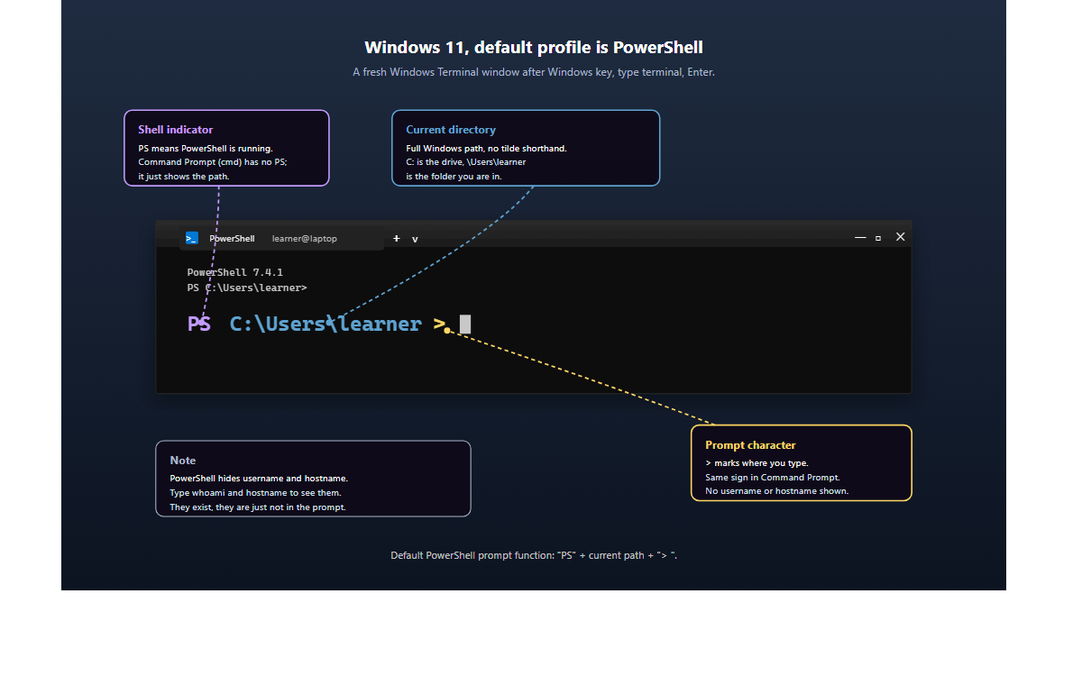
The verification
Close the note. Look away from the screen. From memory, recite the four pieces of your own prompt out loud. Then look back and confirm. If you can name all four without looking, you have the lesson.
These four names are what you will use every time you search for help, every time a tutorial mentions "your working directory," every time a colleague pastes a command into Slack and you have to read it. Today is where they stop being noise.
Why the prompt is software, not decoration
The prompt is generated by your shell every time it returns control to you. A shell is the program that sits between you and the computer, taking your text and turning it into work. The template for the prompt is kept in an environment variable called Prompt String 1 (PS1) on Bash and Zsh, or a function called prompt on PowerShell. That means every character in the line was chosen by someone, and any of them can be changed, rearranged, colored, shortened, or hidden.
You will change your own PS1 later in the curriculum, once you have earned the right to break and fix your shell without panic. For today, knowing that the prompt is software, not a fixed feature of the window, is enough. It is the difference between "my terminal says some symbols" and "my terminal is answering four questions and I can point at each answer." That is the whole mental shift that separates a nervous user from someone who reaches for the command line first.
Ten minutes of observation. Four names. The next lesson is running your first actual command, which the prompt has been waiting to do since you opened the window yesterday.
Full lesson on GitHub
Try it and post your four tokens in the comments if you want me to sanity-check them.
#LearnToCode #AIArchitect #SolutionsArchitecture #TerminalBasics #HealthcareAI

GitHub article (full lesson)
A sign at a train station does three quiet jobs. It tells you where you are (the platform), who is there with you (the line or carriage), and that a train is about to depart (the next destination). The prompt on your terminal does the same three jobs. It is a status bar disguised as a handful of symbols. Once you can point at each piece and name what it is, the Command-Line Interface (CLI) stops looking like a riddle and starts looking like a sign. You are about to walk over to your prompt, label the parts, and write them down.


What you will do
Look at the prompt in your open terminal window, identify the four parts, and write them down on paper or in a note app so you can recite them from memory.

Before you start
You need an open terminal window from L-001: Open the terminal with a keyboard shortcut. If you closed it, reopen it now. You also need something to write with. A sticky note, the Notes app, a text file, any of them works. The point is to move the information out of the screen and into your own handwriting or typing, which is how the four names stick.
No commands will be run that change anything on your machine. This lesson is pure observation, with one optional peek at the template string in the final section.

Step by step
Below are three annotated screens, one for each Operating System (OS) you are likely to be in front of. Find the block that matches yours. Your prompt will look almost exactly like the picture, with your own username, your own machine name, and your own folder name in place of the examples.

The pattern, on paper

Regardless of your OS, the four questions are always the same:
- Who am I on this machine? Username.
- Which machine am I on? Hostname.
- Where in the filesystem am I standing? Current directory.
- Is the machine waiting for my next command? Prompt character.
Write those four questions down before you look at your own prompt. That is the template you will fill in.

On macOS (Zsh)
Your prompt looks something like learner@MacBook-Pro ~ %.

- The piece before the @ is your username. In the picture it is learner; yours will be whatever you signed into the Mac with.
- The piece after the @ and before the space is the machine name. In the picture it is MacBook-Pro; yours might be Elvis-MacBook-Air, Jane-iMac, or anything you chose in System Settings.
- After another space comes the current directory. The tilde character ~ is shorthand for your home folder, /Users/<your-username>. A fresh terminal window always opens in your home folder.
- The % is the prompt character. On Zsh, the default Mac shell since macOS Catalina, it is always % for a regular user. The cursor blinks to the right of it.

On Linux (Bash on Ubuntu, Fedora, or Debian)
Your prompt looks something like learner@laptop:~/projects$.

- The piece before the @ is your username.
- The piece between @ and : is the machine name (hostname).
- The piece after the : and before the $ is the current directory. The tilde ~ means home; ~/projects means a folder called projects inside your home folder.
- The $ is the prompt character. On Bash as a regular user it is always $. If you ever see # here, you are running as the root user, which is a risk topic for a later lesson.

On Windows 11 (PowerShell in Windows Terminal)
Your prompt looks something like PS C:\Users\learner>.

PowerShell hides two of the four tokens to keep the line short. Name what you see:
- PS is the shell indicator. It tells you that PowerShell, not Command Prompt, is the program reading your keystrokes. Command Prompt has no PS in front, it just shows the path.
- C:\Users\learner is the current directory, written in the full Windows style with the drive letter and backslashes. PowerShell does not use the tilde shorthand.
- > is the prompt character.
The other two tokens still exist, they are just not in the line. To see your username, type whoami and press Enter. To see your machine name, type hostname and press Enter. Both commands print one line and return you to the prompt.

Write it down
Now open your note and write four lines:
Username: <what you see, or the output of whoami>
Machine: <what you see, or the output of hostname>
Directory: <the path or the ~ you see>
Prompt character: <$ or % or >>
Fill in your own values. This is the entire hands-on step. Two minutes.

Check it worked
Close the note. Look away from the screen. From memory, recite the four pieces of your own prompt out loud (or to a rubber duck, or a housemate who will humor you). Then look back at the terminal and confirm each one.
You pass the check if you can name all four without looking. If one slips, read it again and try once more. The names are what you will use every time you ask for help on Stack Overflow, every time a tutorial says "your working directory", every time a colleague pastes a snippet into Slack and you have to read it.
If the Windows PowerShell prompt only gives you two of the four, pass the check with the two you can see (shell indicator, directory, prompt character counted as three since PS is really an indicator). The missing two are recoverable with whoami and hostname whenever you want them.

What just happened
You read the prompt as information instead of noise. That reframe is the whole lesson.
The prompt is generated by your shell every time it is ready to accept a command. A shell is the program that sits between you and the computer, taking your text and turning it into work. Bash and Zsh are the common shells on macOS and Linux; PowerShell is the default on Windows 11. Each shell has a template that describes what to print: usernames, hostnames, directories, colors, the time, the battery level, whatever you want. The template is kept in an environment variable.
On Bash and Zsh, that variable is called Prompt String 1 (PS1). The default template on a Debian-family Linux is roughly \u@\h:\w\$, where \u is username, \h is hostname, \w is working directory, and \$ is the prompt character. On Zsh the same four pieces use different codes: %n@%m %1~ %#. PowerShell uses a function called prompt rather than a variable, but the idea is identical: a template is evaluated every time the shell returns control to you.
You do not need to memorize those codes. You do need to remember that the prompt is made of pieces, each piece answers a question, and any of the pieces can be changed or hidden.

Going further
Peek at the raw template. Nothing is saved or changed; you are reading, not editing.
On macOS or Linux, run:
echo $PS1
The output looks like %n@%m %1~ %# on Zsh or a string with \u, \h, \w, \$ on Bash. Notice how each of your four tokens maps to one of those escape codes.
On Windows PowerShell, run:
Get-Content Function:prompt
The output is a short PowerShell function that builds the line you see. It is more readable than the Bash escape codes, but it does the same job.
Changing the template is a later lesson. The point of peeking now is to prove to yourself that the prompt is software, not a fixed feature of the window.

What's next
Next is L-003: Print your first line with echo, where you type your first actual command, and the terminal types something back. That is the full command-response rhythm in one keystroke.

