L-008 · Read a file's contents with cat and less
Module M02 · Files, editors, and package managers · Week 2 day 1

LINKEDIN POST (copy-paste to LinkedIn)
The first time I opened a forty-thousand-line log file with cat, it scrolled past so fast I could not read a single word. The right tool was the one I had not learned yet: a pager. Today's lesson is cat and less, the two verbs every terminal user needs for reading files, plus the q keystroke that gets you out of a pager without panic-closing the window.
This is Day 8 of a 171-lesson path from zero to a Principal Artificial Intelligence (AI) Architect role. First day of module 2. Six exchanges: build a short file, dump it with cat, build a longer file, open it in a pager, press q to quit, then clean up. The pager is more on Windows PowerShell and less on macOS, Linux, or the Windows Subsystem for Linux (WSL).
The analogy is the letter in your mailbox. You can unfold the whole thing and read it in one glance. You can also hold it at the top, read a page, slide it down, read the next page, and stop whenever you like. cat is the whole-letter read. A pager is the page-at-a-time read.

Side-by-side PowerShell (left, primary) and Bash (right) walkthrough. Six exchanges: write notes.txt, dump with cat, build notes-long.txt, open with more or less, quit with q, clean up
The six exchanges on PowerShell (Windows 11)
"one","two","three" > notes.txt
cat notes.txt
1..30 > notes-long.txt
more notes-long.txt
q
Remove-Item notes.txt, notes-long.txt

The same six on Bash (macOS, Linux, WSL)
printf "one\ntwo\nthree\n" > notes.txt
cat notes.txt
seq 1 30 > notes-long.txt
less notes-long.txt
q
rm notes.txt notes-long.txt

Six lines per shell. Under thirty seconds of typing. You have now read a short file two different ways and know how to exit the interactive one.
`cat` is the whole-letter read
cat dumps every line of a file to your terminal and hands control right back. On PowerShell it is an alias for Get-Content. On Bash it is a separate program whose name is short for "concatenate," because the original Unix version was built to join several files end to end. With one file argument, both forms do the same thing: every line on the screen, prompt returns, done.
This is the right tool when the file is short enough to read in one glance, or when you want to feed the file's contents into another command (a future lesson). It is the wrong tool when the file is ten thousand lines long and scrolls past your scrollback buffer before you can see the top.
Pagers are the page-at-a-time read
A pager is a small program whose whole job is to hold a file and show it to you one screen at a time. You press space to advance a screen, q to quit, /pattern to search. The less pager on macOS and Linux is the standard; it ships pre-installed. Windows 11 ships more.com, which has a smaller feature set but the same basic shape: shows a screen of content, waits for a keystroke, quits on q.
The Bash pager (less) always enters its interactive user interface, even on a three-line file. You see the content, then a colon prompt at the bottom, and you press q to get back to your shell.
The Windows pager (more.com) only enters its user interface when the content is bigger than the screen. A three-line file passed to more just dumps. A thirty-line file triggers the -- More -- prompt at the bottom of the screen, which waits for space or q.
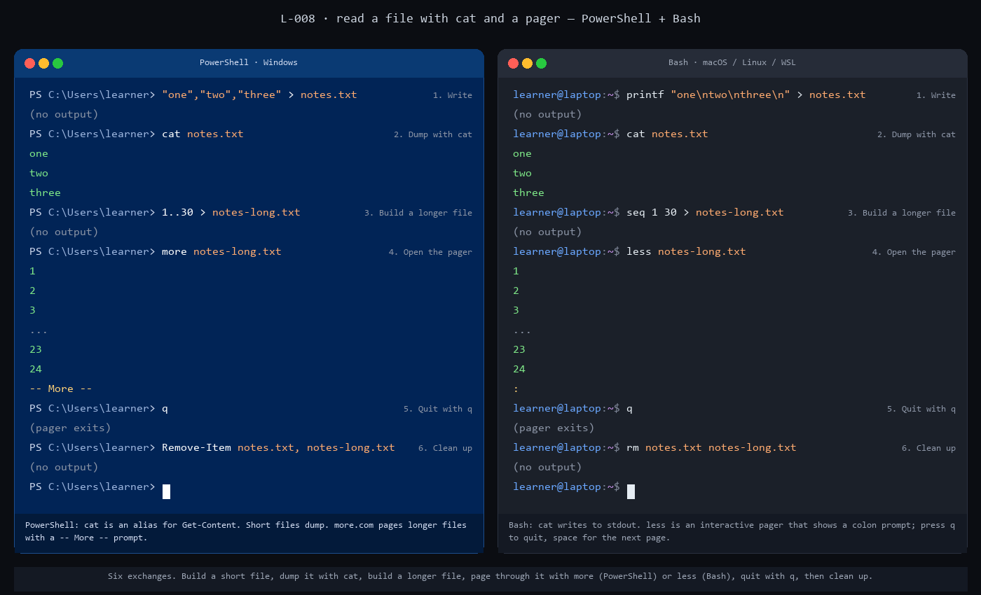
Side-by-side static panel of the 6 exchanges. PowerShell on the left, Bash on the right, with the pager row showing the -- More -- marker (PowerShell) and the colon prompt (Bash)
The keystroke that saves every terminal user about once a week
Type q. No enter required. Every pager in the Unix lineage uses the same quit key, as does man (the manual reader), git log (the commit-history viewer), less, more, and most other interactive command-line tools that display content. Once you internalize q as "get me out of this," you can confidently enter any of those tools and exit them cleanly.
The moment that trips most new learners is the first time they open a pager accidentally. They run a command, the terminal fills with content, the prompt never comes back. They do not know they are inside a pager. They close the terminal, lose their shell state, restart. The fix was always one keystroke: q.
Why PowerShell and Bash both have `cat`
PowerShell ships a handful of Unix-style aliases on top of its own cmdlet names. cat aliases to Get-Content. ls aliases to Get-ChildItem. cp aliases to Copy-Item. The aliases exist so that someone with decades of Unix muscle memory can type familiar words on a Windows machine and have them work. They also mean a Windows learner who picks up a Bash-oriented tutorial can follow along with many of the commands without translation.
Pagers did not get the same treatment. less never shipped with Windows; more.com has been in Windows since the Disk Operating System (DOS) days and was never replaced. If you want the full less feature set on Windows, you install it through Git for Windows or run it inside WSL. This lesson uses whichever pager your operating system ships with by default.
The rule worth remembering
Any command that drops you into a sub-interface, a pager, a text editor, an interactive Python session, holds your terminal until you exit. The exit keystroke varies: q for pagers, Ctrl-X for the nano editor, exit for sub-shells, Ctrl-D for interactive Python. Every tool has one, and if you do not know it, you are stuck.
The habit to build in week two of a career in the Command-Line Interface (CLI): every time you learn a new tool that takes over the screen, write down its exit keystroke before you need it. It is the single most productive thirty seconds you will spend on each tool.
The verification
After the six-line sequence, ls in your home directory should show the same folders it showed before. No notes.txt, no notes-long.txt. If either file is still there, re-run the step 6 cleanup and check again.
If step 4 dumped all thirty lines at once and never showed the pager prompt, your terminal window is tall enough to fit the file. Resize it shorter and retry. Or skip to the full lesson and try the pager on a six-hundred-line system file, which fills any terminal you throw at it.
Full lesson with the full commands, the /etc/services extension, and the failure modes: https://github.com/AriesEmber/Principal-AI-Architect-Curriculum/blob/main/modules/M02-files-editors-and-package-managers/lessons/L-008-read-a-files-contents-with-cat-and-less.md
Tomorrow: nano, the simplest terminal editor, and how to actually change what is inside a file you just read.
#LearnToCode #AIArchitect #SolutionsArchitecture #TerminalBasics #HealthcareAI

GITHUB ARTICLE (full canonical lesson)
Picture a letter arriving in your mailbox. You can unfold the whole thing at once and read it in a glance. You can also hold it at the top, read a page, slide it down, read the next page, and stop whenever you like. A text file works the same way. Today you learn the two verbs for each style of reading: cat dumps the whole letter onto your terminal in one move, and a pager (less on macOS and Linux, more on Windows) hands you one screen at a time. You will build a short file, dump it with cat, build a longer file, open the pager, press q to quit, and clean up.

Side-by-side PowerShell (left, primary) and Bash (right) walkthrough. Six exchanges: write notes.txt, dump with cat, build notes-long.txt, open with more or less, quit with q, clean up
What you will do
Create a three-line text file, read it with cat, create a thirty-line file, open it in a pager, quit the pager with q, then delete both files.
Before you start
You need a terminal open at your home directory, the way L-007: Make and remove directories (capstone) left you. On Windows 11 that is PowerShell showing C:\Users\<yourname>. On macOS or Linux or the Windows Subsystem for Linux (WSL) that is a Bash or Zsh shell showing your home path (/Users/<yourname> or /home/<yourname>). Run pwd once and confirm you are home before starting.
You also need the pager your operating system (OS) ships by default. Windows 11 includes more.com out of the box; every PowerShell install can call it as more. macOS and Linux include less. If you are on Windows PowerShell and want less as well, you can get it from Git for Windows or from a WSL distribution, but this lesson uses the pager your OS already has.
Step by step
Every step shows PowerShell first, because PowerShell is the default shell on Windows 11 and the primary shell of this curriculum. The Bash and Zsh equivalent follows each PowerShell block for readers on macOS, Linux, or WSL.
1. Write a three-line text file
"one","two","three" > notes.txt

PowerShell evaluates the expression on the left side of > as an array of three strings. The > operator sends the array to Out-File, which writes one element per line. The result is a file named notes.txt with three lines of text in your current directory.
Bash equivalent:
printf "one\ntwo\nthree\n" > notes.txt

Bash's printf prints its first argument, interpreting \n as a line break, and the > sends the output to notes.txt instead of the screen. Same three-line file, different path through the shell.
2. Read the file with cat
cat notes.txt

one
two
three

On PowerShell, cat is an alias for Get-Content, which reads the file and writes each line to the screen. On Bash the same command works because cat is a separate program; the name is short for "concatenate," because the original Unix cat was built to join several files end to end. With one file argument, both forms do the same thing: dump every line to the terminal.
Bash equivalent:
cat notes.txt

The output is identical. Three lines on the screen, then the prompt returns, ready for your next command.
3. Build a longer file
A three-line file fits on one screen, so cat is the right verb for it. Real files are often thousands of lines long. To see why pagers exist, build a file that is bigger than your terminal window.
1..30 > notes-long.txt

1..30 is PowerShell's range operator. It produces the integers from 1 to 30, one per line, and > redirects that output to a new file.
Bash equivalent:
seq 1 30 > notes-long.txt

The seq program prints integers in a range, one per line. Same thirty-line file.
4. Open the file in a pager
more notes-long.txt

The terminal fills with the first screen of numbers and shows -- More -- at the bottom. That strip is more.com telling you it is holding the rest of the file and waiting for a keystroke. Press the spacebar to advance one screen, or the enter key to advance one line.
Bash equivalent:
less notes-long.txt

On Bash, less does the same job with a different user interface (UI). You see the first screen of numbers and a single colon (:) at the bottom. That colon is the less command prompt. Space advances a screen, b goes back a screen, arrow keys move one line at a time.
5. Quit the pager
q

Press the q key. No enter needed. The pager exits, the shell prompt returns, and you are back where you started. Both more and less use q for quit. Muscle-memory q is the single most-used pager keystroke in professional Command-Line Interface (CLI) work, because every log viewer, man-page reader, and help-text tool in the Unix lineage uses the same convention.
6. Clean up
Remove-Item notes.txt, notes-long.txt

The comma between the two paths is PowerShell's array syntax. Remove-Item accepts an array and deletes each file.
Bash equivalent:
rm notes.txt notes-long.txt

A space-separated list of paths is how Bash passes multiple arguments to rm. Same result: both files are gone.

Side-by-side static panel of the 6 exchanges in PowerShell (left) and Bash (right), with the pager row showing the -- More -- marker (PowerShell) and the colon prompt (Bash)
Check it worked
Run ls. Neither notes.txt nor notes-long.txt should appear. If one is still there, the step 6 cleanup did not run; re-run it.
If cat notes.txt on step 2 printed something other than one, two, three, the step 1 write did not land as expected. The most common cause on PowerShell is an encoding mismatch: > on older PowerShell versions writes 16-bit Unicode Transformation Format (UTF-16) with a byte-order mark. If you see strange characters, use Set-Content notes.txt "onentwonthree" instead.
If step 4 dumped all thirty numbers at once and never showed the -- More -- or : prompt, your terminal window is tall enough to show the whole file. Resize the terminal shorter and retry, or jump to the extension and use the pager on a longer system file.
What just happened
Two verbs, two styles of reading. cat dumps every byte of a file to the screen and returns control immediately. It is the right choice when the file fits in one glance, or when you want to pipe the contents into another command. A pager shows one screen at a time and holds control until you let it go. It is the right choice when the file is bigger than the screen, when you want to search inside it (/pattern works in both less and more), or when you want to read deliberately.
PowerShell and Bash both recognise cat because PowerShell ships a handful of Unix-style aliases (cat, ls, cp, mv, rm, pwd) on top of its own longer cmdlet names (Get-Content, Get-ChildItem, and so on). Pagers were less lucky: less never shipped with Windows, and more.com has lived in Windows since the Disk Operating System (DOS) days with a much simpler UI. If you need the full less feature set on Windows, install it through WSL or Git for Windows.
The other rule in this lesson is about where control lives. cat gives control back right away. more and less keep control until you press q. Any command that drops you into a sub-interface (a pager, a text editor, an interactive Python session) works the same way: it holds the terminal until you intentionally exit. The keystroke varies (q for pagers, Ctrl-X for nano, exit for shells), and learning each tool's exit verb is part of the price of admission.
Going further
Both more and less really shine on files much bigger than your screen. Linux and macOS ship a file called /etc/services that lists every standard networking service and port, usually around six hundred lines long.
less /etc/services

Press space to page forward. Type /http to search for Hypertext Transfer Protocol (HTTP) entries (forward slash followed by a pattern is the less search syntax). Press q to quit.
Windows ships an equivalent file. From PowerShell:
more $Env:SystemRoot\System32\drivers\etc\services

$Env:SystemRoot is the environment variable that points at the Windows install directory, usually C:\Windows. more paginates through the file the same way.
What's next
Next is L-009: Edit a file with nano. You now know how to read a file two ways; the next lesson is how to change what is inside one, using the simplest terminal editor in wide use.

