L-012 · Install your first tool with a package manager
Module M02 · Files, editors, and package managers · Week 2 day 5

LINKEDIN POST (copy-paste to LinkedIn)
The first command-line tool I installed the "old" way ended up in two folders I could not remember, at two different versions, with one of them broken. The second one I installed through a package manager. That took thirty seconds, worked the first time, and I could remove it in one command. Today you install your first tool that way, and you see a folder the way a book's table of contents shows chapters.
From zero technical knowledge to AI literacy.
Through data, cloud, MLOps, and applied GenAI systems.
Day 12 of 171. Module 2: Files, Editors, and Package Managers (Day 5).
The tool is tree. Its job is to print one root, its sub-folders, and the files under each, as an American Standard Code for Information Interchange (ASCII) outline. Six steps on the Command-Line Interface (CLI): confirm the package manager, install tree, verify the new command, make a small sample folder, drop a file inside it, and run tree.

Side-by-side PowerShell (left, primary) and Bash (right) walkthrough. Six exchanges: confirm the package manager, install tree via winget or brew, verify the install with tree.exe or tree --version, make a practice-cli folder with a src subfolder, drop a README.md inside, run tree on the result
The analogy
Ordering a kitchen gadget online. The catalog is the package manager's repository. The click-to-order is winget install, brew install, or apt install. The box showing up at your door is the binary arriving in a folder your shell already knows about. After today the same three-word command installs every command-line tool you meet in the rest of this curriculum.
The install, side by side
On Windows 11 (PowerShell), tree ships as a GNU's Not Unix (GNU) port named GnuWin32.Tree:
winget install -e --id GnuWin32.Tree

The -e flag forces an exact match on the package ID instead of a substring search. Close that PowerShell window after it finishes and open a fresh one; the installer adds a new folder to the PATH environment variable (PATH), which is the list of folders your shell searches when you type a command name, and a new shell is the simplest way to pick the change up.
On macOS (Terminal), the command is:
brew install tree

On Debian-family Linux or the Windows Subsystem for Linux (WSL), use sudo apt install tree instead. The rest of the lesson works the same way regardless of which you ran.
One cross-platform detail worth knowing
On Windows, typing tree on its own still runs the built-in tree.com in C:\Windows\System32, because that folder comes earlier on PATH than the new GnuWin32 folder. The built-in is a minimal MS-DOS-era version. The GNU port is the one we just installed. To pick it up, name the binary as tree.exe:
tree.exe --version

On macOS and Linux, there is no second tree, so tree --version is enough. This is the first time PATH ordering matters in the curriculum. Tomorrow's lesson (L-013) takes environment variables apart, starting with one you create yourself.
The tiny sample and the payoff
Two more commands build something for tree to draw:
mkdir practice-cli\src
"hi" > practice-cli\README.md

mkdir -p practice-cli/src
echo hi > practice-cli/README.md

Then run tree on it. The GNU binary prints:
practice-cli
├── README.md
└── src

1 directory, 1 file

(On the Windows GNU port the branches render as |-- and ` -- ` instead of ├── and └──`; the meaning is identical.)
That is the whole payoff. Every ├── is a peer entry; every └── is the last entry in a folder. There is no information in the picture that is not on disk, so once you read a tree fluently you can picture a whole project as a small drawing. Most open-source README.md files paste a tree of the repository near the top for exactly this reason.
What you are actually watching happen
A brew install tree or winget install GnuWin32.Tree is three steps in one command. The manager looks up the name in its curated repository, downloads the build that matches your operating system (OS) and processor, and places the binary in a folder the OS already has on PATH. Before package managers were the default on every platform, those three steps were a browser download, an installer wizard, and usually a PATH edit. Every step was a place a version mismatch or a wrong architecture could eat an afternoon. One line, one answer, one version: that is the whole reason package managers won.
There is also a trust story underneath. Installing from a random website means trusting one website, one download, one time. Installing through a package manager means trusting a curated repository with maintainers, a review process, and cryptographic signatures. Microsoft's winget-pkgs, Homebrew's homebrew-core, and the Debian archive each publish their review process and let you audit the source of any package before you install. You usually will not audit, and you do not have to. But when a security advisory lands a month from now, you can name exactly which repository the binary came from. That audit trail is the feature that matters more than speed.
A second tool, same pattern
If you want to confirm the loop is real, install jq the same way.
winget install -e --id jqlang.jq

brew install jq

Then try it on a tiny document:
echo '{"greeting":"hi","count":3}' | jq .

You just installed, verified, and used a second tool in three commands. The pattern does not change as the tools get larger; later in the curriculum the same three steps install Python, Git, and the Terraform binary.
Full lesson with the full command list, the three-things-should-be-true verification, and the cross-shell troubleshooting paths: https://github.com/AriesEmber/Principal-AI-Architect-Curriculum/blob/main/modules/M02-files-editors-and-package-managers/lessons/L-012-install-your-first-tool-with-a-package-manager.md
Tomorrow: set and read your own environment variable, and find out why PATH ordering decided which tree ran.
#LearnToCode #AIArchitect #SolutionsArchitecture #PackageManagers #HealthcareAI

GITHUB ARTICLE (full canonical lesson)
Ordering a kitchen gadget online is faster than driving to the store. You pick it from a catalog, you click once, and a day later it arrives at your door in the right box with the right plug. The package manager you set up yesterday is the same pattern for Command-Line Interface (CLI) tools. You type the name, the manager fetches the right build for your machine, and the new tool is ready in seconds. Today you place the first order. The tool is tree, and its job is to print a folder the way a book's table of contents shows chapters: one root, branches underneath, a clear picture of what contains what. You see your own practice folder as an American Standard Code for Information Interchange (ASCII) outline instead of a flat file listing.

Side-by-side PowerShell (left, primary) and Bash (right) walkthrough. Six exchanges: confirm the package manager, winget install GnuWin32.Tree on PowerShell or brew install tree on Bash, verify the new binary with tree.exe --version or tree --version, make a practice-cli folder with a src subfolder, drop a README.md inside, then run tree on the result to see an ASCII-art outline
What you will do
Install the tree command through your Operating System (OS) package manager, create a small practice folder, and run tree on it to see a branching outline of the folders and files inside.
Before you start
You need to have completed L-011: Install a package manager and your terminal open at your home directory. Run Get-Location (PowerShell) or pwd (Bash) if you need to confirm where you are standing.
This lesson needs the internet. All three package managers from L-011 (winget, brew, apt) reach out to their repositories to fetch the tree package before they can install it. A regular home or office connection is enough.
On Windows, the first winget install asks you to accept the source agreements; press Y and Enter. The prompt only appears once per machine. On macOS, brew install does not ask for a password, because Homebrew owns the folder it installs into (/opt/homebrew or /usr/local).
Step by step
PowerShell commands are shown first because PowerShell is the default shell on Windows 11 and the primary shell of this curriculum. The Bash equivalent follows each PowerShell block for readers on macOS, Linux, or the Windows Subsystem for Linux (WSL).
1. Confirm the package manager is alive
winget --version

brew --version

Expected output is whatever version number L-011 left you on, for example v1.10.320 for winget or Homebrew 4.2.13 for brew. A single version line is the "subscription is live" signal. If you see 'winget' is not recognized or brew: command not found, back up one lesson; nothing below will work until the package manager runs clean.
2. Install tree
Heads up. The next command writes a new program onto your machine and adds its install directory to the system PATH environment variable (PATH), which is the list of folders your shell searches when you type a command name. This is low-risk, signed software from a curated repository, and it is removable with winget uninstall GnuWin32.Tree (Windows) or brew uninstall tree (macOS). Still, it is a real install, not a sandboxed demo.
On Windows, the winget package for tree is a GNU's Not Unix (GNU) port named GnuWin32.Tree. Install it with:
winget install -e --id GnuWin32.Tree

The -e flag is short for --exact and makes winget match the package ID exactly instead of searching by substring. Expected output is three or four lines ending in Successfully installed. Close the PowerShell window when it finishes and open a new one; the install added a folder to PATH, and a fresh shell session is the simplest way to pick it up.
On macOS, run:
brew install tree

Expected output ends with an install-path line like /opt/homebrew/Cellar/tree/2.2.1: 8 files. On Debian-family Linux or inside WSL, use sudo apt install tree instead (you will be asked for your password). The rest of this lesson works the same way after any of the three.
3. Verify the new command
tree.exe --version

tree --version

Expected output is a tree version banner, for example tree v1.7.0 on the GNU port for Windows or tree v2.2.1 on current Homebrew. One cross-platform detail: on Windows, typing tree on its own still runs the built-in tree.com in C:\Windows\System32, because that folder comes earlier on PATH than the new GnuWin32 folder. The built-in has been around since MS-DOS. Adding .exe to the name forces PowerShell to pick up the new GNU port at C:\Program Files (x86)\GnuWin32\bin\tree.exe. On macOS and Linux there is no second tree, so plain tree works.
4. Make a sample folder
mkdir practice-cli\src

mkdir -p practice-cli/src

Both commands create two folders in one go: practice-cli in your home directory, and a subfolder named src inside it. PowerShell's mkdir creates missing parents by default; Bash's -p flag (short for --parents) does the same. Neither shell prints on success.
5. Drop a README inside the folder
"hi" > practice-cli\README.md

echo hi > practice-cli/README.md

The > operator writes a line of text into a new file, the same operator you used in L-010. practice-cli/README.md now contains the word hi and a newline. Silence means the write landed.
6. Run tree on the sample
tree.exe practice-cli

tree practice-cli

Expected output:
practice-cli
├── README.md
└── src

1 directory, 1 file

The GNU port on Windows draws |-- and ` -- ` instead of ├── and └── because the binary targets the Windows console's default code page, but the meaning is identical. Read top-down: practice-cli is the root, README.md is a file inside it, src is a folder inside it. src` is empty, so tree draws nothing beneath it. The bottom line counts one folder and one file.
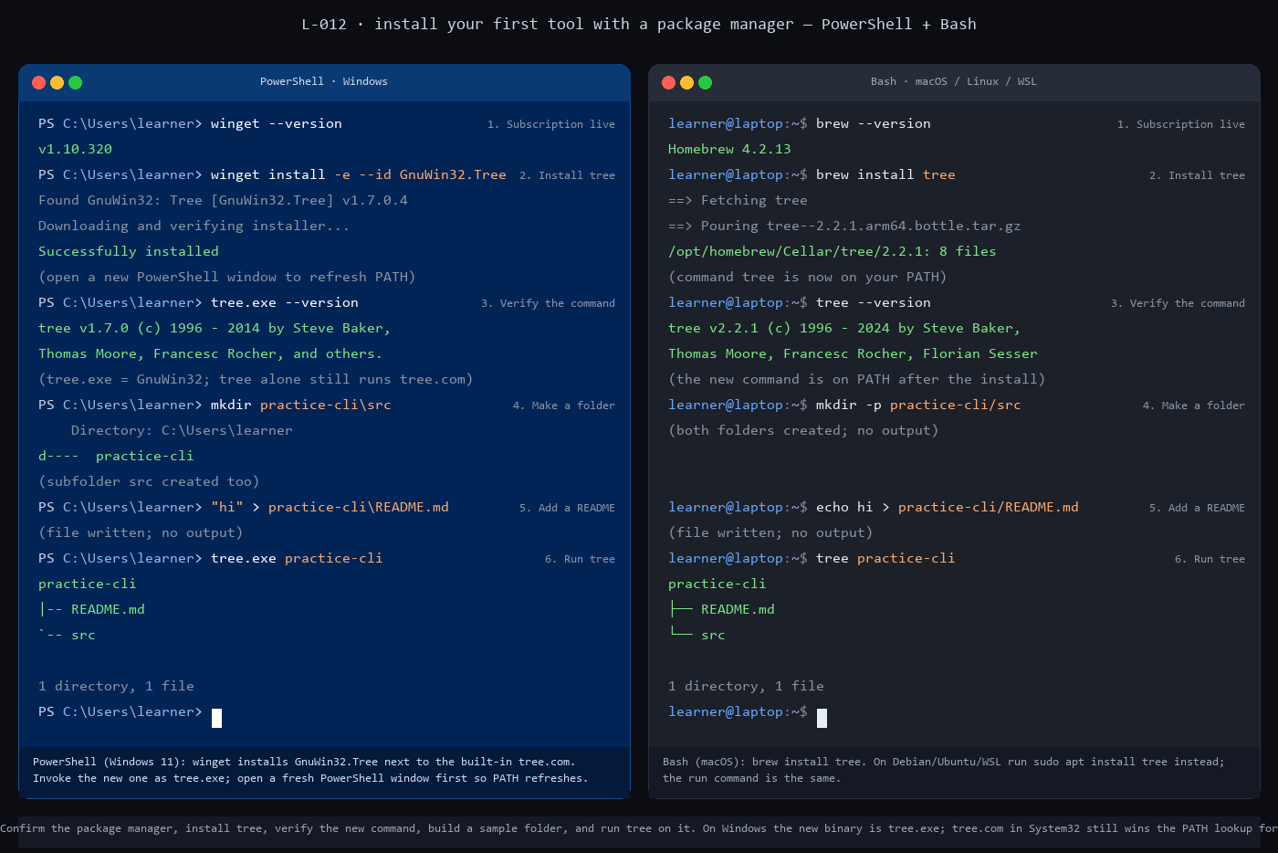
Side-by-side static panel of the 6-exchange walkthrough. PowerShell on the left, Bash on the right, with each exchange showing the command, its output, and a short comment line describing what happened
Check it worked
Three things should be true at the end:
1. tree.exe --version (PowerShell) or tree --version (Bash) prints a tree v... banner. 2. practice-cli exists in your home directory and contains README.md plus a src folder. Run Get-ChildItem practice-cli or ls practice-cli to confirm. 3. tree.exe practice-cli or tree practice-cli prints the ASCII outline above, ending 1 directory, 1 file.
If tree --version returns tree: command not found on macOS or Linux, the install did not finish; re-run step 2 and read the output for an error. If PowerShell prints the Windows built-in's TREE [drive:][path] line instead of a GNU banner, you typed tree instead of tree.exe. If tree.exe itself is not recognized, the new PowerShell window did not pick up the updated PATH; close every PowerShell window, open one fresh, and retry.
If the tree output is empty under practice-cli, the README did not land where you expected. Run Get-Location or pwd to confirm you are in your home directory, then repeat steps 4 and 5.
What just happened
Three ideas carry forward from this lesson.
A package install is three steps in one command. The manager looks up the name in its repository, downloads the build that matches your OS and processor, and drops the binary in a folder the OS already has on PATH. Before package managers were the default, those three steps were a browser download, an installer wizard, and usually a manual PATH edit. The manager collapses all three into one line that either succeeds or prints a specific error.
The new command is on `PATH`, which is why typing its name works. PATH is an ordered list of folders. When you type tree, the shell walks the list and runs the first match. On macOS and Linux, brew install tree drops the binary in /opt/homebrew/bin (or /usr/local/bin), a folder already on PATH, so tree just works. On Windows, winget install GnuWin32.Tree adds a new folder, but C:\Windows\System32 comes earlier and already contains tree.com, so the bare name still runs the built-in. Naming the binary as tree.exe matches on name and extension and skips the ordering problem. L-013 is the full lesson on environment variables; this is the first time the ordering rule matters in practice.
The tree picture maps one-to-one onto folders on disk. Every ├── is a peer entry at the same nesting level; every └── is the last entry inside a folder. There is no information in the ASCII art that is not on your disk. Once you read a tree fluently, you can picture a project layout as a small drawing. Most open-source README.md files include a tree of the repository for exactly this reason.
Going further
Install one more tool with the same pattern to confirm the loop is real. Pick jq, which you will use later to read Uniform Resource Locator (URL) responses that return JavaScript Object Notation (JSON):
winget install -e --id jqlang.jq

brew install jq

On Debian-family Linux or WSL, use sudo apt install jq. Then verify and try it on a tiny JSON document:
jq --version
'{"greeting":"hi","count":3}' | jq .

jq --version
echo '{"greeting":"hi","count":3}' | jq .

Both print jq-1.7.1 (or newer) and a pretty-printed version of the input. You just installed, verified, and used a second tool in three commands. The pattern does not change as the tools get larger; later in the curriculum the same three steps install Python, Git, and the Terraform binary.
What's next
Next is L-013: Set an environment variable and read it back (capstone). You have touched PATH twice already (once when the installer added the tree folder, once when you used .exe to side-step its ordering); L-013 takes environment variables apart with one you create yourself.

