Lesson L-004
Find out where you are with pwd
Module M01: First Contact with the Terminal · Domain D01: Command Line & Environment Fluency · Week 1 · Day 4 · 13 minutes

LinkedIn post (copy-paste ready)
The first time I opened a terminal to do real work, I spent about a minute staring at the prompt before it occurred to me that I had no idea what folder I was in. It turns out there is a four-letter command that answers that question and nothing else, and it is the most-used command I still run on any day.
This is Day 4 of a 171-lesson path I am taking publicly, from zero to a Principal Artificial Intelligence (AI) Architect role. Week one is the command line. Today is the "You Are Here" command. Ten minutes, zero risk, zero files changed.
The analogy I use is the red dot on a shopping-mall map. The dot is useless on its own. What it gives you is the one piece of information you need to plan any route at all: where you stand before you move. Your terminal has the same dot, and the command that shows it is pwd, short for print working directory.

What actually happens
Every running program on your computer has a current working directory attached to it. It is the filesystem location the program treats as its starting point for every file it opens or command it runs. When you open a terminal, the shell inherits one, and for a freshly opened terminal that is your home directory on every mainstream operating system.
pwd prints that value. No calculation, no guessing. The shell already knows the answer. pwd just asks for it and reads it back, as a single line starting with / on macOS and Linux or C:\ on Windows PowerShell.
Three small things to try while you have the terminal open
- Type pwd and press Enter. Read the line that comes back.
- Open a second terminal window and run pwd again. It prints the same line. Fresh terminals always start in the home directory.
- On macOS or Linux, run pwd -P. In a plain home directory the answer is the same, but that flag asks for the physical path on disk with symbolic links resolved. It starts to matter the first time you work inside a repository that lives behind a shortcut.
On Windows PowerShell, pwd is not a separate program. It is an alias for Get-Location. Get-Command pwd will show you that. The command-response rhythm and the absolute-path answer are identical.
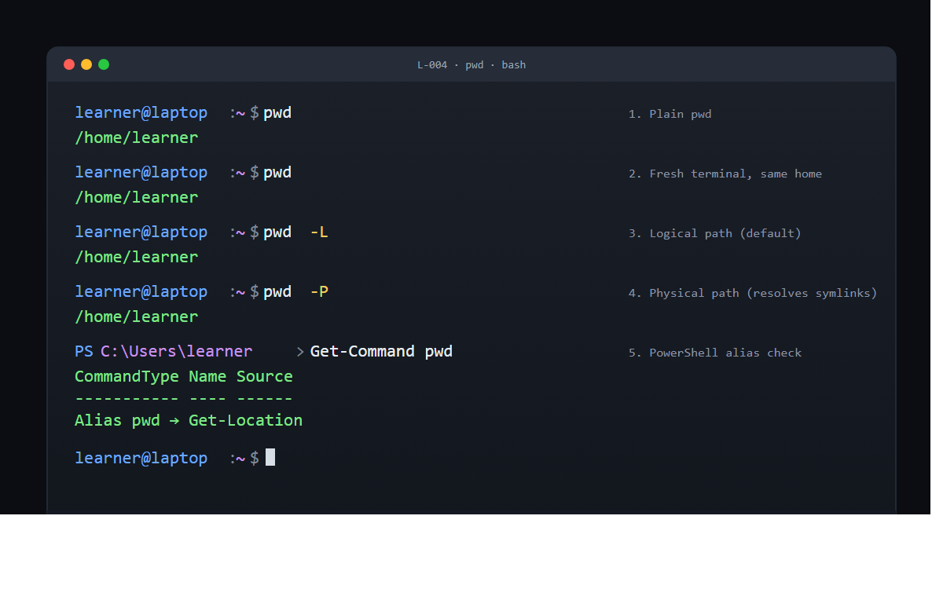
Why this is the first command in every troubleshooting guide
Knowing where you are matters because every other command at the Command-Line Interface (CLI) treats the working directory as the default starting point. Listing files with ls reads from the working directory. Changing directory with cd .. moves relative to it. Running a script written as ./build.sh resolves that ./ against it.
If you do not know where you are, you do not know what those short names actually point at. pwd is the safety check before anything else. It is why, when you post a command-line question anywhere online, the first follow-up is almost always "what does pwd say?"
The answer is always an absolute path. A route from the root of the filesystem to where you stand. Absolute paths never depend on context. That is the whole reason pwd returns one.
The command-response rhythm, again
This is the same rhythm from the echo lesson. You type one line, press Enter, read back one line, and the prompt returns. Argument in, result out, prompt back, ready for the next one.
The answers get more useful as the week goes on. pwd answered "where am I?" Tomorrow, ls will answer "what is around me here?" After that, cd lets you move, mkdir lets you build, and by the end of week one you are setting up a small project directory end to end.
But the rhythm does not change. This is the full pattern of every interaction at a command line, in every major shell, across every operating system a principal architect will ever touch. Python will feel like this. Git will feel like this. The AWS CLI, Azure CLI, and Google Cloud CLI will feel like this.
The verification
If pwd printed one line starting with / or C:\, on the row directly below your command, with the prompt returning after it, the lesson is done. If it said command not found or 'pwd' is not recognized, you typed it wrong (four letters: p, w, d). Retype and try again.
Ten minutes. One command. One line of output. The answer to the question the terminal has been quietly holding the whole time you have been reading this.
Full lesson on GitHub
Try it and tell me what your pwd returned. The shape of that path tells us which operating system you are on and which week-two lesson will matter most to you.
#LearnToCode #AIArchitect #SolutionsArchitecture #TerminalBasics #HealthcareAI

GitHub article (full lesson)
Every shopping mall has a floor map with a red dot on it and the words "You Are Here." The dot is useless on its own. What it gives you is the one piece of information you need to plan any route at all: where you stand before you move. Your terminal has the same dot. It is a four-letter command called pwd, short for print working directory, and it is the first thing a Command-Line Interface (CLI) learner reaches for when they are not sure where they are. You are about to ask it for the dot.


What you will do
Type pwd, press Enter, and read back the absolute path of the folder your terminal is currently standing in.

Before you start
You need an open terminal window from L-003: Print your first line with echo, sitting at its default prompt. If you closed it, open a new one. Nothing else is required. No files will be created, nothing will be downloaded, no settings will change. pwd is a read-only question: it reads the shell’s current state and prints the answer.
If your prompt ends in $ (Bash on Linux, Windows Subsystem for Linux), % (Zsh on macOS), or > (PowerShell on Windows), you are in the right place. Every command below works identically on all three.

Step by step
Each step is one line typed at the prompt, followed by pressing Enter. You do not need to type the prompt itself; only the characters after it.

1. Ask where you are
Type:
pwd
You will see a single line of text, starting with / on macOS or Linux, or with C:\ on Windows PowerShell. For example, on a freshly opened terminal on a Linux or macOS laptop:
/home/learner
On a Mac:
/Users/learner
On PowerShell:
C:\Users\learner
The prompt returns on the line below, ready for the next command.

2. Read the path character by character
Look at what came back. It is not random. It is a route from the root of the filesystem (the / on Linux and macOS, or the drive letter C:\ on Windows) through each nested folder, separated by / or \, down to the folder your terminal is standing in.
Three pieces are worth noticing:
- The leading separator. / says "start at the root of the filesystem." C:\ says "start at the root of the C drive." Both are absolute: they do not depend on where you are.
- The segments. Each folder name between separators is one step further in.
- The final segment. The last name is the folder you are actually in. On a fresh terminal, that is almost always your own username.

3. Write the path down
Copy the line somewhere you can read it later: a sticky note, a text file, the top of a notes document. You will refer back to the home path in the next three lessons.

4. Ask a second time in a new window
Open a second terminal window (the same shortcut you used in L-001). Run pwd again in it:
pwd
You will see the same line as the first window. Every fresh terminal starts in the home directory on every major Operating System (OS). Opening a new window is not the same as moving somewhere new.

5. Optional: see the logical and physical paths
On macOS and Linux, pwd takes two flags worth knowing about:
pwd -L
pwd -P
-L is the default and prints the logical path (the route the shell thinks you took). -P prints the physical path (the real location on disk, with any shortcut links resolved). In a plain home directory they return the same thing. They start to differ once you work inside a repository that was mounted through a symbolic link, which will happen later in the curriculum.
On Windows PowerShell, pwd is not a separate program. It is an alias for Get-Location. You can confirm that with:
Get-Command pwd
The output names pwd as an alias and Get-Location as the real command. The answer it gives is identical.


Check it worked
After step 1, a single line should print on the row directly under your command, starting with / on macOS or Linux, or with C:\ on Windows. The prompt should return on the line after that. If that happened, the lesson has already done its job.
If you saw command not found: pwd or 'pwd' is not recognized, you typed it wrong. It is four letters: p, w, d, in that order. Retype and press Enter again.
If the output is blank, or you see an error mentioning "no such file or directory" before you have run any other command, the folder your terminal started in was deleted or unmounted from under it (rare on a fresh terminal). Close the window and open a new one; it will start in your home directory with no trouble.

What just happened
Every running program on your computer has a current working directory attached to it. It is the filesystem location the program treats as its starting point for every file it opens or command it runs. When you open a terminal, the shell, the program that is reading your keystrokes, inherits a working directory from whatever started it. For a freshly opened terminal, that is your home directory on every mainstream operating system.
pwd prints that value and nothing else. There is no lookup, no guess, no calculation. The shell knows the answer already; pwd just asks for it and reads it back.
Knowing the working directory matters because every other command you run treats it as the default starting point. Listing files (ls), changing directory (cd ..), editing a file by a short name like notes.txt, running a script written as ./build.sh, all of these resolve their names against the working directory. If you do not know where you are, you do not know what those short names actually point at. pwd is the safety check before anything else.
The answer is always an absolute path, a route from the root of the filesystem to where you stand. Absolute paths never depend on context. That is why pwd is the first command any shell hands you, and it is why every troubleshooting guide on the internet eventually asks for its output.

Going further
Open a third terminal window and before running any other command, run pwd. Confirm that the path is the same as the first two. That consistency is a real property of the shell, not a coincidence: the operating system chooses the home directory as the default starting place for any new interactive shell.
Then, on Linux or macOS only, run:
pwd -P
In a plain home directory, the output is identical to plain pwd. Later, when you clone a Git repository into a folder that is actually a symbolic link to storage somewhere else, pwd -P will show the real storage path while plain pwd shows the friendlier link path. Both answers are correct; they are just answering slightly different questions.
On PowerShell, run:
$PWD | Get-Member
$PWD is the object PowerShell uses under the hood for the current location. Get-Member lists every property and method it carries. You do not need to understand the list yet; it is a reference point for later lessons on PowerShell objects.

What's next
Next is L-005: List the contents of a directory with ls. Now that you know where you stand, you are ready to look around.

