Lesson L-001
Open the terminal with a keyboard shortcut
Module M01: First Contact with the Terminal · Domain D01: Command Line & Environment Fluency · Week 1 · Day 1 · 10 minutes

LinkedIn post (copy-paste ready)
The first time I tried to "open the terminal" I wasted ten minutes hunting through menus. Three keystrokes would have done it.
This is Day 1 of a 171-lesson path I am taking publicly, from zero to a Principal Artificial Intelligence (AI) Architect role. Week one is the command line. Lesson one is the keyboard shortcut that opens the terminal on any operating system you are likely to have in front of you. It is ten minutes of work. It is the single highest-payoff keyboard motion in the whole field, and I skipped past it for years because I thought "learning the terminal" started with commands.
Here is the analogy I keep coming back to. The terminal is the kitchen of your computer. The door is closed most of the time. You can see the rest of the house, the windows and menus and apps, but the kitchen is sealed. Nothing gets cooked in there until someone actually opens the door. Every professional who works with servers, cloud infrastructure, or AI systems spends their day in that kitchen. The first skill, before any command or syntax, is opening the door.

What you are about to do
Open the built-in terminal application on your computer using only your keyboard, on whichever Operating System (OS) you are sitting in front of, and leave the window on screen for the next lesson.
Three keystrokes. Pick the block that matches your machine.
On macOS
Press Command plus Space. A small search panel, Spotlight, appears in the middle of the screen. Type the word terminal. Press Return.
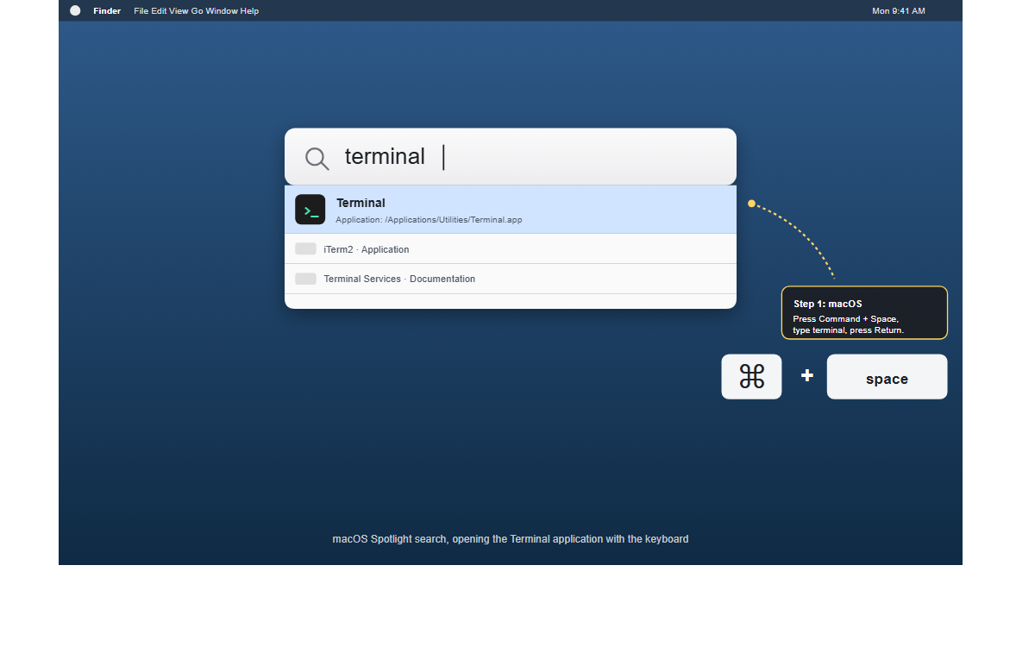
On Windows 11
Press the Windows key (bottom-left, the one with the four-square logo). The Start menu opens with a search box at the top. Type the word terminal. Press Enter.
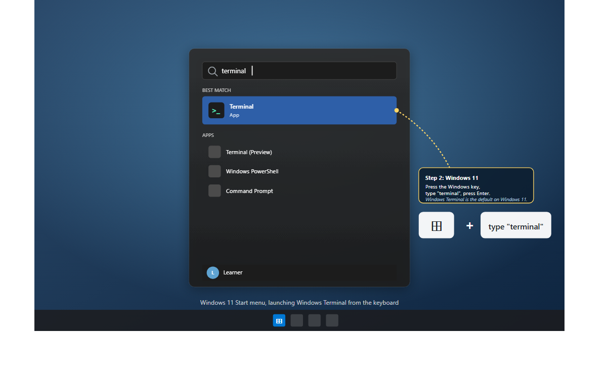
Windows 11 ships Windows Terminal as the default. If you are still on Windows 10 you may see Command Prompt or Windows PowerShell at the top instead. Either is fine for Day 1; pick whichever is highlighted.
On Linux (GNOME)
Press the Super key (same physical key as Windows). The Activities overlay opens with a search bar. Type the word terminal. Press Enter.
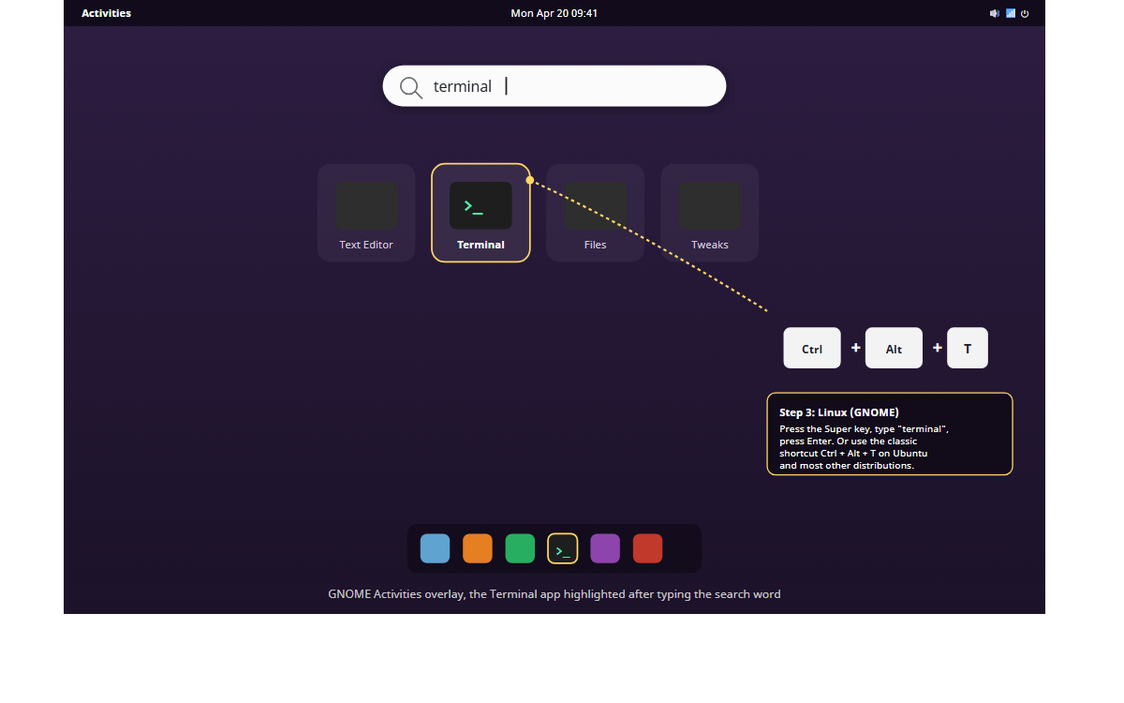
Most distributions also honor Ctrl plus Alt plus T as a direct keypress, no search required. If that combo does nothing, the search path above always works.
How you know it worked
You have a window on screen with its own title bar, a line of text ending in a dollar sign, percent sign, or greater-than sign, and a cursor to the right of that text, blinking on and off about once a second.
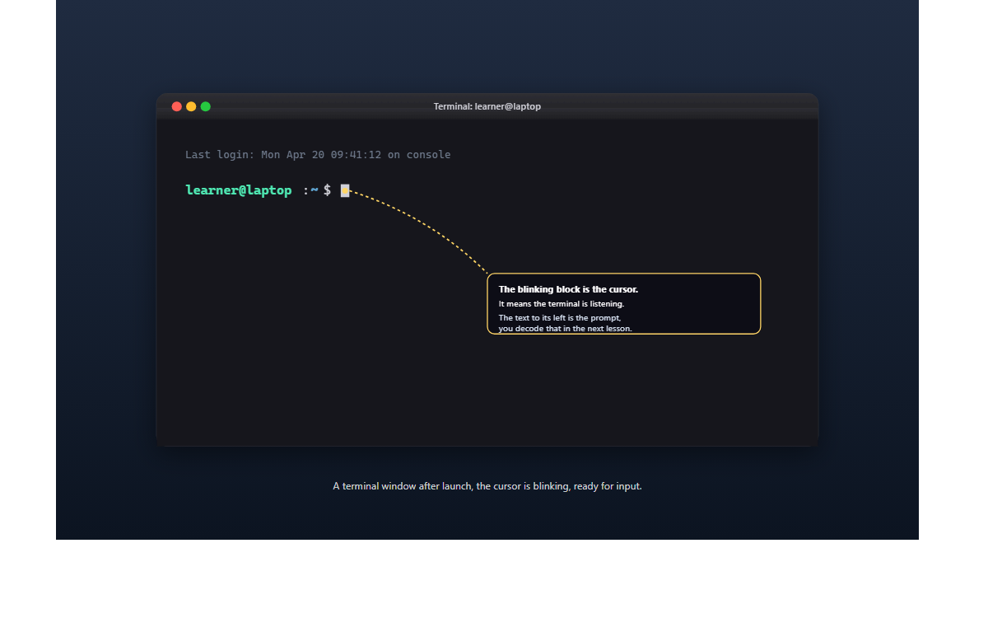
If all three are there, the door is open.
If the search returns nothing for the word terminal, your shortcut may be rebinding. Open Settings, look for Keyboard Shortcuts, and confirm the system-wide search is still set to default. The slower fallbacks, Finder > Applications > Utilities on macOS, the Start menu mouse click on Windows, the app grid on Linux, all still work. But reaching the terminal with three keystrokes is worth the minute it takes to remember.
Why this tiny skill is worth writing about
You launched a Command-Line Interface (CLI) program. A CLI is any program whose primary way of taking input is text typed at a prompt, not a mouse pointer aimed at a button. The Terminal application is the container for that text. Every interesting thing a Principal AI Architect does, running code, moving files around, talking to a cloud, training a small model, happens inside some form of this window.
Reaching for the mouse to hunt through menus breaks the rhythm of typing. Reaching the terminal with three keystrokes, and leaving the mouse alone, is the first rep of a motion you will repeat many thousands of times if you stay in this work. Rep one is today.
I am writing every lesson as if someone who has never touched a terminal is about to follow along in real time, on a Monday night, after a full day of their regular job. That is who I was two years ago. The curriculum is 26 weeks, 12 domains, 171 lessons. It ends with a full Principal-level architecture portfolio: a reference architecture, a solution design document, a cost model, and a recorded walkthrough explaining the design to a non-technical audience. Getting there requires that the first ten minutes are not intimidating. So the first ten minutes are three keystrokes and a blinking cursor.
Leave the window open. Lesson two is reading the prompt, the line of text to the left of the cursor that tells you where you actually are.
Full lesson on GitHub
Try it and tag me when the cursor is blinking.
#LearnToCode #AIArchitect #SolutionsArchitecture #TerminalBasics #HealthcareAI

GitHub article (full lesson)
Think of the terminal as the kitchen of your computer. The door is closed most of the time. You can see the rest of the house, the windows and menus and apps, but the kitchen is sealed. Nothing gets cooked in there until someone actually opens the door and walks in. Every professional who works with servers, cloud infrastructure, or Artificial Intelligence (AI) systems spends their day in that kitchen. The first skill, before any command or syntax, is opening the door. You are about to do exactly that, using only your keyboard, on whichever Operating System (OS) you use.


What you will do
Open the built-in terminal application on your computer using a keyboard shortcut, and leave the window on screen for the next lesson.

Before you start
This is the first lesson, so there is no prior lesson to check. What you need is simpler than that:
- A personal computer running macOS, Windows 11, or a recent Linux distribution with the GNOME desktop (Ubuntu, Fedora, or Debian all qualify).
- A regular user account on that machine. You do not need administrator rights for this lesson. You do not need to install anything.
- Five to ten minutes of quiet time.
If you are borrowing a locked-down work laptop that blocks the built-in terminal, stop and use a personal machine instead. Everything in this curriculum assumes you can open the terminal without a ticket to IT.

Step by step
Pick the block that matches your Operating System. Run those three keystrokes and nothing else for now.

On macOS
- Press Command + Space. A small search panel appears in the middle of your screen. This is Spotlight.
- Type the word terminal. The top result is the built-in Terminal application.
- Press Return. The Terminal window opens.


On Windows 11
- Press the Windows key (the one with the four-square logo, bottom-left of the keyboard). The Start menu appears with a search box at the top.
- Type the word terminal. The top result under "Best match" is Windows Terminal.
- Press Enter. The Terminal window opens.

Windows 11 ships with Windows Terminal as the default terminal application. If you are on Windows 10, you may see "Command Prompt" or "Windows PowerShell" at the top instead. Either is fine for this lesson; pick whichever is highlighted.

On Linux (GNOME)
- Press the Super key (the Windows key, by another name). The Activities overlay appears with a search bar at the top.
- Type the word terminal. The top result is GNOME Terminal, shown as Terminal with a square icon.
- Press Enter. The Terminal window opens.

Most Linux distributions also honor the shortcut Ctrl + Alt + T as a direct keypress to open a terminal, skipping the search entirely. If that combination does nothing on your distribution, the search-based path above always works.

Check it worked
A Terminal window is on your screen. It looks something like this:

Three specific things should be visible.
- A window with its own title bar and controls, separate from your browser and other applications.
- A line of text ending in a character like $, %, or >. That line is called the prompt. You decode it in the next lesson.
- A cursor to the right of the prompt, blinking on and off about once per second.
If all three are there, you are in.
If nothing happens when you press Enter in the search box, the shortcut may be rebinding. Open Settings, look for "Keyboard shortcuts," and confirm that the system-wide search shortcut is still set to the default. If the search returns no result for the word terminal, your system may use a different name for it. On macOS, you can also open Finder, navigate to Applications, then Utilities, and double-click Terminal. On Windows 11, open the Start menu with the mouse and scroll to Windows Terminal under the pinned apps. On Linux, open the app grid and look under System Tools. These fallbacks are slower than the keyboard, which is exactly why the keyboard shortcut is worth the minute it takes to remember.

What just happened
You launched a Command-Line Interface (CLI) program. A CLI is any program whose primary way of taking input is text typed at a prompt, not a mouse pointer aimed at a button. The Terminal application is the container for that text. Everything else in this curriculum, running code, moving files around, talking to a cloud, training a small model, happens inside some form of this window.
Using the keyboard to open the terminal is a small choice with a long payoff. Every time you reach for the mouse to hunt through menus, you break the rhythm of typing. Reaching the terminal with three keystrokes and leaving the mouse alone is the first rep of a motion you will repeat many thousands of times.
Leave the window open for the next lesson.

Going further
If the text in the terminal looks too small to read comfortably, fix that now. Eye strain is the reason people stop practicing.
- macOS Terminal: Press Command + , (comma) to open Settings. Under the Profile tab, set Font to a size between 14 and 16 points.
- Windows Terminal: Press Ctrl + , (comma) to open Settings. Under Defaults, set Font size to 14 or 16.
- GNOME Terminal: Open the hamburger menu in the top-right corner, choose Preferences, then set Font to 14 or 16.
Then resize the window by dragging a corner until it covers about half your screen. That is the size you will use for every lesson in this module.

What's next
Next is L-002: Read a prompt like a sign at a train station, where you learn to decode the text to the left of the cursor so the prompt stops being a mystery and starts being a map.

