CPC 223 B – Web Application and Development

*(Activity number)*

**TASK CONTRIBUTION**

**Subject and Section: CPC 223 B - 2A**

**Leader: Tagle, Aries Joseph V.**

**Members: (Alphabetically arranged by Surname)**

Beltran, Mark John  
Buglosa, Kriesha Mae  
David, Kian Perez  
Roldan Jr , Willie S

1. **Task of each members of the group: (Bullet Form)**

Beltran, Mark John (7/10)

* Designer

Buglosa, Kriesha Mae(9/10)

* CSS/HTML

David, Kian Perez (9/10)

* CSS/HTML

Roldan Jr , Willie S: (10/10)

* CSS

1. **Screenshots of Meeting, Discussion, Tasking (via Message or Call), Brainstorming etc.**

---Meetings were done in the campus, off camera---

Design Passing:

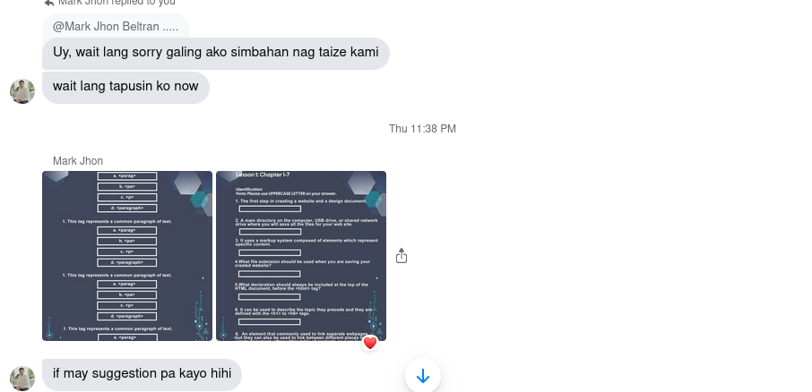

Initial CSS Passing:

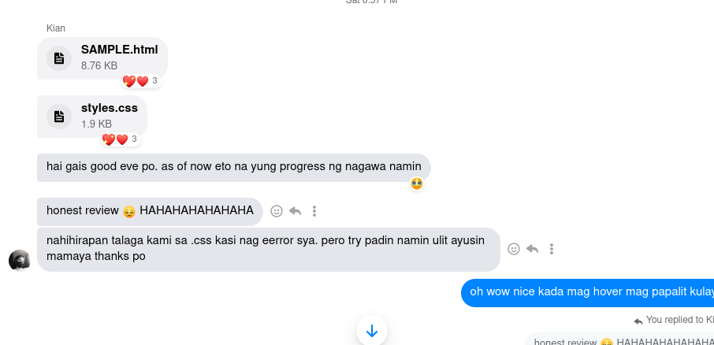

Suggestion Passing:

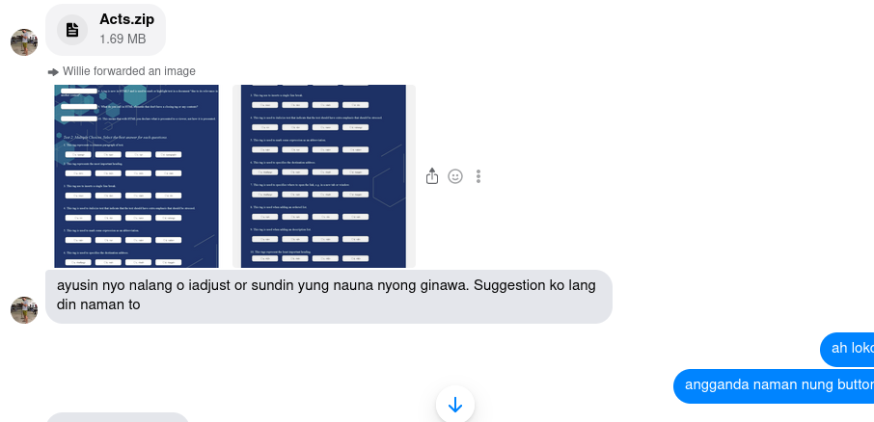HTML Passing

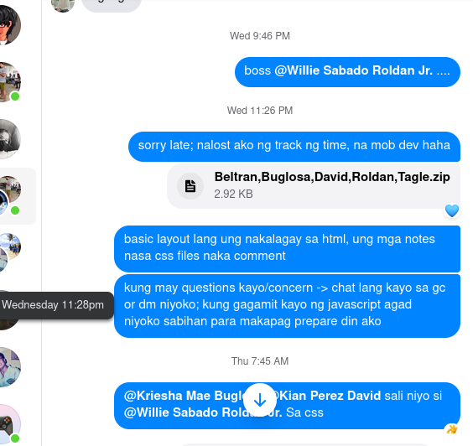

Final Product send

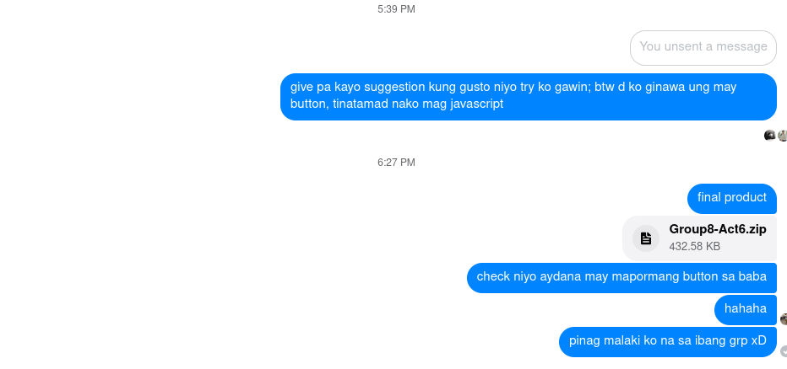

Meetings of the designers/css:

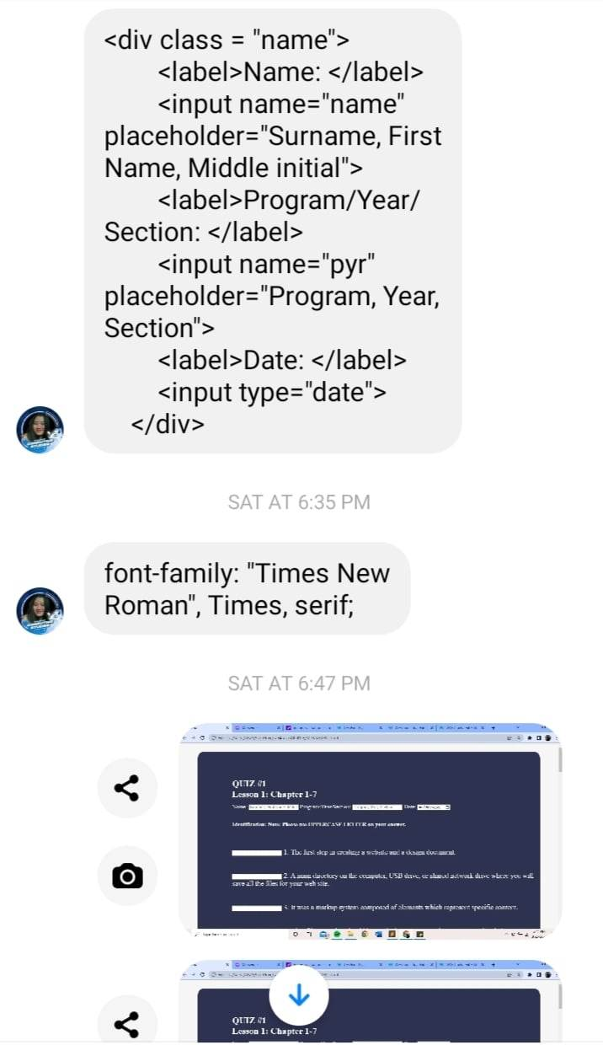

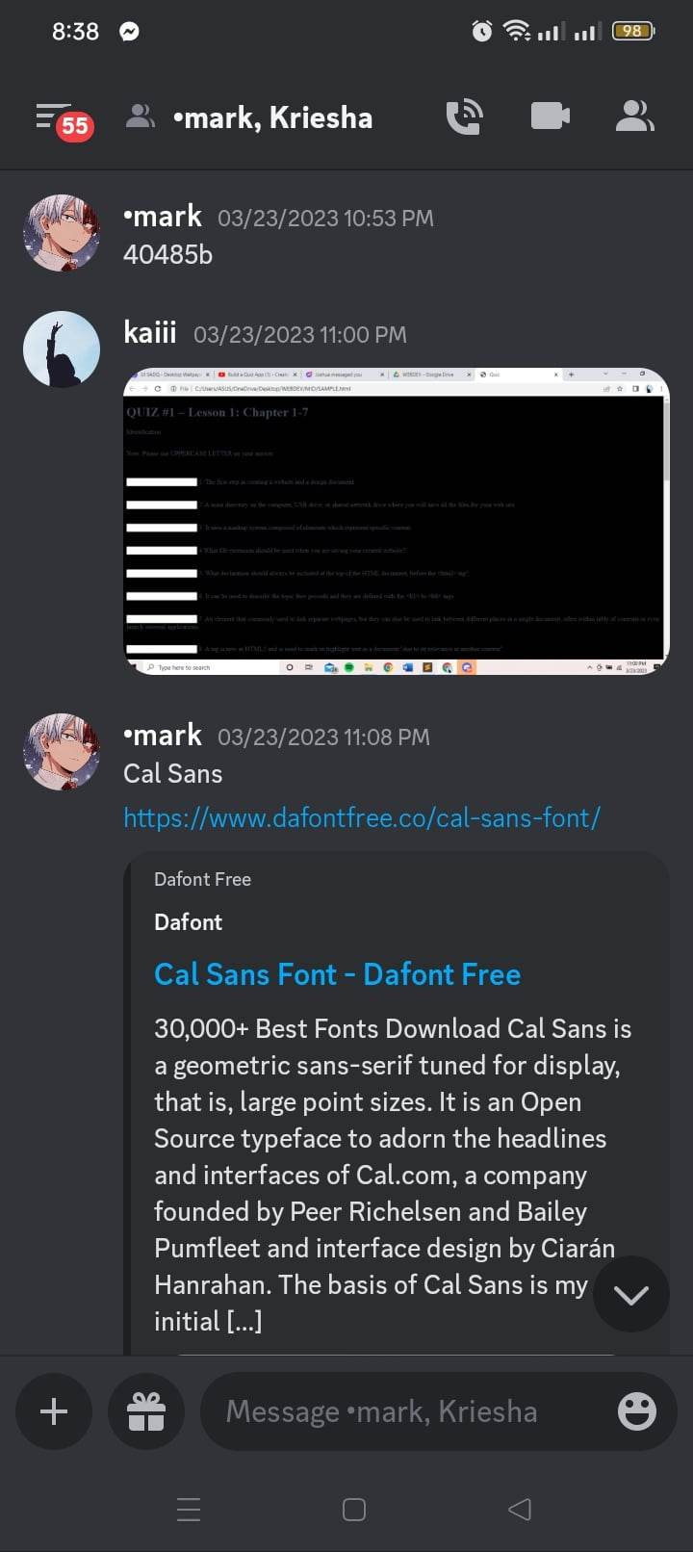

SCORE: _____________