Road Safety Runner
Semester Project Report
A 2D educational road safety game developed in Unity
Student Name | ____________________________
Roll Number | ____________________________
Course / Subject | ____________________________
Teacher / Instructor | ____________________________
Submission Date | ____________________________
Developed using Unity and C#

Contents
- Project Title
- Introduction
- Objective
- Game Story / Concept
- How to Play
- Game Features
- Tools Used
- Scripts Used
- Win and Lose Conditions
- Screenshots
- Conclusion

Project Title
Road Safety Runner

Introduction
Road Safety Runner is a simple 2D educational game created in Unity. The game focuses on teaching basic road safety awareness through interactive gameplay. The player has to cross a road, avoid moving cars, collect safety signs, and reach school safely before the timer ends.
The project was designed as a beginner-friendly semester project. It includes essential game development concepts such as player movement, collision detection, UI, audio, scene management, win and lose conditions, and build/export for Windows.

Objective
The main objective of this project is to create a playable 2D game that teaches safe road crossing behavior in an engaging way.
- Teach the player to avoid traffic while crossing the road.
- Encourage the player to collect safety signs before reaching the school.
- Use lives and a timer to make the game challenging.
- Provide clear feedback through messages, sounds, and game screens.
- Build a complete game with main menu, gameplay, win screen, and game over screen.

Game Story / Concept
The player represents a student or runner who wants to reach school safely. The school is located at the end of the road. Before reaching the school, the player must collect five safety signs placed on the road. These signs represent road safety knowledge and awareness.
The road contains moving cars that act as obstacles. If the player touches a car, one life is lost and the player returns to the start position. The player must make careful decisions, collect all safety signs, and reach the finish point within the time limit.

How to Play
- Start the game from the Main Menu by clicking the Start Game button.
- Move the player using the Arrow Keys or WASD keys.
- Avoid red cars moving across the road.
- Collect all five orange safety signs.
- Reach the school / finish point after collecting all signs.
- Complete the level before the timer reaches zero.

Controls
Control | Action
Arrow Keys / WASD | Move the player up, down, left, and right
Start Game Button | Open the gameplay scene
Try Again / Play Again | Restart the game scene
Main Menu Button | Return to the main menu
Quit Button | Exit the game

Game Features
Feature | Description
Main Menu | The game starts from a menu with Start Game and Quit buttons.
Player Movement | The player can move freely using Arrow Keys or WASD.
Moving Cars | Cars move across the road and act as traffic obstacles.
Lives System | The player starts with three lives and loses one life after touching a car.
Safety Sign Collection | The player must collect five safety signs before winning.
Timer System | The player must complete the level before the time runs out.
Warning Message | If the player reaches school without collecting all signs, a message appears.
Win Screen | A win screen appears after collecting all signs and reaching school.
Game Over Screen | A game over screen appears when lives finish or the timer reaches zero.
Sound Effects | The game includes background music, button click, hit, collect, win, and game over sounds.
Visual Polish | The road includes center lines, zebra crossing, grass sides, cars, safety signs, and school area.

Tools Used
- Unity 6 - game engine used to create the 2D game.
- C# - programming language used for scripts and game logic.
- TextMeshPro - used for clear UI text, buttons, lives, signs, timer, and messages.
- Unity 2D Sprites - used to create the road, cars, player, grass, safety signs, and finish area.
- AudioSource Component - used to play background music and sound effects.
- Pixabay audio resources - used for background music and sound effects.
- Windows Build Profile - used to export the final game as a Windows executable.

Scripts Used
Script Name | Purpose
PlayerController.cs | Controls player movement using keyboard input. It also detects collisions with cars, safety signs, and the finish point.
CarMovement.cs | Moves each car horizontally and loops it back to the opposite side when it reaches the road limit.
GameManager.cs | Manages lives, timer, safety sign count, messages, sound effects, win condition, and game over condition.
MenuManager.cs | Controls menu buttons, scene loading, quit function, and button click sound effects.

Win and Lose Conditions

Win Condition
The player wins the game after collecting all five safety signs and then reaching the school / finish point. When this condition is completed, the Win scene opens and the win sound plays.

Lose Conditions
- The player loses if all three lives are finished after hitting cars.
- The player loses if the timer reaches zero before reaching the school.
- The Game Over scene appears when any lose condition is triggered.

Validation Message
If the player reaches the school without collecting all safety signs, the game shows the message: "Collect all safety signs first!" The player must then continue collecting the remaining signs before winning.

Screenshots
The following screenshots show the main screens and gameplay of Road Safety Runner.

Main Menu
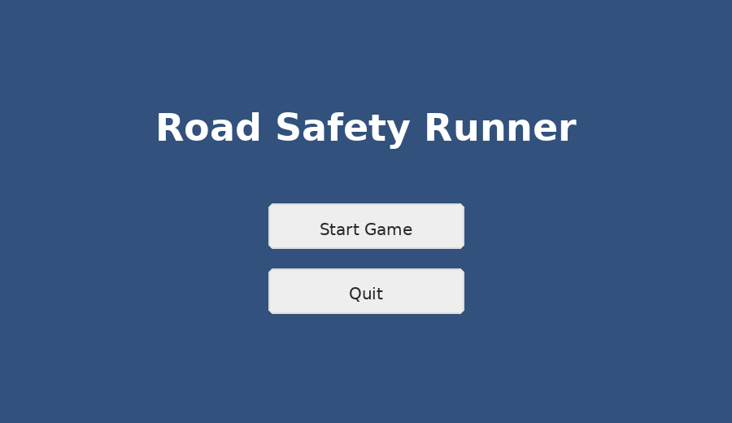
Figure 1: Main Menu screen with Start Game and Quit buttons.

Gameplay
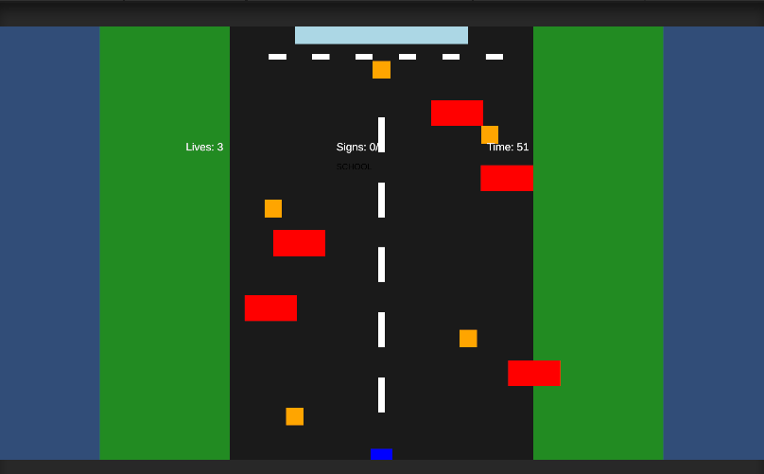
Figure 2: Gameplay screen showing road, cars, safety signs, lives, timer, and finish area.

Win Screen
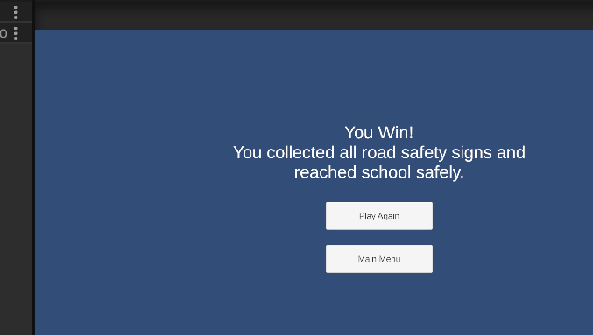
Figure 3: Win screen shown after collecting all safety signs and reaching school.

Game Over Screen
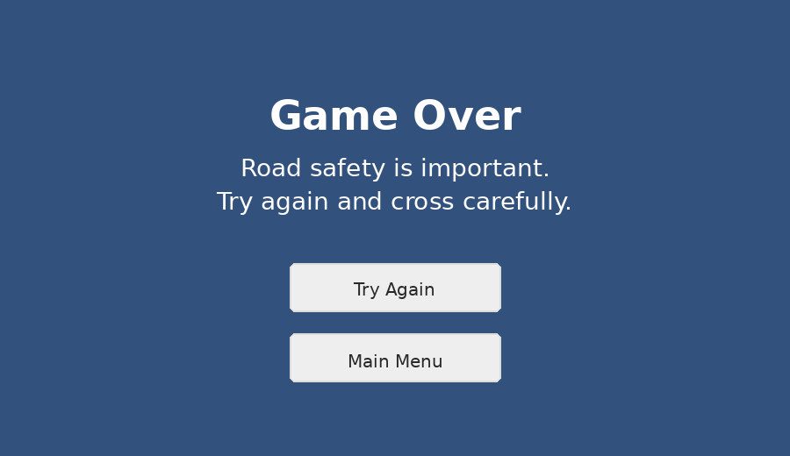
Figure 4: Game Over screen layout with Try Again and Main Menu options.

Conclusion
Road Safety Runner successfully demonstrates the development of a complete 2D Unity game. The project includes important game development elements such as player movement, obstacles, collisions, UI, timer, audio, multiple scenes, win and lose conditions, and Windows build export.
The game also communicates an educational message about careful road crossing, traffic awareness, and safe travel to school.

