

**American International University- Bangladesh**

**Software Engineering**

**Project Report**

**Fall 2019-2020**

**Project Title: Blood Management System**

**Section: J**

|  |  |
| --- | --- |
| Student Name | Student Id |
| Arif Ahmed | **18-37994-2** |
|  |  |
|  |  |
|  |  |

**Content List :**

|  |  |
| --- | --- |
| No.1 | Introduction |
| 1.1 | Background Study |
| No.2 | **Analysis and Problems** |
| 2.1 | Stack Holder |
| 2.2 | Requirements |
| 2.2.1 | User Requirements |
| 2.2.2 | Functional Requirements |
| 2.2.3 | Perfomence Requirements |
| No.3 | **Design** |
| 3.1 | Er Diagram |
| 3.2 | Class Diagram |
| 3.3 | UseCase Diagram |
| 3.4 | StateChart Diagram |
| 3.5 | Ui Design |
| No.4 | **Implementtion** |
| No.5 | **Conclusion** |
|  |  |

**1. Introduction:**

These projects are designed to make us think what we are learning in a slightlyh dofferent way, and to gain practice according to our backgroud study. It is meant to take a while and usually students benefit from working in group

**1.1 Background Study**

The *BLOOD LOBBY MANAGE,ENT SYSTEM* is a great project. This project is ddesigned for successful

completion of a project on blood bank management system.

*The* basic building aim is to provide blood donation service to the city recently. Blood lobby managemt system (BLMS) is a web based application that is designed to store,process,retrieve and analyze information concerned with the administrative and inventory manage,ent with a blood bank.

This project aims at maintaining all the information pertaining to blood donors, different blood groups available in each blood bank and help them manage in a better way.

Project Aim is to provide transparency in this field, make the process of obtaining blood from a blood bank hassle-free and corruption-free and make the system of blood bank management effective

For hospitals,a blood bank known as blood collection center, also is an area in which collected blood bags are stored and preserved for future use in blood transfusion services, Blood transfusion is a medical operation where a patient requires blood or blood product as a life saving measure.

Most blood banks are still running manual system in its processes. As such, there is a lack of efficiency because it is still paper-based on collection information about donors, inventories of blood bags, and blood transfusion services. The lack of proper documentation may in danger patient.s health due to the possibility of having contamminate blood bags shelf life is not monitoried proprly. Hence, a web based blood bank management system might be needed to adderess these issues and problems encountered ro ensure blood transfusion safety*.*

The Blood lobby management system project report contain information related to blood like

* Blood type
* Date of Donation of blood
* validity of Blood’s
* Available Blood group

**2. Analysis and Problems:**

It was difficult to set the JDK information on the system in the mean time. Moreover it was a time consuming affair if a person is new to start working with java.

* It was difficult to solve the problems those were arising during a particular installation of the software because of hardware compatibility issues.
* Moreover there is usage an issue concerned with the software .This issue has been resolved by the WEB-IDE by providing Integrated Environment facility to its users.
* This system provides the feature of uploading a java file already on the local machine of the user or he can make altogether a new java program using this IDE and save it on his local machine also..

**2.1 Stack Holder :**

1. **User Category:**

There are 2-types of Users here. They are:

* Admin
* Normal User

1. **Feature List:**

In this project the “Admin” has the following features:

* Dashboard
* Donated User List
* Donor List
* Add donor
* Update Contact
* Change Password

In this project the “Normal User” has the following features:

* Donor Regestration
* Login
* View Request
* Send Request
* Search Blood
* Change Password
* Donate Blood
* Donated blood list

**2.2 Requirements**

**2.2.1 User Requirements:**

Since end users are the ones who are finally going to use the system, their requirements need to be identified. This involves questioning the end users what their expectations were. The main requirement of the end user is that the system should be easy to use and take less time. In addition to these another important factor was to eliminate the need for database conversion and migration that had to be carried out presently. After conducting interviews with the users a document called the software requirement specification was created. This is the most important document that forms the basis for system development. It should be consistent, complete, unambiguous, traceable and inter-related.

**2.2.2 Functional Requirements:**

The functional requirements specify relationship between the inputs and outputs. All the operations to be performed on the input data to obtain output are to be specified. This includes specifying the validity checks on the input and output data, parameters affected by the operations and the other operations, which must be used to transform the inputs into outputs. Functional requirements specify the behavior of the system for valid input and outputs.

* + 1. **Performance Requirements**

This section includes performance of the product that are set by user interaction and studying the existing system of the organization. These are stated in complete measurable terms, so that they can be verified during system evaluation phase. Some of the performance requirements are stated below.

1. **Design:**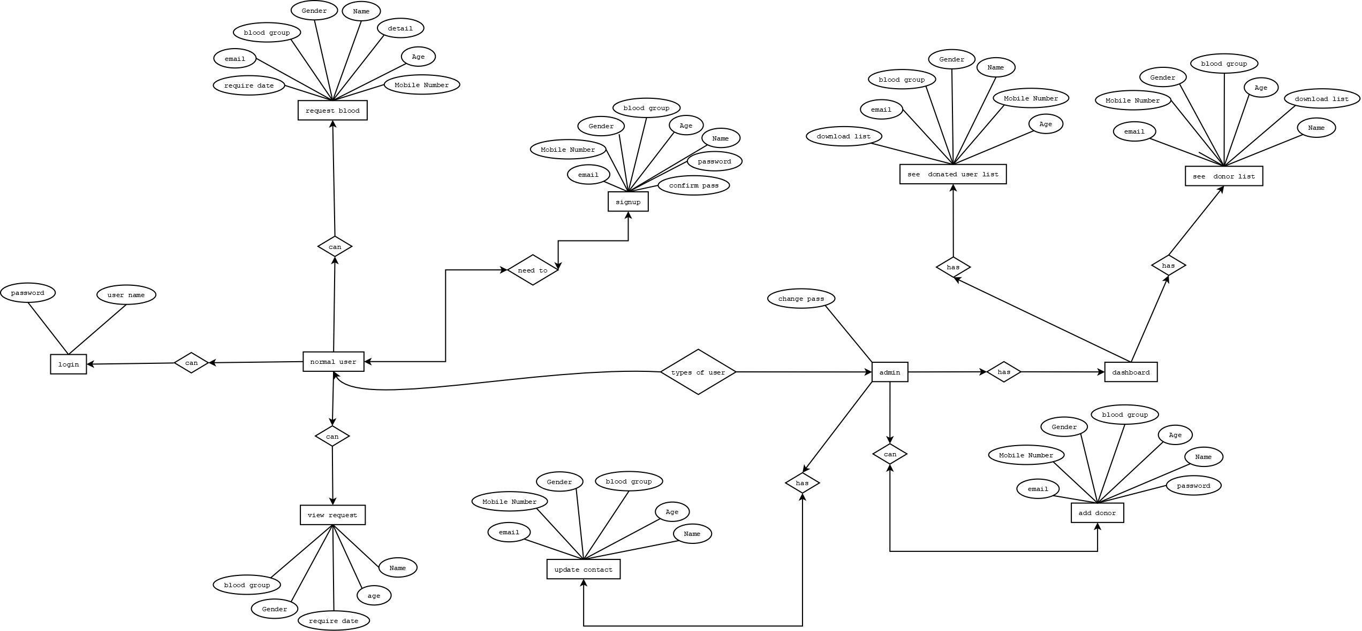

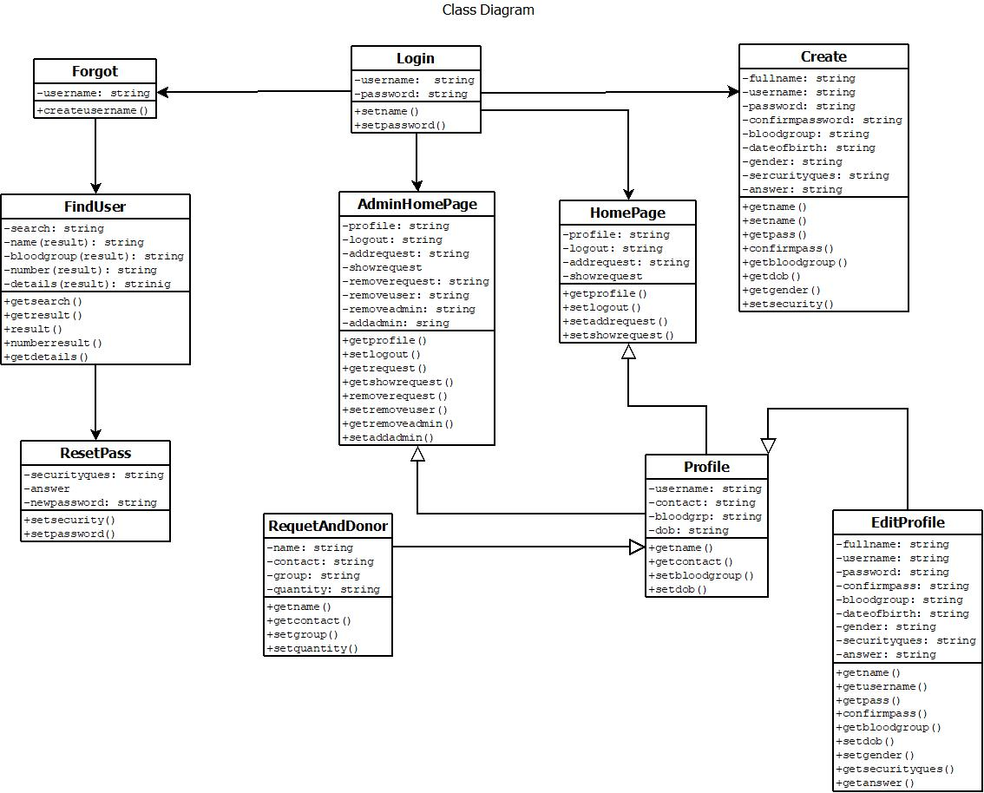

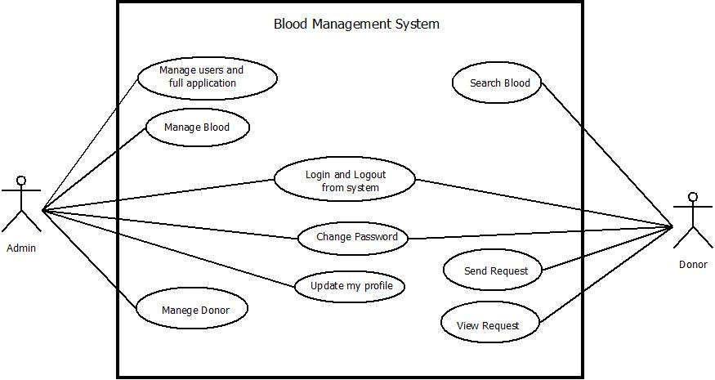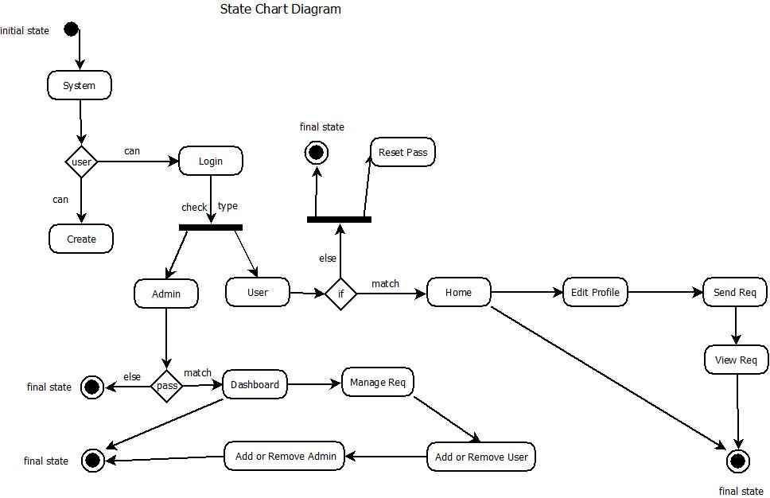

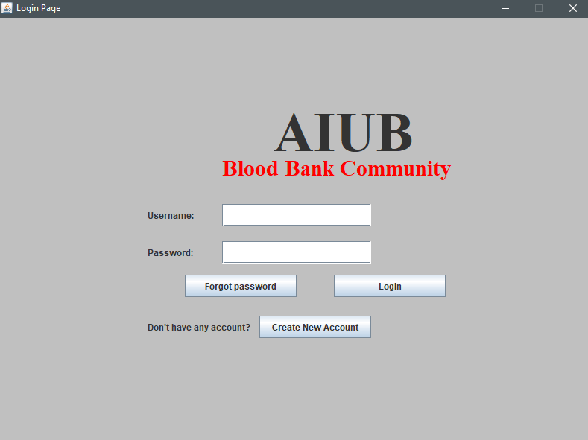

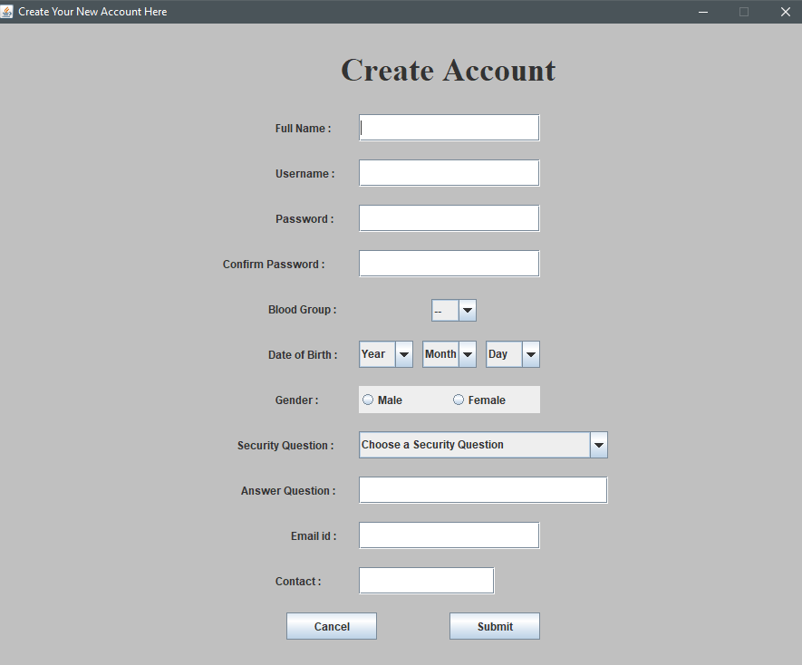

1. **Implementation**

This is initiated after the system has been tested and accepted by the user. In this phase, the system is installed to support the intended business functions. System performance is compared to performance objectives established during the planning phase. Implementation includes user notification, user training, installation of hardware, installation of software onto production computers, and integration of the system into daily work processes.

This continues until the system is operating in production in accordance with the defined user requirements.

1. **Conclusion**

The appropriate management of risk ensures improved outcomes for donors and recipients, generates

confidence in the system, and has a positive impact on public trust in the bloodsystem LimitationsandPossibleFutureImprovements. The main objective of this application is to automate the complete operations of the blood bank. They need maintain hundreds of thousands of records. Also searching should be very faster so they can find required details instantly.

To develop a web-based portal to facilitate the co-ordination between supply and demand of blood . This system makes conveniently available good quality, safe blood and other blood components, which can be provided in a sound, ethical and acceptable manner, consistent with the long-term well being of the community. It actively encourage voluntary blood donation, motivate and maintain a well-indexed record of blood donors and educate the community on the benefits of blood donation. This will also serve as the site for interaction of best practices in reducing unnecessary utilization of blood and help the state work more efficiently towards self-sufficiency in blood.

The system will provide the user the option to look at the details of the existing Donor List, Blood Group and to add a new Donor. It also allows the user to modify the record. The administrator can alter all the system data*.*

Since most blood banks are still in paper-based system, various disadvantages are

experienced by various stakeholders, which endanger the lives of patients and deter the

healthcare system. As such, the researchers aimed to design, develop, and implement an online

blood bank management system (OBBMS). This web-based application allows hospitals in

Oman to make inventories of their blood bags online, subsequently, allowing each hospital to

check the availability of blood bags anytime.

Since most blood banks are still in paper-based system, various disadvantages are

experienced by various stakeholders, which endanger the lives of patients and deter the

healthcare system. As such, the researchers aimed to design, develop, and implement an online

blood bank management system (OBBMS). This web-based application allows hospitals in

Oman to make inventories of their blood bags online, subsequently, allowing each hospital to

check the availability of blood bags anytime.

Since most blood banks are still in paper-based system, various disadvantages are

experienced by various stakeholders, which endanger the lives of patients and deter the

healthcare system. As such, the researchers aimed to design, develop, and implement an online

blood bank management system (OBBMS). This web-based application allows hospitals in

Oman to make inventories of their blood bags online, subsequently, allowing each hospital to

check the availability of blood bags anytime.