

American International University-Bangladesh (AIUB)  
**Department of Computer Science  
Faculty of Science &Technology (FST)  
Fall 19_20**

**Section: J  
Group No: 9**

**PROJECT TITLE**

A software Engineering project submitted

By

*Md Mahbubul Alam Rifat (18-36330-1) (mahbubulalamrifat)*

*Arif Ahmed (18-37994-2) (* *Arif1ahmed)*

*Sohelee Sen (18-38045-2) (Sohelee-sen)*

*Abdur Rahman (18-36340-1) (abdur98rahman)*

The project will be evaluated for the following Course Outcomes

|  |  |
| --- | --- |
| CO3: Choose appropriate software engineering model in a software development environment | Total Marks |
|  |
| Project Background Analysis (needs, goal, benefits, etc.) [5Marks] |  |
| Appropriate Process Model Selection [5Marks] |  |
| Argumentation for model selection with Evidence [5Marks] |  |
| Completeness, Spelling, Grammar and Organization of the Answer [5Marks] |  |
|  | |
| CO4: Explain the roles and their responsibilities in the software project management activities | Total Marks |
|  |
| Content Knowledge (e.g. System Requirements, System Design) [5Marks] |  |
| Project Role identification [5Marks] |  |
| Responsibility Description [5Marks] |  |
| Completeness, Spelling, grammar and Organization of the Answer [5Marks] |  |

Contents

1. PROBLEM DOMAIN 3

1.1 Background to the Problem 3

1.2 Solution to the Problem 3

1.3 Existing / Related Solutions 3

2. SOFTWARE DEVELOPMENT LIFE CYCLE 3

2.1 Process Model 3

2.2 Project Roll Identification and Responsibilities 4

3. PRODUCT AND PROJECT DESCRIPTION 4

3.1 Stakeholders 4

3.2 System Features 4

4. System Quality Attributes 4

4.1 System Architecture 4

4.2 System Interface 5

4.3 Project Requirements 5

# PROBLEM DOMAIN

## Background to the Problem

The BLOOD MANAGEMENT SYSTEM is a great project. This project is designed for successful completion of a project on blood bank management system. The basic building aim is to provide blood donation service to the city recently. Blood lobby management system (BLMS) is a web based application that is designed to store, process ,retrieve and analyze information concerned with the administrative and inventory management with a blood bank. This project aims at maintaining all the information pertaining to blood donors, different blood groups available in each blood bank and help them manage in a better way.

Project Aim is to provide transparency in this field, make the process of obtaining blood from a blood bank hassle-free and corruption-free and make the system of blood bank management effective. For hospitals, a blood bank known as blood collection center, also is an area in which collected blood bags are stored and preserved for future use in blood transfusion services, Blood transfusion is a medical operation where a patient requires blood or blood product as a life saving measure. Most blood banks are still running manual system in its processes. As such, there is a lack of efficiency because it is still paper-based on collection information about donors, inventories of blood bags, and blood transfusion services. The lack of proper documentation may in danger patient’s health due to the possibility of having contaminate blood bags shelf life is not monitored properly. Hence, a web-based blood bank management system might be needed to address these issues and problems encountered to ensure blood transfusion safety.

## Solution to the Problem

The proposed Blood Bank management system helps the people who are in need of a blood by giving them all details of blood group availability or regarding the donors with the same blood group

## Existing / Related Solutions

A number of researches have written on the concept of blood bank management systems with the majority of them praising computerization as a mechanism of achieving efficiency and effectiveness in this area thus not looking at some problems the system may face due to limited or misuse of functionalities. Pah Essah and Said Ab Rahman (2011) proposed a development of a management information system to manage blood bank based on information of donor, recipient and blood. Their system has three modules: the donor module, patient module and blood module. However some crucial issues are left aside in this approach, for instance who is responsible for administration of the system. According to Mailtrey D Gaijjart (2002) proposes a development of blood bank data management system as a solution to prevent near miss events and improve record retrieval. Their argument is that with computerization fast retrieval of records will improve efficiency of blood banks operations. Akshay V Jain Khanter (2009) suggests a management information system application that covers some of the blood bank management issues related to a particular region. An interesting approach by Jeroen Benien and Hein Force (2012) is that of supply chain management for blood and blood products terming the process as irregular and the demand for blood stochastic. This is of great implications if the management of blood banks were to become effective. Finally, E. M. S. S. Ekanayaka and C. Wimaladharma (2015) developed a Blood Bank Management system to gather all the blood donors into one place automatically and inform them constantly about the opportunities to donate blood via a SMS to the donor’s mobile phone. Below is a proposed system that will eliminate all the problems that the blood bank management system are facing currently.

Existing problem

So from the above literature, we make it the aim of our research to pay a very close attention to blood transfusion centers, blood banks and the various processes and stakeholders that are involved in those establishments in order to develop a system that will coordinate and improve the quality of the various activities and processes that are carried out. The system we are proposing will be centralized. This means that it will be a single system that will accommodate different types of users all accessing the same information and a number varying functionalities. The proposed system will be Web-based. It will be developed in HTML 5/CSS and JSP on the WWW platform and will be accessed through the HTTP protocol. HTML 5/CSS will be used to develop the user interface for the application while JSP will be used to implement the backend functionalities. The proposed system will store a large amount of information and therefore will be connected to a database. For this project, we will use H2 database. H2 database is a pretty new, open source database implementation built for java. It can be embedded in the system as a Java library thereby leaving very small footsteps. As a result, it is really fast, secured and quite easy to use. A number of important yet lacking functionalities have been identified while reviewing the existing systems. These functionalities represent the processes that tends to keep the blood centers lagging technologically. On the blood bank side, they will have access to the donor information, recipient data and requests, respond to the various requests, make donation appointments with donors and organize blood donation campaigns to create awareness and attract more donors. They will also be able to have a real time update on their blood repository. The system will also help them eliminate errors from donor’s tests. For the donors, which can be paid or volunteer donors, they will have access to important information on blood donation process and requirements as well as the location of blood centers and blood donation campaigns. They can also be able to register as a regular donator. This provides a vital link that is lacking in the existing systems. With the new system, a donor is just clicks away from any information he needs on a blood center or campaign event. The proposed system will also help eliminate redundancy of performing group and genotype tests every time a donor is donating.

# SOFTWARE DEVELOPMENT LIFE CYCLE

## Process Model

Agile looks evolutionary. It gives teams an opportunity to learn with each new iteration or draft.

Agile allows teams to deliver a prototype and improve it with every cycle.

Agile supports regular and collaborative troubleshooting.

Agile helps teams and individuals effectively prioritize features and work in general.

Teams can make quick-course corrections based on stakeholder feedback.

Team members may prototype a solution or process for the next project’s version.

Teams get rapid feedback from each version or iteration.

Agile empowers team members to work creatively and effectively.

Stakeholders and clients can provide feedback as the project evolves.

This flexible process increases team’s productivity

## Project Roll Identification and Responsibilities

Developing a software from scratch is a lengthy process and requires a lot of effort of multiple people. To finish a project successfully by avoiding project failure and produce a quality-maintained software we need to follow a developing process that suits us most. Keeping that in mind we have already choose two process to develop our software. Now to carry out those process we need to divide all the task of the software’s development life cycle and assign them to the members of the team. Who will perform which set of tasks are determined by the role of that person in project management and development? Those roles and their responsibilities (in our chosen process) can be:

**Customer**: Customer is the source of funding. Pleasing him is all that matters. He writes the requirements and functional tests. He also can prioritize the requirements. He is the who decides if a functional requirement is satisfactory or out of the goal. Here the hospital is the customer

Programmer: They are responsible for writing the source code of the project. Our core team will mainly work as programmer or developer as we lack experience.

**Tester**: Testers test the software for errors, bugs. They also help the customer to write functional test. They are driven by quality rather than delivery time. We can use our associates to test our system as they will be less bias than us.

**Tracker**: Tracker traces the estimates made by the team and gives feedback on how accurate they are in order to improve future estimations. He also traces the progress of each iteration and evaluates whether the goal is reachable within the given resource and time constraints or if any changes are needed in the process. In our project, he must me one of our experienced associates.

**Coach**: He is a person who possess a sound understanding of extreme programming so that he can guide other members following XP. The coach of our development process must be a agile experienced personnel who will be helping us. υ Consultant: Consultant is not directly involved with the development or management. Rather, he is an external member who can provide specific technical knowledge if any directly involved member need any veteran’s suggestion. If anyone of us needs any consultation of a domain we may consult highly experienced personnel of that particular domain.

**Manager**: Manager is the big boss. He makes the big decisions of the project. Again, we may take help from highly experienced personnel as making critical decisions require high estimation and past experience.

# PRODUCT AND PROJECT DESCRIPTION

## Stakeholders

Blood banks

Donors

Blood camp organizers

Hospitals and patients

## System Features

In this project the “Admin” has the following features:

• Dashboard

• Donated User List

• Donor List

• Add donor

• Update Contact

• Change Password

• Donor Registration

• Login

• View Request

• Send Request

• Search Blood

• Change Password

• Donate Blood

• Donated blood list

# System Quality Attributes

## System Architecture

**Activity Diagram**

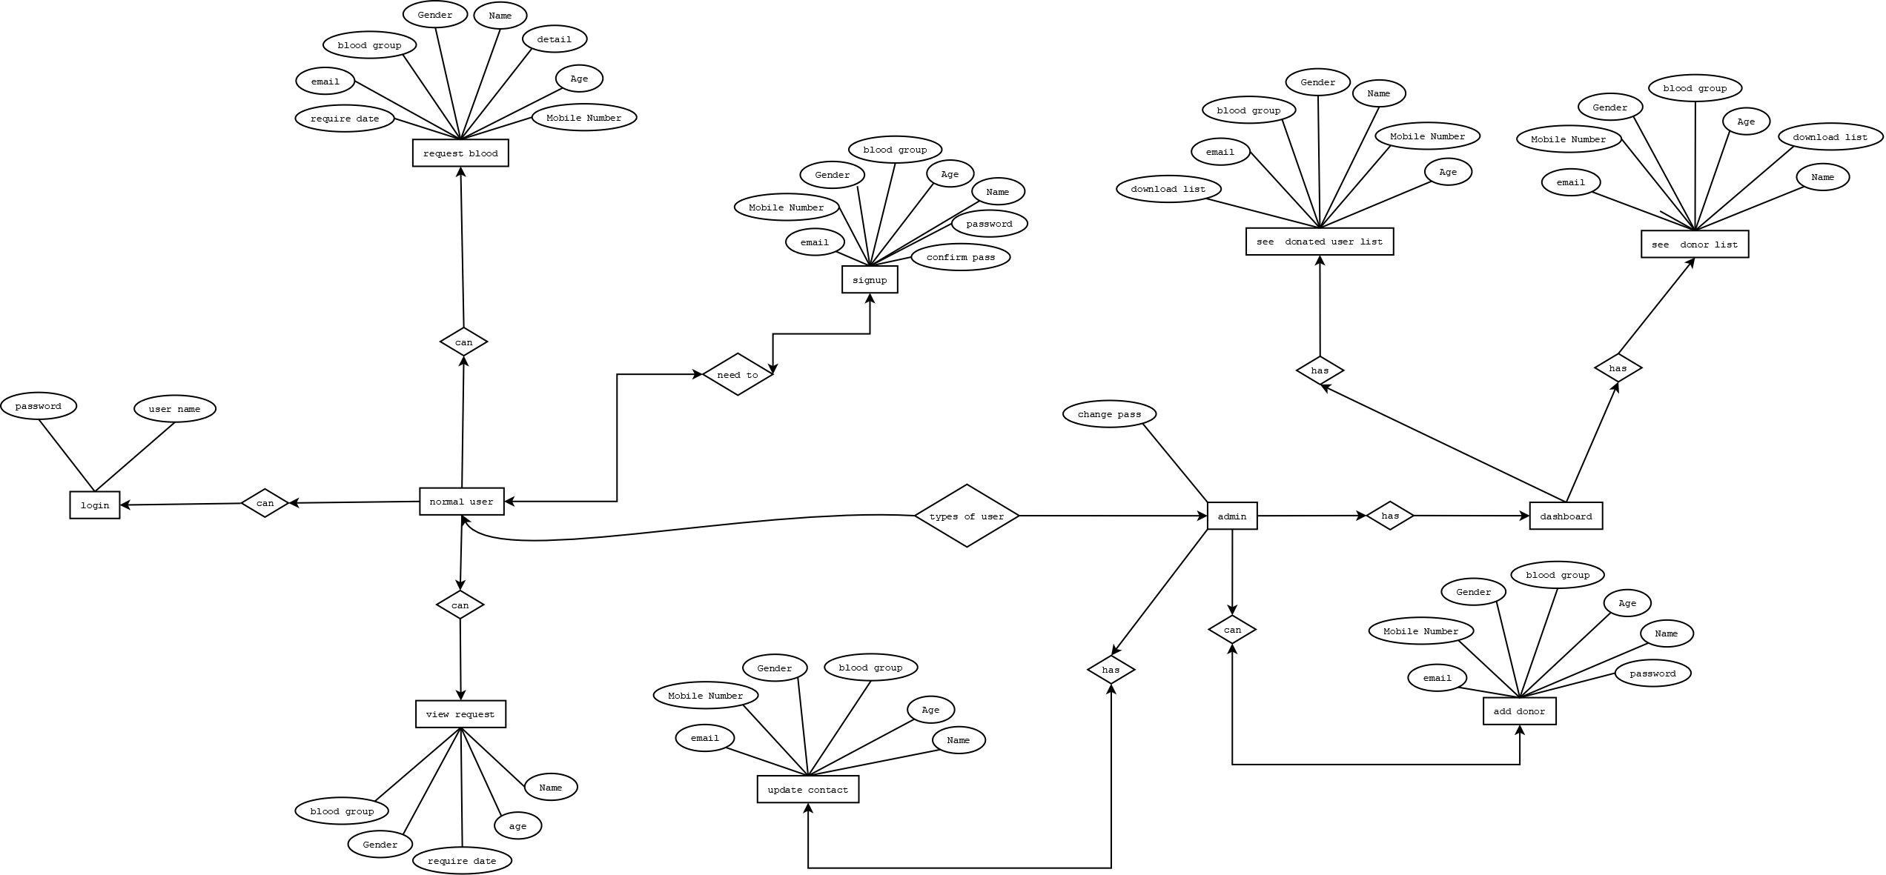

**Class Diagram**

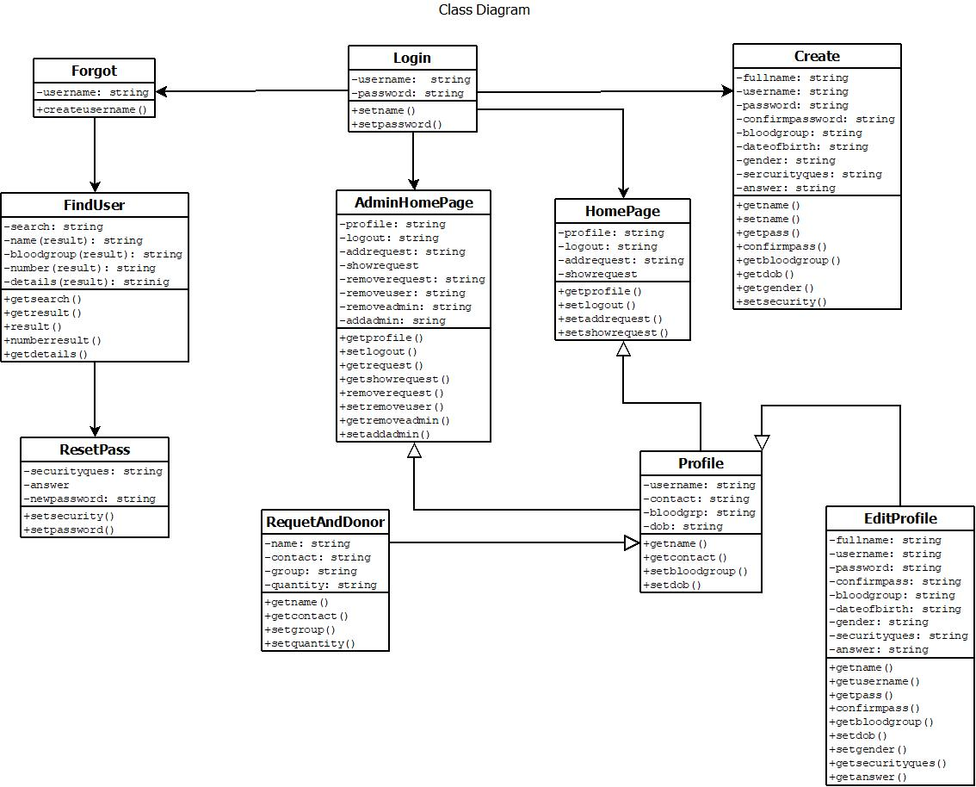

**Use Case Diagram**

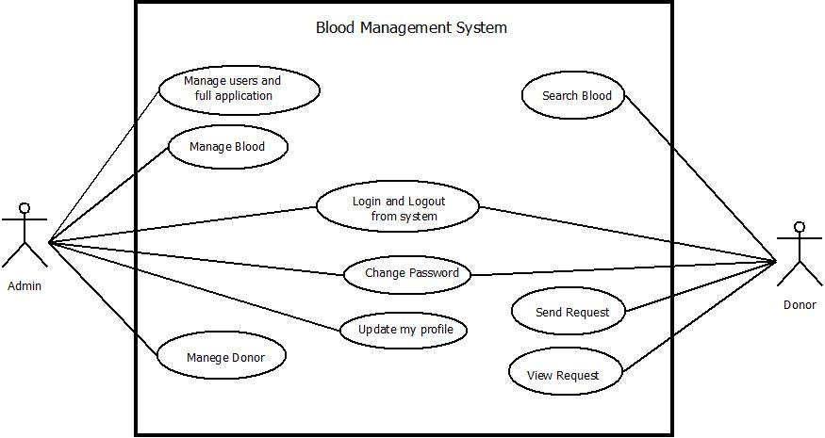

**State Chart Diagram**

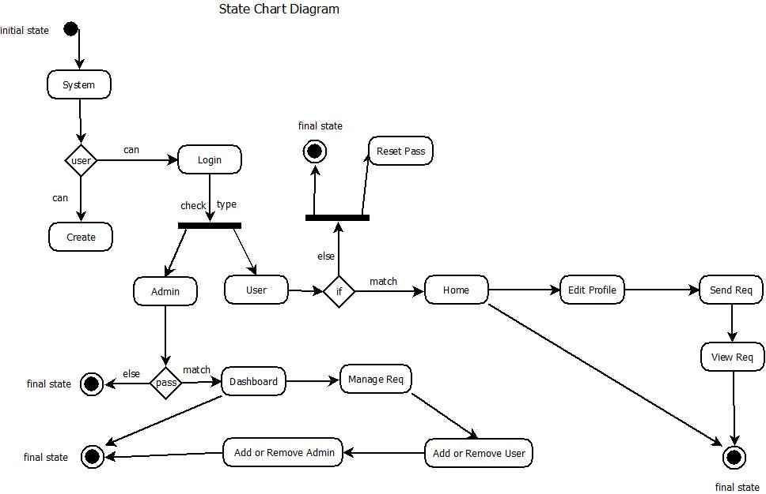

## System Interface

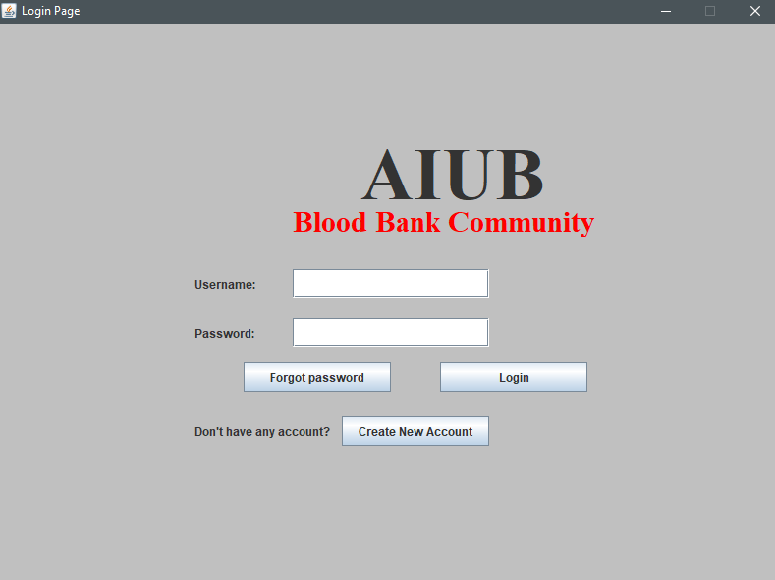

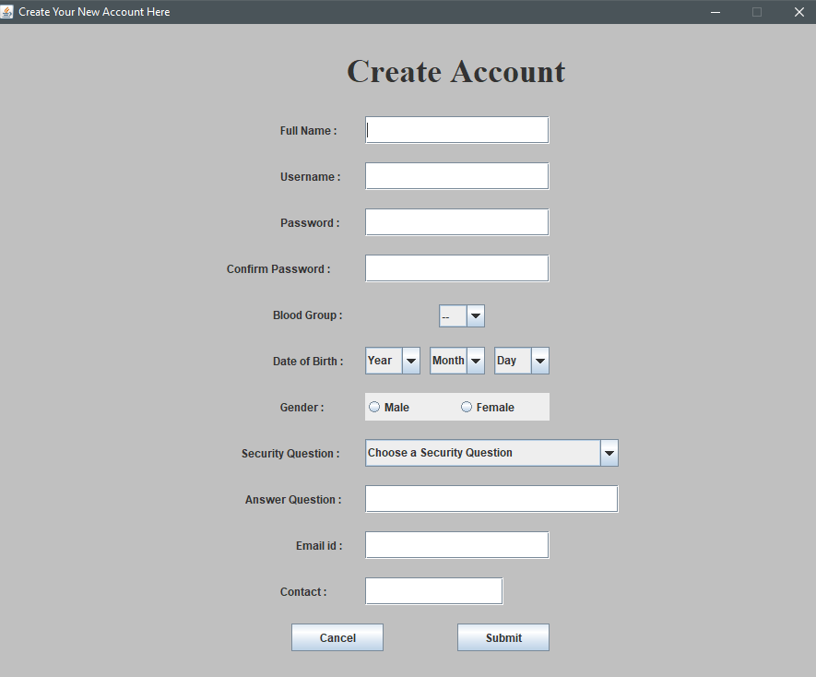

## Project Requirements

**User Requirements:**

Since end users are the ones who are finally going to use the system, their requirements need to be identified. This involves questioning the end users what their expectations were. The main requirement of the end user is that the system should be easy to use and take less time. In addition to these another important factor was to eliminate the need for database conversion and migration that had to be carried out presently. After conducting interviews with the users a document called the software requirement specification was created. This is the most important document that forms the basis for system development. It should be consistent, complete, unambiguous, traceable and inter-related.

**Functional Requirements:**

The functional requirements specify relationship between the inputs and outputs. All the operations to be performed on the input data to obtain output are to be specified. This includes specifying the validity checks on the input and output data, parameters affected by the operations and the other operations, which must be used to transform the inputs into outputs. Functional

requirements specify the behavior of the system for valid input and outputs.

**Performance Requirements**

This section includes performance of the product that are set by user interaction and studying the existing system of the organization. These are stated in complete measurable terms, so that they can be verified during system evaluation phase. Some of the performance requirements are stated below.