Analytics Engineering Project
STEP 1: Set-up GCP Infrastructure with Terraform. Kindly check the process via this link cloud-setup
STEP 2: Kindly check out the data ingestion process into GCP(our Data Lake) and pipeline orchestration with Airflow via this link.
STEP 3: We will now use Airflow to automate the creation of BigQuery(our Data Warehouse) tables, both normal and partitioned, from the files we stored in our Data Lake via this link
STEP 4: Transforming our data with DBT. The details of this step can be found here .

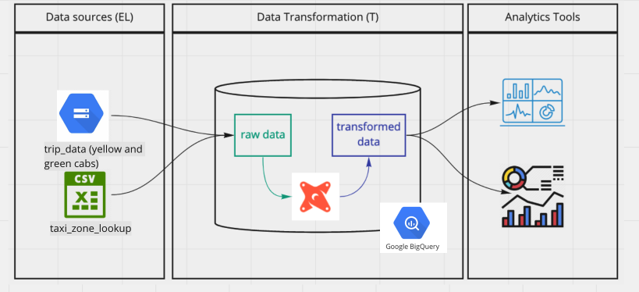
STEP 5: Connect the transformed data to a visualization tool of your choice. In my case I used PowerBI

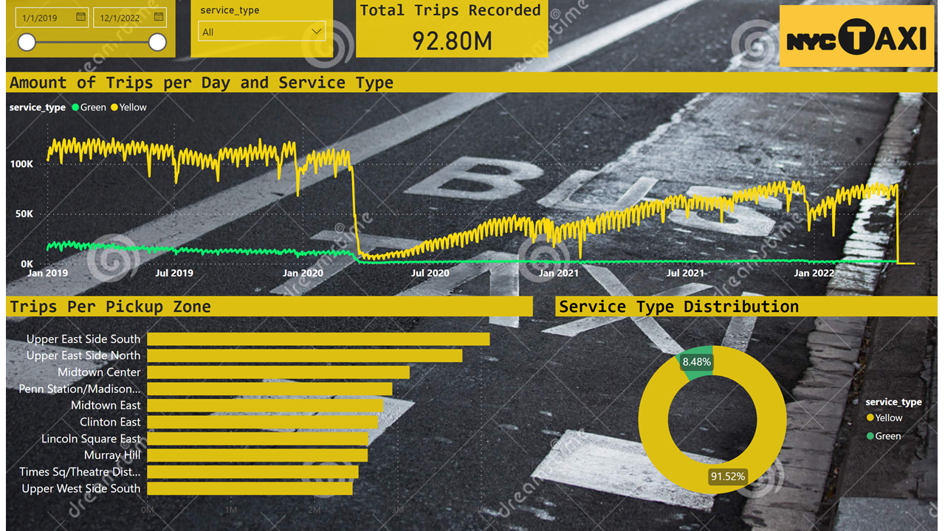

Using the starter project
Try running the following commands:
* dbt run
* dbt test
Resources:
* Learn more about dbt in the docs
* Check out Discourse for commonly asked questions and answers
* Join the dbt community to learn from other analytics engineers
* Find dbt events near you
* Check out the blog for the latest news on dbt's development and best practices

