Freight Rate Prediction – Approach & Validation Report
Machine Learning Engineer assessment | Code: GitHub repository (see README)

1. Summary
The task is to predict posted_rate for 12,000 loads dated Nov–Dec 2025 using 48,000 labelled loads dated Jan–Oct 2025. Because the final predictions are for the future, I validated with forward-chaining (train on earlier months, test on the next month) instead of a random split. The chosen model is a LightGBM lane model (L1 loss on log-rate) with a small explicit market adjustment. It deliberately does not use quote_signal, which I found to be unreliable across time.
Forward-CV, mean of 5 folds (Jun–Oct) | MAE ($) | MAPE | MAPE excl. spikes
Naive: distance × median $/mile by equipment | 225.3 | 10.4% | 7.8%
LightGBM lane model, no date information | 129.1 | 5.3% | 3.1%
+ recent price level (last 30 days) | 119.7 | 5.1% | 2.7%
FINAL: + market_index adjustment | 113.5 | 4.8% | 2.5%
“Excl. spikes” drops test rows whose label is >30% away from the prediction (≈1.4% of rows, see §2), which no feature in the data can explain.

2. Data exploration and data-quality issues
- Temporal shift by design. train_test.csv covers 2025-01-01 to 2025-10-31; validation.csv covers 2025-11-01 to 2025-12-31. Any honest validation has to extrapolate forward in time.
- quote_signal is not trustworthy (key finding). In Jan–Mar, Jun and Sep it is almost exactly rate ÷ distance (within 2% for ~93% of rows – effectively a leak). In Apr, May, Jul and Oct that relationship is inverted (positively correlated with distance), and in Aug it is pure noise. In the validation months it is uncorrelated with distance (r≈0.01), i.e. it looks like the August regime. A model that learns to trust it breaks when it flips: on the August test fold, adding quote_signal raised MAE from $99.7 to $149.4. I excluded it.
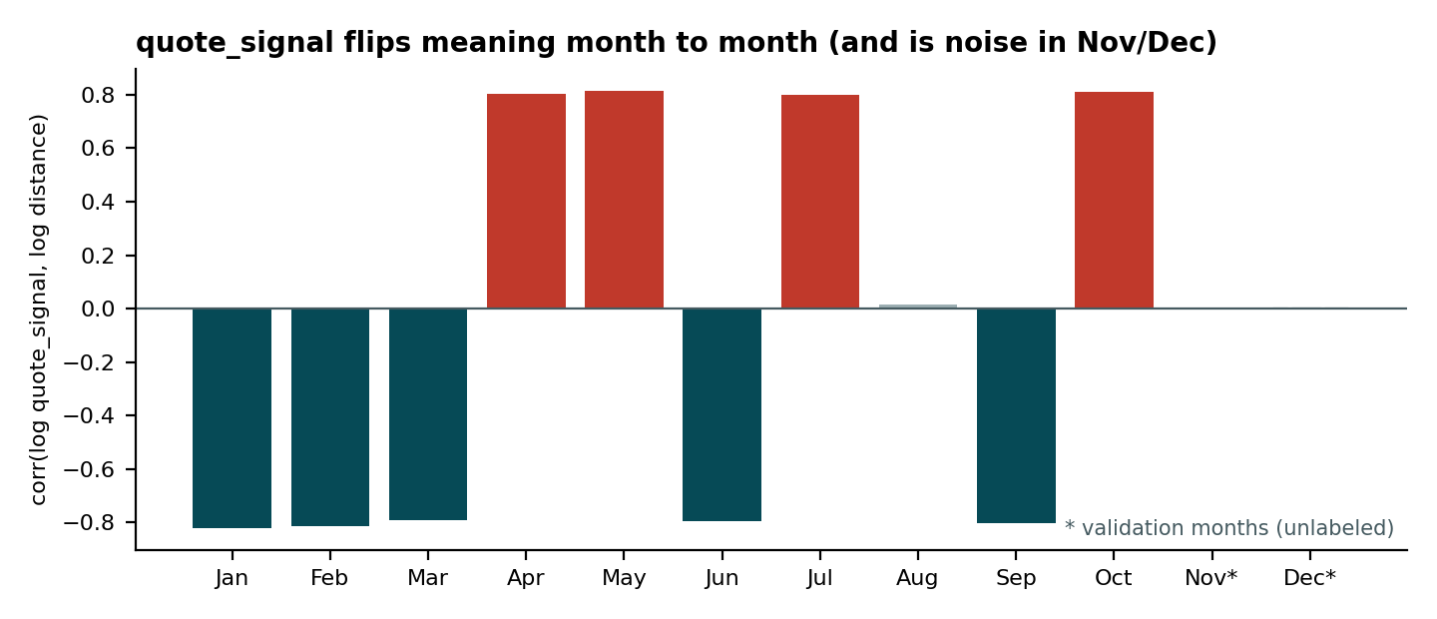
- Weight: 292 negative values in train (145 in validation) – sign errors, fixed with abs(); 300 missing (165 in validation) – left as NaN for LightGBM; 1,204 train rows sit exactly at the 47,500 lb cap (censored), flagged with an indicator.
- market_index: 374 missing in train (249 in validation). It is a daily series, so missing values are filled with the same-date median across loads.
- Unseen cities: validation has 72 cities, train 64. Eight cities (Allentown, Charlotte, Chicago, Jackson, Knoxville, Laredo, Norfolk, San Diego) never appear in training (~12% of validation rows). I therefore use latitude/longitude, not city names or lane IDs. Predicted $/mile for unseen-city lanes (mean 2.19) matches seen-city lanes (2.19).
- Label spikes: about 1.4% of training rates are far from the model (about half far too high, half far too low; rate-per-mile up to ~14). These look like entry errors/extreme outliers. I use an L1 (median) loss so they have little pull; explicitly removing them from training changed CV MAE by <0.1, so the robust loss is sufficient. Residual MAE/RMSE is dominated by them (RMSE ≈ $644 regardless of model).
- Other: no duplicate IDs or rows; distance has a 70-mile floor (48 rows) and runs ~1.18× straight-line distance (median) – kept as is; rate-per-mile falls with distance, and weight, equipment (Reefer > Flatbed > Dry Van) and region (Texas/Oklahoma higher, Northeast lower) all matter.
- Date effect: after removing lane effects, the daily median log-rate residual is smooth (lag-1 autocorrelation 0.96) and tracks market_index (r=0.71 daily; R²=0.86 with a linear trend). Nov–Dec market_index (≈0.93) is close to October’s (≈0.96), so no large level change is expected.

3. Train / validation split approach
Random K-fold would mix future and past rows, let the model learn month-specific quirks (such as the quote_signal regime) and overstate accuracy. I used forward-chaining: for k = June…October, train on all months before k and score on month k. Every fold therefore predicts a month whose date-level conditions were never seen, which is exactly the situation for Nov–Dec. Fold results for the final model:
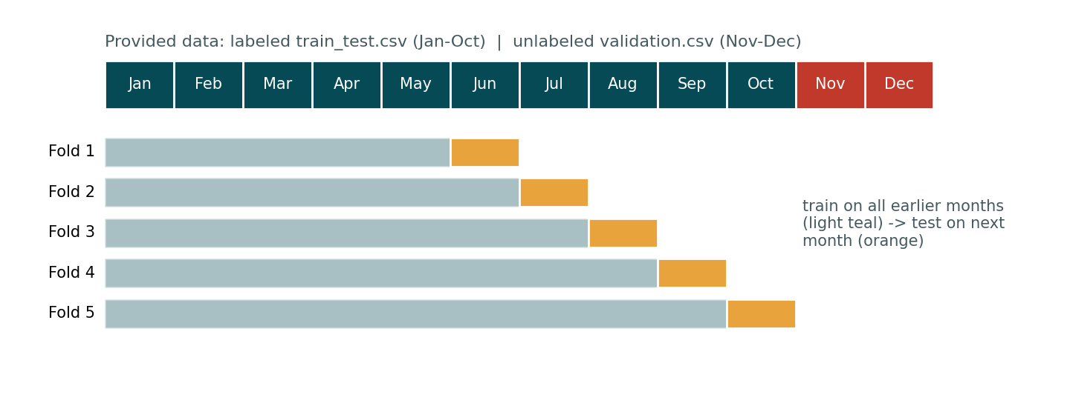
Test month | MAE ($) | MAPE | MedAPE | MAPE excl. spikes
June | 150.1 | 5.4% | 3.2% | 3.5%
July | 108.3 | 4.6% | 2.0% | 2.4%
August | 89.0 | 4.2% | 1.5% | 1.8%
September | 120.4 | 4.9% | 2.5% | 2.9%
October | 99.7 | 4.8% | 1.4% | 1.8%
June is hardest because it follows a sharp rise in the price level. LightGBM hyper-parameters were left at sensible defaults and not tuned. The date-adjustment choices (30-day window, using market_index) were compared on these same folds, so the CV numbers are slightly optimistic. The final model is refit on all 48,000 labelled rows.

4. Model choice and reasoning
- Lane model: gradient-boosted trees on log(rate), L1 loss. Rates are multiplicative in distance/equipment/weight, trees capture the non-linear $/mile-vs-distance curve and regional interactions automatically, and L1 on the log scale optimises median percentage error while ignoring label spikes.
- No raw date features: trees cannot extrapolate to unseen months (they reuse the last leaf), and a raw date lets the model memorise period-specific noise.
- Explicit date adjustment: prediction = lane model × exp(level + β·(market_index − recent market_index)). “level” is the median residual of the last 30 training days (it keeps the model at the current price level) and β = 0.131 is fitted on the daily residual series. This simple term cut CV MAE from $129 to $114 and is easy to explain and sanity-check.
- Rejected: quote_signal (regime-dependent, see §2); raw market_index inside the GBM (it extrapolated badly outside its trained range); linear trend extrapolation (unstable across folds).

5. Fixed December prediction chart
Produced by the provided score.py from the completed december_chart_inputs.csv (Lexington → Fort Wayne, 360 mi, Dry Van, 32,000 lb, only the date varies). The model needs a market_index for each day; I used the same-day median market_index of the validation loads (an input feature, not a label). Day-to-day variation comes only from that market_index series; predictions range $819–$843 (≈$2.28–$2.34/mile).
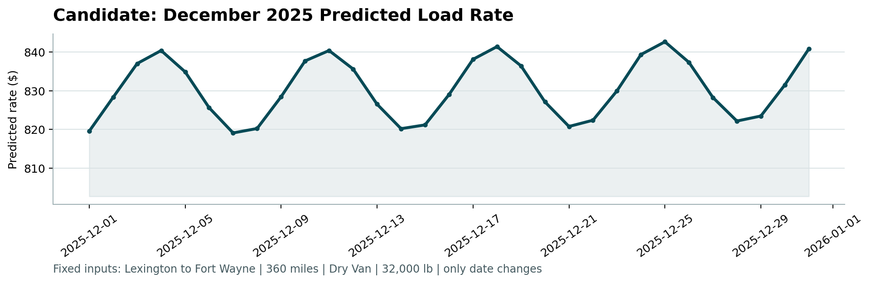

6. Limitations
- Nov–Dec rate level is extrapolated from the last 30 days plus market_index; a regime change not visible in market_index would not be captured (June’s fold error shows the size of that risk).
- Spike labels (~1.4%) are unpredictable from the supplied features; if the final metric is RMSE-based it will be dominated by them for any model.
- The model predicts the conditional median. If the scoring metric rewarded the conditional mean, a slight upward bias correction (~1–2%) could help; this was not applied since the metric is not specified.

