**FINDING OUT THE MOST SUITABLE PLACE NEAR METRO STATIONS OF MUMBAI TO OPEN A CAFÉ**

*FINAL REPORT- BY ARIF KHAN*

**Business Understanding**

Mumbai is the capital city of the Indian state of Maharashtra. According to United Nations, as of 2018, Mumbai is the second most populous city in India after Delhi and the seventh most populous city in the world with a population of 19.98 million.

Mumbai is the financial, commercial and entertainment capital of India. It is also one of the world's top ten centers of commerce in terms of global financial flow, generating 6.16% of India's GDP and accounting for 25% of industrial output, 70% of maritime trade in India (Mumbai Port Trust and JNPT),and 70% of capital transactions to India's economy. Mumbai's billionaires had the highest average wealth of any city in the world in 2008. These assets makes Mumbai one of the best place for doing business. The Mumbai (INDIA) Metro is a rapid transit system serving the city of Mumbai, Maharashtra, and the wider metropolitan region. The system is designed to reduce traffic congestion in the city, and supplement the overcrowded Mumbai Suburban Railway network.

Currently there are 12 metro station in Mumbai, and each one of them provides a great business point of business. So, as a part of my final project we will try to find out near which of the metro station of Mumbai will be best to open up a cafe/restaurant.

**Data**

To complete my final project, I will need the following data

The List of Metro Stations of Mumbai:

Source-

<https://en.wikipedia.org/wiki/List_of_Mumbai_Metro_stations>

Description- This data set contains the required information. And we will use this data set to find out all the metro stations of Mumbai city.

Restaurants/Cafe near each metro stations of Mumbai:

Source-Foursquare API

Description- By using this API we will get all the cafe/restaurants near metro stations of Mumbai city

The category id’s of venues in Foursquare-

<https://developer.foursquare.com/docs/resources/categories>

**Problem:**

Finding out the best Metro Stations of Mumbai near which it will be best to open up a café.

I am considering the number of cafés near the metro stations having a negative weightage on our decision, whereas Schools, Universities, Theaters, and Offices will be considered as having a positive weightage on our, as this venues will attract a lot of customers, and is good for the business of café.

**Tools Used:**

* Foursquare API
* IBM Watson Account
* List of Metro Stations of Mumbai
* The category id’s of venues from Foursquare website
* Jupyter Notebooks

**Methodology:**

In order to do the analysis and suggest the best location, following are the steps we have to follow:

* The Wikipedia page (<https://en.wikipedia.org/wiki/List_of_Mumbai_Metro_stations>) was scrapped using the BeautifulSoup to extract the list of metro stations of Mumbai.
* The Foursquare API is used to get the latitude and longitude of each metro station of Mumbai, also to find out the nearby venues for all the metro stations.
* Different venues are assigned different weightage based on its effect for the business of the café.
* Once the weightage are assigned, each metro be allotted a score based on its nearby venues and its weightage.
* As the scores are calculated the metro station having the highest score will be considered as the perfect spot to open up a café nearby.

**Result:**

Based on the analysis we have done, the following is the result we have got:

Plot to show the location of perfect metro station to open a café nearby and its nearby venues:

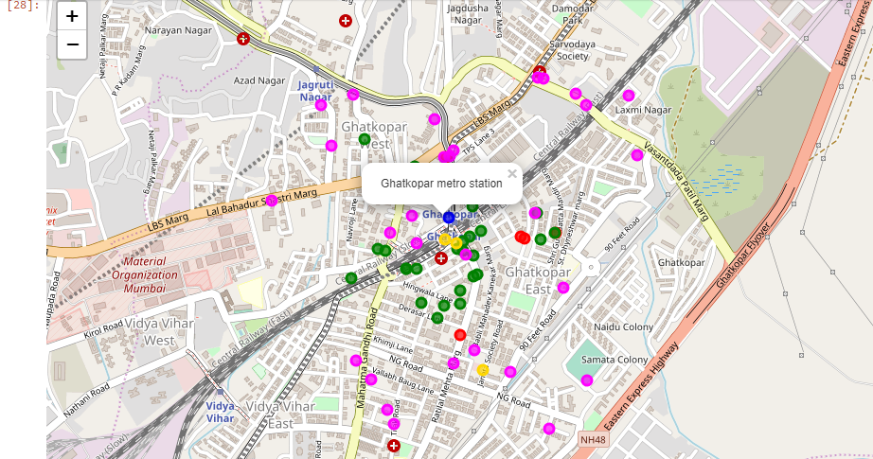

**Discussions and further Improvements:**

* While using Four Square API, we have left out few metro stations because their latitude and longitude cannot be extracted directly from the API. So, in future we can include the left out metro stations also, if their location can be directly extracted.
* Also the weightage given for each venue was not totally correct and was somewhat random, in future we can try to find out better to allot weightage to venues in terms of their effect on the business of café.

**Conclusions:**

Based on the weightage given to each nearby venues of the metro stations, we can conclude the Ghatkopar Metro Station stands out as the most profitable place to open up a café nearby.

**Resources:**

* List of all metro stations of Mumbai: <https://en.wikipedia.org/wiki/List_of_Mumbai_Metro_stations>
* The category id’s of venues in Foursquare-

<https://developer.foursquare.com/docs/resources/categories>

* Four Square API : [https://foursquare.com](https://foursquare.com/)