What is Git?
- Git is a Version Control System (VCS).
- Git helps developers keep track of the history of their code files by storing them in different versions on its own server repository, i.e., GitHub.

Why Git?
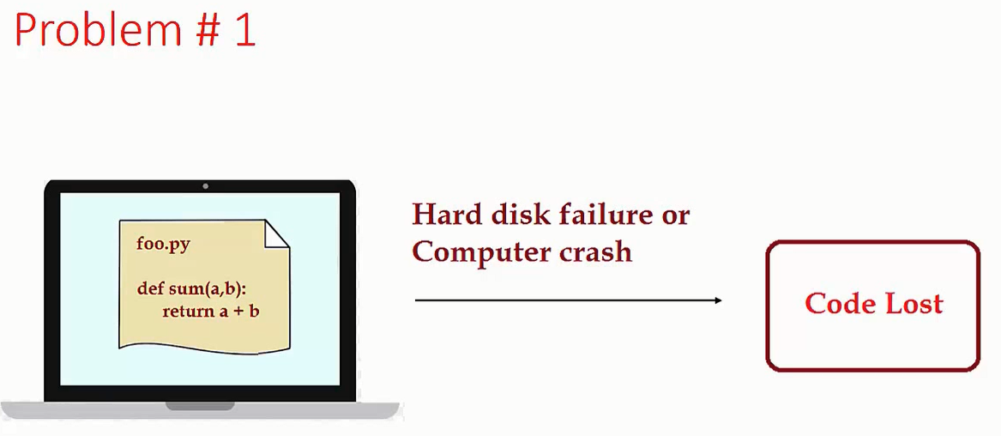

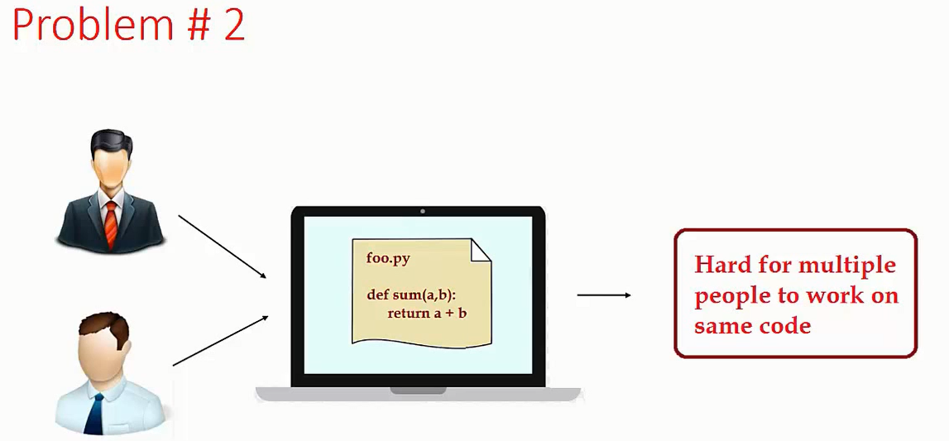

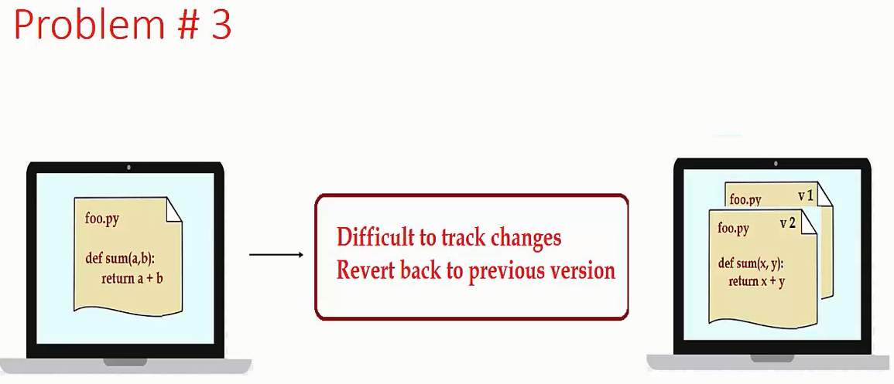

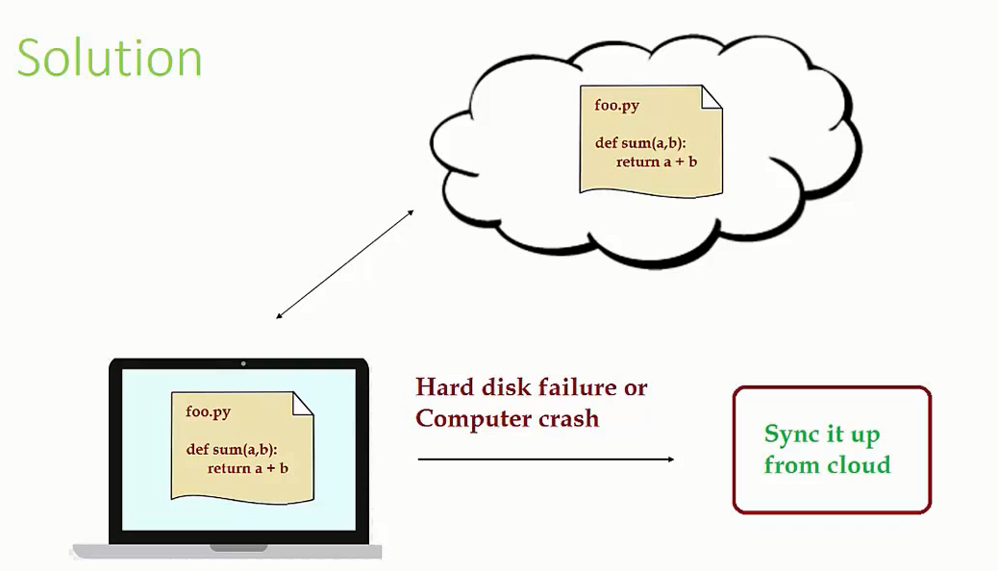

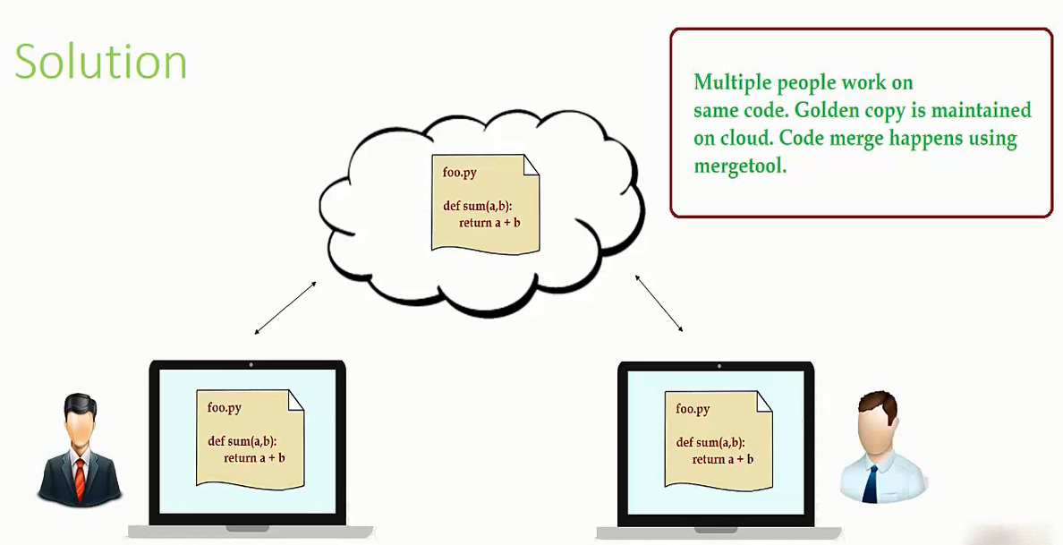

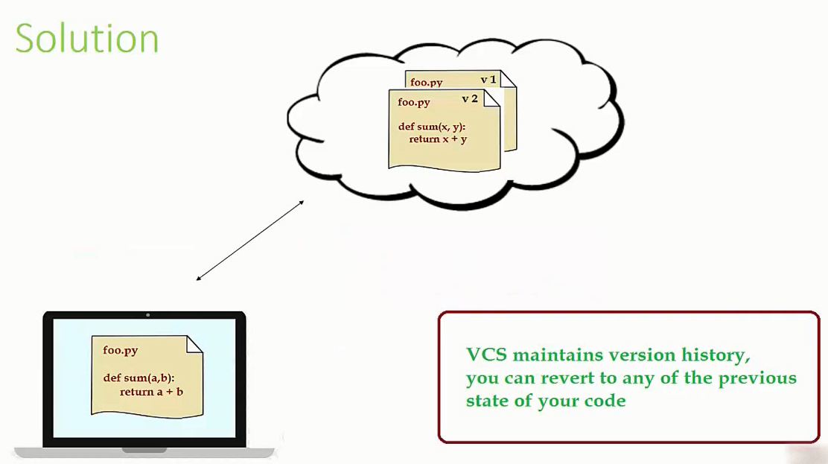

What is GitHub?
GitHub is a website and cloud-based service that helps developers store and manage their code as well as track and control changes to their code.

Difference between Git & GitHub:
Git | GitHub
Git is a tool to execute version control. | GitHub is a platform that utilizes Git to carry out its functionalities.
It is a software and in order to be used it has to be installed. | It is web based hosting service so there is no hassle of installation.
It is a command line tool. | It is a graphical user interface.

Git Life Cycle:

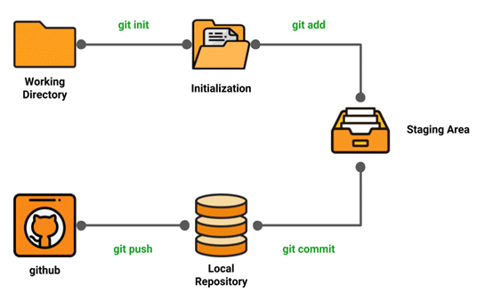

1) Local working directory: The first stage of a Git project life cycle is the local working directory where our project resides, which may or may not be tracked.

2) Initialization: To initialize a repository, we give the command git init. With this command, we will make Git aware of the project file in our repository.

3) Staging area: Now that our source code files, data files, and configuration files are being tracked by Git, we will add the files that we want to commit to the staging area by the git add command. This process can also be called indexing. The index consists of files added to the staging area.

4) Commit: Now, we will commit our files using the git commit -m ‘our message’ command.

We have successfully committed our files to the local repository but we need to share projects files with our team members.

This is when the next stage of the Git life cycle occurs, i.e. in GitHub, we publish our files from the local repository to the remote repository. We do that by using the git push command.

Print the working Directory:
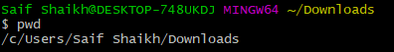

Create a Project Directory:

Go to Project Folder & Print the working Directory:
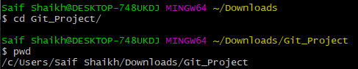

Create couple of files with some data:

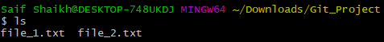

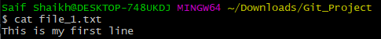

1) git init:
Usage: git init [repository name]
- We have to navigate to our project directory and type the command git init to initialize a Git repository for our local project folder.
- Git will create a hidden .git directory and use it for keeping its files organized in other subdirectories.

2) git status:
Usage: git status
This command will show the modified status of an existing file and the file addition status [Tracked/Untracked] of a new file if any that have to be committed.

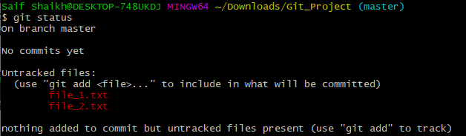

3) git add:
Usage (i): git add [file(s) name]
Usage (ii): git add . OR git add * OR git add -A
This will add the specified file(s) into the Git repository staging area, where they are already being tracked by Git and now ready to be committed.
Note: By specifying . or * it will add all the files present in the current directory.

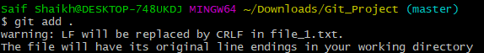

Check the Status:
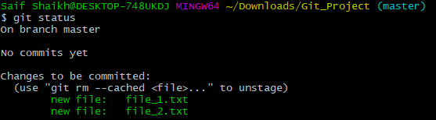
4) git commit:
Usage: git commit -m “message”
- This command records files permanently in the version history.
- All the files, which are there in the directory right now are being saved in the Git file system.

Error:
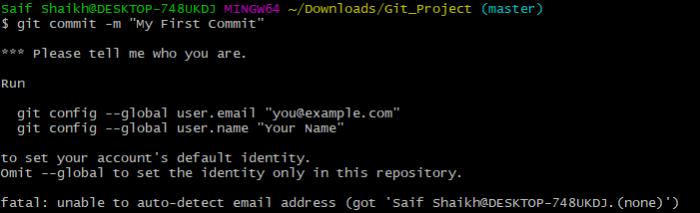

Create a GitHub account & fire below command:
git config --global user.email "smidsytechnologies@gmail.com"
git config --global user.name "saif"
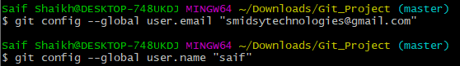

Commit:
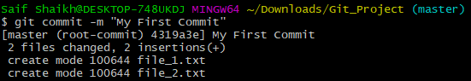

Check the status:
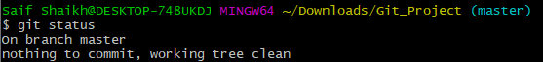

5) git remote:
Usage: git remote add origin “[URL]”
Once everything is ready on our local system, we can start pushing our code to the remote (central) repository of the project.
Login to the GitHub account if the account already exists (If not, sign up on github.com). Now create a repository in GitHub where you need to push your code

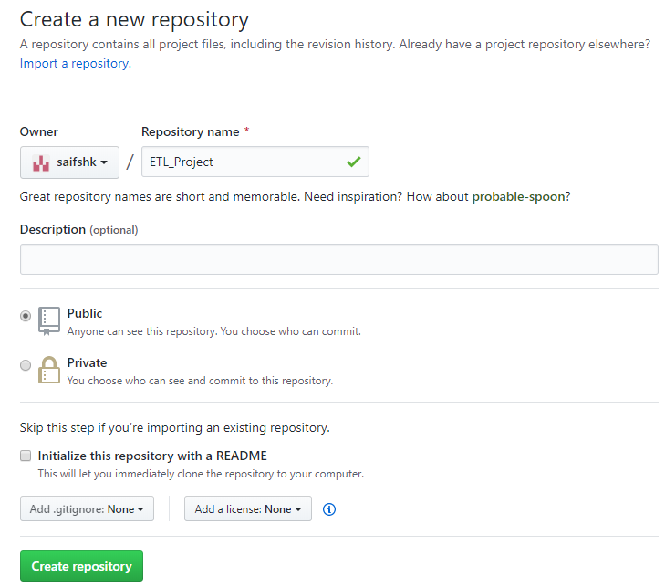

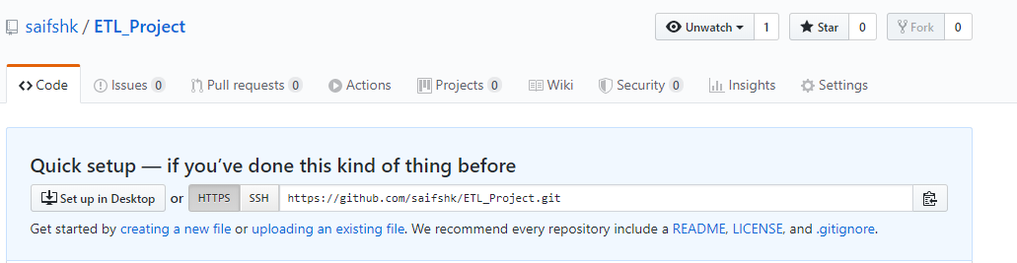

Click on the Copy icon on the right side of the URL box of the GitHub repository to copy the link. Now, we are ready to operate the remote commands in our repository that we have just created.

git remote add origin https://github.com/saifshk/ETL_Project.git

6) git push:
Usage: git push origin [branch name]
Suppose, we have made some changes in the file and want to push the changes to our remote repository on a particular branch. By using the command ‘git push,’ the local repository’s files can be synced with the remote repository on GitHub.

It will ask you your username & password:
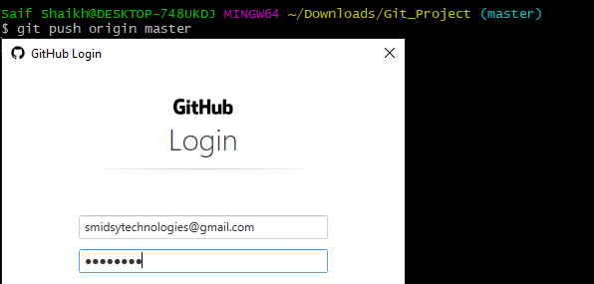

Push Complete:
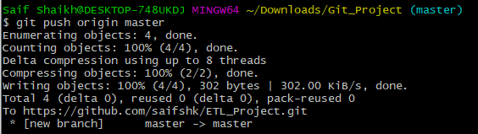

GitHub View to verify local repository is in sync with remote repository:
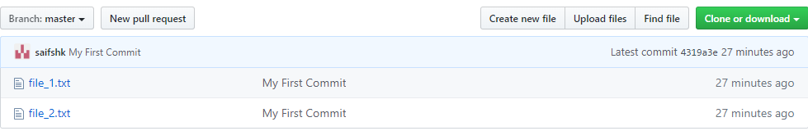

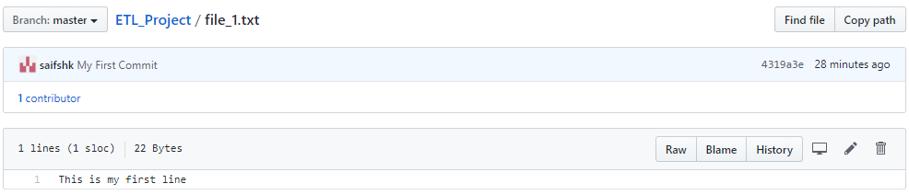

Error:
git pull origin master --allow-unrelated-histories
Now let’s modify file_1.txt:
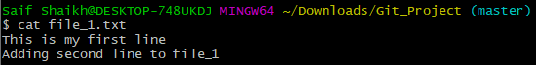

Check the status:
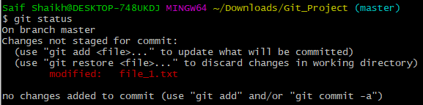

Add & Check the status:
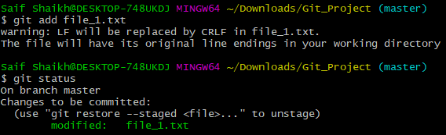

Commit:
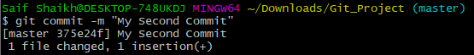

Push:
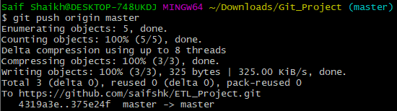

GitHub View to verify local repository is in sync with remote repository:

Ref: https://www.invezzatechnologies.com/how-to-push-single-or-two-or-multiple-files-git-single-commit/
7) git log:
Usage: git log <filename>
This command will show you all logs for the file requested.

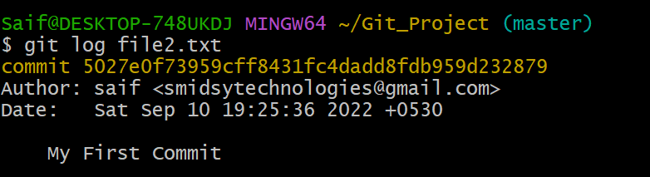

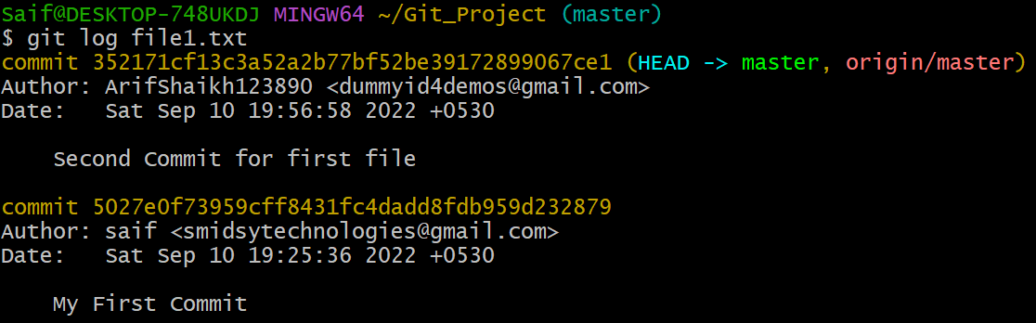

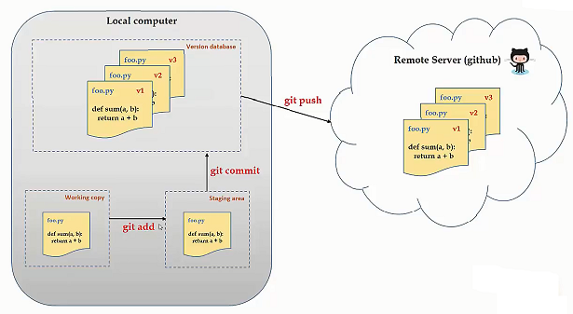

Now, new project team member wants to have this GitHub info in his local:

Create a new dir on local:
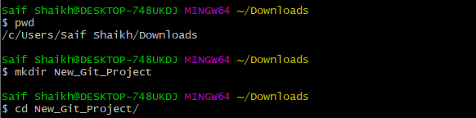

7) git clone:
Usage: git clone [URL]
Suppose, we want to work on a file that is on a remote GitHub repository as another developer.

How can we do that?
- We can work on this file by clicking on Clone or Download and copying the link and pasting it on the terminal with the git clone command.
- This will import the files of a project from the remote repository to our local system.

The below screenshot shows from where to copy the link:
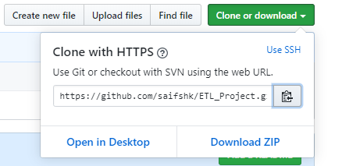

Now, paste the copied link along with the git clone command as shown below:

Before Clone:
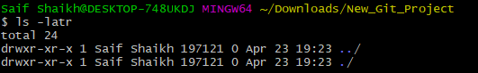

Note: Here, we don’t have to use the git remote add origin command because we have already cloned the remote repository in the local directory. Now, if we push any new file it knows where it has to go.

git clone https://github.com/saifshk/ETL_Project.git
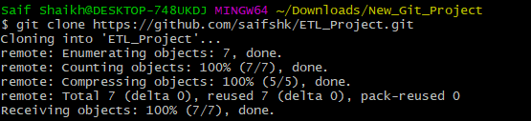

After Clone:
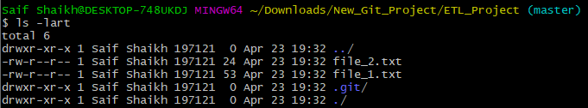

Now the new developer create a file and he follows the cycle of pushing it to GitHub.

Creating a new file with Data:

Git add:
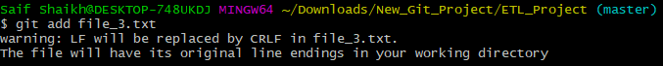

Git commit:
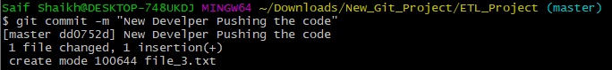

Git push:
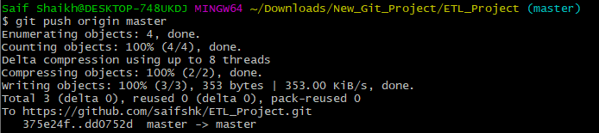

GitHub View to verify new member local repository is in sync with remote repository:
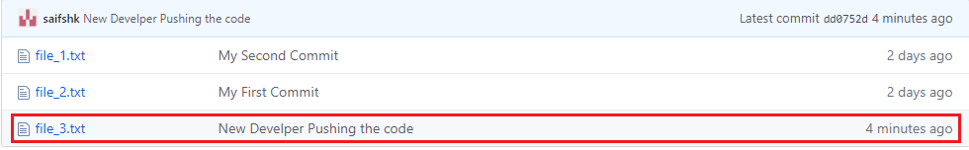

Now the new developer repository & remote GitHub repository is in sync but the earlier developer local repository is not in sync. So to sync execute below command.

Before pull:
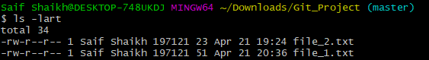

8) git pull:
Usage: git pull origin master OR git pull <url>
The git pull command first runs ‘git fetch’ which downloads the content from the specified remote repository and then immediately updates the local repo to match the content.

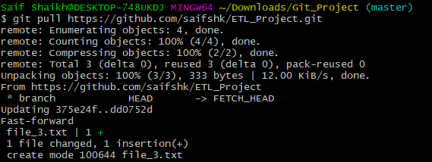
After pull:
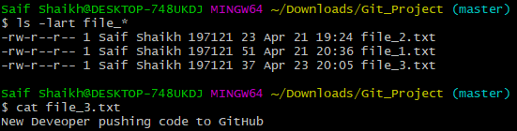

9) Undoing (Not Committed)/Reverting (Committed)/Resetting Code Changes

a) checkout (Undo Not Committed Changes):
Let’s demonstrate how to undo changes.

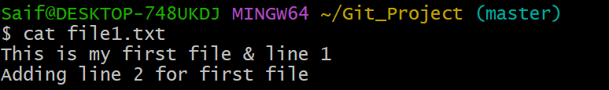

Add New Line to test checkout:
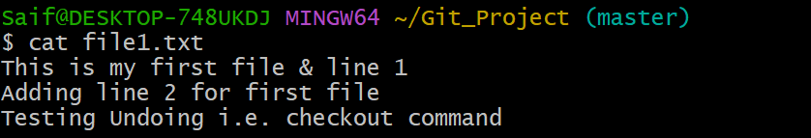

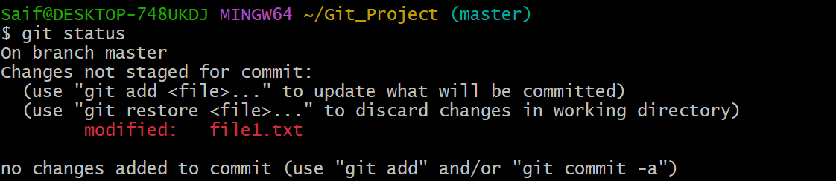

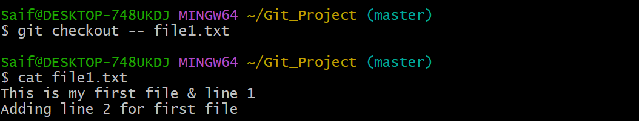
b) checkout multiple files:
git checkout -- file1.txt file2.txt
OR
git checkout -- .

- revert (Undo Committed changes):
cat file1.txt
Add one line of data
git add file1.txt
git commit –m “Put Some Message”
git status

git log
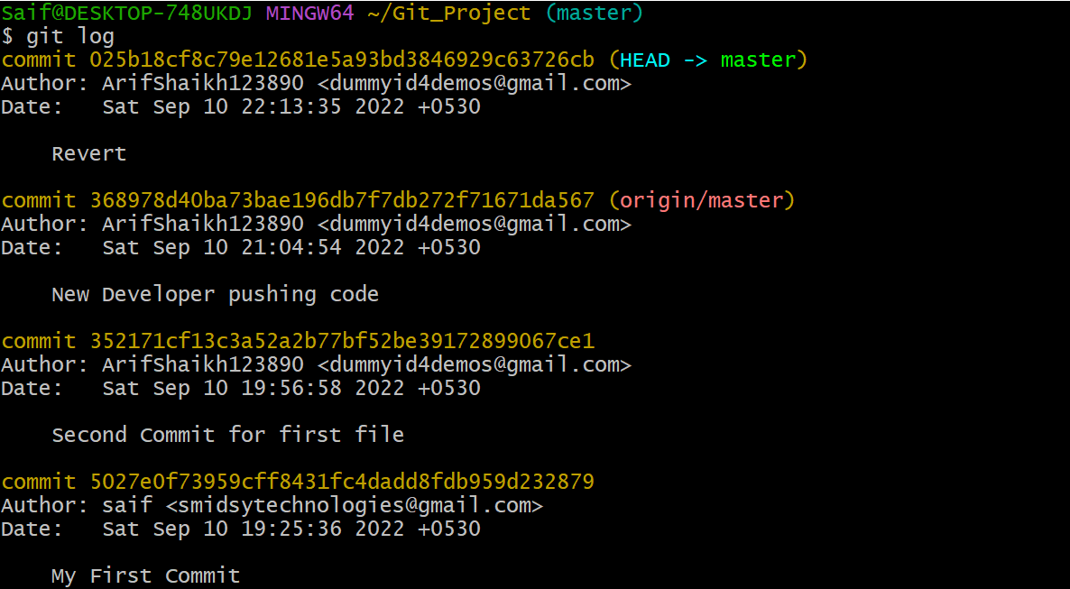

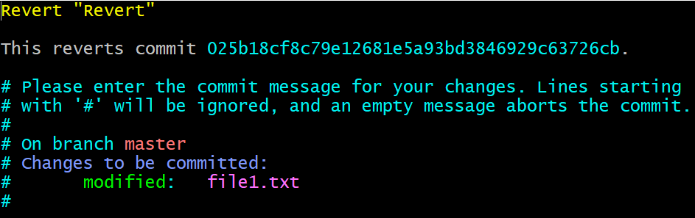
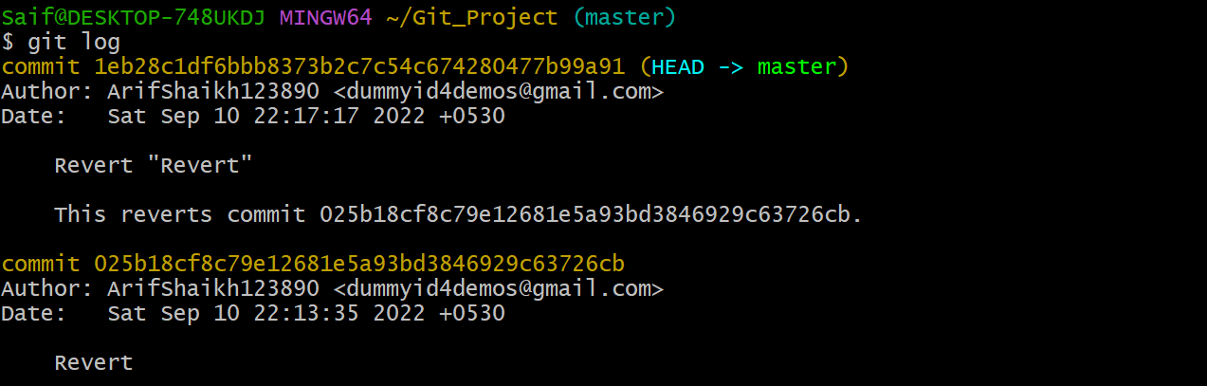

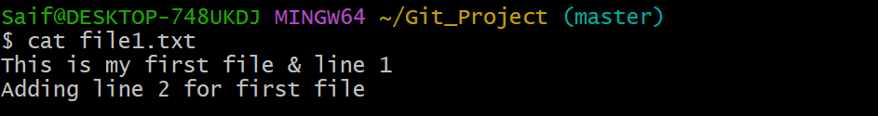

- revert (Undo Committed changes) but when doing revert no implicit commit but user/developer has to commit explicitly
git revert –n <Commit_Id>

- reset (Hard Removal):

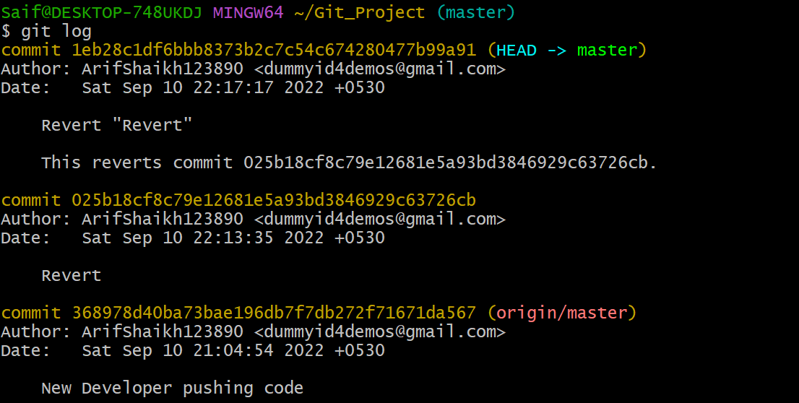

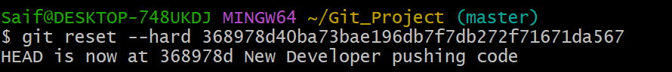

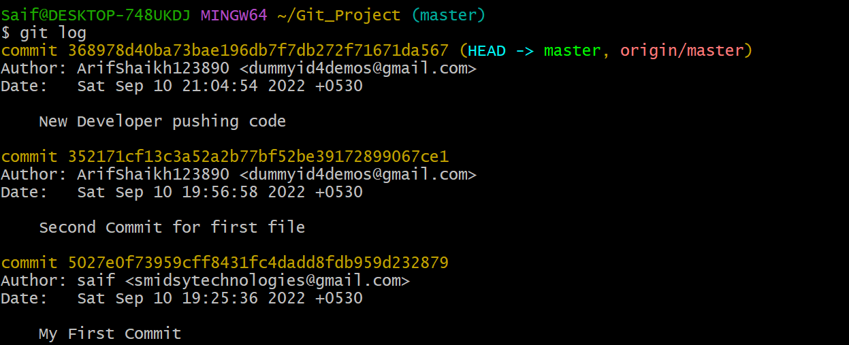

10) git branch:
Usage (i): git branch [name-of-the-branch]
So far, we saw how we can work on Git. Now, imagine, multiple developers working on the same project or repository! To handle the workspace of multiple developers, we can use branches. To create a branch (say, the ‘name-of-the-branch’ is ‘branch1’), we use this command:

View Branches:
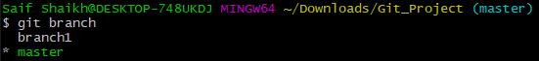

9) git checkout:
Usage (i): git checkout [name-of-the-new-branch]
We use this command to navigate to an existing branch, add new files, and commit the files:

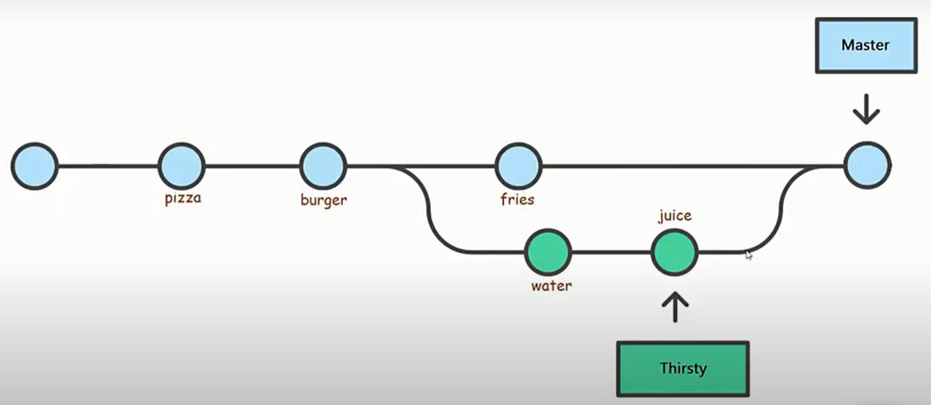

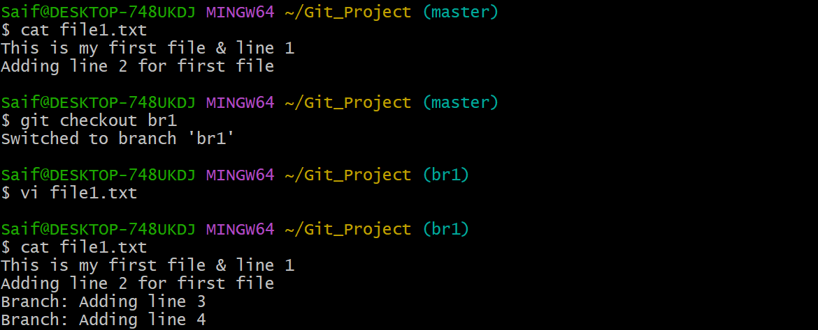
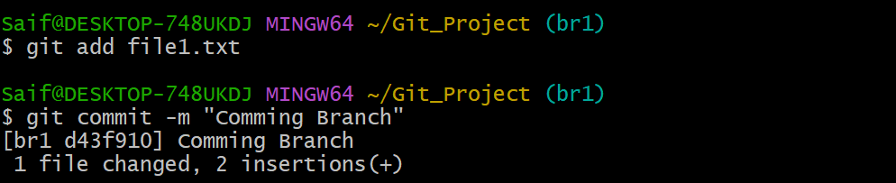

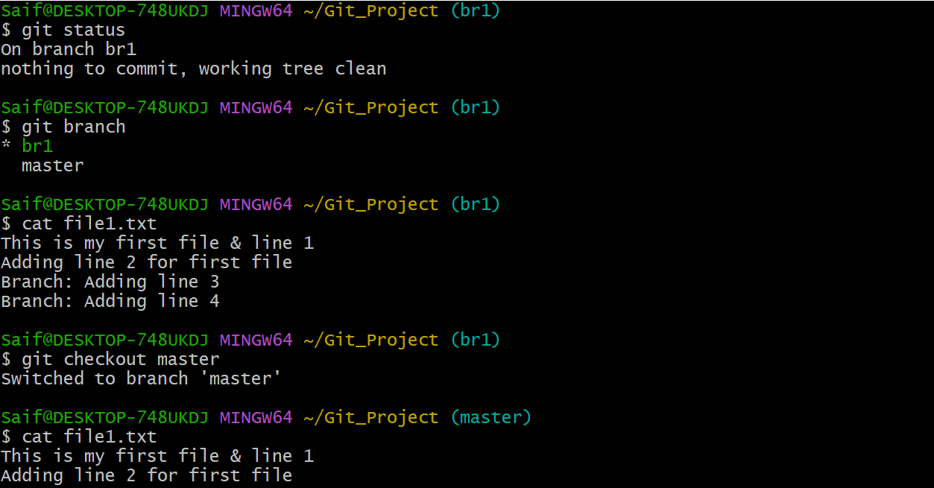

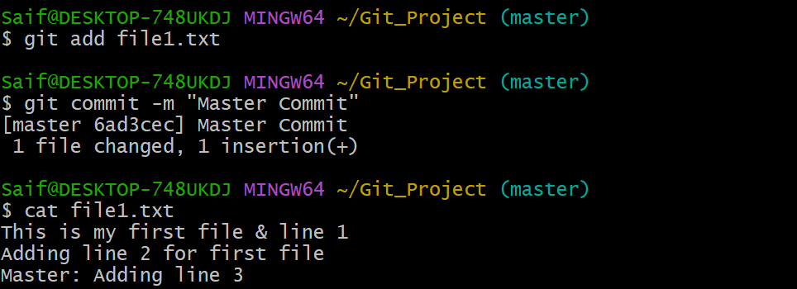

Now if you compare Master & Branch code which is not in sync:
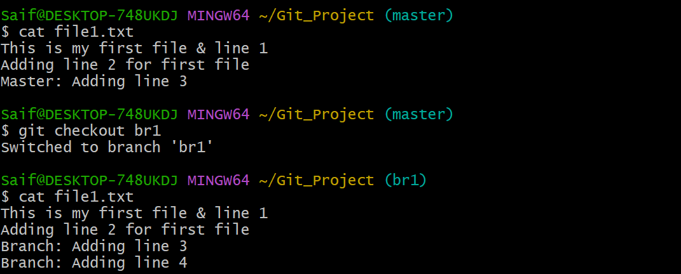
So now to Sync the code to Master from Branch you need to be in Master & Vice-Versa:
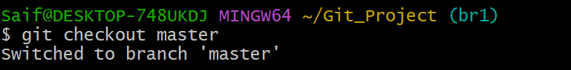

Merge:
git merge br1
git merge --abort

Usage (ii): git branch -D [name -of-the-branch]
Similarly, to delete a branch, we use the git branch -D command:
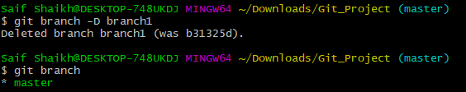

10) git difftool:
It compares the changes of the files side by side.
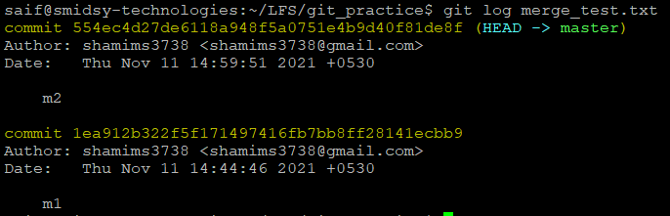

Command:
git difftool 1ea912b322f5f171497416fb7bb8ff28141ecbb9 554ec4d27de6118a948f5a0751e4b9d40f81de8f –y

Output:

To exit press :qa & enter

