What is Data?
Data is a collection of facts, such as numbers, words, measurements, observations or just descriptions of things.

Evolution of Big Data:

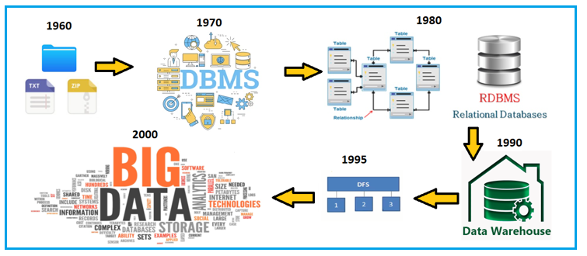

How big is Data?
8 Bits 1 Byte
1024 Bytes 1 KB
1024 KB 1 MB
1024 MB 1 GB
1024 GB 1 TB
1024 TB 1 PB
1024 PB 1 EB
1024 EB 1 ZB
1024 ZB 1 YB
1024 YB 1 BT
1024 BT 1 GT

What is Big Data?
- Lots of Data (Terabytes and Petabytes)
- Big Data is the term for collection of data i.e. so large and complex that it becomes difficult to process using on-hand database management tools or traditional data processing applications.

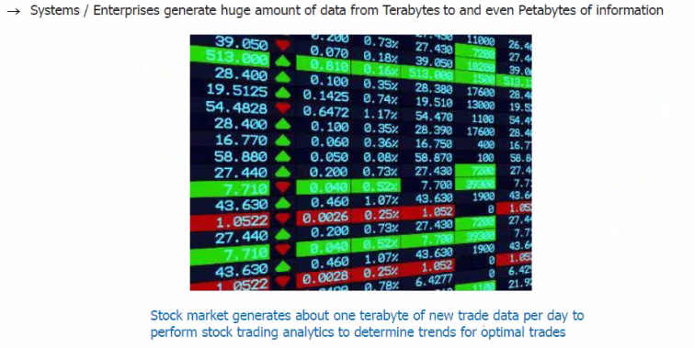

Types of Big Data & their Significance:
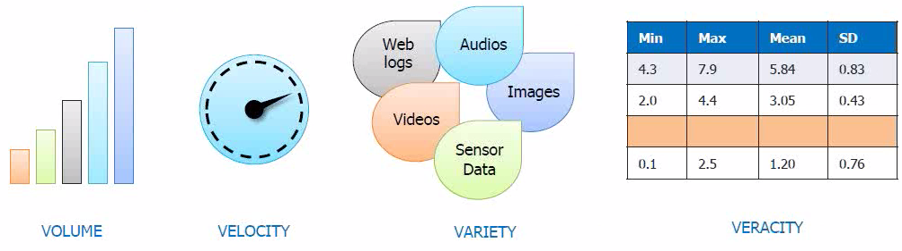

Understanding:
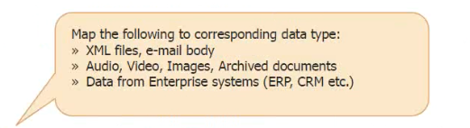

Structured: Relational Data, Data from Enterprise Systems (ERP, CRM etc.)
Semi-Structured: XML files, E-mail body
Un-Structured: Audio, Video, Images, Archived documents, Logs etc.

Challenges:
- Storing large volume of data.
- Processing this large volume of data.

Google Papers:
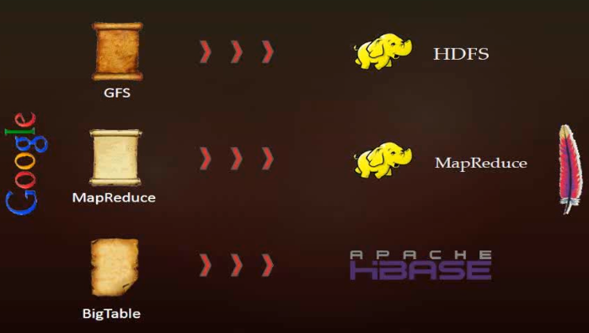

History & Evolution of Hadoop:
Ref: https://data-flair.training/blogs/hadoop-history/

- Year 2002: Nutch project was started by Doug Cutting & Mike Cafarella.
It all started in the year 2002 with the Apache Nutch project.

In 2002, Doug Cutting and Mike Cafarella were working on Apache Nutch Project that aimed at building a web search engine that would crawl and index websites.

After a lot of research, Mike Cafarella and Doug Cutting estimated that it would cost around $500,000 in hardware with a monthly running cost of $30,000 for a system supporting a one-billion-page index.

This project proved to be too expensive and thus found infeasible for indexing billions of webpages. So they were looking for a feasible solution that would reduce the cost.

- Year 2003: Google released white paper on GFS.
Meanwhile, In 2003 Google released a search paper on Google Distributed File System (GFS) that described the architecture for GFS that provided an idea for storing large datasets in a distributed environment. This paper solved the problem of storing huge files generated as a part of the web crawl and indexing process. But this is half of a solution to their problem.

- Year 2004: Google released white paper on Map Reduce.
In 2004, Nutch’s developers set about writing an open-source implementation, the Nutch Distributed File System (NDFS).

In 2004, Google introduced MapReduce to the world by releasing a paper on MapReduce. This paper provided the solution for processing those large datasets. It gave a full solution to the Nutch developers.

Google provided the idea for distributed storage and MapReduce. Nutch developers implemented MapReduce in the middle of 2004.

- Mid 2004: Nutch Implemented NDFS & Map Reduce.

- Year 2006: Development of Hadoop started as a sub-project of Nutch.
The Apache community realized that the implementation of MapReduce and NDFS could be used for other tasks as well.

In February 2006, they came out of Nutch and formed an independent subproject of Lucene called “Hadoop” (which is the name of Doug’s kid’s yellow elephant).

As the Nutch project was limited to 20 to 40 nodes cluster, Doug Cutting in 2006 itself joined Yahoo to scale the Hadoop project to thousands of nodes cluster.

- Year 2007: Yahoo started using Hadoop on 1000 Node Cluster.

- Year 2008: Hadoop became top-level project at Apache.
In January 2008, Hadoop confirmed its success by becoming the top-level project at Apache.

By this time, many other companies like Last.fm, Facebook, and the New York Times started using Hadoop.

Hadoop Defeated supercomputers:
In April 2008, Hadoop defeated supercomputers and became the fastest system on the planet by sorting an entire terabyte of data.

In November 2008, Google reported that its Mapreduce implementation sorted 1 terabyte in 68 seconds.

In April 2009, a team at Yahoo used Hadoop to sort 1 terabyte in 62 seconds, beaten Google MapReduce implementation.

- Year 2011: Apache released first stable version Hadoop 1.0
On 27 December 2011, Apache released Hadoop version 1.0 that includes support for Security, Hbase, etc.

- Year 2012: Hadoop 2.0 version which contains YARN was released.
On 23 May 2012, the Hadoop 2.0.0-alpha version was released. This release contains YARN.

The second (alpha) version in the Hadoop-2.x series with a more stable version of YARN was released on 9 October 2012.

- Year 2017 – Now:
On 13 December 2017, release 3.0.0 was available

On 25 March 2018, Apache released Hadoop 3.0.1, which contains 49 bug fixes in Hadoop 3.0.0.

On 6 April 2018, Hadoop release 3.1.0 came that contains 768 bug fixes, improvements, and enhancements since 3.0.0.

Later, in May 2018, Hadoop 3.0.3 was released.

On 8 August 2018, Apache 3.1.1 was released.

Hadoop 3.1.3 is the latest version of Hadoop.

What is Hadoop?
- Hadoop is a framework that allows distributed processing of large data sets across clusters of commodity computers using a simple programming model.
- It is an Open-Source Data Management with scale out storage and distributed processing.

Hadoop Distributions available in Market:
- Apache: Vanilla flavour, as the actual code is residing in Apache repositories.
- Hortonworks: Popular distribution in the industry.
- Cloudera: It is the most popular in the industry.
- MapR: It has rewritten HDFS and its HDFS is faster as compared to others.
- IBM: Proprietary distribution is known as Big Insights.

All flavours are almost same and if you know one, you can easily work on other flavours as well.

Features of Hadoop:
a) Open Source b) Distributed Processing c) Fault Tolerance
d) Reliability e) High Availability f) Scalability
g) Data Locality

Limitations of Hadoop:
a) Issue with Small Files b) Support for Batch Processing only
c) No Real-time Processing d) Lengthy Code

RDBMS Vs HADOOP
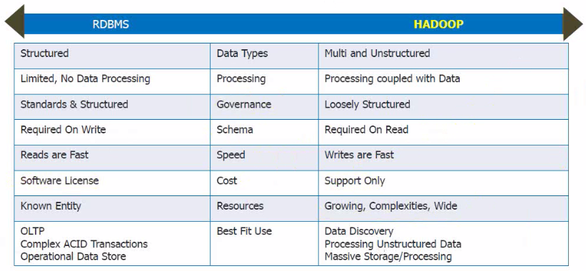

Hadoop 1.x Architecture and its Daemons:
Hadoop 1.x Architecture is a history now because most of the Hadoop applications are using Hadoop 2.x Architecture. But still understanding of Hadoop 1.x Architecture will provide us the insights of how hadoop has evolved over the time.

Hadoop 1.x Major Components: HDFS and MapReduce.

1) HDFS:
HDFS is a Hadoop Distributed FileSystem, where our BigData is stored using Commodity Hardware. It is designed to work with Large DataSets with default block size of 64MB.
a) Name Node:
- There is a single instance of this process which runs on a cluster and that is on a master node.
- It used to store Metadata about DataNode like “How many blocks are stored in Data Nodes, Which DataNodes have data, DataNode Details, locations, timestamps etc.”
- This process reads all the metadata from a file named fsimage and keeps it in memory. After this process is started, it updates metadata for newly added or removed files in RAM.
- It periodically writes the changes in one file called edits as edit logs. This process is heart of HDFS, if it is down HDFS is not accessible any more.

b) Secondary Name Node:
- For this also single instance of this process runs on a cluster. This process can run on a master node (for smaller clusters) or can run on a separate node (in larger clusters) depends on the size of the cluster.
- One misinterpretation from name is “This is a backup Name Node” but it’s NOT.
- It manages the metadata for the NameNode. In the sense, it reads the information written in edit logs (by Name Node) and creates an updated file of current cluster metadata.
- Then it transfers that file back to Name Node so that fsimage file can be updated.
- So, whenever NameNode daemon is restarted it can always find updated information in fsimage file.

c) DataNode:
- There are many instances of this process running on various slave nodes.
- It is responsible for storing individual file blocks on the slave nodes in Hadoop cluster.
- Based on the replication factor, a single block is replicated in multiple slave nodes (only if replication factor is > 1) to prevent data loss.
- This process periodically sends heart beats to NameNode to make NameNode aware that slave process is up and running.
2) MapReduce:
MapReduce is a Distributed and Batch Processing Programming Model. MapReduce also uses Commodity Hardware to process “High Volume of Variety of Data at High Velocity” in a reliable and fault-tolerant manner.
MapReduce component is again divided into two sub-components:
a) Job Tracker:
- Only one instance of this process runs on a master node.
- Any MapReduce job is submitted to Job Tracker first.
- Job Tracker checks for the location of various file blocks used in MapReduce processing.
- Then it initiates the separate tasks on various DataNodes where blocks are present by communicating with Task Tracker Daemons.
b) Task Tracker:
- This process has multiple instances running on the slave nodes.
- It receives the job information from Job Tracker and initiates a task on that slave node.
- In most of the cases, Task Tracker initiates the task on the same node where the physical data block is present.
- Same as DataNode daemon, this process also periodically sends heart beats to Job Tracker to make Job Tracker aware that slave process is running.

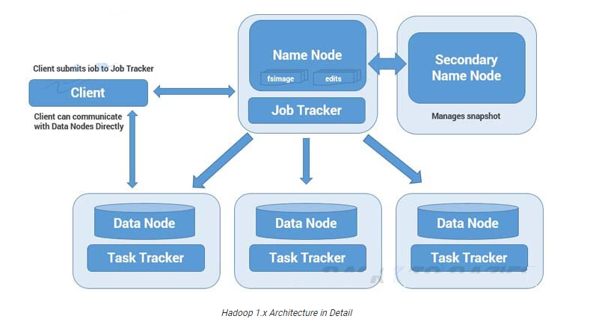

Limitations of Hadoop 1.x Architecture:
- Single Point of Failure as there is no backup NameNode.
- Job scheduling, Resource Management and Job Monitoring are being done by Job Tracker which is tightly coupled with Hadoop. So Job Tracker is not able to manage resources outside Hadoop.
- Job Tracker has to coordinate with all task tracker, so in a very big cluster it will be difficult to manage huge number of task trackers altogether.
- Due to single NameNode, there is no concept of namespaces in Hadoop 1.x. So everything is managed under single namespace.
- Using Hadoop 1.x architecture, Hadoop Cluster can be scaled upto ~4000 nodes only. Scalability beyond that may cause performance degradation and increasing task failure ratio.

Understanding Hadoop 2.x Architecture and its Daemons:
- Hadoop 2.x has some common and new APIs which can be easily integrated with any third party applications to work with Hadoop.
- It has new Java APIs and features in HDFS and MapReduce which are known as HDFS2 and MR2 respectively.
- New architecture has added the architectural features like HDFS High Availability and HDFS Federation.
- Hadoop 2.x is not using Job Tracker and Task Tracker daemons for resource management now on-wards but it is using YARN (Yet Another Resource Negotiator) for Resource Management.

1) HDFS High Availability (HA):
Problem: As you know in Hadoop 1.x Architecture NameNode was a single point of failure, which means if your NameNode is down, you don’t have access to your Hadoop Cluster. How to deal with this problem?

Solution: Hadoop 2.x is featured with NameNode HA which is referred as HDFS High Availability (HA).
- Hadoop 2.x support two NameNodes at a time one node is Active and another is Standby node.
- Active NameNode handles the client operation in the cluster.
- StandBy NameNode manages metadata at the same time via Shared Edit Logs and keeps in-sync with Active NameNode.
- When Active NameNode is down, Standby NameNode takes over and handles the client operation then after.
- HDFS HA can be configured by Using Shared NFS Directory
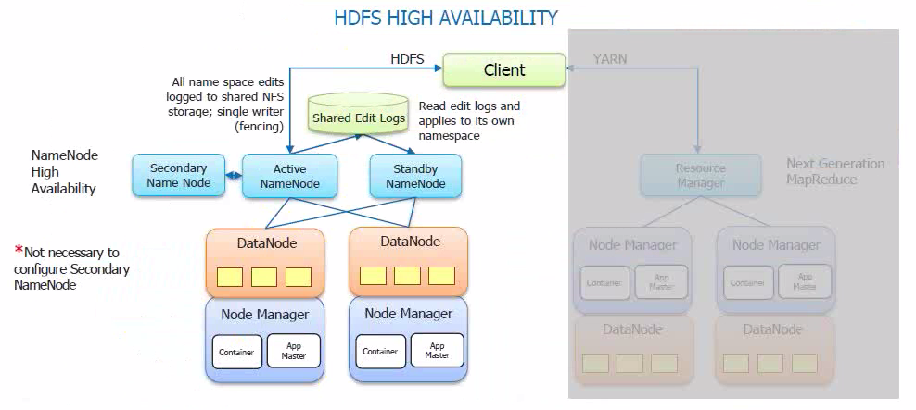
2) HDFS Federation:
Problem: HDFS uses namespace for managing directories, file and block level information in cluster. Hadoop 1.x architecture was able to manage only single namespace in a whole cluster with the help of the NameNode (which is a single point of failure in Hadoop 1.x). Once that Name Node is down you loose access of full cluster data. It was not possible for partial data availability based on name space.
Solution: Above problem is solved by HDFS Federation. Hadoop 2.x Architecture allows to manage multiple namespaces by enabling multiple NameNodes.

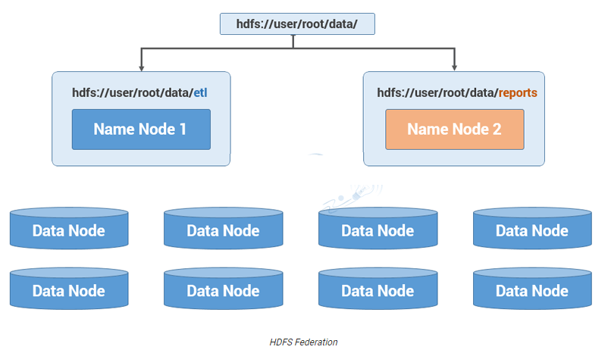
Hadoop 2.x Architecture in Detail:
Hadoop2 Architecture has mainly 2 set of daemons:
1) HDFS 2.x Daemons: NameNode, Secondary NameNode (not required in HA) and Data Nodes.
2) MapReduce 2.x Daemons (YARN): Resource Manager and Node Manager.

HDFS 2.x Daemons:
The working methodology of HDFS 2.x daemons is same as it was in Hadoop 1.x but with following differences.
- Hadoop 2.x allows Multiple Name Nodes for HDFS Federation.
- Hadoop 2.x allows HDFS High Availability in which it can have Active and StandBy Name Nodes (No Need of Secondary Name Node in HA).

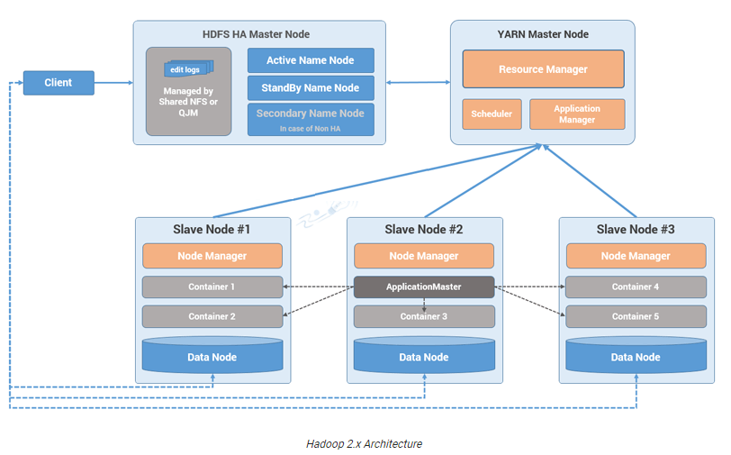

MapReduce 2.x Daemons (YARN):
MapReduce2 has replaced Job Tracker and Task Tracker with YARN components Resource Manager and Node Manager respectively.
a) Resource Manager:
- This has a single instance and the process runs on master node.
- It is responsible for getting job submitted from client and schedule it on cluster, monitor running jobs on cluster and allocating proper resources on the slave node.
- It communicates with Node Manager on the slave node to track the resource utilization.
- It uses two other processes named Application Manager and Scheduler for MapReduce Task and Resource Management.

b) Node Manager:
- This has multiple instances and the process runs on the slave nodes.
- It is responsible for coordinating with Resource Manager for task scheduling and tracking the resource utilization on the slave nodes.
- It also reports the resource utilization back to the Resource Manager.
- It uses two other processes named Application Master and Container for MapReduce Task Scheduling and Execution on the slave nodes.

Hadoop 2.x Core Components:
Storage: Identify the machine where data needs to be stored & Store the data.
Processing: Identify the machine where processing needs to be done & actual execution.

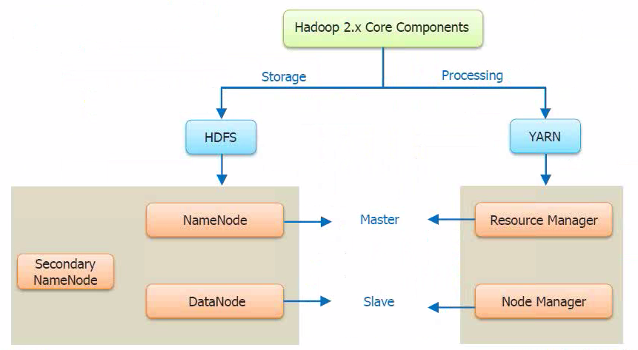

Blocks Size in Hadoop 1.x and 2.x:
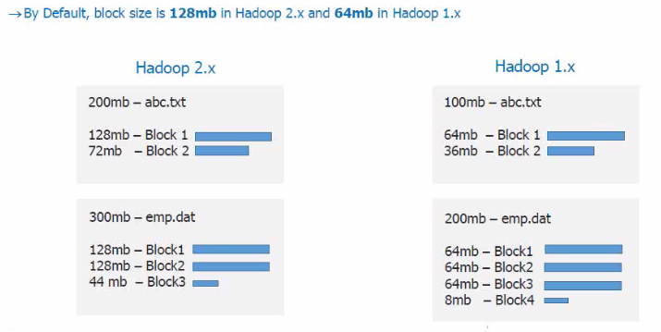

Why is HDFS Block size 128 MB in Hadoop 2.x?
- HDFS have huge data, i.e. Terabytes and Petabytes of data.
- So like Linux file system which have 4 KB block size and if we have block size 4KB for HDFS, then we would be having too many data blocks in HDFS and therefore too much of metadata.
- So managing this huge number of blocks and metadata will create huge overhead and traffic which we don’t want.
- On the other hand, data block size can’t be so large that the system is waiting a very long time for one last unit of data processing to finish its work.

Replication Management:
- Block replication provides fault tolerance. If one copy is not accessible and corrupted, we can read data from other copy.
- The default replication factor is 3 which is configurable. So, each block replicates three times and stored on different DataNodes.
- If we are storing a file of 128 MB in HDFS using the default configuration, we will end up occupying a space of 384 MB i.e. (3*128 MB).
- NameNode receives block report from DataNode periodically to maintain the replication factor.
- When a block is over-replicated/under-replicated the NameNode add or delete replicas as needed.

Rack Awareness:
- In a large cluster of Hadoop, in order to improve the network traffic while reading/writing HDFS file, NameNode chooses the DataNode which is closer to the same rack or nearby rack for read/write request.
- NameNode achieves rack information by maintaining the rack ids of each DataNode.
- Rack Awareness in Hadoop is the concept that chooses DataNode based on the rack information.
- NameNode makes sure that all the replicas are not stored on the same rack or single rack.
- It follows Rack Awareness Algorithm to reduce latency as well as fault tolerance.
- We know that default replication factor is 3 according to Rack Awareness.

Rack Awareness is important to improve:
- High Availability and Reliability.
- Performance of the cluster.
- Improve Network Bandwidth.

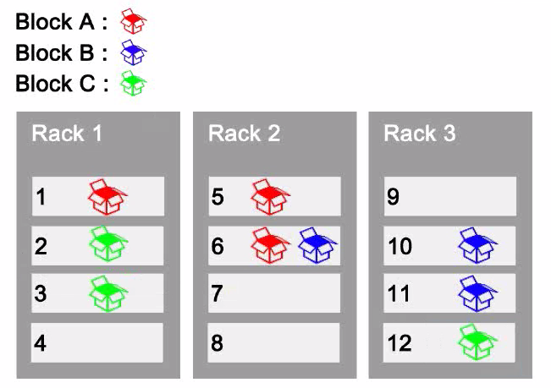

HDFS Commands:

Difference between hdfs dfs & hadoop fs:
fs refers to any file system, it could be local or HDFS but dfs refers to only HDFS file system. So, when we use FS it can perform operation with from/to local or hadoop distributed file system to destination. But specifying DFS operation relates to HDFS. Also, if you need to perform access/transfer data between different file systems, fs is the way to go.
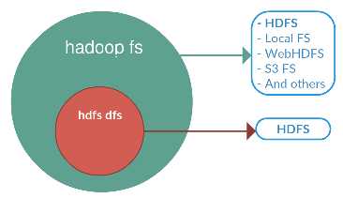
1) ls: To see all files under a directory or at specified path or to see a particular file. For a directory a list of its direct children is returned.
Linux: ls
Hadoop: hadoop fs -ls /

2) mkdir: Create a directory in specified location.
Folder Name: LFS Local File System
Folder Name: HFS Hadoop File System

Linux: mkdir /home/saif/LFS

Hadoop: hadoop fs -mkdir -p /usr/local/hadoop-env/HFS
Note: -p means Do not fail if the directory already exists.

Browse Web UI of Hadoop:
http://localhost:50070/dfshealth.html

3) -put/-copyFromLocal: Copy Command [Linux to Hadoop]
Copy files from the local file system into hdfs. Copying fails if the file already exists.

Syntax: hadoop fs -put <Source_Path> <Target_Path>
hadoop fs -put /home/saif/LFS/file1.txt /usr/local/hadoop-env/HFS/
hadoop fs -copyFromLocal /home/saif/LFS/file2.txt /usr/local/hadoop-env/HFS/

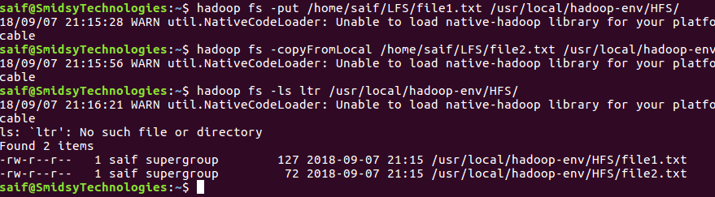

4) -cat: Fetch all files that match the file pattern and display their content.

Syntax: hadoop fs -cat <Path>
hadoop fs -cat /usr/local/hadoop-env/HFS/file1.txt

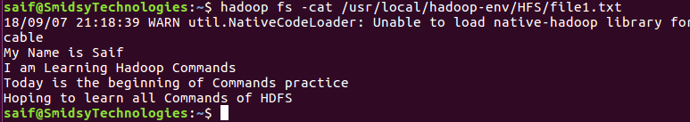

5) touchz: Creates a file of zero length at <path> with current time as the timestamp of that <path>. An error is returned if the file exists with non-zero length.

Syntax: hadoop fs -touchz <Path>
hadoop fs -touchz /usr/local/hadoop-env/HFS/hdp_file1.txt
hadoop fs -touchz /usr/local/hadoop-env/HFS/hdp_file2.txt

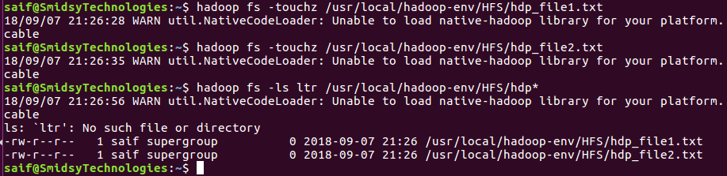
6) -get/-copyToLocal: Copy Command [Hadoop to Linux]
Copy files that match the file pattern <src> to the local name. <src> is kept. When copying multiple files, the destination must be a directory.

Syntax: hadoop fs -get <Source_Path> <Target_Path>
hadoop fs -get /usr/local/hadoop-env/HFS/hdp_file1.txt /home/saif/LFS/
hadoop fs -copyToLocal /usr/local/hadoop-env/HFS/hdp_file2.txt /home/saif/LFS/

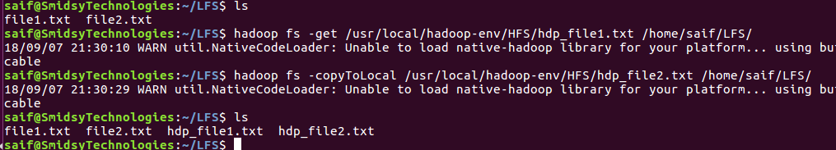

7) -appendToFile:
Appends the contents of all the given src file to the given tgt file. The tgt file will be created if it does not exist.

Syntax: hadoop fs -appendToFile <Source_Path> <Target_Path>
hadoop fs -appendToFile /home/saif/LFS/hdp_file1.txt /usr/local/hadoop-env/HFS/hdp_file1.txt
hadoop fs -appendToFile /home/saif/LFS/hdp_file2.txt /usr/local/hadoop-env/HFS/hdp_file2.txt

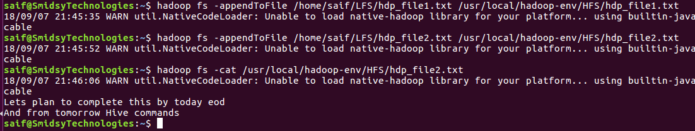

8) -rm [-skipTrash]: Delete all files that match the specified file pattern.

Syntax: hadoop fs -rm <Path>
hadoop fs -rm /usr/local/hadoop-env/HFS/hdp_file1.txt
hadoop fs -rm /usr/local/hadoop-env/HFS/hdp_file2.txt

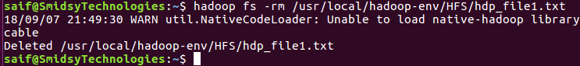
Now, enable the trash interval in core-site.xml from core-default.xml. Save core-site.xml and restart your hadoop cluster.
stop-all.sh
start-all.sh

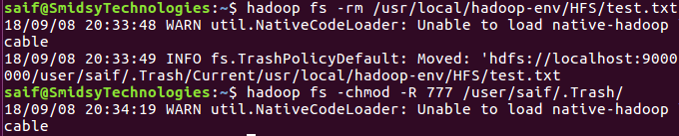

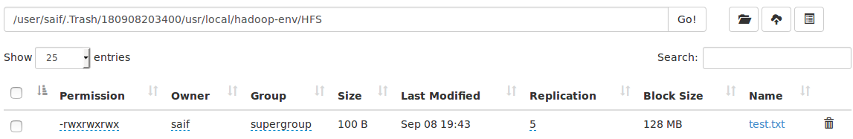

If you check after trash interval time, i.e. 2mins, then nothing will be in Trash.
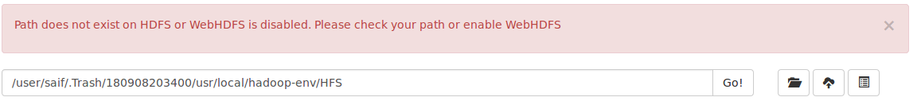

Note: Below command bypasses Trash and gets permanently deleted.
hadoop fs -rm -skipTrash /usr/local/hadoop-env/HFS/file3.txt

Note: To provide permissions recursively from the directory to the held sub-directories & files. Command: hdfs dfs -chmod -R 777 /user/saif/.Trash

9) -count: [-h|-q|-v]
Count the number of directories, files and bytes under the paths that match the specified file pattern.

Syntax: hadoop fs -count <Path>
hadoop fs -count -h -q -v /usr/local/hadoop-env/HFS/

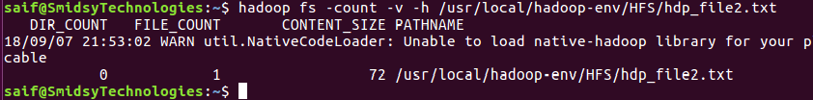
10) -du/-df [-h]: Shows the capacity, free and used space of the filesystem.

Syntax: hadoop fs -du/-df <Path>
hadoop fs -du -h /usr/local/hadoop-env/HFS/
hadoop fs -df -h /usr/local/hadoop-env/HFS/

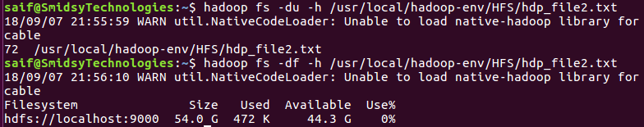

11) -moveFromLocal: Same as -put, except that the source is deleted after it's copied.

Syntax: hadoop fs -moveFromLocal <Source_Path> <Target_Path>
hadoop fs -moveFromLocal /home/saif/LFS/hdp_file1.txt /usr/local/hadoop-env/HFS/

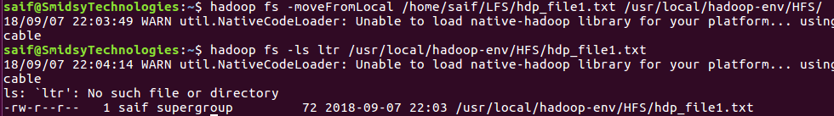

12) -cp: Copy files that match the file pattern <src> to a destination. When copying multiple files, the destination must be a directory.

Syntax: hadoop fs -cp <Source_Path> <Target_Path>
hadoop fs -cp /usr/local/hadoop-env/HFS/hdp_file1.txt /usr/local/hadoop-env/HFS/file3.txt

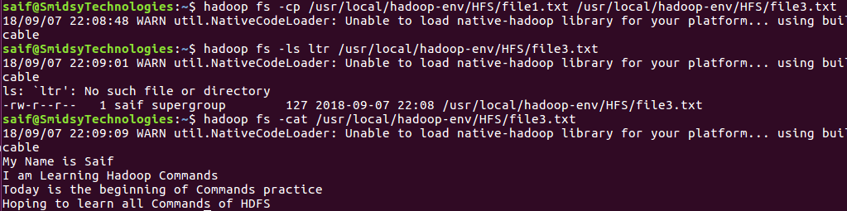

13) -mv: Move files that match the specified file pattern <src> to a destination <tgt>. When moving multiple files, the destination must be a directory.

Syntax: hadoop fs -mv <Source_Path> <Target_Path>
hadoop fs -mv /usr/local/hadoop-env/HFS/file3.txt /usr/local/hadoop-env/HFS/test.txt

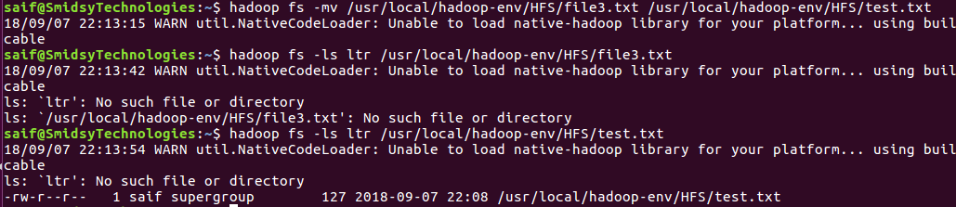

14) -chmod: Changes permissions of a file.

Syntax: hadoop fs -chmod <Path>
hadoop fs -chmod 777 /usr/local/hadoop-env/HFS/test.txt

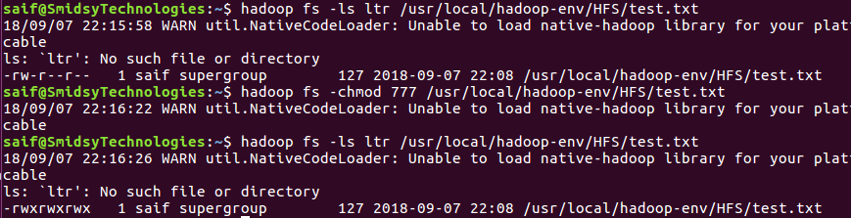

Note: To provide permissions recursively from the directory to the sub-directories & files.
hdfs dfs -chmod -R 777 /user/saif/.Trash

15) -stat [%u|%g|%b|%r|%n|%y|%Y]: Print Statistics about the file/directory at <path> in the specified format. Format accepts file size in blocks (%b), the group name of the owner (%g) and the file name (%n), block size (%o), replication (%r), username of the owner (%u), modification date (%y, %Y)

Syntax: hadoop fs -stat <Path>
hadoop fs -stat %u /usr/local/hadoop-env/HFS/test.txt
hadoop fs -stat %Y /usr/local/hadoop-env/HFS/test.txt epoch converter

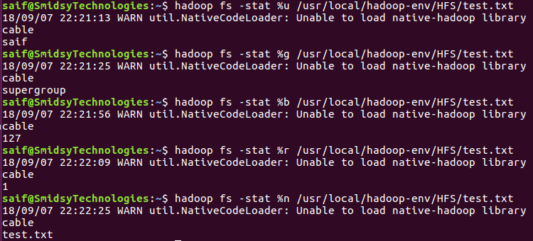

16) -tail: Show the last 1KB of the file. The –f option is used to the show appended data as the file grows.

Syntax: hadoop fs -tail <Path>
hadoop fs -tail /usr/local/hadoop-env/HFS/test.txt

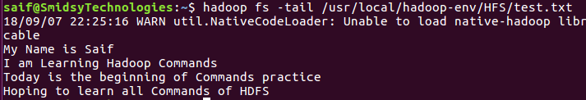

17) -help/-usage: Displays the help/usage for given command or all commands if none is specified.

Syntax: hadoop fs -help OR hadoop fs -usage touchz OR hdfs dfs –help touchz

18) -test [-d|-e|-f|-s|-w|-r|-z]: Answer various questions about <path>, with result via exit status.

Syntax: hadoop fs -test <Path>
hadoop fs -test -d /usr/local/hadoop-env/HFS/

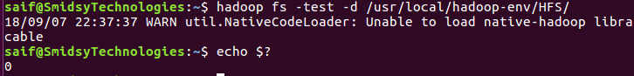
hadoop fs -test -e /usr/local/hadoop-env/HFS/test.txt
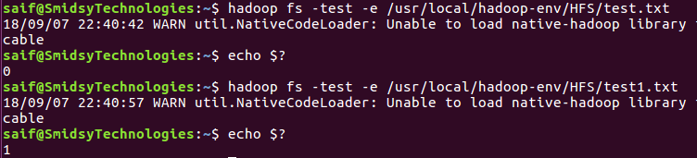

hadoop fs -test -f /usr/local/hadoop-env/HFS/test.txt
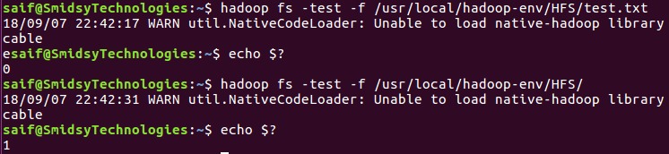

19) -setrep [-w|-R]: Set the replication level of a file. If <path> is a directory then the command recursively changes the replication factor of all files under the directory tree rooted at <path>.

Syntax: hadoop fs -setrep <Path>
hadoop fs -setrep -w 3 /usr/local/hadoop-env/HFS/test.txt

hadoop fs -setrep -stat %r /usr/local/hadoop-env/HFS/test.txt Replication Factor

Web Browser:
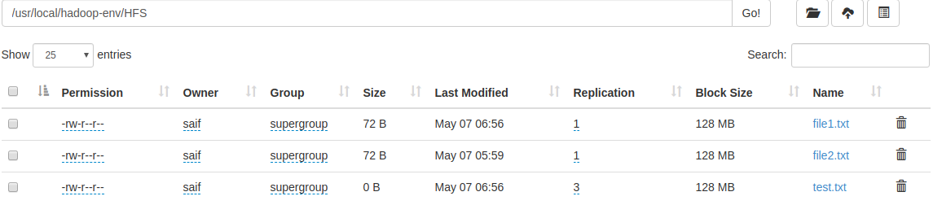
hadoop fs -setrep -R 5 /usr/local/hadoop-env/HFS/test.txt
hadoop fs -setrep -stat %r /usr/local/hadoop-env/HFS/test.txt Replication Factor

20) -find:
Finds all files that match the specified expression and applies selected actions to them. If no path is specified then defaults to the current working directory. If no expression is specified then defaults to -print.

Syntax: hadoop fs -find <Path> [-name|-iname] Filename

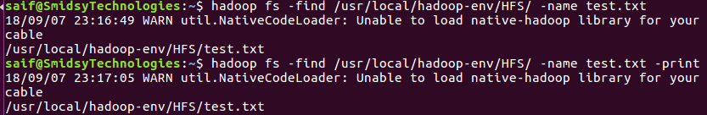

21) -getfacl: Displays the Access Control Lists (ACLs) of files and directories. If a directory has a default ACL, then getfacl also displays the default ACL.

Syntax: hadoop fs -getfacl [-R] <Path>
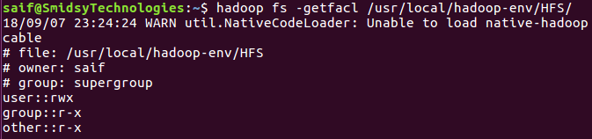

hdfs dfs -getfacl -R /usr/local/hadoop-env/HFS/
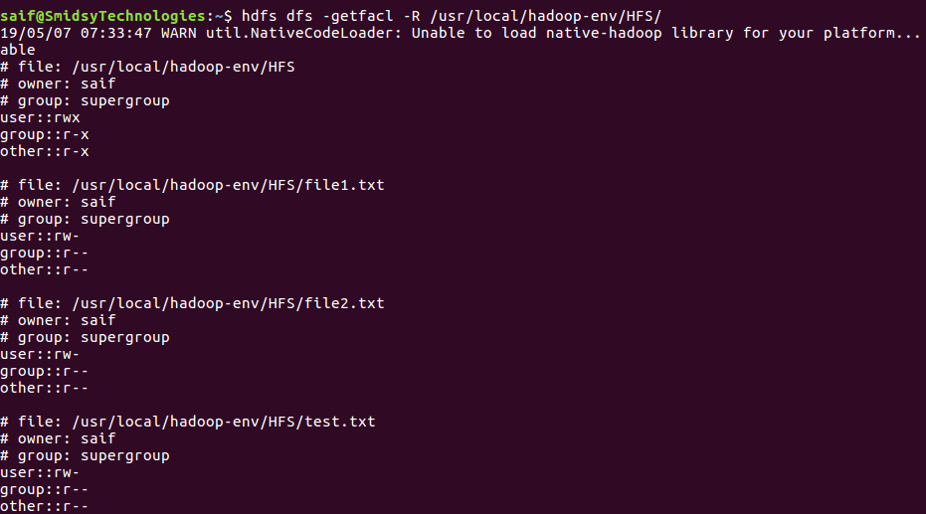
22) -truncate: Truncate all files that match the specified file pattern to the specified length.

Syntax: -truncate [-w] <Length> <Path>

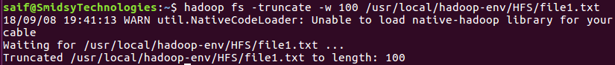

23) -checksum: The checksum of a file depends on its content, block size and the checksum algorithm and parameters used for creating the file.

Syntax: hadoop fs -checksum <Path>

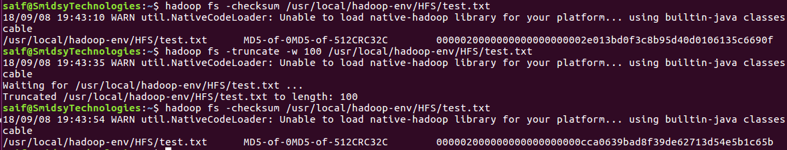

24) -text: It displays zipped file data which cannot be seen by cat command.

Syntax: hdfs dfs -text /usr/local/hadoop-env/HFS/emp.gz
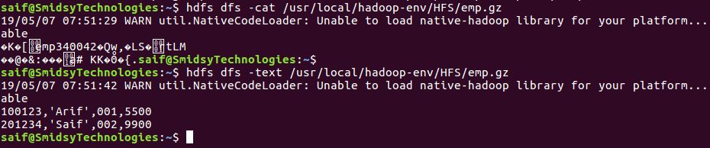

25) –getmerge: Takes the src directory and local destination file as the input. Concatenates the file in the src and puts it into the local destination file. Optionally we can use –nl to add new line character at the end of each file. We can use the –skip-empty-file option to avoid unnecessary new line characters for empty files.

Syntax: hdfs dfs –getmerge [-nl] <src> <localdest>
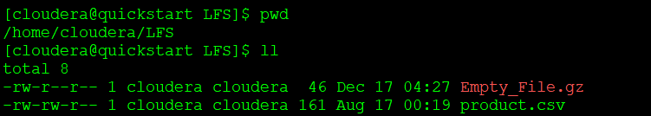
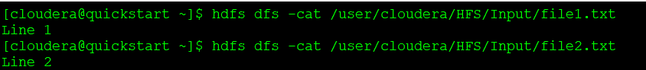

Command: hdfs dfs -getmerge /user/cloudera/HFS/Input/file1.txt /user/cloudera/HFS/Input/file2.txt /home/cloudera/LFS/MergeFile.txt

