**What is Data?**

Data is a collection of **facts**, such as **numbers**, **words**, **measurements**, **observations** or just **descriptions** of things.

**Evolution of Big Data:**

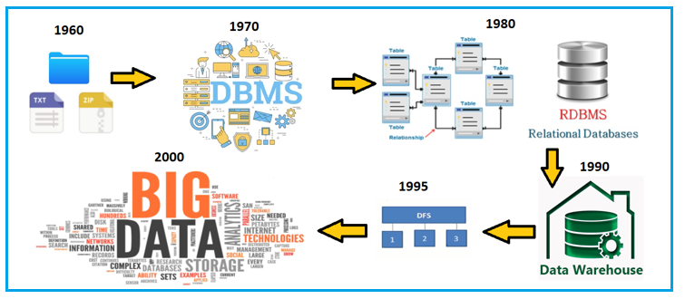

**How big is Data?**

8 Bits 🡪 1 Byte

1024 Bytes 🡪 1 KB

1024 KB 🡪 1 MB

1024 MB 🡪 1 GB

1024 GB 🡪 1 TB

1024 TB 🡪 1 PB

1024 PB 🡪 1 EB

1024 EB 🡪 1 ZB

1024 ZB 🡪 1 YB

1024 YB 🡪 1 BT

1024 BT 🡪 1 GT

**What is Big Data?**

* Lots of Data (Terabytes and Petabytes)
* Big Data is the term for collection of data **i.e.** so large and complex that it becomes difficult to process using on-hand database management tools or traditional data processing applications.

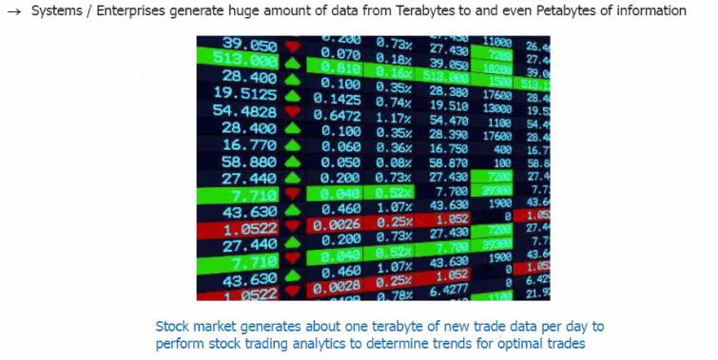

**Types of Big Data & their Significance:**

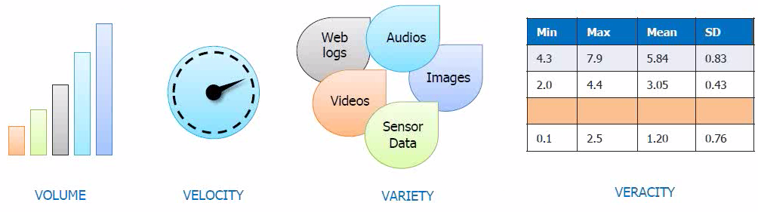

**Understanding:**

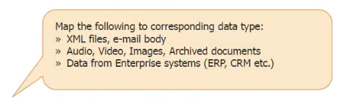

**Structured:** Relational Data, Data from Enterprise Systems (ERP, CRM etc.)

**Semi-Structured:** XML files, E-mail body

**Un-Structured:** Audio, Video, Images, Archived documents, Logs etc.

**Challenges:**

* **Storing** large volume of data.
* **Processing** this large volume of data.

**Google Papers:**

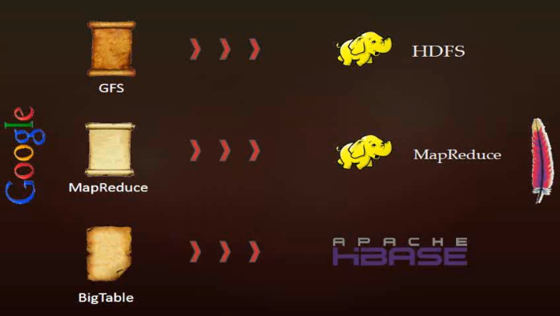

**What is Hadoop?**

* Hadoop is a framework that allows **distributed processing** of **large data sets** across **clusters of commodity computers** using a **simple programming model**.
* It is an **Open-Source** Data Management with **scale out storage** and **distributed processing**.

**Hadoop Distributions available in Market:**

* **Apache:** Vanilla flavour, as the actual code is residing in Apache repositories.
* **Hortonworks:** Popular distribution in the industry.
* **Cloudera:** It is the most popular in the industry.
* **MapR:** It has rewritten HDFS and its HDFS is faster as compared to others.
* **IBM:** Proprietary distribution is known as Big Insights.

**Features of Hadoop:**

**a)** Open Source **b)** Distributed Processing **c)** Fault Tolerance

**d)** Reliability **e)** High Availability **f)** Scalability

**g)** Data Locality

**Limitations of Hadoop:**

**a)** Issue with Small Files **b)** Support for Batch Processing only

**c)** No Real-time Processing **d)** Lengthy Code

**Hadoop 1.x Architecture and its Daemons:**

Hadoop ***1.x Architecture*** is a **history** now because most of the Hadoop applications are using [**Hadoop 2.x Architecture**](https://backtobazics.com/big-data/hadoop/understanding-hadoop2-architecture-and-its-demons/). But still understanding of **Hadoop 1.x Architecture** will provide us the **insights** of how hadoop has **evolved** over the **time**.

**Hadoop 1.x Major Components:** HDFS and MapReduce.

**1) HDFS:**  
HDFS is a Hadoop Distributed FileSystem, where our BigData is stored using Commodity Hardware. It is designed to work with Large DataSets with default block size of **64MB**.

**a) Name Node:**

* There is a **single** instance of this process which runs on a **cluster** and that is on a **master node**.
* It used to store **Metadata** about DataNode like “How many blocks are stored in Data Nodes, Which DataNodes have data, DataNode Details, locations, timestamps etc.”
* This process reads all the metadata from a file named **fsimage** and keeps it in memory. After this process is started, it updates metadata for newly added or removed files in RAM.
* It periodically writes the changes in one file called **edits** as **edit logs**. This process is heart of HDFS, if it is down HDFS is not accessible any more.

**b) Secondary Name Node:**

* For this also **single** instance of this process runs on a **cluster**. This process can run on a **master node** (for smaller clusters) or can **run** on a **separate node** (in larger clusters) depends on the size of the cluster.
* One misinterpretation from name is *“This is a backup Name Node”* but it’s **NOT**.
* It manages the **metadata** for the **NameNode**. In the sense, it reads the information written in **edit logs** (by Name Node) and creates an updated file of **current cluster metadata**.
* Then it transfers that **file** back to **Name Node** so that **fsimage** file can be updated.
* So, whenever NameNode **daemon** is restarted it can always find updated information in **fsimage** file.

**c) DataNode:**

* There are **many** instances of this process running on various **slave nodes**.
* It is responsible for storing individual **file blocks** on the slave nodes in Hadoop cluster.
* Based on the **replication** factor, a single block is replicated in **multiple** slave nodes (**only if replication factor is > 1**) to prevent **data loss**.
* This process periodically sends **heart beats** to NameNode to make NameNode aware that slave process is **up and running**.

**2) MapReduce:**  
MapReduce is a **Distributed** and **Batch** Processing Programming Model. MapReduce also uses **Commodity Hardware** to process “High Volume of Variety of Data at High Velocity” in a **reliable** and **fault-tolerant** manner.

MapReduce component is again divided into two sub-components:

**a) Job Tracker:**

* Only **one** instance of this process runs on a **master** node.
* Any MapReduce job is submitted to **Job Tracker** first.
* Job Tracker checks for the **location** of **various file blocks** used in MapReduce processing.
* Then it **initiates** the separate **tasks** on various **DataNodes** where **blocks** are present by communicating with **Task Tracker** Daemons.

**b) Task Tracker:**

* This process has **multiple** instances running on the **slave** nodes.
* It receives the **job information** from **Job Tracker** and **initiates** a task on that slave node.
* In most of the cases, Task Tracker initiates the task on the **same node** where the **physical data block** is present.
* Same as DataNode daemon, this process also **periodically** sends **heart beats** to Job Tracker to make Job Tracker aware that **slave process** is **running**.

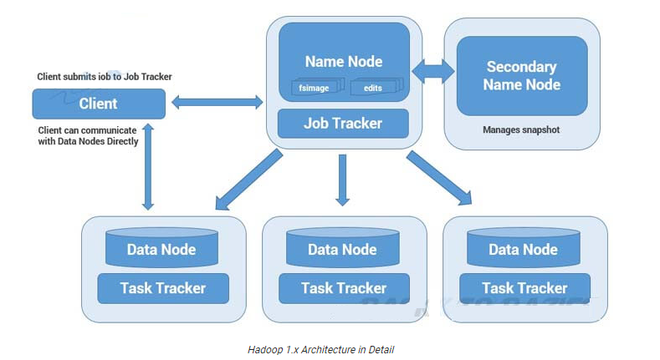

**Limitations of Hadoop 1.x Architecture:**

* **Single Point of Failure** as there is no **backup NameNode**.
* **Job scheduling**, **Resource Management** and **Job Monitoring** are being done by **Job Tracker** which is **tightly coupled** with **Hadoop**. So Job Tracker is **not** able to **manage resources** outside Hadoop.
* Job Tracker has to **coordinate** with all task tracker, so in a very big cluster it will be **difficult** to **manage huge number** of task trackers altogether.
* Due to single **NameNode**, there is no concept of **namespaces** in Hadoop 1.x. So everything is managed under **single namespace**.
* Using Hadoop 1.x architecture, Hadoop Cluster can be scaled upto **~4000 nodes** only. **Scalability** beyond that may cause **performance degradation** and **increasing task failure ratio**.

**Understanding Hadoop 2.x Architecture and its Daemons:**

* Hadoop 2.x has **some common** and **new APIs** which can be **easily integrated** with any **third party applications** to work with Hadoop.
* It has new **Java APIs** and features in HDFS and MapReduce which are known as **HDFS2** and **MR2** respectively.
* New architecture has added the architectural features like **HDFS High Availability** and **HDFS Federation**.
* Hadoop 2.x is not using **Job Tracker** and **Task Tracker** daemons for **resource** **management** now on-wards but it is using **YARN** (Yet Another Resource Negotiator) for **Resource Management**.

**1) HDFS High Availability (HA):**

**Problem:**  As you know in **Hadoop 1.x Architecture NameNode** was a **single point of failure**, which means if your NameNode is **down**, you don’t have access to your Hadoop Cluster. How to deal with this problem?

**Solution:**  Hadoop 2.x is featured with **NameNode HA** which is referred as **HDFS High Availability (HA)**.

* Hadoop 2.x support **two** NameNodes at a time **one** node is **Active** and **another** is **Standby** node.
* Active NameNode handles the client operation in the cluster.
* StandBy NameNode manages **metadata** at the same time via **Shared Edit Logs** and **keeps in-sync** with **Active** NameNode.
* When **Active** NameNode is down, **Standby** NameNode takes over and handles the client operation then after.
* **HDFS HA** can be configured by Using Shared NFS Directory

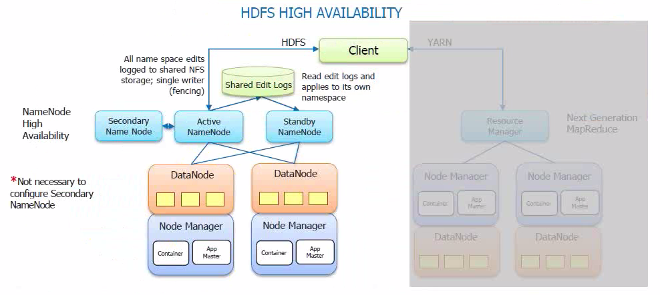

**2) HDFS Federation:**

**Problem:**  HDFS uses namespace for managing directories, file and block level information in cluster. Hadoop 1.x architecture was able to manage only single namespace in a whole cluster with the help of the NameNode (which is a single point of failure in Hadoop 1.x). Once that Name Node is down you loose access of full cluster data. It was not possible for partial data availability based on name space.

**Solution:**  Above problem is solved by HDFS Federation. Hadoop 2.x Architecture allows to manage multiple namespaces by enabling multiple NameNodes.

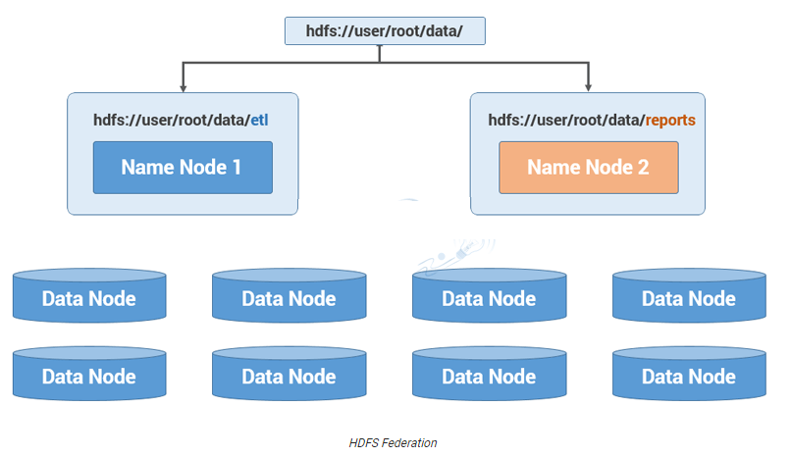

**Hadoop 2.x Architecture in Detail:**

Hadoop2 Architecture has mainly 2 set of daemons:

**1) HDFS 2.x Daemons:**  NameNode, Secondary NameNode (not required in HA) and Data Nodes.

**2) MapReduce 2.x Daemons (YARN):**  Resource Manager and Node Manager.

**HDFS 2.x Daemons:**

The working methodology of HDFS 2.x daemons is same as it was in Hadoop 1.x but with following differences.

* Hadoop 2.x allows **Multiple** Name Nodes for **HDFS Federation**.
* Hadoop 2.x allows **HDFS High Availability** in which it can have **Active** and **StandBy** Name Nodes (No Need of Secondary Name Node in HA).

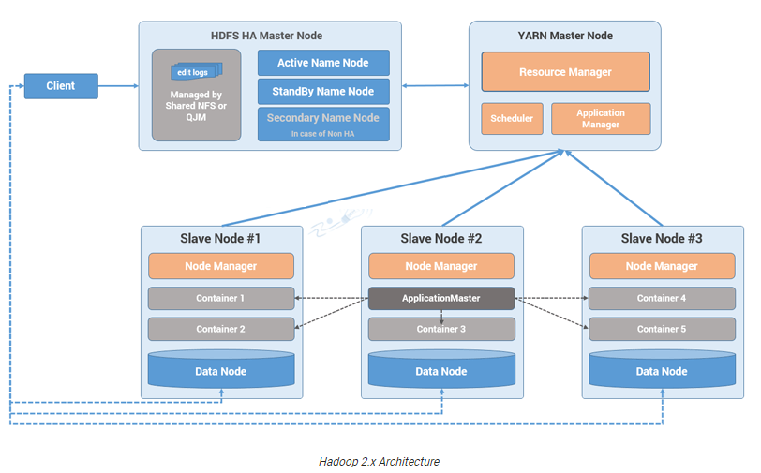

**MapReduce 2.x Daemons (YARN):**

MapReduce2 has replaced Job Tracker and Task Tracker with YARN components Resource Manager and Node Manager respectively.

**a) Resource Manager:**

* This has a **single** instance and the process runs on **master** node.
* It is responsible for getting **job submitted from client** and **schedule** it on cluster, **monitor** **running** jobs on cluster and **allocating proper resources** on the **slave** node.
* It **communicates** with Node Manager on the slave node to **track** the **resource utilization**.
* It uses **two** other processes named ***Application Manager***and ***Scheduler***for **MapReduce** Task and **Resource** Management.

**b) Node Manager:**

* This has **multiple** instances and the process runs on the **slave** nodes.
* It is responsible for **coordinating** with **Resource Manager** for **task scheduling** and **tracking** the **resource utilization** on the **slave** nodes.
* It also reports the **resource utilization** back to the **Resource Manager**.
* It uses two other processes named ***Application Master*** and ***Container*** for **MapReduce Task Scheduling** and **Execution** on the **slave** nodes.

**Hadoop 2.x Core Components:**

**Storage:** Identify the machine where data needs to be stored & Store the data.

**Processing:** Identify the machine where processing needs to be done & actual execution.

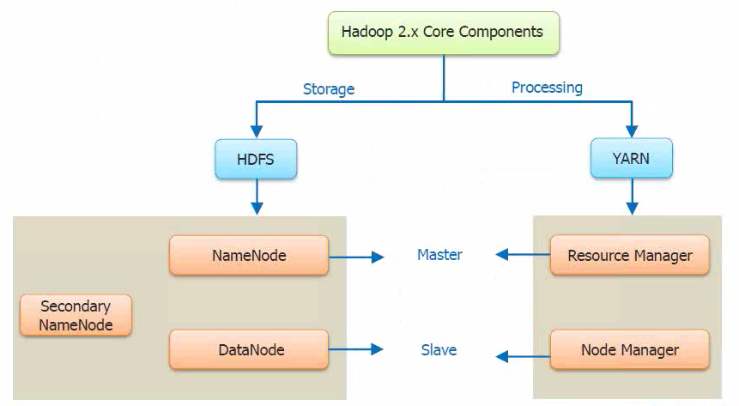

**Blocks Size in Hadoop 1.x and 2.x:**

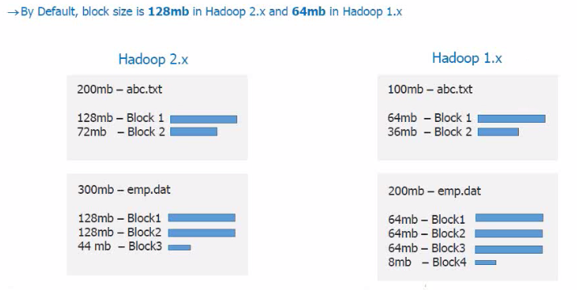

**Why is HDFS Block size 128 MB in Hadoop 2.x?**

* HDFS have huge data, **i.e**. **Terabytes** and **Petabytes** of data.
* So like Linux file system which have **4 KB block size** and if we have block size 4KB for HDFS, then we would be having too many data blocks in HDFS and therefore too much of metadata.
* So **managing** this huge number of blocks and metadata will create **huge overhead** and **traffic** which we don’t want.
* On the other hand, **data block size** can’t be **so large** that the system is waiting a **very long time** for **one last unit of data processing** to **finish** its work.

**Replication Management:**

* Block replication provides **fault** **tolerance**. If one copy is **not** **accessible** and **corrupted**, we can read data from other copy.
* The **default** replication factor is **3** which is configurable. So, each block replicates three times and stored on different DataNodes.
* If we are storing a file of **128 MB in HDFS** using the default configuration, we will end up occupying a space of **384 MB** i.e. (3*128 MB).
* NameNode receives block report from DataNode periodically to maintain the replication factor.
* When a block is **over-replicated/under-replicated** the NameNode **add or delete replicas** as needed.

**Rack Awareness:**

* In a large cluster of Hadoop, in order to **improve** the **network traffic** while **reading/writing** HDFS file, NameNode chooses the DataNode which is **closer** to the same rack or **nearby** rack for **read/write** request.
* NameNode achieves rack information by maintaining the **rack ids** of each DataNode.
* **Rack Awareness** in Hadoop is the concept that **chooses** DataNode based on the rack **information**.
* NameNode makes sure that all the replicas are **not stored** on the **same rack** or **single rack**.
* It follows **Rack Awareness Algorithm** to **reduce latency** as well as **fault tolerance**.
* We know that **default replication factor is 3** according to Rack Awareness.

**Rack Awareness is important to improve:**

* High Availability and Reliability.
* Performance of the cluster.
* Improve Network Bandwidth.

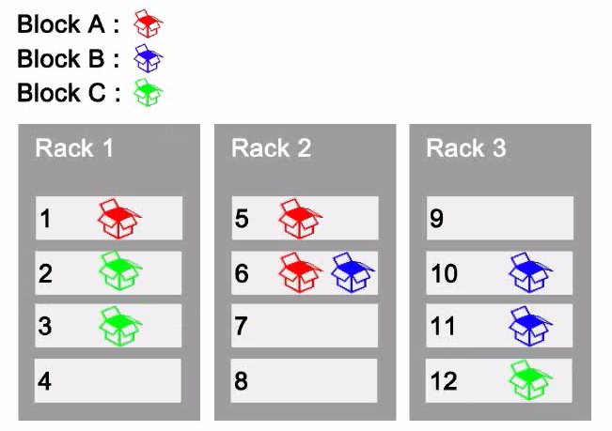

**HDFS Commands:**

**Difference between hdfs dfs & hadoop fs:**

fs refers to any file system, it could be local or HDFS but dfs refers to only HDFS file system. So, when we use FS it can perform operation with from/to local or hadoop distributed file system to destination. But specifying DFS operation relates to HDFS. Also, if you need to perform access/transfer data between different file systems, fs is the way to go.

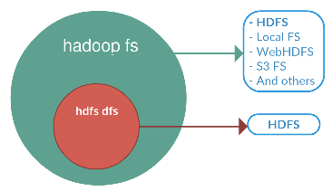

**1) ls:** To see all files under a directory or at specified path or to see a particular file. For a directory a list of its direct children is returned.

**Linux:** ls

**Hadoop:** hadoop fs -ls /

**2) mkdir:** Create a directory in specified location.

Folder Name: LFS 🡪 Local File System

Folder Name: HFS 🡪 Hadoop File System

**Linux:** mkdir /home/saif/LFS



**Hadoop:** hadoop fs -mkdir -p /usr/local/hadoop-env/HFS

**Note:** -p means Do not fail if the directory already exists.

**Browse Web UI of Hadoop:**

<http://localhost:50070/dfshealth.html>



**3)** **-put/-copyFromLocal:** Copy Command [Linux to Hadoop]

Copy files from the local file system into hdfs. Copying fails if the file already exists.

**Syntax: hadoop fs -put <Source_Path> <Target_Path>**

hadoop fs -put /home/saif/LFS/file1.txt /usr/local/hadoop-env/HFS/

hadoop fs -copyFromLocal /home/saif/LFS/file2.txt /usr/local/hadoop-env/HFS/

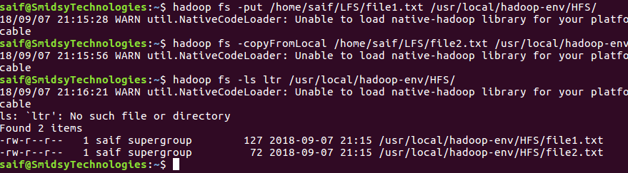

**4) -cat:** Fetch all files that match the file pattern and display their content.

**Syntax: hadoop fs -cat <Path>**

hadoop fs -cat /usr/local/hadoop-env/HFS/file1.txt

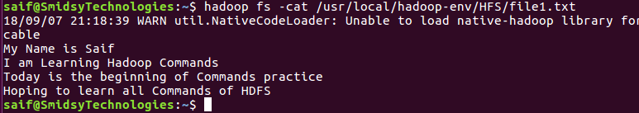

**5) touchz:** Creates a file of zero length at <path> with current time as the timestamp of that <path>. An error is returned if the file exists with non-zero length.

**Syntax: hadoop fs -touchz <Path>**

hadoop fs -touchz /usr/local/hadoop-env/HFS/hdp_file1.txt

hadoop fs -touchz /usr/local/hadoop-env/HFS/hdp_file2.txt

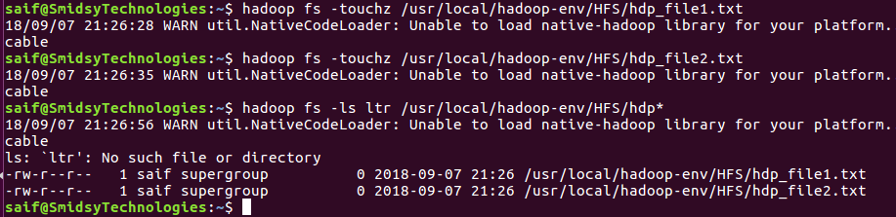

**6)** **-get/-copyToLocal:** Copy Command [Hadoop to Linux]

Copy files that match the file pattern <src> to the local name. <src> is kept. When copying multiple files, the destination must be a directory.

**Syntax: hadoop fs -get <Source_Path> <Target_Path>**

hadoop fs -get /usr/local/hadoop-env/HFS/hdp_file1.txt /home/saif/LFS/

hadoop fs -copyToLocal /usr/local/hadoop-env/HFS/hdp_file2.txt /home/saif/LFS/

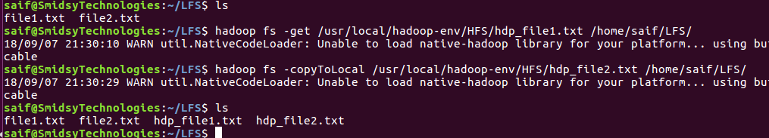

**7) -appendToFile:**

Appends the contents of all the given src file to the given tgt file. The tgt file will be created if it does not exist.

**Syntax: hadoop fs -appendToFile <Source_Path> <Target_Path>**

hadoop fs -appendToFile /home/saif/LFS/hdp_file1.txt /usr/local/hadoop-env/HFS/hdp_file1.txt

hadoop fs -appendToFile /home/saif/LFS/hdp_file2.txt /usr/local/hadoop-env/HFS/hdp_file2.txt

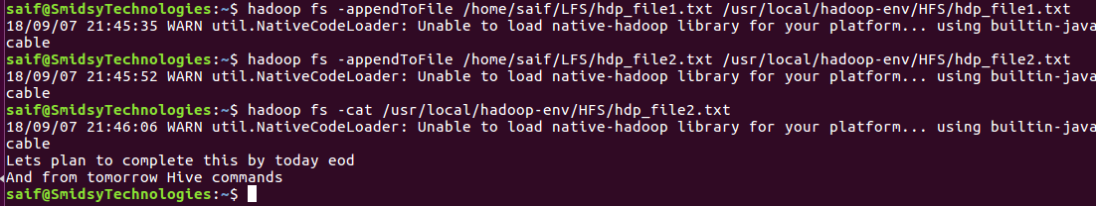

**8) -rm:** Delete all files that match the specified file pattern.

**Syntax: hadoop fs -rm <Path>**

hadoop fs -rm /usr/local/hadoop-env/HFS/hdp_file1.txt

hadoop fs -rm /usr/local/hadoop-env/HFS/hdp_file2.txt

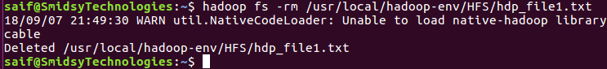

**9) -moveFromLocal:** Same as -put, except that the source is deleted after it's copied.

**Syntax: hadoop fs -moveFromLocal <Source_Path> <Target_Path>**

hadoop fs -moveFromLocal /home/saif/LFS/hdp_file1.txt /usr/local/hadoop-env/HFS/

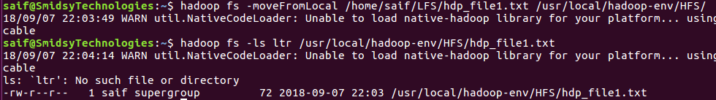

**10) -cp:** Copy files that match the file pattern <src> to a destination. When copying multiple files, the destination must be a directory.

**Syntax: hadoop fs -cp <Source_Path> <Target_Path>**

hadoop fs -cp /usr/local/hadoop-env/HFS/hdp_file1.txt /usr/local/hadoop-env/HFS/file3.txt

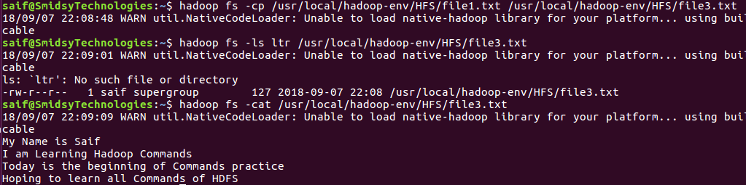

**11) -mv:** Move files that match the specified file pattern <src> to a destination <tgt>. When moving multiple files, the destination must be a directory.

**Syntax: hadoop fs -mv <Source_Path> <Target_Path>**

hadoop fs -mv /usr/local/hadoop-env/HFS/file3.txt /usr/local/hadoop-env/HFS/test.txt

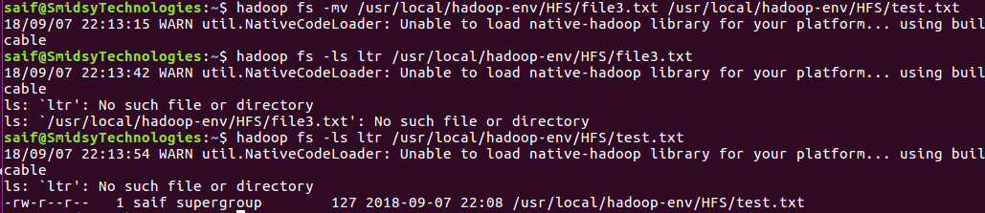

**12) -chmod:** Changes permissions of a file.

**Syntax: hadoop fs -chmod <Path>**

hadoop fs -chmod 777 /usr/local/hadoop-env/HFS/test.txt

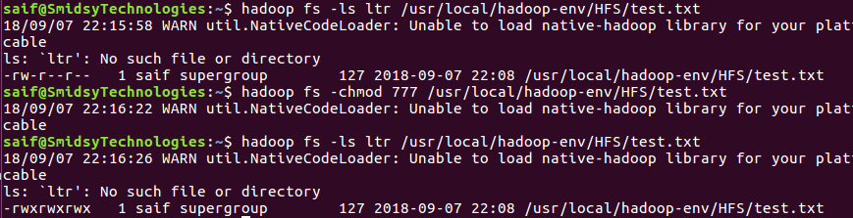

**Note:** To provide permissions recursively from the directory to the sub-directories & files.

**hdfs dfs -chmod -R 777 /user/saif/.Trash**

**13) -stat [%u|%g|%b|%r|%n|%y|%Y]:** Print Statistics about the file/directory at <path> in the specified format. Format accepts file size in blocks (%b), the group name of the owner (%g) and the file name (%n), block size (%o), replication (%r), username of the owner (%u), modification date (%y, %Y)

**Syntax: hadoop fs -stat <Path>**

hadoop fs -stat %u /usr/local/hadoop-env/HFS/test.txt

hadoop fs -stat %Y /usr/local/hadoop-env/HFS/test.txt 🡪 epoch converter

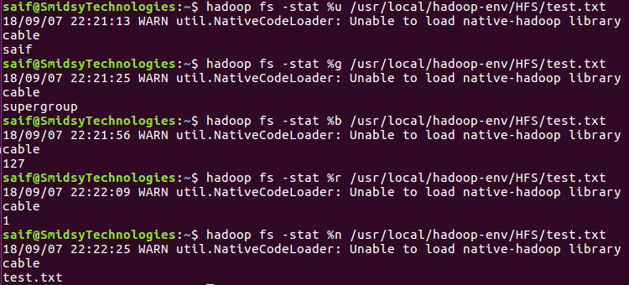

**14) -tail:** Show the last 1KB of the file. The –**f** option is used to the show appended data as the file grows.

**Syntax: hadoop fs -tail <Path>**

hadoop fs -tail /usr/local/hadoop-env/HFS/test.txt

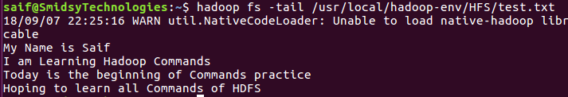

**15) -help/-usage:** Displays the help/usage for given command or all commands if none is specified.

**Syntax: hadoop fs -help OR hadoop fs -usage touchz OR hdfs dfs –help touchz**



**16) -test [-d|-e|-f|-s|-w|-r|-z]:** Answer various questions about <path>, with result via exit status.

**Syntax: hadoop fs -test <Path>**

hadoop fs -test -d /usr/local/hadoop-env/HFS/

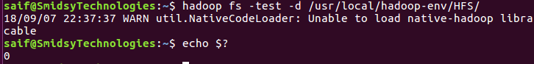

**hadoop fs -test -e /usr/local/hadoop-env/HFS/test.txt**

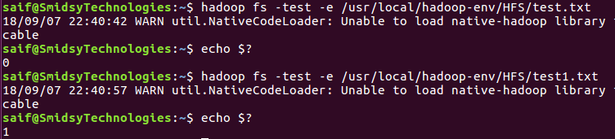

**hadoop fs -test -f /usr/local/hadoop-env/HFS/test.txt**

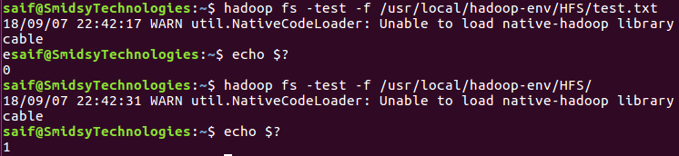

**17) -text:** It displays zipped file data which cannot be seen by cat command.

**Syntax: hdfs dfs -text /usr/local/hadoop-env/HFS/emp.gz**

