**What is BI?**

* The **BI** term refers to **Business Intelligence**.
* It is a data-driven **Decision Support System** (**DSS**), which helps you to **analyze** the data and provide **actionable** information.
* It helps the **Business Manager, Corporate Executives**, and **other users** in making their **decisions** **easily**.

**What is Power BI?**

1. Power BI is a **Data Visualization** and **Business Intelligence** tool that **converts** **data** from different **data sources** to **interactive** **dashboards** and **BI** **reports**.
2. Power BI is provided by **Microsoft** & it has multiple **connectors** and **services**.
3. Power BI **desktop app** is used to **create** reports, while **Power BI Services** (Software as a Service - SaaS) is used to **publish** the reports, and **Power BI mobile app** is used to **view** the **reports** and **dashboards**.
4. These set of services are used by business users to consume data and build BI reports.

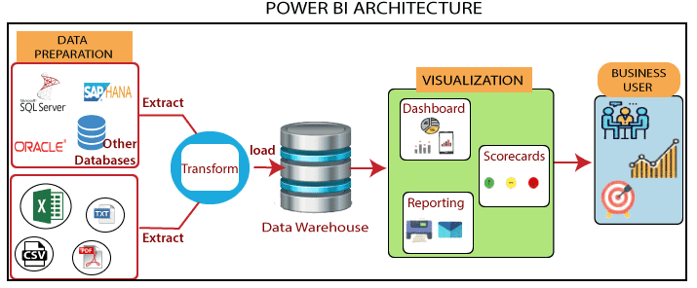

Power BI architecture has three phases. The first two phases use ETL (extract, transform, and load) process to handle the data.

1. **Data Integration:**

* An organization needs to deal with the data that comes from different sources.
* First, extract the data from different sources which can be your separate database, servers.
* Then the data is integrated into a standard format and stored at a common area that's called staging area.

1. **Data Processing:**

* Still, the integrated data is not ready for visualization because the data needs processing before it can be presented.
* This data is pre-processed. For example, the missing values or redundant values will be removed from the data sets.
* After that, the business rules will be applied to the data, and it transforms into presentable data.
* Then this data will be loaded into the data warehouse.

1. **Data presentation:**

* Once the data is loaded and processed, then it can be visualized much better with the use of various visualization that Power BI offers.
* By using of dashboard and reports, we represent the data more intuitively.
* These visual reports help business end-users to take business decision based on the insights.

**Power BI Tools:**

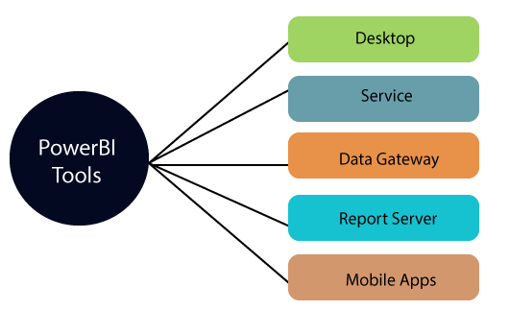

1. **Power BI Desktop:**

* It is a primary authoring and publishing tool.
* Power BI users and developers use it to create brand new models and reports.
* Power BI Desktop tool is available at free of cost.

1. **Power BI Service:**

* The Power BI data modules, dashboards, and reports are hosted in the online software as a service (SaaS).
* Sharing, administration, and collaboration happen in the cloud.
* Power BI Service tool is available at the pro license, and the user has to pay $10 per month.

1. **Power BI Data Gateway:**

* It works as the bridge between the Power BI service & on-premises data sources such as Import, Direct Query, and Live Query.

1. **Power BI Report Server:**

* It hosts paging reports, mobile reports, KPIs, and Power BI desktop reports.
* It requires updates in every four months and managed by the IT team.

1. **Power BI Mobile Apps:**

* It is available for Android, iOS, and Windows.
* You can view reports and dashboards on the Power BI Service Report Server.

🡪 **Installations & Walkthrough of Power BI Desktop**

**🡪 Let’s Start Creating Reports & Visualizations in Power BI:**

**Charts in Power BI Desktop:**

1. Column Chart
2. Stacked Column Chart
3. Combo Chart (Line & Column)

**Filename:** Superstore.xls

**1) Column Chart:**

🡪 Find out Sales by Sub-Category?

**Steps to Prepare Charts:**

**a)** Click on Get Data 🡪 Select Your Dataset 🡪 Click on Orders 🡪 Click on Load.

**b)** Select Stacked Column Chart from Visualizations.

**c)** Drag Sub-Category on X-Axis.

**d)** Drag Sales on Y-Axis

**e)** Do Chart Formatting.

**2) Stacked Column Chart:**

🡪 Find out Sales of Sub-Category by Segment?

**a)** Click on Get Data 🡪 Select Your Dataset 🡪 Click on Orders 🡪 Click on Load.

**b)** Select Stacked Column Chart from Visualizations.

**c)** Drag Sub-Category on X-Axis.

**d)** Drag Sales on Y-Axis

**e)** Drag Segment on Legend

**f)** Do Chart Formatting.

**3) Combo Chart (Line & Stacked Column)**

🡪 Find out Profit & Discount by Order Date & Segment.

**a)** Click on Get Data 🡪 Select Your Dataset 🡪 Click on Orders 🡪 Click on Load.

**b)** Select Line & Stacked Column Chart from Visualizations.

**c)** Drag Order Date on X-Axis.

**d)** Drag Profit on Colum Y-Axis.

e) Drag Discount on Line Y-Axis.

f) Drag Segment on Column Legend.

**e)** Do Chart Formatting.

**Cards & Slicers:**

🡪 Find out Highest Sales, Profit & Quantity by Sub-Category?

a) Select Table.

b) Select Sub-Category, Sales, Profit and Quantity.

c) Do Chart Formatting.

d) Select Card & Drag Sub-Category.

e) Go to Filter, Drag Sub-Category & Filter Top N as 1.

f) Drag Sales/Profit/Quantity & Click Apply Filter.

g) Click Slicer from Visualizations & Drag Market and apply filter based on requirement.

**Data Modelling:**

1. Data modeling is the process of creating a visual representation or a blueprint that defines the information collection and management systems of any organization.
2. The model outlines what data the business collects, the relationship between different datasets, and the methods that will be used to store and analyze the data.

**Data modeling brings the following benefits:**

1. Reduces errors in database software development
2. Facilitates speed and efficiency of database design and creation
3. Creates consistency in data documentation and system design across the organization
4. Facilitates communication between data engineers and business intelligence teams

**Cardinality:**

The Cardinality of the Relationship means having unique or multiple instances per value for the joining field between two tables.

1. One to One Relationship
2. One to Many Relationship
3. Many to One Relationship
4. Many to Many Relationship

**DAX:**

1. DAX stands for Data Analysis Expression.
2. DAX is a formula expression language (i.e. library of functions & operators) which we can use & transform data.
3. DAX is also known as functional language where the full code is kept inside a function.

**Uses of DAX:**

We can add calculation to our Data Model/Visuals/Dashboards.

* Calculated Columns/Measures

|  |  |
| --- | --- |
| **Calculated Column** | **Calculated Measure** |
| Expands Table by creating new column | Summarizes data into a single value |
| Store along with table hence consumes memory | Calculated at runtime so stored temporarily |
| Less analytical capabilities | Rich analytical capabilities |

**E.g. Calculated Column:**

New_Product = [Product Name] &”-“& [Product Category]

New_Profit = [Sales Amount] – [Cost Amount]

**E.g. Calculated Measure:**

Total_Sales = Sum ([Sales Amount])

Total_Profit = Sum ([Sales Amount]) - Sum ([Cost Amount])

Prev_Year_Sale = Calculate (Sum ([Sales Amount]),

SAMEPERIODLASTYEAR (‘Sale’ [Date]))