Exception Handling:
Let’s see Scala Exception and Exceptions Handling and learn about the Scala Try-Catch Blocks and the Throws Keyword in Scala. Along with this, we will cover Scala Finally Block and Scala Exception Handling.

There may be situations your code may misfunction when you run it. These abnormal conditions may cause your program to terminate abruptly. Such runtime errors are called exceptions.

Exception handling is a mechanism which is used to handle abnormal conditions. You can also avoid termination of your program unexpectedly.

Scala Exception Example:
Take a look at the following Scala Exception example. We declare a function to divide two integers and return the result.

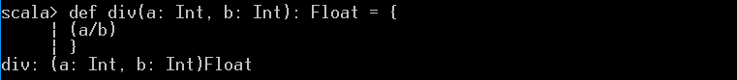

Now, let’s call it:

As you can see, this raises an Arithmetic Exception in Scala.

Scala Try-Catch Blocks:
When we suspect that a line or a block of code may raise an exception in Scala, we put it inside a try block. What follows is a catch block. We can make use of any number of Try-Catch Blocks in a program.

Scala provides try and catch block to handle exception. The try block is used to enclose suspect code. The catch block is used to handle exception occurred in try block. You can have any number of try catch block in your program according to need. If any exception occurs, catch handler will handle it and program will not terminate abnormally

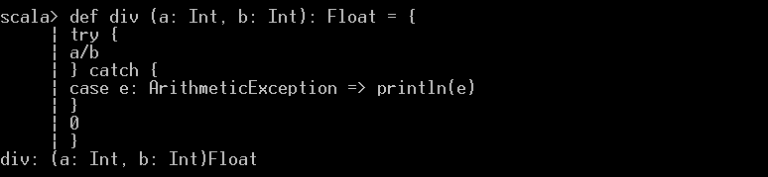

Now, let’s call it:

Let’s take another example of Scala Exception Handling:
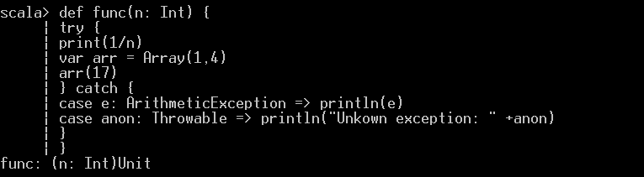

Now, let’s call it:

Throwable is a super class in the exception hierarchy. So, if we want our code to be able to handle any kind of exception, we use Throwable.

Scala Finally Block:
Imagine, if you’re working with a resource and an exception occurs in the middle. You still haven’t released the resource. This could be a file, a network connection, or even a database connection. To deal with such a situation, we have the Finally Block. We can release all resources in this block. Well, whether an exception happens in your code or not, the code under ‘finally’ will run, no matter what.

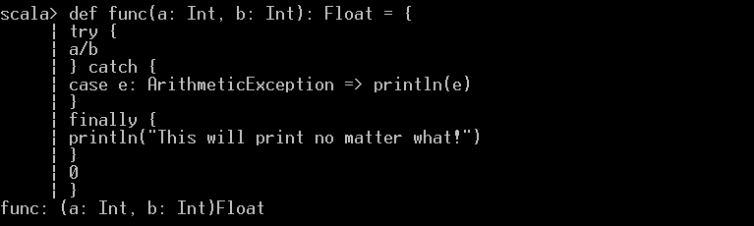

Now let’s call it:
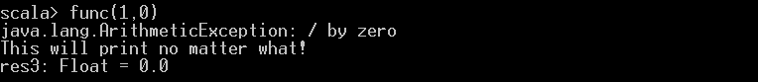

Scala Throw Keyword:
We can also explicitly throw a Scala exception in our code. We use the Throw Keyword for this. Let’s create a custom exception.

In Jewish culture, Bat Mitzvah is coming with age ceremony with age 12 for young boys.

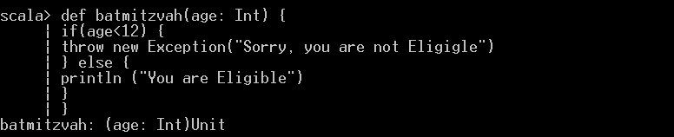

Now, let’s call it:
