Files I/O:
Scala is open to make use of any Java objects and java.io.File is one of the objects which can be used in Scala programming to read and write files.
We don’t have a class to write a file, in the Scala standard library, so we borrow java.io._ from Java. Or you could import java.io.File and java.io.PrintWriter

Import:

- Creating a New File:
To create a new file to write to, we create a new instance of PrintWriter, and pass a new File object to it.

Writing to the File:
Now, to write to the file, we call the method write() on the object we created.

Finally:
At this point, nothing is really visible in the file. To see these changes, reflect in the file Saif.txt, we need to close it with Scala.

Now, when we check the file Saif.txt again, we find:

  - cd <Path_of_File>
  - Type your <File_Name> and press Enter

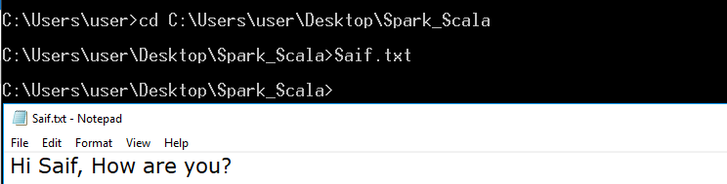

Reading from a File:
Reading from files is really simple. You can use Scala's Source class and its companion object to read files. Following is the example which shows you how to read
from "Saif.txt" file which we created earlier.

The Import:
The class we need to import here is scala.io.Source

Reading from the File:
To read the contents of this file, we call the fromFile() method of class Source- with the filename as argument. On this, we call the method mkString, like we’ve seen in different collections so far.

Reading Between the Lines (Pun Intended):
To read individual lines instead of the whole file at once, we can use the getLines() method. For this, let’s add some contents to our file.
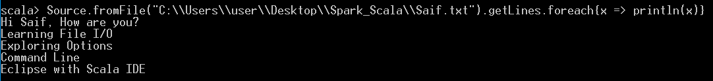

Using an Iterator:
We can also make use of an iterator to get one line at a time:
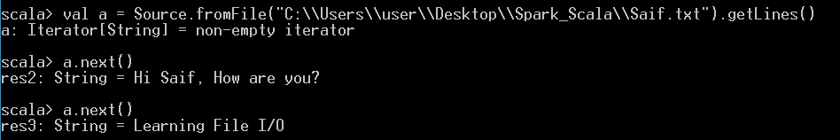

Extracting Individual Lines with take():
When we talked iterators, we saw the use of the method take(n) to return the first n values from the iterator. This is what we’re going to use here.
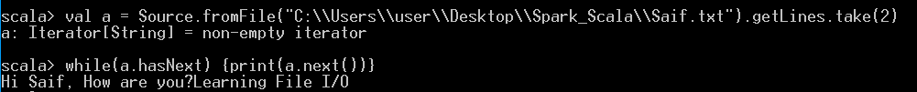
If we passed 1 to take(), it would only print the first line.

Extracting Individual Lines with slice(start, until):
The method slice(start, until) returns an iterator over lines start to until-1.

