Scenario: E-Commerce Order Processing System

Business Requirement
An e-commerce company receives customer orders as JSON files in an Amazon S3 bucket.
Whenever a new order file is uploaded:
S3 → Lambda → DynamoDB
Lambda should read the order, validate it, calculate the order amount, and store the processed order in DynamoDB.
An EC2 instance will be used by the operations team to upload order files to S3 and verify the processed data.

Architecture
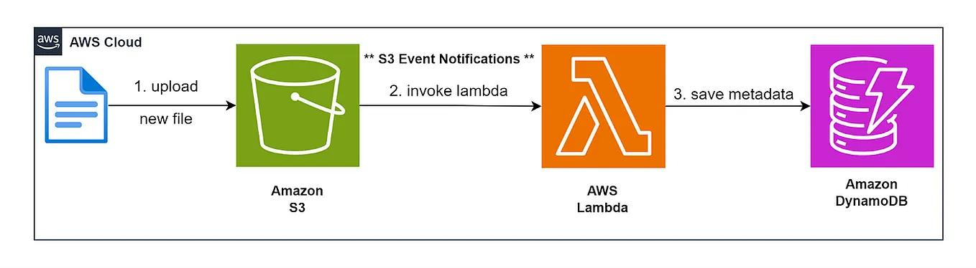
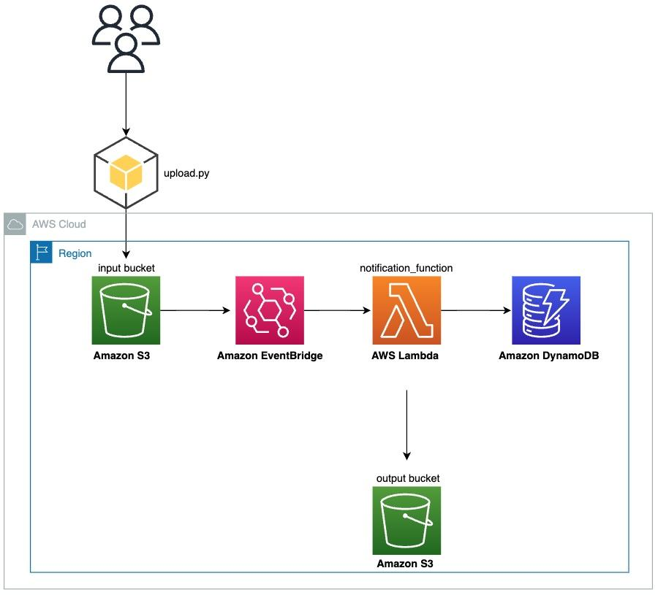
Operations Team
|
| Upload JSON
v
+---------+
| EC2 |
+----+----+
|
v
+---------+
| S3 |
| Orders |
+----+----+
|
ObjectCreated
|
v
+---------+
| Lambda |
+----+----+
|
Validate & Calculate
|
v
+-----------+
| DynamoDB |
| Orders |
+-----------+

Implementation Tasks

Task 1 — Create S3 Bucket
Create:
ecommerce-orders-<unique-name>
Create folders:
incoming/
processed/
error/
Order files will be uploaded to:
incoming/

Task 2 — Create DynamoDB Table
Create table:
Orders
Partition key:
order_id String
Expected attributes:
order_id
customer_id
product_id
quantity
unit_price
total_amount
order_status
processed_timestamp
Example:
{
"order_id": "ORD1001",
"customer_id": "C101",
"product_id": "P501",
"quantity": 3,
"unit_price": 500,
"order_status": "NEW"
}
Lambda should calculate:
total_amount = quantity × unit_price
Result:
total_amount = 1500

Task 3 — Create Lambda Function
Create Lambda:
process-order
Runtime:
Python 3.12
Lambda should:
- Receive S3 ObjectCreated event.
- Identify the uploaded JSON file.
- Read the file from S3.
- Parse JSON.
- Validate mandatory fields:
  - order_id
  - customer_id
  - product_id
  - quantity
  - unit_price
- Calculate total_amount.
- Add:
order_status = "PROCESSED"
- Store the record in DynamoDB.
- Move/copy successfully processed files to:
processed/
- Invalid files should go to:
error/

Task 4 — Configure S3 → Lambda Trigger
Configure the S3 event notification:
Event type:
ObjectCreated
Prefix:
incoming/
So:
EC2
↓
S3/incoming/order.json
↓
Lambda automatically triggered
↓
DynamoDB

Task 5 — Create EC2 Instance
Launch an EC2 instance:
Amazon Linux 2023
t3.micro
Install AWS CLI if required.
Configure the EC2 instance with an IAM role allowing:
s3:PutObject
s3:GetObject
s3:ListBucket
The EC2 instance should not have direct DynamoDB write permission.

Task 6 — Upload Order from EC2
Create:
order1.json
Example:
{
"order_id": "ORD1001",
"customer_id": "C101",
"product_id": "P501",
"quantity": 3,
"unit_price": 500
}
Upload:
aws s3 cp order1.json s3://ecommerce-orders-<unique-name>/incoming/
This should automatically trigger Lambda.

Task 7 — Verify DynamoDB
After Lambda execution, DynamoDB should contain:
order_id | customer_id | product_id | quantity | unit_price | total_amount | status
ORD1001 | C101 | P501 | 3 | 500 | 1500 | PROCESSED

Task 8 — Test Invalid Data
Upload:
{
"order_id": "ORD1002",
"customer_id": "C102",
"product_id": "P502",
"quantity": -5,
"unit_price": 200
}
Lambda should identify the invalid quantity and not insert it into DynamoDB.
Move the file to:
error/

Task 9 — Test Duplicate Order
Upload:
ORD1001
again.
Lambda should detect that the order_id already exists and prevent duplicate processing.
This introduces a useful idempotency requirement.

Final Flow
1. EC2
|
| Upload order JSON
v
2. S3 /incoming
|
| ObjectCreated Event
v
3. Lambda
|
| Validate
| Calculate amount
| Check duplicate
|
+---- Invalid ---> S3 /error
|
+---- Valid -----> DynamoDB
|
v
Order Stored
|
v
S3 /processed

Difficulty: Medium
This is a good 2–3 hour practical lab because students need to work with:
- S3
- EC2
- IAM Roles
- Lambda
- S3 Event Notifications
- DynamoDB
- Python/Boto3
- JSON processing
- Error handling
- Idempotency/duplicate handling
Assessment extension: Give students 10 JSON files containing a mixture of valid, invalid, and duplicate orders and ask them to implement the complete pipeline without manual intervention.

