**Screentshot of Source Bucket with File:**

**Step 2: Creating a Data Pipeline**

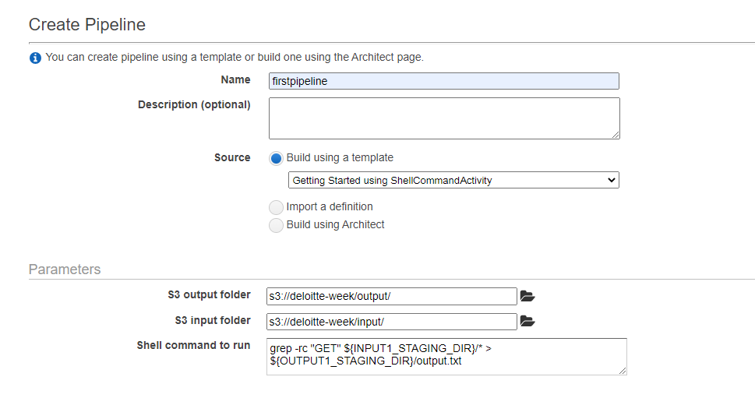

**Adding Roles & Logs:**

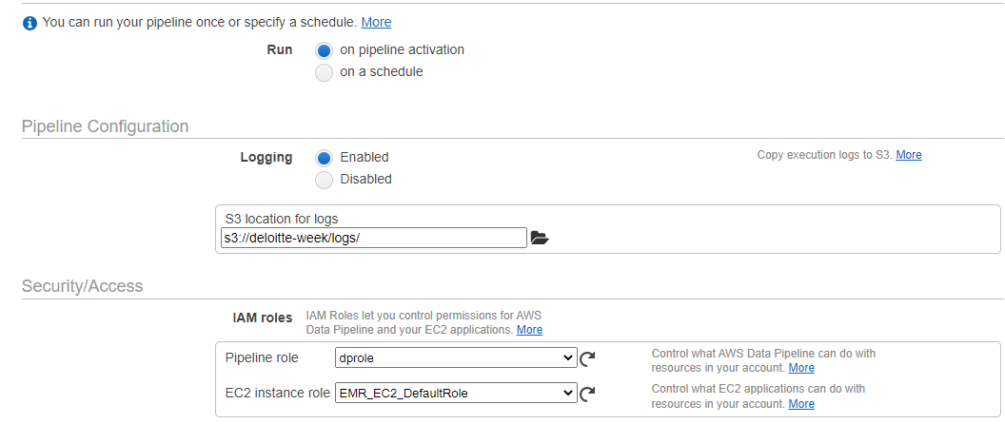

**Screentshot of Target Bucket with File:**