02/05/2024
Project :Music Recommendation System



Group member :
1.Kazi Azizul Haque(221014088)
2.Obidur Rahaman( 221014051)
Section : 01
Course title :
AI & machine learning lab{CSE_3202}
Project Name:Music Recommendation System

Project Description:
A user friendly interface for the users to search for songs according to their taste.
The music recommendation system uses machine learning to suggest user 20 similar songs according to the lyrics and name of the given song.

Features:

Music recommendation system uses machine learning to search songs according to users
liking. By analyzing listening history and preferences, AI algorithm suggests new songs and
artists that user is likely to enjoy. This system also takes into account music genre and other
factors to make sure user gets the perfect song for any mood. With the collaborative filtering
approach, user will discover new music.

Project Purpose:
To give the user a chance to find songs similar to their favorite songs using machine learning
algorithm.

Softwares used:
1.jupyter notebook
2.pycharm
3.google chrome

Languages used:
1.python
2.html

Screenshots------

Homepage:

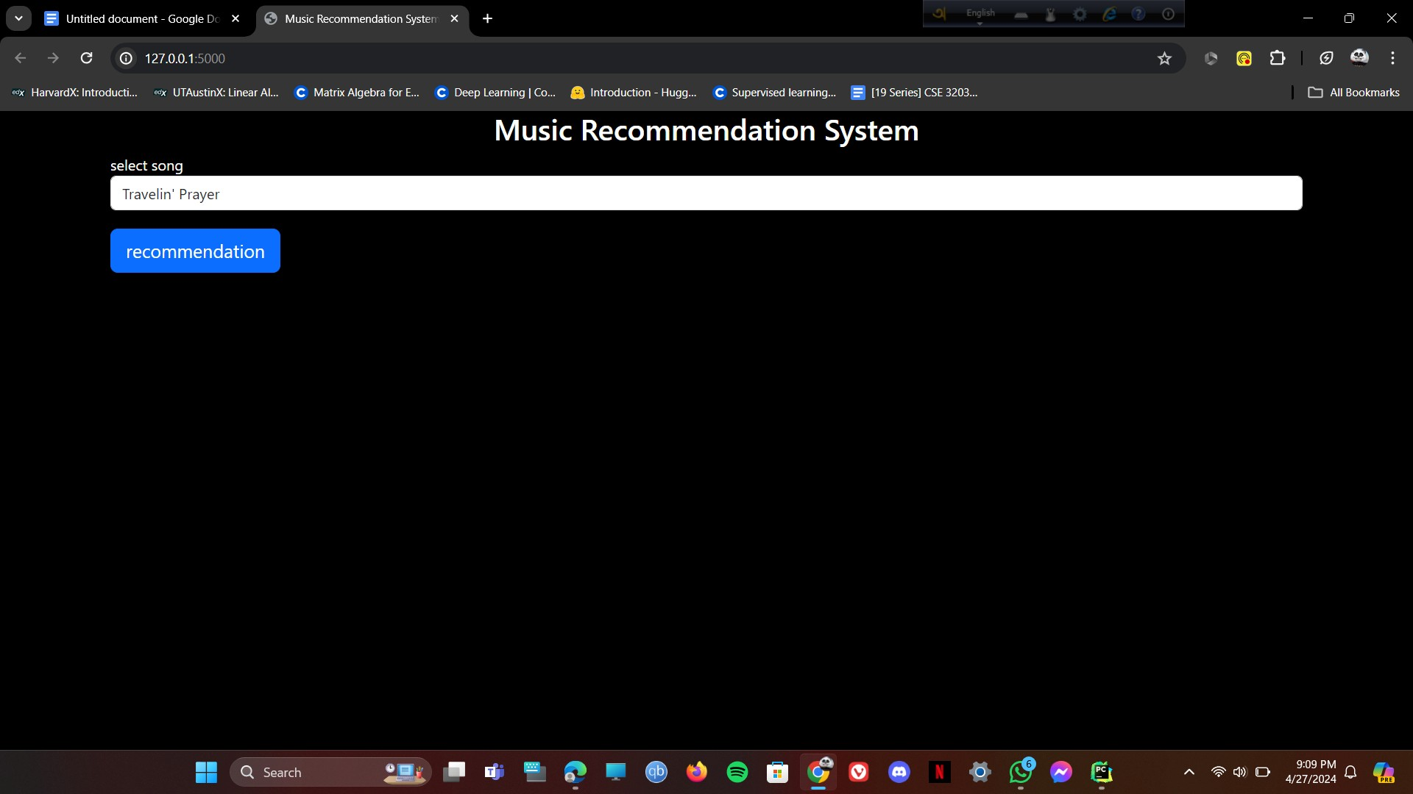

Search options:

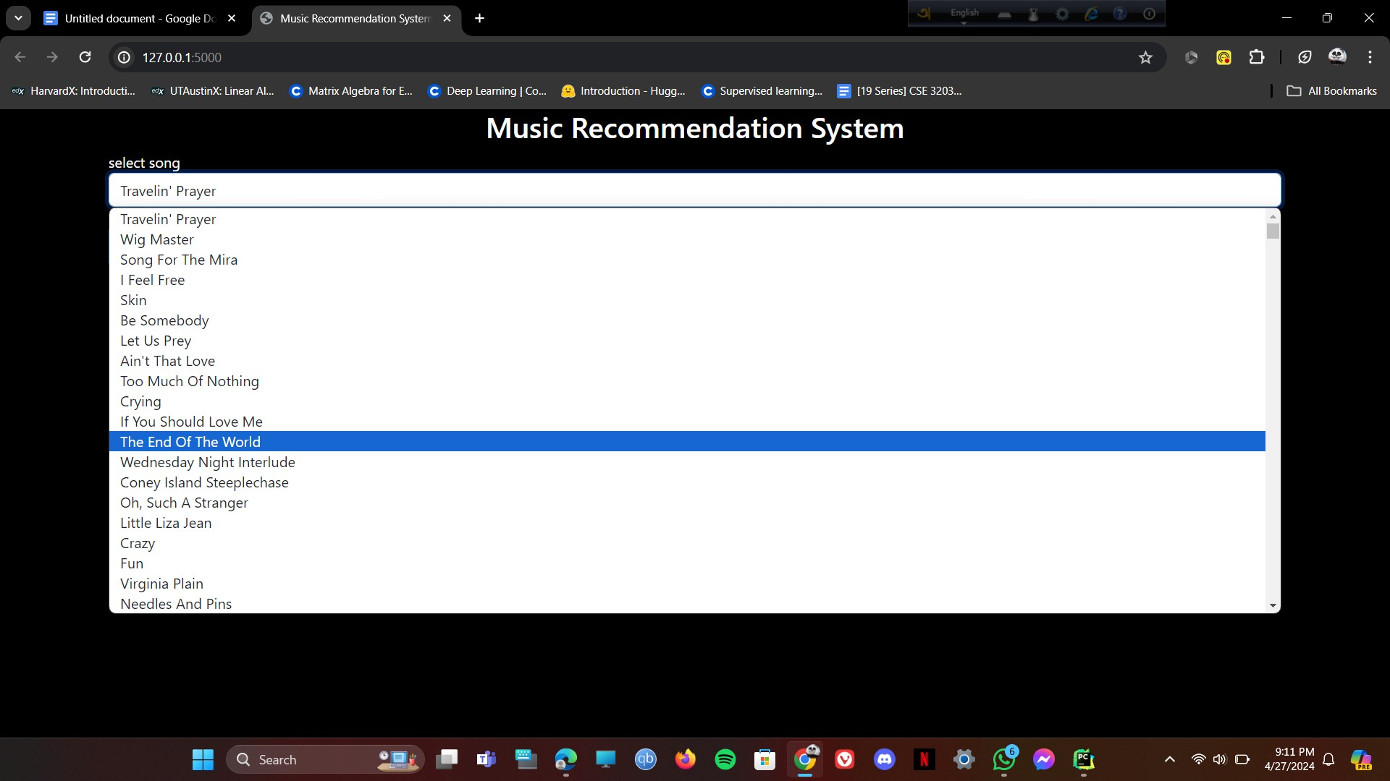

Recommendations:

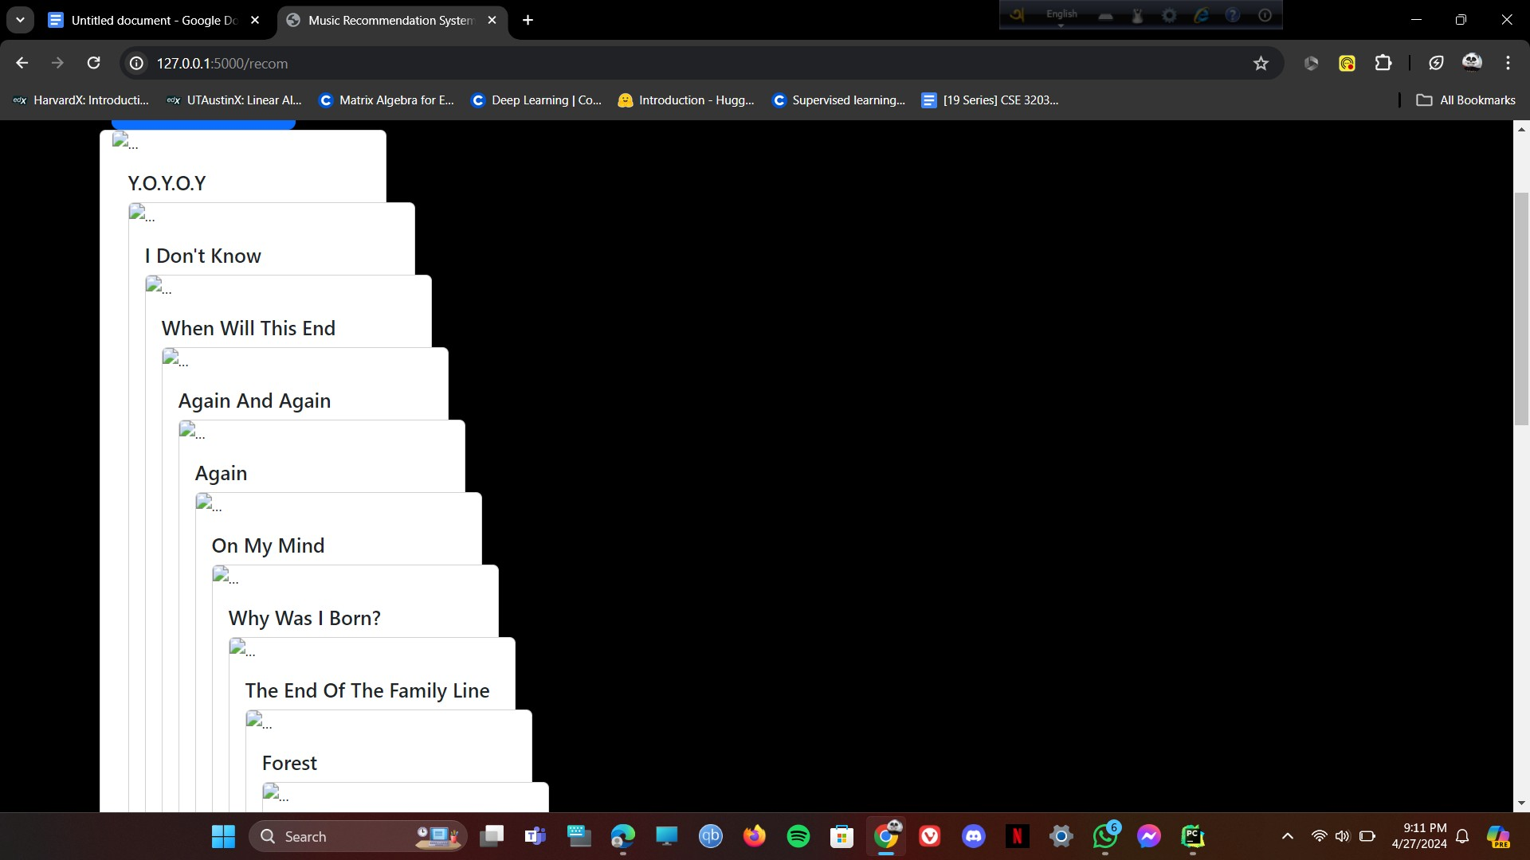

Limitations:
1.There are no search option in the system which is a drawback.
2.No logo could be added to the recommended songs as a result the recommended songs are stacked upon one another and look awkward.

Scope for betterment:
The backend part of the recommendation system works properly but there is always scope for improvement . The user interface of the website is not properly functionable.The recommended songs does not show properly with their logo which can be fixed.The dataset can be enriched with more songs,

