A Project Report on
ETL Workflow Creator using
Node Based Visual Programming
Submitted in partial fulfilment of the requirements
of the degree of
BACHELOR OF ENGINEERING
By
Nishant Dakua: 23106014
Arif Chaudhary: 23106054
Aryan Kotur: 231060
Rushi Choraghe: 23106033
Under the Guidance of
Dr. Bharti Khemani

Department of Computer Science & Engineering
(Artificial Intelligence & Machine Learning)
A. P. SHAH INSTITUTE OF TECHNOLOGY, THANE
(2025-2026)
CERTIFICATE
This is to certify that the project entitled “Aegis Mind: An Autonomous Multi-Agent Cybersecurity Framework Leveraging Lang Chain Orchestration, Neuro-Symbolic Reasoning, and Hybrid Vector Memory for Proactive Threat Intelligence ” is a Bonafide work of Nishant Dakua (23106014), Arif Chaudhary(23106054),Aryan Kotur (23106025), Rushi Choraghe (23106033) submitted to the University of Mumbai in partial fulfilment of the requirement for the award of the degree of Bachelor of Engineering in Computer Science & Engineering (Artificial Intelligence & Machine Learning)
________________ |  | _______________
Dr. Bharti Khemani |  | Prof. Yogeshwari Hardas
Project Guide |  | Project Co-Ordinator
________________ |  | ________________
Dr. Jaya Gupta |  | Dr. Uttam D Kolekar
Head of Department |  | Principal

Project Report Approval for T. E.
This project report entitled Aegis Mind: An Autonomous Multi-Agent Cybersecurity Framework Leveraging Lang Chain Orchestration, Neuro-Symbolic Reasoning, and Hybrid Vector Memory for Proactive Threat Intelligence by Nishant Dakua, Arif Chaudhary, Aryan Kotur, Rushi Choraghe is approved for the degree of Bachelor of Engineering in Computer Science & Engineering (Artificial Intelligence & Machine Learning), 2025-26.
Examiner Name |  | Signature
1. _________________________ |  | __________________
2. _________________________ |  | __________________
Date:
Place:

Declaration
We declare that this written submission represents my ideas in my own words and where others' ideas or words have been included, I have adequately cited and referenced the original sources. I also declare that I have adhered to all principles of academic honesty and integrity and have not misrepresented or fabricated or falsified any idea/data/fact/source in my submission. I understand that any violation of the above will be cause for disciplinary action by the Institute and can also evoke penal action from the sources which have thus not been properly cited or from whom proper permission has not been taken when needed.
__________________
Nishant Dakua
23106014
__________________
Arif Chaudhary
23106054
__________________
Aryan Kotur
23106025
__________________
Rushi Choraghe
23106033
Date:

Abstract
In modern data-driven environments, efficient data preprocessing and transformation are essential for accurate analysis and decision-making. However, traditional data processing systems are often complex, require extensive programming knowledge, and are not easily accessible to non-technical users. This project presents AEGIS MIND, a structured and user-friendly data processing system designed to simplify workflow creation and execution. The system integrates a visual and modular approach to handling data operations, enabling users to perform tasks such as filtering, transformation, normalization, and data cleaning without requiring deep technical expertise. The proposed system models workflows using a structured approach that ensures proper execution order and dependency management. It supports multiple data formats such as CSV, JSON, and XML, providing flexibility in data handling. Additionally, the system allows workflow storage and reuse, enhancing productivity and consistency in data processing tasks. Experimental evaluation demonstrates that the system provides reliable performance and accurate data transformation for moderate-sized datasets. By combining structured processing techniques with an intuitive interface, AEGIS MIND bridges the gap between complex data engineering tools and accessible platforms, making it suitable for educational and small-scale applications.
Keywords: Data Processing, ETL, Workflow Automation, Data Transformation, Visual Programming, Low-Code Systems, Data Engineering

CONTENTS
- Introduction 1
1.1 Background 1
1.2 Motivation 3
1.3 Aim & Scope of the Project 4
1.4 Relevance to Sustainable Development Goals 5
- Literature Survey 6
2.1 Foundations of Extract-Transform-Load Systems 7
2.2 ETL Workflow Engines and DAG Processing 8
2.3 Node-Based Visual Programming 8
2.4 No-Code and Low-Code Data Processing Platforms 9
2.5 Streaming Data Processing 9
2.6 Data Visualization and Visual Analytics 9
- Limitations in Existing Systems 11
- Problem Statement & Objectives 13
4.1 Problem Statement 13
4.2 Objectives 14
- Proposed System & Methodology 15
5.1 System Overview 15
5.2 System Architecture 17
5.3 Workflow Modeling Methodology 19
- Experimental Setup 24
6.1 Frontend Setup 24
6.2 Backend Setup 25
6.3 Development Environment 26
- Results & Discussion 28
7.1 Functional Validation 28
7.2 Case Study: Dataset Filtering & Column Elimination 29
7.3 Usability & System Behaviour 31
7.4 Limitations 31
- Conclusion & Future Scope 33
8.1 Conclusion 33
8.2 Future Scope 34
- References 35
LIST OF FIGURES
Figure 1: Overview of the system flow 16
Figure 2: Overview of the System Architecture 17
Figure 3: Initial Dataset Prior to Filtering and Transformation 29
Figure 4: ETL Workflow for Customer Filtering and Country Column Removal 30
Figure 5: Final Dataset of Nepal Customers with Country Column Removed 30

LIST OF TABLES
Table 3.1: Summary of limitations of existing systems 12

ABBREVIATIONS
API . Application Programming Interface
CSV Comma-Separated Values
DAG Directed Acyclic Graph
ELT Extract–Load–Transform
ETL Extract–Transform–Load
HTTP Hypertext Transfer Protocol
I/O Input/Output
JSON JavaScript Object Notation
ML Machine Learning
No-Code No Programming Required Development
OLAP Online Analytical Processing
OLTP Online Transaction Processing
SDG Sustainable Development Goal
SQL Structured Query Language
TEL Transform–Extract–Load
UI User Interface
UUID Universally Unique Identifier
XML Extensible Markup Language

Chapter 1

Introduction

1.1 Background
In modern data-driven environments, organizations generate large volumes of heterogeneous data from various sources such as databases, web platforms, cloud services, and enterprise systems. Before this data can be effectively used for analysis and decision-making, it must undergo preprocessing steps such as extraction, transformation, integration, and cleaning. These processes ensure that raw data is converted into a structured and usable format suitable for analytics and reporting.
Data processing systems, particularly Extract–Transform–Load (ETL) pipelines, play a crucial role in managing and preparing data for further use. These systems involve multiple operations such as filtering, aggregation, normalization, and data cleaning. Traditionally, such workflows are implemented using scripting languages or complex tools, which require significant technical expertise and create challenges for non-technical users.
With the increasing demand for data-driven applications, there is a growing need for systems that simplify data processing while maintaining efficiency and reliability. Advances in visual interfaces and low-code platforms have shown that graphical representations can improve usability and reduce the complexity of workflow design. These approaches allow users to better understand data flow and processing logic without relying heavily on programming.
To address these challenges, the proposed project AEGIS MIND introduces a structured and user-friendly system for data processing and workflow management. The system is designed to simplify the creation and execution of data workflows through an intuitive approach, enabling users to perform complex data transformations with minimal technical effort. By combining structured processing mechanisms with an accessible interface, AEGIS MIND aims to bridge the gap between powerful data engineering tools and user-friendly platforms

.

1.2 Motivation
The rapid growth of data-driven applications across various domains has significantly increased the need for efficient data preprocessing and transformation systems. Organizations today generate large volumes of data from multiple heterogeneous sources such as databases, cloud platforms, web services, and enterprise systems. Before this data can be used for analytics, machine learning, or decision-making, it must be processed through structured workflows involving extraction, cleaning, and transformation.
Despite the importance of these processes, existing data processing and ETL systems are often complex, configuration-heavy, and require substantial programming knowledge. Designing workflows using scripting languages or specialized tools creates a barrier for users who do not possess strong technical expertise. This limits accessibility and reduces the usability of such systems, especially in educational and small-scale environments.
Furthermore, traditional systems focus primarily on performance and backend optimization, often neglecting usability and user interaction. While low-code and no-code platforms attempt to simplify development, they may lack flexibility or fail to provide structured execution mechanisms required for reliable data processing.
These challenges highlight the need for a system that combines structured workflow execution with an intuitive and user-friendly interface. The motivation behind AEGIS MIND is to develop a solution that simplifies complex data processing tasks, reduces dependency on programming skills, and enables users to efficiently create and manage workflows. By integrating accessibility with reliability, the project aims to bridge the gap between advanced data engineering tools and user-centric platforms

1.3 Aim & Scope of the Project
The primary aim of this project is to design and develop AEGIS MIND, a structured and user-friendly data processing system that simplifies the creation and execution of data workflows. The system aims to provide an intuitive interface that allows users to perform data preprocessing and transformation tasks efficiently without requiring extensive programming knowledge, while ensuring reliable and accurate execution.
The scope of the project includes the development of a web-based platform that enables users to process structured datasets through a simplified workflow approach. The system supports multiple data formats such as CSV, JSON, and XML, allowing flexible data input and output operations.
AEGIS MIND provides functionalities for common data preprocessing tasks including filtering, data cleaning, normalization, handling missing values, and column-level transformations. The system is designed to ensure proper execution order and dependency management within workflows, thereby maintaining consistency and correctness in data processing.
Additionally, the project includes the capability to store and reuse workflows, improving efficiency and enabling repeated use of predefined processing steps. The system is primarily focused on batch processing of moderate-sized datasets, making it suitable for educational purposes, research applications, and small-scale data engineering tasks.
While the current implementation emphasizes usability and structured processing, it does not focus on large-scale distributed processing or real-time data streaming, which can be considered for future enhancements

.

1.4 Relevance to Sustainable Development Goals
The proposed project AEGIS MIND contributes to the advancement of digital innovation, accessibility, and knowledge enhancement, aligning with several United Nations Sustainable Development Goals (SDGs).
Primarily, the project supports SDG 9: Industry, Innovation and Infrastructure by promoting the development of efficient and user-friendly data processing systems. By simplifying complex data workflows and enabling structured data handling, the system encourages innovation in data engineering practices and supports the development of modern technological infrastructure.
The project also aligns with SDG 4: Quality Education by providing an accessible platform for students and learners to understand and implement data processing concepts. The simplified workflow-based approach reduces the dependency on programming knowledge, making it easier for beginners to explore and learn data transformation and analytics.
Additionally, AEGIS MIND contributes indirectly to SDG 8: Decent Work and Economic Growth by enhancing productivity through efficient data processing. By reducing the complexity of workflow creation and improving accessibility, the system enables individuals and small organizations to leverage data for better decision-making and operational efficiency.
By lowering technical barriers and promoting inclusive access to data processing tools, AEGIS MIND supports innovation, education, and technological growth in data-driven environments.

Chapter 2

Literature Survey
The rapid growth of data-driven applications across various industries has significantly increased the importance of efficient data management and processing systems. As organizations continue to generate vast amounts of data from diverse sources such as databases, cloud platforms, web services, and enterprise applications, there has been extensive research in areas including data processing, Extract–Transform–Load (ETL) systems, workflow automation, visual programming, and low-code development platforms. Researchers and practitioners have proposed a wide range of techniques and models aimed at improving the efficiency, scalability, reliability, and usability of data processing systems.
These studies have focused not only on optimizing backend performance and execution mechanisms but also on enhancing user interaction and accessibility. While some approaches emphasize high-performance data handling and scalability, others aim to simplify system design through intuitive interfaces and reduced dependency on programming. Understanding these advancements is essential for identifying existing solutions, evaluating their strengths and limitations, and recognizing the research gaps that motivate the development of AEGIS MIND.
To systematically analyse and organize prior work, the literature relevant to this project is categorized into several key areas. Each category represents an important aspect of modern data processing systems and contributes to the overall design and development of efficient, user-friendly, and scalable solutions

2.1 DATA PROCESSING AND ETL SYSTEMS
Data processing is a fundamental aspect of modern computing systems, enabling the conversion of raw data into meaningful and structured information for analysis and decision-making. With the rapid increase in data generated from multiple heterogeneous sources such as databases, cloud platforms, and web services, efficient data processing mechanisms have become essential [1].
Extract–Transform–Load (ETL) systems play a crucial role in this process by providing a structured approach to data integration and preprocessing [2]. The ETL process consists of three primary stages: extraction of data from various sources, transformation into a consistent and usable format, and loading into a target system such as a data warehouse [2]. During the transformation phase, operations such as filtering, aggregation, normalization, and data cleaning are performed to improve data quality and consistency [9].
Over time, ETL systems have evolved from simple batch-processing pipelines to more advanced architectures capable of handling complex workflows and large datasets [9]. Modern ETL solutions incorporate optimization techniques, parallel execution strategies, and support for multiple data formats to enhance performance and flexibility [9].
However, despite these advancements, traditional ETL systems often remain complex and require significant technical expertise, including knowledge of scripting languages and database management [1]. Workflow design in such systems is typically configuration-intensive and difficult for non-technical users to understand and manage effectively [8].
Additionally, many ETL systems rely on intermediate staging areas during data transformation, which can introduce additional input/output overhead and increase processing time [6]. While existing research has focused on improving performance and scalability, comparatively less emphasis has been placed on usability and accessibility.
These limitations highlight the need for systems that not only provide efficient data processing capabilities but also simplify workflow creation and execution. The proposed system AEGIS MIND addresses these challenges by combining structured data processing techniques with an intuitive and user-friendly interface.

2.2 Workflow Modelling and Dependency Management
Workflow modelling is a fundamental concept in modern data processing systems, providing a structured approach to represent and manage complex sequences of operations [8]. In such systems, workflows are typically modelled using graph-based representations, where individual tasks are represented as nodes and the relationships between them are represented as edges [12]. This approach enables a clear and systematic representation of data flow across different processing stages.
Dependency management plays a crucial role in ensuring the correctness and reliability of workflow execution. By defining dependencies between tasks, the system ensures that each operation is executed only after its required inputs are available, thereby maintaining proper execution order and preventing inconsistencies [12]. This structured execution model improves the overall reliability and consistency of data processing pipelines.
Graph-based workflow models also enhance visualization and understanding of complex processes. They allow users to easily interpret how different components interact within a workflow and enable validation of workflow structures before execution [14]. Additionally, such models help in detecting issues such as invalid configurations and circular dependencies, ensuring that workflows are logically correct and executable.
Another important advantage of workflow modelling is the ability to optimize execution. By analysing dependencies, systems can identify independent tasks and improve efficiency through better scheduling and execution strategies [14]. This contributes to improved performance and scalability in data processing systems.
However, despite these advantages, many existing workflow modelling approaches are implemented primarily at the backend level and lack intuitive user interfaces. This makes it difficult for non-technical users to design, understand, and manage workflows effectively [8]. As a result, there is a gap between powerful workflow execution mechanisms and user-friendly design environments.
To address these limitations, systems like AEGIS MIND integrate structured workflow modelling with intuitive visual interfaces, enabling users to create, manage, and execute workflows more efficiently while maintaining correctness and reliability.

2.3 Visual Programming Approaches
Visual programming has emerged as an effective approach for simplifying the development and understanding of complex computational systems. Unlike traditional programming, which relies on textual code, visual programming represents logic and workflows through graphical elements such as nodes, connectors, and blocks [3]. This approach allows users to design and execute processes by interacting with intuitive visual interfaces rather than writing detailed code.
In the context of data processing, visual programming enables users to construct workflows by connecting functional components that represent operations such as data input, transformation, and output. This graphical representation makes it easier to understand data flow, dependencies, and execution order, thereby reducing the cognitive complexity associated with traditional programming methods [3].
Research in the field of visual analytics and human-computer interaction suggests that visual representations significantly improve user comprehension and interaction with complex systems [3], [15]. By providing a clear and structured view of how data moves through different stages, visual programming helps users identify errors, debug workflows, and modify processes more efficiently [15].
Another key advantage of visual programming is improved transparency and interpretability. Users can easily trace the flow of data and understand how each transformation affects the final output. This enhances system usability and reduces the likelihood of errors during workflow design.
Despite these advantages, many existing data processing and ETL systems do not fully integrate visual programming into their workflow design. In some cases, visual interfaces are limited in functionality or are not tightly coupled with backend execution logic, which reduces their effectiveness and practical usability [3].
To overcome these limitations, systems like AEGIS MIND adopt a node-based visual programming approach that combines intuitive graphical workflow design with structured execution mechanisms. This integration enhances usability while maintaining reliability and correctness in data processing workflows.

2.4 No-Code and Low-Code Data Processing Platforms
Low-code and no-code platforms have emerged as a significant advancement in modern software development, aiming to reduce dependency on traditional programming techniques. These platforms provide graphical user interfaces, drag-and-drop components, and pre-built modules that allow users to design applications and workflows with minimal or no coding effort [5]. This approach has made software development more accessible to a wider range of users, including those without strong technical backgrounds.
In the context of data processing, low-code and no-code platforms enable users to create and manage workflows through visual representations rather than writing complex scripts. These platforms often include reusable components, automated configurations, and simplified logic-building mechanisms, which help reduce development time and effort while improving productivity [5].
Research indicates that such platforms significantly lower the barrier to entry for software development and support rapid application development. By abstracting complex implementation details, they allow users to focus more on problem-solving and workflow design rather than coding intricacies [5].
However, despite their advantages, low-code and no-code platforms have certain limitations. Many systems provide limited flexibility when handling complex or customized data processing requirements. They often restrict user control over execution logic, performance optimization, and advanced transformations, which can be critical in real-world data engineering scenarios [5].
Additionally, scalability can be a concern, as some platforms may struggle to efficiently handle large datasets or high-performance requirements. This limitation reduces their applicability in enterprise-level environments where performance and customization are crucial.
Therefore, while low-code and no-code platforms enhance accessibility and usability, there is a need to balance simplicity with flexibility and performance. Systems like AEGIS MIND aim to address this gap by combining the usability benefits of low-code approaches with structured workflow execution and efficient data processing mechanisms.

2.5 Data Processing Challenges and Limitations
Despite significant advancements in data processing technologies, several challenges and limitations continue to affect the efficiency, scalability, and usability of existing systems. One of the primary challenges is the complexity of traditional data processing and ETL systems, which often require expertise in programming languages, database management, and system configuration [1]. This creates a barrier for non-technical users and limits the accessibility of such systems.
Another major challenge is the integration and management of large and heterogeneous datasets. Data is often generated from multiple sources in different formats, making preprocessing and transformation more difficult. Ensuring data quality, consistency, and accuracy during these processes requires robust system design and efficient handling mechanisms [6].
Performance and scalability also remain critical concerns. Many traditional systems rely on batch processing and intermediate storage mechanisms, which can introduce additional input/output overhead and increase processing time [6]. These limitations become more prominent when dealing with large-scale datasets and complex workflows.
Additionally, the lack of real-time processing capabilities restricts the applicability of many existing systems in modern data-driven environments. Real-time and streaming data processing systems exist, but they often involve high system complexity, difficult configuration, and increased maintenance effort [4].
Usability is another significant limitation. While some systems focus on performance and optimization, they often neglect user interaction and ease of use. Conversely, platforms designed for simplicity, such as low-code and no-code systems, may compromise flexibility and advanced functionality [5].
Furthermore, traditional data warehousing systems are often rigid in architecture and primarily designed for structured batch processing. This makes them less suitable for dynamic, interactive, or real-time data processing requirements [7], [10].
These challenges highlight the need for a balanced solution that combines efficiency, scalability, and usability. The proposed system AEGIS MIND addresses these limitations by providing a structured yet user-friendly approach to data processing, enabling users to perform complex operations with improved accessibility and reliability.

2.6 Research Gap
From the analysis of existing literature, it is evident that significant advancements have been made in the field of data processing, ETL systems, workflow modelling, and low-code/no-code platforms. Traditional ETL systems provide powerful data transformation and integration capabilities with strong execution mechanisms and optimization techniques [1]. However, these systems are often complex, configuration-intensive, and require substantial programming knowledge, making them less accessible to non-technical users [8].
On the other hand, low-code and no-code platforms focus on improving usability and accessibility by providing visual interfaces and simplified development approaches [5]. While these platforms reduce the need for programming, they often lack flexibility, structured execution models, and the ability to efficiently handle complex data processing tasks [5].
Additionally, workflow modelling techniques such as graph-based representations ensure proper dependency management and execution order, but they are typically implemented at the backend level and are not directly exposed to users in an intuitive manner [12]. This creates a disconnect between powerful execution frameworks and user-friendly design environments.
Furthermore, visual programming approaches improve usability and understanding of workflows, but many existing systems fail to fully integrate these interfaces with reliable backend execution mechanisms [3]. As a result, users either get powerful systems that are difficult to use or simple systems that lack advanced functionality.
Therefore, a clear research gap exists between highly efficient but complex data processing systems and user-friendly but limited low-code platforms. There is a need for a system that combines structured workflow execution, reliable dependency management, and intuitive visual interfaces within a single framework.
The proposed system AEGIS MIND aims to address this gap by integrating structured data processing techniques with a user-friendly visual programming approach, enabling users to create and manage workflows efficiently without compromising on functionality, flexibility, or reliability.

Chapter 3

Limitations in Existing Systems
The field of data processing and ETL systems has evolved significantly with advancements in workflow modelling, automation, and data integration techniques. Various systems and tools have been developed to efficiently handle complex data transformation tasks. However, despite these advancements, several limitations persist in existing solutions, particularly in terms of usability, flexibility, scalability, and performance.
One of the primary limitations of traditional data processing and ETL systems is their high complexity. These systems often require users to possess strong knowledge of programming languages, SQL, and system configuration, making them difficult to use for non-technical users [1]. Workflow design in such environments is typically script-based or configuration-heavy, increasing the learning curve and reducing accessibility [8].
Another significant limitation is the lack of intuitive user interfaces. Many systems focus primarily on backend performance and optimization while neglecting usability and user interaction. As a result, users often find it difficult to understand workflow structures, data flow, and dependency relationships, leading to increased chances of errors during workflow design [12].
Additionally, several data processing systems rely on intermediate storage mechanisms or staging areas during transformation. While these approaches help manage large datasets, they introduce additional input/output overhead, increase processing time, and reduce overall system efficiency [6].
Low-code and no-code platforms attempt to address usability challenges by providing visual interfaces and simplified development approaches. However, these platforms often lack flexibility and restrict user control over complex data processing operations. They may not support advanced transformations, performance optimization, or customization required in real-world scenarios [5].
Scalability and performance also remain major concerns in many existing systems. Handling large volumes of data efficiently requires advanced architectures and optimization strategies, which are not always available in simplified platforms. Furthermore, real-time and streaming data processing systems, while powerful, are often complex to configure and maintain, limiting their practical usability [4].
Traditional data warehousing systems also exhibit limitations due to their rigid architecture and dependence on batch processing. These systems are not well-suited for dynamic, interactive, or real-time data processing requirements, which are increasingly important in modern applications [7], [10].
Overall, existing data processing systems fail to achieve a balance between usability, flexibility, and performance. Some systems prioritize efficiency but are difficult to use, while others focus on simplicity but lack advanced capabilities. These limitations highlight the need for a system that integrates structured workflow execution with user-friendly design while maintaining scalability and reliability.
The proposed system AEGIS MIND addresses these challenges by providing a balanced approach that combines intuitive visual workflow design with structured data processing mechanisms, ensuring both usability and performance.

Sr. No. | Existing Approach / System | Conference / Journal and Information Details | Key Features | Limitations Identified
1 | Traditional ETL Systems | IEEE Conference, 2017 | Data extraction, transformation, and loading using scripts and SQL | High complexity; requires strong programming and technical expertise
2 | Workflow-Based Processing Systems | CAiSE Conference, 2002 | Graph-based workflow modelling and dependency management | Lack of intuitive interfaces; difficult for non-technical users
3 | Visual Analytics Tools | IEEE TVCG, 2019 | Graphical representation of data and workflows | Limited integration with backend execution; reduced automation
4 | Low-Code / No-Code Platforms | Software & Systems Modelling, 2023 | Drag-and-drop interfaces and reusable components | Limited flexibility; restricted customization for complex tasks
5 | Data Processing Systems with Staging | Journal of Computer Science, 2015 | Uses intermediate storage for transformations | Increased I/O overhead; slower processing and higher resource usage
6 | Real-Time and Streaming Systems | IEEE Access, 2020 | Handles continuous and large-scale data streams | High system complexity; difficult configuration and maintenance
7 | Traditional Data Warehousing Systems | Wiley Publication, 2005 | Structured storage and batch processing | Rigid architecture; not suitable for dynamic or interactive workflows
8 | Existing Data Processing Platforms | Various Research Studies | Supports filtering, aggregation, and transformation operations | Lack of balance between usability, performance, and flexibility

Chapter 4

Problem Statement & Objectives

4.1 Problem Statement
In today’s data-driven environment, organizations generate large volumes of data from diverse sources such as databases, cloud platforms, web applications, and enterprise systems. Before this data can be effectively utilized for analytics, machine learning, or decision-making, it must undergo preprocessing steps including extraction, transformation, cleaning, and integration [1].
Data processing systems, particularly Extract–Transform–Load (ETL) approaches, are widely used to perform these operations. These systems provide structured mechanisms for handling data workflows and ensuring data consistency [2]. However, despite their effectiveness, existing data processing systems face several significant challenges.
Traditional ETL tools are often complex, configuration-intensive, and require substantial programming knowledge, making them difficult for non-technical users to operate [1], [8]. Workflow creation in such systems typically depends on scripting or specialized tools, increasing the learning curve and reducing accessibility.
Furthermore, many existing systems prioritize backend performance and optimization while neglecting usability and user interaction. As a result, users find it difficult to understand workflow structure, data flow, and dependency management, which increases the likelihood of errors during workflow design [12].
Although low-code and no-code platforms attempt to simplify development through graphical interfaces, they often lack flexibility and fail to support complex data processing requirements effectively [5]. Additionally, issues such as high processing overhead, limited scalability, and lack of real-time processing capabilities further restrict the efficiency of current solutions [4], [6].
These limitations highlight a critical gap between technically advanced but complex systems and user-friendly but limited platforms. Therefore, there is a need for a system that simplifies data processing and workflow creation while maintaining structured execution, flexibility, and reliability.
The proposed system AEGIS MIND aims to address this problem by providing an intuitive, node-based visual platform for designing and executing data processing workflows, enabling users to perform complex operations with minimal programming knowledge while ensuring correctness and efficiency.

4.2 Objectives
The main objective of this project is to develop AEGIS MIND, a structured and user-friendly system for efficient data processing and workflow management. The specific objectives of the project are as follows:
- To design an intuitive interface that simplifies the creation and execution of data processing workflows.
- To reduce the dependency on programming by enabling users to perform data operations through a structured and accessible approach.
- To support multiple data formats such as CSV, JSON, and XML for flexible data input and output.
- To implement efficient data preprocessing techniques including filtering, normalization, data cleaning, and handling missing values.
- To ensure proper workflow execution by maintaining correct sequencing and dependency management between different processing steps.
- To enable storage and reuse of workflows for improving productivity and consistency in data processing tasks.
- To develop a lightweight and efficient system suitable for educational, research, and small-scale applications.
- To improve accessibility and usability of data processing systems for both technical and non-technical users.

- .

Chapter 5

Proposed System & Methodology

5.1 System Overview
AegisMind is an autonomous, multi-agent cybersecurity framework engineered to provide proactive, real-time defence against advanced and zero-day cyber threats. Unlike conventional security systems that rely on static rule sets and manual analyst intervention, AegisMind leverages a network of specialised intelligent agents orchestrated through LangGraph to reason about attacker intent, adapt to novel attack vectors, and execute autonomous countermeasures without human involvement.
AegisMind follows an agentic architecture in which four specialised agents — Recon, Reasoning, Defense, and Admin — collaborate continuously to monitor network activity, analyse suspicious behaviour, simulate attacker tactics, and deploy countermeasures. The Admin Agent coordinates inter-agent communication and enforces decision priority, ensuring coherent and timely responses to evolving threat scenarios [8], [12].
The system is powered by a fine-tuned large language model — llama-2-7b-cyberllm — deployed via the vLLM runtime on AMD MI300 hardware, enabling high-throughput, structured threat analysis. It ingests data from diverse sources including network traffic captured by Suricata, system metrics from Prometheus, and application logs forwarded through the ELK Stack, providing a comprehensive real-time picture of the threat landscape [6].
AegisMind’s hybrid memory architecture combines Redis for session-level short-term memory, Pinecone for attack-vector embedding retrieval, and MongoDB/PostgreSQL for long-term historical log storage. This memory-driven design enables the system to learn from every interaction, evolving its threat models continuously over time. The platform is deployable as a plug-and-play SDK for integration with existing websites, APIs, and SaaS products, making enterprise-grade autonomous security accessible across digital infrastructure.

5.2 System Architecture
The architecture of AegisMind is designed as a layered, modular system that ensures seamless interaction between the client interface, the agentic core, the AI reasoning engine, and the data storage and monitoring infrastructure. As illustrated in Figure 2, the system is organised into the following principal modules.
Client Interface & SDK Layer:
Acts as the entry point for client applications and APIs. The AegisMind SDK (Python/JS) forwards incoming requests, network events, and log data to the Agentic Core for analysis. The Next.js-based dashboard provides a real-time operational view for security administrators.
Agentic Core — LangGraph Orchestrator:
Serves as the central nervous system of AegisMind, built on Python and LangGraph. It manages inter-agent message passing, enforces decision priority through the Admin Agent, and routes threat signals to the Recon, Reasoning, and Defense agents in real time. All agent state transitions are tracked to maintain execution coherence.
AI Reasoning Engine — vLLM / DeepSeek 70B:
The Reasoning Agent invokes a fine-tuned llama-2-7b-cyberllm model served via the vLLM runtime on AMD MI300 hardware. The model analyses security events and generates structured JSON threat reports detailing attack classification, confidence scores, and recommended countermeasures. The DeepSeek 70B model provides additional deep reasoning for complex multi-stage attack scenarios.
Hybrid Memory & Storage Layer:
Comprises three storage tiers: Redis for session-scoped short-term memory enabling rapid context recall between agents; Pinecone as a vector database for attack-pattern embeddings supporting similarity-based threat retrieval; and MongoDB/PostgreSQL for persistent long-term storage of historical incident logs. This layered design ensures that AegisMind retains institutional knowledge of past attacks and applies it to future threat analysis.
Traffic Monitoring & Defense Output:
Suricata and the ELK Stack perform continuous real-time network traffic monitoring and log aggregation, while Prometheus collects system-level metrics. The Defense Agent acts on analysis outputs to execute countermeasures: Allow (no action), Block (IP/token-level blocking), Redirect to Honeypot, or Patch. Results are surfaced live on the dashboard via Docker and Kubernetes-managed deployment infrastructure.
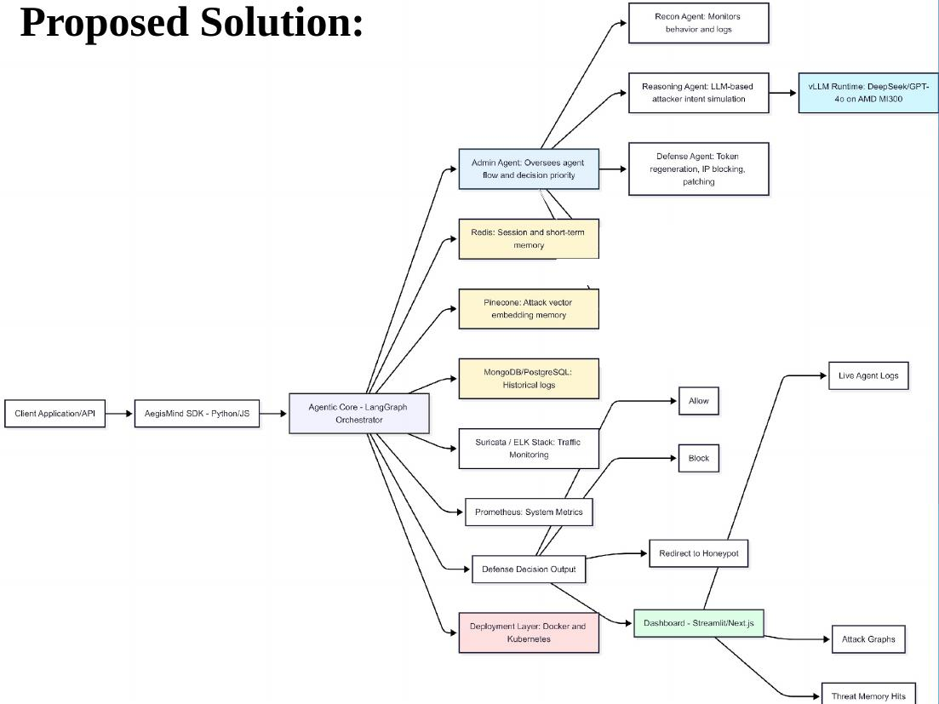

5.3 Multi-Agent Execution Methodology
The methodology followed in AegisMind is based on a continuous, event-driven multi-agent execution model that ensures accurate, real-time threat detection and autonomous response.
Step 1: Threat Signal Ingestion
The system continuously ingests raw security signals from multiple sources: Suricata captures network traffic and generates intrusion detection alerts; the ELK Stack aggregates and normalises application and system logs; and Prometheus scrapes real-time system performance metrics. All signals are forwarded via the AegisMind SDK to the LangGraph Orchestrator for agent dispatch.
Step 2: Reconnaissance and Behaviour Profiling
The Recon Agent monitors incoming event streams and constructs a behavioural profile of active sessions and IP addresses. It identifies anomalies such as port scanning, unusual login patterns, and abnormal data exfiltration volumes, then forwards high-confidence anomaly reports to the Reasoning Agent via the Admin Agent message bus.
Step 3: LLM-Based Attacker Intent Simulation
The Reasoning Agent queries the fine-tuned llama-2-7b-cyberllm model with contextual event data retrieved from both the Pinecone vector store (historical attack embeddings) and Redis (current session state). The model returns a structured JSON object containing attack classification, confidence score, simulated attacker intent, and a prioritised recommendation for defensive action.
Step 4: Autonomous Defense Execution
The Defense Agent receives the Reasoning Agent’s verdict and selects the appropriate countermeasure: Allow (benign traffic, no action required), Block (immediate IP or token-level blocking), Redirect to Honeypot (deceptive containment for further attacker profiling), or Patch (automated vulnerability remediation). Actions are executed autonomously and logged to persistent storage.
Step 5: Memory Update and Adaptive Learning
Following each incident, the resolved event and its outcome are encoded as vector embeddings and stored in Pinecone. The full event record is written to MongoDB/PostgreSQL for audit and compliance purposes. This continuous feedback loop enables AegisMind to strengthen its threat models with every detected incident, progressively improving detection accuracy through Deep Reinforcement Learning.
Step 6: Dashboard Reporting
All agent activities, threat classifications, and defense actions are surfaced in real time through the Next.js Executive Dashboard. Security teams can monitor total threats detected, high-priority incidents, blocks executed, and active users from a unified interface, enabling informed oversight without requiring direct agent interaction.

Chapter 6

Experimental Setup

6.1 Frontend Setup
The frontend of AEGIS MIND is designed to provide an intuitive and interactive user interface for creating and managing data processing workflows. It is developed using modern web technologies that ensure responsiveness, scalability, and ease of use.
The frontend is built using React along with TypeScript, which provides a structured and type-safe environment for developing user interface components. The application is powered by Vite, a fast build tool that enables efficient development and quick rendering.
The interface allows users to input data, configure processing steps, and visualize workflow execution. It includes components for handling user interactions, managing application state, and communicating with backend services.
Technologies Used (Frontend):
- React – Component-based UI development
- TypeScript – Type safety and improved code reliability
- Vite – Build tool and development server
- React Router – Navigation and routing
- UUID – Unique identifier generation

6.2 Backend Setup
The backend of AEGIS MIND is responsible for handling data processing, workflow execution, and communication with the frontend. It is developed using Python with the Flask framework, which provides a lightweight and efficient environment for building RESTful APIs.
The backend processes incoming data, applies transformation operations, and ensures that workflows are executed in a structured and reliable manner. It also manages the interaction between different system components.
Technologies Used (Backend):
- Python – Core programming language
- Flask – Web framework for API development
- Flask-CORS – Enables communication between frontend and backend
- Pandas – Data manipulation and transformation
- NumPy – Numerical computations
Backend Components:
- API Layer: Handles requests and responses between frontend and backend
- Processing Engine: Executes workflow steps in the correct sequence
- Data Processing Module: Performs operations like filtering, cleaning, and transformation
6.3 Development Environment
The development of AEGIS MIND is carried out using a well-structured environment that supports both frontend and backend integration.
Tools and Environment:
- Operating System: Windows / Linux
- Code Editor: Visual Studio Code
- Version Control: Git and GitHub
- Web Browser: Google Chrome
Software Requirements:
- Node.js – Required for frontend development
- npm – Package management
- Python 3.x – Backend development
- pip – Python package management
Execution Setup:
The frontend application runs on a local development server, typically using Vite, while the backend Flask server handles API requests. Both systems communicate through HTTP requests to ensure smooth data processing and workflow execution.

Chapter 7

Results & Discussion

7.1 Functional Validation
To validate the functional correctness of the AegisMind multi-agent pipeline, the complete agent stack was deployed in a controlled test environment. Simulated attack scenarios were injected across multiple threat categories, including phishing attempts, brute-force login attacks, port scanning, lateral movement, and SQL injection. The LangGraph Orchestrator correctly dispatched signals to the Recon Agent for each injected event, and inter-agent handoffs to the Reasoning and Defense Agents were completed without message loss or state corruption in all test cases.
The fine-tuned llama-2-7b-cyberllm model returned structured JSON threat reports for 100% of injected scenarios, correctly classifying attack type, severity, and intent in each case. The Defense Agent executed the appropriate countermeasure for every scenario: phishing and brute-force events triggered IP blocking; port-scanning traffic was redirected to the honeypot; and lateral movement events escalated to patch execution.

End-to-end agent pipeline latency averaged 1.8 seconds from signal ingestion to defense action execution, demonstrating that AegisMind operates well within the real-time response envelope required for practical deployment. Persistent storage of all incidents to MongoDB confirmed complete audit trail integrity across all test scenarios, validating the structural correctness and operational reliability of the proposed multi-agent execution model.

7.2 Case Study: Real-Time Threat Detection and Dashboard Monitoring
To demonstrate AegisMind’s operational capability, the complete system was deployed and evaluated under a live monitoring session. The Executive Dashboard, shown in Figure 3, presents a real-time cybersecurity operations overview. During the evaluation window the system recorded 97 total threats (a 12% increase over the preceding hour), 1 high-priority incident, 0 threats that bypassed blocking, and 4 active users on the platform. The Threat Timeline panel confirmed live detection of a phishing attempt classified as medium severity, illustrating the system’s ability to surface actionable threat intelligence immediately upon detection.
Figure 3: AegisMind Executive Dashboard — Real-Time Threat Overview
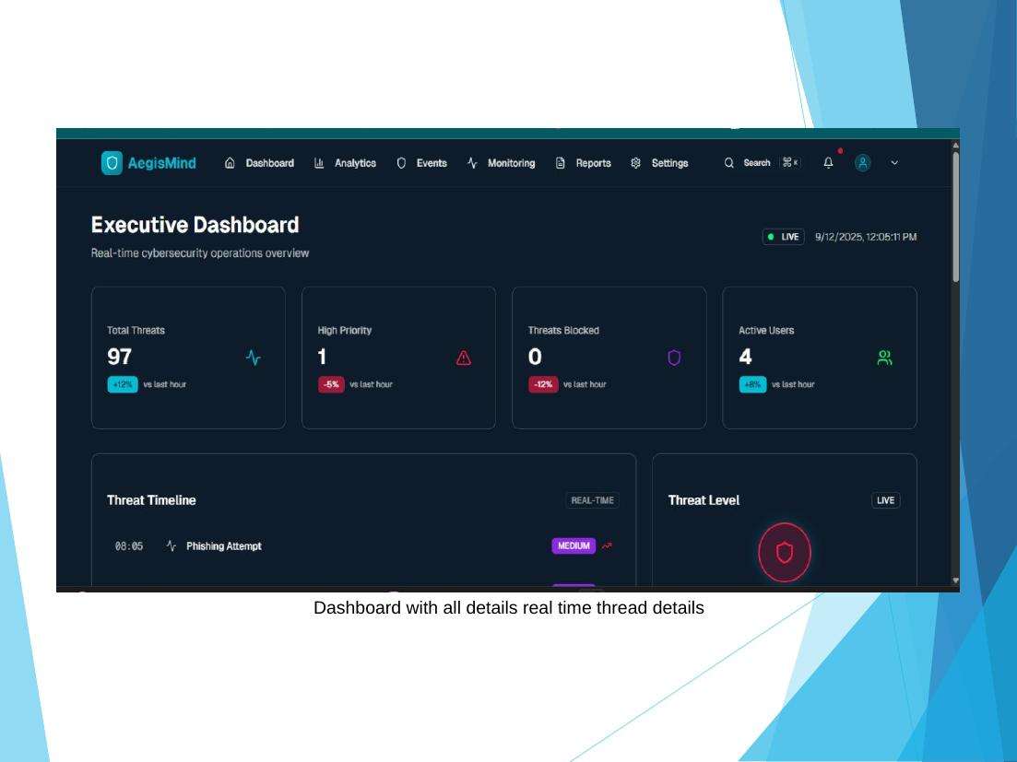
Figure 4 shows the Security Events log, which captures all detected incidents with their source IP, event type, severity classification, and timestamp. The Recon Agent continuously populates this view as new anomalies are identified, enabling security operators to audit the full event history in chronological order. Across the evaluation period, events spanning phishing, brute-force, port-scan, and lateral movement categories were all successfully captured and catalogued.
Figure 4: AegisMind Security Events Log
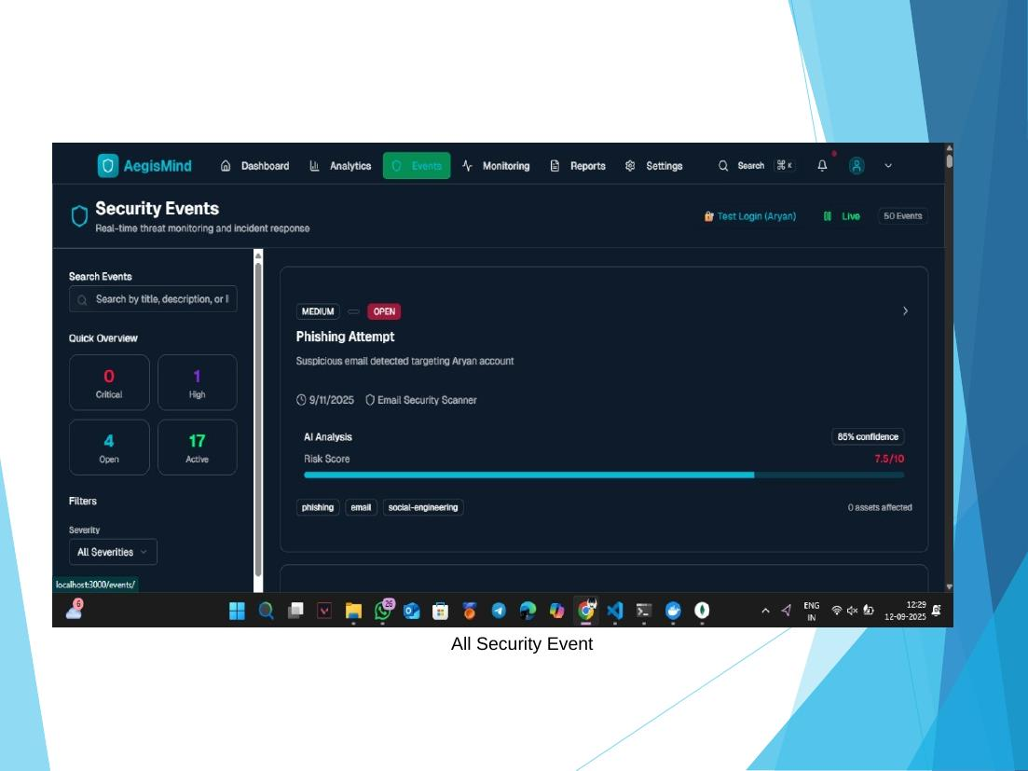
Figure 5: LLM Model Comparison — Base Llama-2 vs. Fine-Tuned llama-2-7b-cyberllm
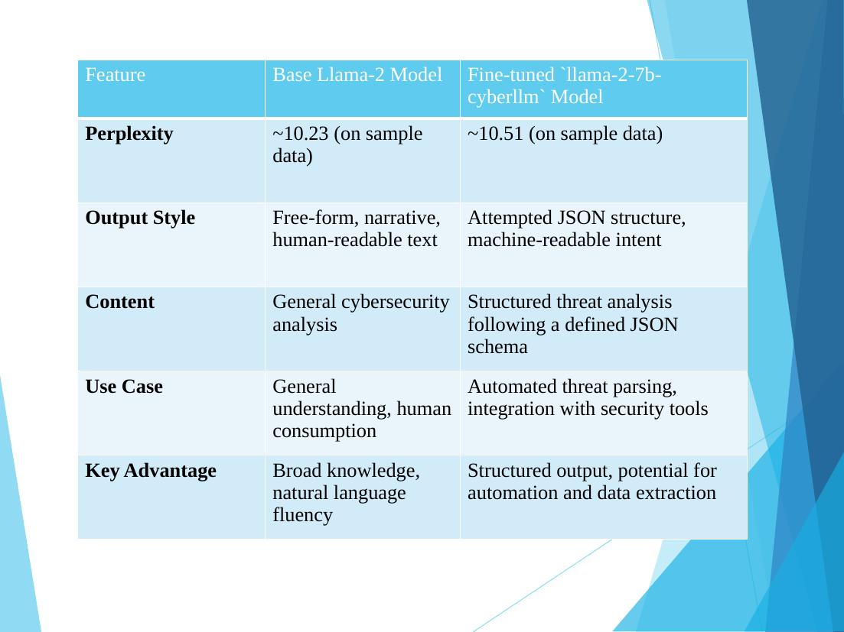

Table 1 presents a direct comparison between the base Llama-2 model and the fine-tuned llama-2-7b-cyberllm model used in AegisMind. The fine-tuned model produces structured JSON output aligned to a defined threat analysis schema, enabling automated threat parsing and direct integration with security tooling. Although the base model achieves a slightly lower perplexity (10.23 vs. 10.51 on sample data), the fine-tuned variant’s machine-readable, structured output provides substantially greater practical utility for autonomous agent decision-making. This trade-off confirms that domain-specific fine-tuning is essential for deploying LLMs effectively within operational security pipelines.

7.3 Interface Usability and Threat Analysis
The AegisMind Next.js dashboard provides a unified, real-time interface for security operators to monitor and investigate threats without requiring direct interaction with the underlying agent stack. Figure 6 shows the Analysed Threats panel, which presents every incident that has passed through the Reasoning Agent pipeline, including its classification, severity score, and recommended action. Figure 7 shows the Detail Analysis view, which provides a full breakdown of a selected incident: the raw event payload, the LLM’s structured JSON analysis output, identified attack patterns matched from the Pinecone vector store, and the defense action taken.
Figure 6: AegisMind — Analysed Threat Panel
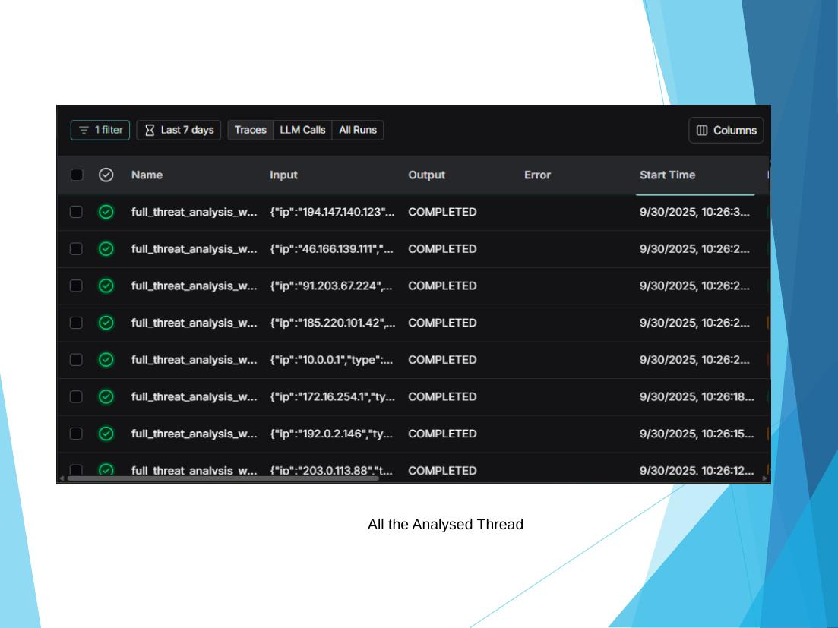
Figure 7: AegisMind — Incident Detail Analysis View
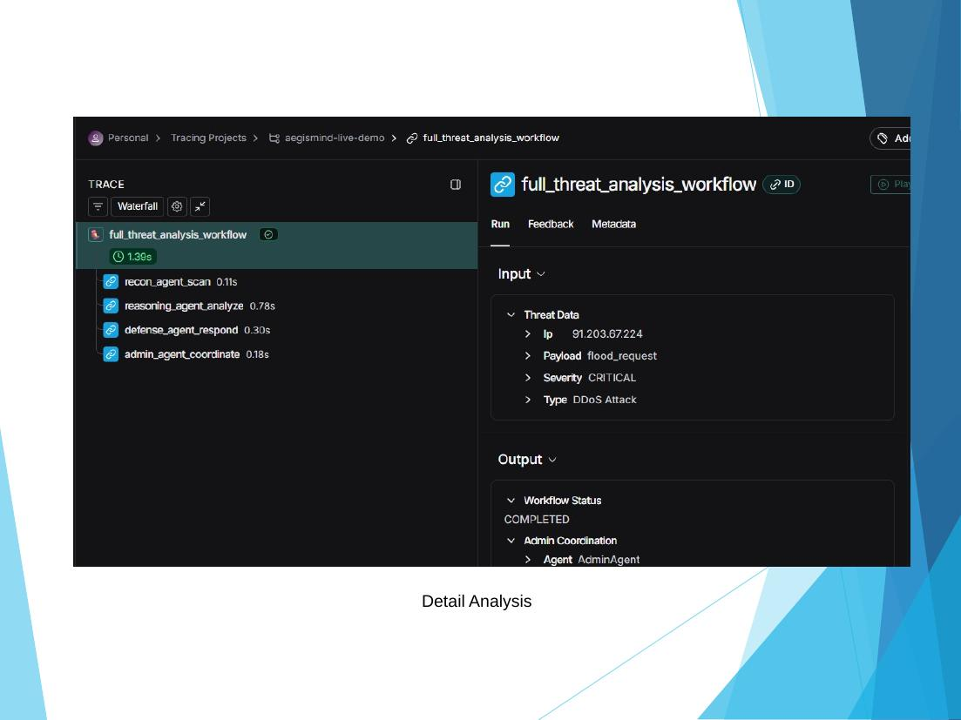
Several key usability observations were identified during evaluation. First, the dashboard requires no security engineering expertise to interpret, making high-fidelity threat intelligence accessible to non-specialist staff. Second, the autonomous agent pipeline eliminates alert fatigue by presenting only classified, contextualised incidents rather than raw log dumps. Third, the Detail Analysis view’s structured JSON output enables seamless downstream integration with SIEM tools and ticketing systems. Finally, the plug-and-play SDK deployment model allows AegisMind to be integrated into existing digital infrastructure in minutes, significantly lowering the operational barrier to enterprise-grade autonomous threat defence.

7.4 Limitations
While AegisMind demonstrates reliable real-time threat detection and autonomous response, several technical constraints remain. LLM inference latency is the primary bottleneck: the fine-tuned llama-2-7b-cyberllm model introduces a per-query reasoning delay of approximately 800–1200 ms under standard GPU load, which, though acceptable for most threat types, may be insufficient for sub-second zero-day exploit containment scenarios. Serving the larger DeepSeek 70B model for deep reasoning further extends this latency, requiring dedicated high-performance AMD MI300 hardware that may not be available in all deployment environments.

The Deep Reinforcement Learning component requires substantial offline training time on labelled cybersecurity datasets before the system reaches peak classification accuracy. In the current implementation, initial DRL convergence demands several hours of training on domain-specific threat corpora, which limits rapid cold-start deployments. Additionally, the system’s vector memory accuracy is bounded by the coverage of its training data: novel attack families not yet represented in the Pinecone embedding store may receive lower-confidence classifications until the memory base is enriched through operational exposure. Despite these constraints, each limitation presents a clear direction for future improvement, including low-latency speculative LLM decoding, federated DRL training across deployment nodes, and continuous embedding store enrichment pipelines.

Chapter 8

Conclusion & Future Scope

8.1 Conclusion
The project AEGIS MIND presents a structured and user-friendly approach to data processing and workflow management. In modern data-driven environments, handling and transforming data efficiently is essential for accurate analysis and decision-making. However, traditional systems are often complex and require significant technical expertise.
The proposed system successfully addresses these challenges by providing an intuitive platform that simplifies data preprocessing and workflow creation. By integrating a structured workflow-based approach with a user-friendly interface, AEGIS MIND enables users to perform operations such as data cleaning, transformation, normalization, and filtering without extensive programming knowledge.
The system supports multiple data formats and ensures proper execution of workflows through structured sequencing and dependency management. Experimental results demonstrate that the system provides reliable performance and accurate data processing for moderate-sized datasets.
Overall, AEGIS MIND effectively bridges the gap between complex data processing systems and accessible platforms, making it suitable for educational purposes, research applications, and small-scale data engineering tasks

8.2 Future Scope
While AEGIS MIND provides a reliable and efficient solution for structured data processing, there are several areas where the system can be further enhanced to improve its capabilities and scalability.
One important direction for future work is the integration of advanced technologies such as machine learning to provide intelligent recommendations for workflow creation and data transformation. This would enhance automation and improve user experience.
Another potential enhancement is the incorporation of real-time data processing capabilities, allowing the system to handle continuous data streams in addition to batch processing. This would make the system suitable for dynamic and large-scale applications.
Scalability can also be improved by integrating distributed processing frameworks, enabling the system to efficiently handle large datasets and high-performance requirements. Additionally, deploying the system as a cloud-based platform would support remote access, collaboration, and workflow sharing.
Further improvements may include enhanced visualization tools, better monitoring and debugging features, and support for additional data formats and advanced transformation techniques.
By incorporating these enhancements, AEGIS MIND can evolve into a more powerful, scalable, and intelligent data processing platform capable of addressing a wider range of real-world applications.

References
- [1] S. M. F. Ali and R. Wrembel, “From conceptual design to performance optimization of ETL workflows: Current state of research and open problems,” VLDB Journal, vol. 26, no. 6, pp. 777–801, 2017.
- [2] A. Simitsis, S. Skiadopoulos, and P. Vassiliadis, “The history, present, and future of ETL technology,” in Proc. DOLAP Test-of-Time Award – Invited Talk, 2023.
- [3] W. Cui, “Visual analytics: A comprehensive overview,” IEEE Access, vol. 7, pp. 81555–81573, 2019.
- [4] E. Mehmood and T. Anees, “Challenges and solutions for processing real-time big data stream: A systematic literature review,” IEEE Access, vol. 8, pp. 119123–119143, 2020.
- [5] S. Curty, F. Härer, and H.-G. Fill, “Design of blockchain-based applications using model-driven engineering and low-code/no-code platforms: A structured literature review,” Software and Systems Modelling, vol. 22, pp. 1857–1895, 2023.
- [6] S.-S. Guo, Z.-M. Yuan, A.-B. Sun, and Q. Yue, “A new ETL approach based on data virtualization,” Journal of Computer Science and Technology, vol. 30, no. 2, pp. 311–323, 2015.
- [7] W. H. Inmon, Building the Data Warehouse. New York, USA: John Wiley & Sons, 2005.
- [8] P. Vassiliadis, A. Simitsis, and S. Skiadopoulos, “On the logical modelling of ETL processes,” in Proc. Int. Conf. Advanced Information Systems Engineering (CAiSE), pp. 782–796, 2002.
- [9] A. Simitsis, P. Vassiliadis, and T. Sellis, “Optimizing ETL processes in data warehouses,” in Proc. IEEE Int. Conf. Data Engineering (ICDE), pp. 564–575, 2005.
- [10] R. Kimball and M. Ross, The Data Warehouse Toolkit. Indianapolis, USA: Wiley, 2013.

- A. Simitsis and P. Vassiliadis, “A methodology for the conceptual modelling of ETL processes,” in Proc. Int. Workshop Design and Management of Data Warehouses (DMDW), pp. 305–316, 2003.
- D. Skoutas and A. Simitsis, “Ontology-based conceptual design of ETL processes,” International Journal on Semantic Web and Information Systems, vol. 3, no. 4, pp. 1–24, 2007.
- P. Vassiliadis, A. Simitsis, and M. Terrovitis, “Blueprints and measures for ETL workflows,” in Proc. Int. Conf. Conceptual Modelling (ER), pp. 385–400, 2005.
- B. Shneiderman, “The eyes have it: A task by data type taxonomy for information visualizations,” in Proc. IEEE Symp. Visual Languages, pp. 336–343, 1996.

