Nama : Arif Fadillah Wicaksono
Kelas : TI-3A
NIM : 2407411007

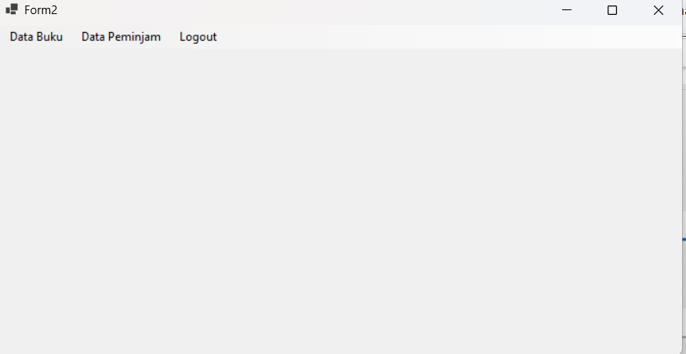
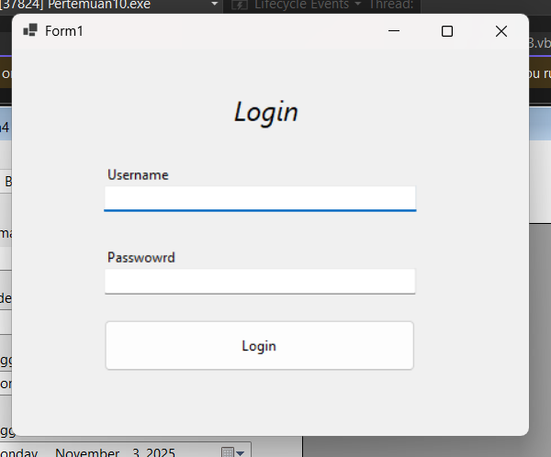

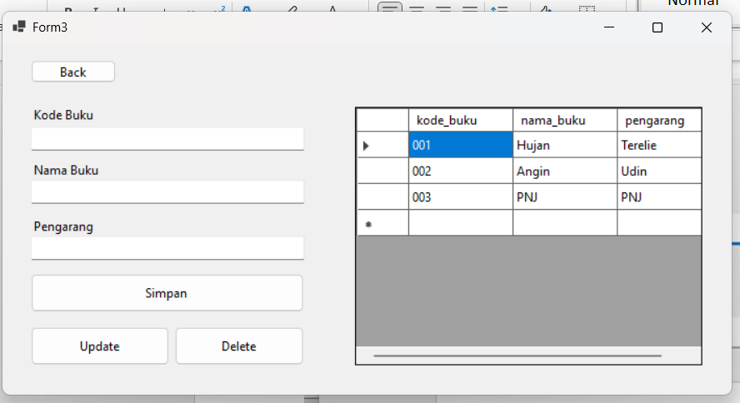

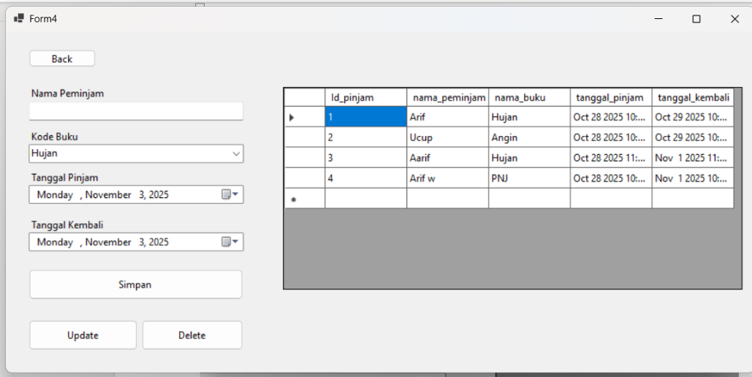

Code
Form 1
Imports Microsoft.Data.SqlClient

Public Class Form1
Private Sub Form1_Load(sender As Object, e As EventArgs) Handles MyBase.Load
TextBox2.PasswordChar = "*"
End Sub

Private Sub Button1_Click(sender As Object, e As EventArgs) Handles Button1.Click
Try
Using conn As SqlConnection = GetConnection()
conn.Open()
Using cmd As New SqlCommand("SELECT * FROM login WHERE username = @username AND password = @password", conn)
cmd.Parameters.AddWithValue("@username", TextBox1.Text)
cmd.Parameters.AddWithValue("@password", TextBox2.Text)
Using reader As SqlDataReader = cmd.ExecuteReader()
If reader.HasRows Then
MessageBox.Show("Login berhasil!", "Success", MessageBoxButtons.OK, MessageBoxIcon.Information)
Dim frm As New Form2
frm.Show()
Me.Hide()
Else
MessageBox.Show("Username atau password salah.", "Login Gagal", MessageBoxButtons.OK, MessageBoxIcon.Warning)
End If
End Using
End Using
End Using
Catch ex As Exception
MessageBox.Show("Terjadi kesalahan: " & ex.Message, "Error", MessageBoxButtons.OK, MessageBoxIcon.Error)
End Try
End Sub
End Class

Form 2
Public Class Form2
Private Sub LogoutToolStripMenuItem_Click(sender As Object, e As EventArgs) Handles LogoutToolStripMenuItem.Click
Dim frm As New Form1
frm.Show()
Me.Close()
End Sub

Private Sub DataBukuToolStripMenuItem_Click(sender As Object, e As EventArgs) Handles DataBukuToolStripMenuItem.Click
Dim frm As New Form3
frm.Show()
Me.Close()
End Sub

Private Sub DataPeminjamToolStripMenuItem_Click(sender As Object, e As EventArgs) Handles DataPeminjamToolStripMenuItem.Click
Dim frm As New Form4
frm.Show()
Me.Close()
End Sub
End Class

Form 3
Imports System.Windows.Forms.VisualStyles.VisualStyleElement
Imports Microsoft.Data.SqlClient

Public Class Form3

Private Sub Form3_Load(sender As Object, e As EventArgs) Handles MyBase.Load
TampilData()
End Sub

Private Sub TampilData()
Using conn As SqlConnection = GetConnection()
conn.Open()
Using da As New SqlDataAdapter("SELECT * FROM buku", conn)
Dim dt As New DataTable()
da.Fill(dt)
dataBuku.DataSource = dt
End Using
End Using
End Sub
Private Sub DataGridView1_CellClick(sender As Object, e As DataGridViewCellEventArgs) Handles dataBuku.CellClick
If e.RowIndex >= 0 Then
Dim row As DataGridViewRow = dataBuku.Rows(e.RowIndex)
TextBox1.Text = row.Cells("kode_buku").Value.ToString()
TextBox2.Text = row.Cells("nama_buku").Value.ToString()
TextBox3.Text = row.Cells("pengarang").Value.ToString()
End If
End Sub

Private Sub Button1_Click(sender As Object, e As EventArgs) Handles Button1.Click
ErrorProvider1.Clear()
Dim isValid = True
If String.IsNullOrWhiteSpace(TextBox1.Text) Then
ErrorProvider1.SetError(TextBox1, "Kode Buku harus diisi")
isValid = False
End If
If String.IsNullOrWhiteSpace(TextBox2.Text) Then
ErrorProvider1.SetError(TextBox2, "Nama Buku harus diisi")
isValid = False
End If
If String.IsNullOrWhiteSpace(TextBox3.Text) Then
ErrorProvider1.SetError(TextBox3, "Pengarang harus diisi")
isValid = False
End If

If Not isValid Then
MessageBox.Show("Periksa kembali data yang belum diisi!", "Validasi", MessageBoxButtons.OK, MessageBoxIcon.Warning)
Exit Sub
End If

Using conn = GetConnection()
conn.Open()

Dim query = "INSERT INTO buku (kode_buku, nama_buku, pengarang) VALUES (@kb, @nb, @pengarang)"
Using cmd As New SqlCommand(query, conn)
cmd.Parameters.AddWithValue("@kb", TextBox1.Text)
cmd.Parameters.AddWithValue("@nb", TextBox2.Text)
cmd.Parameters.AddWithValue("@pengarang", TextBox3.Text)
cmd.ExecuteNonQuery()
End Using
MessageBox.Show("Data Berhasil Ditambahkan")
TextBox1.Clear()
TextBox2.Clear()
TextBox3.Clear()
TampilData()
End Using
End Sub

Private Sub Button3_Click(sender As Object, e As EventArgs) Handles Button3.Click
If TextBox1.Text = "" Then
MessageBox.Show("Masukkan Kode buku yang ingin dihapus!", "Peringatan", MessageBoxButtons.OK, MessageBoxIcon.Warning)
Exit Sub
End If
Dim result As DialogResult = MessageBox.Show("Yakin ingin menghapus data ini?", "Konfirmasi", MessageBoxButtons.YesNo, MessageBoxIcon.Question)
If result = DialogResult.Yes Then
Using conn As SqlConnection = GetConnection()
conn.Open()
Dim query As String = "DELETE FROM buku WHERE kode_buku=@kb"
Using cmd As New SqlCommand(query, conn)
cmd.Parameters.AddWithValue("@kb", TextBox1.Text)
Dim rowsAffected As Integer = cmd.ExecuteNonQuery()
If rowsAffected > 0 Then
MessageBox.Show("Data berhasil dihapus!", "Informasi", MessageBoxButtons.OK, MessageBoxIcon.Information)
TextBox1.Clear()
TextBox2.Clear()
TextBox3.Clear()
Else
MessageBox.Show("Data tidak ditemukan!", "Kesalahan", MessageBoxButtons.OK, MessageBoxIcon.Error)
End If
End Using
End Using
TextBox1.Clear()
TextBox2.Clear()
TextBox3.Clear()
TampilData()
End If
End Sub

Private Sub Button2_Click(sender As Object, e As EventArgs) Handles Button2.Click
If TextBox1.Text = "" Then
MessageBox.Show("Masukkan NIM yang ingin diperbarui!", "Peringatan", MessageBoxButtons.OK, MessageBoxIcon.Warning)
Exit Sub
End If
Using conn As SqlConnection = GetConnection()
conn.Open()
Dim query As String = "UPDATE buku SET nama_buku=@nb, pengarang=@pengarang WHERE kode_buku=@kb"
Using cmd As New SqlCommand(query, conn)
cmd.Parameters.AddWithValue("@kb", TextBox1.Text)
cmd.Parameters.AddWithValue("@nb", TextBox2.Text)
cmd.Parameters.AddWithValue("@pengarang", TextBox3.Text)
Dim rowsAffected As Integer = cmd.ExecuteNonQuery()
If rowsAffected > 0 Then
MessageBox.Show("Data berhasil diperbarui", "Informasi", MessageBoxButtons.OK, MessageBoxIcon.Information)
Else
MessageBox.Show("Data tidak ditemukan!", "Kesalahan", MessageBoxButtons.OK, MessageBoxIcon.Error)
End If
End Using
End Using
TextBox1.Clear()
TextBox2.Clear()
TextBox3.Clear()
TampilData()
End Sub

Private Sub Button4_Click(sender As Object, e As EventArgs) Handles Button4.Click
Dim frm As New Form2
frm.Show()
Me.Close()
End Sub
End Class

Form 4
Imports System.Windows.Forms.VisualStyles.VisualStyleElement
Imports Microsoft.Data.SqlClient

Public Class Form4

Private selectedId As Integer = -1

Private Sub TampilData()
Using conn As SqlConnection = GetConnection()
conn.Open()

Dim query As String = "
SELECT
p.Id_pinjam,
p.nama_peminjam,
b.nama_buku,
p.tanggal_pinjam,
p.tanggal_kembali
FROM pinjam p
INNER JOIN buku b ON p.kode_buku = b.kode_buku
"

Using da As New SqlDataAdapter(query, conn)
Dim dt As New DataTable()
da.Fill(dt)
dataPeminjam.DataSource = dt
End Using
End Using
End Sub

Private Sub Form4_Load(sender As Object, e As EventArgs) Handles MyBase.Load
Try
Using conn As SqlConnection = GetConnection()
conn.Open()

Dim cmd As New SqlCommand("SELECT kode_buku, nama_buku FROM buku", conn)
Dim da As New SqlDataAdapter(cmd)
Dim dt As New DataTable()

da.Fill(dt)

ComboBox1.DataSource = dt
ComboBox1.DisplayMember = "nama_buku"
ComboBox1.ValueMember = "kode_buku"
End Using

Catch ex As Exception
MessageBox.Show("Gagal memuat data: " & ex.Message)
End Try

TampilData()
End Sub

Private Sub Button1_Click(sender As Object, e As EventArgs) Handles Button1.Click
ErrorProvider1.Clear()

Dim isValid As Boolean = True

If String.IsNullOrWhiteSpace(TextBox1.Text) Then
ErrorProvider1.SetError(TextBox1, "Nama peminjam harus diisi")
isValid = False
End If

If ComboBox1.SelectedIndex = -1 Then
ErrorProvider1.SetError(ComboBox1, "Buku harus dipilih")
isValid = False
End If

If Not isValid Then
MessageBox.Show("Periksa kembali data yang belum diisi!", "Validasi", MessageBoxButtons.OK, MessageBoxIcon.Warning)
Exit Sub
End If

Dim kodeBukuDipilih As String = ComboBox1.SelectedValue.ToString()

Try
Using conn = GetConnection()
conn.Open()

Dim query As String = "INSERT INTO pinjam (nama_peminjam, kode_buku, tanggal_pinjam, tanggal_kembali)
VALUES (@np, @kb, @tgl_pinjam, @tgl_kembali)"

Using cmd As New SqlCommand(query, conn)
cmd.Parameters.AddWithValue("@np", TextBox1.Text)
cmd.Parameters.AddWithValue("@kb", kodeBukuDipilih)
cmd.Parameters.AddWithValue("@tgl_pinjam", DateTimePicker1.Value)
cmd.Parameters.AddWithValue("@tgl_kembali", DateTimePicker2.Value)
cmd.ExecuteNonQuery()
End Using
End Using

MessageBox.Show("Data Berhasil Ditambahkan", "Sukses", MessageBoxButtons.OK, MessageBoxIcon.Information)

ResetForm()
TampilData()

Catch ex As Exception
MessageBox.Show("Terjadi kesalahan saat menyimpan data: " & ex.Message, "Error", MessageBoxButtons.OK, MessageBoxIcon.Error)
End Try
End Sub

Private Sub dataPeminjam_CellClick(sender As Object, e As DataGridViewCellEventArgs) Handles dataPeminjam.CellClick
If e.RowIndex >= 0 Then
Dim row As DataGridViewRow = dataPeminjam.Rows(e.RowIndex)

selectedId = Convert.ToInt32(row.Cells("Id_pinjam").Value)
TextBox1.Text = row.Cells("nama_peminjam").Value.ToString()
ComboBox1.Text = row.Cells("nama_buku").Value.ToString()
DateTimePicker1.Value = Convert.ToDateTime(row.Cells("tanggal_pinjam").Value)
DateTimePicker2.Value = Convert.ToDateTime(row.Cells("tanggal_kembali").Value)
End If
End Sub

' === UPDATE ===
Private Sub Button2_Click(sender As Object, e As EventArgs) Handles Button2.Click
If selectedId = -1 Then
MessageBox.Show("Pilih data yang akan diperbarui terlebih dahulu!", "Peringatan", MessageBoxButtons.OK, MessageBoxIcon.Warning)
Exit Sub
End If

Try
Using conn As SqlConnection = GetConnection()
conn.Open()

Dim query As String = "UPDATE pinjam
SET nama_peminjam = @np,
kode_buku = @kb,
tanggal_pinjam = @tp,
tanggal_kembali = @tk
WHERE Id_pinjam = @id"

Using cmd As New SqlCommand(query, conn)
cmd.Parameters.AddWithValue("@np", TextBox1.Text)
cmd.Parameters.AddWithValue("@kb", ComboBox1.SelectedValue.ToString())
cmd.Parameters.AddWithValue("@tp", DateTimePicker1.Value)
cmd.Parameters.AddWithValue("@tk", DateTimePicker2.Value)
cmd.Parameters.AddWithValue("@id", selectedId)

Dim result = cmd.ExecuteNonQuery()
If result > 0 Then
MessageBox.Show("Data berhasil diperbarui!", "Sukses", MessageBoxButtons.OK, MessageBoxIcon.Information)
ResetForm()
TampilData()
Else
MessageBox.Show("Data tidak ditemukan!", "Error", MessageBoxButtons.OK, MessageBoxIcon.Error)
End If
End Using
End Using

Catch ex As Exception
MessageBox.Show("Terjadi kesalahan saat memperbarui data: " & ex.Message, "Error", MessageBoxButtons.OK, MessageBoxIcon.Error)
End Try
End Sub

' === DELETE ===
Private Sub Button3_Click(sender As Object, e As EventArgs) Handles Button3.Click
If selectedId = -1 Then
MessageBox.Show("Pilih data yang akan dihapus terlebih dahulu!", "Peringatan", MessageBoxButtons.OK, MessageBoxIcon.Warning)
Exit Sub
End If

Dim result As DialogResult = MessageBox.Show("Apakah Anda yakin ingin menghapus data ini?", "Konfirmasi Hapus", MessageBoxButtons.YesNo, MessageBoxIcon.Question)

If result = DialogResult.Yes Then
Try
Using conn As SqlConnection = GetConnection()
conn.Open()

Dim query As String = "DELETE FROM pinjam WHERE Id_pinjam = @id"

Using cmd As New SqlCommand(query, conn)
cmd.Parameters.AddWithValue("@id", selectedId)
cmd.ExecuteNonQuery()
End Using
End Using

MessageBox.Show("Data berhasil dihapus!", "Sukses", MessageBoxButtons.OK, MessageBoxIcon.Information)
ResetForm()
TampilData()

Catch ex As Exception
MessageBox.Show("Terjadi kesalahan saat menghapus data: " & ex.Message, "Error", MessageBoxButtons.OK, MessageBoxIcon.Error)
End Try
End If
End Sub

Private Sub ResetForm()
TextBox1.Clear()
ComboBox1.SelectedIndex = -1
DateTimePicker1.Value = DateTime.Now
DateTimePicker2.Value = DateTime.Now
selectedId = -1
End Sub

Private Sub Button4_Click(sender As Object, e As EventArgs) Handles Button4.Click
Dim frm As New Form2
frm.Show()
Me.Close()
End Sub
End Class

Di grid peminjaman buku, kolom yang ditampilkan berupa nama_buku, namun saat proses penyimpanan ke database, nilai yang dimasukkan adalah id_buku.