Wildtouch
S P E C I A L I S I N G I N S O U V E N I R S F O R A T T R A C T I O N S
JMS — Jewellery Management System
USER MANUAL
For Admins, Managers and Viewers
Sterling-K Ltd · wildtouch.co.uk

Roles at a Glance
ADMIN — Full control of the system.
- Everything Managers can do
- Delete records everywhere (orders, invoices, products, clients…)
- Manage users & roles, change password
- See the History audit trail
MANAGER — Runs the day-to-day work.
- Create & edit orders, clients, products, planograms, designs, River orders
- Generate invoices, partials & packing lists
- Manage whiteboard and tasks (including deleting tasks)
- Cannot delete core records or manage users
VIEWER — Read-only access.
- Browse every page and search all data
- Download PDFs (invoices, packing lists, planograms)
- Any attempt to create, edit or delete shows a “view-only access” message
- Contact an Admin if you need more access

Contents
1. Signing In
2. Dashboard
3. Global Search
4. Clients
5. Inventory (Components)
6. Products & Groups
7. Planogram
8. Digital Whiteboard
9. Task Manager
10. Orders
11. Design Tracker
12. River
13. Agents
14. Branding Cards
15. Invoicing
16. History (Admin)
17. Settings & User Management
18. Shift Manager

1. Signing In
Every user signs in with a username (or email) and password created by an Admin in Settings. Your role — Admin, Manager or Viewer — decides what you can do once inside.
WHO CAN DO WHAT | ROLES
Sign in and browse all data | ADMIN · MANAGER · VIEWER
Create new user accounts | ADMIN

TO SIGN IN
- Open the app and enter your username (e.g. admin) or email.
- Enter your password and press Sign In.
- You land on the Dashboard. If your details are wrong you'll see an error — contact your Admin if you're locked out.
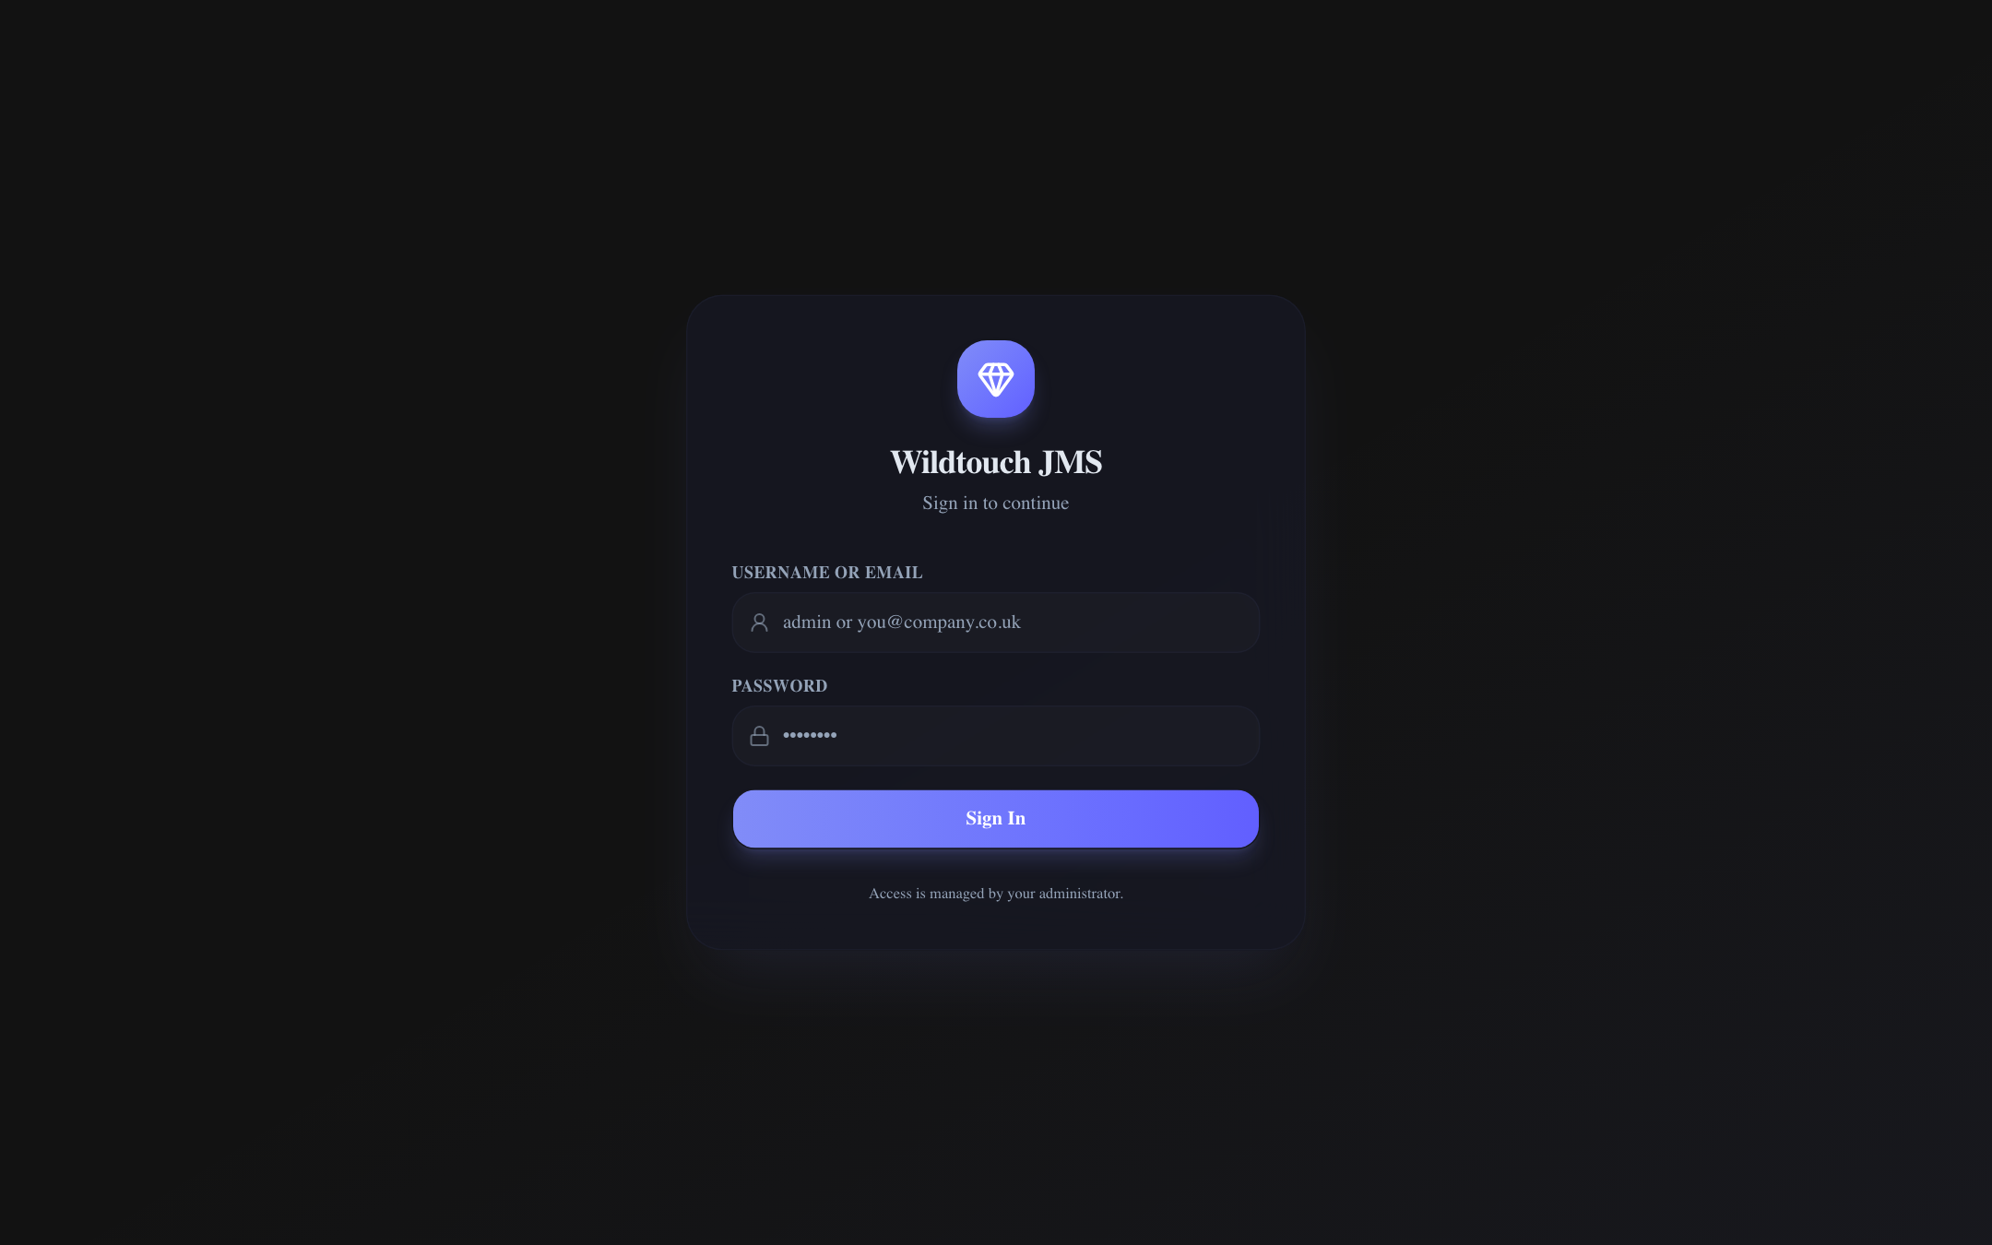
The sign-in screen

2. Dashboard
The home screen. It shows live business numbers pulled from the database: active orders, active clients, catalogue size, month-to-date revenue, a 7-day revenue chart, the orders pipeline and low-stock alerts.
WHO CAN DO WHAT | ROLES
View the dashboard | ADMIN · MANAGER · VIEWER
Create New Order (top-right button) | ADMIN · MANAGER

Tip: The Stock Alerts card highlights components at or below their threshold — restock these via River or Inventory.
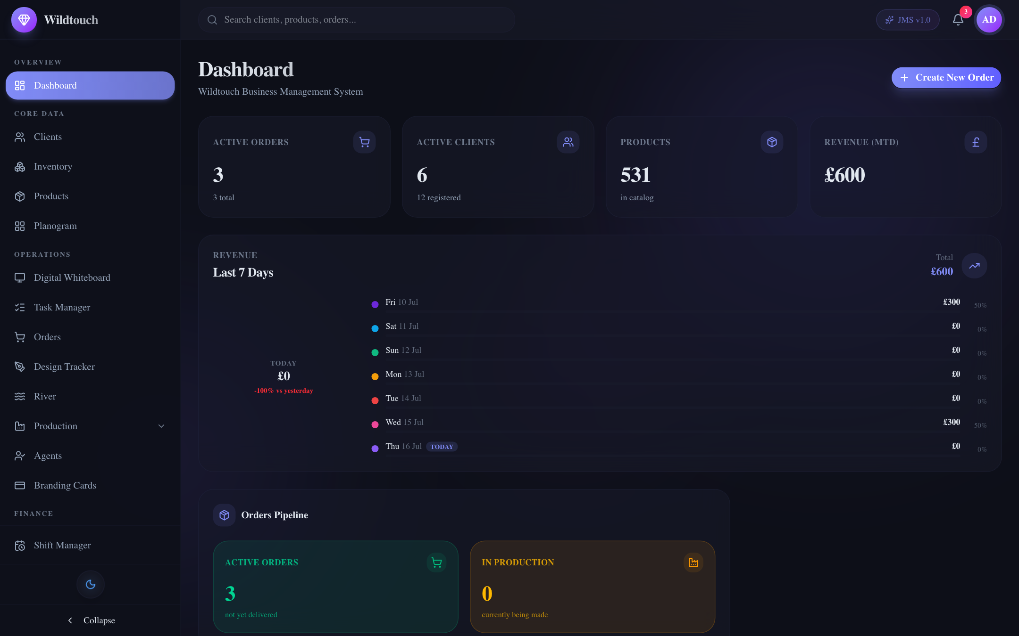
Dashboard with live stats, revenue and pipeline

3. Global Search
The search bar in the top header finds anything: clients, products, orders, invoices and planograms. Results are grouped with a coloured badge per type.
WHO CAN DO WHAT | ROLES
Search everything | ADMIN · MANAGER · VIEWER

TO SEARCH
- Click the header search box and start typing (name, code, order number…).
- Use the arrow keys to move through results and Enter to open one, or just click it.
- Products open the Products page pre-filtered; everything else opens its own page.
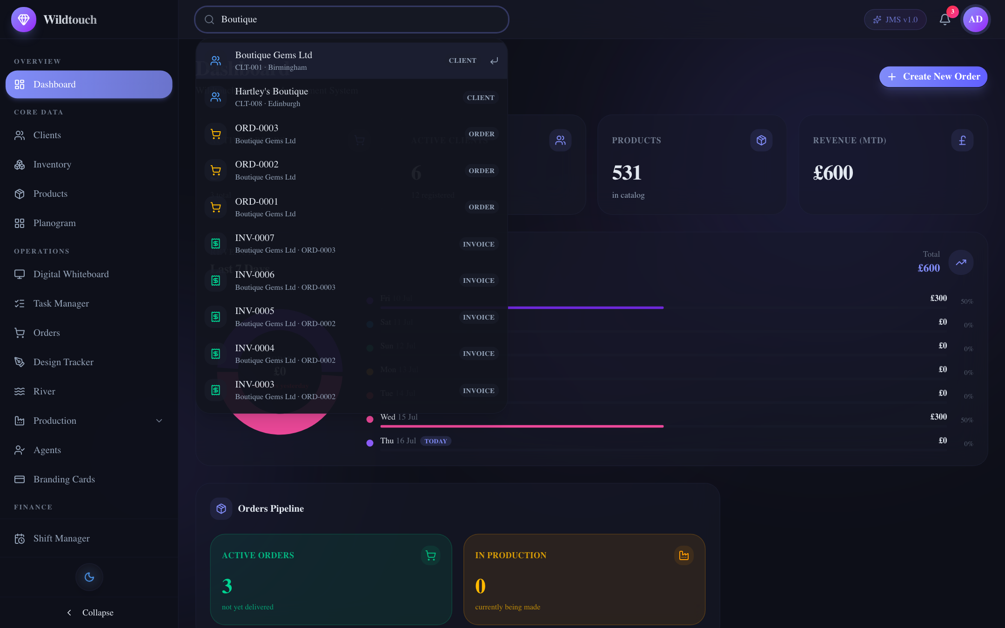
Typing a client name shows their record, orders and invoices

4. Clients
The customer database. Each client holds contacts, addresses, invoicing settings (VAT rate, PO requirement), product preferences, brand card & barcode images — and Pricing: this client's £ price for each product category, which drives every invoice.
WHO CAN DO WHAT | ROLES
View clients and profiles | ADMIN · MANAGER · VIEWER
Add / edit clients (incl. pricing & VAT) | ADMIN · MANAGER
Delete a client | ADMIN

TO SET A CLIENT'S CATEGORY PRICES
- Open the client, press Edit, and scroll to the Pricing section.
- Search a product group (groups are created on the Products page), type the £ price, press Add.
- Repeat per category, then Save. Invoices for this client now bill each planogram product at its category's price.
TO SET THE VAT RATE
- Edit the client → Invoicing → VAT rate (%). New invoices apply this rate automatically.
Tip: Click the brand card or barcode image on a profile to view it full-screen.
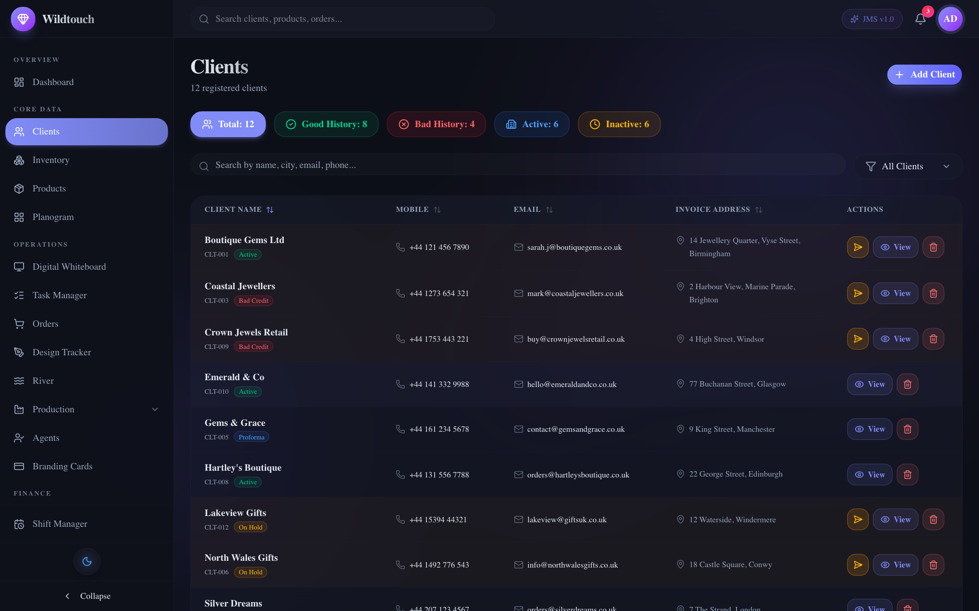
Clients list
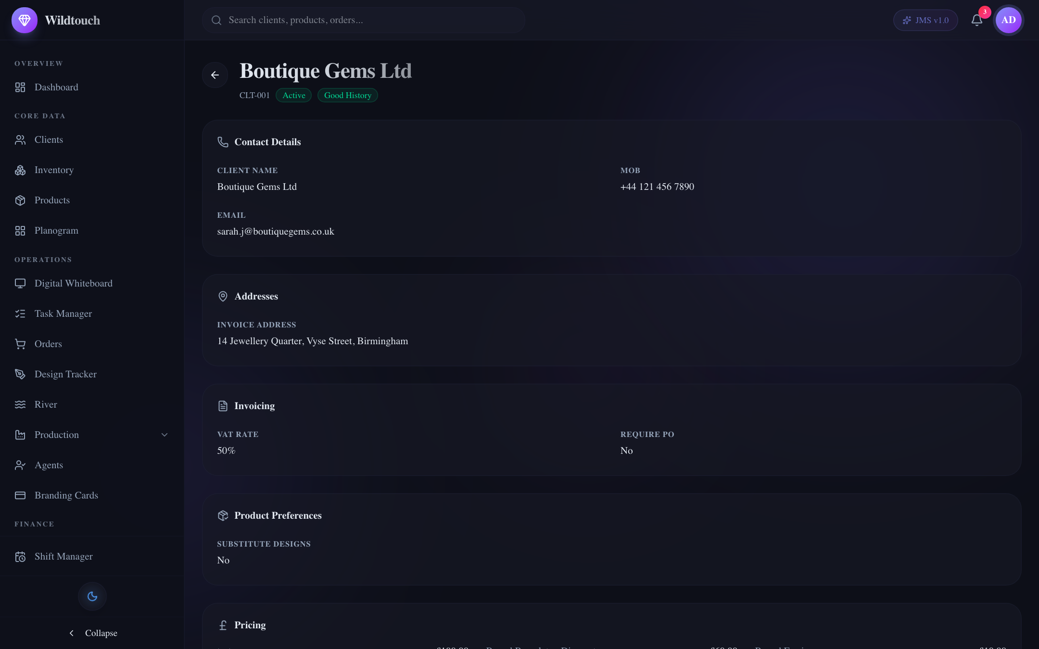
A client profile — contacts, invoicing, pricing and images

5. Inventory (Components)
The stock room. Inventory holds components — the physical parts (charms, findings, cards) that products are built from. Completing a River order tops these up automatically; confirming orders can deduct them.
WHO CAN DO WHAT | ROLES
View stock levels | ADMIN · MANAGER · VIEWER
Add / edit components & quantities | ADMIN · MANAGER
Delete a component | ADMIN

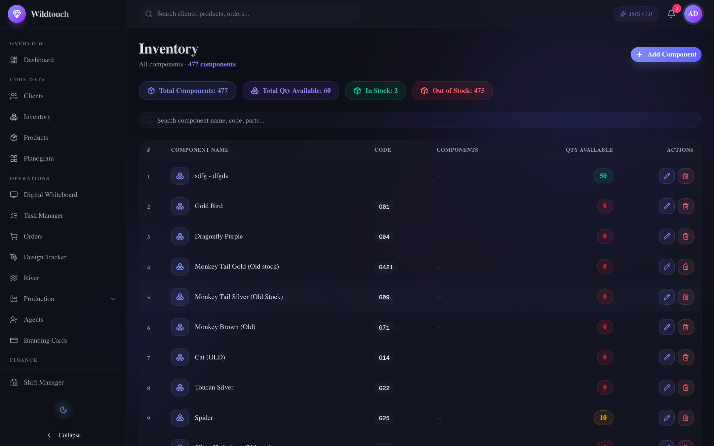
Component stock list

6. Products & Groups
The sellable catalogue. A product has a name, optional code, a photo, a Group (its category — e.g. Magnets, Large Keyrings) and a bill of materials: which inventory components it is made from. The Group matters: invoices are priced per group using each client's category prices.
WHO CAN DO WHAT | ROLES
View the catalogue | ADMIN · MANAGER · VIEWER
Create / edit products and groups | ADMIN · MANAGER
Delete a product | ADMIN

TO CREATE A PRODUCT
- Products → Create a Product.
- Name it, optionally add a code and upload a photo.
- Pick its Group (type to search; typing a new name creates the group on save).
- Search inventory components and add each with its per-unit quantity, then Create.
TO ADD A GROUP WITHOUT A PRODUCT
- Products → Add Group.
- Type the group name and press Add — it is instantly available in client Pricing.
- Deleting a group from the list asks for confirmation first.
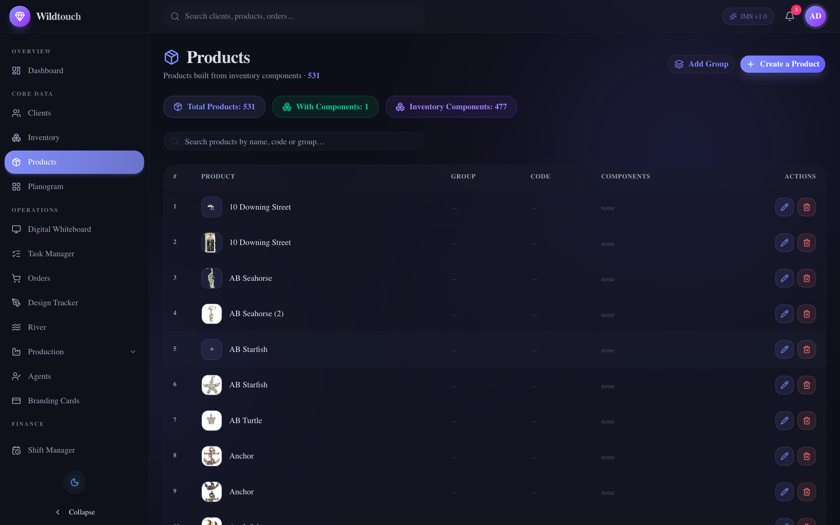
Products list with Group column
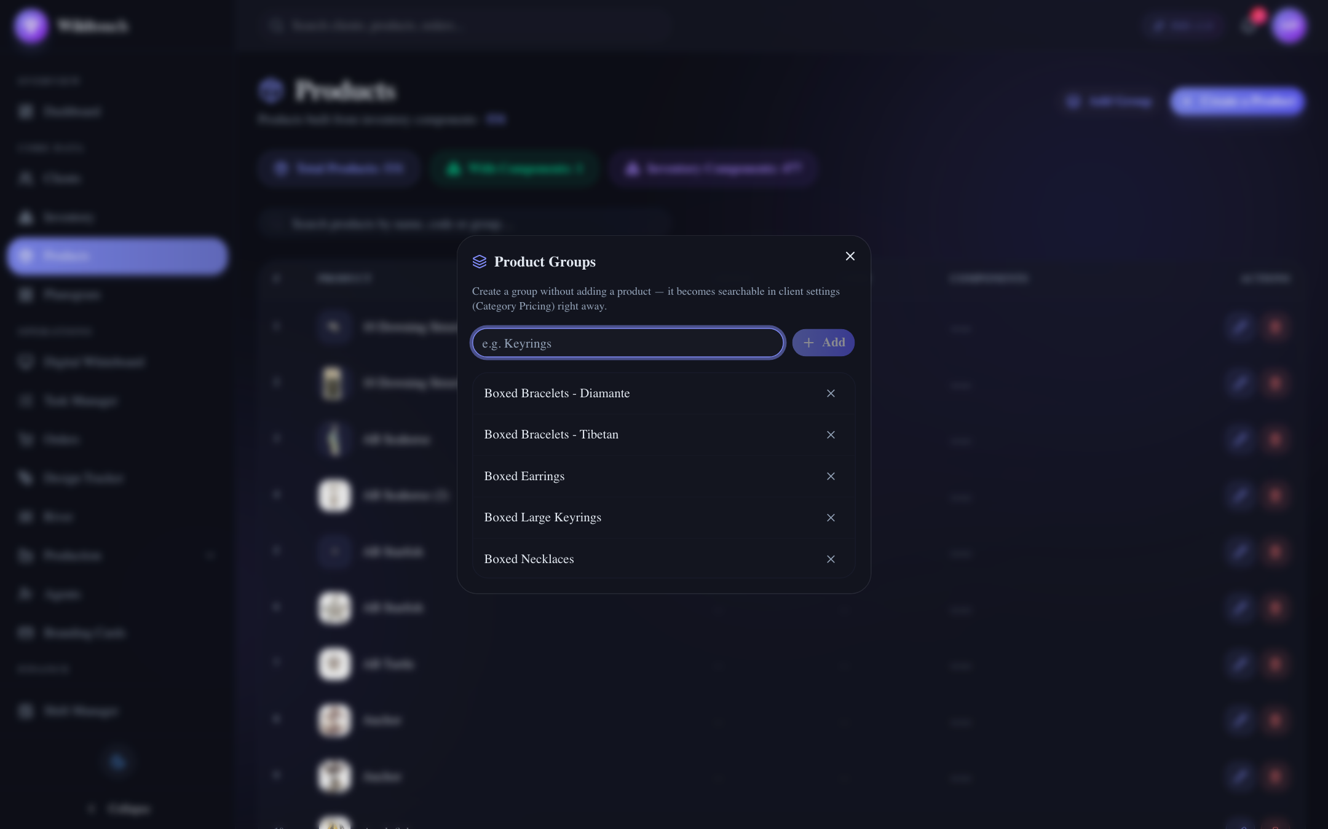
The Add Group dialog — create and manage categories

7. Planogram
Stand layouts. Built-in planograms cover the standard Wildtouch stands; the builder lets you create custom ones where every grid cell is its own product with a photo and quantity. Each side can also carry a Charms list shown at the bottom of the side and on prints.
WHO CAN DO WHAT | ROLES
View planograms & print PDFs | ADMIN · MANAGER · VIEWER
Build, edit and duplicate planograms | ADMIN · MANAGER
Delete a planogram | ADMIN

TO BUILD A PLANOGRAM
- Planogram → Add New Planogram.
- Name it, choose sides / rows / columns, then Generate Grid.
- In each cell, search a product — its photo appears — and set the quantity.
- Fill the Charms field per side if needed, then Save Planogram.
TO EDIT OR DUPLICATE
- Open a custom planogram → Edit changes anything (including charms); Duplicate makes a “(Copy)” to start from.
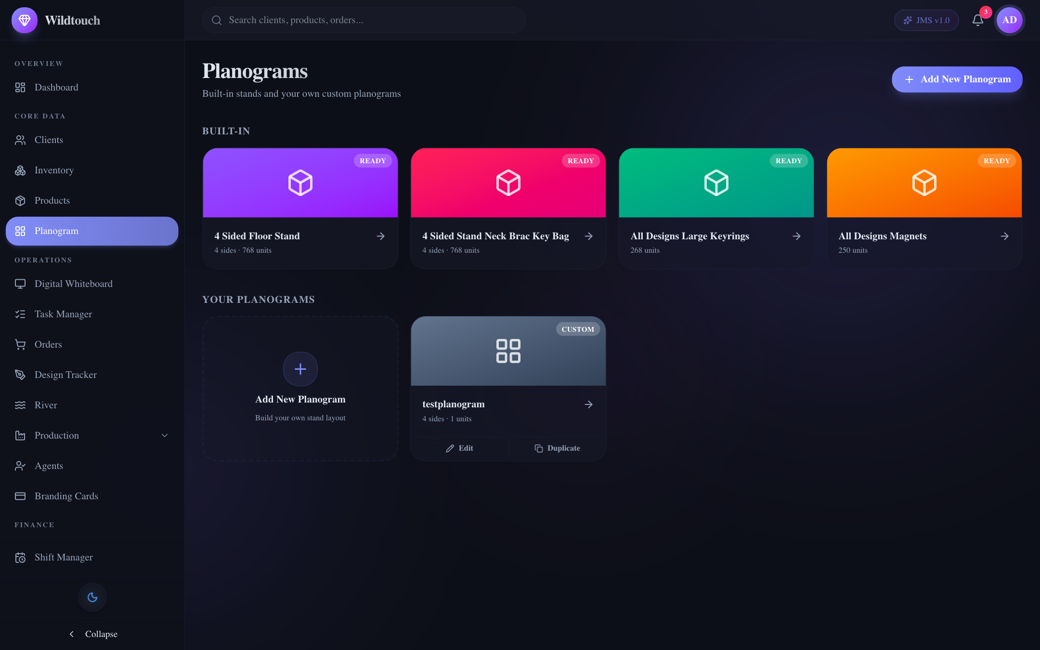
Built-in and custom planograms
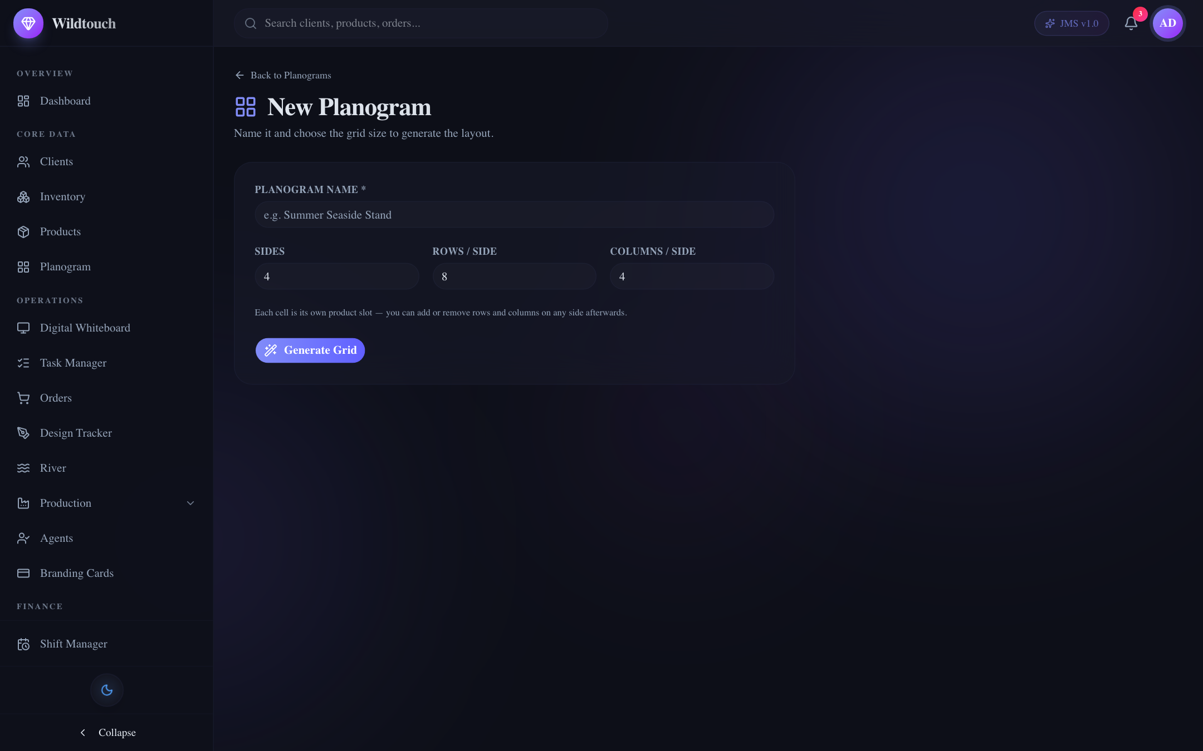
The builder setup — name and grid size

8. Digital Whiteboard
A shared board for quick order/task tracking — the digital version of the office whiteboard. All roles can see it; Admins and Managers can add, update and remove entries.
WHO CAN DO WHAT | ROLES
View the board | ADMIN · MANAGER · VIEWER
Add / edit / delete entries | ADMIN · MANAGER

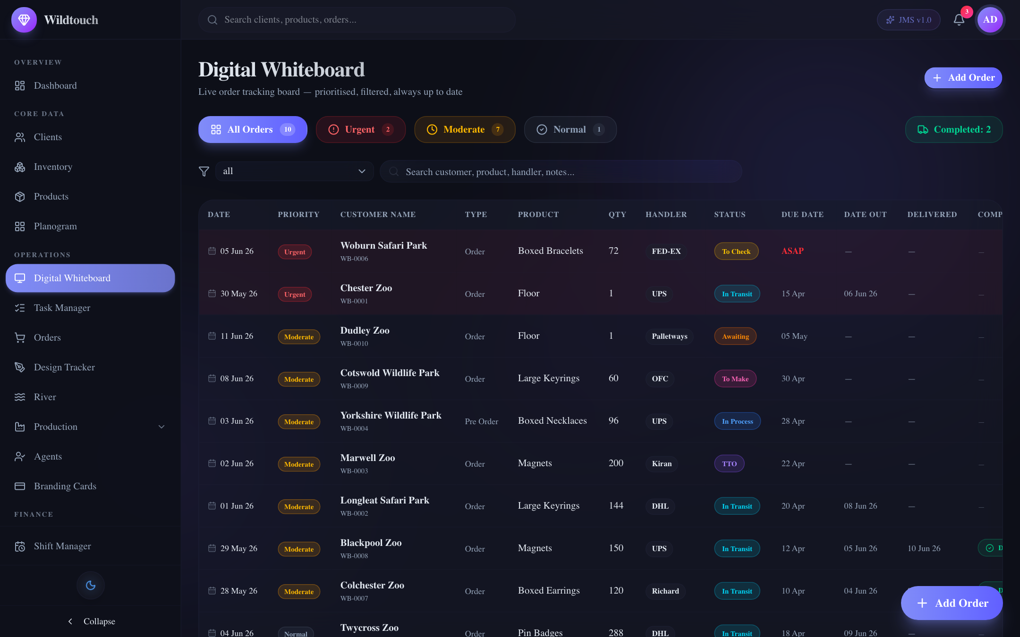
The Digital Whiteboard

9. Task Manager
Daily task lists per employee. Pick a date, add tasks with an employee, a note, status and priority. Tasks sort High → Medium → Low, and each row's note is editable inline (saves when you click away).
WHO CAN DO WHAT | ROLES
View tasks | ADMIN · MANAGER · VIEWER
Add, complete, edit and delete tasks | ADMIN · MANAGER

TO ASSIGN A TASK
- Pick the date with the calendar (top-right).
- Choose the employee (searchable), type the task and an optional note, set status & priority, press Add Task.
- Tick the circle to mark complete; use the dropdown to change priority any time.
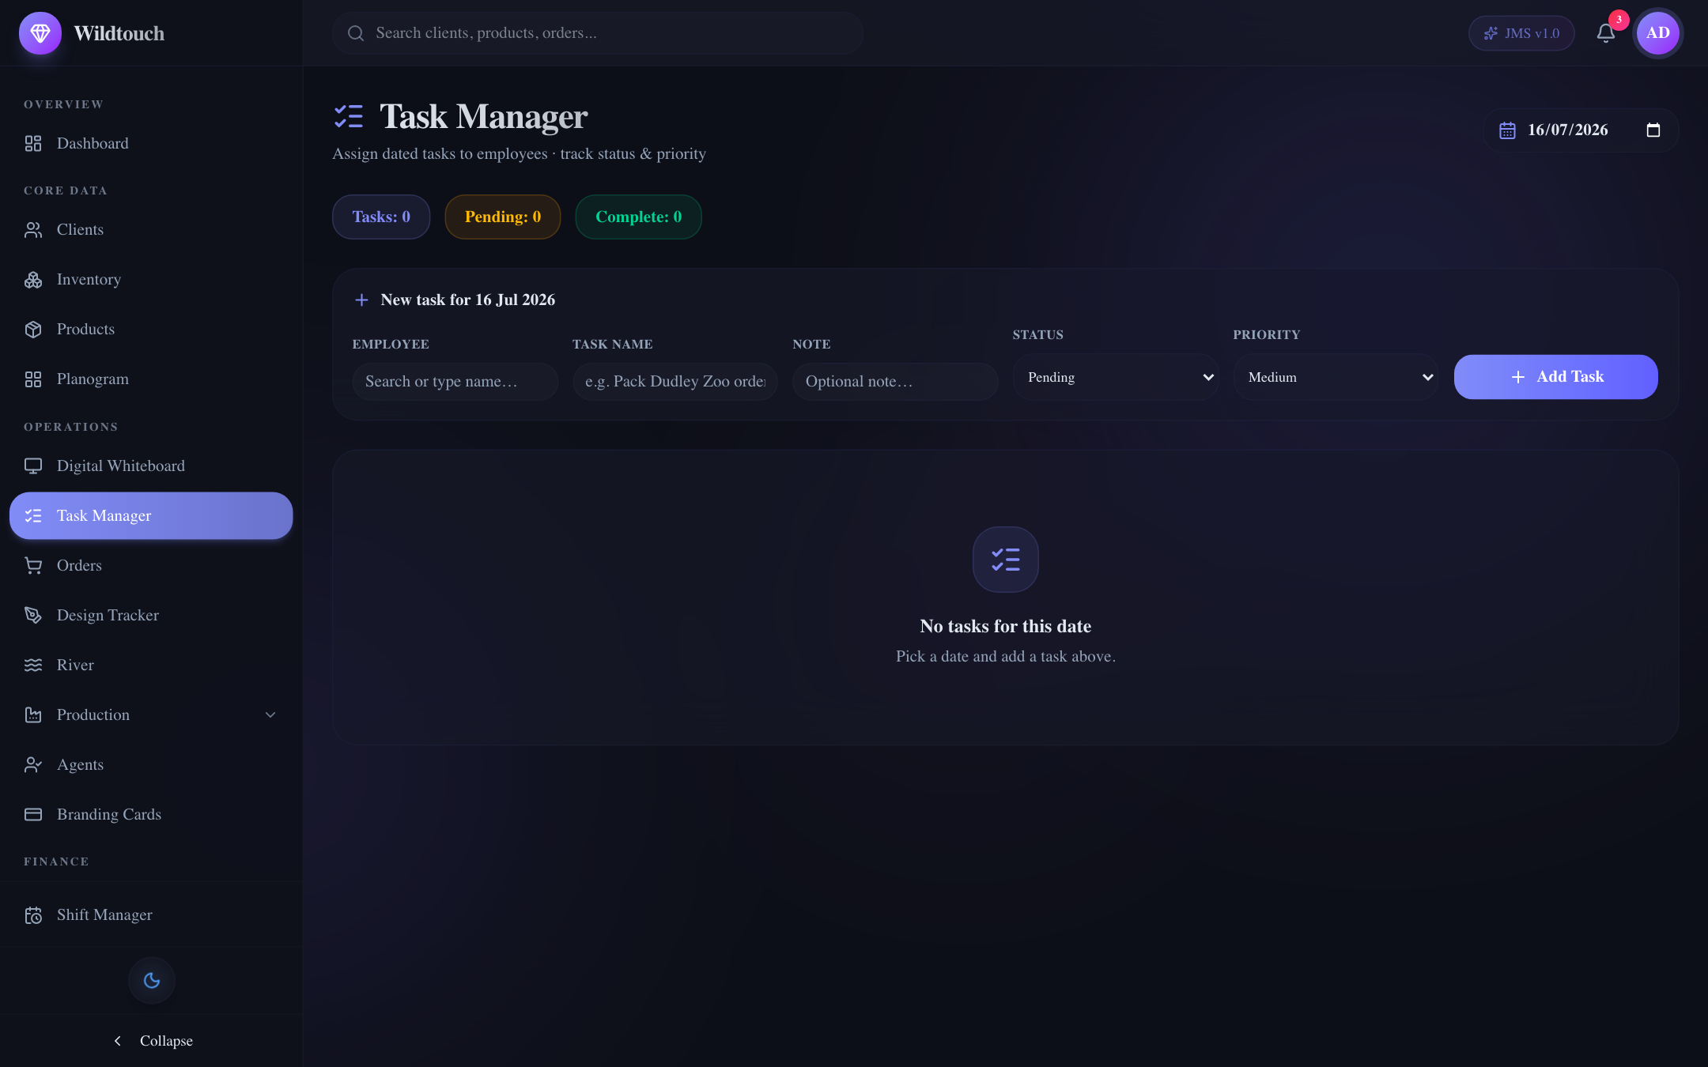
Tasks for a selected date, sorted by priority

10. Orders
The heart of the system. Orders are created through a wizard (planogram → stock check → client → review) and confirming one generates its invoice automatically, billed by product category at the client's prices. The list shows a date filter, per-row Packing List and Partial invoice buttons, and an Invoice Summary panel at the bottom (total invoiced, partial invoiced, outstanding — date-aware).
WHO CAN DO WHAT | ROLES
View orders, print order PDFs & packing lists | ADMIN · MANAGER · VIEWER
Create orders & partial invoices | ADMIN · MANAGER
Delete an order | ADMIN

TO CREATE AN ORDER
- Orders → Create New Order.
- Pick a planogram and set quantities — the stock step checks component availability.
- Choose the client (addresses pre-fill) — Review shows the invoice preview billed by category.
- Confirm Order — the order and its invoice are created together.
TO GENERATE A PACKING LIST
- Press Packing List on any order row (or inside the order).
- Choose With or Without Proof of Delivery — the slip opens on screen with a Download PDF button.
TO BILL IN INSTALMENTS (PARTIAL INVOICES)
- Press Partial on the order row (or New Partial Invoice inside the order).
- Enter the amount (quick 25% / 50% / Remaining buttons) — the remaining balance is tracked per order.
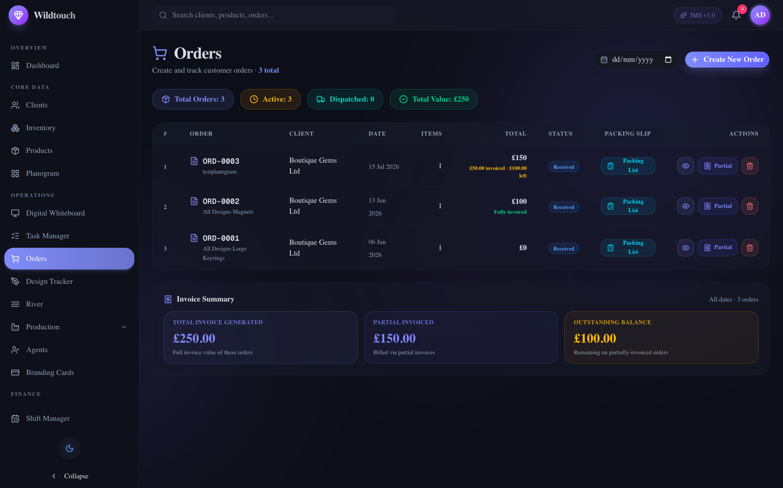
Orders list — packing list, partial invoicing, date filter
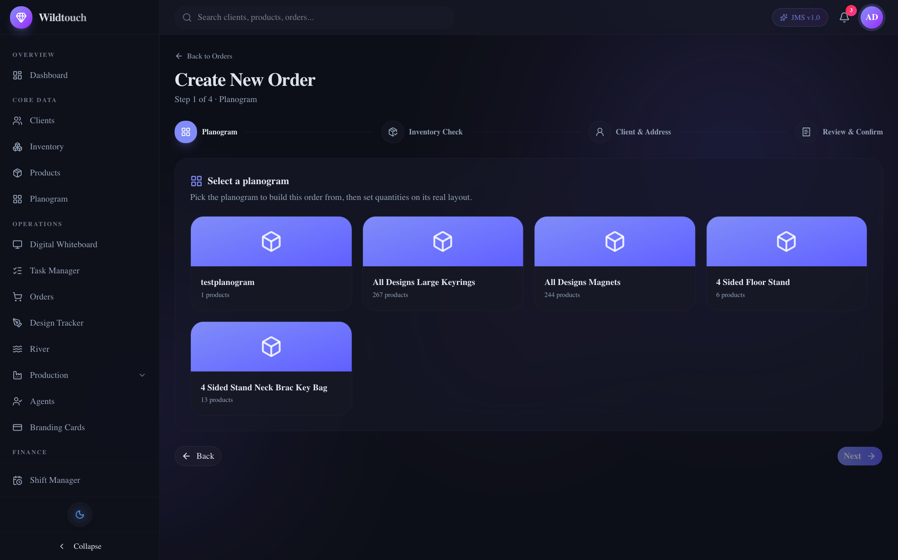
The order wizard
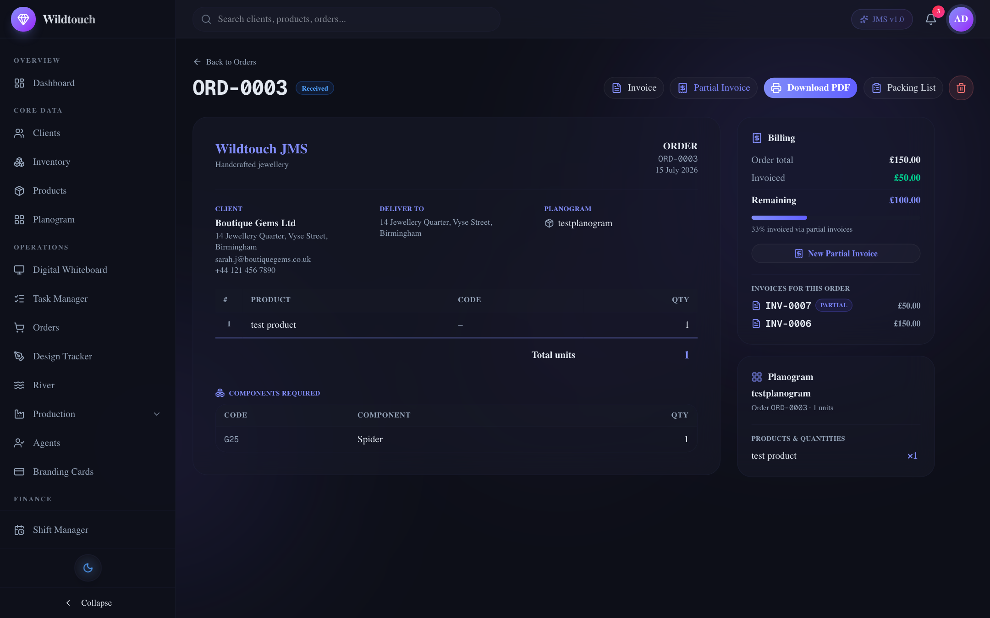
An order — billing panel, invoices, packing list
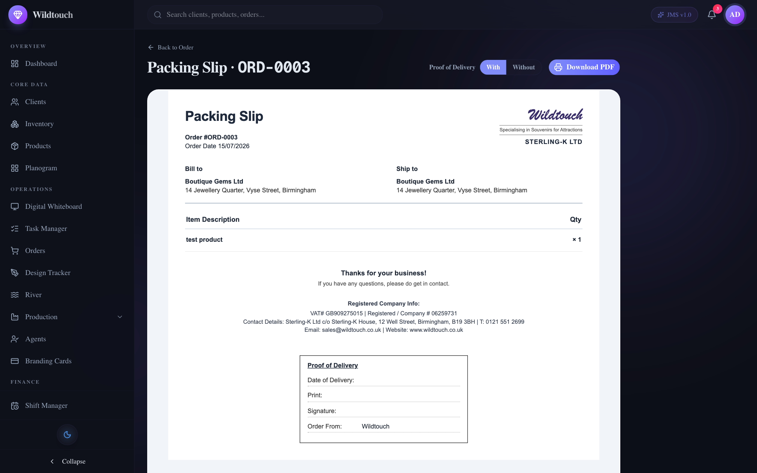
Packing slip (Proof of Delivery optional)

11. Design Tracker
The pipeline for new component designs. Each design moves through Stages: New Design Request → Research → Feedback → New Design Template. Reaching the final stage marks it finished and sends it to River as an orderable component. Moving a design backwards requires a note, and every stage change is recorded in the History column.
WHO CAN DO WHAT | ROLES
View designs | ADMIN · MANAGER · VIEWER
Add / edit designs & change stages | ADMIN · MANAGER
Delete a design | ADMIN

TO TRACK A DESIGN
- Add Design — the row opens like a spreadsheet: image, name, client, category, notes, code sheet, brochure and Ordered columns.
- Move the Stage dropdown forward as work progresses.
- Choosing “New Design Template → River” finishes it — River gets a New Design notification.
- Moving back a stage asks for a mandatory reason, saved to the row's History.
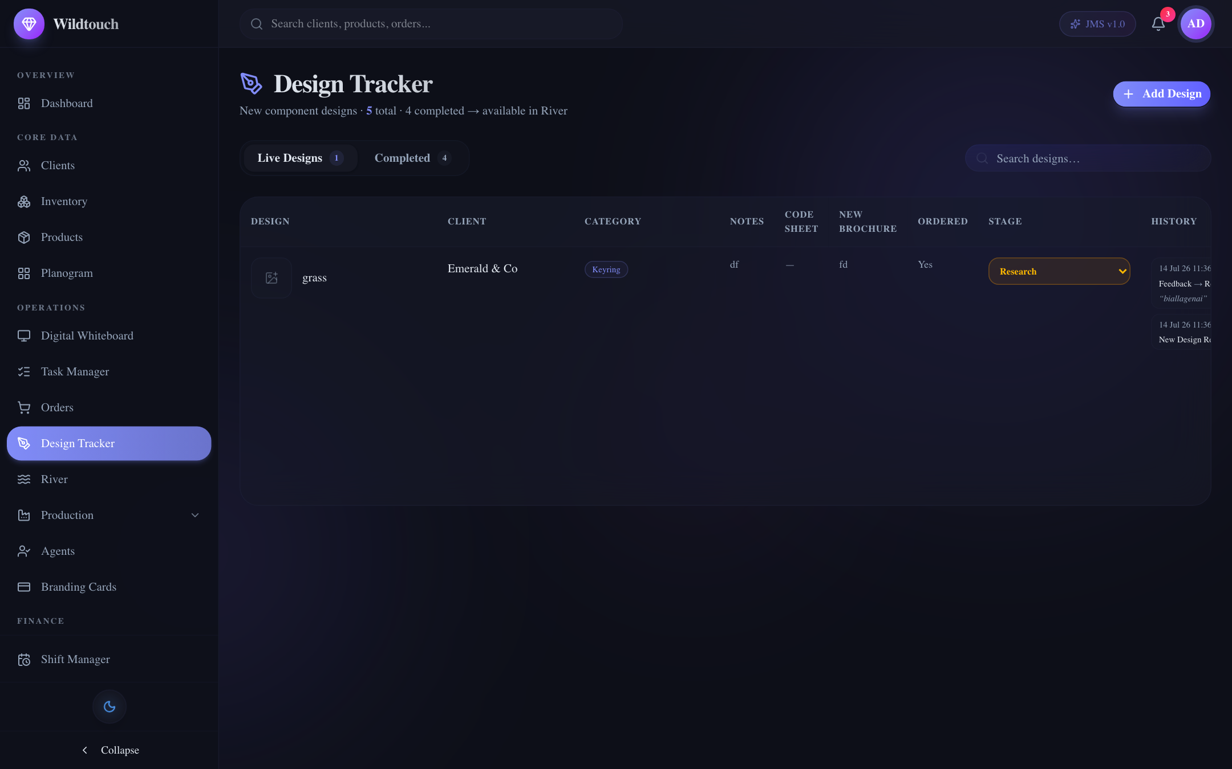
Live designs with Stage and History columns

12. River
Purchase orders to the vendor River, who makes new components. Rows edit inline like a spreadsheet: order number, component (searchable from completed designs), quantities, £/¥ values, priority, shipment method and a dated notes log. Receiving stock — fully or partially — adds it straight into Inventory.
WHO CAN DO WHAT | ROLES
View River orders | ADMIN · MANAGER · VIEWER
Add / edit orders, receive stock | ADMIN · MANAGER
Delete a River order | ADMIN

TO ORDER A NEW DESIGN
- The New Design button shows finished designs waiting to be ordered — press Order it to pre-fill a row.
- Fill quantity, values, priority and shipment, then Save.
TO RECEIVE STOCK
- Use Complete (everything) or Partial (a quantity) on the row.
- The received amount is added to Inventory automatically — first receipt creates the component, later ones top it up.
Tip: Notes default to today's date — just type and press Add; pick another date only when back-dating.
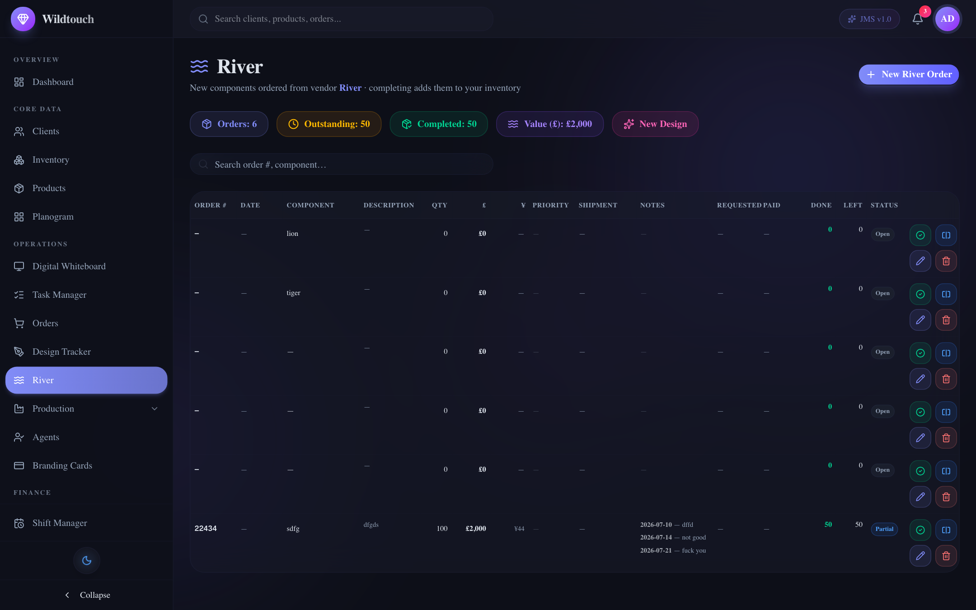
River orders with inline editing and the New Design notification

13. Agents
Sales agents with their contact details and referred points.
WHO CAN DO WHAT | ROLES
View agents | ADMIN · MANAGER · VIEWER
Add / edit agents | ADMIN · MANAGER
Delete an agent | ADMIN

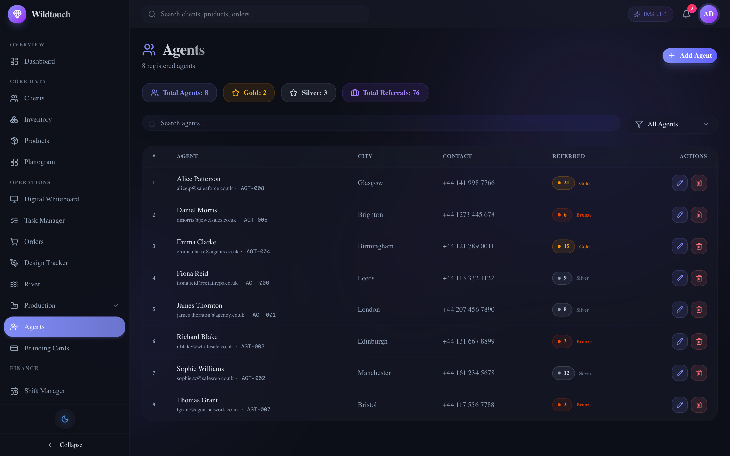
Agents list

14. Branding Cards
A searchable gallery of every client's uploaded brand card. Each card links back to its client; images are uploaded on the client profile.
WHO CAN DO WHAT | ROLES
Browse the gallery | ADMIN · MANAGER · VIEWER

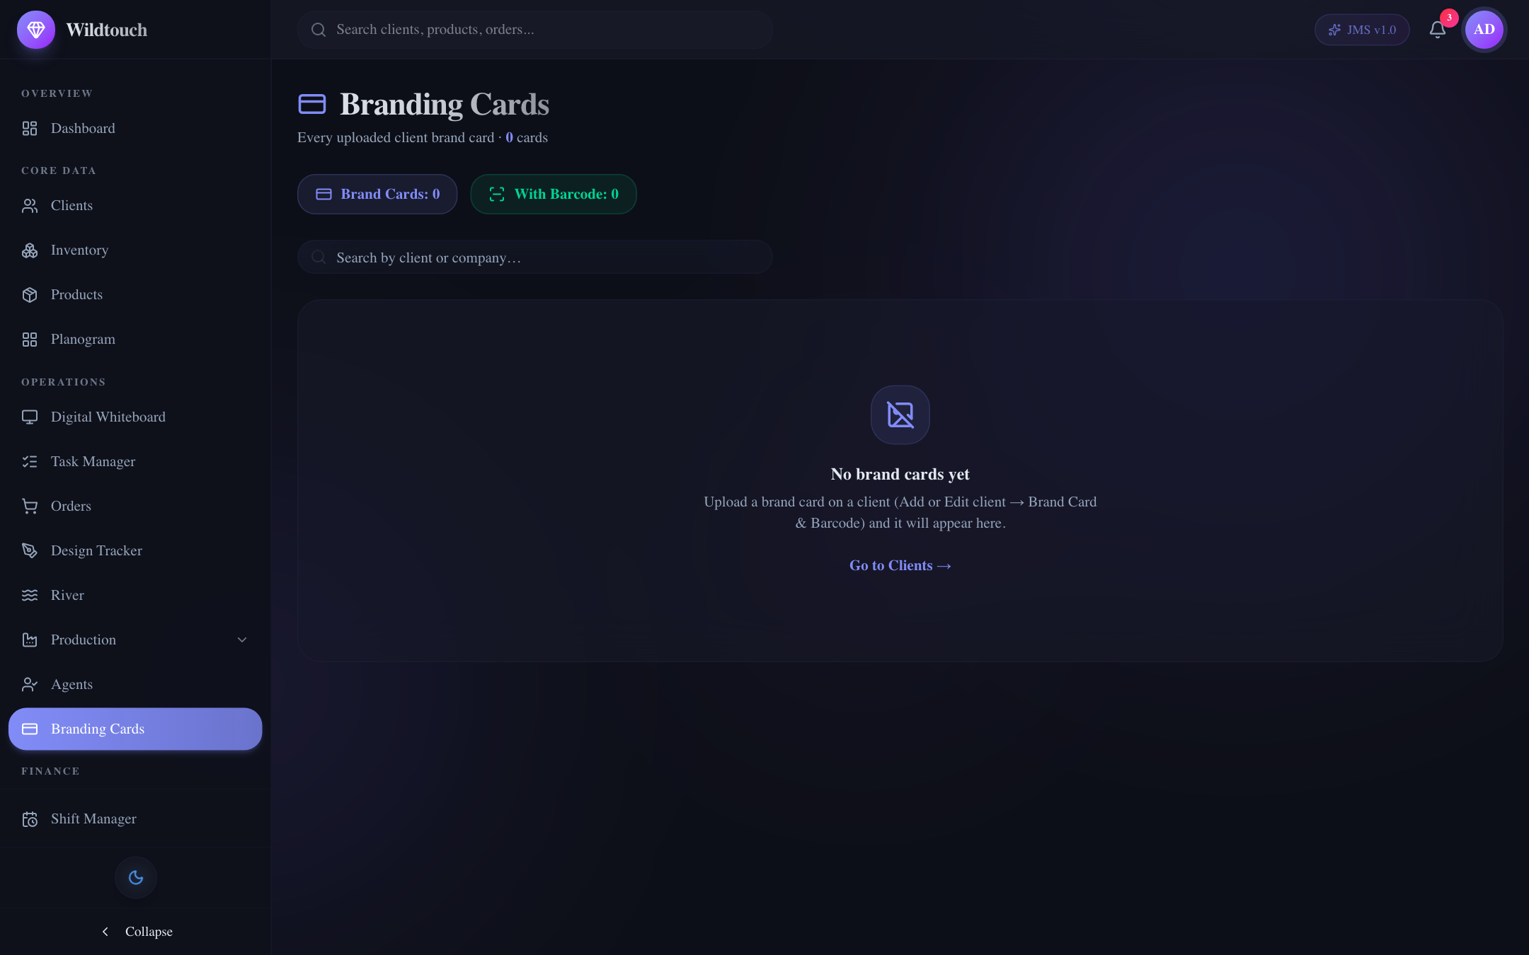
Brand card gallery

15. Invoicing
Every confirmed order produces an invoice in the official Wildtouch / Sterling-K layout — on screen and as an identical PDF. Line items are the product categories (not individual products), priced from the client's category prices, with the client's VAT applied. Partial invoices show the amount due now, what was previously invoiced, and the balance remaining.
WHO CAN DO WHAT | ROLES
View invoices & download PDFs | ADMIN · MANAGER · VIEWER
Generate invoices (by confirming orders) & partials | ADMIN · MANAGER
Delete an invoice (also deletes its order) | ADMIN

ON AN INVOICE PAGE YOU CAN
- Download PDF — the printed invoice, identical to the screen.
- Download the Planogram PDF from the side panel — products with photos and quantities, no pricing.
- See the planogram summary beside the invoice (screen only, never printed).
Tip: Deleting an invoice is admin-only and removes the linked order and all its sibling invoices — the confirmation dialog spells this out.
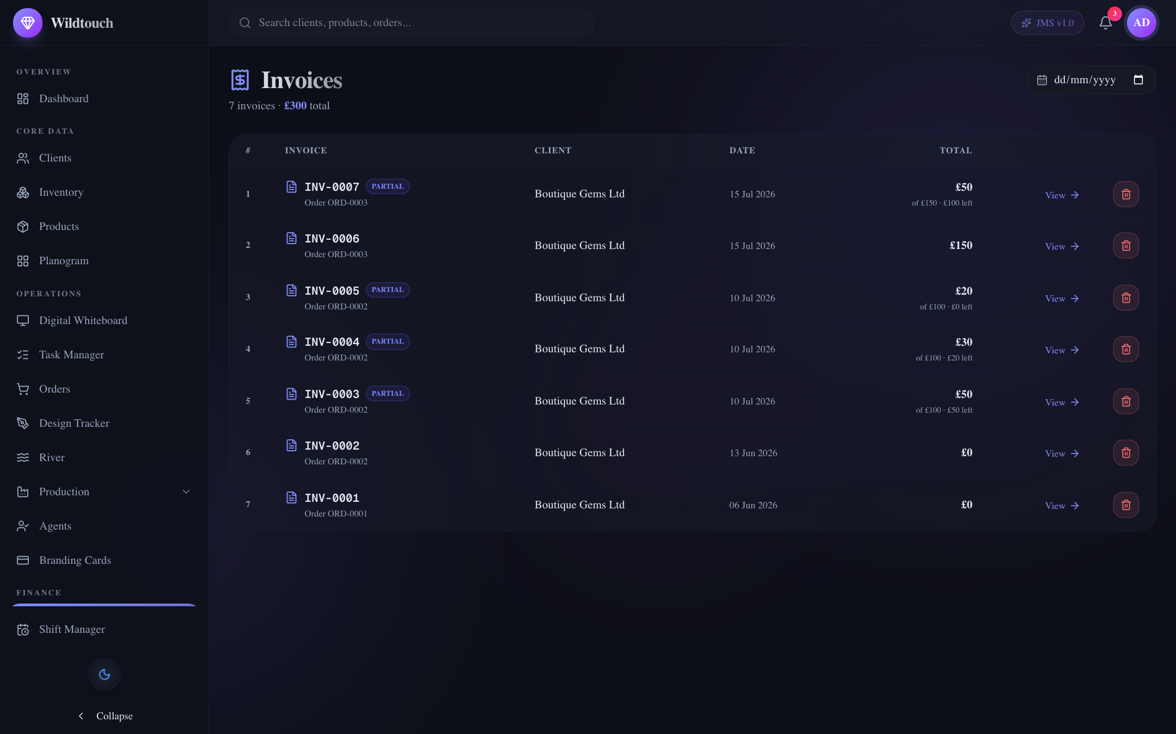
Invoices list with date filter
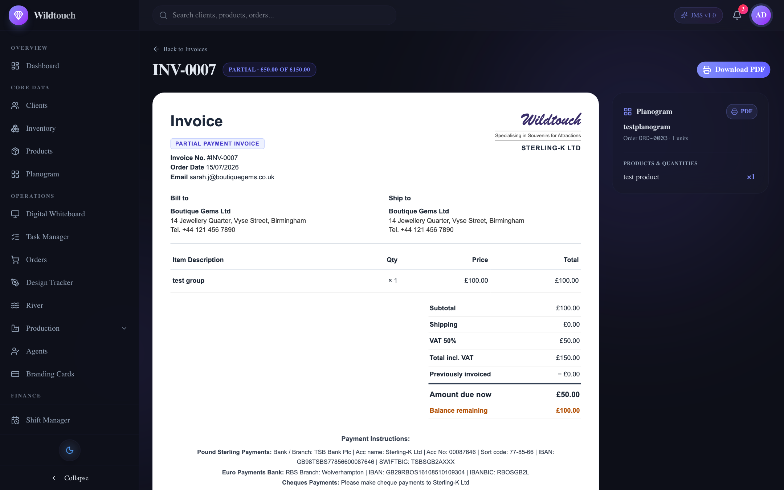
An invoice with the planogram side panel

16. History (Admin)
The audit trail. Every add, update, delete, receive and completion across the app is recorded with who did it, what changed and the exact time — grouped by date with search and a date picker. Only Admins can see this page.
WHO CAN DO WHAT | ROLES
View the activity history | ADMIN

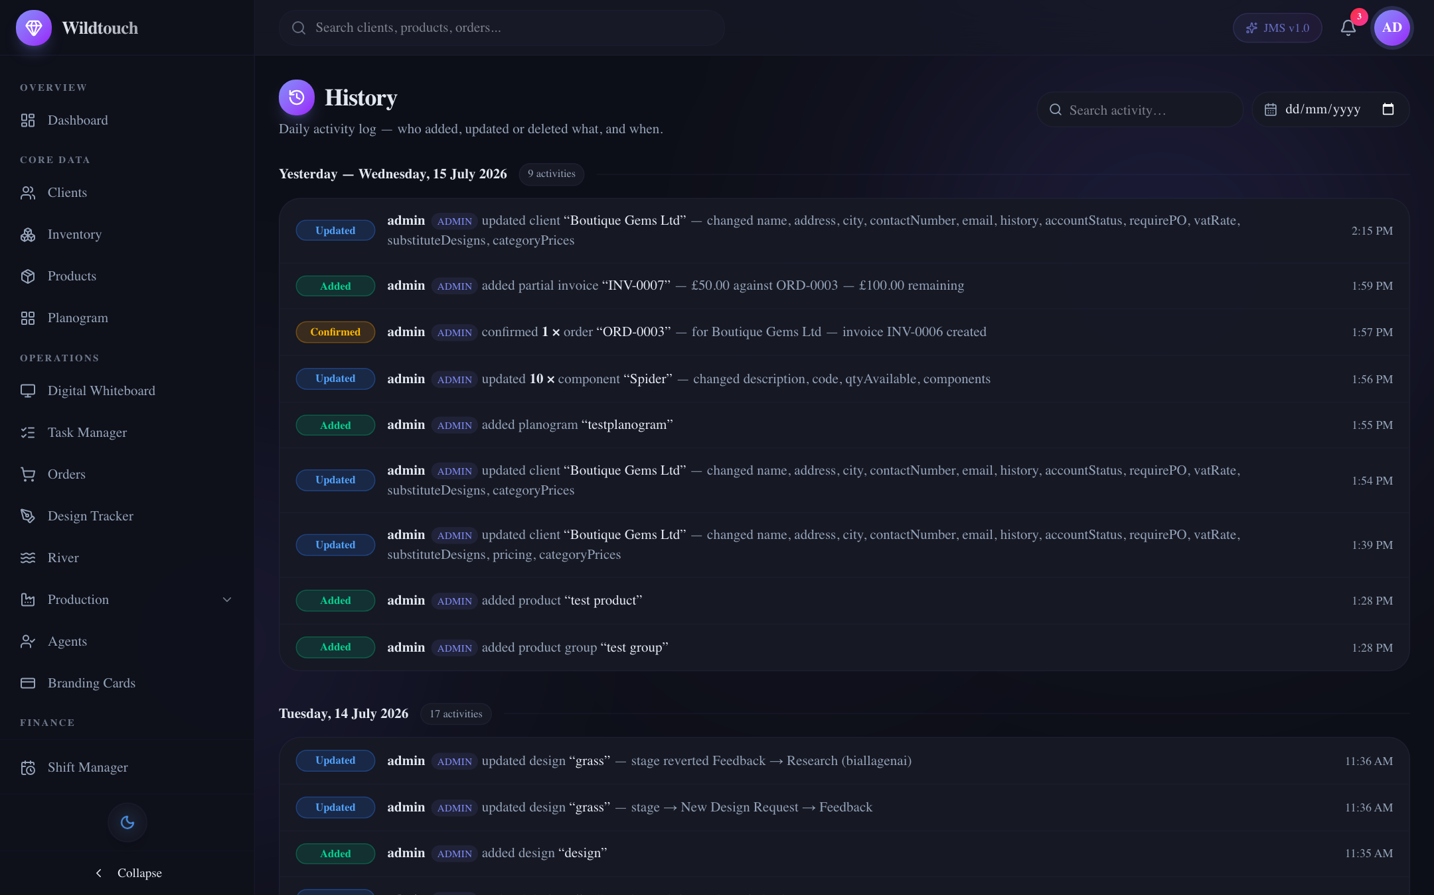
Daily activity feed (admin only)

17. Settings & User Management
Your account details, plus (for Admins) password change and user management. Admins create accounts with a username, email, password and role — Viewer, Manager or Admin — and can delete any account except their own.
WHO CAN DO WHAT | ROLES
View own account | ADMIN · MANAGER · VIEWER
Create / delete users, choose roles | ADMIN
Change password (code sent to the master email) | ADMIN

TO ADD A USER
- Settings → Users → fill username, email, password (minimum 8 characters).
- Pick the role: Viewer (read-only), Manager (day-to-day work) or Admin (everything).
- Press Create — share the credentials with the person privately.
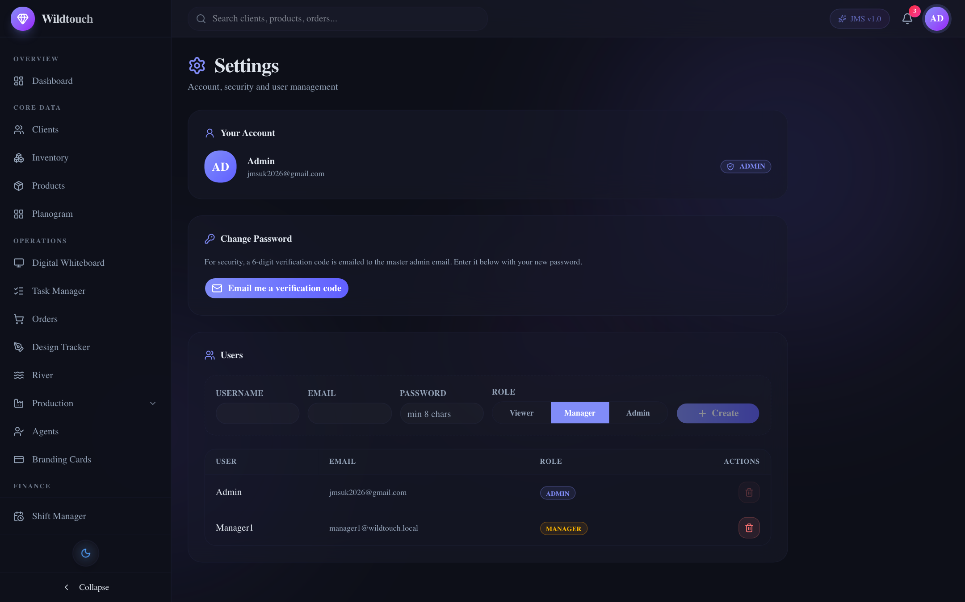
Settings — account, password and users

18. Shift Manager
The staff shift rota, pinned at the bottom of the sidebar. Employee names from here also feed the Task Manager's employee search.
WHO CAN DO WHAT | ROLES
View shifts | ADMIN · MANAGER · VIEWER
Manage shifts | ADMIN · MANAGER

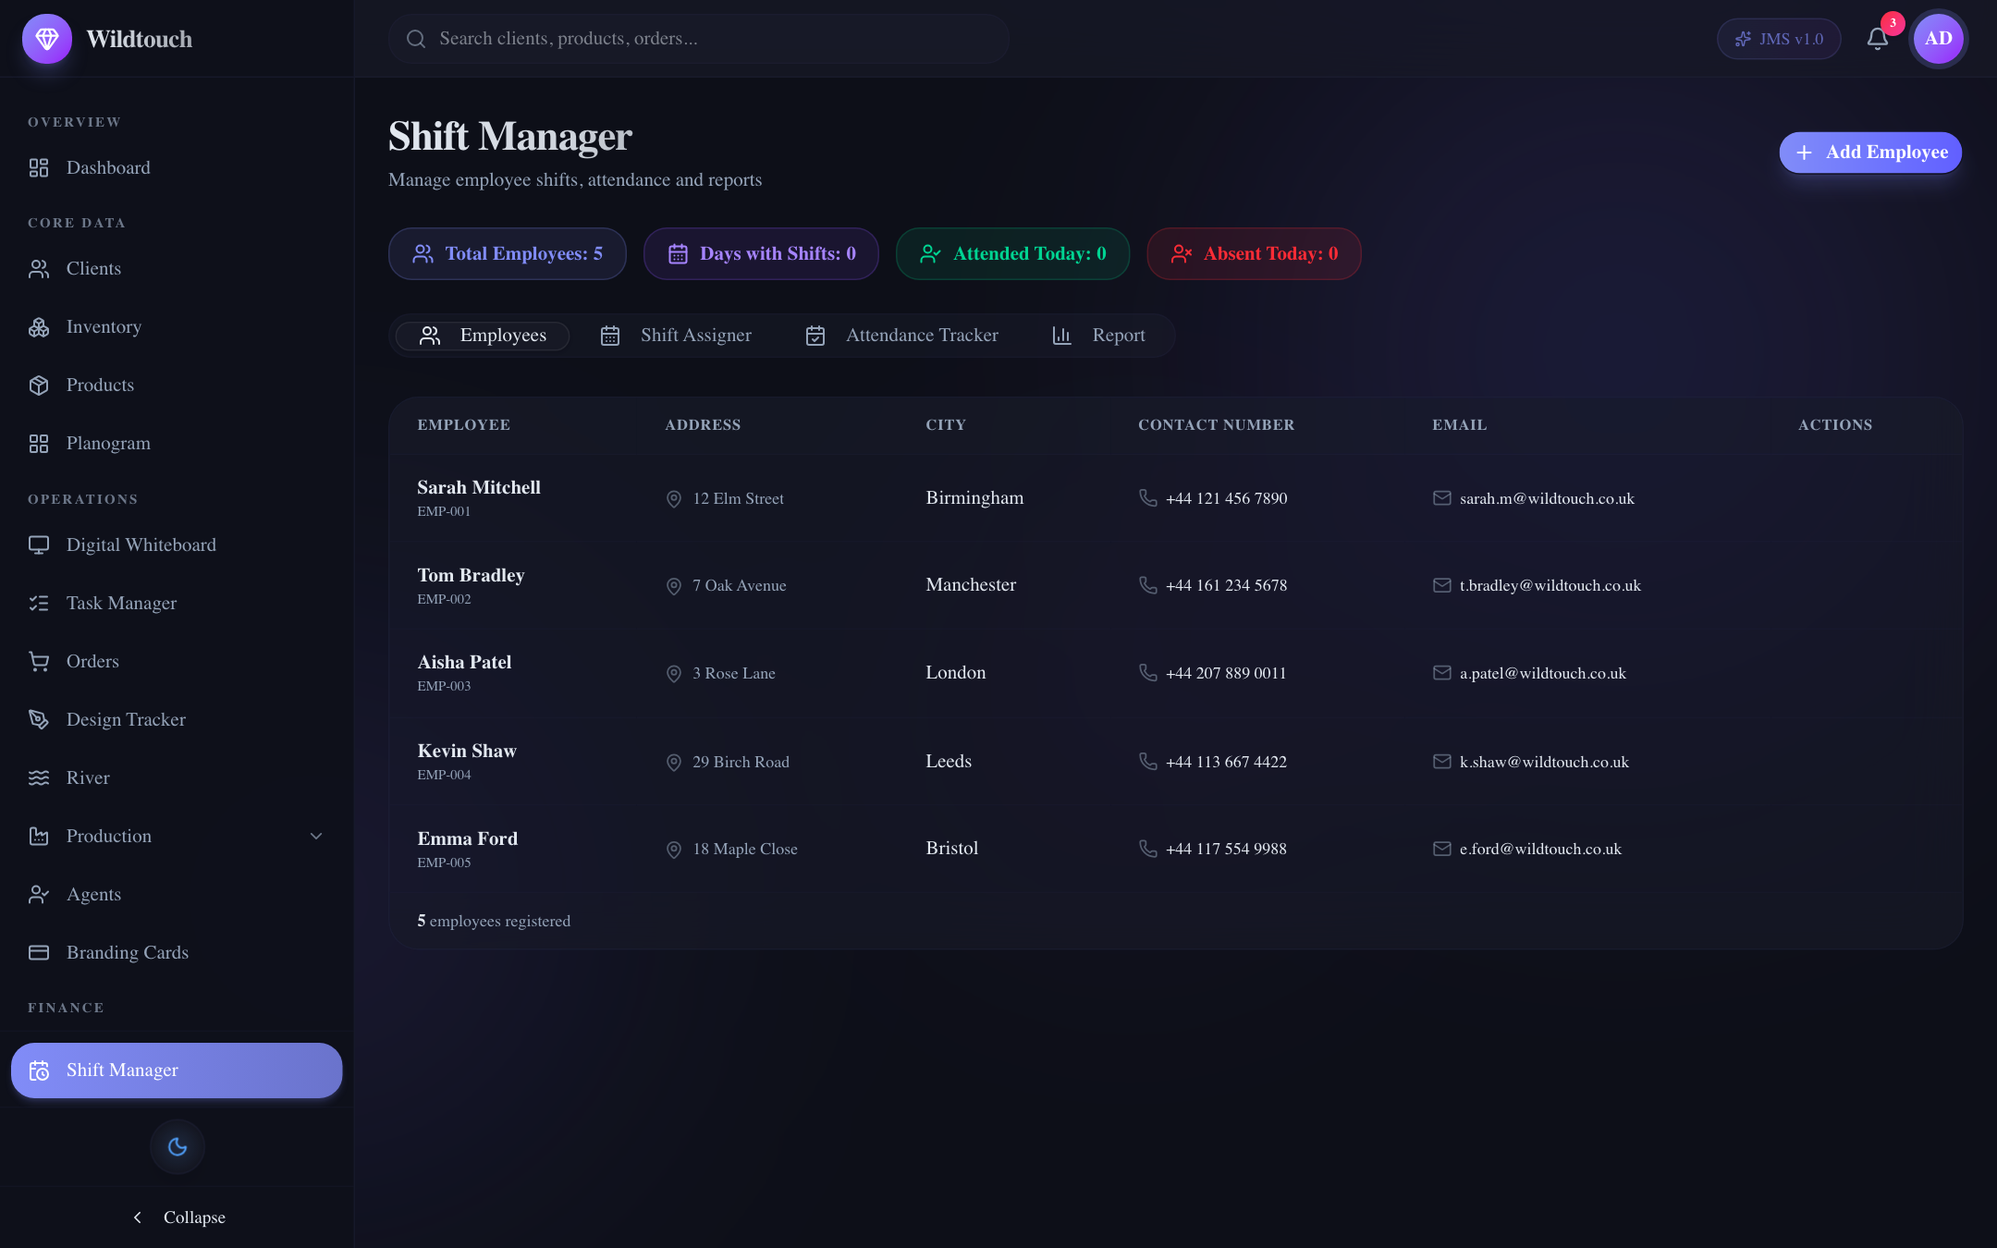
Shift Manager
Wildtouch JMS · User Manual · If something here doesn't match what you see, your role may not include that action — ask your Admin.

