**Bangladeshi local fruits detection and calorie calculator using CNN**

**BY**

**Md. Fahim Hasan**

**ID: 163-15-8322**

**Md. Ariful Islam**

**ID: 163-15-8406**

**Sadia Sultana Kumu**

**ID: 163-15-8516**

This Report Presented in Partial Fulfillment of the Requirements for the Degree of Bachelor of Science in Computer Science and Engineering

Supervised By

**Shah Md Tanvir Siddique**

#### Assistant Professor

#### Department of CSE

Daffodil International University



## DAFFODIL INTERNATIONAL UNIVERSITY

**DHAKA, BANGLADESH**

**DECEMBER 2020**

## APPROVAL

This Project/internship titled **“Bangladeshi Local Fruit Detection and Calorie Analysis”** submitted by Md Fahim Hasan, Md. Ariful Islam, Sadia Sultana Kumu, ID No: 163-15-8322, 163-15-8406, 163-15-8516 to the Department of Computer Science and Engineering, Daffodil International University has been accepted as satisfactory for the partial fulfillment of the requirements for the degree of B.Sc. in Computer Science and Engineering and approved as to its style and contents. The presentation has been held in November 2020.

**BOARD OF EXAMINERS**

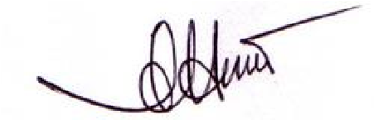

**Dr. Syed Akhter Hossain Chairman**

**Professor and Head**

Department of Computer Science and Engineering

Faculty of Science & Information Technology Daffodil International University

(Name) Internal Examiner

Designation

Department of CSE

Faculty of Science &amp; Information Technology

Daffodil International University

(Name) External Examiner

Designation

Department of -------

Jahangirnagar University

## DECLARATION

We now declare that we have done this project under **Shah Md Tanvir Siddique,** Daffodil International University. We also declare that neither this project nor any part of this project has been submitted elsewhere to award any degree or diploma.

**Supervised by:**

**Shah Md Tanvir Siddique**

Lecturer (Senior Scale)

Department of CSE

Daffodil International University

**Submitted by:**

**Md. Fahim Hasan**

ID: 163-15-8322

Department of CSE

Daffodil International University



**Md. Ariful Islam**

ID: 163-15-8406

Department of CSE

Daffodil International University



**Sadia Sultana Kumu**

ID: 163-15-8516

Department of CSE

Daffodil International University

# ACKNOWLEDGEMENT

First, we express our heartiest thanks and gratefulness to Almighty God for His divine blessing that makes us possible to complete the final year project/internship successfully.

We grateful and wish our profound indebtedness to **Shah Md Tanvir Siddique,** Department of CSE Daffodil International University, Dhaka. In-depth Knowledge & keen interest of our supervisor in machine learning, natural language processing, and data mining to carry out this project. His endless patience, scholarly guidance, continual encouragement, constant and energetic supervision, constructive criticism, valuable advice, reading many inferior drafts, and correcting them at all stages have made it possible to complete this project.

We would like to express our heartiest gratitude to Dr. Syed Akhter Hossain, Head**,** Department of CSE, for his kind help to finish our project and other faculty members and the CSE department staff Daffodil International University.

We would like to thank our entire coursemate at Daffodil International University, who took part in this discussion while completing the course work.

Finally, we must acknowledge with due respect the constant support and patients of our parents.

## ABSTRACT

Bangladesh has many varieties of local fruits. Now some of them are moribund. The purpose of our paper is to introduce those local and moribund fruits to the next generation. Though all Bangladeshi fruit names and their identities are already in the survey, we do not carry those surveys all the time with us, and most ordinary people do not know about them. So an automatic fruit identifier can solve this problem and help many people know about fruits immediately. A method of deep convolutional neural networks (CNN) is used to classify fruits from fruit images. We achieved an accuracy score of about 96.93%. This method is very appropriate to detect fruits in real-time.

**TABLE OF CONTENTS**

|  |  |
| --- | --- |
| **CONTENTS** | **PAGE** |
| Board of examiners | i |
| Declaration | ii |
| Acknowledgments | iii |
| Abstract | iv |
| **CHAPTER** |  |
| **CHAPTER 1: INTRODUCTION** | **1-4** |
| 1.1 Introduction | 1 |
| 1.2 Motivation | 1-2 |
| 1.3 Rational of the study | 2 |
| 1.4 Research Question | 2 |
| 1.5 Expected Outcome | 3 |
| 1.6 Report Layout | 4 |
| **CHAPTER 2: BACKGROUND** | **5-16** |
| 2.1 Related Work | 5 |
| 2.2 Comparative Analysis and Summery | 8 |
| 2.3 Scope of the Problem | 9 |
| 2.4 Challenges | 10 |
| **CHAPTER 3: RESEARCH METHODOLOGY** | **17-22** |

3.1 Research Subject and Instrumentation 17

3.2 Dataset Utilized 17

3.3 Statistical Analysis 18

3.4 Proposed Methodology 19

3.5 Implementation Requirements 20

**Chapter 4: Experimental Results and Discussion 23-27**

4.1 Experimental Setup 23

4.2 Experimental Results & Analysis 25

**Chapter 5: Summary, Conclusion, Recommendation and 28**

**Implication for Future Research**

5.1 Summary of the Study 28

5.2 Conclusions 28

5.3 Implication for Further Study 28

**References 29-31 LIST OF FIGURE**

## CHAPTER 1

## Introduction

* 1. **Introduction**

Local things contain the culture of a nation. Local fruits are also part of them. Those contain vitamins and carbohydrates like fiber and sugar and have lots of local history behind them. Those are also available at a low price. When we purchase fruits, we ignore these fruits because they are local, and we think they contain fewer vitamins. However, some local fruits are natural medicine for some chronic diseases. Fruit detection can be used in the food industry and the education system and can also use by foreigners to introduce them to our local fruit. Many researchers recognize fruits using various methods, but most of them for collection from the farm using AI in harvesting time [3] [4].

However, those are not focused on only fruit detection and not for ordinary people. Gathering information about a local or moribund fruit from a local library or survey is difficult for foreigners. There are around 2000 types of various fruits globally, and people know very few of them. Nowadays, people rely on small smart device systems because they can easily carry and work like a mini-computer. Fruit recognition from images using smartphones can help both who are working as a nutritionist and ordinary people. Detection using images is more accurate, faster, and error-free. The purpose of this paper is to propose our dataset of images containing local and moribund fruits. The dataset has 4200 images of 6 fruits, and we have used Guava, Ceylon olive, Carambola, and Water Caltrop, Amla, and Spondias mombin for our paper. We did not use any downloaded dataset to train our model. To get the desired accuracy, we have made our dataset, which contains many images. Our purpose is to introduce Bangladeshi local and moribund fruits to the next generation and worldwide.

**1.2 Motivation**

Nowadays, so many technologies can be developed using images. Image classification is one of the most important sectors of ML. Several works have been done with image detection. Some AI assistants like Yu-Dong Zhang [9], Lei Hou [10], Etc., have been developed, but these are not applicable for detecting different moribund Bangladeshi types fruits from images. With Bengali moribund fruits, there are only a few words, and the accuracy of those systems is very poor.

In Bangladesh, we have many types of moribund fruits that contain more vitamins than commonly known fruits. If we can introduce them to the world, then we can export those fruits as well. Moribund fruits are naturally known to rural people, but it is important to introduce them to the next generation.

So, considering this situation, we decided to construct a system that can detect the moribund fruits from images. The objective of this research is to build an effective system with a well-off dataset that can help people to know about Bangladeshi moribund fruits and calories.

**1.3 Rationale of the Study**

Many types of research have been published on image classification of fruit, but most of them are using common fruits worldwide. These methods or mechanisms are being used in several automatic systems. Very few researchers work on Bangladeshi moribund fruit detection, and most of them have low accuracy. Local fruits from different angles give different accuracy. There is a significant lack of Bengali local fruit detection systems in ML using fruit image detection.

Image detection based applications are playing a significant role in the recent period. The applications may be helpful in various ways, such as fruit harvesting, system development for the food industry, Etc. To maximize the uses of image detection based applications using Bengali fruits for the welfare of the next generation people, we get interested in working with this.

**1.4 Research Questions**

* When people express the same language in various accents, do the vocal folds emit various wavelengths?
* How can we collect the data of different dialects?
* Which methods can be applied for the feature extractions?
* Which algorithm should be used for classification to find the best result?
* Can this study be useful for the rural inhabitants of Bangladesh?

**1.5 Expected Outcome**

This research-based project's future result is to develop an application for the general population of the world to know about moribund Bangladeshi fruits and their calories. This type of application may help in many ways. Such as:

* This application may help in collecting moribund fruits with high calories.
* Sometimes, moribund fruits are good for controlling many diseases, so this application can help people.
* This research can be beneficial for the next generation of people to know about moribund Bangladeshi fruits.

**1.6 Report Layout**

In **chapter 1**, this report discusses what we are going to do, why we are going to do it, and how we will do it. Overall, the motivation behind this work with the expected outcome is described briefly in this chapter.

In **chapter 2,** the related work of this sector has been described. And summarizing their work findings from their works also noted in this section. By finding their limitation, we set our goals by explaining the challenges.

In **chapter 3,** this report discusses the methodology that has been used in this work. Some theoretical topics are also discussed in this chapter, which is related to this work. The process of data collection, data pre-processing, feature extraction, methodologies used in this work are briefly discussed in this chapter.

In **chapter 4,** the result came from the previous chapter have been presented, and the comparison and best process also showed in this chapter.

In **chapter 5,** the summary of the project is the main focus. Future work, conclusion, limitation, and recommendation are also noted in this last chapter of the report.

## CHAPTER 2

## Background

This chapter will describe related works with our project. Many types of research have been completed about image classification from fruits. We already know that various fruit has a various shape. Depending on those image datasets, many types of research have been done. We will describe the summary of this research in this chapter. Additionally, the project model, strengths, weaknesses of those researchers will be discussed as well.

**2.1 Related Works**

We have seen techniques to detect images using traditional Neural Networks and Convolutional Neural Networks widely used for a long time in several works. Many fruit recognition systems have successfully developed for fruit detection using those techniques. Horea Mureşan, Mihai Oltean, proposes recognizing fruits using deep learning from images [1].

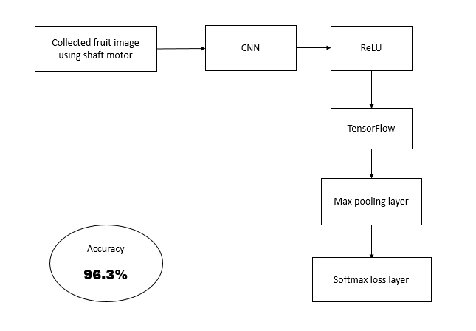

Fig: Their proposed model

For identifying fruits from images, they used deep neural networks. Companies are also using this for working in the augmented reality field. They create an autonomous robot for doing more complex industrial work. It also can be used for categorizing fruits. In this paper, they used TensorFlow also. We have planted fruits in a low-speed motor shaft to take a short movie of 20 seconds behind the fruits.

For detecting fruit [2], Nashat M. Hussain Hassan and Ahmed A. Nashat proposed a technique with three algorithms. Those are Texture Homogeneity Measuring Technique (THMT), Special Image Convolution Algorithm (SICA), and Fuzzy C-Means (FCM) algorithm. Those are applicable in automatic harvesting robots. This paper is about to detect the external olive defect,

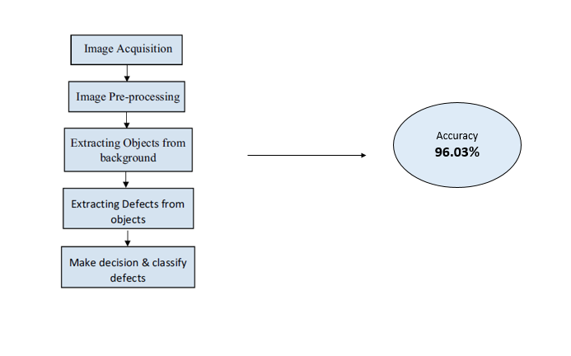

Fig: Their proposed model

which can help the oils and pickles industry. Used techniques follow five stages for detecting fruit from images: sample collection and image acquisition, image Pre-processing, Image segmentation, classifying defects, and decision-making and classification defects, and decision and make decisions and classify defects. Fruit detection in natural environments, which is usable in automatic robots in harvesting time, estimation of yield systems, and quality monitoring systems, are proposed by Guichao Lin, Yunchao Tang, Xiangjun Zou, Jiabing Cheng, and Juntao Xiong [3].

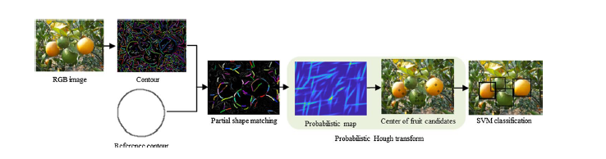

Fig: Their proposed model

Techniques based on color are susceptible to change the illumination and low contrasts between leaves and fruits, and the proposed technique was base on the contour information. In the very Firstly, a discriminative shape descriptor is derived to represent the arbitrary fragment's geometrical properties and is also applied to the bidirectional partial shape matching to detect subfragments of interest that match parts of a reference contour. Then, a probabilistic Hough transforms developed to aggregate these sub-fragments for obtaining fruit candidates. Finally, fruits verify by a support vector machine classifier trained on color and texture features. Citrus, tomato, pumpkin, bitter gourd also towel gourd and provided mango datasets. Experiments on these datasets demonstrate that the proposed approach was competitive for detecting most types of fruits, such as green, orange, circular, and non-circular, in natural environments.

To improve fruit detection for harvesting, orange used the thermal temporal variation in the citrus canopy as a potential approach proposed by D.M. Bulanon, T.F. Burks, V. Alchanatis [5].

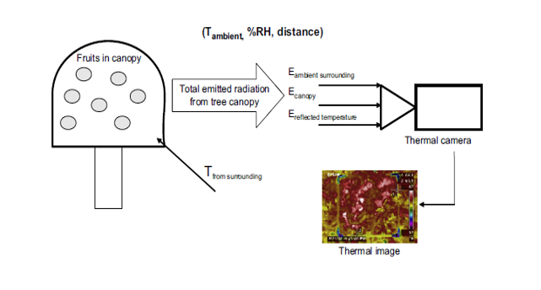

Fig: Their proposed model

Using a thermal infrared camera, and tree canopy were monitored on 24 h cycles. Four different trees were observed on four separate days. The fruit's surface temperature, ambient temperature, and relative humidity (RH) were measured using a portable Dew Point Meter. The acquired thermal images for fruit emissivity were corrected by them, estimated to be 0.90, the ambient temperature also the RH, and the reflected temperature. Fruit and canopy temperature profile is demonstrated a relatively large temperature gradient, which occurred from the afternoon (16:00) until midnight. The fruits were very successfully segmented in the thermal images using image processing techniques during the time range of the largest temperature difference and suggest the potential application of thermal imaging for improved detection for harvesting.

Paper [4] proposed by Hasan Basri, Iwan Syarif, Sritrustra Sukaridhoto, a Deep learning method using faster R-CNN to detect multi-fruits classification. The input used mango and pitaya fruits.

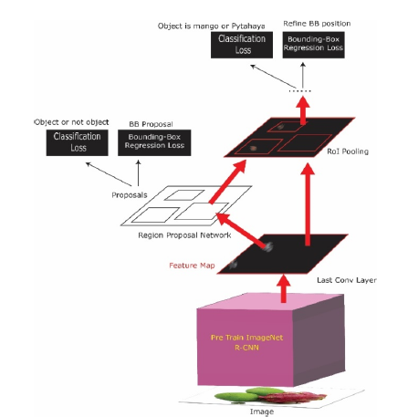

Fig: Their proposed model

The dataset is real data taken from a farmer at harvest time and then into two classes; the classification is mango and pitaya for training object detection. They used the MobileNet model on the TensorFlow platform.

For improving the fruit detection for harvesting the orange, the thermal temporal variation in the citrus canopy is used, as a potential approach proposed by D.M. Bulanon, T.F. Burks, V. Alchanatis [5]. Using a thermal infrared camera, and tree canopy monitored on 24 h cycles. Four different trees were observed on four separate days. The fruit's surface temperature, ambient temperature, and relative humidity (RH) were measured using a portable Dew Point Meter. The acquired thermal images for fruit emissivity were corrected by them, estimated to be 0.90, the ambient temperature also the RH, and the reflected temperature. Fruit and canopy temperature profiles demonstrate a relatively large temperature gradient, which occurred from the afternoon (16:00) until midnight. Also, the fruits were successfully segmented in the thermal images using image processing techniques during the time range of the enormous temperature difference and which suggests the potential application of thermal imaging for improved detection for harvesting.

Paper [6] proposed by A. Gongal, S. Amatya, M. Karkee, Q. Zhang, K. Lewis is about Variable lighting condition, occlusions, and clustering are some of the essential issues needed to be addressed for accurate detection and also localization of fruit in orchard environment. Various techniques have been investigating to fix this issue using different types of sensors, and also their combinations are as well as with different image processing techniques.

In this paper[7], the method proposed by Dahua Li, Mingming Shen, Dong Li, and Xiao Yu, which combines texture features, shape features, and color features to solve segmenting the target and background of apple picking robot in complex background.The gray-scale difference statistical method is utilized to get the texture feature vector of the image. According to the texture feature vector, the support vector machine (SVM) was used to segment the image preliminary, and then the shape and color features are combined to achieve precise segmentation.

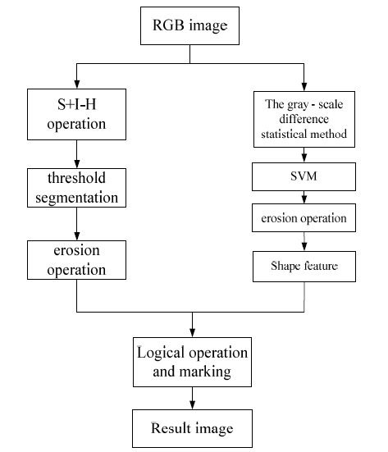

Fig: Their proposed model

Using deep CNN, a novel approach [8] has proposed by Inkyu Sa, Zongyuan Ge, Feras Dayoub, Ben Upcroft, Tristan Perez, and Chris McCoolto fruit detection. Building a fast, reliable, and accurate fruit detection system is vital for an autonomous agricultural robotic platform. They adopt this model, through transfer learning, for the task of fruit detection using imagery obtained from two modalities: color (RGB) and Near-Infrared (NIR). For combining the multi-modal (RGB and NIR), information early and late fusion methods are explored.

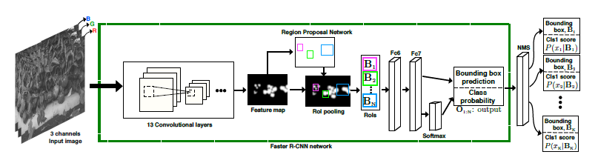

Fig: Their proposed model

Yu-Dong Zhang, Zhengchao Dong & Xianqing Chen & Wenjuan Jia & Sidan Du & Khan Muhammad & ShuiHua Wang proposed a technique [9] that contains 13-layers of CNN and data augmentation. They validated 13-layer its optimal structure.

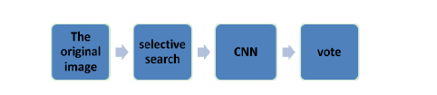Lei Hou, QingXiang Wu*, Qiyan Sun, Heng Yang, and Pengfei Li proposed fruit recognition based on the convolution neural network(CNN)[10]. Using a selective search algorithm of image regions are extracted, then the regions have been selected using the entropy of fruit images, and finally, these regions are regarded as the input of the CNN neural network for training and recognition. The final decision is made based on a fusion of all-region classifications using the voting mechanism.

Fig: Their proposed model

In our paper, an effective way of tackling the identification of fruits from images by CNN and Adam Optimizer is presented. We are using CNN with Adam optimizer and automatic learning rate reduction technique. The presented model gave promising results on classification and identifying fruits.

|  |  |  |  |
| --- | --- | --- | --- |
| **Work** | **Model** | **Accuracy** | **Dataset** |
| Horea MURES_AN, Mihai OLTEAN | CNN | 96.3%. | Fruit |
| Nashat M. Hussain Hassan1 · Ahmed A. Nashat1 | T.H.M.T | 98% | Olive |
| Lei Hou, QingXiang Wu | CNN | 99.77% | Fruit |
| Hasan Basri, Iwan Syarif, Sritrustra Sukaridhoto | R-CNN | 99% | Mangoes and pitaya fruits |
| D.M. Bulanona,*, T.F. Burksa, V. Alchanatisb | Thermal temporal variation | 95% | Orange |
| Inkyu Sa *, Zongyuan Ge, Feras Dayoub, Ben Upcroft, Tristan Perez and Chris McCool | Faster Region-based CNN | 83% | Fruit |
| Proposed Model | CNN+Adam | 96.93% | Moribund fruits of Bangladesh |

**2.2** **Comparative Analysis and Summary**

A lot of research work has been done about image classification. Many researchers have done it in many ways. In most of the cases, CNN was used for feature extraction. And then, many researchers have given many shapes to the data. Some of them collect data from the noise-free environment, and some of the researchers collected data from a normal environment, and then they have given a new shape to those data. Moribund fruits are seasonal, so that researchers are faced

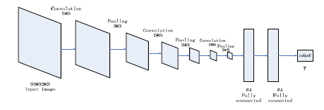

Fig: Structure of CNN

with many problems while they are collecting data. At the same time, it is also clear that collecting data is not that much easy. Because there are hugely lacking data resources. At last, we did not find any dataset which contains only Bangladeshi moribund fruit images. Figure 2.1 is showing the summarized general process of all researchers.

Collecting Image

Data set pre-processing

Optimizing Model

Preparation of train, test, and validation sets

Performance Calculation

Calorie Calculation

Final Result

Figure 2.1: In general process

**2.3 Scope of the Problem**

Fruit detection may help in many ways. In some cases, it may help to identify local fruits. If we got any local fruit, then through this image classification system, we could detect the fruit's name and details. In some cases, this can be the one best system to store the history of moribund fruits. On the other side, this system can help tourists know about the moribund fruits of a country. This will help next-generation people; they will know the history of moribund fruits through this system.

**2.4 Challenges**

1. **Data Collection:** The most common challenge is collecting the data. Because there are no datasets for moribund Bangladeshi fruits. At the same time, the source of collecting the data for different local fruits is not easy enough. For collecting the data, we had to go to many different places and bazaars. Because it is not possible to collect all the different fruit at the same time in the same place. Additionally, we needed some unique data like Water Caltrop fruit for this project, which is rare, and this was also a big challenge.
2. **Collect the exact fruit:** As we mentioned before, for this project, we had to need a special kind of data, and this was also the main challenge. Other hand, we needed to collect noise-free data.
3. **Making fruit image Compatible with the system:** We have made our dataset. So, we had to face many problems to shape the data properly, and then we have faced problems to compatible the data with the system. However, the good thing is, we researched a lot for this, and then we learned a lot.
4. **Model Selection:** Though much research has been done about image classification, it is still challenging research for Bangladeshi moribund fruit. Because most of the research has been done on common fruits, which is why many models have already been introduced, it was a difficult task to select the proper model for Bangladeshi moribund fruit.

Which will provide the best rate of accuracy.

1. **Proposed Workflow:** As we had to find out the best workflow for this project, we had to experiment with many processes. The workflow of this project is given below:

Input Image

Convolution

Pooling

Fully connected

SpftMax

-

Output Classification

Figure 2.7: Workflow of the project

## CHAPTER 3

## Research Methodology

**3.1 Research Subject and Instrumentation**

At this point, we will discuss the instruments and techniques we used for collecting our research data. Data is the essential element of any research, and when it is about image processing using machine learning, it requires a massive amount of data. We collected a total of 3600 images of different fruits. It was tough to collect all the data.

1. **Data Acquisition :**

We have collected our dataset via smartphone, which was from real fruit. Our dataset contains 3600 images with 600 images for each fruit type. The pre-processing technique was used in four steps. We cropped and resized images to a 100 x 100 matrix. Using the split and merge algorithm, we removed the background.

1. **Dataset Preparation :**

The image's background did not have entirely white, so that we used white paper as a background. It is easy to use the CNN model in a square-shaped image. We cropped the image into a square shape. Imaged we used as a dataset are Full HD. To reduce the illumination difference Minmax() normalization was used on the dataset,

Z𝑖= …….. [1]

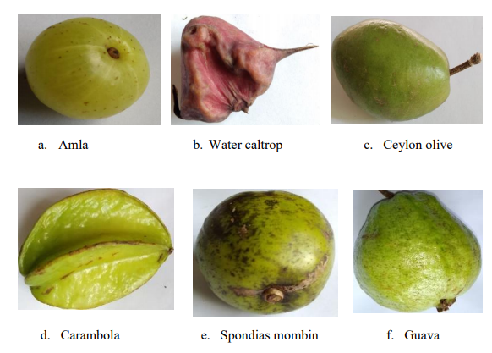

Fig: Sample of our dataset

1. **Proposed Model:**

CNN stands for convolutional neural networks. It is prevalent in the field of computer vision. The main reason behind its popularity is its efficiency in pattern classification. It can give better performance than the long-established methods. CNN's are the most representative supervised Deep Learning Model.

**3.2 Dataset Utilized**

This is a multilayered CNN model. The proposed model uses an optimizer named ADAM. The initial learning rate was set to 0.001. Which was automatically reduced as the learning rate progressed. For convolution 1, filter = 64, kernel size = (3x3), stride = (1x1), padding is set to “same” and activation function is ReLU. After a (2x2) max-pooling layer with stride = (2x2) was set.

**ReLU(X) = MAX (0, X)** …………. [2]

For convolution layer 2 and convolution layer 3, filter = 64, kernel size = (3x3), stride = (1x1), padding is set to “same” and activation function is ReLU is used. For convolution layer 4, filter = 96, kernel size = (3x3), stride = (1x1), padding is set to “same” and activation function is ReLU. Then a (2x2) max-pooling layer with stride = (2x2) is placed.

In the last convolution layer, convolution 5, filter = 192, kernel size = (3x3), stride = (1x1), padding is set to “same” and activation function is ReLU. Then a (2x2) max-pooling layer with stride = (2x2). A 25% dropout is used to reduce overfitting.

**Root Mean Square Error:**  flattened the image, and a dense layer with 100 units was placed. The activation function was ReLU. 50% dropout is used to reduce overfitting at the final output layer, Using six units of SoftMax activation. The error matric Categorical Cross Entropy was used.

(𝑧)𝑗= 𝑒𝑥𝑖Σ𝑒𝑧𝑘𝐾𝐾=1 𝑓 𝑜𝑟 𝑗=1,..𝑘 ……… [3]

𝐿𝑖 = − Σ𝑡𝑖+𝑗 𝑗(𝑝𝑖, 𝑗) ………… [4]

**Optimization:** The right choice for optimization algorithms in deep learning models can have noticeable improvement in reducing training time and improvement inaccuracy. In 2014, ADAM was an optimization algorithm with an adaptive learning rate specifically for training deep neural networks. Recently in deep learning applications like computer vision, ADAM optimizer is getting immense popularity. This algorithm combines the right parts of both the adaptive Gradient Algorithm (AdaGrad) and Root Mean Square Propagation (RMSProp). ADAM sets individual learning rates at each parameter from approximations of the first and second moments at the gradients. This algorithm is an update to the traditional stochastic gradients descent algorithm. Instead of the classical stochastic gradient descent, the ADAM optimizer was used for better performance. Optimizer ADAM with beginning learning rate = 0.001 was used in the proposed model.

𝑢𝑖= (1− 𝛽2 )Σ𝛽2𝑡−1 𝑡𝑖=1𝑔𝑖2 …………. [5]

Instead of additional mean square loss, cross-entropy performs better in classification problems. So, instead of a mean square, a cross-entropy error was calculated in the model. For cross-entropy is unlikely to stall out because of the weight changes. They do not get smaller and smaller as the training progresses. The learning rate determines the steps by which the values of parameters will be updated. Too high or too low learning rate are not suitable for the optimizer. However, getting that perfect learning rate intuitively not always gives the best result. In the proposed model, an automatic Learning Rate reduction technique was used. The learning rate is changed dynamically by monitoring validation accuracy.

**3.4 Proposed Methodology**

This work followed a procedure or methodology for getting the ultimate result. Figure 3.10 will discuss our methodology briefly.

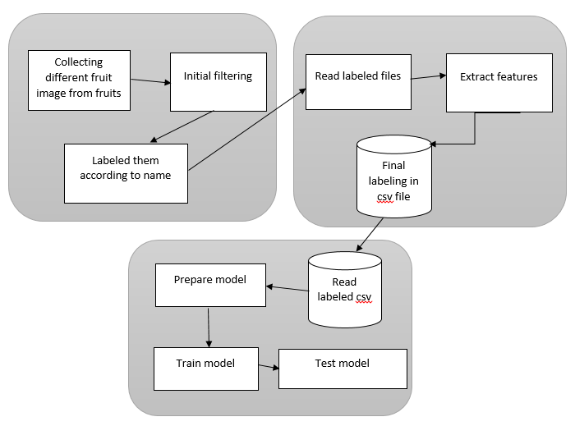

Fig 3.1: Proposed method

According to the figure, our first work is collecting raw data and label them by storing them into folders, and then the most critical and complex work, which is extracting the images and label them according to fruit name. And at last, train model using those data.

**3.5 Implementation Requirements** **Python**

**3.8:**

Python is a high-level programming language [16]. It can be used for desktop GUI and web applications, but most importantly, it has a rich resource in data science and machine learning. Which helps us to complete our work efficiently. The less complexity and easiness of the python programming language increase its acceptance to all the tech enthusiasts. And we used a 3.8+ version in our research work, the updated version of the time.

**Anaconda 4.5.12:**

This the free and open-source distribution of python [17]. This is also available for R programming language. This a bundle installer. By installing a single thing its install lots of necessary tools for data science. Even it comes with a concept of the virtual environment. We can isolate different projects from each other to use different requirements for each of them. We used the 4.5.12 version of the anaconda, the updated version of the time.

**Jupyter notebook:**

We used a jupyter notebook for writing the code [18]. This web-based open-source allows you to write codes, visualize the data, use equations, and a lot more. We used the 6.0.3 version of the Jupiter notebook.

**Keras:**

Keras is a deep learning library written in python language [19]. This library makes the works easy. They already developed the calculation parts. We just use them in the proper place according to our necessary. In the backend, Keras is using TensorFlow. Some other libraries are using Keras as backend, but Keras is most developed and prosperous. We used Keras 2.3 with the TensorFlow 2.0 version. This work used Keras and TensorFlow for experimenting with the image classification on its dataset.

**Google Colab:**

Collaboratory, or "Colab" for short, is a product from Google Research. Colab allows anybody to write and execute arbitrary **python** code through the browser and is especially well suited to machine learning, data analysis, and education.

## CHAPTER 4

## Experimental Results and Discussion

**4.1 . Model Training**

The proposed model was trained on a defined training set, and the validation set was created from the dataset. The batch size was set to 32. The automatic Learning Rate Reduce algorithm monitored accuracy. At first learning, The rate had to be initialized to a value, but it was adjusted accordingly after that. After five epochs, the accuracy was monitored manually, and the learning rate was reduced. The model has trained again for one epoch to achieve good accuracy.

**A. Model Evaluation**

The model proposed here was trained and tested on the dataset. The accuracy found is promising compared to other related works. The results on the dataset are described in the following.

**B. Train, Test, Validation Sets**

We collect the fruit database; fruit samples are collected from 6 different categories. The initial size of images was 4000x3000 pixels, which were resized to 100x100 pixels. Resized 100x100 pixel images were not turned into a gray-scale. This model uses a three-channel image. Because the details are better represented in RGB. The image was cropped for resizing to maintain the square aspect ratio. To train the model with good patterns and characteristics of leaves background, the images were cleared and painted white. The proposed model was trained in 2 categories of images. Images were divided into two sets. Set I had 80% of data for training the model and set 2 had 20% for testing the model. Each species of plant had 600 images. To train the model, a total of 500 images were used. And other 100 images were used to test the model. So we have 3000 images for the training set and 600 for testing.

**C. Model Performance**

Parameters that are not going to be learned in the training process but needed to be set are known as hyperparameters. Some of the hyperparameters are the model's learning rate, Iteration/epoch, batch-size, Etc. The hyperparameter learning rate is set manually in the other related models, but here the automatic Learning Rate reduction technique was used. Other hyperparameters were set intuitively. The table shows the hyperparameters for our proposed model. After training, the model for one epoch model gets a validation accuracy of 13.48%.

The model ran for five epochs resulted in a training accuracy of 96.93% and validation of 12.25%. Validation and training accuracy changes in different epochs are showing in the table.

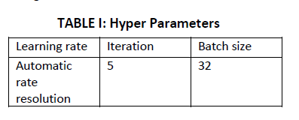

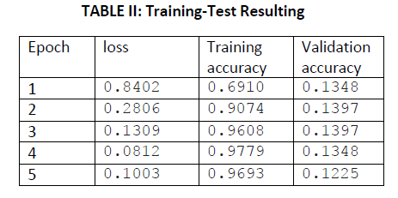

The accuracy and the loss graph is shown in the figure. The comparison between the proposed model and other models are shown in the table.

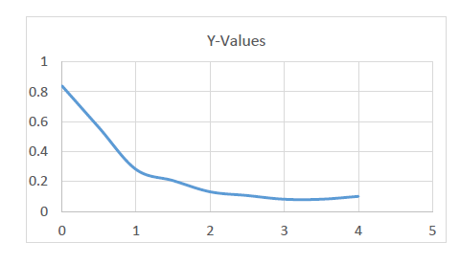

Fig 4.2: **Model Loss Evaluation**

Gradient boosting is another classifier we tried. This is an updated and modified version of previously developed Ada-boosting. This is nothing but a decision tree; this algorithm tries to improve the decision tree's performance by multiple iterations.

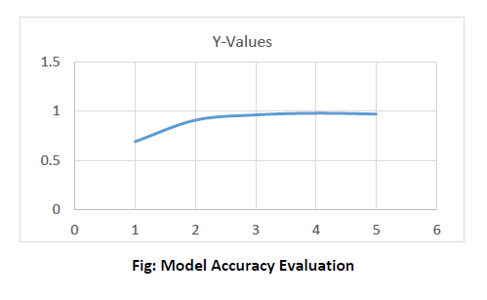

Figure 4.3 shows a less accurate result than our decision tree, so our experiment went wrong at that point. However, till then, it was clear that the random forest was given us a better result.

Then we tried a deep neural network. We used three hidden layers with input and output layers. Below figure 4.4 will describe the model information properly.

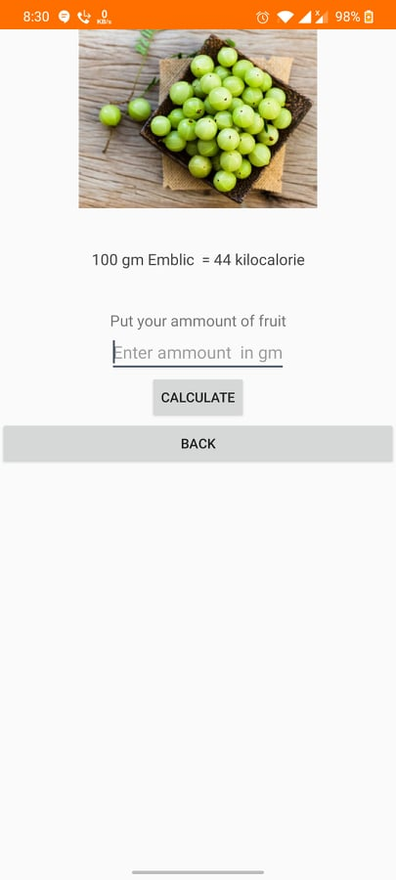We have made an application which is part of our project. Which can truly detect fruits we have used as dataset from real life and it can also measure calories by its own. Which we have implemented manually. If we input amount of fruit in grams then the application give us the calories based on fruit amount.

Fig: Application system

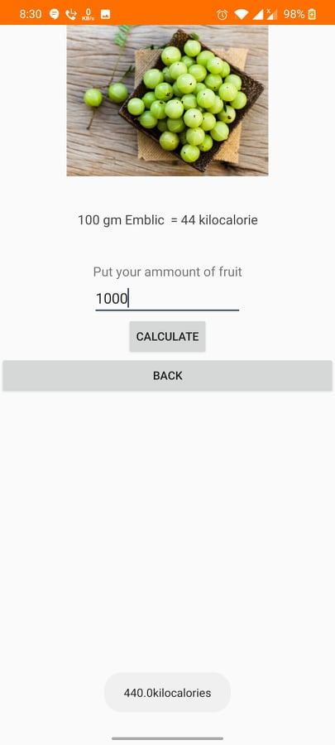

Fig: Application system

## CHAPTER 5

## Summary, Conclusion, Recommendation, and Implication for Future Research

**5.1 Summary of the Study**

The research project is developed for detecting an image of the moribund fruit of Bangladesh. For introducing the moribund fruit to the next generation of Bangladesh, it is important to identify the fruit of local areas. We used image classification techniques for extracting the fruit criteria from images and used multiple machine learning and deep learning techniques for feeding the machine. We split our dataset into 80% and 20% ratio for training and testing. This work used 80% for training and 20% for testing the system.

**5.2 Conclusion**

an effective way of tackling the identification of fruits from images by CNN and Adam Optimizer has presented. They are using CNN with Adam optimizer and automatic learning rate reduction technique. The proposed model gave promising results on classification and identifying fruits.

**5. 3 Implication for Further Study**

We must try to make things better always. Even in this work, there are lots of things that can be improved. Some future work is listed below:

* This research can include increasing the fruits in the dataset to test the model. Testing the model in other publicly available datasets and measuring accuracy. Also, improving the model's performance on complex fruit images will be an extension of this work.
* We need more verities in fruit. Verity gives a model more strength.
* Trying more classifiers and comparing them.

## REFERENCES

1. <https://www.researchgate.net/publication/321475443_Fruit_recognition_from_images_using_deep_learning>
2. <https://www.researchgate.net/publication/324135255_New_effective_techniques_for_automatic_detection_and_classification_of_external_olive_fruits_defects_based_on_image_processing_techniques>
3. <https://www.researchgate.net/publication/324135255_New_effective_techniques_for_automatic_detection_and_classification_of_external_olive_fruits_defects_based_on_image_processing_techniques>
4. [https://www.researchgate.net/publication/330791971_Faster_R CNN_Implementation_Method_for_Multi-Fruit_Detection_Using_Tensorflow_Platform](https://www.researchgate.net/publication/330791971_Faster_R%20CNN_Implementation_Method_for_Multi-Fruit_Detection_Using_Tensorflow_Platform)
5. <https://pubag.nal.usda.gov/catalog/741877>
6. <http://treefruit.wsu.edu/publications/sensors-and-systems-for-fruit-detection-and-localization-a-review/>
7. <https://ieeexplore.ieee.org/document/8015825>
8. <https://www.ncbi.nlm.nih.gov/pubmed/27527168>
9. <https://link.springer.com/article/10.1007/s11042-017-5243-3>
10. <https://www.semanticscholar.org/paper/Fruit-recognition-based-on-convolution-neural-Hou-Wu/10cbf4b88a29b7270ef7435ea1301ae2953c2dc7>
11. <https://ieeexplore.ieee.org/document/9117385>
12. <https://www.sciencedirect.com/science/article/abs/pii/S1389128619306978>
13. <https://ieeexplore.ieee.org/abstract/document/8976303>
14. <https://link.springer.com/article/10.1007/s11119-020-09709-3>
15. <https://www.sciencedirect.com/science/article/abs/pii/S1537511020302002>
16. <https://www.sciencedirect.com/science/article/abs/pii/S016816991932232X>
17. <https://www.sciencedirect.com/science/article/abs/pii/S0925521419312815>
18. <https://www.sciencedirect.com/science/article/abs/pii/S0168169919326274>
19. <https://www.mdpi.com/1424-8220/19/20/4599>
20. <https://ieeexplore.ieee.org/abstract/document/8821922>
21. <https://ieeexplore.ieee.org/abstract/document/8862834>
22. <https://www.sciencedirect.com/science/article/abs/pii/S0168169916312455>