1


Mini-Project

Market Visit Problem

Course Title: Operating Systems

Course Code : CSE325

Section : 01

Group No : 06

Submitted To:

Dr. Md. Nawab Yousuf Ali

Professor

Department of Computer Science Engineering

Submitted By:

Md. Ariful Islam

ID: 2021-1-60-028

Saurov Sikder

ID: 2021-1-60-053

Muhammad Sadman Tajwer

ID: 2021-1-60-030

Department of Computer Science Engineering

2
Market Visit Problem

Project Description:

The market visit problem involves managing the availability and competition of a one-of-a-kind hand-painted vase that Alice admires but ultimately decides not to buy due to its high price. She regrets her decision and searches for the vase online. To solve this problem, a C program can be developed using semaphores, processes, and thread mutex locks to manage the availability of the vase, synchronize the artist's inventory between the market and the online platform, and represent Alice's different actions concurrently. The program can simulate Alice's experience while addressing the concurrency issues that arise in this scenario.

Project Analysis:

The goal of this project is to develop a C program that simulates Alice's experience of finding a unique, handcrafted vase at a local artisan market and her subsequent decision-making process. The program addresses potential concurrency issues related to the availability of the vase and synchronization of the artist's inventory between the market and an e-commerce platform. Semaphores are used to manage the availability of the vase and ensure that it is not sold to multiple customers simultaneously. Processes represent different actions Alice takes and can run concurrently, while thread mutex locks synchronize the artist's inventory. The program provides an interactive and realistic simulation of Alice's experience, while also demonstrating the effectiveness of using concurrency control techniques.

Abstruct:

This project involves developing a C program that simulates a scenario where a software engineer, Alice, visits a market to buy a unique vase. The program uses semaphores, mutex locks, and processes to manage the availability of the vase, synchronize the artist's inventory between the market and online platform, and address potential concurrency issues. The code implements functions to simulate Alice's actions, such as visiting the market, searching online, and making a purchase, and updates the inventory accordingly.

Introduction:

The project is a multi-process implementation of a scenario where Alice, a software engineer, visits a local artisan market to look for a unique, handcrafted vase. The project simulates the process of Alice finding the vase at the market, searching for the vase online, and making a purchase. The implementation uses semaphores and mutexes to manage the availability of the vase in the artist's inventory, market inventory, and online inventory.

Semaphore: The semaphore is used to manage the availability of the vase. Specifically, a semaphore named 'vase_semaphore' is initialized with an initial value of 1. This semaphore is used to ensure that only one thread can access the vase at any given time. When a thread wants to access the vase, it must decrement the semaphore value using 'sem_wait()' and increment the semaphore value using 'sem_post()' once it's done with the vase.

Process: A process is a program in execution, which has its own memory space and system resources. Using multiple processes can also improve performance and reliability, as each process can be assigned specific tasks and run independently. In this project, multiple processes could be used to process different parts of the input data.

Thread Mutex Lock: The thread mutex lock is used to ensure that only one thread can modify the shared inventory data structures at any given time. Specifically, each of the three functions ('visit_market()', 'search_online()', and 'make_purchase()') uses a thread mutex lock to protect the shared 'artist_inventory' structure. When a thread wants to modify the 'artist_inventory', it must acquire the mutex lock using 'pthread_mutex_lock()' and release it using 'pthread_mutex_unlock()' once it's done.

4

Main Code:

#include <stdio.h>
#include <stdlib.h>
#include <pthread.h>
#include <semaphore.h>
#include <unistd.h>
#include <sys/wait.h>

These are the standard header files for input/output, memory allocation, threading, semaphores, process control, and waiting.

{
int vase_count;
pthread_mutex_t lock;
} inventory_t;

This defines a structure ‘inventory_t’ to represent the artist's inventory. It contains an integer variable ‘vase_count’ to represent the number of vases in stock, and a mutex variable lock to protect concurrent access to the ‘vase_count’ variable.

sem_t vase_semaphore;

This declares a semaphore variable ‘vase_semaphore’ to manage the availability of the vase.

inventory_t artist_inventory;
inventory_t market_inventory;
inventory_t online_inventory;

These are the three inventory locations for the vase: the artist's inventory, the market, and the
online platform.

void init_inventory(inventory_t *inventory, int count)
{
inventory->vase_count = count;
pthread_mutex_init(&inventory->lock, NULL);
}

This is a function to initialize the shared inventory data structure. It takes a pointer to the ‘inventory_t’ structure and an integer count of the number of vases in stock. It initializes the ‘vase_count’ variable to the provided count and initializes the ‘lock’ mutex to its default value.

5

void visit_market()
{
pthread_mutex_lock(&artist_inventory.lock);
if (market_inventory.vase_count > 0)
{
sem_wait(&vase_semaphore);
printf("Alice finds the vase at the market but decides not to buy it.\n");
sem_post(&vase_semaphore);
}
else
{
printf("The vase is not available at the market.\n");
}
pthread_mutex_unlock(&artist_inventory.lock);
}

This is a function to simulate Alice visiting the market to purchase the vase. It locks the artist's inventory mutex, checks if the vase is available in the market inventory, and either prints a message that Alice found the vase but decided not to buy it or a message that the vase is not available in the market. It then unlocks the artist's inventory mutex.

void search_online()
{
pthread_mutex_lock(&artist_inventory.lock);
if (online_inventory.vase_count > 0)
{
printf("Alice finds the vase online and decides to buy it.\n");
sem_wait(&vase_semaphore);
online_inventory.vase_count--;
artist_inventory.vase_count--;
sem_post(&vase_semaphore);
printf("Alice has successfully purchased the vase.\n");
printf("\n\nAfter Details : \n");
printf("Item in Artist's inventory : %d\n",artist_inventory.vase_count);
printf("Item in market's inventory : %d\n",market_inventory.vase_count);
printf("Item in online's inventory : %d\n",online_inventory.vase_count);
}
else
{
printf("The vase is not available online.\n");
}
pthread_mutex_unlock(&artist_inventory.lock);
}
void make_purchase()
{
pthread_mutex_lock(&artist_inventory.lock);

6

if (market_inventory.vase_count > 0)
6 {
printf("Alice decides to buy the vase at the market.\n");
sem_wait(&vase_semaphore);
market_inventory.vase_count--;
artist_inventory.vase_count--;
sem_post(&vase_semaphore);
printf("Alice has successfully purchased the vase.\n");
printf("\n\nAfter Details : \n");
printf("Item in Artist's inventory : %d\n",artist_inventory.vase_count);
printf("Item in market's inventory : %d\n",market_inventory.vase_count);
printf("Item in online's inventory : %d\n",online_inventory.vase_count);
}
pthread_mutex_unlock(&artist_inventory.lock);
}

The code provided includes two functions: ‘search_online()’ and ‘make_purchase()’.
‘search_online()’ function is called to simulate Alice searching for the vase online. The function first locks the artist_inventory's mutex, checks if the vase is available in the online inventory, and if so, decrements the vase semaphore to indicate that the vase is no longer available. Then it updates the online inventory and artist inventory to reflect the purchase and prints the updated inventory details. Finally, it unlocks the mutex and prints a message to indicate that the purchase is complete.

‘make_purchase()’ function is called to simulate Alice buying the vase at the market. The function first locks the artist_inventory's mutex, checks if the vase is available in the market inventory, and if so, decrements the vase semaphore to indicate that the vase is no longer available. Then it updates the market inventory and artist inventory to reflect the purchase and prints the updated inventory details. Finally, it unlocks the mutex and prints a message to indicate that the purchase is complete.

Both functions are using semaphores to ensure that only one thread can access and modify the vase inventory at a time. The mutex is also used to ensure that only one thread at a time can access the artist inventory.

int main()
{
pid_t pid1, pid2, pid3;
int ai,mi,oi;
sem_init(&vase_semaphore, 0, 1);
printf("Initial Inventory details : \n");

printf("Item in Artist's inventory : ");
scanf("%d",&ai);
printf("\nItem in market's inventory : ");
scanf("%d",&mi);
printf("\nItem in online's inventory : ");
scanf("%d",&oi);
printf("\n");
init_inventory(&artist_inventory, ai);
init_inventory(&market_inventory, mi);
init_inventory(&online_inventory, oi);
int x;
while(1)
{
printf("\n1.Alice did not decide to buy.");
printf("\n2.Alice will buy from market.");
printf("\n3.Alice will buy from online.");
printf("\n4.Exit.\n");
printf("Enter your choice :");
scanf("%d",&x);
switch(x)
{
case 1:
pid1 = fork();
if (pid1 == 0)
{
visit_market();
}
break;
case 2:
pid2 = fork();
if (pid2 == 0)
{
make_purchase();
}
break;
case 3:
pid3 = fork();
if (pid3 == 0)
{
search_online();
}
break;
case 4:
exit(0);
default:
printf("Wrong input try again.\n");
}
waitpid(pid1, NULL, 0);

waitpid(pid2, NULL, 0);
waitpid(pid3, NULL, 0);
pthread_mutex_destroy(&artist_inventory.lock);
}
return 0;
}

This is a program that simulates a marketplace where Alice, the buyer, can either visit a physical market or search for a vase online to buy. The program uses semaphores and mutexes to ensure that the inventory is synchronized and consistent.

The program starts by initializing the inventory and creating three child processes using the ‘fork()’ function to simulate Alice's shopping activities.The main process waits for all child processes to complete and then destroys the mutexes used to protect the inventory.

The program offers Alice three options:

- Alice decides not to buy the vase: This option forks a child process that simply visits the market without making any purchases.

- Alice buys the vase from the market: This option forks a child process that calls the ‘make_purchase()’ function. This function checks if the vase is available in the market inventory, decrements the vase semaphore, updates the market and artist inventory, and then prints a message to indicate that the purchase is complete.

- Alice buys the vase online: This option forks a child process that calls the ‘search_online()’ function. This function checks if the vase is available in the online inventory, decrements the vase semaphore, updates the online and artist inventory, and then prints a message to indicate that the purchase is complete.

The program uses a switch-case statement to allow the user to choose one of the three options. The program prompts the user to enter the initial inventory details of the artist, market, and online inventories.The program also initializes the semaphore used to synchronize access to the vase and creates a mutex for each inventory to protect against race conditions.

Finally, the program waits for all child processes to complete using the ‘waitpid()’ function and then destroys the mutexes and semaphore.
10

Output :
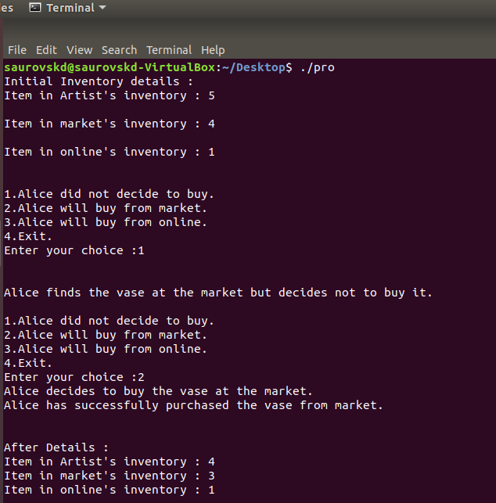

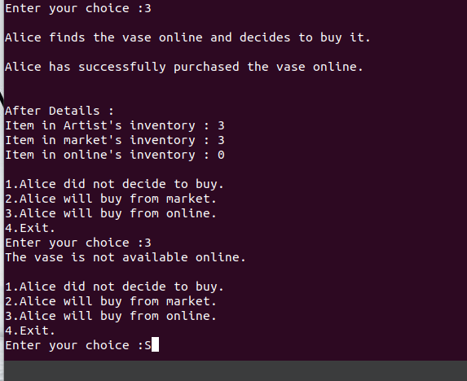

Conclution:

In conclusion, the C program can effectively simulate Alice's experience of finding, deciding not to buy, regretting her decision, and searching for the vase online, while also addressing the potential challenges and concurrency issues that arise in this scenario. By using semaphores, processes, and thread mutex locks, the program can manage the availability of the vase, represent Alice's actions, and synchronize the artist's inventory between the market and the online platform

