QuitMate - Tobacco Awareness Mobile Application
User Manual
A Comprehensive Operational & Technical Guide to the Tobacco Cessation Mobile Application



Prepared & Developed By
Md. Ariful Islam (ID: MUH2325010M)
Mohammed Karimul Mowla (ID: ASH2325031M)
Institute of Information Technology
Noakhali Science and Technology University

Table of Contents
Chapter 1: Introduction & System Architecture 4
1.1 Purpose of the User Manual 4
1.2 About QuitMate 4
1.3 System Architecture & Tech Stack 4
1.4 User Roles & Access Hierarchy 4
Chapter 2: Getting Started & User Onboarding 5
2.1 System Requirements & Installation 5
2.2 Launching QuitMate 5
2.3 Authentication & Google Sign-In 7
2.4 Profile Assessment Setup 8
2.4.1 Educational Qualification / Class Selection 8
2.4.2 User Name Input 9
2.4.3 Age Selection 10
2.4.4 Gender Selection 11
2.4.5 Quit Plan Duration Setup 12
Chapter 3: QuitMate Mobile Application Guide 14
3.1 Home Dashboard & Cessation Tracker 14
3.2 Daily Quit Plan ("Daily Porikolpona") 16
3.3 Daily Check-in & Craving Log 17
3.4 Emergency SOS Craving Relief 18
3.5 Financial Savings & Health Milestones 19
3.6 Support Group & Community Forum ("Sohoyota Group") 20
3.7 Educational Content & Health Modules 21
3.8 Gamification & Achievement Badges 22
3.9 User Profile & Account Management 23
Chapter 4: System Administration & Troubleshooting 26
4.1 Troubleshooting Matrix 26
4.2 Frequently Asked Questions (FAQ) 26
4.3 Technical Support & Contact Details 26

List of Figures
Figure 1: QuitMate Application Icon 5
Figure 2: Application Splash Screen Interface 6
Figure 3: Google Sign-In & Authentication Interface 7
Figure 4: Profile Assessment - Educational Qualification / Class Selection 8
Figure 5: Profile Assessment - User Name Input 9
Figure 6: Profile Assessment - User Age Selection 10
Figure 7: Profile Assessment - User Gender Selection 11
Figure 8: Profile Assessment - Quit Plan Duration Setup 12
Figure 9: QuitMate Home Dashboard & Progress Tracker 14
Figure 10: Daily Quit Plan (Daily Porikolpona) Interface 16
Figure 11: Daily Check-in & Craving Tracker 17
Figure 12: Emergency SOS Craving Relief Interface 18
Figure 13: Financial Savings & Health Milestones Screen 19
Figure 14: Support Group (Sohoyota Group) Community Portal 20
Figure 15: Educational Health Articles & Cessation Content 21
Figure 16: Gamification & Achievement Badge Interface 22
Figure 17: User Profile & Account Configuration Screen 23

List of Tables

Table 1: QuitMate System Architecture & Component Stack 4
Table 2: Onboarding Profile Assessment Parameters Matrix 13
Table 3: QuitMate Mobile Application Feature Capabilities 24
Table 4: Common Troubleshooting & Solutions Matrix 25

Chapter 1: Introduction & System Architecture

1.1 Purpose of the User Manual
The purpose of this manual is to provide operational guidance, feature descriptions, and technical specifications for end-users and health facilitators operating the QuitMate mobile platform. It ensures seamless onboarding and effective daily usage.

1.2 About QuitMate
QuitMate is designed to address tobacco addiction by leveraging behavioral therapy principles, positive reinforcement, real-time tracking, and peer community interaction. Tobacco dependency poses severe long-term health risks; QuitMate simplifies the cessation journey into manageable daily goals, celebrating tobacco-free milestones and providing instant intervention during high-craving moments.

1.3 System Architecture & Tech Stack
The QuitMate ecosystem comprises a cross-platform Flutter client mobile application backed by a Node.js/Express REST API backend server, Supabase (PostgreSQL) database, Groq AI engine (Llama 3.3), Socket.io WebSockets, and Firebase Authentication.
Table 1: QuitMate System Architecture & Component Stack
Component | Technology Stack | Core Functionality & Role | Deployment
Mobile Client | Flutter, Dart, Riverpod, Hive | Client interface for end-users: profile assessment, daily quit plan, check-in tracking, SOS craving relief, money saver, gamification, community forum. | Android / iOS
Cloud Backend & AI Engine | Express.js (Node.js REST API), Supabase (PostgreSQL), Groq AI (Llama 3.3) | REST API endpoints for user auth, AI quit plan & SOS coping strategies generation, user profiles, and data persistence. | Cloud Server / Render
Real-Time & Auth Services | Socket.io WebSockets, Firebase Auth (Google Sign-In) | Real-time chat messaging for Sohoyota Group, Google authentication, and push notification sync. | Cloud Engine

1.4 User Roles & Access Hierarchy
QuitMate mobile client is designed for End-Users seeking tobacco cessation support. End-users have access to personalized quit dashboards, craving logs, community forums, and profile configurations. The QuitMate application was jointly developed by Md. Ariful Islam and Mohammed Karimul Mowla.

Chapter 2: Getting Started & User Onboarding

2.1 System Requirements & Installation
To run the QuitMate mobile application seamlessly, mobile devices should meet the following minimum specifications:
- Android OS: Version 7.0 (Nougat) or higher (RAM: 2 GB minimum).
- iOS: Version 13.0 or higher.
- Internet Connectivity: Active Wi-Fi or Mobile Data connection required for account authentication and cloud syncing.

2.2 Launching QuitMate
Upon installing the application package, locate the QuitMate icon on your device home screen or app drawer. Tapping the icon launches the app, displaying a clean, branded splash screen while initializing local application storage and network services.
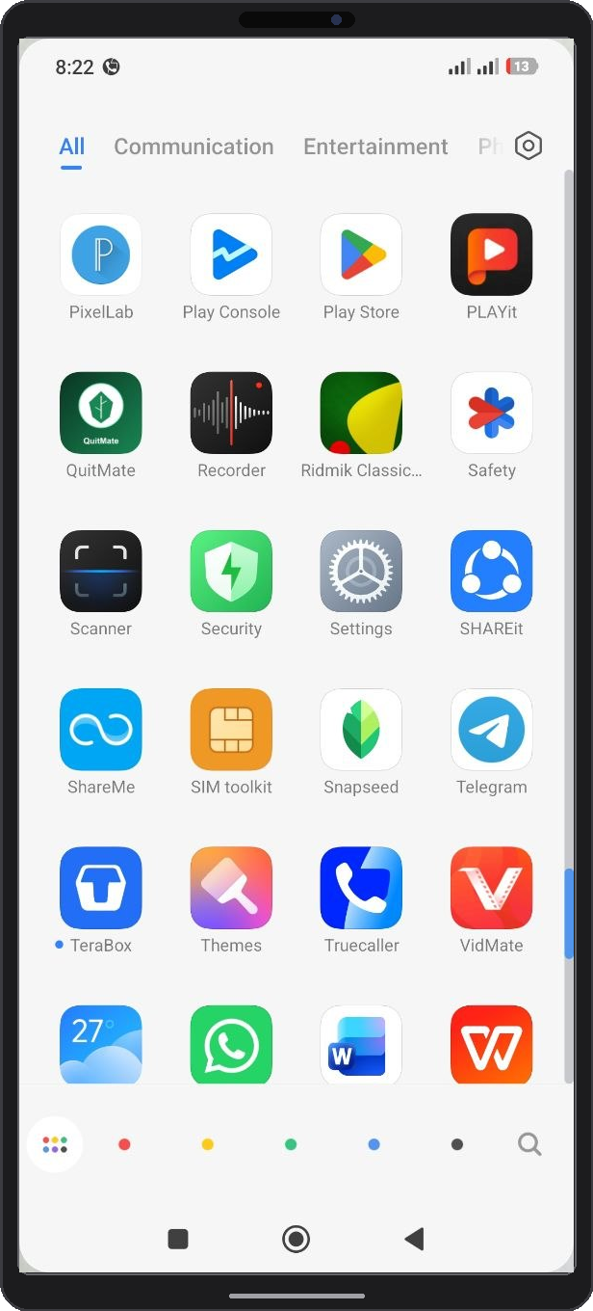
①
Figure 1: QuitMate Application Icon
① QuitMate Application Icon: App launcher on the Android/iOS home screen. Tapping this icon initializes application storage, Hive database, and Firebase cloud listeners.

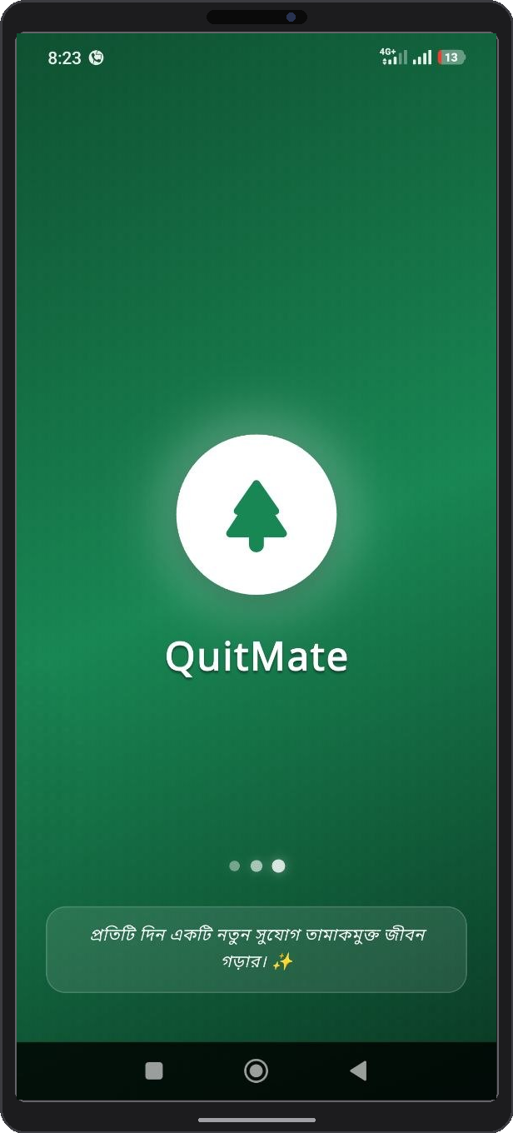
①
②
Figure 2: Application Splash Screen Interface

① QuitMate Brand Emblem: Displays official anti-tobacco branding logo and app title.
② Initialization Progress Loader: Indicates active loading of system assets, user authentication tokens, and local cache databases.

2.3 Authentication & Google Sign-In
QuitMate offers seamless, secure one-tap authentication via Google Sign-In. This ensures user profiles are securely tied to Google Cloud credentials, enabling automatic progress cloud backups and effortless account recovery across multiple devices.

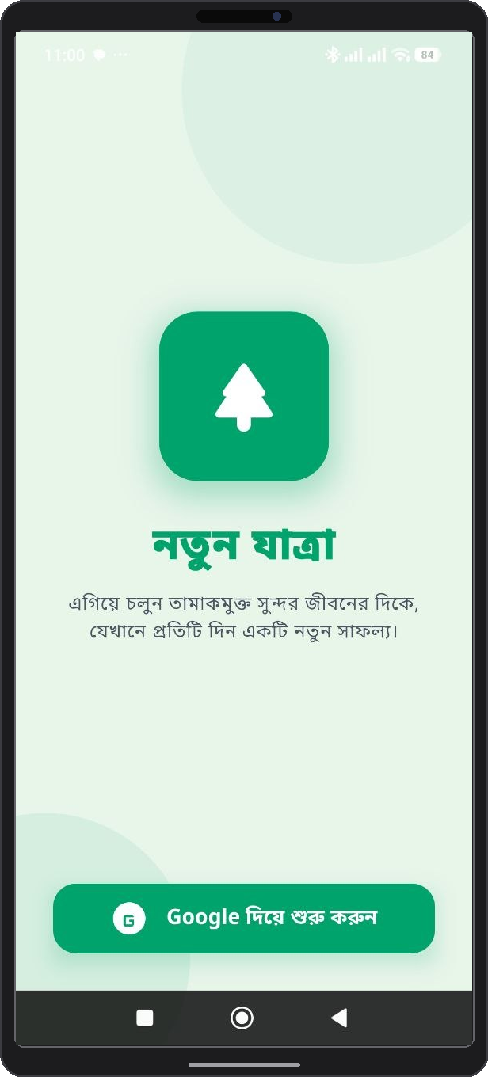
①
②
Figure 3: Google Sign-In & Authentication Interface
① Welcome & Security Header Card: Displays security overview and user data privacy assurance.
② Google One-Tap Sign-In Button: Triggers OAuth 2.0 Google single sign-on authentication flow.
③ Terms & Privacy Policy Link: Opens official documentation regarding data encryption and anonymous handling.

2.4 Profile Assessment Setup
Following initial authentication, new users undergo a guided assessment wizard. This assessment collects essential smoking history data to dynamically calibrate personalized quitting metrics, money savings calculators, and health recovery timelines.

2.4.1 Educational Qualification / Class Selection
Users enter their educational qualification or student class/grade (e.g., Class 10, HSC, University/Degree level). This demographic classification tailors educational content, daily guidance difficulty, and contextual support intensity for the user.

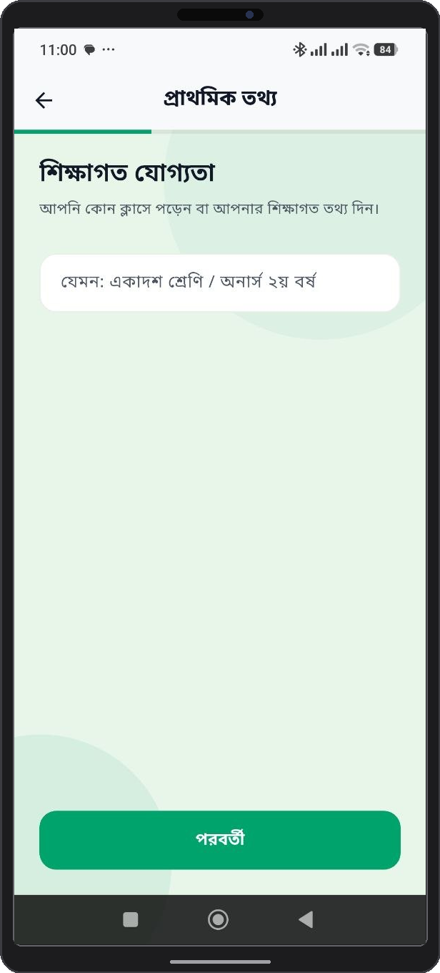
①
②
Figure 4: Profile Assessment - User Category Selection
① Educational Qualification Input Field: Text field to enter student class or educational level ('আপনার শিক্ষাগত যোগ্যতা/শ্রেণি প্রদান করুন').
② Next Action Button: Saves selected category and advances to Name input screen.

2.4.2 User Name Input
Enter your preferred display name. This name is used to personalize daily motivational alerts and greeting messages on the Home Dashboard.

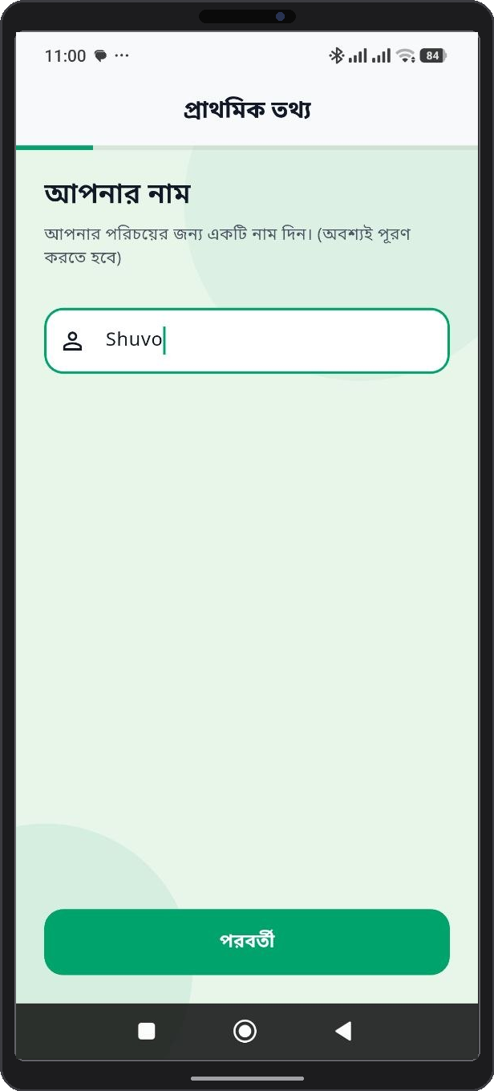
①
②
Figure 5: Profile Assessment - User Name Input
① Display Name Textfield: Alphanumeric input box to type preferred user display name or alias.
② Continue Button: Validates text input and proceeds to Age selection step.

2.4.3 Age Selection
Select your age bracket. Age parameters help QuitMate compute baseline biological recovery benchmarks, such as lung capacity improvement rate and cardiovascular risk reduction timers.

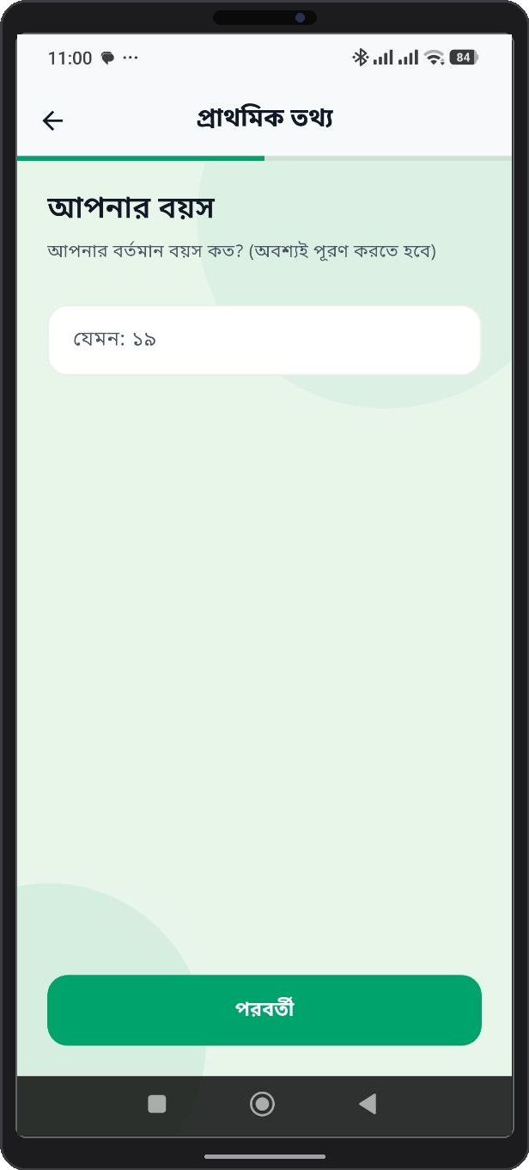
①
②
Figure 6: Profile Assessment - User Age Selection
① Age Picker / Input Control: Interactive picker to define user age (used in physiological recovery algorithms).
② Confirm Age Button: Saves age selection and advances to Gender selection.

2.4.4 Gender Selection
Select gender orientation to fine-tune health insights and wellness recommendations tailored to demographic health indicators.

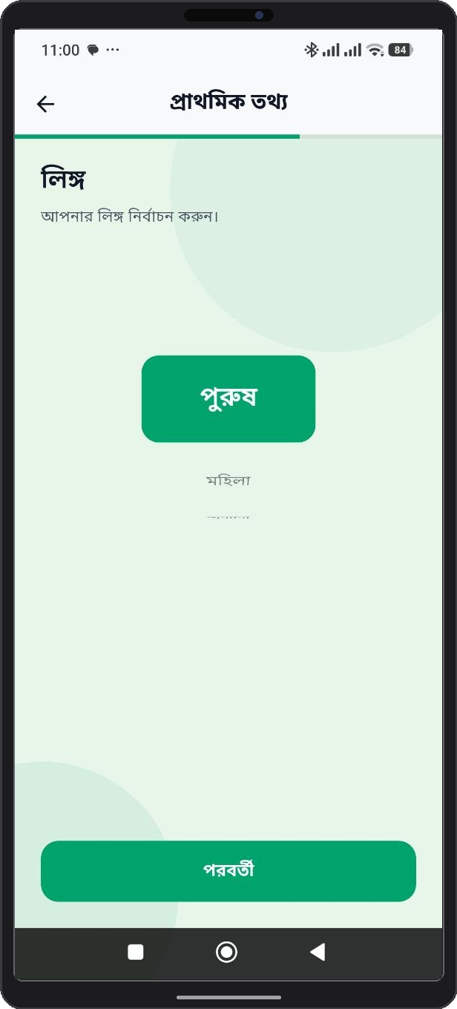
①
②
Figure 7: Profile Assessment - User Gender Selection
① Gender Selection Cards: Radio selection options (Male, Female, Non-binary/Prefer not to say).
② Proceed Button: Saves gender profile data and advances to Plan Duration setup.

2.4.5 Quit Plan Duration Setup
Specify your target quit duration (e.g., 30 days, 60 days, 90 days, or permanent cessation). QuitMate constructs a milestone-driven roadmap based on this target date.

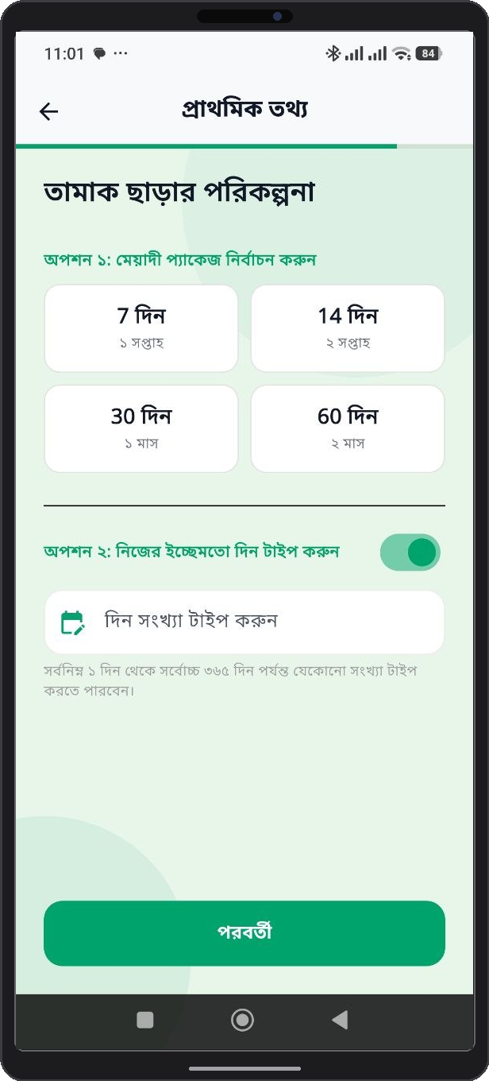
①
②
Figure 8: Profile Assessment - Quit Plan Duration Setup
① Target Quit Duration Picker: Duration options picker (30 Days, 60 Days, 90 Days, Lifetime Cessation).
② Finish Setup & Launch Button: Finalizes onboarding, initializes quit timers, and opens Home Dashboard.

Table 2: Onboarding Profile Assessment Parameters Matrix
Assessment Step | Input Field / Selection | System Function & Impact
1. Educational Qualification / Class | Text Input (e.g. Class 10, HSC, Degree) | Captures user educational/grade background for tailored content and profile customization.
2. Display Name | Text Input (3-20 characters) | Personalizes application headers, greeting cards, and community posts.
3. User Age | Numeric Input (7 to 100 years) | Sets age demographic for personalized health guidance.
4. Gender | Radio Option (পুরুষ / মহিলা / অন্যান্য) | Adapts health tips and demographic-specific wellness articles.
5. Plan Duration | Duration Selection (7, 14, 30, 60 days or Custom 1-365 days) | Establishes total target quit timeline for AI quit plan generation.

Chapter 3: QuitMate Mobile Application Guide

3.1 Home Dashboard & Cessation Tracker
The Home Dashboard is the primary central hub of QuitMate. It features real-time progress counters displaying consecutive tobacco-free days, hours, and minutes. It also presents live statistics for total money saved, tobacco avoided, and current health recovery percentages.

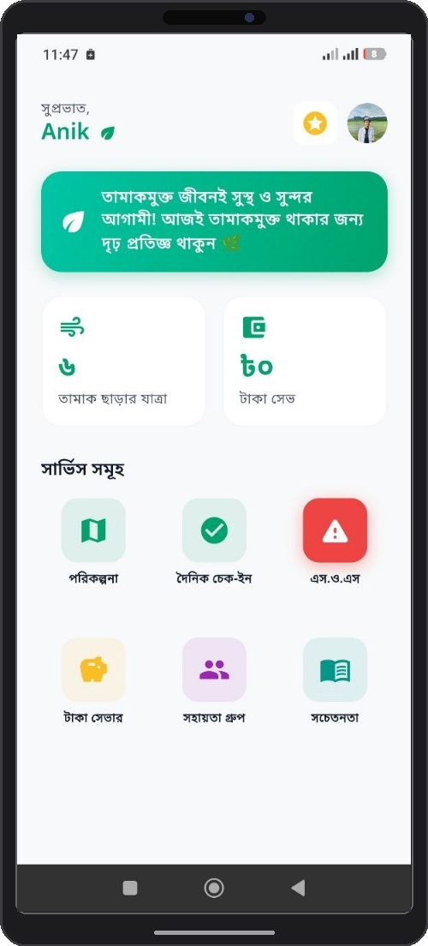
①
②
③
④
⑤
⑥
⑦
⑧
⑨
⑩
⑪
Figure 9: QuitMate Home Dashboard & Progress Tracker
① Motivational Message Banner: Top green banner displaying daily motivational quote to reinforce quitting commitment
('তামাকমুক্ত জীবনই সুস্থ ও সুন্দর আগামী! আজই তামাকমুক্ত থাকার জন্য দৃঢ় প্রতিজ্ঞ থাকুন 🌿').
② Tamak Charar Jatra (Days Smoke-Free Counter): Stat card tracking consecutive smoke-free days elapsed since quitting ('৬ তামাক ছাড়ার যাত্রা').
③ Taka Saved (Money Saved Counter): Stat card dynamically tracking financial money saved based on cigarette pack price ('৮০ টাকা সেভ').
④ Porikolpona (Daily Plan Service Icon): Quick action icon launching personalized 24-hour daily quit plan goals.
⑤ Dainik Check-in (Daily Check-in Service Icon): Quick action icon opening daily craving, mood, and trigger check-in logger.
⑥ SOS (Emergency Panic Service Icon): Prominent red emergency icon launching instant craving distraction and breathing exercises.
⑦ Taka Saver (Money Saver Service Icon): Quick action icon opening cumulative financial savings tracker and wishlist reward planner.
⑧ Sohoyota Group (Support Group Service Icon): Quick action icon opening community peer discussion and mutual support forum.
⑨ Sachetanata (Awareness / Educational Content Icon): Quick action icon linking to expert health articles, videos, and coping guides.
⑩ Gamification Star Badge Icon: Header star icon displaying current quitter reward level and accumulated achievement XP points.
⑪ User Profile Avatar Icon: Header user photo icon opening personal account settings, display name edit, and habit configuration.

3.2 Daily Quit Plan ("Daily Porikolpona")
The Daily Quit Plan module breaks down long-term cessation into achievable 24-hour tasks. Users receive curated daily goals, such as hydration targets, deep breathing exercises, physical activity challenges, and cognitive distraction tasks.

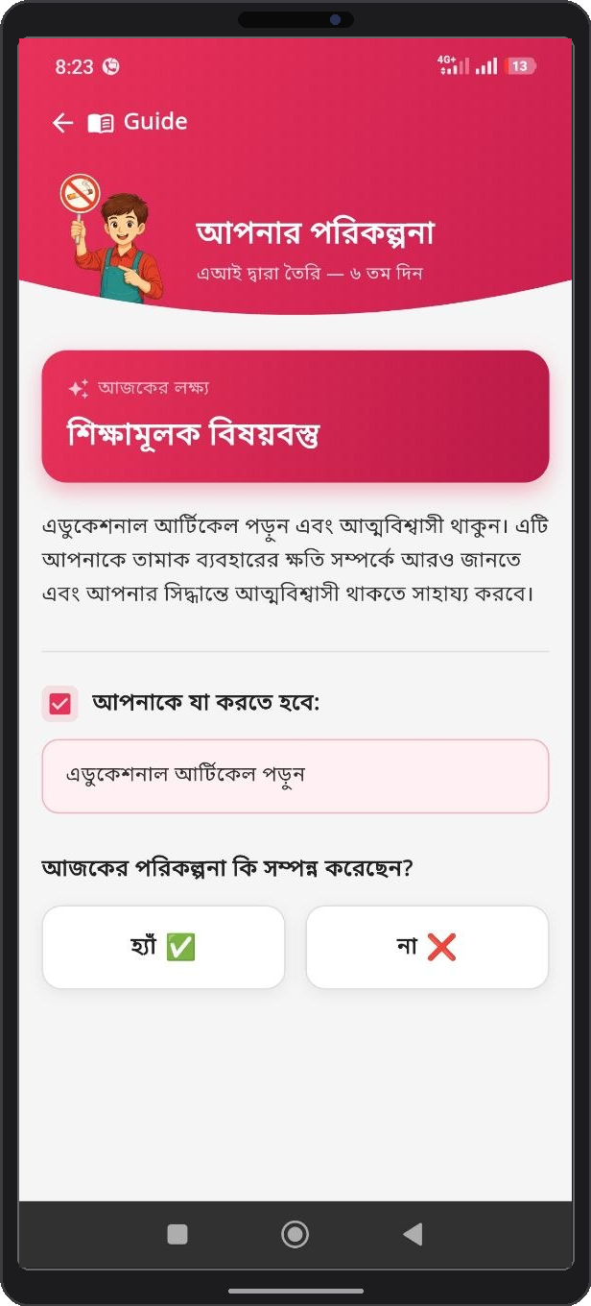
①
②
④
Figure 10: Daily Quit Plan (Daily Porikolpona) Interface
① Daily Date Navigation Header: Calendar date switcher to view past completed tasks or upcoming goals.
② 24-Hour Task Checklist Container: List of personalized daily micro-tasks (hydration, 10-min walk, breathing exercises).
③ Task Completion Check Toggles: Interactive checkboxes to mark goals completed .

3.3 Daily Check-in & Craving Log
Every evening, users complete a quick Daily Check-in. This feature logs whether the user successfully remained smoke-free, records craving intensity levels, identifies relapse triggers (e.g., stress, social gatherings, alcohol), and logs overall mood trends.
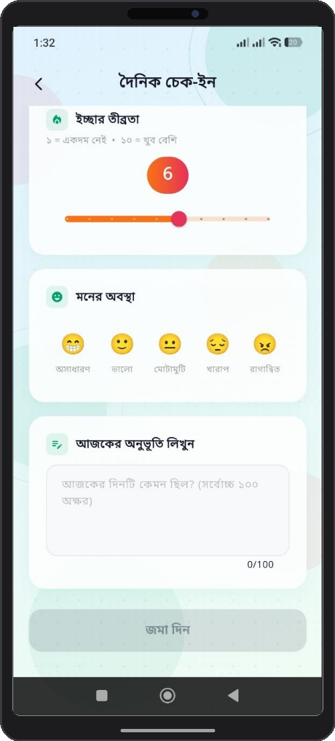
①
②
③
④
⑤
Figure 11: Daily Check-in & Craving Tracker
① Daily Check-in Header Bar: Top navigation header bar with back navigation button ('দৈনিক চেক-ইন').
② Icchar Tribrata (Craving Intensity Slider): Interactive rating scale slider (1 to 10) logging urge severity ('ইচ্ছার তীব্রতা: ১ = একদম নেই, ১০ = খুব বেশি').
③ Moner Obostha (Mood Selector Cards): Interactive emoji cards to log daily mood ('অসাধারণ', 'ভালো', 'মোটামুটি', 'খারাপ', 'রাগান্বিত').
④ Ajker Onubhuti Likhun (Daily Note Text Box): Text area (up to 100 characters) to log personal daily journal thoughts ('আজকের অনুভূতি লিখুন').
⑤ Joma Din (Submit Check-in Button): Action button to save daily check-in entry and update consecutive streak counter ('জমা দিন').

3.4 Emergency SOS Craving Relief
During acute craving spikes, users can press the prominent Emergency SOS Button on the navigation bar. Activating SOS instantly presents 5 rapid craving distraction and coping options: a 5-minute craving survival timer, guided 4-7-8 breathing exercises, a water intake logger, friend speed-dial support, and a walking activity completion tracker.
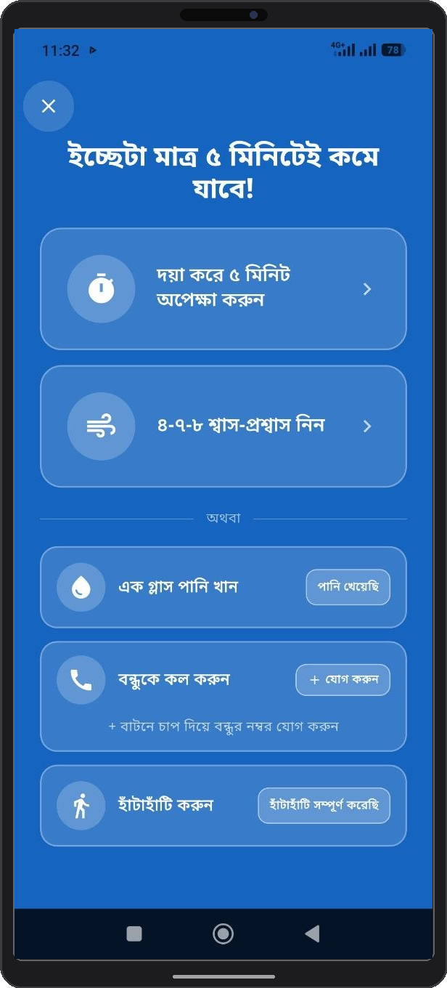
③
④
①
②
⑤
Figure 12: Emergency SOS Craving Relief Interface
① 5-Minute Survival Timer Card: Interactive countdown timer card encouraging users to wait out acute cravings ('দয়া করে ৫ মিনিট অপেক্ষা করুন').
② 4-7-8 Breathing Exercise Card: Guided deep breathing animation card for immediate anxiety and stress relief ('৪-৭-৮ শ্বাস-প্রশ্বাস নিন').
③ Drink a Glass of Water Card: Hydration intervention task card with completion toggle ('এক গ্লাস পানি খান').
④ Call a Friend Card: Speed-dial support feature allowing users to call or add a trusted friend ('বন্ধুকে কল করুন').
⑤ Take a Walk Card: Physical movement distraction activity card with activity completion logger ('হাঁটাহাটি করুন').

3.5 Financial Savings & Health Milestones
The Money Saver screen dynamically calculates cumulative money saved based on daily tobacco expenditure. It features an interactive button to add new personal reward dreams ('নতুন স্বপ্ন') and correlates saved funds with real-world wishlist targets (e.g., books, clothes, gadgets) to provide tangible positive reinforcement.
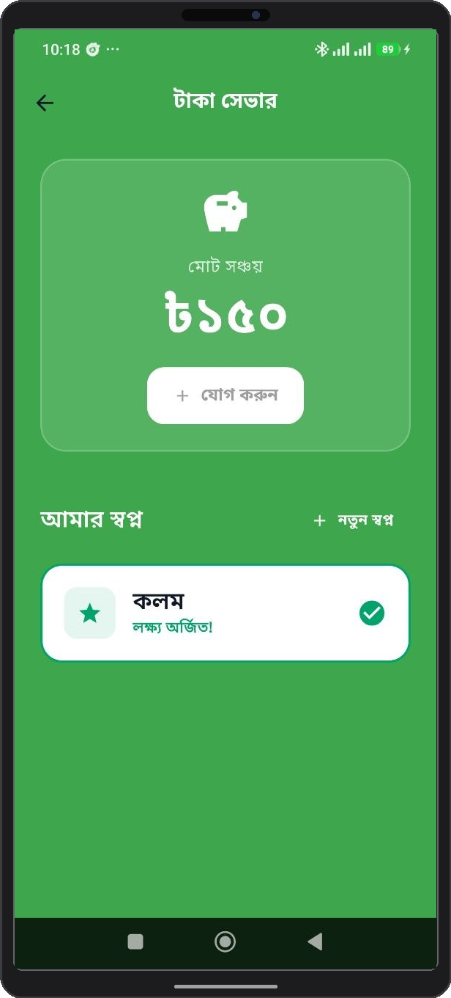
①
②
③
Figure 13: Financial Savings & Health Milestones Screen
① Total Accumulated Savings Banner: Highlighted metric banner showing total money saved to date ('মোট সঞ্চয়').
② Wishlist & Reward Milestones List: Correlates accumulated saved funds with user-defined reward targets and wishlist dreams (books, clothes, gadgets).
③ Notun Sopno Button (Add New Dream Button): Interactive action button allowing users to add a new personal wishlist target or reward dream ('নতুন স্বপ্ন')

3.6 Support Group & Community Forum ("Sohoyota Group")
The 'Sohoyota Group' community tab allows users to connect with fellow quitters. Users can post progress updates, share personal stories, exchange coping strategies, and offer encouragement to peers navigating similar cessation challenges.
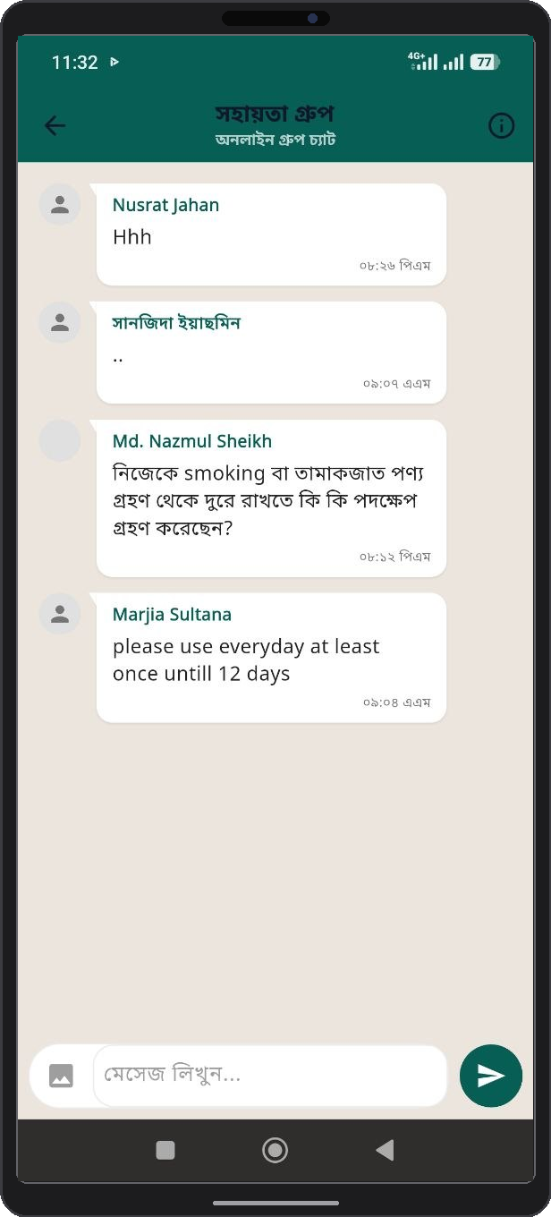
①
Figure 14: Support Group (Sohoyota Group) Community Portal
① Community Guideline Exclamation Icon (!): Top right exclamation icon indicating official community guidelines, forum safety rules, respectful discussion policies, and content moderation guidelines for peer interactions.

3.7 Educational Content & Health Modules
Access a comprehensive library of evidence-based health articles, expert videos, and micro-learning modules. Topics include managing nicotine withdrawal symptoms, nutritional guidance during quitting, stress reduction techniques, and long-term relapse prevention.
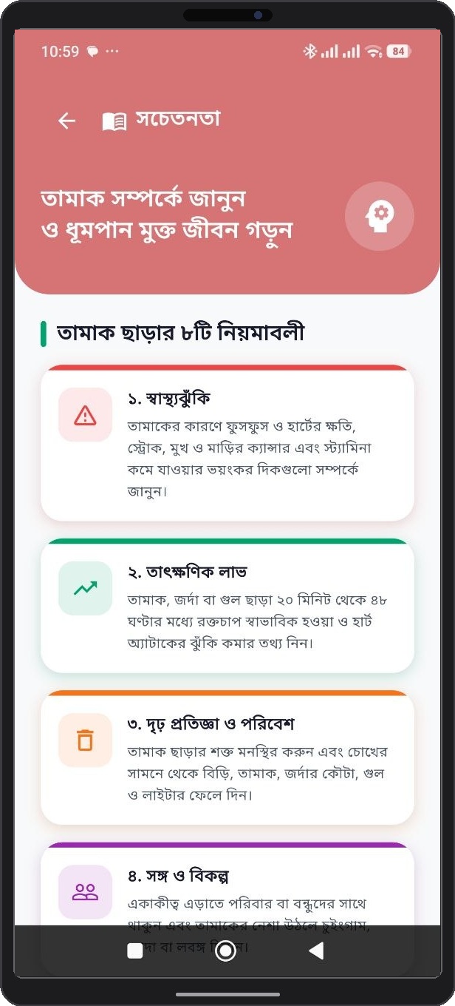
Figure 15: Educational Health Articles & Cessation Content

3.8 Gamification & Achievement Badges
To maintain engagement, QuitMate incorporates a rich gamification framework. Users earn digital badges, unlock achievement trophies, and level up as they reach key quit milestones (e.g., 24 Hours Smoke-Free, 1 Week Clean, 1 Month Hero, Money Saver Milestone).

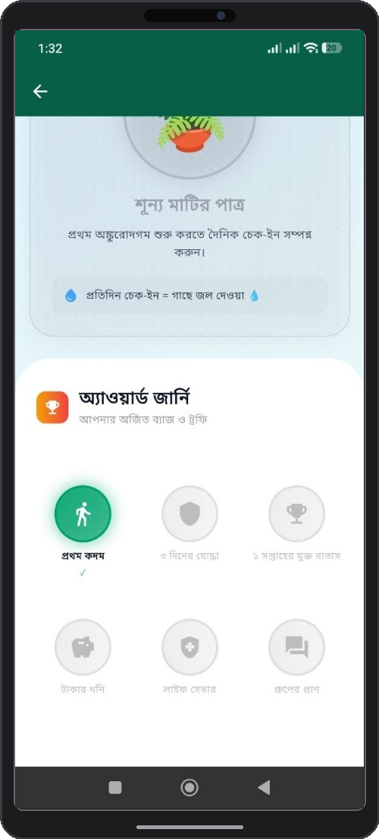
①
②
③
④
⑤
⑥
⑦
⑧
Figure 16: Gamification & Achievement Badge Interface
① Shunya Matir Patra (Plant Growth Card): Card tracking daily check-in streak and virtual plant watering progress ('শূন্য মাটির পাত্র').
② Award Journey Header Banner: Title banner introducing earned badges and trophies ('অ্যাওয়ার্ড জার্নি: আপনার অর্জিত ব্যাজ ও ট্রফি').
③ Unlocked Badge - Prothom Kodom (First Step): Milestone badge celebrating initial quitting milestone ('প্রথম কদম').
④ Badge - 3 Diner Joddha (3 Days Warrior): Badge awarded for maintaining 3 consecutive smoke-free days ('৩ দিনের যোদ্ধা').
⑤ Badge - 1 Saptaher Mukto Batas (1 Week Fresh Air): Badge awarded for completing 1 full smoke-free week ('১ সপ্তাহের মুক্ত বাতাস').
⑥ Badge - Takar Khoni (Money Mine): Financial savings milestone badge ('টাকার খনি').
⑦ Badge - Life Saver: Biological health recovery milestone badge ('লাইফ সেভার').
⑧ Badge - Group-er Pran (Heart of Group): Community engagement milestone badge ('গ্রুপের প্রাণ').

3.9 User Profile & Account Management
The Profile screen allows users to manage personal account details, edit profile information, configure push notification schedules, adjust privacy & security settings, access help & support, request account deletion, or sign out securely.
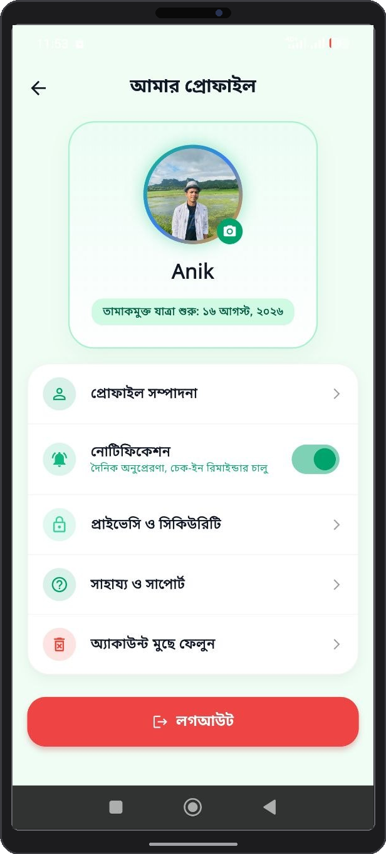
⑦
⑥
⑤
④
③
①
②
Figure 17: User Profile & Account Configuration Screen
① Profile Picture & User Info Header: Displays user photo, display name ('Anik'), and quit journey start date ('তামাকমুক্ত যাত্রা শুরু: ১৬ আগস্ট, ২০২৬').
② Profile Sompadona (Edit Profile Link): Link to re-configure user personal details, display name, and profile settings ('প্রোফাইল সম্পাদনা').
③ Notification Settings Switch: Toggle switch to enable or disable daily motivation alerts and check-in reminders ('নোটিফিকেশন').
④ Privacy & Security Option: Access account data protection settings and privacy options ('প্রাইভেসি ও সিকিউরিটি').
⑤ Help & Support Link: Assistance portal for user guidelines, support, and feedback ('সাহায্য ও সাপোর্ট').
⑥ Delete Account Option: Security feature allowing users to permanently delete their account ('অ্যাকাউন্ট মুছে ফেলুন').
⑦ Logout Action Button: Prominent red button to securely log out of the active user session ('লগআউট').
Table 3: QuitMate Mobile Application Feature Capabilities
Mobile Module | Screen Reference | Core Functional Features
Home Dashboard | Figure 9: Home screen.png | Real-time quit timer, health recovery %, money saved counter, tobacco avoided.
Daily Quit Plan | Figure 10: daily porikolpona.png | Structured 24-hour tasks, goal checklists, daily wellness challenges.
Daily Check-in | Figure 11: daily check in.png | Craving intensity logger, trigger tracker, daily mood entry, streak calculator.
Emergency SOS | Figure 12: sos button.png | 5-minute craving survival timer, 4-7-8 breathing exercise, drink water reminder, call a friend link, and take a walk logger.
Money Saver | Figure 13: Money saver screen.png | Total money saved banner, Notun Sopno button (add new dream), wishlist and reward milestones list.
Community Forum | Figure 14: Sohoyota group.png | Peer discussion board, post sharing, encouragement likes, group support.
Educational Content | Figure 15: educational content.png | Nicotine withdrawal articles, coping guides, health video tutorials.
Gamification Hub | Figure 16: gamification icon.png | Milestone badges, achievement trophies, quit level progression system.
My Profile | Figure 17: my profile.png | Profile picture & info header, profile edit (Profile Sompadona), notification toggle, privacy & security, help & support, delete account, logout.

Chapter 4: System Administration & Troubleshooting

4.1 Troubleshooting Matrix
If you encounter operational issues while using QuitMate, consult the troubleshooting matrix below for quick solutions.
Table 4: Common Troubleshooting & Solutions Matrix
Symptom / Issue | Probable Cause | Recommended Solution
Google Sign-In fails or hangs | Network disruption or Google Play Services out of date. | Check internet connection, update Google Play Services, restart the app.
Dashboard stats not updating | Local offline cache waiting for cloud sync. | Pull down on Home Dashboard to refresh, verify mobile data is active.
Push notifications not received | Notification permissions disabled in system settings. | Navigate to Phone Settings > Apps > QuitMate > Allow Notifications.
SOS button unresponsive | Device background service restricted by battery saver. | Disable battery saver mode for QuitMate in device battery settings.

4.2 Frequently Asked Questions (FAQ)
Q1: Is QuitMate free to use?
Ans: Yes, QuitMate is fully open-access for users seeking tobacco cessation support.
Q2: What happens if I slip up and consume tobacco?
Ans: Use the Daily Check-in to log the slip-up. QuitMate will analyze the trigger, adjust your daily plan, and offer supportive guidance without resetting all your hard-earned progress.
Q3: How is my personal data protected?
Ans: All data is encrypted in transit and at rest using Firebase cloud security standards.

4.3 Technical Support & Contact Details
For technical support, bug reporting, or feedback, please contact the development team:
- App Developers: Md. Ariful Islam (ID: MUH2325010M) & Mohammed Karimul Mowla (ID: ASH2325031M)
- Institution: Institute of Information Technology, Noakhali Science and Technology University (NSTU)
- Project Repository: https://github.com/Ariful-Islam010/tamak

Supervisor Approval
Project Title: QuitMate – Tobacco Awareness

Group Members:
1. Md Ariful Islam ID: MUH2325010M
2. Mohammed Karimul Mowla ID: ASH2325031M

I have reviewed the User Manual Report of the above-mentioned SPL-2 project.
Supervisor:
Tasnim Rahman
Assistant Professor,
IIT, NSTU

_________________________________

Supervisor Signature
Date: 16-8-2026

