SOFTWARE TECHNICAL DOCUMENTATION
QuitMate Mobile Application
User Manual
A Comprehensive Operational & Technical Guide to the Tobacco Cessation Mobile Application
―――――――――――――――――――――――――――――――――――――――――――――
Prepared & Developed By:
• Md. Ariful Islam (ID: MUH2325010M)
• Mohammed Karimul Mowla (ID: ASH2325031M)
Institute of Information Technology
Noakhali Science and Technology University
Document Version: 1.0 | Release Date: August 2026

Document Control & Revision History
This user manual is maintained under strict document version control. Any updates, feature additions, or modifications to the QuitMate application suite are reflected in updated revisions of this document.
Table 1 1: Document Revision & Approval History
Version | Date | Author(s) | Key Changes & Summary | Status
0.1 | 10 Aug 2026 | Md. Ariful Islam | Initial draft of mobile screen workflows and architecture outline. | Draft
0.2 | 15 Aug 2026 | M. K. Mowla | Added mobile assessment parameters and feature capabilities. | Reviewed
1.0 | 21 Aug 2026 | Ariful & Mowla | Final Release: Mobile app focused manual with updated screenshots & transparent shapes. | Approved

Executive Summary
QuitMate is an evidence-based, digital health mobile application designed to assist individuals in quitting smoking and tobacco consumption. By combining personalized quitting plans, real-time health progress tracking, financial savings calculators, emergency SOS craving support, educational micro-modules, and community peer support, QuitMate provides a holistically supportive ecosystem for users striving for a tobacco-free lifestyle.
This document serves as the comprehensive User Manual for the QuitMate Mobile Application. Every screen interface is presented inside a clean mobile phone mockup frame overlaid with 100% transparent, native Microsoft Word red shape callout objects that can be moved, resized, or adjusted manually inside Word.

Table of Contents
Document Control & Revision History 2
Executive Summary 2
Table of Contents 2
List of Figures 4
List of Tables 5
Chapter 1: Introduction & System Architecture 6
1.1 Purpose of the User Manual 6
1.2 About QuitMate 6
1.3 System Architecture & Tech Stack 6
1.4 User Roles & Access Hierarchy 6
Chapter 2: Getting Started & User Onboarding 7
2.1 System Requirements & Installation 7
2.2 Launching QuitMate 7
2.3 Authentication & Google Sign-In 9
2.4 Profile Assessment Setup 10
2.4.1 User Category / Class Selection 11
2.4.2 User Name Input 11
2.4.3 Age Selection 12
2.4.4 Gender Selection 13
2.4.5 Quit Plan Duration Setup 14
Chapter 3: QuitMate Mobile Application Guide 17
3.1 Home Dashboard & Cessation Tracker 17
3.2 Daily Quit Plan ("Daily Porikolpona") 18
3.3 Daily Check-in & Craving Log 19
3.4 Emergency SOS Craving Relief 21
3.5 Financial Savings & Health Milestones 22
3.6 Support Group & Community Forum ("Sohoyota Group") 23
3.7 Educational Content & Health Modules 23
3.8 Gamification & Achievement Badges 24
3.9 User Profile & Account Management 26
Chapter 4: System Administration & Troubleshooting 28
4.1 Troubleshooting Matrix 28
4.2 Frequently Asked Questions (FAQ) 28
4.3 Technical Support & Contact Details 28

List of Figures
Figure 1: QuitMate Application Icon 8
Figure 2: Application Splash Screen Interface 9
Figure 3: Google Sign-In & Authentication Interface 10
Figure 4: Profile Assessment - User Category Selection 11
Figure 5: Profile Assessment - User Name Input 12
Figure 6: Profile Assessment - User Age Selection 13
Figure 7: Profile Assessment - User Gender Selection 14
Figure 8: Profile Assessment - Quit Plan Duration Setup 15
Figure 9: QuitMate Home Dashboard & Progress Tracker 17
Figure 10: Daily Quit Plan (Daily Porikolpona) Interface 19
Figure 11: Daily Check-in & Craving Tracker 20
Figure 12: Emergency SOS Craving Relief Interface 21
Figure 13: Financial Savings & Health Milestones Screen 22
Figure 14: Support Group (Sohoyota Group) Community Portal 23
Figure 15: Educational Health Articles & Cessation Content 24
Figure 16: Gamification & Achievement Badge Interface 25
Figure 17: User Profile & Account Configuration Screen 26

List of Tables
Table 1 1: Document Revision & Approval History 2
Table 2: QuitMate System Architecture & Component Stack 6
Table 3: Onboarding Profile Assessment Parameters Matrix 15
Table 4: QuitMate Mobile Application Feature Capabilities 26
Table 5: Common Troubleshooting & Solutions Matrix 28

Chapter 1: Introduction & System Architecture

1.1 Purpose of the User Manual
The purpose of this manual is to provide operational guidance, feature descriptions, and technical specifications for end-users and health facilitators operating the QuitMate mobile platform. It ensures seamless onboarding and effective daily usage.

1.2 About QuitMate
QuitMate is designed to address tobacco addiction by leveraging behavioral therapy principles, positive reinforcement, real-time tracking, and peer community interaction. Tobacco dependency poses severe long-term health risks; QuitMate simplifies the cessation journey into manageable daily goals, celebrating smoke-free milestones and providing instant intervention during high-craving moments.

1.3 System Architecture & Tech Stack
The QuitMate ecosystem comprises a cross-platform Flutter client mobile application backed by Firebase serverless infrastructure.
Table 2 2: QuitMate System Architecture & Component Stack
Component | Technology Stack | Core Functionality & Role | Deployment
Mobile Client | Flutter, Dart, Provider / Bloc | Client interface for end-users: assessment, tracking, SOS, gamification, community. | Android / iOS
Cloud Backend | Firebase Auth, Firestore, Cloud Storage | Real-time user data synchronization, authentication, media storage, push notifications. | Cloud
Notification Engine | Firebase Cloud Messaging (FCM) | Automated daily check-in reminders, motivational alerts, panic support dispatching. | Cloud Engine

1.4 User Roles & Access Hierarchy
QuitMate mobile client is designed for End-Users seeking tobacco cessation support. End-users have access to personalized quit dashboards, craving logs, community forums, and profile configurations.

Chapter 2: Getting Started & User Onboarding

2.1 System Requirements & Installation
To run the QuitMate mobile application seamlessly, mobile devices should meet the following minimum specifications:
• Android OS: Version 7.0 (Nougat) or higher (RAM: 2 GB minimum).
• iOS: Version 13.0 or higher.
• Internet Connectivity: Active Wi-Fi or Mobile Data connection required for account authentication and cloud syncing.

2.2 Launching QuitMate
Upon installing the application package, locate the QuitMate icon on your device home screen or app drawer. Tapping the icon launches the app, displaying a clean, branded splash screen while initializing local application storage and network services.
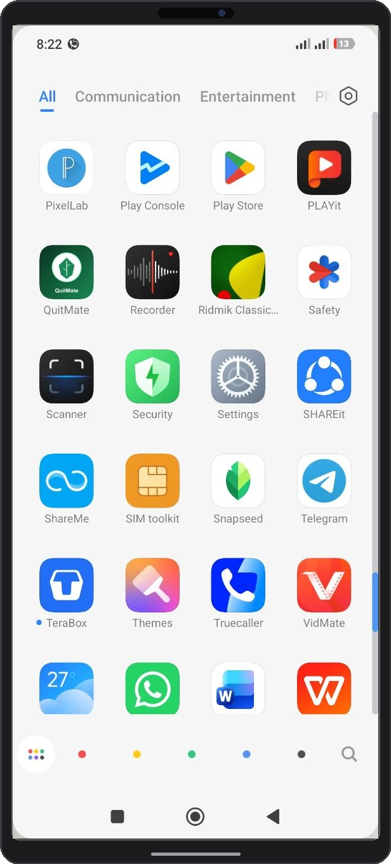
①
Figure 1 1: QuitMate Application Icon
① QuitMate Application Icon: App launcher on the Android/iOS home screen. Tapping this icon initializes application storage, Hive database, and Firebase cloud listeners.

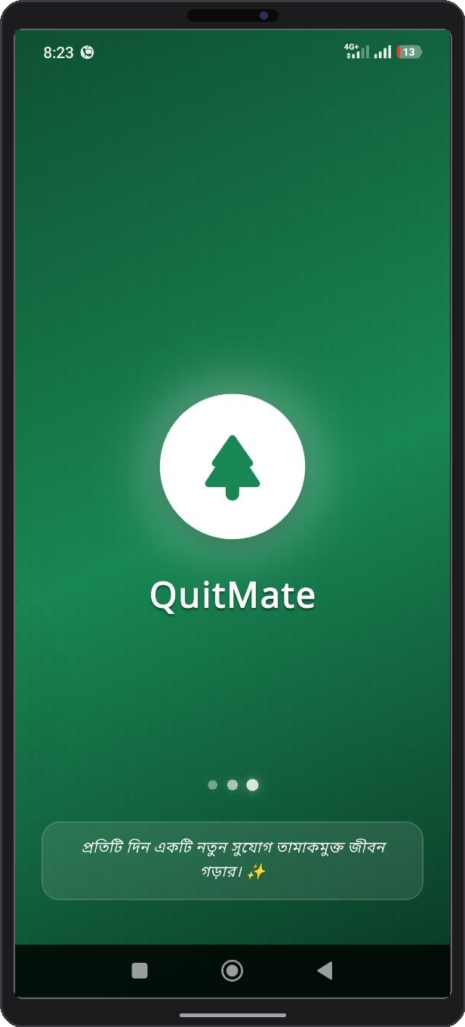
②
①
Figure 2 2: Application Splash Screen Interface
① QuitMate Brand Emblem: Displays official anti-tobacco branding logo and app title.
② Initialization Progress Loader: Indicates active loading of system assets, user authentication tokens, and local cache databases.

2.3 Authentication & Google Sign-In
QuitMate offers seamless, secure one-tap authentication via Google Sign-In. This ensures user profiles are securely tied to Google Cloud credentials, enabling automatic progress cloud backups and effortless account recovery across multiple devices.
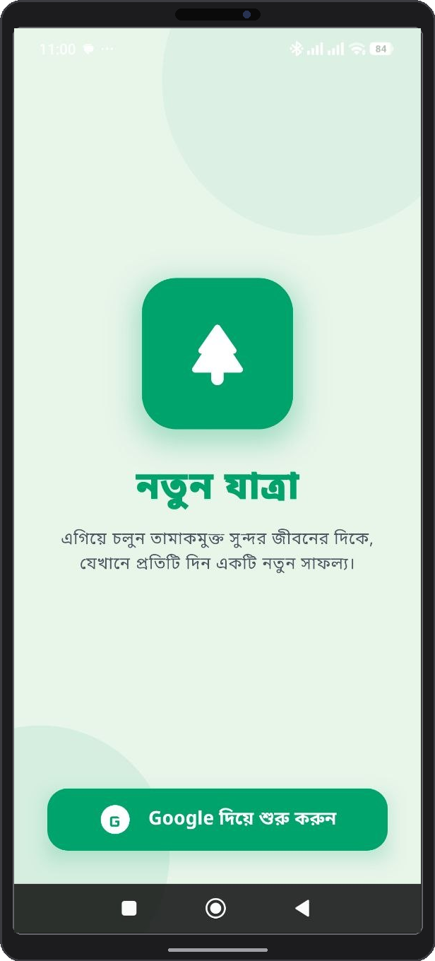
②
①
Figure 3 3: Google Sign-In & Authentication Interface
① Welcome & Security Header Card: Displays security overview and user data privacy assurance.
② Google One-Tap Sign-In Button: Triggers OAuth 2.0 Google single sign-on authentication flow.
③ Terms & Privacy Policy Link: Opens official documentation regarding data encryption and anonymous handling.

2.4 Profile Assessment Setup
Following initial authentication, new users undergo a guided assessment wizard. This assessment collects essential smoking history data to dynamically calibrate personalized quitting metrics, money savings calculators, and health recovery timelines.

2.4.1 User Category / Class Selection
Users select their addiction profile or category (e.g., Heavy Smoker, Moderate Smoker, Casual Smoker, or Vaper). This classification tailors daily task difficulty and craving support intensity.
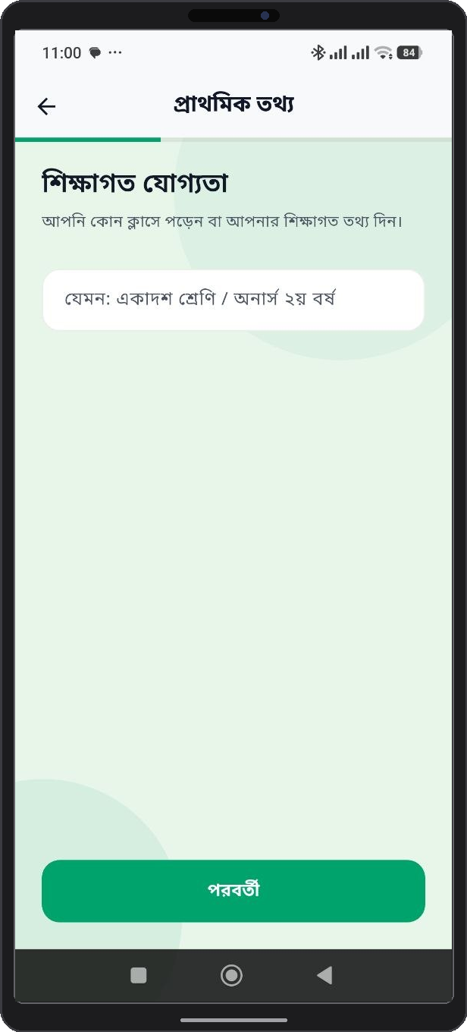
②
①
Figure 4 4: Profile Assessment - User Category Selection
① Addiction Category Cards: Interactive cards to classify addiction severity (Heavy Smoker, Moderate Smoker, Light Smoker, Vaper).
② Next Action Button: Saves selected category and advances to Name input screen.

2.4.2 User Name Input
Enter your preferred display name. This name is used to personalize daily motivational alerts and greeting messages on the Home Dashboard.
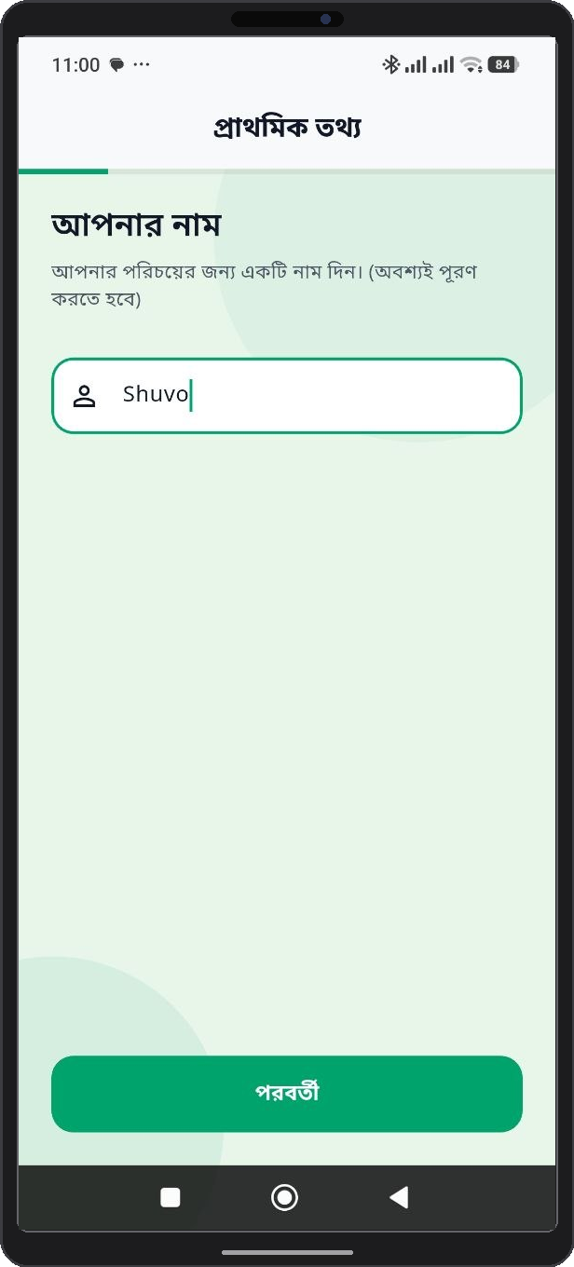
②
①
Figure 5 5: Profile Assessment - User Name Input
① Display Name Textfield: Alphanumeric input box to type preferred user display name or alias.
② Continue Button: Validates text input and proceeds to Age selection step.

2.4.3 Age Selection
Select your age bracket. Age parameters help QuitMate compute baseline biological recovery benchmarks, such as lung capacity improvement rate and cardiovascular risk reduction timers.
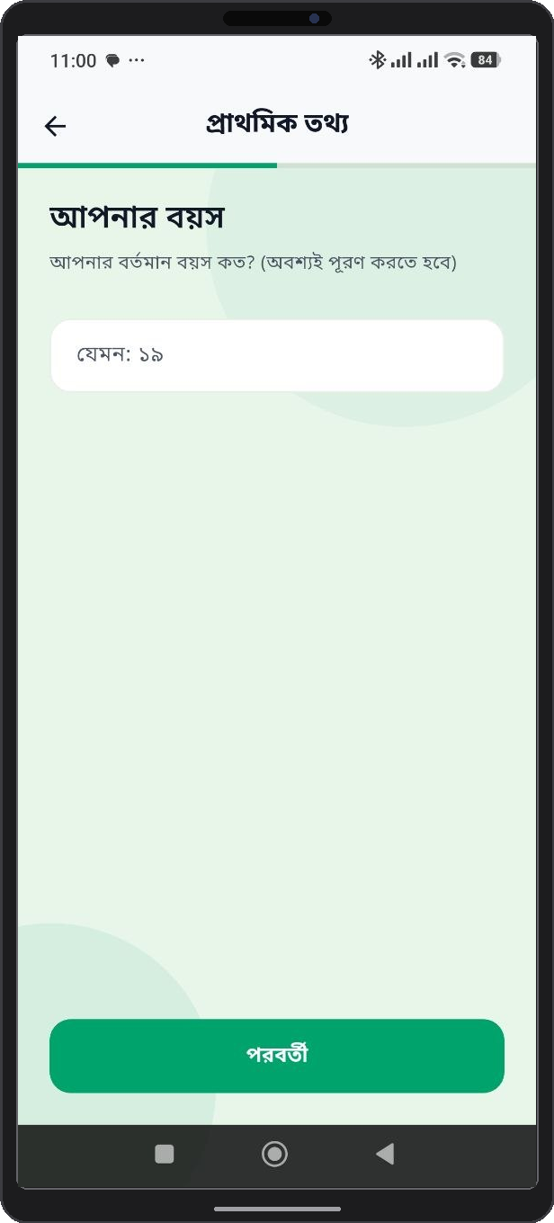
②
①
Figure 6 6: Profile Assessment - User Age Selection
① Age Picker / Input Control: Interactive picker to define user age (used in physiological recovery algorithms).
② Confirm Age Button: Saves age selection and advances to Gender selection.

2.4.4 Gender Selection
Select gender orientation to fine-tune health insights and wellness recommendations tailored to demographic health indicators.
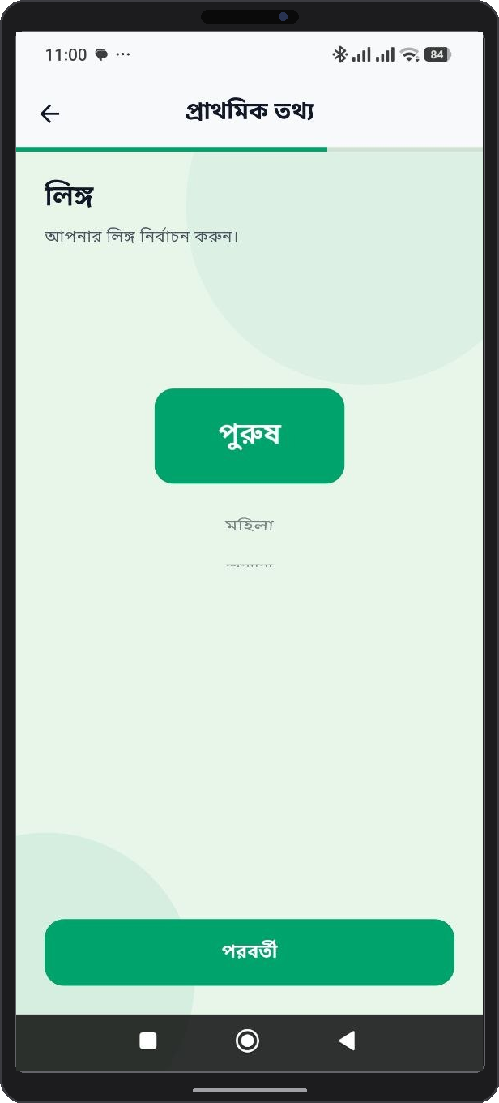
②
①
Figure 7 7: Profile Assessment - User Gender Selection
① Gender Selection Cards: Radio selection options (Male, Female, Non-binary/Prefer not to say).
② Proceed Button: Saves gender profile data and advances to Plan Duration setup.

2.4.5 Quit Plan Duration Setup
Specify your target quit duration (e.g., 30 days, 60 days, 90 days, or permanent cessation). QuitMate constructs a milestone-driven roadmap based on this target date.
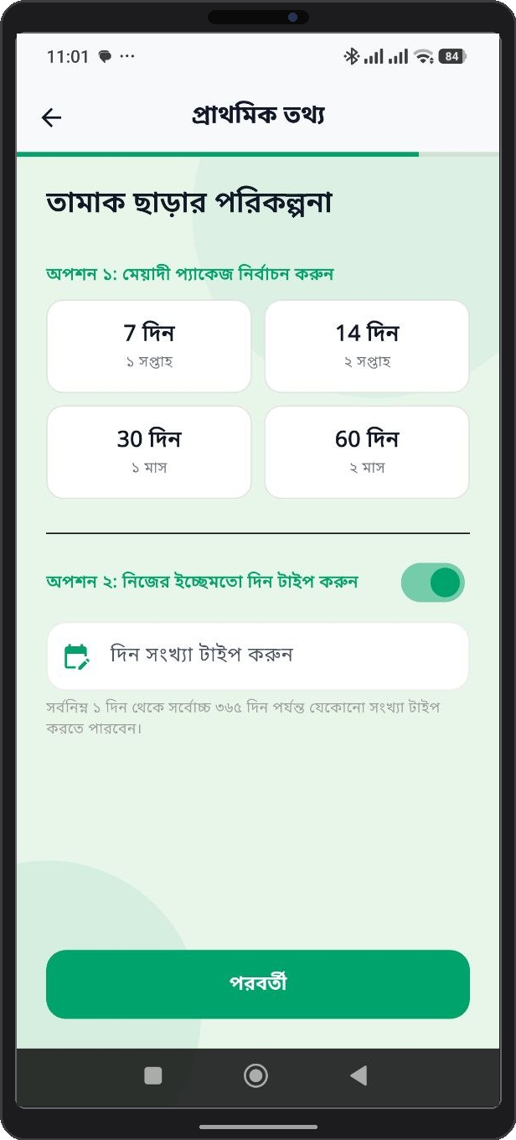
②
①
Figure 8 8: Profile Assessment - Quit Plan Duration Setup
① Target Quit Duration Picker: Duration options picker (30 Days, 60 Days, 90 Days, Lifetime Cessation).
② Finish Setup & Launch Button: Finalizes onboarding, initializes quit timers, and opens Home Dashboard.

Table 3 3: Onboarding Profile Assessment Parameters Matrix
Assessment Step | Input Field / Selection | System Function & Impact
1. Smoker Class | Dropdown (Heavy / Moderate / Light) | Calibrates daily cigarette savings baseline & craving alert frequency.
2. Display Name | Text Input (Alphanumeric) | Personalizes application headers, greeting cards, and community posts.
3. User Age | Numeric Slider / Picker | Calculates customized physiological health recovery milestone speeds.
4. Gender | Radio Button Selection | Adapts health tips and demographic-specific wellness articles.
5. Plan Duration | Duration Picker (Days / Weeks) | Establishes total target quit timeline and achievement badge milestones.

Chapter 3: QuitMate Mobile Application Guide

3.1 Home Dashboard & Cessation Tracker
The Home Dashboard is the primary central hub of QuitMate. It features real-time progress counters displaying consecutive smoke-free days, hours, and minutes. It also presents live statistics for total money saved, cigarettes avoided, and current health recovery percentages.
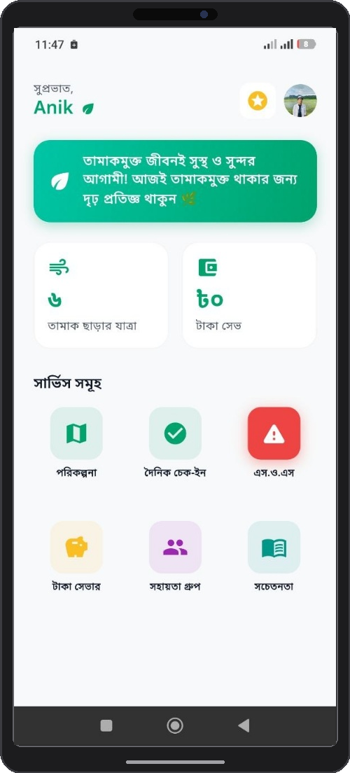
⑪
⑩
⑨
⑧
⑦
⑥
⑤
④
③
②
①
Figure 9 9: QuitMate Home Dashboard & Progress Tracker
① Motivational Message Banner: Top green banner displaying daily motivational quote to reinforce quitting commitment ('তামাকমুক্ত জীবনই সুস্থ ও সুন্দর আগামী! আজই তামাকমুক্ত থাকার জন্য দৃঢ় প্রতিজ্ঞ থাকুন 🌿').
② Tamak Charar Jatra (Days Smoke-Free Counter): Stat card tracking consecutive smoke-free days elapsed since quitting ('৬ তামাক ছাড়ার যাত্রা').
③ Taka Saved (Money Saved Counter): Stat card dynamically tracking financial money saved based on cigarette pack price ('৮০ টাকা সেভ').
④ Porikolpona (Daily Plan Service Icon): Quick action icon launching personalized 24-hour daily quit plan goals.
⑤ Dainik Check-in (Daily Check-in Service Icon): Quick action icon opening daily craving, mood, and trigger check-in logger.
⑥ SOS (Emergency Panic Service Icon): Prominent red emergency icon launching instant craving distraction and breathing exercises.
⑦ Taka Saver (Money Saver Service Icon): Quick action icon opening cumulative financial savings tracker and wishlist reward planner.
⑧ Sohoyota Group (Support Group Service Icon): Quick action icon opening community peer discussion and mutual support forum.
⑨ Sachetanata (Awareness / Educational Content Icon): Quick action icon linking to expert health articles, videos, and coping guides.
⑩ Gamification Star Badge Icon: Header star icon displaying current quitter reward level and accumulated achievement XP points.
⑪ User Profile Avatar Icon: Header user photo icon opening personal account settings, display name edit, and habit configuration.

3.2 Daily Quit Plan ("Daily Porikolpona")
The Daily Quit Plan module breaks down long-term cessation into achievable 24-hour tasks. Users receive curated daily goals, such as hydration targets, deep breathing exercises, physical activity challenges, and cognitive distraction tasks.
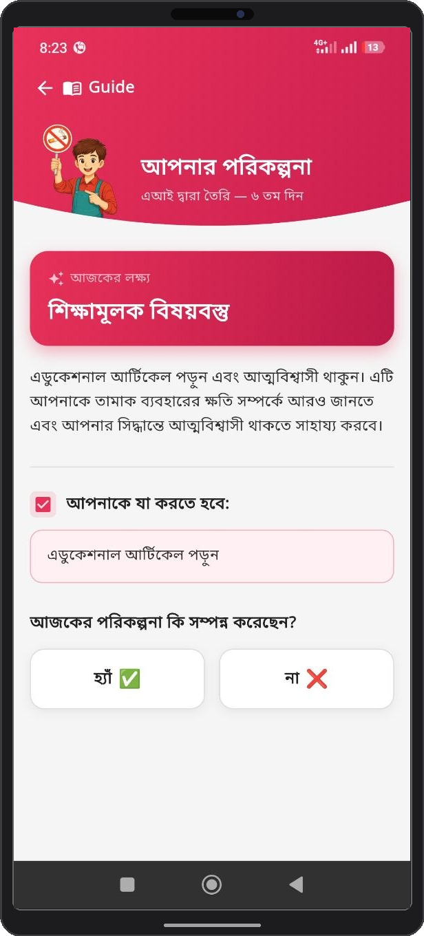
④
②
①
Figure 10 10: Daily Quit Plan (Daily Porikolpona) Interface
① Daily Date Navigation Header: Calendar date switcher to view past completed tasks or upcoming goals.
② 24-Hour Task Checklist Container: List of personalized daily micro-tasks (hydration, 10-min walk, breathing exercises).
③ Task Completion Check Toggles: Interactive checkboxes to mark goals completed .

3.3 Daily Check-in & Craving Log
Every evening, users complete a quick Daily Check-in. This feature logs whether the user successfully remained smoke-free, records craving intensity levels, identifies relapse triggers (e.g., stress, social gatherings, alcohol), and logs overall mood trends.
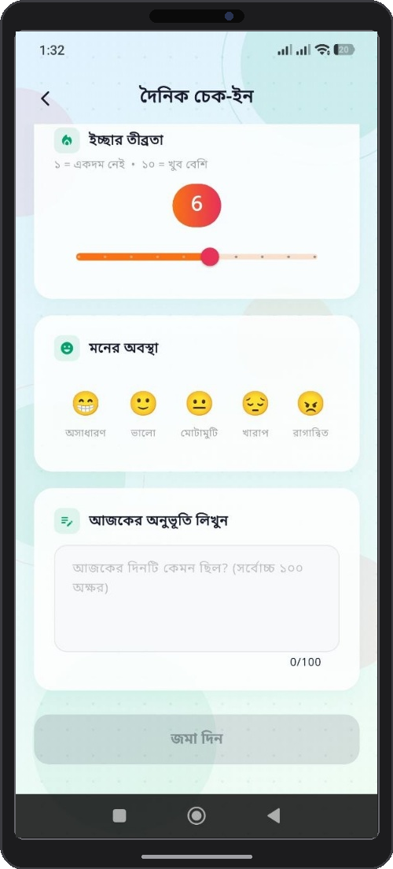
⑤
④
③
②
①
Figure 11 11: Daily Check-in & Craving Tracker
① Daily Check-in Header Bar: Top navigation header bar with back navigation button ('দৈনিক চেক-ইন').
② Icchar Tribrata (Craving Intensity Slider): Interactive rating scale slider (1 to 10) logging urge severity ('ইচ্ছার তীব্রতা: ১ = একদম নেই, ১০ = খুব বেশি').
③ Moner Obostha (Mood Selector Cards): Interactive emoji cards to log daily mood ('অসাধারণ', 'ভালো', 'মোটামুটি', 'খারাপ', 'রাগান্বিত').
④ Ajker Onubhuti Likhun (Daily Note Text Box): Text area (up to 100 characters) to log personal daily journal thoughts ('আজকের অনুভূতি লিখুন').
⑤ Joma Din (Submit Check-in Button): Action button to save daily check-in entry and update consecutive streak counter ('জমা দিন').

3.4 Emergency SOS Craving Relief
During acute craving spikes, users can press the prominent SOS Emergency Button located on the navigation bar. Activating SOS instantly launches rapid distraction tools, guided 4-7-8 breathing exercises, motivational audio clips, and quick-dial support contacts to prevent relapse.
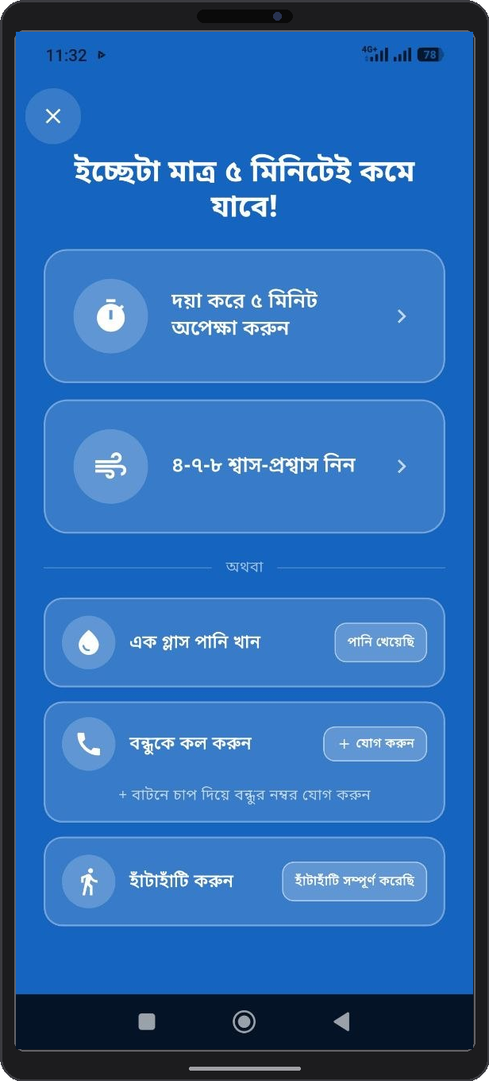
④
③
②
①
Figure 12 12: Emergency SOS Craving Relief Interface
① Emergency Panic Button Trigger: Prominent red button triggering immediate acute craving distraction workflow.
② Guided 4-7-8 Breathing Card: Launches interactive visual breathing animation for immediate stress relief.
③ Motivational Audio & Quote Cards: Quick playable audio clips and uplifting quotes to reinforce willpower.
④ Emergency Support Call Dialer: One-tap phone link to national tobacco cessation support hotlines.

3.5 Financial Savings & Health Milestones
The Money Saver screen dynamically calculates the cumulative money saved based on pack cost and daily consumption rate. It correlates saved funds with real-world reward items (e.g., buying a book, movie ticket, or gadget) to provide tangible positive reinforcement.
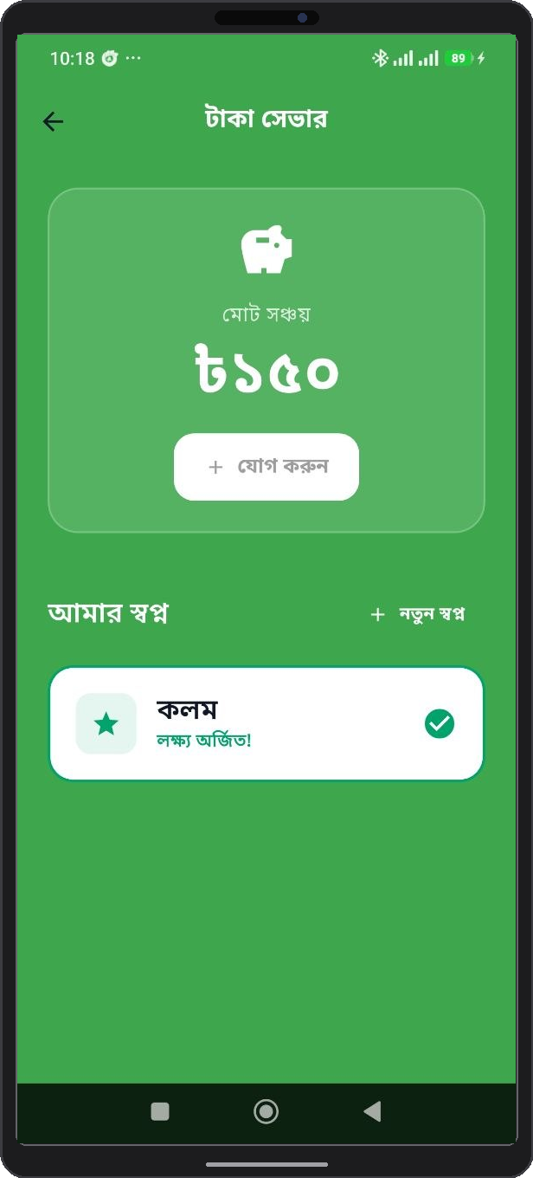
③
②
①
Figure 13 13: Financial Savings & Health Milestones Screen
① Total Accumulated Savings Banner: Highlighted metric banner showing total money saved to date.
② Daily Cost Breakdown Card: Displays pack expenditure rate, cost per cigarette, and hourly savings.
③ Wishlist & Reward Milestones List: Correlates saved money with real-world purchase targets (books, clothes, gadgets).

3.6 Support Group & Community Forum ("Sohoyota Group")
The 'Sohoyota Group' community tab allows users to connect with fellow quitters. Users can post progress updates, share personal stories, exchange coping strategies, and offer encouragement to peers navigating similar cessation challenges.
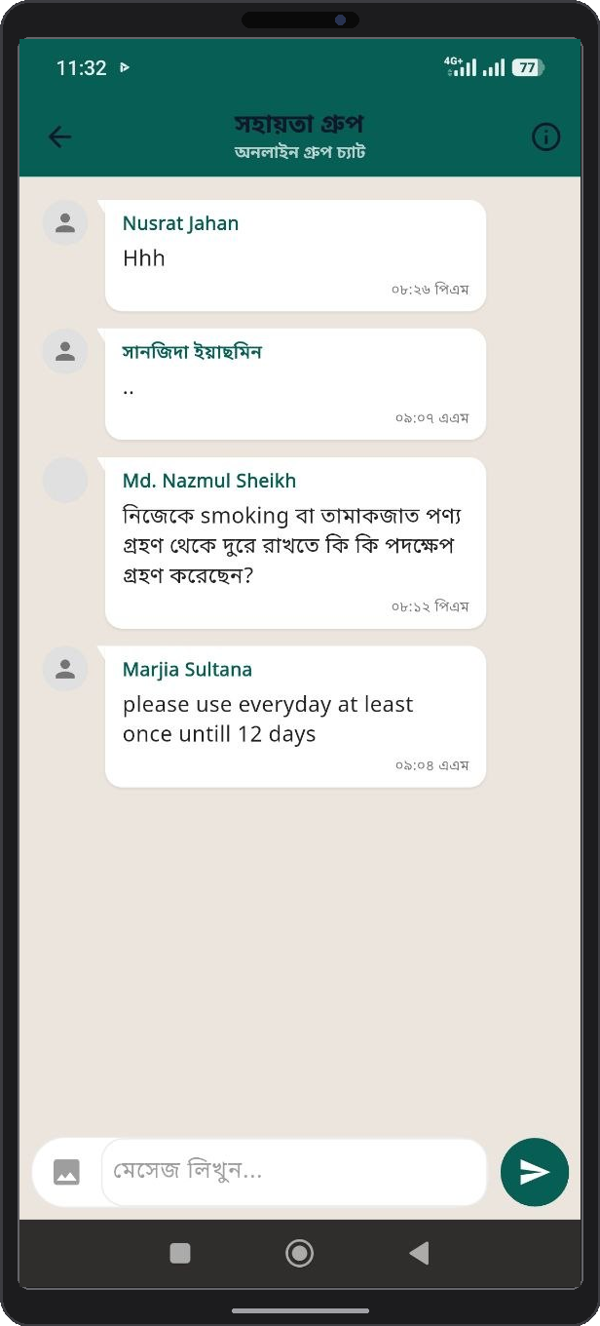
①
Figure 14 14: Support Group (Sohoyota Group) Community Portal
① Community Guideline Exclamation Icon (!): Top right exclamation icon indicating official community guidelines, forum safety rules, respectful discussion policies, and content moderation guidelines for peer interactions.

3.7 Educational Content & Health Modules
Access a comprehensive library of evidence-based health articles, expert videos, and micro-learning modules. Topics include managing nicotine withdrawal symptoms, nutritional guidance during quitting, stress reduction techniques, and long-term relapse prevention.
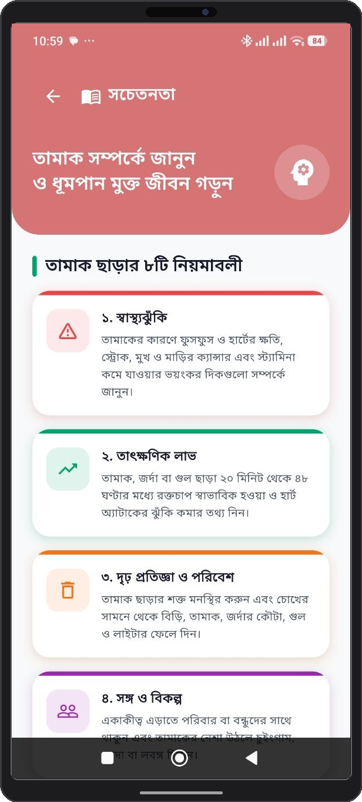
Figure 15 15: Educational Health Articles & Cessation Content

3.8 Gamification & Achievement Badges
To maintain engagement, QuitMate incorporates a rich gamification framework. Users earn digital badges, unlock achievement trophies, and level up as they reach key quit milestones (e.g., 24 Hours Smoke-Free, 1 Week Clean, 1 Month Hero, Money Saver Milestone).
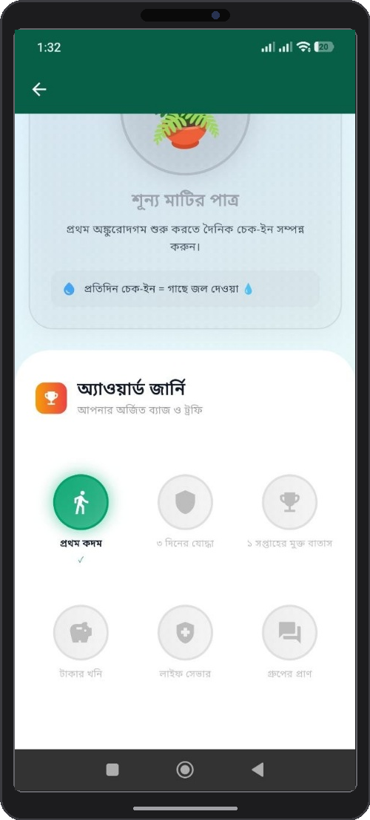
①
②
③
④
⑤
⑥
⑦
⑧
Figure 16 16: Gamification & Achievement Badge Interface
① Shunya Matir Patra (Plant Growth Card): Card tracking daily check-in streak and virtual plant watering progress ('শূন্য মাটির পাত্র').
② Award Journey Header Banner: Title banner introducing earned badges and trophies ('অ্যাওয়ার্ড জার্নি: আপনার অর্জিত ব্যাজ ও ট্রফি').
③ Unlocked Badge - Prothom Kodom (First Step): Milestone badge celebrating initial quitting milestone ('প্রথম কদম').
④ Badge - 3 Diner Joddha (3 Days Warrior): Badge awarded for maintaining 3 consecutive smoke-free days ('৩ দিনের যোদ্ধা').
⑤ Badge - 1 Saptaher Mukto Batas (1 Week Fresh Air): Badge awarded for completing 1 full smoke-free week ('১ সপ্তাহের মুক্ত বাতাস').
⑥ Badge - Takar Khoni (Money Mine): Financial savings milestone badge ('টাকার খনি').
⑦ Badge - Life Saver: Biological health recovery milestone badge ('লাইফ সেভার').
⑧ Badge - Group-er Pran (Heart of Group): Community engagement milestone badge ('গ্রুপের প্রাণ').

3.9 User Profile & Account Management
The Profile screen allows users to manage personal account details, adjust quitting preferences, update cigarette pricing metrics, configure push notification schedules, view historical log archives, or sign out securely.
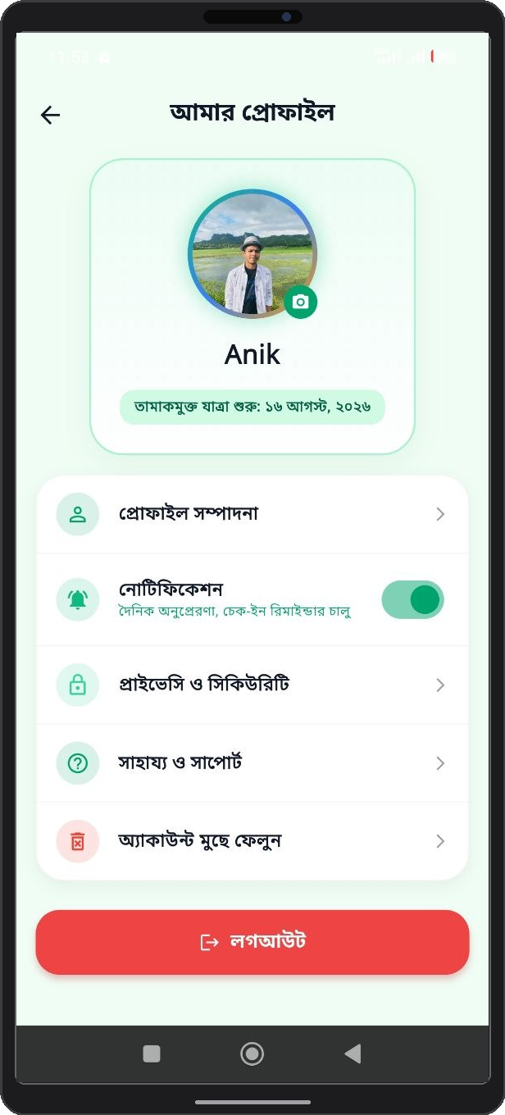
①
②
③
④
Figure 17 17: User Profile & Account Configuration Screen
① Profile Avatar & User Header: Displays user display photo, name, and member join date.
② Cigarette Price & Habit Edit Link: Re-configures pack cost, daily cigarette count, and target quit date.
③ Push Notification Toggles: Toggle switches to enable/disable check-in reminders and SOS alerts.
④ Sign-Out Account Button: Securely logs out of active session and clears local session cache.

Table 4 4: QuitMate Mobile Application Feature Capabilities
Mobile Module | Screen Reference | Core Functional Features
Home Dashboard | Figure 9: Home screen.png | Real-time quit timer, health recovery %, money saved counter, cigarettes avoided.
Daily Quit Plan | Figure 10: daily porikolpona.png | Structured 24-hour tasks, goal checklists, daily wellness challenges.
Daily Check-in | Figure 11: daily check in.png | Craving intensity logger, trigger tracker, daily mood entry, streak calculator.
Emergency SOS | Figure 12: sos button.png | Instant craving relief button, guided breathing timer, panic support contacts.
Money Saver | Figure 13: Money saver screen.png | Financial savings tracker, purchase milestone planner, cost analytics.
Community Forum | Figure 14: Sohoyota group.png | Peer discussion board, post sharing, encouragement likes, group support.
Educational Content | Figure 15: educational content.png | Nicotine withdrawal articles, coping guides, health video tutorials.
Gamification Hub | Figure 16: gamification icon.png | Milestone badges, achievement trophies, quit level progression system.
My Profile | Figure 17: my profile.png | Account configuration, pricing metrics edit, notification toggle, data export.

Chapter 4: System Administration & Troubleshooting

4.1 Troubleshooting Matrix
If you encounter operational issues while using QuitMate, consult the troubleshooting matrix below for quick solutions.
Table 5 5: Common Troubleshooting & Solutions Matrix
Symptom / Issue | Probable Cause | Recommended Solution
Google Sign-In fails or hangs | Network disruption or Google Play Services out of date. | Check internet connection, update Google Play Services, restart the app.
Dashboard stats not updating | Local offline cache waiting for cloud sync. | Pull down on Home Dashboard to refresh, verify mobile data is active.
Push notifications not received | Notification permissions disabled in system settings. | Navigate to Phone Settings > Apps > QuitMate > Allow Notifications.
SOS button unresponsive | Device background service restricted by battery saver. | Disable battery saver mode for QuitMate in device battery settings.

4.2 Frequently Asked Questions (FAQ)
Q1: Is QuitMate free to use?
Ans: Yes, QuitMate is fully open-access for users seeking tobacco cessation support.
Q2: What happens if I slip up and smoke a cigarette?
Ans: Use the Daily Check-in to log the slip-up. QuitMate will analyze the trigger, adjust your daily plan, and offer supportive guidance without resetting all your hard-earned progress.
Q3: How is my personal data protected?
Ans: All data is encrypted in transit and at rest using Firebase cloud security standards.

4.3 Technical Support & Contact Details
For technical support, bug reporting, or feedback, please contact the development team:
• Lead Developer: Md. Ariful Islam (ID: MUH2325010M)
• Co-Developer: Mohammed Karimul Mowla (ID: ASH2325031M)
• Institution: Institute of Information Technology, Noakhali Science and Technology University (NSTU)
• Project Repository: https://github.com/Ariful-Islam010/tamak

