Institute of Information Technology
Noakhali Science and Technology University
Bachelor of Science in Software Engineering
Course Name: Software Project Lab-II
Course Code: SE 3112
PROJECT USER MANUAL REPORT
Title: QuitMate – Tobacco Awareness
Submitted By:  Md Ariful Islam  ID: MUH2325010M  Mohammed Karimul Mowla  ID: ASH2325031M | Supervised By:  Supervisor's Name: ____________  Designation: __________________  Institute of Information Technology  Noakhali Science and Technology University

Submission Date: August 2026

Table of Contents

[ Open in Word -> press Ctrl+A -> press F9 -> select 'Update entire table' -> OK ]

List of Figures
Figure 1: Google Sign-In / Login Screen
Figure 2: Profile Assessment – Name Input
Figure 3: Profile Assessment – Age Input
Figure 4: Profile Assessment – Gender Selection
Figure 5: Profile Assessment – Educational Info
Figure 6: AI Quit Plan – Date & Duration Selection
Figure 7: Home Dashboard Screen
Figure 8: AI-Generated Quit Plan Screen
Figure 9: Money Saver Screen
Figure 10: Gamification – Tree Growth Screen
Figure 11: Educational Content Screen
Figure 12: Daily Check-In Screen
Figure 13: SOS Emergency Screen
Figure 14: Peer Support Community Screen
Figure 15: User Profile Screen

1. Project Overview
QuitMate is a Flutter-based mobile application designed to assist tobacco users in quitting their habit. The app provides an AI-powered personalized quit plan, daily habit tracking, a real-time peer support community, financial savings tracking, and a gamified progress system. The application is developed in Bengali to serve Bangladeshi users in a culturally relevant and accessible way.

Purpose of the Project
- To provide a structured, AI-driven digital companion for individuals seeking to quit tobacco use.
- To raise awareness about the health and financial consequences of tobacco use.
- To motivate users through gamification, peer support, and real-time savings tracking.

Main Objectives
- Generate personalized AI-powered day-by-day quit plans using Groq AI.
- Track daily tobacco-free streaks, mood, and craving levels.
- Display money saved since the user quit tobacco.
- Provide an SOS craving-distraction tool with breathing exercises and a timer.
- Support community motivation through a real-time peer support forum.
- Motivate users with a gamified virtual tree-growth visualization.
- Offer educational articles and health recovery milestones.

Target Users
- Tobacco and cigarette users who are motivated to quit.
- Students and young adults in Bangladesh aged 15 to 40.
- Health-conscious individuals and counselors supporting quit-smoking programs.

Major Functions of the System
- Secure Google Sign-In authentication via Firebase.
- Multi-step profile onboarding and addiction assessment.
- AI-generated personalized quit plan.
- Daily check-in: mood tracking, craving level, and reflection notes.
- SOS Emergency screen with breathing exercises and 5-minute wait timer.
- Money Saver: tracks daily savings and personal Dream Goals.
- Peer Support Forum: real-time community chat with image sharing.
- Gamification: virtual tree that grows with each tobacco-free day.
- Educational content: health facts and articles about tobacco harm.
- Web-based Admin Panel for monitoring users and moderating content.

2. System Requirements

2.1 Hardware Requirements
The following minimum hardware is required to run QuitMate:
Component | Minimum Requirement
Processor | Quad-core 1.4 GHz or higher
RAM | 2 GB (Recommended: 4 GB)
Storage | 100 MB free internal storage
Display | 5.0 inch, 720p resolution or higher
Smartphone | Android smartphone
Internet Connection | Required (WiFi or Mobile Data)

2.2 Software Requirements
The following software environment is required:
Software / Platform | Specification
Mobile Operating System | Android 7.0 (Nougat) or higher
Application Framework | Flutter (Dart SDK ^3.10.8)
Authentication | Firebase (Google Sign-In OAuth 2.0)
Backend Server | Node.js + Express.js + PostgreSQL
AI Service | Groq AI API
Real-time Communication | Socket.IO

3. Installation and Setup
QuitMate is distributed as an Android APK file. Follow the steps below to install and configure the application on your device.
- Download the QuitMate APK file from the provided link or QR code.
- On your Android device, go to Settings > Security and enable 'Install from Unknown Sources'.
- Open the downloaded APK from your file manager and tap Install.
- Once installed, open QuitMate from your app drawer.
- Grant required permissions: Internet, Notifications, and Storage.
- Tap 'Google দিয়ে শুরু করুন' on the login screen to sign in with your Google account.
- Complete the Profile Assessment (name, age, gender, education, plan duration, quit date).
- Your AI Quit Plan is generated automatically. You are taken to the Home Dashboard.

Screenshot:
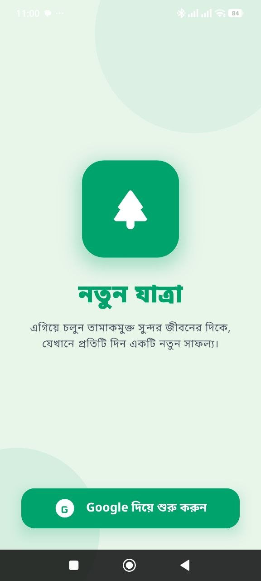
Figure 1: Google Sign-In / Login Screen

4. Getting Started

4.1 How to Open the Application
Tap the QuitMate icon on your home screen or app drawer. The application displays an animated splash screen followed by the Login screen.

4.2 Registration Procedure
QuitMate uses Google Sign-In, so no separate username or password is required. A Google account is sufficient to register.
- Tap the 'Google দিয়ে শুরু করুন' button on the login screen.
- Select your Google account from the popup.
- The system verifies your account via Firebase Authentication.
- First-time users are redirected to the Profile Assessment screen.

4.3 Login Procedure
Returning users who have completed the profile assessment are logged in automatically:
- Open the app and tap 'Google দিয়ে শুরু করুন'.
- Select your registered Google account.
- You are redirected directly to the Home Dashboard.

4.4 Home Page / Dashboard Description
The Home Dashboard is the central navigation hub. It displays:
- A time-based Bengali greeting (Good Morning / Afternoon / Evening / Night).
- A motivational banner showing tobacco-free days achieved.
- Two stat cards: Tobacco-free days and Money saved (in BDT).
- A 3x2 feature grid: Quit Plan, Daily Check-In, SOS, Money Saver, Community, Education.

Screenshot:
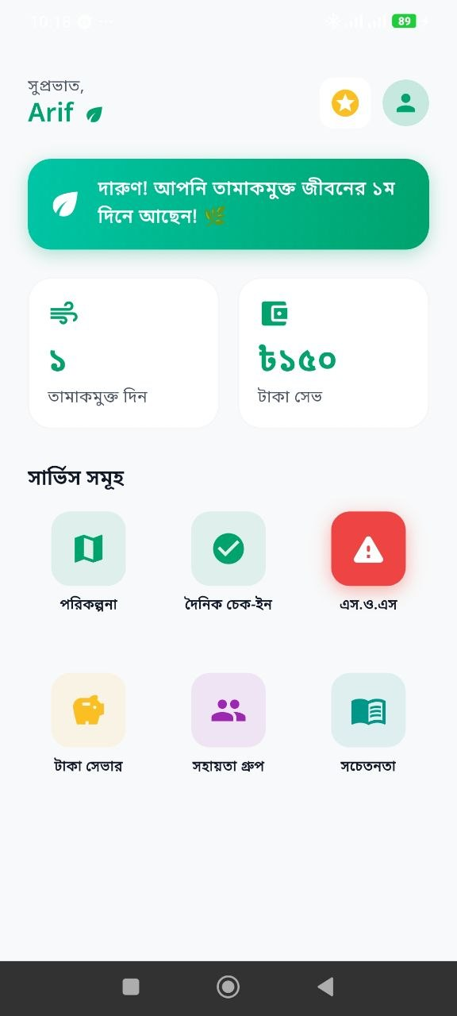
Figure 7: Home Dashboard Screen

4.5 Navigation Instructions
From the Home Dashboard, tap any feature card to open the corresponding screen. A back arrow is available on all sub-screens to return. The top-right corner provides shortcuts to Gamification (star icon) and User Profile (profile photo).

5. User Roles
QuitMate has two main user roles with different access levels and permissions.

5.1 Administrator
The Administrator accesses the system via a web-based Admin Panel secured with a password. Administrator capabilities include:
- View real-time statistics: total users, active users, messages, SOS logs, check-ins.
- View and manage all registered user accounts.
- Monitor and moderate community forum posts and messages.
- Export data reports in CSV format.
- Review completed goals, savings logs, and mood averages.

5.2 Registered User
A Registered User signs in via Google and has access to all app features:
- Complete profile assessment and generate a personalized AI Quit Plan.
- Submit daily check-ins (mood, craving level, reflection).
- Access the SOS Emergency screen during craving episodes.
- Track money saved and set personal Dream Goals.
- Participate in the Peer Support community forum.
- Grow a virtual tree through the Gamification system.
- Read educational articles on tobacco harm and health recovery.
- Manage profile: change photo, reset quit date, toggle notifications, logout.

5.3 Guest User
QuitMate does not support guest browsing. Users must sign in via Google to access any feature. This ensures data security and community privacy.

6. Functionalities and Usage Instructions
This is the main section of the User Manual. Each major feature of QuitMate is described below with step-by-step instructions and screenshots.

6.1 User Registration / Login
QuitMate uses Google OAuth 2.0 via Firebase for secure authentication. No separate username or password is required.

Steps:
- Open the QuitMate application.
- On the Login screen, tap 'Google দিয়ে শুরু করুন' (Start with Google).
- A Google account selection popup appears on your device.
- Tap your registered Google account.
- The app verifies your identity via Firebase.
- First-time users go to Profile Assessment. Returning users go to Home Dashboard.

Screenshot:

Figure 1: Google Sign-In / Login Screen

6.2 User Login – Profile Assessment
After the first sign-in, users complete a 5-step profile assessment. This information is used to generate a personalized AI-powered quit plan.

Steps:
- Step 1 – Name: Enter your full name.
- Step 2 – Educational Info: Enter your class or educational background.
- Step 3 – Age: Enter your age.
- Step 4 – Gender: Select your gender (Male / Female / Other).
- Step 5 – Plan Setup: Select quit duration (7, 14, 30, or 60 days) and set your Quit Date.
- Tap 'পরিকল্পনা তৈরি করুন'. The system generates your AI quit plan via Groq AI.
- Upon completion you are redirected to the Home Dashboard.

Screenshots:
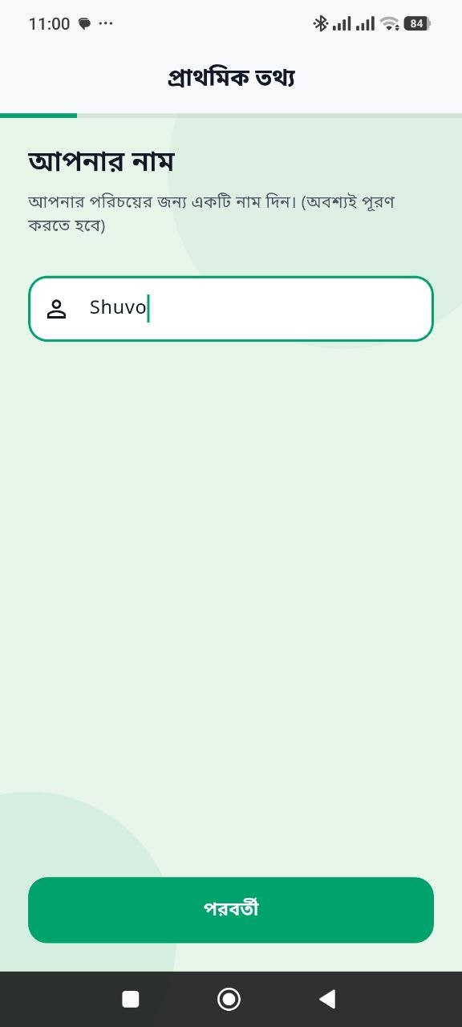 | 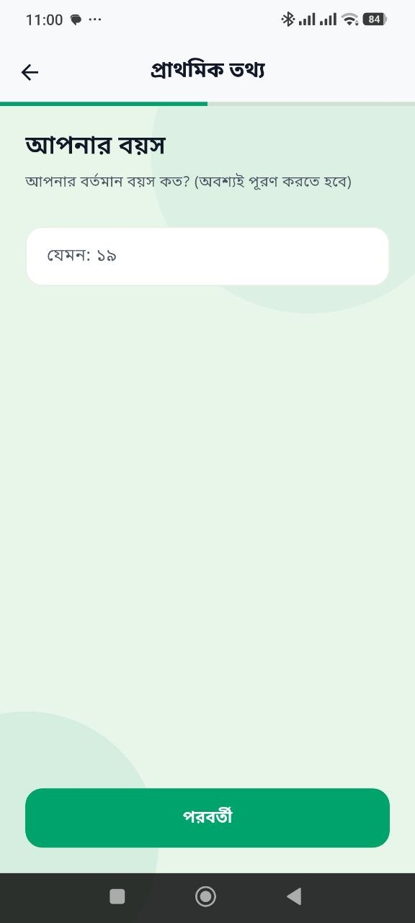
Figure 2: Profile Assessment – Name Input | Figure 3: Profile Assessment – Age Input

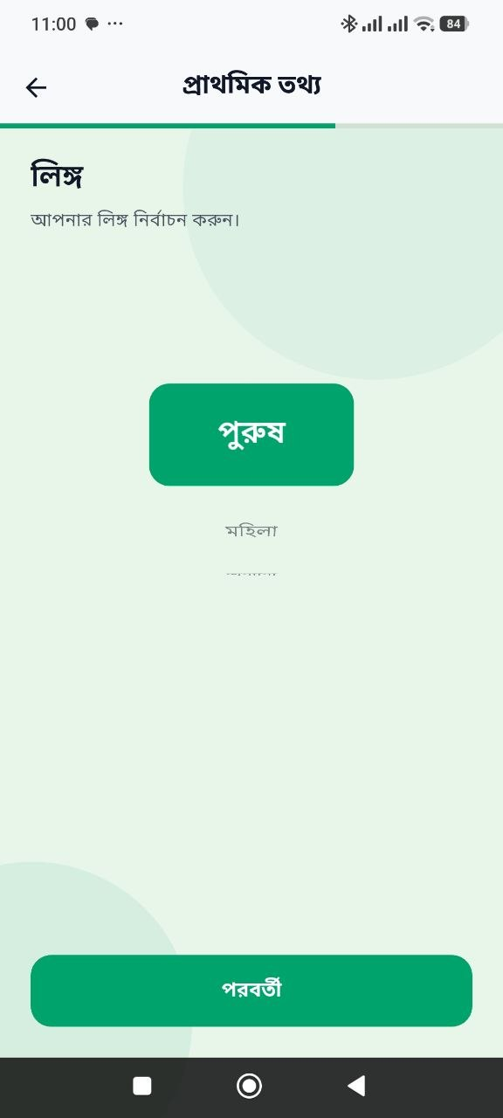 | 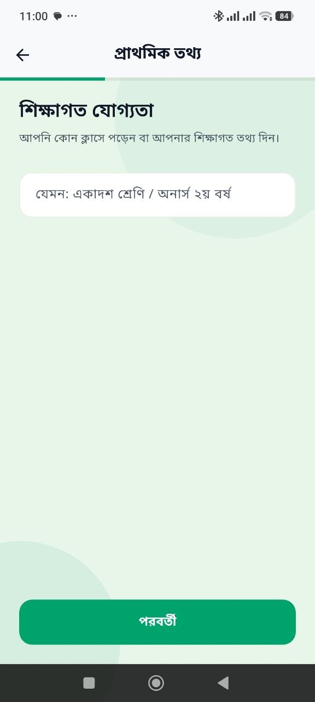
Figure 4: Profile Assessment – Gender Selection | Figure 5: Profile Assessment – Educational Info

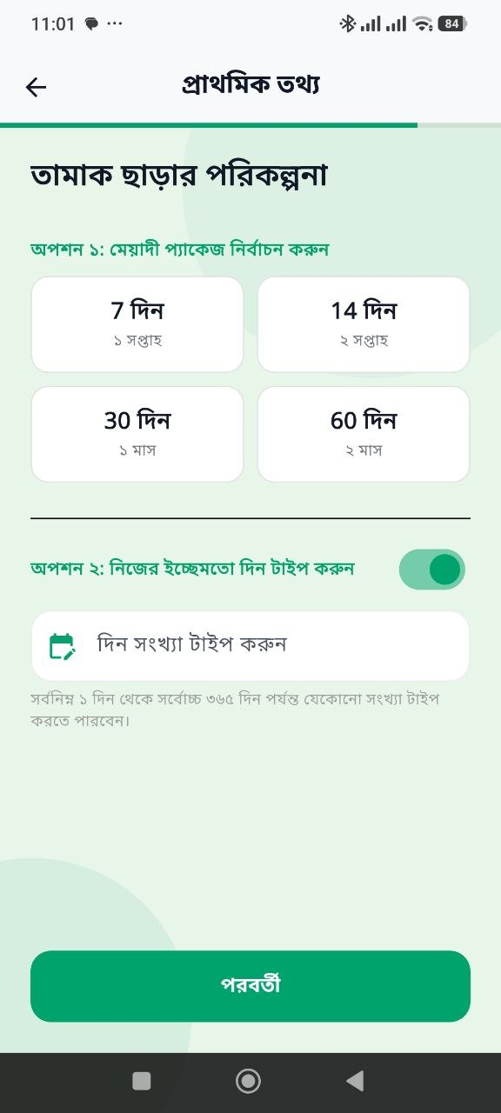
Figure 6: AI Quit Plan – Date & Duration Selection

6.3 Dashboard
The Home Dashboard is the central hub of QuitMate, providing a quick overview of the user's quit journey and access to all features.

Dashboard Components:
- Greeting Banner: Time-based greeting (e.g., 'সুপ্রভাত!').
- Motivational Strip: Displays tobacco-free days (e.g., '৩য় দিনে আছেন').
- Stat Card 1: 'তামাকমুক্ত দিন' – Total tobacco-free days since quit date.
- Stat Card 2: '৳ টাকা সেভ' – Total money saved in BDT.
- Feature Grid: 6 quick-access cards for all main features.

Screenshot:

Figure 7: Home Dashboard Screen

6.4 Add/Create Information – Daily Check-In
Users submit a daily check-in to record mood, craving level, and tobacco use status. This is the primary data entry feature of the app.

Steps:
- Tap 'দৈনিক চেক-ইন' (Daily Check-In) from the Home Dashboard.
- Select your current mood using the 5 emoji options (Excellent to Angry).
- Use the craving level slider to rate craving intensity (1 = Low, 5 = High).
- Indicate whether you used tobacco today: 'হ্যাঁ' (Yes) or 'না' (No).
- Write an optional reflection note.
- Tap Submit to save. A success message appears and the gamification tree updates.
Note: Only one check-in is allowed per day.

Screenshot:
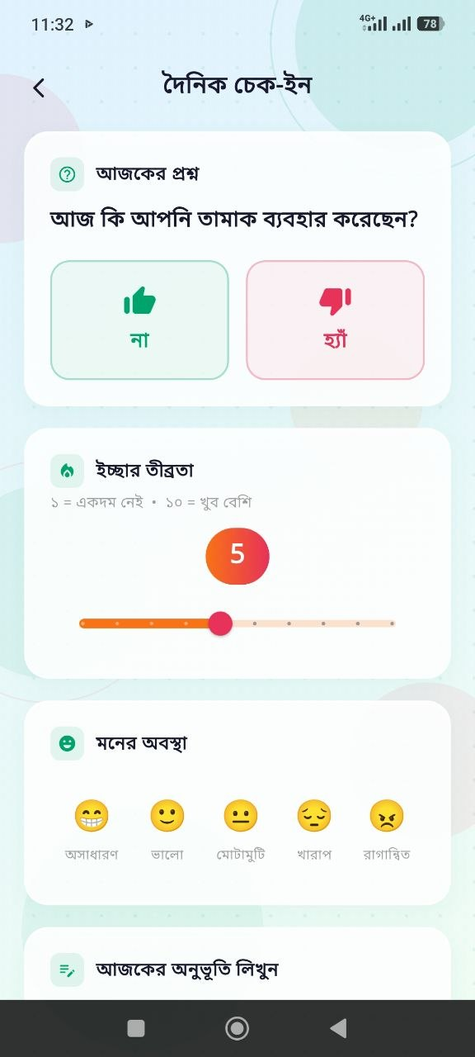
Figure 12: Daily Check-In Screen

6.5 View/Search Information

6.5.1 AI Quit Plan
Users can view their personalized day-by-day quit plan:
- Tap 'পরিকল্পনা' (Plan) from the Home Dashboard.
- The screen shows today's goal title and description.
- Read the 'আপনাকে যা করতে হবে' (What you need to do) section.
- At the end of the day, answer whether today's plan was completed (Yes / No).

Screenshot:
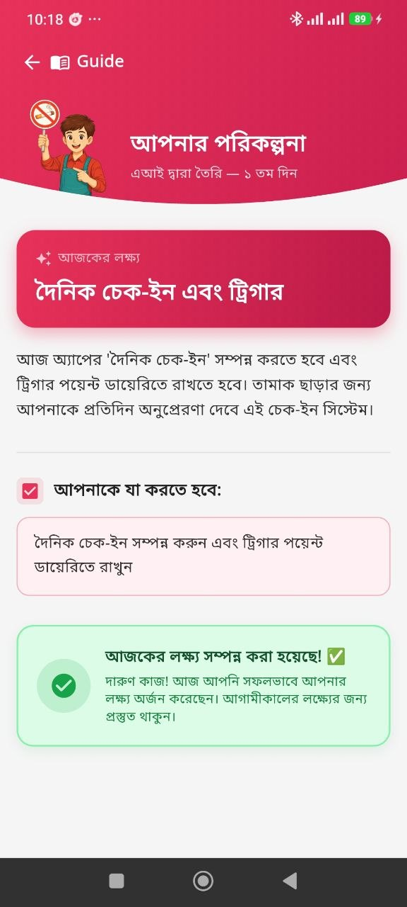
Figure 8: AI-Generated Quit Plan Screen

6.5.2 Money Saver
Users can view savings and set Dream Goals:
- Tap 'টাকা সেভার' (Money Saver) from the Home Dashboard.
- View total amount saved in BDT and a log of savings entries.
- View Dream Goals with progress bars showing progress toward each goal.

Screenshot:
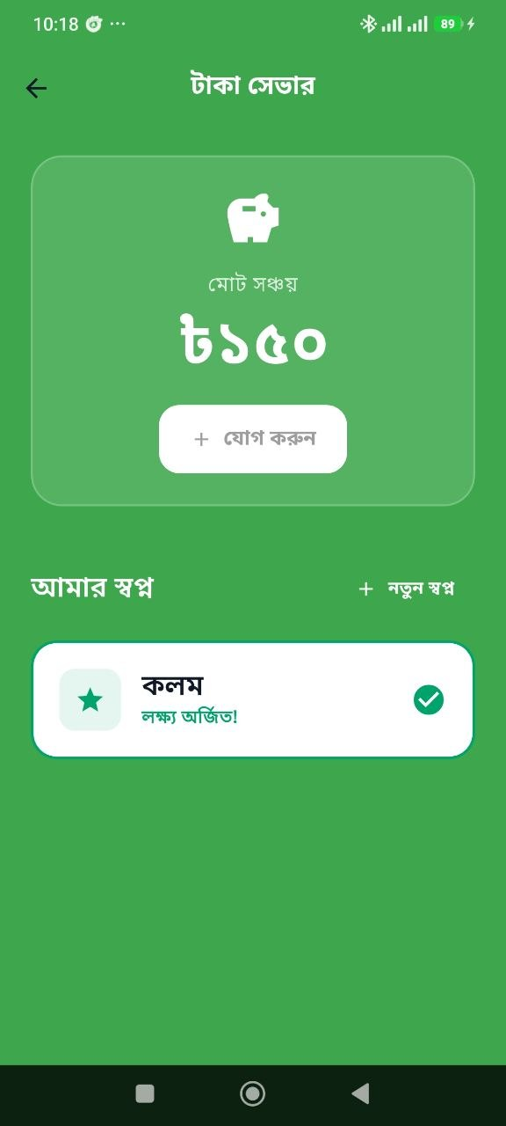
Figure 9: Money Saver Screen

6.5.3 Educational Content
Users can browse health articles and tobacco awareness content:
- Tap 'সচেতনতা' (Awareness) from the Home Dashboard.
- Browse categorized health articles and fact cards.
- Tap any card to expand and read the full content.

Screenshot:
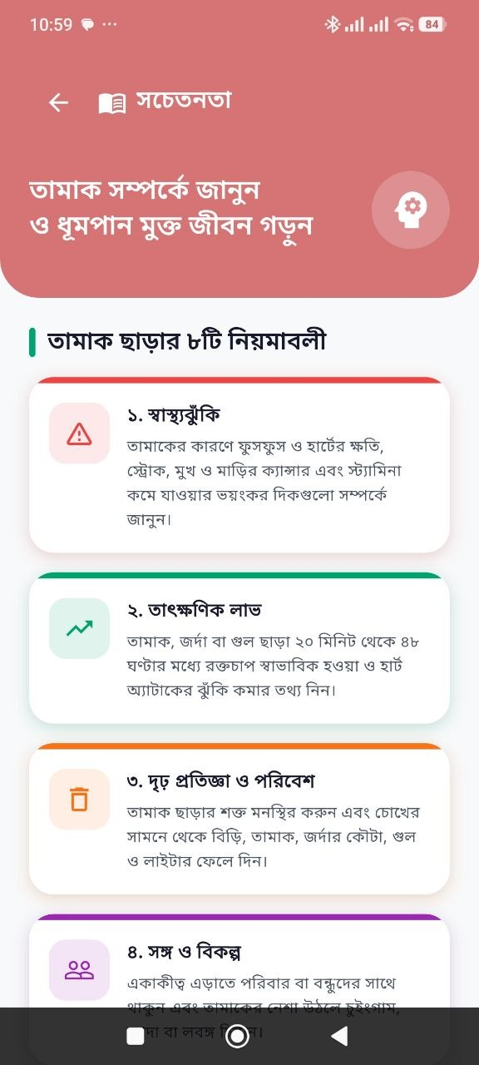
Figure 11: Educational Content Screen

6.6 Update/Edit Information

Updating Quit Date:
- Tap the profile photo (top-right) to open the Profile screen.
- Scroll down and tap 'Reset Quit Date'.
- Select a new quit date and confirm. The app updates the plan and counter.

Updating Profile Photo:
- Go to the Profile screen and tap the camera icon on your photo.
- Select a new photo from your device gallery. It uploads immediately.

Updating Notification Settings:
- Go to the Profile screen and toggle the Notifications switch.

6.7 Delete Information
Users can delete their own community forum posts:
- Open 'সহায়তা গ্রুপ' (Peer Support) from the Home Dashboard.
- Find your own message in the feed.
- Long-press your message and tap Delete.
Note: Users can only delete their own messages. Administrators can delete any message from the Admin Panel.

6.8 Additional Features

6.8.1 SOS Emergency / Craving Support
The SOS screen provides instant craving-distraction tools for moments when the urge to use tobacco is overwhelming.
- Tap the red 'এস.ও.এস' (SOS) button on the Home Dashboard.
- Mode 1: '৫ মিনিট অপেক্ষা' – 5-minute countdown to outlast the craving.
- Mode 2: '৪-৭-৮ শ্বাস' – Animated 4-7-8 breathing guide with audio.
- Track water intake and walking using interactive buttons.
- Tap 'বন্ধুকে কল করুন' to call an emergency contact.

Screenshot:
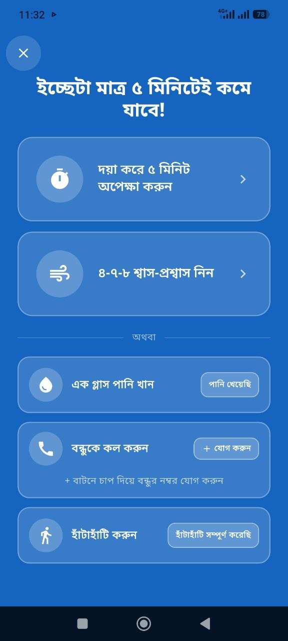
Figure 13: SOS Emergency Screen

6.8.2 Peer Support Community Forum
A real-time community chat where users share experiences and motivate each other.
- Tap 'সহায়তা গ্রুপ' (Support Group) from the Home Dashboard.
- View the live community feed.
- Type a message at the bottom and tap the send button.
- Tap the image icon to share a photo from your gallery.

Screenshot:
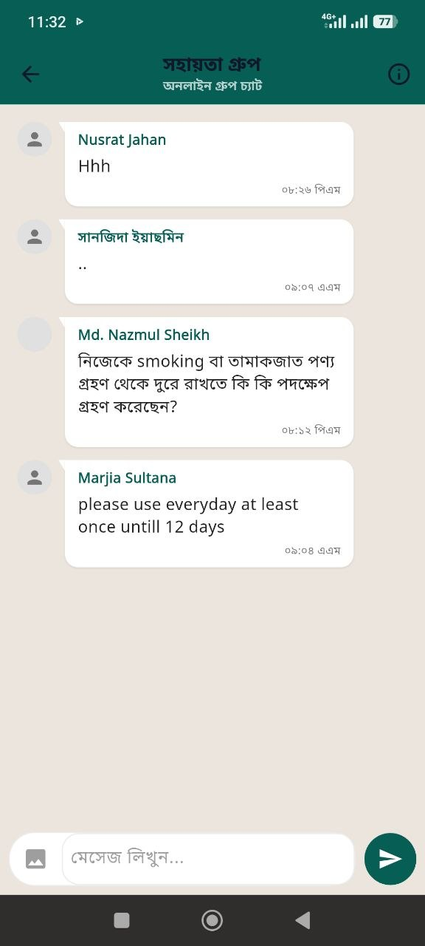
Figure 14: Peer Support Community Screen

6.8.3 Gamification – Tree Growth
A virtual tree grows with each tobacco-free daily check-in, progressing through 6 stages: Empty Pot → Seed → Sapling → Leaves → Young Tree → Full-Grown Tree. If tobacco is marked as used, the tree becomes pest-infected. Three consecutive tobacco-free check-ins restore the tree.

Screenshot:
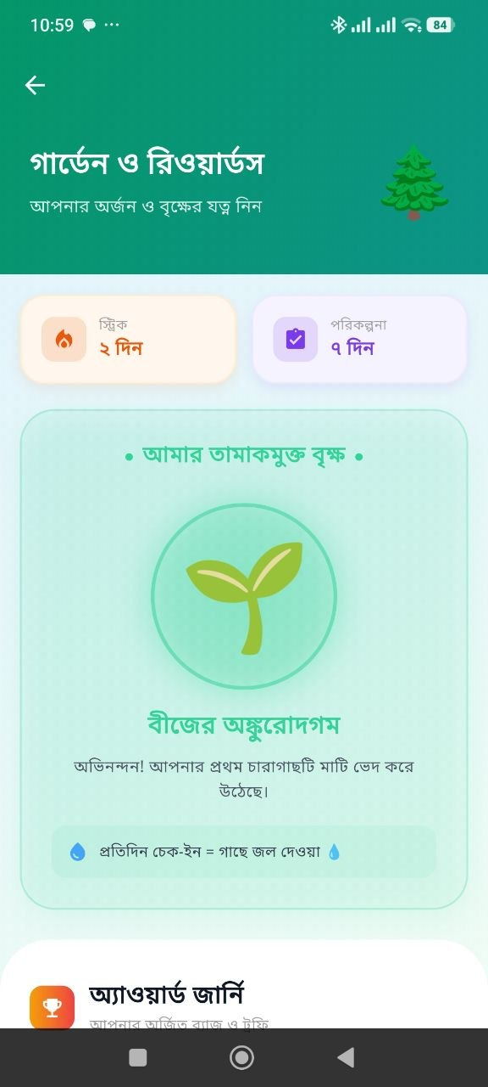
Figure 10: Gamification – Tree Growth Screen

6.8.4 User Profile
The Profile screen allows users to manage account settings:
- View and change profile photo.
- Enable or disable daily reminder notifications.
- Reset Quit Date.
- Access Help & Support.
- Logout from the application.

Screenshot:
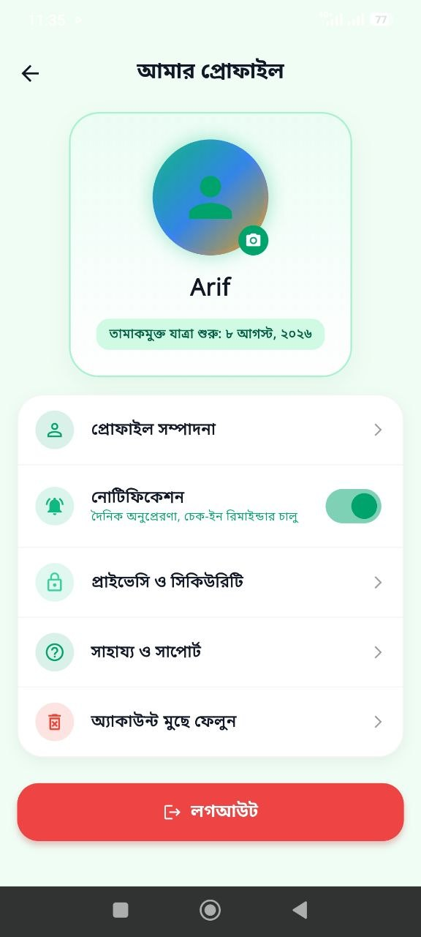
Figure 15: User Profile Screen

7. Input and Output Description
The following table describes the major inputs, processing actions, and expected outputs for each key function of QuitMate.

Feature | Input Required | Processing | Expected Output
Google Sign-In | Google account | Firebase verifies identity | User logged in and redirected
Profile Assessment | Name, Age, Gender, Plan | Groq AI generates plan; DB saved | Profile created; plan generated
Daily Check-In | Mood, Craving, Tobacco | Data saved; streak updated | Check-in recorded; tree updated
Quit Plan Response | Yes / No answer | Response saved; progress updated | Status card shown for the day
SOS Emergency | Mode selection | Timer or breathing guide started | 5-min timer or breathing displayed
Money Saver | Savings amount (BDT) | Amount added to log | Total savings updated
Dream Goal | Goal name, target BDT | Goal saved to database | Goal with progress bar shown
Community Post | Text or image | Published via Socket.IO | Message visible to all users
Educational Content | Article tap | Content loaded | Full article displayed

8. Error Messages and Troubleshooting
The following table lists common problems, their possible causes, and solutions.

Problem | Possible Reason | Solution
Unable to log in | No internet or sign-in cancelled | Check internet. Try again.
Connection Problem dialog | Server unreachable or timeout | Check internet. Wait and retry.
AI Plan not generated | Groq AI API timeout | Retry with stable internet.
Forum not loading | Socket.IO failed or server offline | Pull to refresh. Reopen app.
Already checked in today | One check-in per day limit | Expected behavior. Try tomorrow.
Notifications not received | Permission not granted | Settings > Apps > QuitMate > Notifications > Enable.
App crashes on startup | Corrupted cache or outdated APK | Clear cache. Restart or reinstall.
Image upload fails | File too large or poor connection | Use smaller image or switch to WiFi.
Savings not updating | Backend sync failure | Pull to refresh. Check internet.
Application not starting | Permissions not granted | Reinstall and grant all permissions.

9. Frequently Asked Questions (FAQ)
Q1. How can I create an account?
Answer: Follow the registration procedure in Section 6.1. QuitMate uses Google Sign-In, so no separate account creation is required.
Q2. What should I do if I forget my password?
Answer: QuitMate does not use a separate password. Login is handled by Google. Use the 'Forgot Password' option on the Google sign-in page if needed.
Q3. What if I relapse and use tobacco again?
Answer: Open Daily Check-In and honestly mark tobacco used. The tree becomes pest-infected. Complete 3 consecutive tobacco-free check-ins to restore it. A relapse is not a failure — simply restart your journey.
Q4. Can I change my Quit Date?
Answer: Yes. Go to Profile screen > scroll down > tap 'Reset Quit Date' > select a new date > confirm.
Q5. How is the money saved amount calculated?
Answer: Money saved = tobacco-free days × estimated daily tobacco cost configured during profile assessment.
Q6. Is my data private and secure?
Answer: Yes. QuitMate uses Firebase Authentication (Google OAuth 2.0) and a secure Node.js + PostgreSQL backend. Data is not shared with third parties.
Q7. Can I use the app without internet?
Answer: Limited offline functionality is available via cached data. AI plan generation, the Community Forum, and data sync require internet.
Q8. How do I turn off notifications?
Answer: Profile screen > toggle the Notifications switch to OFF.
Q9. Can I delete a forum post?
Answer: Yes. Long-press your own message in Peer Support > tap Delete.
Q10. What is the 4-7-8 breathing technique?
Answer: Inhale for 4 seconds, hold for 7 seconds, exhale for 8 seconds. Repeat 3–4 times to significantly reduce craving intensity.

10. Logout and Exit Procedure

10.1 Logout Procedure
- From the Home Dashboard, tap your profile photo (top-right) to open the Profile screen.
- Scroll down to the bottom of the Profile screen.
- Tap the 'লগআউট' (Logout) button.
- Confirm the action if prompted.
- You are redirected to the Login screen. All data remains saved on the server.

10.2 Exiting the Application
- Press the device Back button from the Home Dashboard to exit the app.
- Or use the Recent Apps button and swipe away the QuitMate card.
Note: Pressing the Home button does not log you out. Your session remains active until you explicitly tap Logout.

11. Limitations and Precautions

11.1 Technical Limitations
- Internet Required: Most features including Sign-In, AI plan generation, and Community Forum require internet.
- Android Platform: Currently built and tested primarily for Android devices.
- One Check-In Per Day: Users can submit only one Daily Check-In per day.
- AI Dependency: Quit Plan generation depends on Groq AI API availability.
- Backend Dependency: The app relies on a hosted Node.js server.

11.2 Medical Disclaimer
QuitMate is a digital motivational tool, not a substitute for professional medical advice or addiction counseling. Users with severe nicotine addiction should consult a licensed healthcare professional in addition to using this application.

11.3 Privacy Precautions
- Do not share your Google account credentials with others.
- The community forum is visible to all registered users. Do not share personal contact information in posts.

12. Contact / Support Information
For technical support or queries related to QuitMate:

Support Type | Details
In-App Help | Profile > Help & Support
Email Support | support@quitmate.app
Project Supervisor | Contact your assigned academic supervisor for project queries.
Tobacco Quit Helpline | 16000 (Bangladesh – toll-free)

Appendix
Additional screenshots, diagrams, and system information for QuitMate are provided in this section.

A. Complete Screenshot Gallery
All available real mobile screenshots of the QuitMate application:

 | 
Figure 1: Google Sign-In / Login Screen | Figure 2: Profile Assessment – Name Input

 | 
Figure 3: Profile Assessment – Age Input | Figure 4: Profile Assessment – Gender Selection

 | 
Figure 5: Profile Assessment – Educational Info | Figure 6: AI Quit Plan – Date & Duration Selection

 | 
Figure 7: Home Dashboard Screen | Figure 8: AI-Generated Quit Plan Screen

 | 
Figure 9: Money Saver Screen | Figure 10: Gamification – Tree Growth Screen

 | 
Figure 11: Educational Content Screen | Figure 12: Daily Check-In Screen

 | 
Figure 13: SOS Emergency Screen | Figure 14: Peer Support Community Screen


Figure 15: User Profile Screen

B. System Architecture
- Frontend: Flutter mobile app (Android) with Riverpod state management.
- Backend: Node.js + Express.js REST API with PostgreSQL database.
- Authentication: Firebase (Google Sign-In OAuth 2.0).
- AI Engine: Groq AI API (LLaMA 3 model).
- Real-time: Socket.IO for live community chat.
- Local Storage: Hive for offline caching.
- Admin Panel: HTML + Vanilla JS served by Express.

C. Technology Stack
Component | Technology
Mobile Framework | Flutter 3.x (Dart SDK ^3.10.8)
State Management | Riverpod 2.x
Authentication | Firebase + Google Sign-In
Backend | Node.js + Express.js
Database | PostgreSQL
AI Engine | Groq AI API (LLaMA 3)
Real-time Chat | Socket.IO
Local Cache | Hive DB
Notifications | Flutter Local Notifications
Admin Panel | HTML + Vanilla JS + Express

Supervisor Approval

Project Title: _____________________________________________

Group Members:
1. Md Ariful Islam ID: MUH2325010M
2. Mohammed Karimul Mowla ID: ASH2325031M

I have reviewed the User Manual Report of the above-mentioned SPL-2 project.
Supervisor's Name: __________________________________________
Signature: ______________________________________________
Date: __________________________________________________

Important: The report must contain the supervisor's signature. Without the supervisor's signature, the group will not be allowed to participate in the SPL-2 Final Presentation.

